Forensic Analysis of Memetic Image Propagation: Introducing the SMOC BRISQUEt Method

| James A. Hodges  Affiliation, USA  james.hodges@utexas.edu | Mitch Chaiet  Harvard Kennedy School Shorenstein Center, USA  mitchchaiet@hks.harvard.edu | Praful Gupta  Affiliation, Country  praful_gupta@utexas.edu |
| --- | --- | --- |

ABSTRACT

This sample paper describes the formatting requirements for ASIST conference proceedings. Please review this document for the formatting details which are intended to provide a consistent format for our Proceedings. Abstracts should be no more than 150 words. The abstract should be a concise statement of the problem, approach, findings, and implications of the work described. It should clearly state the paper’s contribution to the field. This section is required.

KEYWORDS

Add not more than 5 keywords or phrases separated by semicolons for use in indexing this paper; these may also be used to identify appropriate reviewers. This section is required.

INTRODUCTION

This study proposes a two-step process for understanding the memetic spread of images via social media networks. The affordances of many social networking platforms facilitate more effective and widespread sharing of images when compared against video, text, or other media formats. Images are typically sourced from one post on a social platform, downloaded to a user’s device, and uploaded elsewhere online. Furthermore, in the wake of increased platform moderation around sensitive topics like the COVID-19 pandemic and 2020 U.S. Presidential elections, controversial content is frequently spread via screenshots, archive links, and other novel methods in order to evade automatic filtering and moderation processes (Acker and Chaiet, 2020). This paper demonstrates two separate methods for understanding the memetic spread of imagery, before demonstrating the combined use of both approaches. The authors begin with interpretive human identification of diegetic elements in a digital image in order to retrace a general sense of its path across multiple users and platforms. Next, the authors apply a newly trained blind, no-reference image-quality analysis algorithm in order to generate a quantified score of image characteristics that can identify the level of JPEG compression across a corpus of images. These methods encompass provenance, hierarchical genealogies, and fingerprinting.

By combining human interpretation with computational analysis of compression, the authors generate a more robust account of the images’ specific genealogical histories than either technique alone. This richer account of memetic copying and distribution offers insight into the specific vectors of spread used to propagate controversial content and evade moderation on social platforms. Differences between digitally-generated images and “natural” photographs make certain images more amenable to interpretive and computational analysis, respectively.

Background

Every time an image is uploaded to a social platform, it is compressed using some form of algorithm in order to reduce its required bandwidth and streamline user experience (Joshi and Sarode 2020). At the same time, user behaviors such as screen capture can produce new visual features related to the on-screen elements present on their device, including user interface elements like captions, commentary, or GUI elements. Therefore, each time an image is propagated from one place to another, it will undergo a subtle change in both its visual and technical composition. The paper presents a methodology for understanding both of these elements in media distribution via social platforms, using a combination of machine learning and human interpretation.

First, we assess the visual quality of imagery and changes in visual compression between discrete copies of memetic images using a specially trained version of No-Reference (NR) Image Quality Assessment (IQA) enabled by Mittal, et al’s (2011; 2012) Blind/Referenceless Image Spatial Quality Evaluator (BRISQUE), which we have retrained for our purposes and named **BRISQUEt** (an acronym for “Blind/Referenceless Image Spatial Quality Evaluator: reTrained”). Based on the study, the authors conclude by making estimates concerning the specific avenues and extent of spread afforded to different copies of key sample images.

RQ1: How can the human interpretation of diegetic image components be used to interpret the spread of memetic image content online, and in what contexts is such an approach most productive?

RQ2: How can computational analysis of image compression be used to interpret the spread of memetic image content online, and in what contexts is such an approach most productive?

Related Work

The ability to copy and distribute digital media is often seen as one of its key attributes. Significant existing research within media and cultural studies offers useful definitions and critical interpretations that can enrich technical research (Parikka 2007, Davison 2012, Shifman 2014, Stein et al 2014, Gaboury 2015). Computer and information science has tackled these issues by automating various forms of content identification, evaluation, and classification, with a particular focus on identifying content that is false or misleading (Farid 2006, Gupta et al 2013, Ma et al 2013, Conroy et al 2015, Rubin 2016). A more recently emerging and still-developing third thread of research also exists, which combines the aforementioned humanistic and computational approaches to understanding memetic distribution (Teyssou et al 2017, Acker and Chaiet 2020, Singh et al 2020).

The present study joins recent scholarship in the small but growing field of literature that combines technical and humanistic methods. In particular, we demonstrate the value of interpretive analysis that focuses on the presence of user interface elements from a user’s personal networked device in images and video (thus attesting to certain details about that user’s personal information practices), as well as the computational identification of image compression (which attests roughly to the number of times an image has been re-uploaded and compressed by online social networks). By combining these threads of research, we advance a mixed-methods approach to understanding media sharing online and work toward developing a richer, more well-balanced methodological toolkit for media and information research to employ when conducting their work.

Humanistic media studies scholars have developed robust definitions and critical approaches to digital media, in particular exploring the subtle effects of certain definitional decisions. For example, while the terms “meme” and “viral” are often used interchangeably to describe the spread of digital media, scholars like Shifman (2014) point out that these terms come from different origins and possess different meanings. Viral media was originally used to refer specifically to media that is, or is thought to be, self-replicating within host machines in the sense of a biological virus (Parikka 2007). The notion of a meme, on the other hand, emerges from evolutionary studies emphasizing the role of social activity in transmitting cultural habits (Davison 2012). In this study, we prefer the notion of memetic spread, which builds on the study of memes, as well as its etymological roots in terms like mimesis and copying.

Existing information and computer science research addressing memetic spread has addressed the detection of doctored content online in considerable depth. Early in the 21st century, Farid (2006) began developing forensic tools to detect alterations and distortions in photography (2006). Gupta et al (2013) demonstrates a different approach, using metadata drawn from specific social networks (such as user details and timestamping) in order to identify fake images. Conroy et al (2015) build further on this approach by using network analysis combined with computational linguistics. Additional research using linguistic identification, such as that by Rubin et al (2016), has worked to identify misleading content that is primarily textual in nature. In the realm of video, Teyssou et al (2017) have also developed new software that can identify falsification in video, expanding upon previous research addressing images and text. Teyssou et al also highlight an important characteristic of research problems in media verification, noting “the problem of online information verification is very complex and touches upon a number of research fields, including media studies and journalism (p. 23). The present study builds on Teyssou’s multi-pronged approach by drawing on both technical and humanistic approaches.

Singh et al (2020) provide another example of multi-pronged analysis of online media, by automating both visual and textual analysis. Yet where multi-pronged approaches like those of Singh et al and Teyssou et al still primarily aim to automate the detection of misleading media, the present study focuses on understanding memetic spread, rather than detecting veracity. By demonstrating a methodological approach that can help researchers forensically reconstruct the information behaviors of users that spread memetic content, this study enriches scholarly knowledge about the ethos of sharing and specific techniques employed when images are shared across multiple platforms and networks.

Case study: Interpretive analysis using the SMOC method (Sourcing Memetic Online Content)

In order to demonstrate interpretive analysis of memetic content, this case study examines a series of social media posts (image and text) collected and preserved during the storming of the U.S. Capitol Building on January 6, 2021. After collecting the corpus, two particular screenshots posted as to Twitter are analyzed for the visual characteristics that identify unique patterns of cross-platform propagation from the same original post. By identifying the specific social networks whose user’s handles and interface elements are displayed in the images, as well as evidence of the technical modalities used to reproduce the images, we are able to draw qualitative conclusions about the nature of sharing and copying among proponents of a particular memetic object. We term these visual elements “diegetic user interface elements,” using a notion of “diegesis” that is drawn from cinema studies to refer to visual markings that are contained within the frame of a selected media object. In this case, the user interface elements are *diegetic* to the social media post because they are included in the post contents, rather than being superimposed around the post as they would be when viewing an object through the social network’s user interface.

Data collected for this portion of the research was manually curated into a GitHub repository comprising screenshots of the posts in question, copies of the images included within posts, and a record of metadata for all collected tweets (Berk and Chaiet 2021). For the sake of demonstrating interpretive analysis, a tweet by the Twitter user “StunningTruthSeekr” (@stunningtruthsr) was selected for further analysis (see Figure 1), alongside a separate tweet by Twitter user “RC0076” (@rwacollins). The posts in question are exemplary of the layered quality that visual elements often accumulate during the process of circulation. Like the rings of a tree, interface elements can stack up next to one another over time, with each instance attesting to a hierarchical unit of time-- in this case, one act of sharing. These qualities are most clearly visible in the two images attached to the post in question. This dataset includes both screenshots and post URLs. While screenshots are generally useful for interoperability between contexts, post URLs and archived versions thereof provide richer contextual information. For more information, see Nelson (2021).

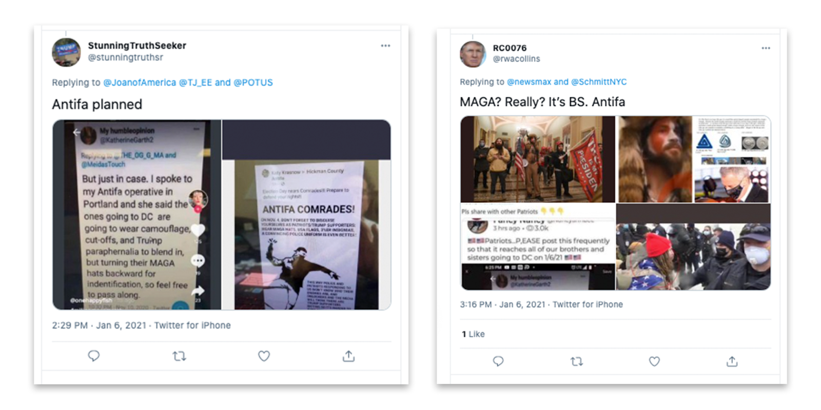

In the first Twitter post in Figure 1, StunningTruthSeekr includes two popular images that suggest members of left-wing “Antifa” (short for “anti-fascist”) groups may have planned to participate in the January 6 actions while disguised as members of right-wing “Patriot” or “MAGA” groups loyal to then-president Donald J. Trump. This narrative was widely deployed in right-wing media as a way of deflecting associations with the insurrectionists that stormed the U.S. Capitol (Grynbaum et al 2021). By examining the specific techniques and paths used to spread this narrative through memetic means, an interpretive analysis of the post’s contents, we note the cross-platform spread, as well as the coexistence of both screen capture and photographic duplication (taking a photo of one’s screen) -- two particular information behaviors that complicate attempts at automating detection of misleading content in methods established by existing research.

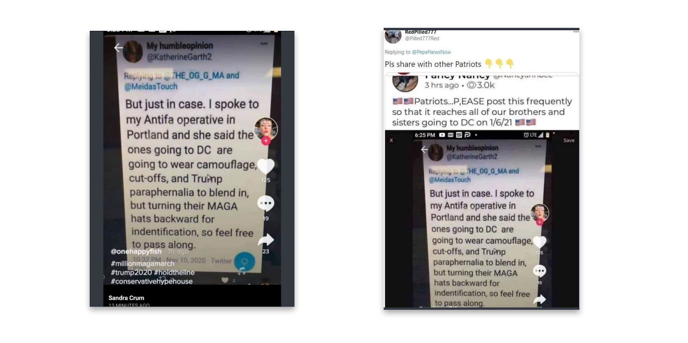

The first image included in StunningTruthSeekr’s Tweet (Figure 2) shows evidence of at least three acts of cross-platform sharing-- first on Twitter, then on TikTok, and finally on FaceBook. This finding is informed by the main content, which contains the word “Twitter” and a characteristic timestamp at bottom of the white screenshot containing the image’s main contents. It is also supported by the avatar, heart icon, comment icon, and share arrow present along the image’s right edge, all of which are characteristic of TikTok’s user interface. Additional evidence of an intermediary appearance in Twitter can be faintly identified by the presence of a twitter user interface (with black background) just beneath the main image’s white field. Finally, the black bar at bottom of the image reading “Sandra Crum” and “13 minutes ago” are consistent with the mobile interface for Facebook. Thus before StunningTruthSeekr reposted this image via Twitter, it had already been propagated across different social networks at least three times, and shared at least four times overall. Also present in StunningTruthSeekr’s first image is a skewed perspective and reflection of artificial lighting, suggesting that the image was captured by photographing the user’s screen, rather than downloading or screen capture. “Vernacular” information practices such as these complicate efforts at rationalizing and predicting user behaviors and are therefore challenging to automated systems (Gaboury 2015), and therefore make the identification of diegetic evidence a useful step in expanding disinformation detection efforts.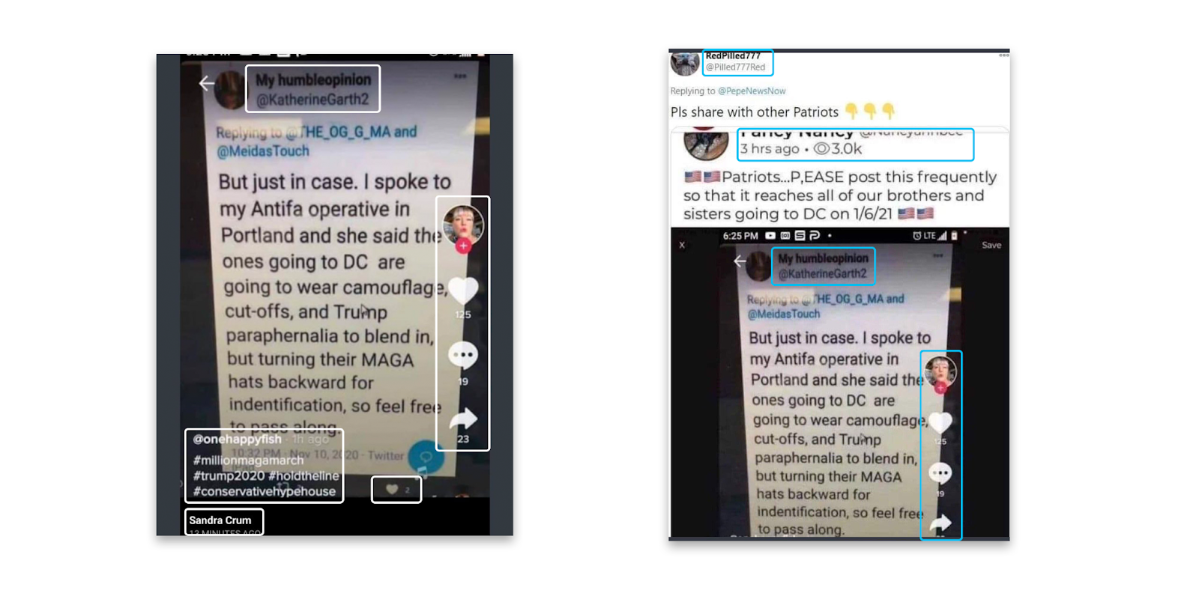

The second image of StunningTruthSeekr’s post also contains diegetic interface elements and evidence of screen photography. The image appears to display a Facebook post on the “Hickman County Antifa” Facebook page by “Katie Krasnow,” while the image’s skewed perspective and surrounding desktop environment suggest that it was downloaded to a user’s Macintosh desktop before being photographed for additional sharing. The white stripes on either side of the image suggest that this photographed image was subsequently recorded via screen capture over a white background. The black stripes above and below suggest the image was screen shotted once again afterwards, while the grey stripe at bottom indicates that this final act of screen capture was performed on an Apple iPhone X or later, after the manufacturer introduced the “home bar” as a replacement for its earlier “home button” designs (Patel 2017). These diegetic interface elements suggest that the original Facebook post was photographed at least once and screenshotted at least twice. They also suggest that the two images in StunningTruthSeekr’s post arrived through different histories of sharing and mimesis.

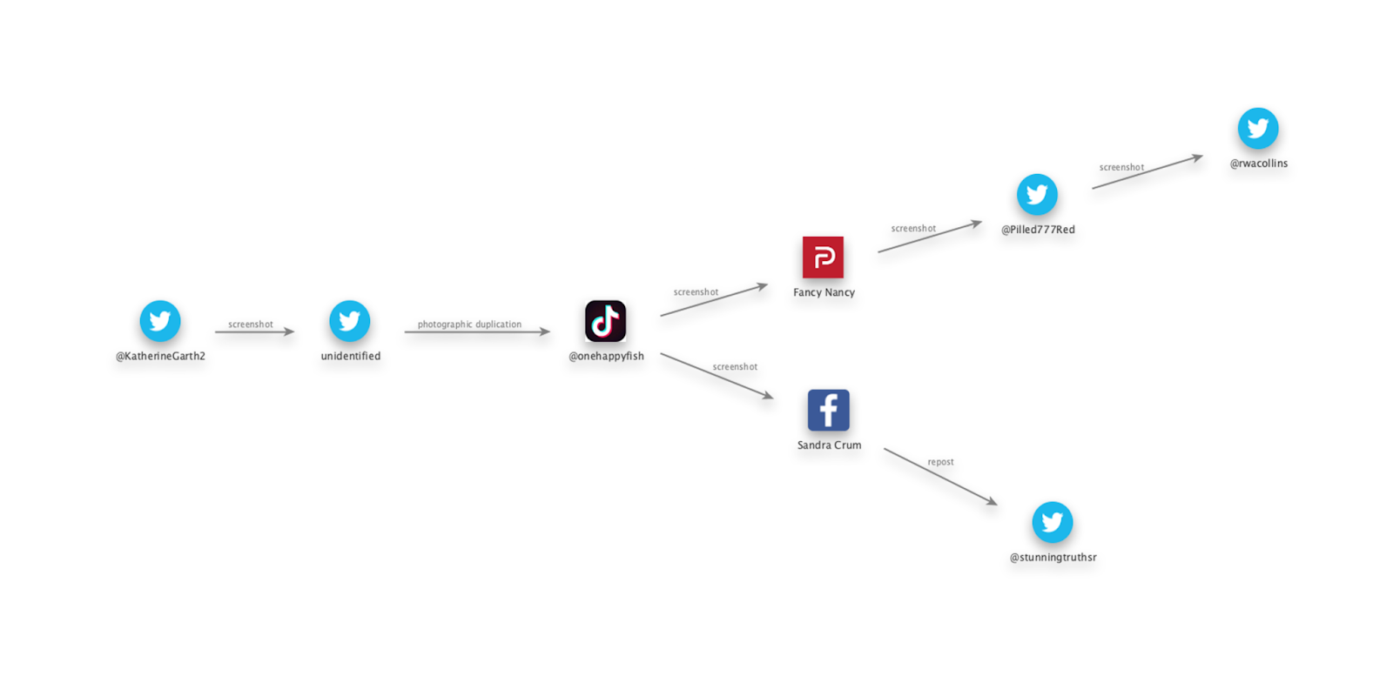

By enumerating the particular acts and techniques of sharing used to spread this particular narrative, this case study shows that human users can interpret interface elements and qualitative properties of an image that may be skewed in perspective, obscured by lighting effects, related to specific interfaces and interface changes, and subject to inconsistently colored or oriented arrangement. This approach is most effective in identifying features and pathways for further exploration, whether automated or performed by humans (RQ1). At the same time, this approach has clear limitations. It does not track all sharing, but rather only detects sharing actions that produce some form of visible alteration to the image. For more subtle variations, computational analysis is warranted. In ideal cases, both approaches would be applied together in order to most effectively identify the paths used in distributing a particular unit of misinformation. Like a forensic crime scene investigation, reconstructing the specific timeline of events during analysis may help to identify the particular parties, environments, and tools used in carrying out the acts in question.

Case study: Computational analysis using BRISQUEt

While digital-born imagery such as screenshots often carry diegetic markers of their propagation histories, measuring the spread of natural imagery must be analyzed separately. We analyze the propagation of natural images by measuring the compression artifacts present in natural imagery (a form of digital decay) by applying a newly trained blind, no-reference image-quality analysis algorithm in order to generate a quantified score of image characteristics that can identify the level of JPEG compression across a corpus of images. These methods encompass provenance, hierarchical genealogies, and fingerprinting, and expand upon simple perceptual hashing with rough estimations of spread.

By measuring the visual quality of natural imagery, subtle changes in compression associated with reposting can be quantified, allowing for a visual fingerprinting method which functions in a similar manner to a perceptual hash, while allowing for a generalized hierarchy to be assumed. This data can be ethnographically interpreted as a “genealogical” record of how close images are to the point of origin. Assuming that imagery gets more compressed as it gets shared, changes in visual compression can be used in combination with other metadata, such as timestamps, to determine patterns of sourcing and propagation.

The spread of natural imagery begins with its inception - the time, date, and location, and device with which it was captured. The original image serves as a ground truth for quality. Once posted online, natural images are propagated memetically in a peer-to-peer fashion across public channels and into closed subnetworks. In order to assess the spread of a particular piece of content, a memetic propagation analysis can be created, which maps the various locations discrete copies of the same image have been posted. A linear, graphical memetic analysis encapsulates the spread of an image over time while associating it with other metadata in order to assume a genealogy of spread.

When images are chosen for analysis, various changes in aspect ratio, user edits, diegetic UI elements, and other visual phenomenon can skew the results of BRISQUEt. When all images selected for comparison are discrete copies of the same image, with no changes in resolution or aspect ratio, the original files can be compared directly using BRISQUEt. When a corpus of imagery incorporates differences in aspect ratios, resolutions, etc. the images are aligned using image manipulation software and a representative sample is sliced from each image where they overlap (Walter 2021). This controls for changes in compression.

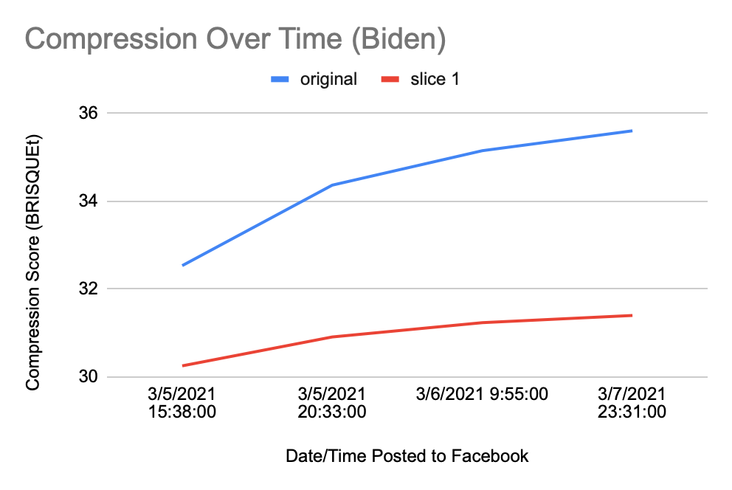A frame from a YouTube video filmed during the Biden presidency (occuring at the 01:22 mark) serves as an exemplary “ground truth” selection of determining a genealogical hierarchy from multiple discrete copies of the same image (Weekly Conversation 2021). This frame was selected as an ingredient asset within a new work, an image macro unrelated to the original video, and then spread memetically across many publicly accessible social networks. We analyze four separate posts from March 5-7, 2021 on Facebook, each containing a discrete copy of the image. Since each of these images are discrete copies, we can directly compare both the original images and representative slices thereof. When the individual BRISQUEt scores are mapped to the timestamps posted, the image appears to “age” or “decay” as compression increases over time, leading to subtle decreases in visual quality. Determining a definite relationship as to the sourcing and reuploading of these examples requires further interpretive work, such as interviewing the page owners. However, a hierarchy can be identified between images that are “upstream” (closer to source) and those that are “downstream” (further from source). From these findings which interpretive work can determine which copies came “before” or “after” the others.

|  |  |  |  |
| --- | --- | --- | --- |
| https://lh5.googleusercontent.com/YagFh5xiwsBDiZMwFjy63fpycykixtURMfJDYO2BrYwyNtgf51vXEbY_JIP5h6ZnyI3WOMi0Jkf-JSS5tTdBVM4ZhEvBvyaK_KUX16D-q2g8id2HxuaQulbIs_vnlpaGDa_31fNj | https://lh4.googleusercontent.com/C04FDg-r3UN13Q6GOlPCz-KULaJgS-_ASGxSvf6RuaRRXrrLKFUslkNDOprzl5bBK6ZX1gPXyp6ko25DG3gLBvDoda0cUhk8S9RU8f8b52I12fhT1na_5amS83FhxsL73fQMagZg | https://lh5.googleusercontent.com/bAA73z9GxaPaagrlhYZmoGpBLWZJqAHy6cnHKb1I7ErTJkCyIgC-lzD_LqmlIWL4V_nQ9OS0Jw0Or7Nb09nGA2q1NqPNRwMfB-WN_wWR-H5cG-ZmZHTNxTdr93cpOH6Uyr0UAAaP | https://lh6.googleusercontent.com/guWhI3uRdPm6636hvWBvwbGfkc3AfMlqQxhbDFPaMHfT5etkwyIE5WVN105va1EjlQe2uSXNKt4YwiVxBZIhSOA9IHJSj_VoQPIEep99UHptgfZldfeZxMaD1QI3W71dwSoWEk9w |
| **30.252573** | **30.91004** | **31.235117** | **31.39871** |
| 1 | 2 | 3 | 4 |

|  |  |  |  |  |  |
| --- | --- | --- | --- | --- | --- |
| **index** | **source** | **file size** | **original** | **slice 1** | **timestamp** |
| 1 | MCxK2 | 38 KB | 32.53254 | 30.252573 | 3/5/2021 15:38:00 |
| 2 | TheKinoplex | 30.4 KB | 34.36434 | 30.91004 | 3/5/2021 20:33:00 |
| 3 | WheresFrankOceanAsWell | 31.9 KB | 35.14824 | 31.235117 | 3/6/2021 9:55:00 |
| 4 | IndecentAsAllHell | 31.4KB | 35.60043 | 31.39871 | 3/7/2021 23:31:00 |

|  |  |  |  |
| --- | --- | --- | --- |
| **index** | **source url** | **handle** | **archive url** |
| 1 | <https://www.facebook.com/MCxK2/photos/a.100696408010497/464898614923606/> | MCxK2 | <https://websatchel.com/j/pages/O83q89UjiWDjZvQOcOhMyTyk/avAM75Bg1Pi94Ojm18KuM1bQ/> |
| 2 | <https://www.facebook.com/TheKinoplex/photos/a.104157184829866/205288104716773> | TheKinoplex | <https://websatchel.com/j/pages/O83q89UjiWDjZvQOcOhMyTyk/A0fiQC3YiMvCgdVlk9PqbWjj/> |
| 3 | <https://www.facebook.com/WheresFrankOceanAsWell/posts/285096592980532> | WheresFrankOceanAsWell | <https://websatchel.com/j/pages/O83q89UjiWDjZvQOcOhMyTyk/fBIyMxaPM0jvrScc3uFUntVO/> |
| 4 | <https://www.facebook.com/IndecentAsAllHell/posts/280265963455011> | IndecentAsAllHell | <https://websatchel.com/j/pages/O83q89UjiWDjZvQOcOhMyTyk/dYtfoV8WPqBHIDkR2a0EO2Wb/> |

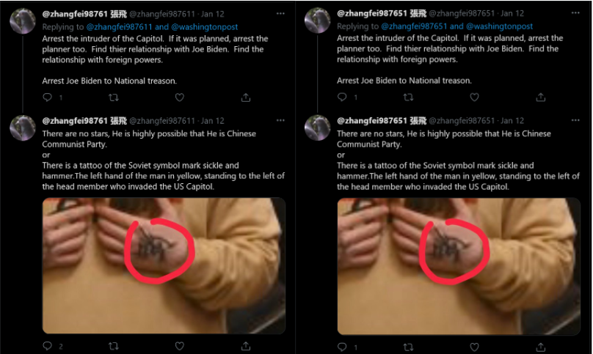

In addition to identifying hierarchies, BRISQUEt can also be used to fingerprint discrete copies or slices of a corpus of imagery. This method can be used to determine content sources programmatically using visual quality alone. We detail an example of coordinated inauthentic behavior (CIB), where two different Twitter accounts, @zhangfei987611 and @zhangfei987651, post the exact same image across 5 separate posts. The similarities in these discrete handles along with the BRISQUEt fingerprinting proves that these two accounts are managed from the same source, and the image posted across both accounts was sourced from the same content repository.

|  |  |  |  |  |
| --- | --- | --- | --- | --- |
| https://lh5.googleusercontent.com/gOBZIUQL0ImtvLKElNiMtqGkdor7MTXgydnMDz_JkaE8-E4a6eiyzcb_tyC8LlsnZ66SFVZiWOsa7aa4NKpN_ksVWNkS4wB6E4iZ57PEQp6edVuEqagT8H6UCl4_k6p8XxRaPAWy | https://lh5.googleusercontent.com/OThL5VC-rkK3tXItvNbH22Rmwl-6bRi6XOUDSttIBoLL6T7exC95F1pjAtWzUsJE24ycBalrTLg8NT8QquCpvUWhVSVjMpaCYQcDlx2BizfVcDso-I0aL05EGYWn9k11wV9f1r6w | https://lh5.googleusercontent.com/frToormx78rtGCk4W0D26zgKhlViLJfeBAHtGGUu67QLI-WiIIhbmmfNbC7A675CCxZeKs8GLqLYPQKxX8bQbwEvl9K6v_CXgKfYiQUszzHI5cgnEdlOGNv9uKNyOmyyJgvJzR8g | https://lh6.googleusercontent.com/REpROoneKHvRhWCN_72DwJRFDGvEEggHfkZ-H1OSSE6_ix0Dmv36jzPA2tR3-FgZIN3CxlL9LS2hYv5MWlKECC0nuxaECTpAslobH2Dyg9FlRIuP5pnTmhUghQsgvz3HLkvQfI-C | https://lh4.googleusercontent.com/sVqKszxmwTbAgmpnGfl8YNtADC1HX0zqbZd__arpx8NwFMUEme4-ph6clZm9MxVxlv8PrhtV0-yWedc0UNJmn4BJ7eRk6s5ZsW5a13agwXzfZZAQRg1f6CvbgXJrSJoGE70COuQE |
| zhangfei987611 | zhangfei987611 | zhangfei987611 | zhangfei987651 | zhangfei987651 |
| 24.03049825 | 24.03049825 | 24.03049825 | 24.03049825 | 24.03049825 |
| 7 | 8 | 10 | 11 | 12 |

|  |  |  |  |  |  |  |
| --- | --- | --- | --- | --- | --- | --- |
| **index** | **handle** | **file size** | **original** | **slice 1** | **slice 2** | **slice 3** |
| 7 | zhangfei987611 | 31 KB | 30.89832572 | 28.23423216 | 27.2201 | 24.03049825 |
| 8 | zhangfei987611 | 31 KB | 30.89832572 | 28.23423216 | 27.2201 | 24.03049825 |
| 10 | zhangfei987611 | 31 KB | 30.89832572 | 28.23423216 | 27.2201 | 24.03049825 |
| 11 | zhangfei987651 | 31 KB | 30.89832572 | 28.23423216 | 27.2201 | 24.03049825 |
| 12 | zhangfei987651 | 31 KB | 30.89832572 | 28.23423216 | 27.2201 | 24.03049825 |

|  |  |  |
| --- | --- | --- |
| **index** | **source** | **archive** |
| 7 | <https://twitter.com/zhangfei987611/status/1349683852357222402> | <https://websatchel.com/j/pages/O83q89UjiWDjZvQOcOhMyTyk/EpraGkXKP9hxURJi5vwtiJKY/> |
| 8 | <https://twitter.com/zhangfei987611/status/1349314369990000641> | <https://websatchel.com/j/pages/O83q89UjiWDjZvQOcOhMyTyk/IRwe8YD4Af8DiUDDXiEY9IqF/> |
| 10 | <https://twitter.com/zhangfei987611/status/1349111386194919424> | <https://websatchel.com/j/pages/O83q89UjiWDjZvQOcOhMyTyk/rx0g4wA0vLoDmQLC9QPU1hxE/> |
| 11 | <https://twitter.com/zhangfei987651/status/1349014813901529091> | <https://websatchel.com/j/pages/O83q89UjiWDjZvQOcOhMyTyk/f7UbOfqAOTSr7SlLcWh4mpkC/> |
| 12 | <https://twitter.com/zhangfei987651/status/1348934799763795970> | <https://websatchel.com/j/pages/O83q89UjiWDjZvQOcOhMyTyk/C8ultIhT767gh3NTHgTqYiKd/> |

Conclusion

On This study has shown a combination of methods for reconstructing the memetic spread of media content online. It has done so by highlighting the roles of specific sharing modalities related to the computing and social networking platforms that users employ in the sharing process. Practices like screen photography, cross-posting on multiple networks, capturing screenshots, and uploading in new compressed media formats all leave forensic traces of user activity in the media objects. For visual characteristics related to photography and cross-platform spread, an interpretive approach can effectively enumerate the layers of evidence created by specific sharing actions. For subtler visual characteristics related to image compression, a computational analysis can help to establish which instances of a file are further “upstream” (closer to source), and which are further “downstream” (further away from source).

While this approach is limited by its inability to ascertain exact numbers of sharing actions and/or image re-uploads, it nevertheless provides an enriched sense for the techniques and networks used in circulating any given image. Thus while existing and current research effectively addresses the question of identifying misleading information online, our approach instead shows a method for understanding the spread of misleading information once it has been identified.

ACKNOWLEDGMENTS (Optional)

Sample text: We thank all the volunteers and all publications support and staff who wrote and provided helpful comments on previous versions of this document. Authors 1, 2, and 3 gratefully acknowledge the grant from NSF (#1234-5678-ABC). This is just an example.

REFERENCES

References use the References Style. References should be in alphabetical order by last name of first author.

Acker, A., & Chaiet, M. (2020). The weaponization of web archives: Data craft and COVID-19 publics. *Harvard Kennedy School Misinformation Review*. <https://doi.org/10.37016/mr-2020-41>

Berk, E., & Chaiet, M. (2021). Capitol-Riots [GitHub Repository]. https://github.com/memeticinfluence/capitol-riots (Original work published 2021)

Conroy, N. K., Rubin, V. L., & Chen, Y. (2015). Automatic deception detection: Methods for finding fake news. *Proceedings of the Association for Information Science and Technology*, *52*(1), 1–4. <https://doi.org/10.1002/pra2.2015.145052010082>

Davison, P. (2012). The Language of Internet Memes. In M. Mandiberg (Ed.), *The Social Media Reader* (pp. 120–134). New York University Press.

Farid, H. (2006). Digital doctoring: How to tell the real from the fake. *Significance*, *3*(4), 162–166. <https://doi.org/10.1111/j.1740-9713.2006.00197.x>

Gaboury, J. (2015, February 6). *On Vernacular Computing*. Art Papers. [https://web.archive.org/web/20150206051446/https://www.artpapers.org/feature_articles/2015_0102-feature3.html](https://web.archive.org/web/20150206051446/https:/www.artpapers.org/feature_articles/2015_0102-feature3.html)

Gupta, A., Lamba, H., Kumaraguru, P., & Joshi, A. (2013). Faking Sandy: Characterizing and identifying fake images on Twitter during Hurricane Sandy. *WWW ’13 Companion: Proceedings of the 22nd International World Wide Web Conference*, 729–736. https://doi.org/10.1145/2487788.2488033

Jin, Z., Cao, J., Zhang, Y., Zhou, J., & Tian, Q. (2017). Novel Visual and Statistical Image Features for Microblogs News Verification. *IEEE Transactions on Multimedia*, *19*(3), 598–608. <https://doi.org/10.1109/TMM.2016.2617078>

Mittal, A., Moorthy, A. K., & Bovik, A. C. (2012). No-Reference Image Quality Assessment in the Spatial Domain. *IEEE Transactions on Image Processing*, *21*(12), 4695–4708. <https://doi.org/10.1109/TIP.2012.2214050>

Mittal, A., Moorthy, A. K., & Bovik, A. C. (2011). Blind/Referenceless Image Spatial Quality Evaluator. *2011 Conference Record of the Forty Fifth Asilomar Conference on Signals, Systems and Computers (ASILOMAR)*, 723–727. <https://doi.org/10.1109/ACSSC.2011.6190099>

Nelson, M. (2021). Uncertainty in replaying archived Twitter pages. https://www.slideshare.net/phonedude/uncertainty-in-replaying-archived-twitter-pages

Rubin, V., Conroy, N., Chen, Y., & Cornwell, S. (2016, June 17). Fake News or Truth? Using Satirical Cues to Detect Potentially Misleading News. *Proceedings of NAACL-HLT 2016*. Association for Computational Linguistics, San Diego, CA. https://doi.org/10.18653/v1/W16-0802

Singh, V. K., Ghosh, I., & Sonagara, D. (2020). Detecting fake news stories via multimodal analysis. *Journal of the Association for Information Science and Technology*, 72(1), 3–17. https://doi.org/10.1002/asi.24359

Teyssou, D., Leung, J.M., Apostolidis, E., Apostolidis, K., Papadopoulos, S., Zampoglou, M., Papadopoulou, O., & Mezaris, V. (2017). *The InVID Plug-in: Web Video Verification on the Browser*. 23–30. <https://doi.org/10.1145/3132384.3132387>

The White House. (2021, February 6). A Weekly Conversation: On the Line With Michele. https://www.youtube.com/watch?v=52gVNZY-r1U