**Admin**

Imagine wala pang laman to. Unang gagawin is to create a whole school year and its details. So unang una need ditto is yung UI para sa pag gawa ng school year. So parang pag sign up yan ng account sa facebook step by step. 1. Create School year 2. Classes 3. Assigning of advisers, etc. !Kelangan ko ng process dito parang step by step process.

Process din kapag mag start ng bagong school year pero may existing na school year.

**Dashboard**

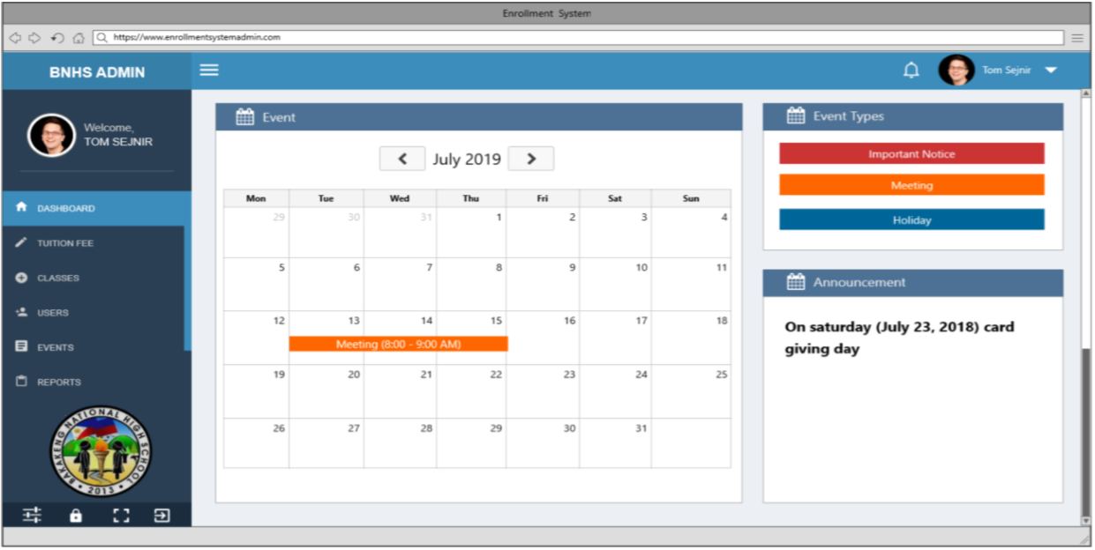

Pwede na maliit lang yung event calendar gaya lang sana neto tas may legends nalang siguro sa taas (gaya nung nasa event types mo). Tas kapag ihohover makikita yung summary nung event and pag clinic yun mag momodal tas lalabas yung detailed desciprtion ng event.

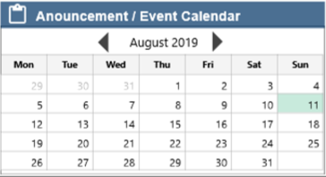

Notification – makikita lahat ng requests (change password, added student, upcoming events, etc). Kelangan ko ng lahat ng detailed list na mag aapear sa notification. Suggestion ko parang facebook type yung notification. Pag clinick yung isa sa mga notification mag reredirect sa page na gusto puntahan (for example. Request of change password pupunta sa page na mag ichechange yung password)

**Tuition Fee**

Change the ‘Tuition Fee’ section to ‘Statement of Accounts’ kasi di lang naman tuition fee ang laman nun. Suggestion ko din may summary sana? (for example summary ng mga di pa cleared or not cleared – meaning may mga balances pa tas makikita yung names lang) before yung general view nung statement of accounts.

Tapos instead ‘sort logo’ per header, ‘Sort by:’ tapos dropdown. Sort by name, Balance Status Payment Date.

**Classes**

Wala na sanang tab. Isang container lang tas Andun lahat ng schedule lahat ng classes and yung teachers tas parang may field dun na ‘Adviser’ tas lalabas name nung adviser tas may edit adviser din. Sugestion parang isang table lang tas mag chechange change nalang yung details based on section. So parang may drag down na ‘Grade-Level and Section:’ tas dragdown na andun lahat ng grade levels and section. Wala na din button ng add class or add subject.

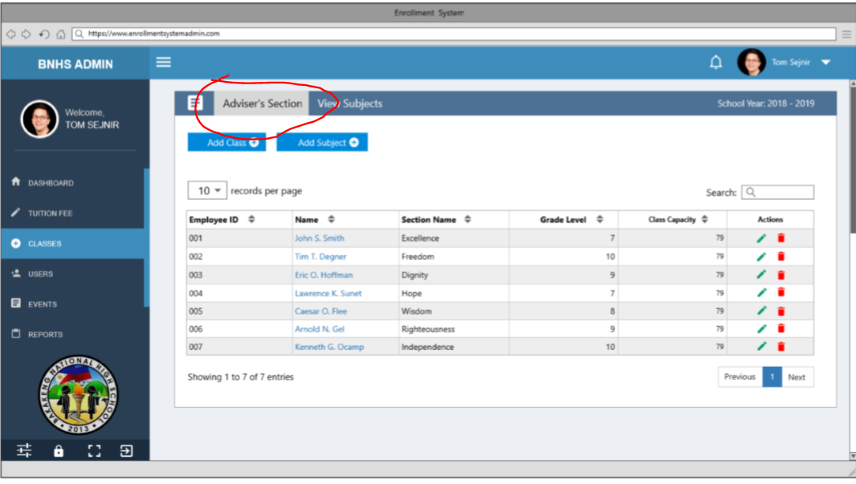

**Users**

List ng users (for the current school year). Kahit wala na yung alerts na ‘requesting to reset password’ kasi nasa notification na yun.

Kulang – ng UI for resetting the password of a user. Tapos wag na din yung ‘sort by’ buttons sort by drag down nalang. Sort by: Name, Department.

Define – Padefine naman ako ano yung mga status. Like for example Active ano ibig sabihin pag user is active. Explanation din ng mga buttons under actions and ano mangyayare both front end and back end.

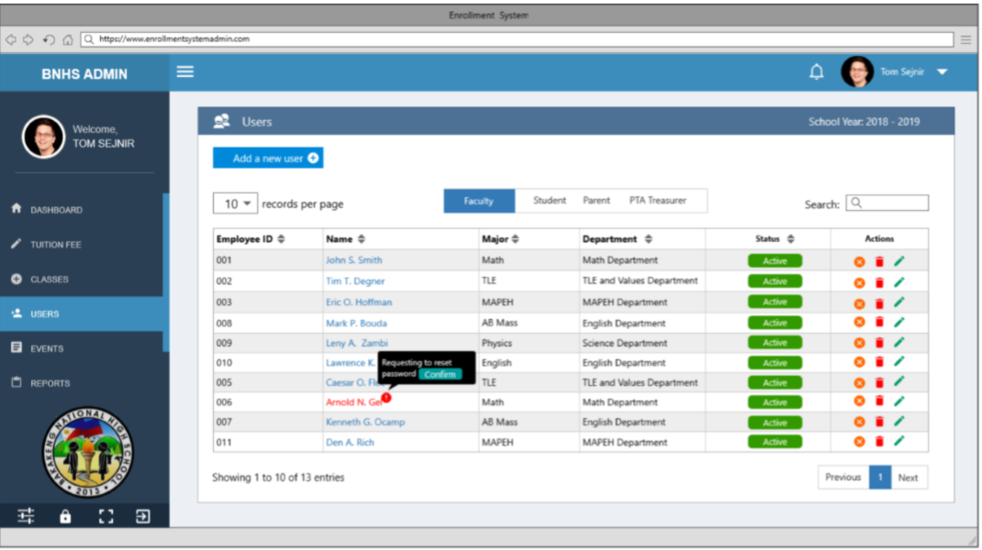

Dagdagan ng choice Add a new user what if student yung user para mawala na yung account type. Interface din pala ng pag gawa ng student user, pta tres. Kasi faculty lang yun andito.

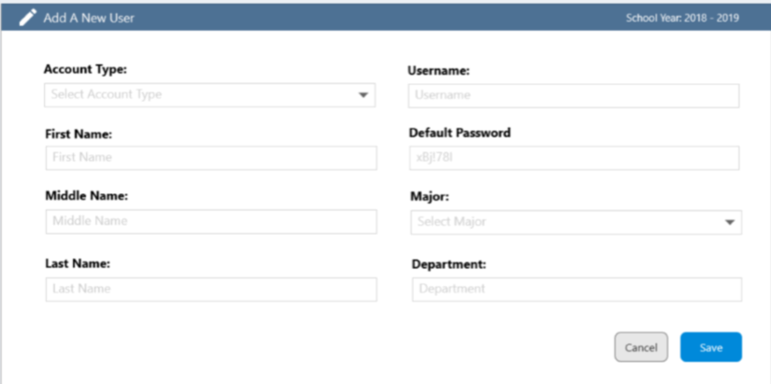

Sa update information di na yung admin ang mag uupdate. Yung mga users na with approval nalang ng admin.

**Events**

Separate sana yung ui for adding announcements and events kasi iba iba naman sila ng field. Tapos Mavieview yung announcements na napost, and calendar para sa mga events.

**Reports**

Mas maayos sana yung reports. For ex pag student, reports lang ng students nan aka enroll sa school year, name, grade-level and section.

Need ko din ng detailed na igegenerate na report ng system.

**Archive**

Different section sana tong archive. Para andun yung pag archive ng current school year. Saka andun din yung pag view ng archives.

Makikita sana nung admin yung summary ng iaarchive na data. Tapos hindi automatically archive data. May button sana to archive data tas mag papakita yung summary.

Need ko din ng report about pano tong arhive both front end and back end and ano ano yung mga data na iaarchive.