Roadmap Baseline - Tribe & Veloce Media Consumer Banking App
Version: 3.0
Date: February 2026
Status: For Review and Alignment
Parties: Tribe Systems Ltd (“Tribe”), Veloce Media Group (“Veloce”)
Reference documents:
- Tribe Program Roadmap (22 January 2026)
- Veloce Figma Feedback (4 February 2026)
Purpose: This document presents an updated delivery roadmap incorporating Veloce’s feedback on Tribe’s Figma designs and aligned to a banking-first, engagement-smart product strategy. It supersedes the January 2026 roadmap.

1. Context

What We Heard
Following your review of the original Figma designs, we received clear direction: the wallet and card should be the primary experience, not content or social feeds. You asked for comprehensive card management, a robust rewards ecosystem, Quadrant merchandise access, a dedicated help and support section, and a cleaner navigation structure.

How We Responded
We have made three strategic shifts:
- Banking-first, wallet-centric architecture. The wallet is now the home screen. Every session starts with the user’s financial position - balance, card, recent transactions.
- Brand-agnostic core. The platform supports Veloce, Quadrant and future partners from a single codebase with themed builds per partner.
- Engagement-smart approach. Rather than the heavy content experience in the original designs or a purely banking-only app, we are introducing a measured middle ground - lightweight, data-driven engagement surfaces that give users reasons to open the app daily while remaining operationally simple to manage.

2. Guiding Principles
- Banking-first UX - The wallet is the home screen. Engagement features complement the banking experience; they do not compete with it.
- Brand-agnostic core - The platform supports multiple partners from a single codebase. Partner-specific elements are configured per build, not hard-coded.
- Engagement-smart, not content-heavy - Engagement features are data-driven and measurable, not dependent on high-volume content operations.
- Operational simplicity - Launch features must be maintainable by a small team. Features requiring dedicated editorial or moderation operations are sequenced for post-launch.
- Measure before scaling - Every engagement surface tracks user interactions from launch. Expansion is gated on evidence, not assumption.
- Responsible delivery - Features with significant compliance, fraud or moderation overhead are sequenced after core stability is proven.

3. Roadmap Overview
Phase | Timing | Theme | Key Deliverables
Alignment | Jan–Feb 2026 | Scope Lock | Updated roadmap, rewards funding model, success metrics
Phase 1 | Q1 2026 | Core Build | Onboarding, wallet, virtual card, transfers, infrastructure
Phase 1B | Q1 2026 (parallel) | Ecosystem MVP | Engage tab, wallet carousel, behaviour-triggered rewards
Phase 2 | Apr–May 2026 | Pilot | Family & Friends, 500–2,000 users, no new features
Phase 3 | June 2026 | Public Launch | Money 2026 - full banking + engagement live
Phase 4 | H2 2026 | Growth & Monetisation | Gated on 25k monthly transacting users
Phase 5 | 2027 | Strategic Expansion | Gated on proven unit economics

4. Navigation Structure
We are proposing one change to the navigation structure from Veloce’s feedback. The rationale is explained below.
Proposed navigation (4 tabs):
Tab | Role | Content at Launch
Wallet | Primary / landing | Balance, card, transactions, card controls, add funds, send money, Ecosystem Highlights carousel
Engage | Secondary | Curated feed of partner announcements, upcoming events, new rewards, behind-the-scenes teasers
Rewards | Tertiary | Merch, Events, Rewards, Experiences, Partner sub-tabs
Shop | Quaternary | Links to external Quadrant Shopify store
Side menu (account icon, top-left): Profile hub, My Account, PITStop Help, Legal

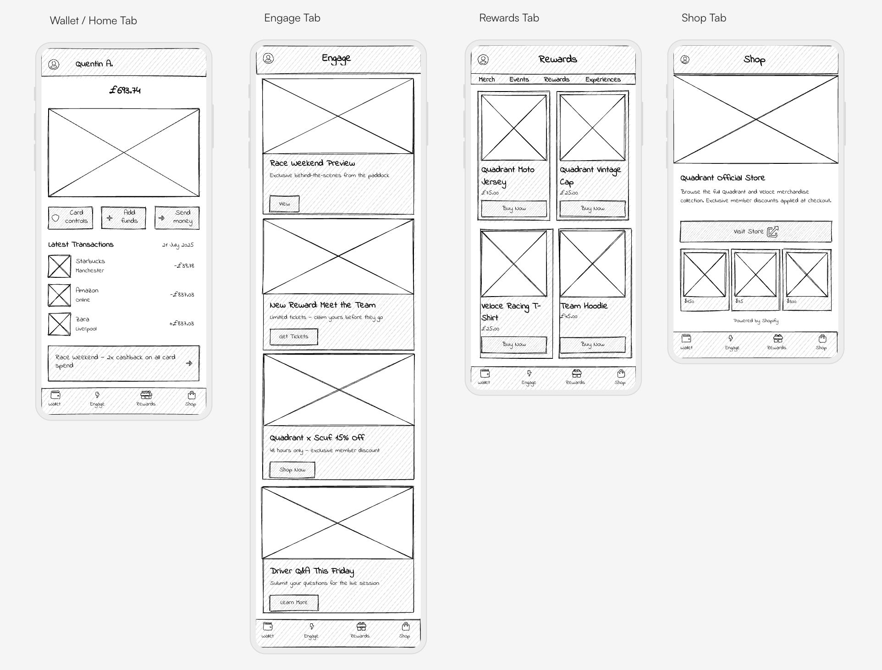

Why Engage replaces Payments
Your feedback proposed a Payments tab with transfers, standing orders, direct debits and peer-to-peer payments. We’ve thought carefully about this, and we’re recommending the Engage tab in its place at launch for three reasons:
- Engagement drives the metrics that matter. Fan engagement content - announcements, events, behind-the-scenes access - gives users reasons to open the app between transactions. Higher daily active users drives more card transactions, which drives higher scheme marketing revenue for Veloce. Content and perks are what makes fans pay £4.99/month instead of using a free banking app.
- Outbound transfers belong in the Wallet. Sending money is a wallet action - it sits naturally alongside “Add funds” and “Card controls” as a quick action on the wallet home screen. Users expect to manage their money from where they see their money.
- The Payments tab needs feature depth to earn its place. With standing orders, direct debits and P2P payments responsibly deferred to Phase 4 (see Appendix B), the tab would launch with a single “Transfer money” button. A near-empty tab in prime navigation undercuts the premium feel of the product - and of the subscription price.
This is a middle ground. The original Figma designs had three content-heavy tabs (Buzz, Insider, Spotlight) with social features, infinite scroll and live feeds. That was too operationally heavy for launch. A purely banking-only app with no engagement surface is too thin to justify a subscription or differentiate from free alternatives. The Engage tab is the measured middle ground - a curated feed of 5–10 items, managed via remote config, tracked for engagement, and operationally lightweight.
The Payments tab returns in Phase 4 when standing orders, direct debits and P2P payments are built - at that point, there is enough feature depth to justify dedicated navigation.

5. Ecosystem Strategy
The ecosystem creates three engagement surfaces that work together to make the app sticky beyond balance-checking.

5.1 Engage Tab (Curated Feed)
A lightweight, curated feed in its own navigation tab. Not infinite scroll. Not a social media feed. Think “curated newsletter.”
Content types at launch: - Partner announcements (new rewards available, event launches) - Upcoming events and experiences (with “View” or “Get tickets” actions) - New rewards and offers highlights - Behind-the-scenes teasers (driver photos, race day content, exclusive clips) - Race/match day highlights
What makes this operationally light: - 5–10 items visible at any time - not an infinite scroll - Content managed via remote config or lightweight CMS - not a real-time editorial system - No user-generated content, no comments, no social features - no moderation burden - Each item is a card: image + headline + short description + action button - Veloce/Quadrant supplies the content (as agreed in the partnership)
What makes this strategically powerful: - Every item tracks impressions, tap-throughs and conversions - This data feeds Phase 4 sponsor campaigns and segmented offers - A/B testing of content types reveals what drives engagement - enabling data-informed expansion

5.2 Ecosystem Highlights (Wallet Home Carousel)
A dynamic 1–3 slot carousel on the wallet home screen, below the card and quick actions. This is the brand touchpoint that every user sees in every banking session.
- Reward unlock announcements, event incentives, limited-time offers, VIP tier recognition
- Surfaces highlights FROM the Engage tab and Rewards tab onto the wallet home
- Tracks impressions, tap-throughs and conversions

5.3 Engagement Rewards (Behaviour-Triggered)
Financial behaviour triggers rewards, creating a loop between card usage and the fan ecosystem.
Trigger | Reward | Business Value
Spend £X in a month | Entry to prize draw | Drives card usage - supports scheme marketing
Transact on match/race day | Cashback boost | Ties banking to the fan calendar
Upgrade account tier | Exclusive perk unlock | Increases revenue per user
Refer a friend who activates | VIP status bump | Organic acquisition at low cost
First card transaction | Welcome bonus | Drives activation rate
Dependency - reward funding: These rewards require real incentives funded by Veloce/Quadrant. The reward funding model needs to be confirmed during the current scope alignment period.

6. Phase Summary

Alignment (Jan–Feb 2026)
We are here now. Objectives: lock MVP scope, confirm reward funding model, align on success metrics and scheme marketing targets. Deliverables: this roadmap, confirmed Engage tab content commitment from Veloce, reward funding agreement.

Phase 1: Core Build (Q1 2026)
The primary build delivers a stable, fully functional banking experience: onboarding with UK KYC, wallet with real-time balance, virtual Visa card, full card management (freeze, details, Apple Wallet, order physical card, limits), outbound UK bank transfers, Rewards tab with five content categories (Merch, Events, Rewards, Experiences, Partner), Shop tab (external Shopify link), PITStop AI support, push notifications, and brand theming for Veloce and Quadrant.
In parallel, we build the enabling infrastructure: event analytics, impression tracking, offer redemption tracking, tier/segment tagging, GDPR consent layer, and a basic rewards ledger. This is invisible to users but critical - it’s the measurement framework that makes Phase 4 monetisation possible.

Phase 1B: Ecosystem MVP (Parallel)
Built alongside Phase 1: the Engage tab (curated content feed), the wallet home carousel (Ecosystem Highlights), and the behaviour-triggered reward mechanics (Engagement Rewards). See Section 5.

Phase 2: Pilot (Apr–May 2026)
500–2,000 invited users. Strict rule: no new features during pilot. Focus on banking stability, engagement metrics validation, PITStop support load, and analytics infrastructure accuracy. Go/no-go assessment for public launch.

Phase 3: Public Launch (June 2026)
Public UK launch at Money 2026. Everything from Phases 1 and 1B is live. Three account tiers: Everyday (£4.99/mo), Plus (£6.99/mo), Premium (£89.99/yr). Physical card orderable at £4.99 (virtual-first UX).
Features not live at launch: full Payments tab (returns Phase 4), P2P payments, standing orders, direct debits, community/social features, crypto/Web3, marketplace, deep personalisation. See Appendix B for rationale.

Phase 4: Growth & Monetisation (H2 2026)
Gated on 25,000 monthly transacting users (not just registered - users who make at least one card transaction per month).
Additions: Payments tab (with sufficient feature depth), sponsor-funded campaigns, segmented offers, analytics dashboard for Veloce, standing orders, direct debits, card customisation, savings pots, expanded rewards mechanics. P2P payments only if strategically justified by data.

Phase 5: Strategic Expansion (2027)
Gated on proven unit economics (subscription + interchange covers acquisition cost).
Advanced rewards, crypto via third-party provider, token-gated experiences, marketplace, EU expansion.

7. Dependencies

From Veloce / Quadrant
What | When | Notes
Brand assets (logos, imagery, colour specs) | End of Feb 2026 | Required for themed builds
Rewards content (Merch, Events, Experiences, Partner items) | March 2026 | Product images, descriptions, pricing
Engage tab content (announcements, events, teasers) | March 2026 | 5–10 curated items for launch
Reward funding commitment | During Scope Alignment | Budget for Engagement Rewards incentives
Scheme marketing target alignment | During Scope Alignment | Shared KPIs and growth targets
Review and sign-off on this roadmap | February 2026 | Enables build to proceed

From Tribe
What | When
Updated wireframes | Following roadmap sign-off
Technical architecture and infrastructure | Phase 1 build
PITStop AI training and configuration | Phase 1 build

From Equals / Railsr
What | When | Notes
API documentation and sandbox | Q1 2026 | Onboarding, KYC, card, transactions
KYC verification service | Phase 1 | UK identity verification
Virtual card issuance | Phase 1 | Visa card provisioning
Physical card production | Phase 3 | £4.99 per card, 5–7 day delivery
Transaction processing | Phase 1 | Payments, top-ups, transfers

8. Success Metrics

Pilot (Phase 2)
Metric | Target | Source
Onboarding completion rate | >80% of invited users | Analytics
Card activation rate | >70% within 7 days | Analytics
Monthly transacting users | >60% of activated users | Analytics
Engage tab daily views | >30% of daily active users | Impression tracking
Ecosystem Highlights tap-through | >15% of impressions | Impression tracking
Engagement Rewards redemption | >10% of eligible users | Rewards ledger
PITStop resolution rate | >80% of Tier 1 queries | Support platform
App crash rate | <1% of sessions | Crash reporting

Launch (Phase 3)
Metric | Target | Source
Monthly transacting users | 25,000+ (Phase 4 gate) | Analytics
Card spend velocity | Increasing month-on-month | Transaction data
App Store rating | >4.0 stars | App Store / Google Play
Referral conversion rate | >5% of users refer a friend | Referral tracking

Appendix A: Detailed Phase Breakdown & Change Tracking

Phase 1: Core Banking Features
Feature | Status | Notes
Onboarding + UK KYC | [UNCHANGED] | 6-step registration, tier selection, KYC via Equals
Wallet home with balance and card | [UNCHANGED] | Branded virtual Visa, real-time balance
Transaction history | [EVOLVED] | Expanded: pending/completed sections, search, date filter
Add funds | [UNCHANGED] | Apple Pay, Google Pay, Visa, Mastercard, bank transfer
Card controls hub | [EVOLVED] | Full management: freeze, details, Apple Wallet, order physical, report issue
Allowances and limits | [UNCHANGED] | Tabbed display: allowances, limits, transfers
Outbound UK bank transfers | [EVOLVED] | Moved from Payments tab into Wallet as a quick action
Rewards tab (5 content categories) | [UNCHANGED] | Merch, Events, Rewards, Experiences, Partner
Shop tab (external store) | [UNCHANGED] | Links to Quadrant Shopify store
PITStop AI support | [EVOLVED] | AI chatbot for Tier 1 support - in side menu as you proposed
Account management | [UNCHANGED] | Profile hub, My Account (Profile/Bank/Card tabs)
Cross-cutting (security, auth, a11y) | [UNCHANGED] | Push notifications, biometric auth, theming, consent, security

Phase 1: Enabling Infrastructure
Feature | Status | Purpose
Event-driven analytics | [EVOLVED] | Foundation for all engagement measurement
Impression and click-through tracking | [EVOLVED] | Measures what users see and engage with
Offer redemption tracking | [EVOLVED] | Tracks reward claims
Tier and segment tagging | [EVOLVED] | Enables Phase 4 segmented offers and sponsor targeting
Consent and GDPR layer | [EVOLVED] | Compliant data collection from day one
Rewards ledger | [EVOLVED] | Tracks earned and redeemed rewards

Phase 1B: Ecosystem MVP
Feature | Status | Notes
Engage tab (curated feed) | [NEW] | Lightweight content feed replacing the Payments tab
Ecosystem Highlights carousel | [NEW] | Dynamic 1–3 slot carousel on wallet home
Engagement Rewards engine | [NEW] | Behaviour-triggered reward mechanics

Appendix B: Deferred Features - Rationale

Payments Tab and Advanced Payment Features
Your feedback included: A dedicated Payments tab with transfers, standing orders, direct debits and P2P payments.
Our recommendation: Replace the Payments tab with an Engage tab at launch. Restore the Payments tab in Phase 4 when there is sufficient feature depth. Move outbound transfers into the Wallet tab.
Rationale: At launch, 80% of the proposed Payments features are responsibly deferred (see below). A tab with one functional button and four “Coming Soon” placeholders damages the premium feel of the app and wastes prime navigation space. Outbound transfers are a natural Wallet action. The Engage tab uses that navigation slot to drive daily active usage - which directly supports scheme marketing revenue.

Peer-to-Peer Payments and Request Money
Your feedback included: Transfers between users, request money.
Our recommendation: Phase 4, gated on active user volume.
Rationale: P2P payments require AML monitoring of user-to-user flows, fraud detection for social engineering, and dispute resolution. These are solvable but add substantial compliance work that would risk the June launch. P2P becomes valuable at scale when Tribe-to-Tribe transfers create a closed-loop economy.

Standing Orders and Direct Debits
Your feedback included: Standing orders and direct debit management.
Our recommendation: Phase 4.
Rationale: Direct debit origination requires BACS membership or sponsored access through Equals. Standing orders require scheduling infrastructure with guaranteed execution and retry logic. Basic outbound transfers (in the Wallet) cover the core need at launch.

Card Personalisation and Savings Pots
Your feedback included: Card personalisation (custom card design) and savings pots.
Our recommendation: Phase 4.
Rationale: Both are valuable features that strengthen the product’s differentiation. Card personalisation requires artwork production and card scheme approval workflows that sit outside the critical path for June. Savings pots require a separate ledger model and FSCS communication considerations. Neither blocks launch, and both are well-suited to Phase 4 when the core product is proven and we have user data to inform the experience.

Community and Social Features
Our recommendation: Phase 4 at earliest, likely Phase 5.
Rationale: Social features require content moderation at scale and carry brand safety risk. The Engage tab provides curated engagement without moderation overhead.

Full Content Feeds (Buzz, Insider, Spotlight)
Original designs included: Three rich content tabs with social interactions, articles, curated collections and video.
Our recommendation: Replaced by the Engage tab - a single, curated, lightweight feed.
Rationale: Three content tabs required editorial operations, content pipelines and moderation. The Engage tab achieves the same goal - app stickiness and brand presence - with dramatically lower operational burden. If Engage tab metrics prove strong, richer content can be introduced in Phase 4.

Appendix C: Change Log from January 2026 Roadmap
Item | Jan 2026 Roadmap | Feb 2026 Baseline | Change
Home screen | Content-integrated | Wallet-first (banking-centric) | [EVOLVED]
Navigation | 5 areas with content focus | 4 tabs: Wallet, Engage, Rewards, Shop + side menu | [EVOLVED]
Payments tab | Proposed with transfers, standing orders, P2P | Replaced by Engage tab; transfers moved to Wallet | [EVOLVED]
Engage tab | Not in original; replaced Buzz/Insider/Spotlight | Curated lightweight content feed | [NEW]
Card management | Basic card display | Full hub: freeze, details, controls, limits, Apple Wallet | [EVOLVED]
Transaction history | Basic list | Search, date filter, pending/completed sections | [EVOLVED]
PITStop AI support | Basic chatbot | In-app AI chatbot for Tier 1 queries | [NEW]
Ecosystem Highlights | Not in original | Dynamic carousel on wallet home (1–3 slots) | [NEW]
Engagement Rewards | Not explicit | Behaviour-triggered reward mechanics | [NEW]
Analytics infrastructure | Not explicit | Event tracking, impressions, conversions, rewards ledger | [NEW]
Rewards tab content | Part of content-first approach | 5 sub-tabs with Veloce/Quadrant content (preserved) | [UNCHANGED]
Content feeds (Buzz/Insider/Spotlight) | Phase 1 (3 heavy tabs) | Replaced by single Engage tab | [EVOLVED]
P2P payments | Phase 3–4 | Phase 4, gated | [MOVED]
Request money | Phase 3–4 | Phase 4, gated | [MOVED]
Standing orders | Phase 1 (tentative) | Phase 4 | [MOVED]
Direct debits | Phase 1 (tentative) | Phase 4 | [MOVED]
Community /social | Phase 4 | Phase 4–5, gated on evidence | [MOVED]
Crypto/Web3 | Phase 4–5 | Phase 5, gated on unit economics | [UNCHANGED]
Physical cards | At launch | Orderable from launch (£4.99), virtual-first | [EVOLVED]
Phase 4 entry criteria | Not specified | 25k monthly transacting users | [NEW]
Phase 5 entry criteria | Not specified | Proven unit economics | [NEW]

This document is confidential and intended for Tribe Systems and Veloce Media Group only.

