Classes Exercise

Implement a class Radio corresponding to the following diagram

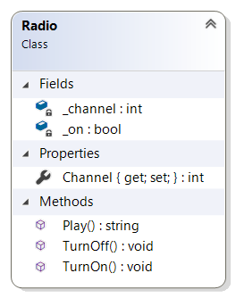

The default value of _channel is 1 and _on is false

The radio has four channels: 1, 2, 3, 4

The channel can only be changed when the radio is on.

The radio can play only if it is on, in which case it returns a string indicating which channel it is playing on, for example:

"Playing channel 4"

If an attempt is made to play the radio while it is off, the string "Radio is off" is returned.