Status Report for FOX-1 Development

Mitch (MCU development):

Zach brought prototype #3 (the best looking one) to Dayton, and I attempted to continue development on prototype #1. After encountering and fixing some internal OS bugs, it was discovered that neither prototype #1 nor prototype #2 MCUs can communicate with their respective camera modules on the configuration bus.

Development was resumed on prototype #1. I found buried in the Linux kernel's v4l code an implementation of a driver for the OV7670 module that we use. I've been borrowing some of this kernel code in an attempt to set up the exposure and color control registers. Additionally, I tested JPEG compression on-chip. The compression routine causes some unhandled exception that I am unable to trace at the moment. I think it might be an invalid address reference or overflow in the DCT routine.

Our images are still coming out with a red hue and oversaturated. I'll try using the lens from the eval boards to see if the IR coating is messing up the color balance. There's some other artifacts from image processing that need resolving as well:

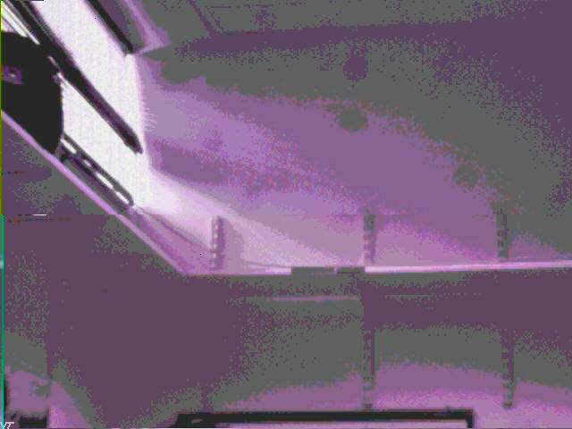

Kevin (PC interface)

As we have been having a few technical difficulties with some of our prototype boards, I have been working on the simulation side of things. I have created a dummy program for both the IHU and our EXP4 boards. The simulators were designed to imitate the inputs and outputs of each respective board. The internals of each program are of a basic design and do not reflect the actual flight software. The main design goals were to be able to send any command from the command prompt over serial. As well as having a standalone demonstration of normal operation between the two programs. The specifications for message passing was derived from the "AMSAT Fox-1A: IHU to Experiment Interface Control Document".

I have created a small program written in C that compiles into two separate binaries, dummy_ihu and dummy_exp4. Each executable can currently send any command in it's command list without any issue. The demonstration mode is still under development. These files are located under the dummy_fox1directory on my working branch.

The final step is to implement the image transfer. I will begin with sending over an already compressed image. Once this is functional I may add in the compression algorithm implemented on the board itself. Once the simulators are completed I will use them in the development of the command processing code on the flight board itself. The simulators will also be a good demonstration tool to present to the folks at AMSAT.

Zach (Hardware)
Get in contact with Kevin Lee about re-soldering the camera chips for prototypes 1 and two as well as the blue wiring of UART1. Planning to do this next week.
Get minor Eagle update for UART changes done and to Advanced Circuits.
We are itching to order final flight boards to begin the final assembly, but with the relaxed timeline we will hold off a bit until we get a 100% perfect image from the proto-type boards.
Also beginning to think about and put together an article for the AMSAT Journal delivering the details of the project to get out from under ITAR’s boot.

