In Rmd:

Mass et al 2008 welke action units in ding v tilia anguli superior

ZET CODE AL KLAAR! Voro analyses straks

-overloop deze tekst en pas originele tekst aan + voeg afbeeldingen toe + pas zw lijn aan!

PUT SPLITVIOLIN+Overlap first!

MAKE SPLITVIOLINS SMALLER!

**Disgust: 9+15+16**

**Surprise 1+2+5+26**

**Joy 6+12**

Hello everyone! Today Mitchel and I are presenting you the first results of the data analysis of the PMS Study.   
Let me first introduce you to what this study is about.

PMS or Premenstrual Syndrome, is a disorder exclusive to people who have their periods. People who have PMS get a range of symptoms such as mood swings, anxiety, tiredness, sleep problems, abdominal pain and bloating, tender breasts, headaches, spotty skin and changes in appetite and sex drive, and lower serotonin levels. The etiology and symptoms of PMS and depression have been linked together as well.

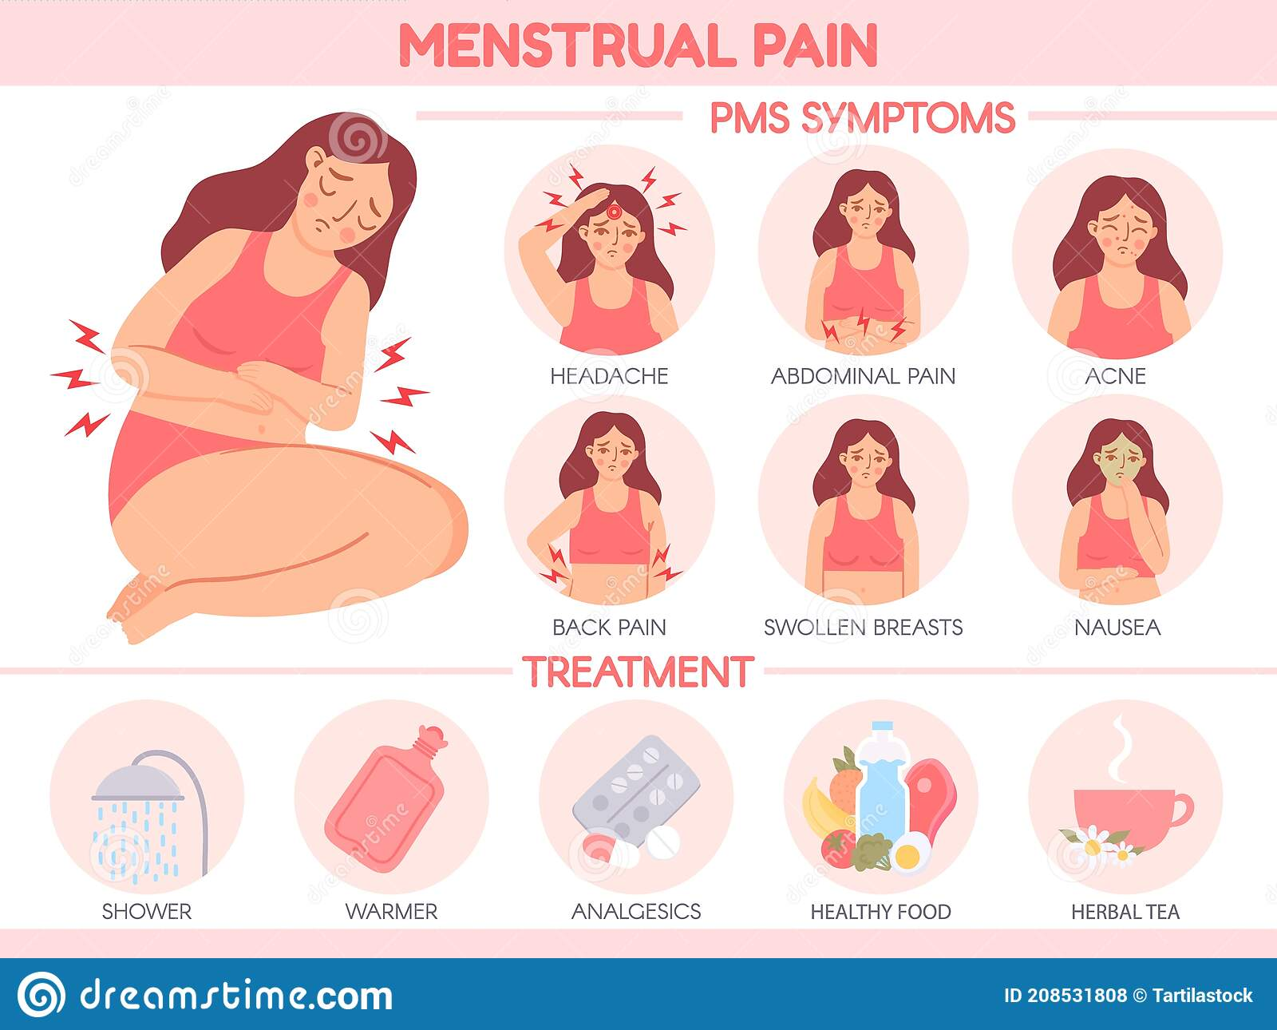

As the name suggests, this happens before menstruation, during the luteal phase. Symptoms disappear 1-2 days into menstruations.

S   
About 75% of the menstruating population experiences some symptoms, 20-30% has moderate to sever symptoms and about 5-8% has PMDD levels of symptoms.

In this study, the question was wether or not people with PMS have higher stress, more rumination and more negative responses than people without PMS, as well as if there is a difference depending on wether we measure this during the premenstrual or luteal phase or during the follicular phase. The follicular phase is the phase after menstruation and before ovulation.

We did some screening on sex, age and such as well as a screening for premenstrual symptoms. This gave us 3 groups: low and high PMS and PMDD. Because we cannot give an official PMDD diagnosis we grouped these participants together with the high participants. This gives us two groups: noPMS and PMS.

We then tested the participants twice, based on their cycle. Each time they had to fill in some questionnaires, judge pictures on valence and arousal and were filmed through their webcam for analysis of their emotional expressions.

Let’s first look at PSS and BSRI.   
PSS stands for Perceived Stress Scale. This scale measured stress at the two time points. BSRI stands for Brief State Rumination index. This measures, you guessed it, rumination.

We looked at PSS and BSRI for the PMS and no PMS group, and for testmoment 1 and 2, or for the follicular and premenstrual/luteal phase.

We first fitted several moments and took the one with the lowest AIC, meaning the model with the best fit to the data, and then did anova and contrasts of means.   
When we look at PSS we can see a significant effect (with an alpha of 0.05) of PMS, even when we control for Testmoment, but we found no significant effect of Testmoment   
We can conclude that participants with PMS have more stress and ruminate more.

Then we looked at the DASS or Depression Anxiety Stress Scale. This is a trait measurement so we did not look at the effect of testmoment here, only at people with and without PMS.

Here, we see that people with PMS scored higher than people with low PMS scores on all 3 DASS Subscales.

Now, let’s look at the images the participants had to judge. These were IAPs images which is a dataset of images that has already been thoroughly scored in the past. Participants could indicate how the images scored for them on Valence (upper row) and arousal (second row). There were two image groups, A and B, that were counterbalanced. So each image group would have for example a puppy, a scary image etc. The order was also counterbalanced, meaning some participants got A on the first testmoment, some got B.

We looked at the images and at participants who were outliers, e.g. who rated an image negatively when everyone else rated the image positively to see if there were any trends. We removed one participant who always rated 0 or 100.

We found that people with PMS rated the images higher on Arousal on average, but found no significant differences for Valence. When controlling for Testmoment we got the same results.

We also checked if there were differences between our study and the norms on these images in arousal and valence, and found high and significant correlations. We also did not find much differences between the image groups A and B.