Cloud & SDET IDE Platforms: Comprehensive Documentation

1. Introduction
This document provides comprehensive documentation for two distinct cloud-based Integrated Development Environments (IDEs): the CloudIDE Platform and the SDET IDE Platform. This manual serves as a complete guide for users of all levels, from beginners to advanced enterprise teams.
The CloudIDE Platform is a general-purpose, cloud-native development environment designed for a wide range of programming tasks. It offers a feature-rich experience comparable to modern desktop IDEs, with the added benefits of cloud accessibility, real-time collaboration, and scalable performance.
The SDET IDE Platform is a specialized environment tailored for Software Development Engineers in Test (SDETs) and quality assurance professionals. It builds upon the foundation of the CloudIDE Platform, incorporating a suite of advanced tools for testing, automation, and quality assurance, making it a unique and powerful solution for an underserved market.
This documentation will cover the features, architecture, and usage of both platforms, providing clear, step-by-step instructions, technical specifications, and best practices.

2. CloudIDE Platform Documentation

2.1. Executive Overview
The CloudIDE Platform is a modern, scalable, and secure cloud-based IDE that empowers developers to write, test, and deploy code from any device with a web browser. It provides a complete development environment in the cloud, eliminating the need for complex local setups and enabling seamless collaboration among team members.
The platform is built on a robust, cloud-native architecture that leverages microservices, containerization, and real-time communication technologies to deliver a high-performance, resilient, and feature-rich experience. With a focus on developer productivity, the CloudIDE Platform integrates a powerful code editor, secure code execution, and comprehensive project management tools.

2.2. Target Audience
The CloudIDE Platform is designed for a broad audience of software developers, including:
- Individual Developers & Freelancers: Seeking a flexible, accessible, and cost-effective development environment.
- Development Teams: Requiring collaborative tools, centralized project management, and consistent development environments.
- Enterprises: Needing a secure, scalable, and customizable platform with advanced security and compliance features.
- Students & Educators: Looking for an easy-to-use platform for learning and teaching programming without the hassle of local environment setup.

2.3. Key Features
The CloudIDE Platform offers a wide array of features designed to enhance productivity and collaboration:
- Advanced Code Editor: Powered by Monaco Editor, providing a VS Code-like experience with features like IntelliSense, syntax highlighting, and debugging.
- Real-Time Collaboration: Work with your team in the same file, at the same time, with multi-cursor support and presence tracking.
- Secure Code Execution: Run your code in isolated, secure containers with support for multiple languages, including Node.js, Python, Java, Go, and Rust.
- Integrated Terminal: A full-featured terminal in the IDE for running commands, scripts, and interacting with the underlying container.
- Git Integration: Seamlessly connect to your Git repositories on GitHub, GitLab, and Bitbucket.
- Project & File Management: A familiar file tree, drag-and-drop support, and robust project management features.
- Customizable Environment: Tailor the IDE to your needs with customizable themes, settings, and extensions.
- AI-Powered Assistance: Get smart code completions, suggestions, and bug detections to accelerate your workflow.

2.4. Getting Started Guide
Getting started with the CloudIDE Platform is simple and straightforward.
1. Registration: * Navigate to the platform’s registration page. * You can sign up using your email address and a secure password, or by using your existing Google or GitHub account for a faster setup.
2. Login: * Once registered, you can log in using your credentials or via OAuth with Google or GitHub. * The platform uses secure JWT-based authentication to protect your account.
3. Creating a New Project: * After logging in, you’ll be taken to your dashboard. * Click the “New Project” button to start the project creation wizard. * You can choose from a variety of project templates for different languages and frameworks, or start with a blank project.
4. Importing a Project from Git: * To work on an existing project, you can import it from a Git repository. * Select the “Import from Git” option and provide the URL of your repository. * The platform will clone the repository into your workspace, and you can start coding immediately.

2.5. User Interface Walkthrough
The user interface of the CloudIDE Platform is designed to be intuitive and familiar to developers who have used modern code editors.
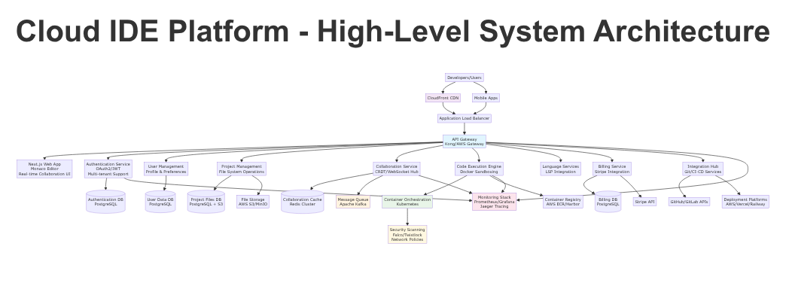 Figure 1: High-Level Architecture of the CloudIDE Platform.
Main Components of the UI:
- File Explorer (Left Sidebar): Displays the file and folder structure of your project. You can create, delete, rename, and move files and folders from here.
- Editor Area (Center): This is where you’ll spend most of your time writing code. You can have multiple tabs open for different files.
- Terminal (Bottom Panel): A fully functional terminal for running commands, managing dependencies, and interacting with your project’s environment.
- Top Menu Bar: Provides access to file operations, settings, help, and user account management.
- Status Bar (Bottom): Displays information about the current file, Git branch, and other contextual information.

2.6. Core Functionalities
The CloudIDE Platform is packed with features to make you more productive.

Code Editing
The core of the platform is the Monaco Editor, which provides a best-in-class editing experience: * IntelliSense: Smart code completion, parameter info, and quick info. * Syntax Highlighting: For a wide range of languages. * Code Navigation: Go to Definition, Find All References, and a symbol tree. * Debugging: Integrated debugging support for multiple languages.

Code Execution
You can run your code directly within the IDE in a secure, containerized environment: * Click the “Run” button to execute the current file. * The output of your code will be displayed in the integrated terminal. * The execution environment is isolated, so you don’t have to worry about interfering with other users or the platform itself.

Real-time Collaboration
Collaborate with your team in real-time: * Invite team members to your project to start a collaborative session. * See their cursors and selections in real-time as they type. * The platform uses Conflict-free Replicated Data Types (CRDTs) to ensure that all changes are merged seamlessly without conflicts.
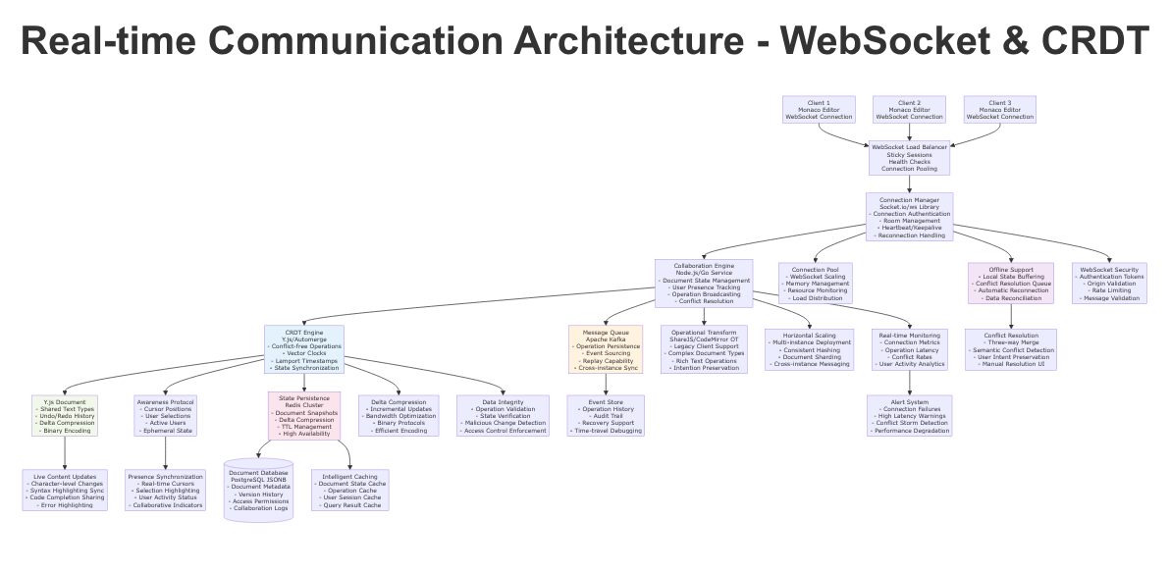 Figure 2: Real-time communication architecture enabling collaboration.

2.7. Project Management
Manage your projects efficiently with the platform’s built-in tools: * Project Dashboard: View all your projects in one place. * Project Templates: Start new projects quickly with pre-configured templates. * Access Control: Control who has access to your projects with role-based permissions (owner, collaborator, viewer).

2.8. Subscription and Billing
The CloudIDE Platform offers a range of subscription plans to meet the needs of different users, from individuals to large enterprises. The platform uses a hybrid model that combines predictable monthly subscriptions with usage-based billing for resource-intensive features.
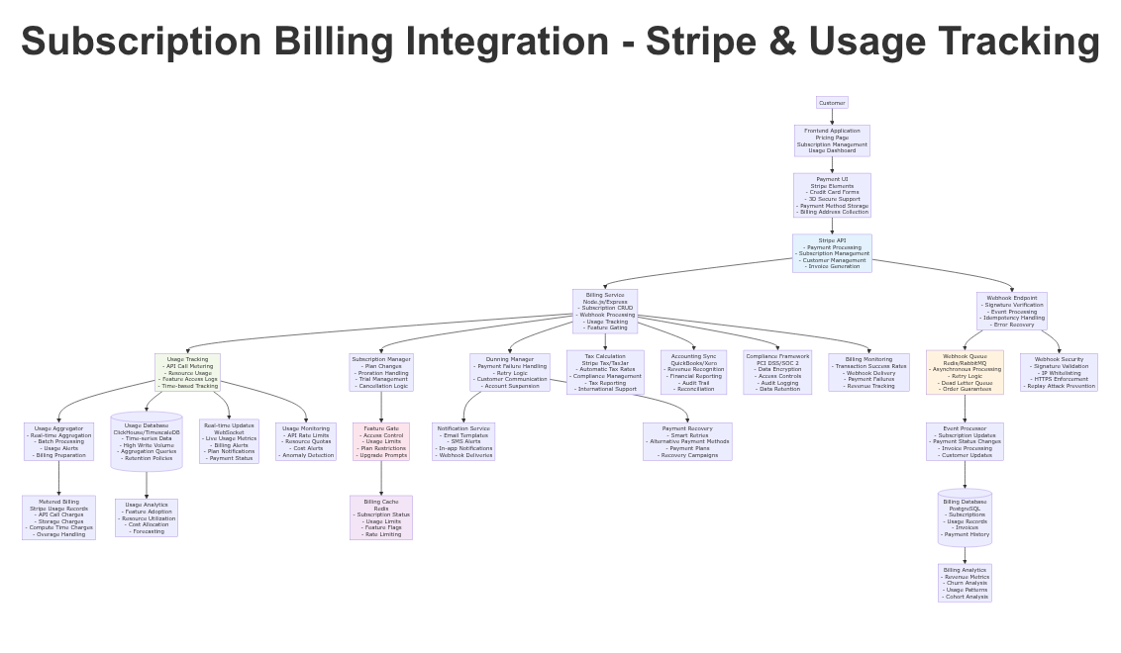 Figure 3: Subscription billing integration with Stripe.

Subscription Tiers
Tier | Price (monthly) | Target Audience | Key Features
Community | Free | Students, Hobbyists | 20 compute hours/month, 5GB storage, public projects
Pro | $19 | Individual Developers | 100 compute hours/month, 50GB storage, private projects, AI features
Team | $39/user | Small to Medium Teams | 500 compute hours/user/month, 200GB shared storage, advanced collaboration
Enterprise | Custom | Large Organizations | Unlimited compute, 1TB+ storage, self-hosting, advanced security
For detailed pricing and a full feature comparison, please visit our pricing page.

Usage-Based Billing
In addition to the base subscription, the platform uses a usage-based model for AI-powered features and additional resource consumption. This ensures that you only pay for what you use, providing a cost-effective and flexible solution.

2.9. Settings and Customization
You can customize the CloudIDE Platform to match your personal workflow and preferences.
- Editor Settings: Customize the editor’s appearance and behavior, including theme, font size, keybindings, and more.
- Theme: Choose from a variety of built-in light and dark themes, or create your own custom theme.
- Keybindings: The editor supports VS Code-compatible keybindings, and you can customize them to your liking.
- User Preferences: Manage your profile, notification settings, and linked accounts from the user settings page.

2.10. Security Features
The CloudIDE Platform is built with security as a top priority. We employ a multi-layered security architecture to protect your code and data.
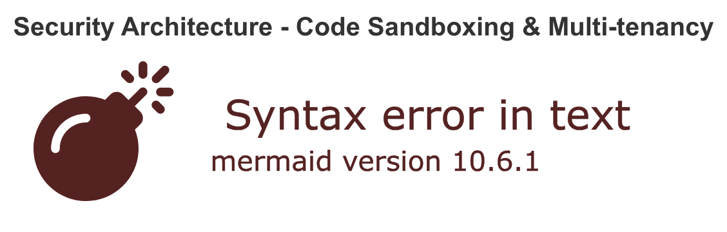 Figure 4: A multi-layered security architecture.
- Secure Code Execution: User code is executed in isolated, sandboxed containers using technologies like gVisor and Kata Containers to prevent container escapes.
- Multi-Tenant Isolation: The platform uses Kubernetes namespaces and network policies to ensure that each tenant’s data and resources are completely isolated.
- Data Encryption: All data is encrypted at rest and in transit using industry-standard encryption protocols (TLS 1.3, AES-256).
- Identity and Access Management (IAM): The platform uses robust authentication and authorization mechanisms, including JWT and OAuth2, with support for multi-factor authentication (MFA).
- Secure Development Lifecycle: We follow a secure development lifecycle (SDL) with regular security audits, penetration testing, and vulnerability scanning.

2.11. Troubleshooting and FAQ
Q: I can’t connect to my Git repository.
A: Ensure that you have provided the correct repository URL and that you have the necessary permissions to access it. If you are using a private repository, make sure you have added your SSH key to your Git provider.
Q: My code is running slowly.
A: Check your resource consumption in the dashboard. If you are on the Free or Pro plan, you may have hit your resource limits. Consider upgrading to a higher plan for more resources.
Q: I’m having trouble with the editor.
A: Try clearing your browser cache and reloading the page. If the problem persists, please contact our support team.

2.12. Technical Specifications
- Frontend: React, Next.js, TypeScript, Monaco Editor
- Backend: Node.js, Express, TypeScript, Microservices Architecture
- Database: PostgreSQL, Redis
- Containerization: Docker, Kubernetes, gVisor, Kata Containers
- Real-time Communication: WebSockets, Socket.io, Y.js (CRDTs)
- Authentication: JWT, OAuth2
- Billing: Stripe
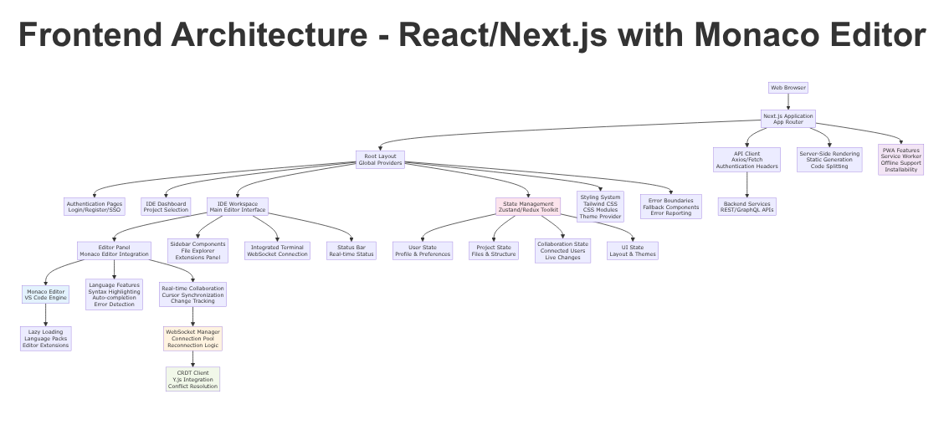 Figure 5: Frontend architecture of the CloudIDE Platform.
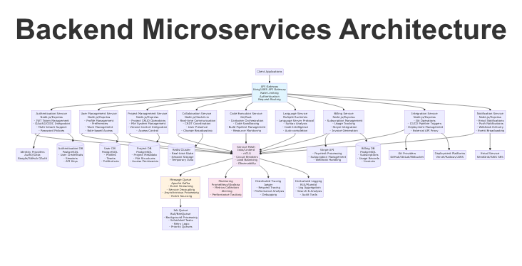 Figure 6: Backend microservices architecture.
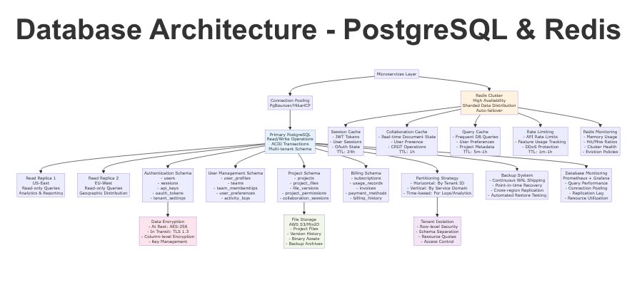 Figure 7: Database architecture.
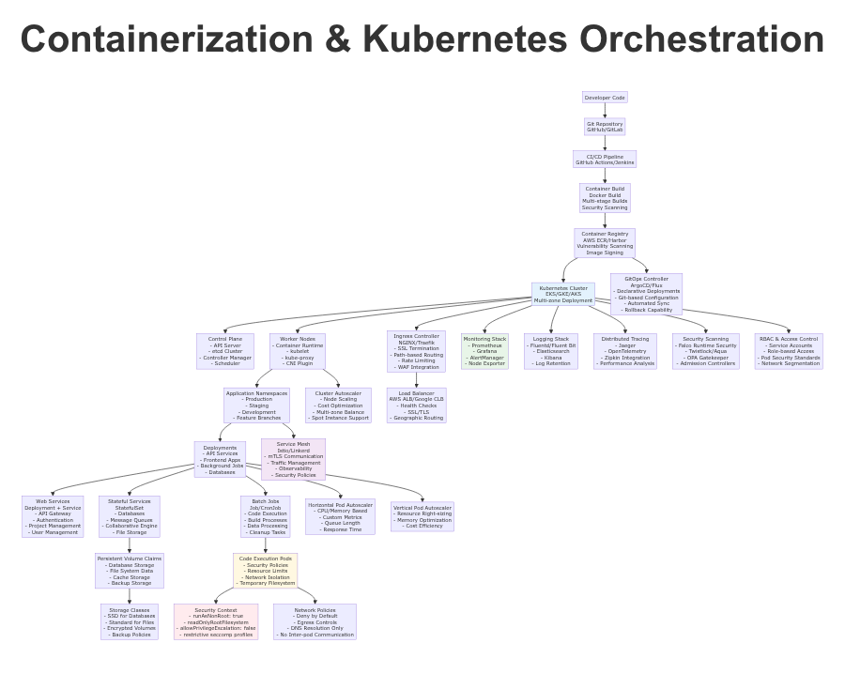 Figure 8: Containerization and Kubernetes orchestration.

3. SDET IDE Platform Documentation

3.1. Executive Overview
The SDET IDE Platform is a specialized, professional-grade cloud IDE built for Software Development Engineers in Test (SDETs), QA engineers, and automation specialists. It extends the powerful foundation of the CloudIDE Platform with a comprehensive suite of tools and features specifically designed for testing and quality assurance. This platform is the first of its kind to provide a dedicated, cloud-native environment for the entire testing lifecycle, from test creation and execution to reporting and analysis.
By integrating advanced testing frameworks, automation tools, and performance testing capabilities directly into the IDE, the SDET IDE Platform streamlines the testing process, enhances productivity, and empowers teams to deliver high-quality software faster.

3.2. Target Audience
The SDET IDE Platform is tailored for professionals in the software testing and quality assurance domain:
- SDETs and Automation Engineers: Who need a powerful environment for writing, running, and debugging automated tests.
- QA Teams: Looking for a collaborative platform to manage test cases, execute test runs, and analyze results.
- Performance Engineers: Who require tools for load testing, stress testing, and performance analysis.
- DevOps and CI/CD Engineers: Who need to integrate automated testing into their deployment pipelines.

3.3. Key Features
The SDET IDE Platform includes all the features of the CloudIDE Platform, plus a range of specialized tools for testing:
- Advanced Testing Framework Support: Native integration with popular testing frameworks like Selenium, Cypress, Playwright, Jest, and more.
- Cross-Browser and Cross-Device Testing: Run your tests across multiple browsers and device emulators to ensure broad compatibility.
- Performance Testing Suite: Conduct load testing, stress testing, and spike testing with up to 100,000 virtual users.
- API Testing and Service Virtualization: A Postman-like interface for API testing and the ability to mock API responses.
- Test Automation and CI/CD Integration: Seamlessly integrate your automated tests with Jenkins, GitHub Actions, and other CI/CD tools.
- Advanced Test Analytics and Reporting: A comprehensive dashboard for visualizing test results, tracking trends, and identifying flaky tests.
- Visual Testing: Compare screenshots and identify visual regressions automatically.
- Mobile Testing: Test your applications on iOS and Android simulators.

3.4. Getting Started Guide
The getting started process for the SDET IDE Platform is the same as for the CloudIDE Platform. During project creation, you will have the option to choose from a variety of SDET-specific project templates that come pre-configured with popular testing frameworks.

3.5. User Interface Walkthrough
The user interface of the SDET IDE Platform includes all the elements of the CloudIDE Platform, with the addition of a dedicated “Test” panel. This panel provides access to all the testing-specific features, including the test explorer, test execution controls, and performance testing dashboard.

3.6. Core Functionalities

Test Creation and Execution
- Write your tests in the familiar code editor with full support for your chosen testing framework.
- Use the Test Explorer to view all the tests in your project, grouped by suite and file.
- Run individual tests or entire test suites with a single click.
- Debug your tests with the integrated debugger, setting breakpoints and inspecting variables just as you would with your application code.

Performance Testing
- Configure and run performance tests directly from the IDE.
- Define the number of virtual users, test duration, and ramp-up time.
- Monitor the performance of your application in real-time with live metrics for response time, throughput, and error rate.

API Testing
- Use the integrated API testing tool to send requests to your APIs and validate the responses.
- Create and manage collections of API requests.
- Write assertions to verify the correctness of your API responses.

3.7. Project Management
In addition to the standard project management features, the SDET IDE Platform includes test case management capabilities. You can link your automated tests to test cases, track their execution status, and generate test run reports.

3.8. Subscription and Billing
The SDET IDE Platform offers specialized subscription tiers and add-ons for testing professionals.
- SDET Specialist Add-On: For an additional $15/month on top of any paid plan, you get access to advanced testing features, including the mobile testing lab and visual testing.
- Enterprise Tier: The Enterprise plan includes the full suite of SDET features, with unlimited test executions and enterprise-grade performance testing capabilities.

3.9. Settings and Customization
In addition to the standard IDE settings, you can configure the testing-specific features to match your team’s workflow. For example, you can configure the test runner, set up custom reporters, and integrate with your existing test management tools.

3.10. Security Features
The SDET IDE Platform inherits all the security features of the CloudIDE Platform, ensuring that your test code and test data are always secure.

3.11. Troubleshooting and FAQ
Q: My Cypress tests are failing to run.
A: Ensure that you have selected a project template that includes Cypress, or that you have correctly installed and configured Cypress in your project. Check the terminal output for any error messages.
Q: I can’t access the performance testing features.
A: Performance testing is available on the Team and Enterprise tiers. If you are on a lower tier, you will need to upgrade your plan to access this feature.

3.12. Technical Specifications
The technical specifications for the SDET IDE Platform are the same as for the CloudIDE Platform, with the addition of a suite of integrated testing tools and frameworks.

4. Platform Comparison
While the SDET IDE Platform is built on top of the CloudIDE Platform, there are key differences in their target audience and feature set.

4.1. Comparison Table
Feature | CloudIDE Platform | SDET IDE Platform
Target Audience | General Developers | SDETs, QA Engineers
Core IDE | Yes | Yes
Real-time Collaboration | Yes | Yes
Secure Code Execution | Yes | Yes
Advanced Testing Frameworks | No | Yes
Cross-Browser Testing | No | Yes
Performance Testing | No | Yes
API Testing Suite | No | Yes
Visual Testing | No | Yes (Add-on/Enterprise)
Mobile Testing | No | Yes (Add-on/Enterprise)
Pricing | Starts from Free | Starts from Pro + SDET Add-on

5. Migration Guide
Migrating from the CloudIDE Platform to the SDET IDE Platform is a seamless process.
- For Pro and Team users: You can simply add the SDET Specialist Add-On to your existing subscription from your billing settings. This will unlock all the advanced testing features.
- For Enterprise users: The Enterprise plan for the CloudIDE platform can be customized to include all the features of the SDET IDE platform. Please contact our sales team to tailor your plan.
There is no need to migrate your projects or data. Once the SDET features are enabled for your account, they will be available in all your existing and new projects.

6. Best Practices
To get the most out of our platforms, we recommend the following best practices:
- Use Project Templates: Start new projects with our pre-configured templates to save time on setup.
- Leverage Real-time Collaboration: Work with your team in real-time to improve productivity and knowledge sharing.
- Customize Your Environment: Take the time to customize the editor and settings to match your personal workflow.
- Use the Integrated Terminal: The integrated terminal is a powerful tool for managing your project and running commands.
- Keep Your Dependencies Updated: Regularly update your project’s dependencies to ensure you have the latest security patches and features.

7. Integration Capabilities
The CloudIDE and SDET IDE platforms are designed to integrate seamlessly with your existing development workflow.
- Version Control: Connect to your repositories on GitHub, GitLab, and Bitbucket.
- CI/CD: Integrate with popular CI/CD tools like Jenkins, GitHub Actions, and GitLab CI.
- AI and ML: The platforms integrate with AI coding assistants like Claude and GPT-4o.
- Package Management: The platforms have native support for npm, yarn, pnpm, pip, and Maven.

8. Support and Contact Information
If you have any questions or need assistance, please don’t hesitate to contact our support team.
- Community Forums: For general questions and discussions, please visit our community forums.
- Priority Support: Pro, Team, and Enterprise users have access to priority support via email. Please check your dashboard for contact details.
- Sales: For inquiries about our Enterprise plan, please contact our sales team at sales@ide-platform.com.

9. Sources
This documentation was compiled using information from a variety of sources, including:
- Stripe Webhook Documentation - High Reliability - Official Stripe documentation.
- Stripe Proration Documentation - High Reliability - Official Stripe documentation.
- CodeMirror vs Monaco Editor: A Comprehensive Comparison - High Reliability - Independent research.
- CodeSandbox Pricing Plans and Features - High Reliability - Official company pricing page.
- GitHub Codespaces Features and Capabilities - High Reliability - Official Microsoft/GitHub documentation.

Full List of Sources
[1] Stripe Webhook Documentation
[2] Stripe Proration Documentation
[3] Usage-Based Billing Models Guide
[4] Failed Payment Recovery Guide
[5] Feature Gating Implementation Guide
[6] Stripe Tax Compliance Solution
[7] SaaS Churn Metrics Analysis
[8] Metered Billing Software Guide
[9] SaaS Billing Fundamentals
[10] Enterprise Billing Solutions
[11] CodeMirror vs Monaco Editor: A Comprehensive Comparison
[12] Comparing Code Editors: Ace, CodeMirror and Monaco
[13] Migrating from Monaco Editor to CodeMirror
[14] Monaco Editor - Official Documentation
[15] CodeMirror - Code Editor Component
[16] Integrating LSP with the Monaco Code Editor
[17] Monaco Editor Repository
[18] CodeMirror Extensions Documentation
[19] CodeSandbox Pricing Plans and Features
[20] Introducing CodeSandbox CDE (Cloud Development Environment)
[21] Replit Pricing and Plans
[22] StackBlitz Pricing and Features
[23] Ona Pricing and Development Environments
[24] GitHub Codespaces Features and Capabilities
[25] GitHub Codespaces Billing Information
[26] CodePen Pro Features and Pricing
[27] Codecademy Workspaces Online Code Editor
[28] Eclipse Che Kubernetes-Native IDE
[29] Introducing WebContainers Technology
[30] WebContainers Technology Overview
[31] JSFiddle Online Code Playground
[32] WebSocket Architecture Best Practices for Real-Time Applications
[33] Building Real-Time Collaboration Applications: OT vs CRDT
[34] Deciding Between CRDTs and OT for Data Synchronization
[35] WebSockets vs SSE vs Long-Polling vs WebRTC vs WebTransport
[36] Mastering Real-Time Collaborative Editing with Yjs and WebSockets
[37] Automerge CRDT Library
[38] Upwelling: Combining Real-Time Collaboration with Version Control
[39] Scaling WebSocket Servers: Load Balancing & High Availability
[40] Message Delta Compression for Bandwidth Optimization
[41] Horizontal Scaling with WebSocket Tutorial
[42] Docker Engine Security
[43] Kubernetes Multi-tenancy
[44] Docker Security: Dissecting Namespaces, cgroups, and OverlayFS
[45] Container Escape Prevention Techniques
[46] Container Security Best Practices
[47] Restrict Container Syscalls with seccomp
[48] Kubernetes Resource Quotas
[49] Kubernetes Network Policies
[50] Docker Seccomp Security Profiles
[51] Falco Cloud Native Runtime Security
[52] Pod Security Standards
[53] Docker OverlayFS Storage Driver
[54] Container Security Performance Benchmarking
[55] Secure Runtime for Code Generation Tools
[56] Docker User Namespace Remapping
[57] Microservices vs. Monolithic Architecture
[58] Microservices Lessons From Netflix
[59] Autoscaling Workloads
[60] Database Scaling Fundamentals
[61] Event-Driven Architecture Complete Guide
[62] Distributed Systems Observability
[63] Load Balancing Algorithms Comparison
[64] Cloud Cost Optimization Best Practices
[65] Highly Available Multi-Region Design
[66] Real-Time Collaborative Document Editor Design
[67] Google Docs Architecture Real-Time Collaboration
[68] Scaling on AWS Part 2: >10K Users
[69] CDN Evolution: From Static Content to Edge Computing
[70] Event-Driven Architecture Patterns Guide
[71] Database Scaling Techniques: Sharding, Replication, and Caching
[72] Microservices Observability: Patterns, Pillars & Tools
[73] Kubernetes Autoscaling Patterns: HPA, VPA and KEDA
[74] Cloud Load Balancing Strategies for Traffic Spikes
[75] Secure by Design: Implementing Zero Trust Principles in Cloud-Native Architectures
[76] Kubernetes Multi-tenancy Security Documentation
[77] Kubernetes Multi-Tenancy: a Guide for 2024
[78] API Security Best Practices
[79] Identity and Access Management in Cloud Security
[80] SIEM Compliance: How to Meet Regulatory Requirements
[81] Container Security: What It Is, Architecture, and Best Practices
[82] Architecture strategies for securing a development lifecycle
[83] SOC Playbooks Role in Modern Cybersecurity
[84] OWASP Top Ten
[85] SSL/TLS Best Practices for 2023
[86] 10 Container Security Best Practices in 2025
[87] Container Escape Vulnerabilities: Prevention and Detection
[88] Container Security and the Importance of Secure Runtimes
[89] Open-Source Container Security: A Deep Dive into Trivy, Clair and Grype
[90] cgroup v2 Configuration Guide
[91] Global Cloud IDE Market Report - Market Size and Growth Projections
[92] AI Coding Assistant Pricing Analysis 2025
[93] The Shift Toward Usage-Based SaaS Pricing
[94] Top 15 Best Automation Testing Tools in 2025
[95] GitHub Codespaces Billing and Pricing
[96] CodeSandbox Pricing Plans and Features
[97] Replit Pricing and Plans
[98] StackBlitz Pricing and Features

