Skip to content
- Home
- News
- Movies
- TV Shows
- What To Watch
- Sports
Watch Now
Trending:
TV Shows
Survivor Season 51: Meet The Cast
Your all-new castaways
By Doriean Stevenson | Published 2:22 PM EST, Sep 16, 2026
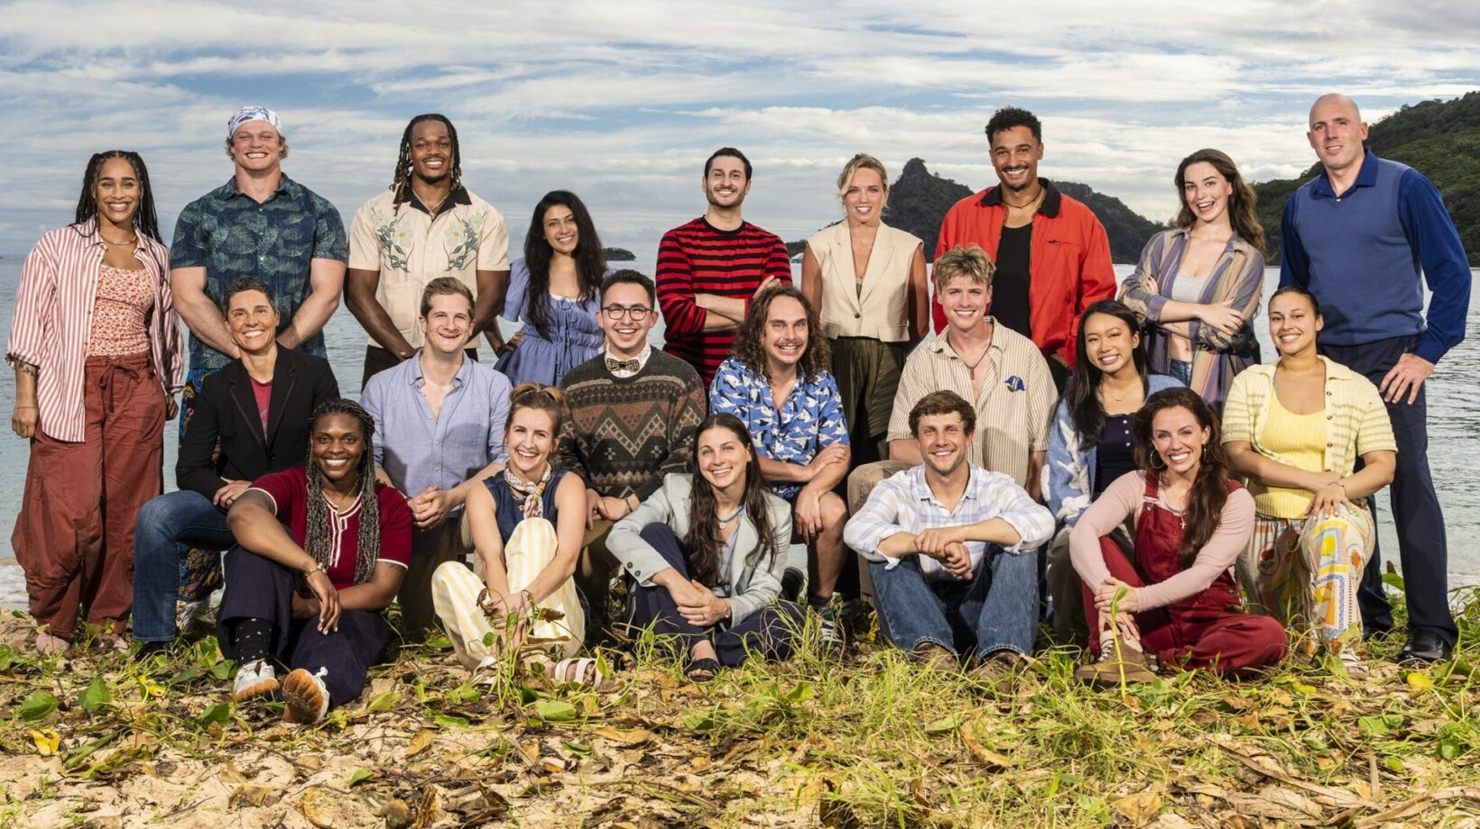
^{CBS}
CBS has revealed the 21 new castaways competing in Season 51 of Survivor. Fans have been anticipating the show’s return ever since the historic Survivor 50 wrapped. Unlike Season 50, Season 51 consists of an entirely new group of players.
The cast includes players ages 24 to 49 with a wide variety of occupations, including a professional wrestler, criminal-defense attorney, voice actress, chef, farmer, and more. The competitors will compete in what host Jeff Probst has called the show’s new Open Era, with a twist that could bring idols and advantages from throughout the show’s history back into the game, creating permanent uncertainty.
Keep reading to get to know every castaway, where they are from, their age, background information, and more.
Key facts about Survivor Season 51
- Premiere: Wednesday, Sept. 23, 2026
- Premiere length: Two hours, 8-10 PM ET/PT
- Network/Streaming: CBS/Paramount+*
- Number of castaways: 21 first-time players
*New episodes can be streamed live on Paramount+ as they air on CBS via the Paramount+ Premium plan, or they can be streamed on the day after they air via any Paramount+ plan.
Get Started With Paramount+
Who is in the Survivor 51 cast?
Season 51 features 21 first-time competitors. Here’s the list:
- Aaliyah Puglia
- Alexis Levine
- An “Thien An” Nguyen
- Ana Sani
- Angelica “Jelly” Loblack
- Brady Booker
- Carter Krull
- Cristian Chavez
- Danny “Kilby” Kilby
- Devin Way
- Eric Macksoud
- Jenna Doore
- Kristin Flickinger
- Lewis Kelly
- Linnea Capobianco
- Maggie Nestor
- Mike Pinsky
- Ori Jean-Charles
- Patt Cannaday
- Rob Antonson
- Sharonda Cox
Meet the castaways
Aaliyah Puglia
CBS
- Age: 24
- Hometown: Gloucester City, New Jersey
- Current residence: Providence, Rhode Island
- Occupation: Chef
Aaliyah is a bold, independent woman who loves watching people enjoy her cooking. As a chef, she has learned a thing or two about social politics in the kitchen. She handles egos, builds trust with her co-workers, and has learned to adapt. Aaliyah hopes to use those skills on the show and said, “I’m not here to find myself. I’m here to win the title and come back with something my family can be proud of.”
Alexis Levine
CBS
- Age: 34
- Hometown/current residence: Atlanta, Georgia
- Occupation: Criminal defense attorney
Alexis said on the YouTube livestream: “There have been people on Survivor, thus far, who have been recovering from addiction. There have been lawyers and moms. There have been really strategic women who are cunning and manipulative and savage, but you have not seen one person who is all those things, and that is me, ladies and gentlemen. Buckle up!” This wife and young mother is a social butterfly who is already planning to hide her real job in order to win.
An “Thien An” Nguyen
CBS
- Age: 24
- Hometown/current residence: Fort Worth, Texas
- Occupation: Medical student
Being on Survivor is Thien An’s dream, a once-in-a-lifetime opportunity and challenge she’s ready to take on. She is set to make genuine connections and trade books for brawn as she fights to win. Thien An is competitive, wears her heart on her sleeve, and wants to “play the most authentic, cutthroat game possible.”
Ana Sani
CBS
- Age: 34
- Hometown: Richmond Hill, Ontario, Canada
- Current residence: Toronto, Ontario, Canada
- Occupation: Voice actress
Ana is a voice actress who has worked on several cartoons (Mysticons, Ollie’s Pack, Strawberry Shortcake: Berry in the Big City), but is ready to take the leap from animation to real life on Survivor. Ana, her sister, and mother have been watching the show since she was 9 years old. She tragically lost her mother in 2020 to cancer and will be looking to her for guidance, as she is her “north star.” “I’m going to win Survivor because I’m not afraid to take risks. I’m going to play a little deviously, and no one is going to see it coming because I’m cutesy,” said Ana.
Angelica “Jelly” Loblack
CBS
- Age: 29
- Hometowns: Garland, Texas, and Midwest City, Oklahoma
- Current residence: Bloomington, Indiana
- Occupation: Sociology professor
This curious, talkative, spontaneous, and fun young woman is a sociology professor who is a fan of the show and even uses it in her classroom. She is not outdoorsy and doesn’t like fish, but Jelly hopes to go far in the sociology experiment that is Survivor. She teaches her students that the game establishes a hierarchy and family dynamics that she hopes to use to her advantage. “I want the challenge. I want to be humbled. I want to be confronted with my biggest weaknesses so I can grow from them,” said Jelly.
Brady Booker
CBS
- Age: 27
- Hometown: La Salle, Illinois
- Current residence: Knoxville, Tennessee
- Occupation: Professional wrestler
Brady is a professional wrestler who has appeared on AEW Dark, WWE NXT: Level Up and WWE NXT under his fighting name Bodhi Hayward. When he’s not in the ring, Brady is outdoors hunting, fishing, hiking, and camping, or he’s at home watching Survivor with his big family. “Everyone looks at me and probably thinks: ‘big, dumb jock.’ And you know what? I hope so, Brody, because that’s what I’m going to push the envelope on. The second they let their foot off the gas pedal, that’s the moment I’m going to use this brain I got in here to get after them,” Brady said.
Carter Krull
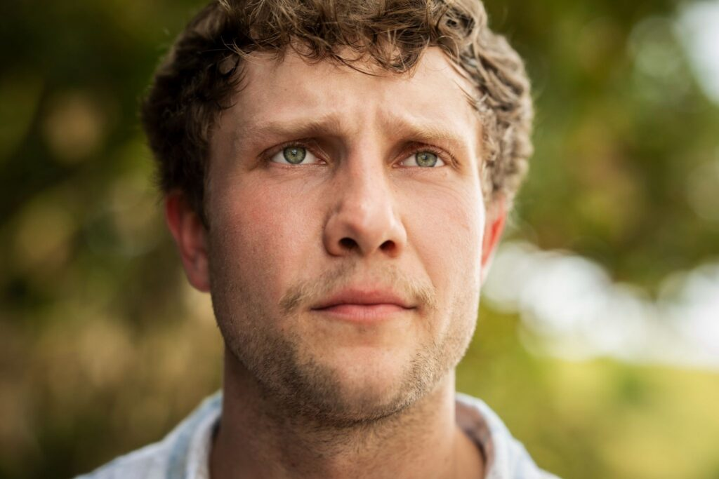CBS
- Age: 24
- Hometown: Rock Rapids, Iowa
- Current residence: Sioux Falls, South Dakota
- Occupation: Livestock farmer
Carter likes to stay busy as he farms, drives a snow cone truck, and runs a moving company. He also dabbles in photography and videography. “Survivor has been in my DNA since I was a little kid,” said Carter. He’s been watching the game with his mother for years. Carter is a good guy who can read people pretty well and hopes to be the guy people can trust in the game.
Cristian Chavez
CBS
- Age: 26
- Hometown/current residence: Salt Lake City, Utah
- Occupation: Head of HR
Cristian is a very bubbly, eccentric person with a loud laugh you won’t forget. He’s ready to give it his all on this season of Survivor. “My dad passed away a few years ago, and he ingrained in us so deeply that your own internal drive is so important, and whatever that is, go 110% into it,” said Cristian. He is a competitive person and wants to give off “little brother energy” in the game and take home the grand prize.
Danny “Kilby” Kilby
CBS
- Age: 30
- Hometown: Mount Forest, Ontario, Canada
- Current residence: London, Ontario, Canada
- Occupation: Game designer
Kilby is a hard-working game designer and a self-professed Survivor dork who loves puzzles. He grew up in a small town with a single mom and learned how to work hard from an early age. Kilby loves the show and even met his girlfriend through an Internet Survivor game. “I’m the type of player who’s not just gonna think outside of the box. I’m gonna smash it, fasten it into a weapon, and shank my enemies with it,” said Kilby.
Devin Way
CBS
- Age: 33
- Hometown: Lufkin, Texas
- Current residence: Los Angeles, California
- Occupation: Actor
Devin Way might look familiar to some, as he is an actor who has appeared on shows like Sistas, Queer as Folk, and Grey’s Anatomy, a profession he is planning on keeping a secret while on the show. This charming, charismatic young man had a tough childhood and is not a fan of the water or the beach, but he really loves people and games. “If Joe and Devins had a baby, that is what you are looking at,” said Devin. He wants to play a strategic game without lying and backstabbing, to be a man of his word.
Eric Macksoud
CBS
- Age: 34
- Hometown: Lincoln, Rhode Island
- Current residence: Windsor Locks, Connecticut
- Occupation: Mental health counselor
Eric hopes to use his counseling skills in the game by building rapport and relationships right off the bat. He has been watching the show since he was eight and plans to do whatever it takes to bring home the grand prize. “Overall, I want to make friends with these people; however, if any of them cross me, that’s when the fangs are gonna come out. That’s when I’m gonna bite their necks, suck their blood, toss them in the ocean, and sustain,” Eric said.
Jenna Doore
CBS
- Age: 30
- Hometown: Perrysburg, Ohio
- Current residence: Toledo, Ohio
- Occupation: Wedding photographer
Jenna is a huge fan of Survivor and even includes a clause in her wedding photography contracts warning clients that, if she achieves her “lifelong dream of going on the show,” she will not make their event. Energetic, empathetic, and determined, Jenna has been making up her own immunity challenges since she was a little girl. She connects well with people and hopes people underestimate her as a “little artist.” Jenna said this about joining the show: “I have been preparing for this, like it’s my destiny.”
Kristin Flickinger
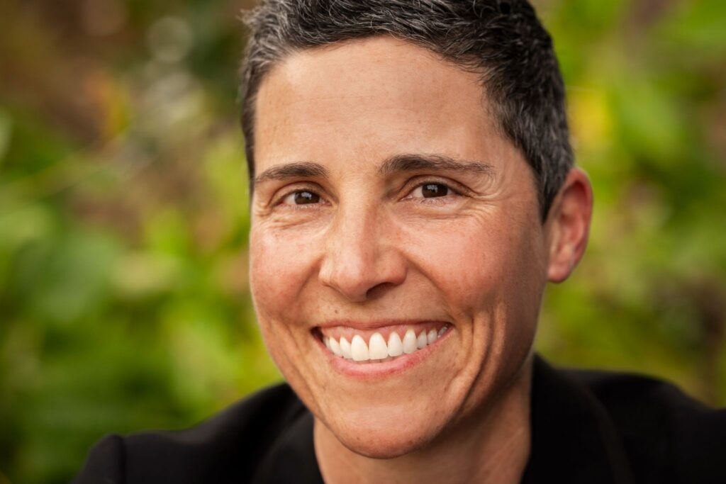CBS
- Age: 49
- Hometown: Ketchum, Idaho
- Current residence: Santa Barbara, California
- Occupation: Crisis management
Kristin is the oldest castaway in Season 51 at 49. She’s good in a crisis, cool, calm, and collected. Kristin has been working for the LGBTQ+ community for 25 years, the same amount of time she has been applying to be on Survivor. The show “reached into my chest and grabbed me and was like, you got to play this game,” said Kristin. She is ready for an adventure of a lifetime.
Lewis Kelly
CBS
- Age: 28
- Hometown: Dublin, Ireland
- Current residence: Puerto Rico
- Occupation: Farmer
“Everybody loves a cheeky Irish person. We have great crack, we have the best banter,” said Lewis. He is married to a Puerto Rican wife, and they live in a school bus on their tiny farm. This chaotic and mischievous farmer knows what it’s like to go on an adventure and try something completely new. He’s ready for a once-in-a-lifetime opportunity on the show and is not going to waste it.
Linnea Capobianco
CBS
- Age: 25
- Hometown: Kearny, New Jersey
- Current residence: Jersey City, New Jersey
- Occupation: Entrepreneur
Social, goofy, super logical, and not afraid to be weird, Linnea is a confident woman who runs a lingerie and adult toy business with her brother. “I’m here because I say yes to things even when I’m scared. I say yes to things that are a big challenge or that would make me super uncomfortable,” said Linnea. She has been a fan of the show since she was a kid and is excited to join the cast.
Maggie Nestor
CBS
- Age: 40
- Hometown: Middleway, West Virginia
- Current residence: Charles Town, West Virginia
- Occupation: Farmer
Maggie has a degree in therapy and is a homeschool teacher to her kids. She has been watching the show since she was 15 and is ready for the challenge. Her husband thinks she’s a little crazy, but Maggie is determined and has a lot of goals for the show. She is an athletic, lifetime hunter and fisher and hopes to catch a shark and some fish while on the show and learn to make fire without flint. “I don’t really register fear. I think fear is only as large as you make it,” said Maggie.
Mike Pinsky
CBS
- Age: 32
- Hometown/current residence: New York City
- Occupation: Baseball executive
He is the assistant director of baseball operations, which entails advising general managers on players to trade and sign, negotiate contracts, and help teams make it to the World Series. Mike has been “playing” Survivor since he was a kid, making up challenges, pretending to be Jeff, and voting each other out. He went to Princeton, married his high school sweetheart, and is eager to enter the game and get playing. “I don’t do anything for second place. I’m here to win the game, period. Full stop,” said Mike.
Ori Jean-Charles
CBS
- Age: 27
- Hometown/current residence: Spring Valley, New York
- Occupation: Personal trainer
Book smart, street smart, and a former athlete (he played Division I football), Ori is made for Survivor. “I’m not playing for the experience, I’m not playing to make friends, I’m playing to win a million dollars and change my family’s life,” Ori said. He has done his homework of watching previous seasons and is ready to work with the women in the game. Why? Because six out of nine of the last winners were women. Ori – who describes himself as consistent – is prepared to get in game mode, lock in, and take home the grand prize.
Patt Cannaday
CBS
- Age: 33
- Hometown: Tampa, Florida
- Current residence: Washington, D.C.
- Occupation: Federal prosecutor
Patt is a Navy prosecutor who is a bit nerdy and the first woman in her family to go into the military. She comes from a military family with her husband, dad, and brother all serving. Patt is keen on challenging herself by taking on the show. As for gameplay, Patt said, “When I’m in an alliance, I want them to feel that closeness with me, but now I’m ready to go to war with any of these people.” She hopes being in the game is similar to boot camp: she was tired, exhausted, and hungry, but having a blast.
Rob Antonson
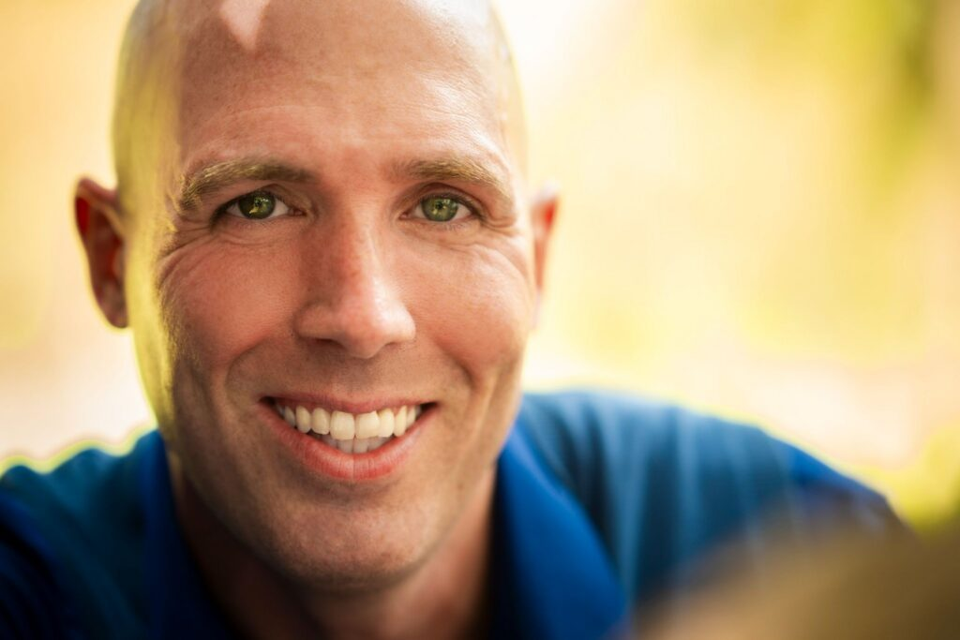CBS
- Age: 40
- Hometown: Johnston, Rhode Island
- Current residence: Cumberland, Rhode Island
- Occupation: Airline gate agent
Rob is a husband and father of three kids who works for the airlines. This funny, outgoing, competitive, loving, and somewhat adventurous guy has many layers. Rob’s son told him he couldn’t do the show, so he took the challenge and applied to be on Survivor. “My secret weapon out here would be the gift of gab,” said Rob. He would love to have friends for life and make solid relationships that will survive a blindside.
Sharonda Cox
CBS
- Age: 34
- Hometown: Pompano Beach, Florida
- Current residence: Richmond, Kentucky
- Occupation: OBGYN resident
Sharonda is a doctor and wife who’s ready to take her skills and apply them to the game of Survivor. She’s spent most of her life doing things for other people, but she wants to play this game for herself and do something new. “I’ve survived my entire life, and now it’s time for me to thrive,” said Sharonda. She’s ready to use her tenacity, street smarts, and book smarts to be the Sole Survivor.
What is the Open Era?
The “Open Era” of Survivor is a new chapter that changes the game like never before with a bold twist – every element (twist, idol, and advantage) throughout the show’s history can potentially enter the game whenever and without warning. The new castaways face an unpredictable adventure where they must adapt and strategize in a constantly changing game.
When does Season 51 premiere?
Survivor Season 51 premieres on Wednesday, Sept. 23, at 8 PM ET/PT. You can watch it on CBS and Paramount+. To watch the episode as it airs live, you need a Paramount+ subscription to the Paramount+ Premium plan. Catch the action on demand the day after it airs with a subscription to any Paramount+ plan, either Paramount+ Premium or Paramount+ Essential. And binge-watch all 50 previous seasons of this iconic competition show with a subscription to any plan. Visit the Paramount+ Help Center for more information on plans and pricing.
Get the watch info below:
Survivor Season 51
- Premiere date: Sept. 23, 2026
- Time: 8 PM ET/PT
- New episodes air: Weekly on Wednesdays
- Channel: CBS
- Streaming live: Paramount+ (Paramount+ Premium plan)
- Streaming on demand: Paramount+ (Paramount+ Premium plan and Paramount+ Essential plan)
Watch Survivor on Paramount+
Survivor continues to evolve, and things are about to get wild when the show returns on
Sept. 23 at 8 PM ET/PT. Be sure to watch every episode of Season 51 airing Wednesdays on CBS and streaming on Paramount+. Catch up on all the gameplay from the previous 50 seasons available to binge-watch on Paramount+ now, and don’t forget to tune in this fall to meet the new players hitting the beach for an unforgettable season.
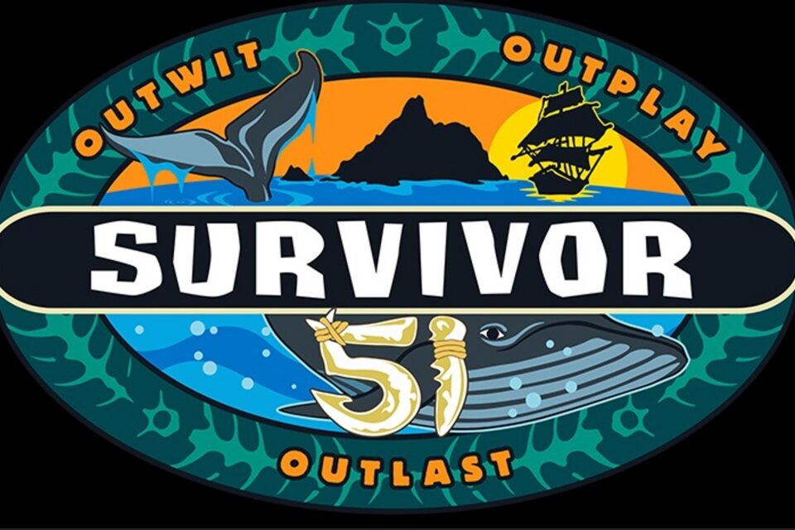
Survivor
Watch Now
FAQ
How many contestants are on Survivor 51?
Twenty-one contestants will compete on Survivor Season 51. All 21 castaways are first-time players.
Are there any returning players on Survivor 51?
No. There are no returning players in the Survivor Season 51 cast. The cast is made up of new players, not returning players, as in, most recently, the 50th anniversary season of Survivor.
Who is the oldest Survivor 51 contestant?
Kristin Flickinger is the oldest contestant on Survivor Season 51, at 49 years old. She has been applying to be on the show for 25 years.
Who is the youngest Survivor 51 contestant?
An “Thien An” Nguyen is the youngest contestant on Survivor Season 51, at the age of 24. She is a medical student who’s ready to take on the competition and play “the most authentic, cutthroat game possible.”
Where was Survivor 51 filmed?
Survivor Season 51 was filmed in the Mamanuca Islands in Fiji. Survivor has been filming continuously in Fiji since 2016.
Explore more about: TV Shows What To Watch

Doriean Stevenson
See more by Doriean Stevenson
Related Articles
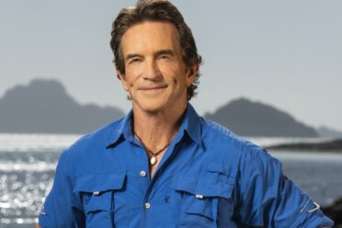
News

Survivor 51: Everything You Need To Know

by Sneak Peak Staff Aug 26, 2026

TV Shows

Everything You Need To Know About Survivor Season 49

by Joal Ryan Nov 5, 2025

TV Shows

How To Watch Every Season Of Survivor

by Joal Ryan May 26, 2026

TV Shows

Survivor 50: Everything You Need To Know

by Joal Ryan May 21, 2026

TV Shows

Love Survivor 50? Watch These 6 Seasons Next

by Stephanie Hartsell May 22, 2026

TV Shows

Meet The Big Brother Season 28 Cast

by Sneak Peak Staff Jul 13, 2026

News

Everything You Need To Know About Big Brother Season 27

by Joan Kubicek Jul 9, 2025

TV Shows

Big Brother Season 28: Everything You Need To Know

by Stephanie Hartsell Sep 18, 2026
Today’s Top Peaks

TV Shows

School Spirits Season 4: Everything You Need To Know

by Joan Kubicek Sep 22, 2026

TV Shows

Lioness Season 3: Everything You Need To Know

by Sneak Peak Staff Sep 22, 2026

Sports

Ravens vs. Cowboys NFL Game – Where To Watch And Stream Live, Date And Time

by Lance Cartelli Sep 22, 2026

TV Shows

2026 VMAs: How To Watch The MTV Video Music Awards

by Sunny Nasiri Sep 21, 2026

TV Shows

All The Queen’s Men: Meet The Cast Of Season 5

by Doriean Stevenson Sep 21, 2026

TV Shows

Wild Cherry Ending Explained: What Happened in the Finale?

by Joan Kubicek Sep 21, 2026
Explore More

Sports

Raiders vs. Saints NFL Game – Where To Watch And Stream Live, Date And Time

by Lance Cartelli Sep 22, 2026

Sports

Patriots vs. Jaguars NFL Game – Where To Watch And Stream Live, Date And Time

by Lance Cartelli Sep 22, 2026

Sports

Chiefs vs. Dolphins NFL Game – Where To Watch And Stream Live, Date And Time

by Lance Cartelli Sep 22, 2026

Sports

Bengals vs. Steelers NFL Game – Where To Watch And Stream Live, Date And Time

by Lance Cartelli Sep 22, 2026

Sports

Texans vs. Colts NFL Game – Where To Watch And Stream Live, Date And Time

by Lance Cartelli Sep 22, 2026

Sports

Titans vs. Giants NFL Game – Where To Watch And Stream Live, Date And Time

by Lance Cartelli Sep 22, 2026

Sports

UFC Schedule 2026: Dates, Start Times For Events Streaming On Paramount+

by Sneak Peak Staff Sep 21, 2026

Sports

How To Watch UFC 331: Van vs Pantoja 2: How To Watch On Demand

by Lance Cartelli Sep 21, 2026
View All

- Home
- News
- Movies
- TV Shows
- What To Watch
- Sports
- Paramount+ UK
To Paramount+
Sneak Peak is the official news source for what's streaming on Paramount+, your inside guide to the shows, movies, and live sports you love.
Copyright ©2026 Paramount - All Rights Reserved.
About Sneak Peak
Privacy Policy
Terms of Use
Your Privacy Choices
California Notice

