6.301 Project Deliverable 2 – Simulation

# SPICE Simulation

Used a super simple model with same beta as hand calculations:

.model NPN NPN(IS=1E-14 Bf=100 RB=0 RC=0 RE=0)

.model PNP PNP(IS=1E-14 Bf=100 RB=0 RC=0 RE=0)

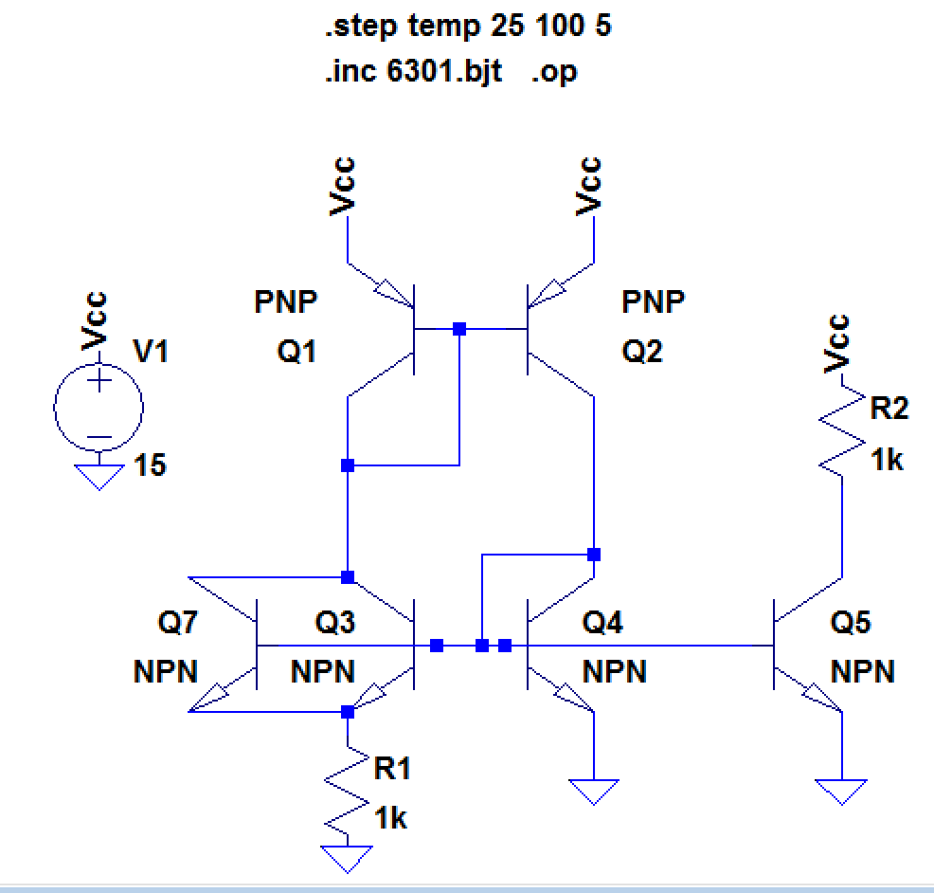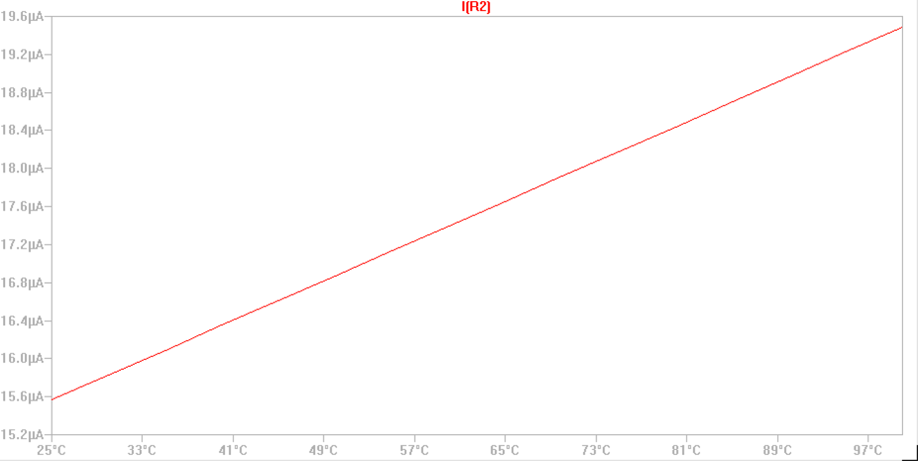

# Hand calculation vs SPICE simulation

