6.301 Project Deliverable 3

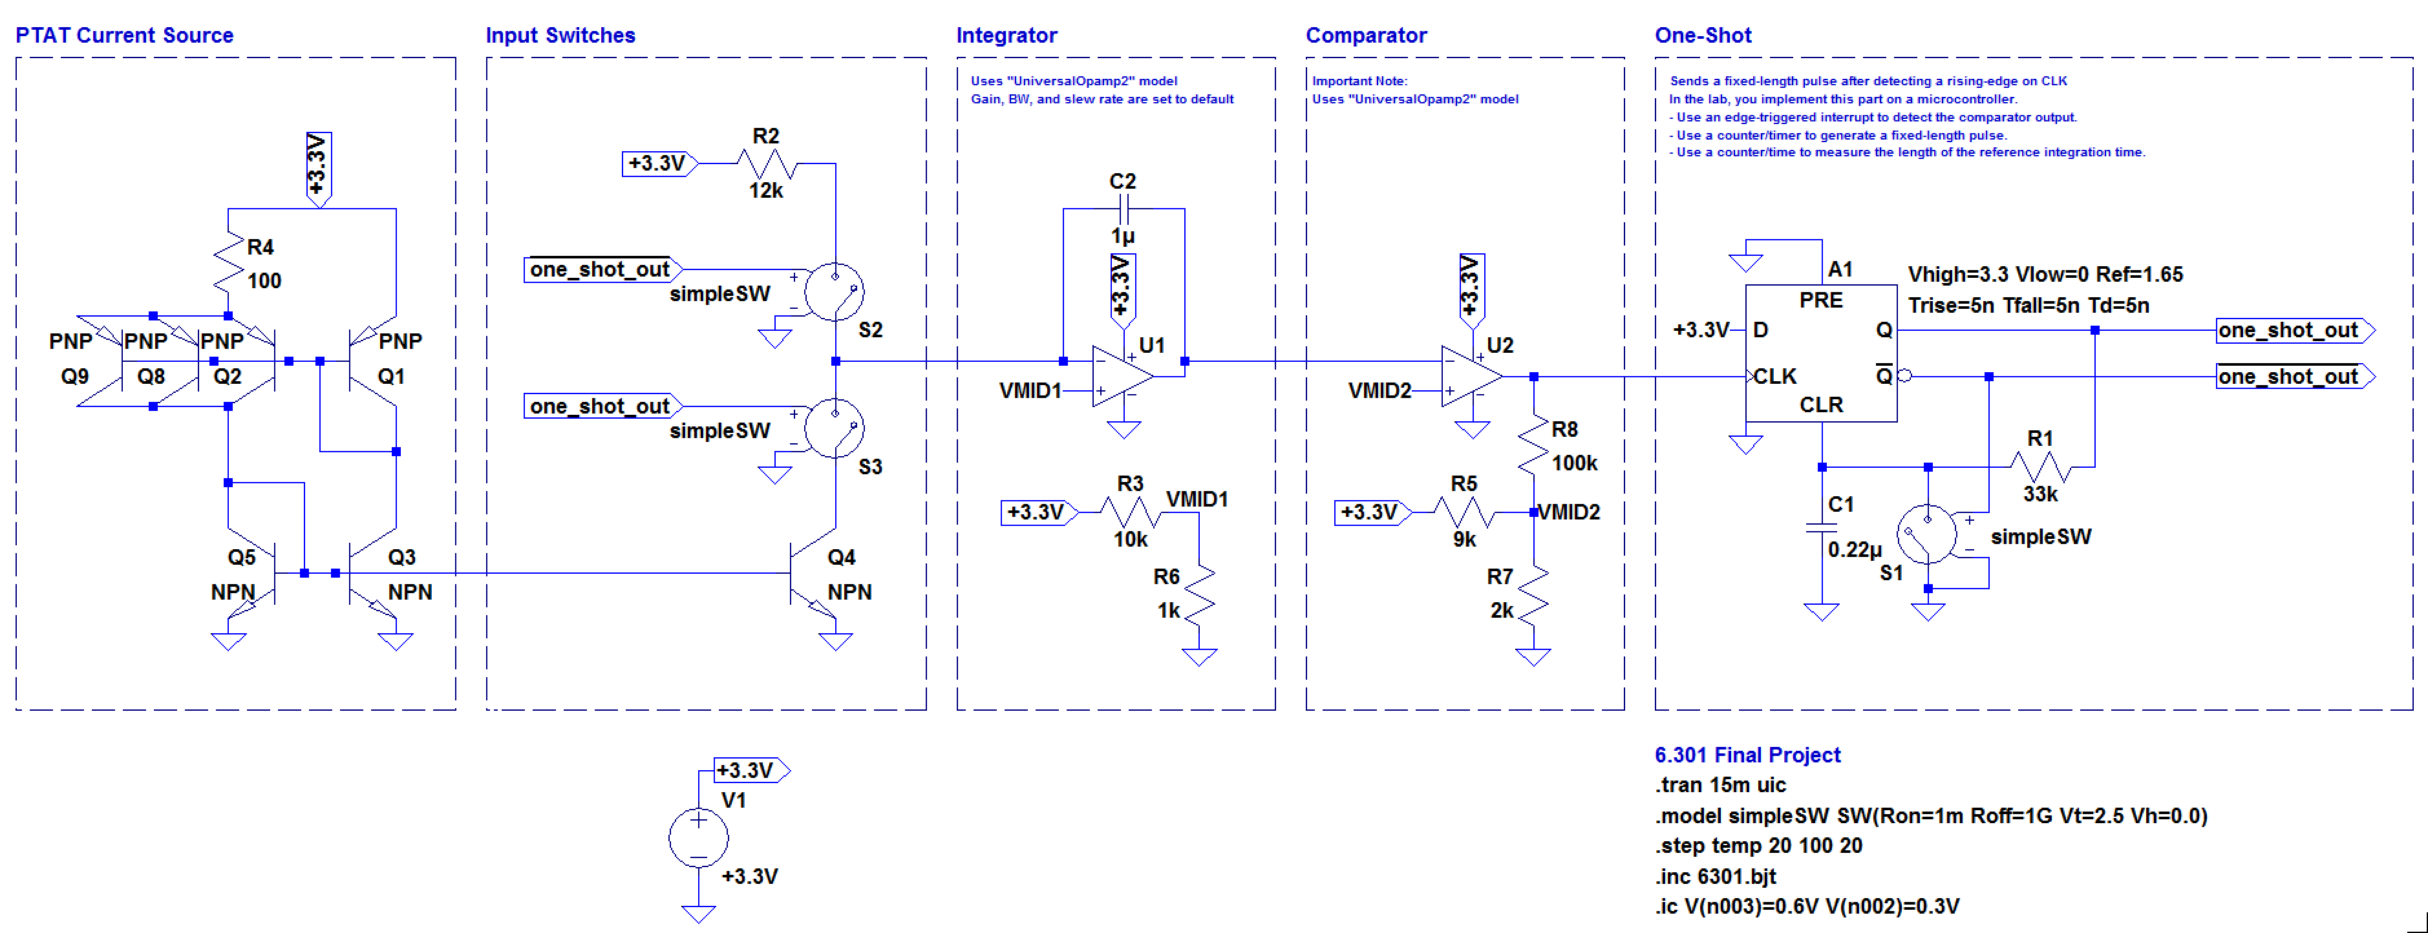

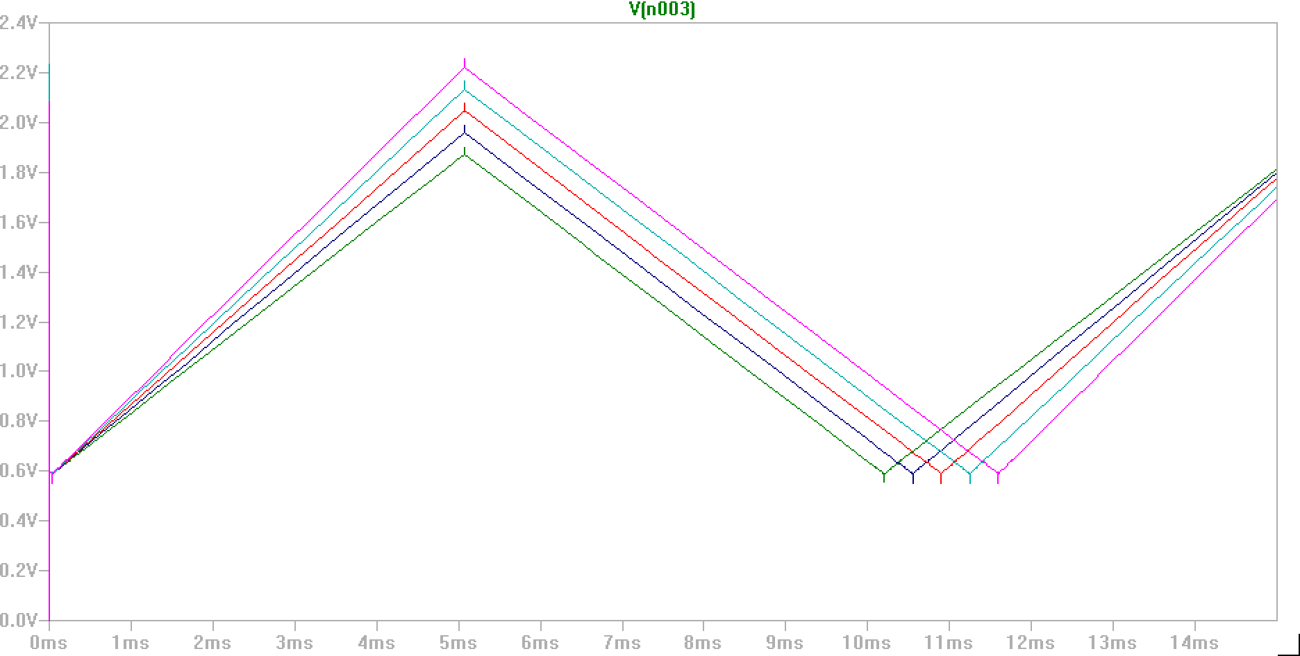

Changes:

* Upper and lower rails changed to 3.3V and GND.
* Opamp noninverting input set to 0.3V
* Comparator noninverting input set a bit higher (0.6V) and with a bit of hysteresis.
* V_REF changed to +3.3V to avoid temperature dependence of V_REF.
* Input resistor moved to only the V_REF branch to allow for direct current input to integrator.
* PTAT source now has 3 paralleled PNP BJTs to balance PNP and NPN counts for MQP parts and R4 decreased to 100Ohm to increase current.
* R2 adjusted to make currents similar at room temp.
* C2 decreased slightly because of lower current.