Magic Realm – Documentation

Team Information:
- Team Members:
  - Mitchell Hird (Student 100881078)
  - Albert Cho (Student 100857664)
  - Anthony Tasca (100410783)
- Team Number: 13
Section 1: Requirements
Requirement ID | Requirement Description | Traceability (Page Number)
MR-FR-01 | Display supplied board and make it scrollable | N/A
MR-FR-02 | Support placement of dwellings and ghosts | N/A
MR-FR-03 | Refresh the board upon execution of each action of a character | N/A
MR-FR-04 | Support Amazon, Captain, Swordsman, Dwarf, Black Knight | Page 61 - 64
MR-FR-05 | Support characters moving from clearing to clearing | Page 16
MR-FR-06 | Support character hiding | Page 16
MR-FR-07 | Support cheat mode | N/A
MR-FR-08 | Support Networking | N/A
MR-FR-09 | Support one round character-2-character combat between 2 players with 2* limit | N/A
MR-FR-10 | Characters can start on different dwellings | Page 61 - 64
MR-FR-11 | Display multiple items on the same clearing ( characters and clearings ) | N/A
MR-FR-12 | Support treasures (10to50g + 1to20 notoriety + -5to30 fame) | Page 16 - 17
MR-FR-13 | Support treasures appearing, discovery, and looting | Page 16 - 17
MR-FR-14 | Support searching for hidden paths, secret passages, hidden enemies | Page 16 - 17
MR-FR-15 | Support multi-round multi-character combat | Page 27
MR-FR-16 | Support Cloak of mist, Magic spectacles | Page 67 - 68
MR-FR-17 | Support victory points | Page 13
MR-FR-18 | Support Lost Castle, Lost City | Page 14
MR-FR-19 | Support random rolls | N/A
MR-FR-20 | Support multi-round combat with 1 monster | Page 27
MR-FR-21 | Support random placement of chits | N/A
MR-FR-22 | Note: Currently there are no monster rolls, monsters are present on board but do not spawn  Support 3 distinct monsters, each activated by 2 distinct possible monster rolls | N/A
MR-FR-23 | Zooming Map | N/A
MR-FR-24-A | Support fatigued and wounded counters | Page 26 - 30
MR-FR-24-B | Support resting | Page 18

Section 2: Testing Functional Requirements
Requirement ID | Test Plan For Testing Functional Requirement
MR-FR-01 | Testable by starting a new game and scrolling the board located on the right
MR-FR-02 | Testable by starting the game and seeing where the dwellings and ghosts are located. If cheat mode is enabled, this feature can also be tested by specifying a location where a dwelling should be located, and then observing that dwelling appears on the clearing selected.
MR-FR-03 | Testable by committing an action as a player in the game then observing the changes to the board. All of the other clients connected should be updated based on the type of action that is committed. For example if a player moves from a clearing to another clearing, every single board should represent this new change
MR-FR-04 | Testable by starting a new game with any of these character
MR-FR-05 | Testable by pressing the move button while it is your turn then clicking on a highlighted clearing they you would like to move to. Clearings that are not highlighted, should not allow players to move to them.
MR-FR-06 | Testable by pressing the hide button while it is your turn. If the die roll passes, then the player will be come hidden and their icon will change from brown to green.
MR-FR-07 | Testable by starting a game after pressing the cheat mode option in the options menu then starting the game to place dwellings and committing an action that requires a dice roll. A window will open that allow testers to place objects where ever they wish on the board. Also if cheat mode is enabled and a die roll is
MR-FR-08 | Testable by starting two or more instances of the game. Then on one instance, go to the menu and select “Networking” and click on “Host Game”. From here you will specify your port number, and then select host. Then on the instances of the game, select networking and join game in order to join the new server.
MR-FR-09 | Testable by ending a turn on a clearing that contains another player and does not contain a monster. The 2* limit can be tested by trying to select a combination chits that exceed the 2* limit. The system should let the user know that selection of chit should be invalid.
MR-FR-10 | Testable by starting a game as either the Dwarf or Captain then selecting which dwelling you wish to start on
MR-FR-11 | Testable by hovering over a clearing that contains multiple items (indicated by a question mark). A new window should display when clearing is hovered over.
MR-FR-12 | Testable by looting a clearing that you have searched for treasure in then looking at your earnings
MR-FR-13 | Testable by pressing the Search button while it is your turn then looking at the discovered treasure and looting it
MR-FR-14 | Testable by pressing the search button while on a clearing that has a hidden path or passage or enemies and succeeding in your roll. Roll results for finding particular items in a clearing are as follows:  - Die Roll <= 2: Treasures in clearing found  - Die Roll == 3: Find hidden enemies in clearing  - Die Roll == 4 or 5: Find hidden paths in clearing  - Die Roll == 6: Find Nothing
MR-FR-15 | Killing a character creates a treasure pile out of his/her possessions  Testable by searching a clearing where a player has died. A treasure pile should be present on the tile that contains all treasure of the dead player
MR-FR-16 | Testable by looting either item and observing their effects. Cloak of mists is located in Bvalley2 and magic spectacles are located in BLand1
MR-FR-17 | Testable by setting your victory points during character creation then satisfying them
MR-FR-18 | Simplification: Lost City and Castle are both assigned flutter sound chit which spawns a flying dragon.  Both are also displayed when the game starts  Testable by starting a game and then looking at the board to see where the lost city and castle are, also noticing that there is a sound chit on each of their tiles
MR-FR-19 | Testable by committing an action that requires a roll of the dice multiple times and observing a multiple outcomes
MR-FR-20 | Testable by ending your turn on the same clearing as a single monster
MR-FR-21 | Chits can be randomly placed on any tile or clearing in cheat mode, if not using cheat mode they will be at a default location
MR-FR-22 | Simplification: combat between 1 player and multiple monsters is possible but not multiple players and multiple monsters  Testable by starting the game in cheat mode then placing multiple monsters on the same clearing then ending your turn on that clearing
MR-FR-23 | Testable by using the mouse wheel while focusing on the board
MR-FR-24-A | Simplification: The chits that you use in combat are the ones that get wounded when you are struck in combat, instead of in the actual rules where you select a chit to fatgiue  Testable by beginning combat and selecting either a fight action or a movement action.
MR-FR-24-B | Testable by selecting rest from the player lists and using the new window to rest your chits.

Section 3: Use Cases
UC-01 | Player Starts The Game
Description | Player starts the application for the first time and gets ready to play the game
Actors | One application, one to many individual players waiting to play
Starting Condition | N/A
Main Sequence | - User starts the game application  - System responds with an opening screen, waiting for user input  - User selects to start a new game from the menu provided  - System builds the player listing, board, and player movement options  - User enters player information by clicking on available add button, specifies both the name and class they which to play as  - Step 5 is repeated until the desired amount of players has been meant  - User starts game
Post-Condition | Game has started and players begin taking their desired turns

UC-02 | Player Attempting To Move To New Clearing
Description | After game is running, player attempts to move along the board
Actors | Current player for the turn
Starting Condition | UC-01 must be meant before this can be carried out
Main Sequence | - Current player of the game selects the move option from the available list  - System responds by highlighting all available clearings that connected to there player's connected clearings  Repeatedly:  - Player selects a valid area for the character movement  - System checks the area to see if is a valid move for the player  - System records “M-” followed by the clearing name to the player's log  - System moves player to new area, highlighting new connected clearings for the next movement
Post-Condition | Player has moved their current clearing to the new clearing
Alternative Scenarios | - The player might at any point select to cancel the movement action by selecting another action from the ones provided  - Player may not actually move from their current clearing as they can move back and forth in between tiles

UC-03 | Player Attempts To Hide In Current Clearing
Description | During the current player's turn they attempt to hide for their turn
Actors | Current player for the turn
Starting Condition | UC-01 must be meant before this can be carried out
Main Sequence | - User starts their turn and is unhidden if the are currently hidden  - User selects hide from the available list of commands available  - System generates value to determine if player becomes hidden  - If player becomes hidden, their tile becomes green until they become unhidden from another means  - If player stays unhidden then their tile will remain the same
Post-Condition | Player has been hidden based on the result from the system

UC-04 | Treasure Searching And Looting
Description | During the player's turn they search and/or loot the current clearing they are in
Actors | Current player for the turn
Starting Condition | UC-01 must be met before this can be carried out
Main Sequence | - User starts their turn  - User selects the search option from the list of commands  - System responds with dialogue with available options for searching  - User selects to either search or loot from the clearing  - If user selects to search clearing, system searches the player's clearing, giving the player access to the hidden items if they are found  - If user selects loot, the player loots the available treasure and adds it to their current collection
Post-Condition | Player has searched the area and may have new treasures added to their inventory

UC-05 | Displaying Detailed Character Sheet
Description | Steps for displaying the character sheet for the selected player
Actors | One or more players currently playing the game
Starting Condition | Application must be ran but the game does not need to have been started.
Main Sequence | - User selects a player from the list  - User clicks on the option to show detailed card  - System responds by displaying the character detail sheet for the selected player's class
Post-Condition | Player detail has been displayed

UC-06 | Player Enters Combat With Another Player
Description | Steps for conducting combat between a player and another player
Actors | More than one player currently playing the game
Starting Condition | UC-01 must be met before this can be carried out and multiple players must be unhidden on the same clearing
Main Sequence | - All players have sent their turn and two players are unhidden on the same clearing  - A combat user interface is opened for the players  - The luring phase of combat is initiated  - Users select which enemies they would like the lure by pressing the enemy buttons in the combat user interface  - The charging phase of combat is initiated  - The manoeuvres and attack phase of combat is initiated  - Users select whether or not they would like to thrust, swing, or smash for their attack  - Users select whether or not they would like to dodge, duck, or charge for their manoeuvre  - Attacking phase is resolved  - Harm is calculated and applied to users  - Fatigue is calculated and applied to users  - Steps 3 through 6 are repeated until there is no more than one player in a clearing or nothing happens for 2 rounds
Post-Condition | Combat has been resolved

UC-07 | Player Hosts A Networked Game And Starts It
Description | After a new game has been created, the user presses Host Game
Actors | One player who is going to host the game
Starting Condition | User has started the application and pressed New Game under the file menu
Main Sequence | - User presses the Host Game button in the Networking Menu  - User enters which port he/she would like to host the game on  - User confirms hosting a game by pressing the Host button  - User adds local players to the game and waits for other users to join the networked game  - Step 4 is repeated until all of the desired players have been added  - Host presses the start game button
Post-Condition | A networked game is in motion

UC-08 | Player Joins A Game
Description | After a new game has been created, the user presses Join Game
Actors | One player who is going to join a game
Starting Condition | User has started the application and pressed New Game under the file menu
Main Sequence | - A user presses the join game button in the Networking menu  - The user enters the ip address and port of the game that he/she would like to join  - The user attempts to join the game by pressing the join game button  - If there is a game being hosted by somone at the ip/port location then the user joins that game  - If there is no game being hosted at the specified ip/port then the user is redirected to the join game view
Post-Condition | A user has joined a hosted game

UC-09 | Host Selects Chit and Dwelling Locations In Cheat Mode
Description | A player enters cheatmode before pressing the start game button
Actors | The host of the game
Starting Condition | The host must enable cheat mode then satisfy UC-07
Main Sequence | 1. The dwelling and sound chit placement view is displayed  2. Host chooses a clearing, to place the current item, from the location combo box  3. Host presses the set button or the randomize button in order to place that item  4. Steps 2 and 3 are repeated until all of the available items are placed  5. The environment chit placement view is displayed  6. Host chooses a tile, to place the current item, from the location combo box  7. Host presses the set button or the randomize button in order to place that item  8. Steps 6 and 7 are repeated until all of the available items are placed
Post-Condition | A game has been set up using cheat mode and is under way

UC-10 | Player Rolls The Dice In Cheat Mode
Description | A player decides the outcome of his or her dice roll in cheat mode
Actors | One player who is making a dice roll in game
Starting Condition | The game has begun, a user has enabled cheat mode and has conducted an action that requires a roll
Main Sequence | 1. The cheat mode roll view has opens for the user  2. User enters an integer, into the input field, that is between 1 and the  highest possible roll value that is shown.  3. User decides whether or not to set the roll  - User presses the OK button and sets the roll to the desired value  - User presses the Randomize button and randomizes the dice roll
Post-Condition | The roll has been set to the desired value or has been randomized

UC-11 | Player Sets Victory Points
Description | A player decides which 5 victory points he/she will need to win the game
Actors | A single player who has selected their character
Starting Condition | A new game must have been made and a user must have added a player with a name and class
Main Sequence | - User selects how many victory points they would like to assign to the first category (gold) using the combo box  - Step 1 is repeated for each following category untill exactly 5 victory points have been assigned  - User presses the set button  - If the number of victory points is equal to 5 then the player has been added to the game  - Else, step 2 and 3 are repeated
Post-Condition | A player has set his or her victory conditions and that player has been added to the game

UC-12 | Player Chooses Starting Location
Description | A player decides on which of the available locations it will start
Actors | A player hosting a game or playing alone
Starting Condition | UC-01 or UC-07 must be satisfied and one or more players in the game must be a Dwarf or Captain
Main Sequence | - The character placement view is dispalyed for the first character  - Host chooses which of the available dwellings that character will start on  - Step 1 and 2 are repeated until all of the players whos class is dwarf or captain has had their starting location chosen
Post-Condition | One of more players have had their starting location chosen and the game starts

UC-13 | Player Satisfies Victory Points
Description | A player wins the game
Actors | A single player who is playing the game
Starting Condition | A player has acquired some new gold notoriety fame or great treasure
Main Sequence | - A User has satisfied all of their victory points this turn  - That user send their turn  - A dialog is displayed to all clients that tells them who has won the game  - The game ends for all users
Post-Condition | The game has ended and someone has won

UC-14 | Swordsman Chooses His Turn
Description | A player who is using the swordsman chooses when they get to play
Actors | A single player who is using the swordsman
Starting Condition | The game has started and a new day has begun where at least player is using the swordsman
Main Sequence | - The turn selection view is displayed to the a user who is playing the swordsman  - That user selects when he/she would like to play their turn, from the drop down box available  - User presses the OK button to commit their decision  - Steps 1 through 4 are repeated until all users who are playing the swordsman have chosen when they want to play
Post-Condition | The swordsmen have decided when they would like to take their turn this day

UC-15 | Player Rests
Description | A player, who's turn it is, uses an action to 'rest'
Actors | A single player who's turn it is
Starting Condition | A game has started and it is the turn of a player who has actions to spend
Main Sequence | - The player presses the rest button  - The RestView is displayed to the user  - The user clicks on a chit that he/she would like to move from the Active list to the Fatigued list  - The user presses on the 'Move Right' button to move the chit  - Steps 3 and 4 are repeated until the user has moved all of the Action chits they wanted to  - The user clicks on a chit that he/she would like to move from the Fatigued list to the Active list or the Wounded list  - The user presses the 'Move Left' button to move that chit to the Active list  - The user presses the 'Move Right' button to move that chit to the Wounded list  - Steps 6 is repeated until the user has moved all of the Fatigued chits they wanted to  - The user clicks on a chit in the Wounded list that they would like to move to the Fatigued list  - The user presses the 'Move Right' button to move the chit  - Steps 8 and 9 are repeated until all of the Wounded chits that the user wanted to move are moved  - Steps 3 through 10 are repeated until all of the chits have been moved to the list that the user wants them to be in  - The user presses the confirm button to confirm the Rest
Post-Condition | The user has rested during his/her action

UC-16 | Player Enters Combat With One or More Monsters
Description | The current player enters and finishes combat with one or more monsters
Actors | A single player who's turn it is
Starting Condition | The game must have started and a player must have ended their turn on the same tile as a monster
Main Sequence | - The monster combat view is displayed for the user  - The user decides whether or not he/she would like to alert their weapon  - User selects which monster he/she would like to attack from the monster drop down box  - User selects which attack he/she would like to use (smash, thrust, or swing) using the available buttons  - User selects which shield he/she would like to use with the available buttons  - User selects which maneuver he/she would like to use with the available buttons  - User presses the Attack Curr. Monster button to signal that they are attacking that monster  - User presses the Start Combat button or the Run button in order to determine what happens in that round of combat  - Steps 2 through 7 are repeated until the user has run away, died, or killed all of the monsters
Post-Condition | The user has ended combat with one or more monsters

Section 4: Unbounded Case Models

UC - 01
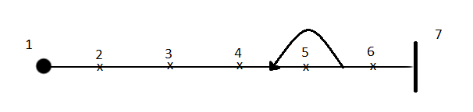

Tag | Responsibility
1 | User starts the game application
2 | System responds with an opening screen, waiting for user input
3 | User selects to start a new game from the menu provided
4 | System builds the player listing, board, and player movement options
5 | User enters player information by clicking on available add button, specifies both the name and class they which to play as
6 | User starts the game
7 | The game has started

UC – 02
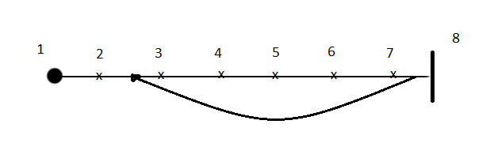
Tag | Responsibility
1 | Current player of the game selects the move option from the available list
2 | System responds by highlighting all available clearings that connected to player's connected clearings
3 | Player selects a valid area for the character movement
4 | System checks the area to see if it is available for the player to move to
5 | System records “M-” followed by the clearing name to the player's log
6 | System moves player to new area
7 | System highlights clearings connected to new area
8 | Player has finished moving to the desired clearing

UC-03
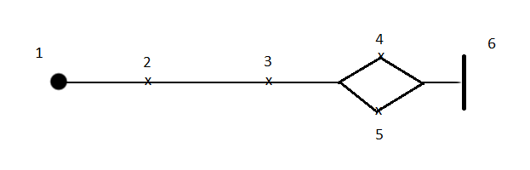

Tag | Responsibility
1 | User start their turn and is unhidden if they are currently hidden
2 | User selects hide from the available list of commands
3 | System generates value to determine if player becomes hidden
4 | Player becomes hidden, their tile becomes green until they become unhidden
5 | Player stays unhidden (hiding failed)
6 | The player has attempted to become hidden

UC-04
Tag | Responsibility
1 | User starts their turn
2 | User selects the search option from the list of commands
3 | System responds with a dialogue that contains options for searching
4 | User has selected to search clearing, system searching the clearing and gives the player access to hidden items if found
5 | User selects loot, the player loots the available treasure and adds it to their inventory
6 | The player has searched or looted their clearing

UC-05
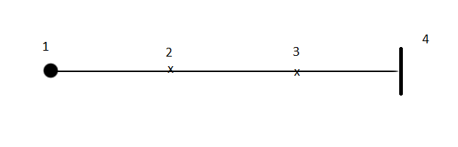
Tag | Responsibility
1 | User selects a player from the list
2 | User clicks on the option to show detailed card
3 | System responds by displaying the character detail sheet for the selected player's class
4 | Player detail has been displayed

UC-06
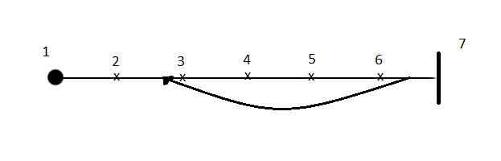
Tag | Responsibility
1 | All players have sent their turn and two players are unhidden on the same clearing
2 | A combat user interface is opened for the players
3 | The luring phase of combat is initiated, users select the enemies they want to lure
4 | The charging phase of combat is initiated
5 | Players select which maneuver they would like to use and which attack they would like to use
6 | Attacking phase is resolved, harm and fatigue is calculated and applied
7 | No more than one player is on the clearing or nothing has happened for 2 rounds, combat is resolved

UC-07

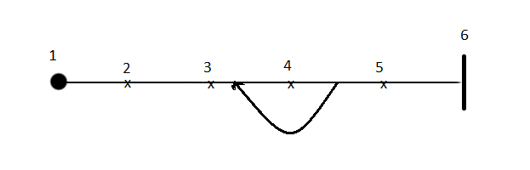
Tag | Responsibility
1 | User presses the Host Game button in the Networking Menu
2 | User enters which port he/she would like to host the game on
3 | User confirms hosting a game by pressing the Host button
4 | User adds local players to the game and waits for other users to join the networked game
5 | Host presses the start game button
6 | A networked game is in motion

UC-08

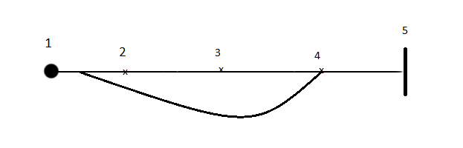
Tag | Responsibility
1 | A user presses the join game button in the Networking menu
2 | The user enters the ip address and port of the game that he/she would like to join
3 | The user attempts to join the game by pressing the join game button
4 | If there is no game being hosted at the specified ip/port then the user is redirected to the join game view
5 | A user has joined a hosted game

UC-09
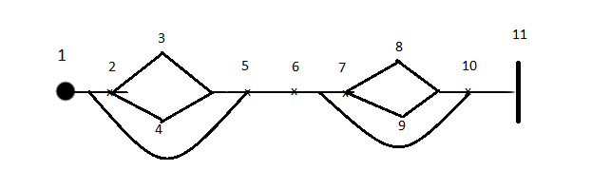
Tag | Responsibility
1 | The dwelling and sound chit placement view is displayed
2 | Host chooses a clearing, to place the current item, from the location combo box
3 | Host presses the set button to place the item
4 | Host presses the randomize button to place the item
5 | Steps 2 through 4 are repeated until all of the available items are placed
6 | The environment chit placement view is displayed
7 | Host chooses a tile, to place the current item, from the location combo box
8 | Host presses the set button to place the item
9 | Host presses the randomize button to place the item
10 | Steps 6 and 7 are repeated until all of the available items are placed
11 | A game has been set up using cheat mode and is under way

UC-10
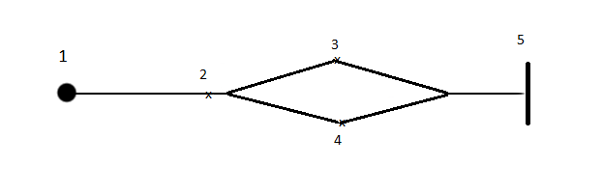

Tag | Responsibility
1 | The cheat mode roll view has opens for the user
2 | User enters an integer, into the input field, that is between 1 and the highest possible roll value that is shown.
3 | User presses the OK button and sets the roll to the desired value
4 | User presses the Randomize button and randomizes the dice roll
5 | The roll has been set to the desired value or has been randomized

UC-11
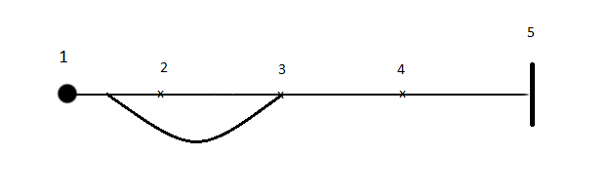
Tag | Responsibility
1 | Victory points selection view is displayed
2 | User selects how many victory points they would like to assign to the first category (gold) using the combo box
3 | Step 2 is repeated for each following category untill exactly 5 victory points have been assigned
4 | User presses the set button
5 | A player has set his or her victory conditions and that player has been added to the gamw

UC-12
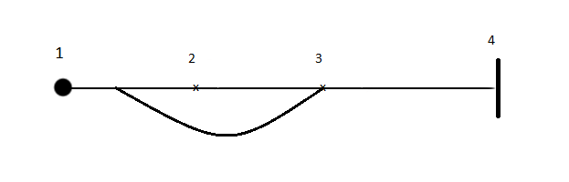
Tag | Responsibility
1 | The character placement view is dispalyed for the first character
2 | Host chooses which of the available dwellings that character will start on
3 | Step 1 and 2 are repeated until all of the players whos class is dwarf or captain has had their starting location chosen
4 | One of more players have had their starting location chosen and the game starts

UC-13
Tag | Responsibility
1 | A User has satisfied all of their victory points this turn
2 | That user send their turn
3 | A dialog is displayed to all clients that tells them who has won the game
4 | The game has ended and someone has won

UC-14
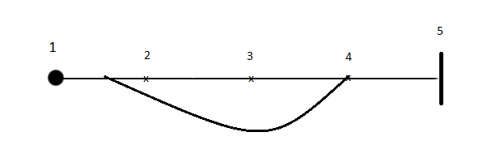

Tag | Responsibility
1 | The turn selection view is displayed to the a user who is playing the swordsman
2 | That user selects when he/she would like to play their turn, from the dropdown box available
3 | User presses the OK button to commit their decision
4 | Steps 2 and 3 are repeated until all users who are playing the swordsman have chosen when they want to play
5 | The swordsmen have decided when they would like to take their turn this day

UC-15

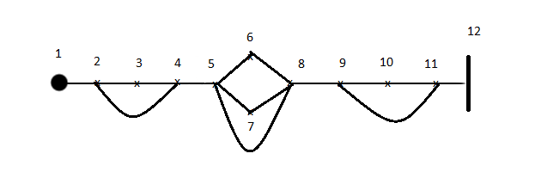

Tag | Responsibility
1 | The RestView is displayed for the user
2 | User clicks on a chit that he/she would like to move from the active list to the fatigued list
3 | User presses the 'Move Right' button to move the chit
4 | Steps 2 and 3 are repeated until the user has moved all chits from the active state to the fatigued state that they wanted to
5 | User clicks on a chit that he/she would like to move from the fatigued list to the wounded list or the active list
6 | User presses the 'Move Right' button to move the chit to the wounded list
7 | User presses the 'Move Left' button to move that chit to the active list
8 | Steps 5 through 7 are repeated until the user has moved all chits from the active state to the fatigued state that they wanted to
9 | User clicks on a chit that he/she would like to move from the wounded list to the fatigued list
10 | User presses the 'Move Left' button to move the chit
11 | Steps 9 and 10 are repeated until the user has moved all chits from the active state to the fatigued state that they wanted to
12 | The user has rested and moved each chit to the location they would like to

UC-16

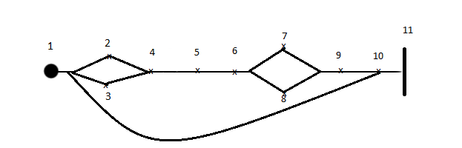

Tag | Responsibility
1 | Monster combat view is displayed to the user
2 | User decides whether or not he/she would like to alert their weapon
3 | User selects which monster he/she would like to attack
4 | User selects which attack he/she would like to use
5 | User selects which shield he/she would like to use
6 | User selects which maneuver he/she would like to use
7 | User presses the attack current monster button
8 | User presses the run button
9 | User presses the Start combat button and the damage that round is calculated
10 | Steps 2 through 9 are repeated until the user is dead, the monster is dead, or the user has successfully run
11 | User has completed combat with one or more monsters

Section 5: Functionality Documentation
Section 5.1: Design Decisions
Section: UI and data representation display
Pattern Used: MVC Pattern
Reason: We decided to use the MVC structural pattern as a basis for the representing the user interface to the players of the game. The pattern made it relatively easy to take the logic of the game and display it within the view. The pattern also made it extremely easy to manipulate the models representing the data after an user triggered and representing the change within the user interface.

Section: Networking Data Handling
Pattern Used: Variant Of The Mediator Pattern
Reason: We decided to use a variant of the mediator pattern in order to implement the networking aspect of the project. The reason for using the pattern was that it provided an effective way to take the data sent by the object streams, and call specific methods with the GameView.java class. This patten can be seen in use mainly within the ServerReadThread class. When an object sent from the client, is then read by the ServerReadThread, and then the data received mediated by the reader thread and passed into a method for the corresponding container object that is then used to update the current state of the game on receiving end of the message.

Section: Message Transmission Between Server And Client
Pattern Used: Composite Pattern
The composite pattern is also used in our networking and message transmission, and it is mainly used within the ServerMainThread class. Within ServerMainThread there is a collection of ServerReadThread that stored. These ServerReadThreads each represent a thread that is used to read incoming messages that received by the client. By using this pattern we were able to produce a server object that sends messages to every single client when a message is sent out from the server, that also is able to send messages out to every other client when a new message is received.

Section: Chit Production
Pattern Used: Simplified Factory Pattern
For the chit production our group decided to use a simplified version of the factory pattern. When chits are needed throughout the course of the game, the ChitFactory class is used to produce the chits needed for situation that need them. The reason we chose to use this pattern was because it provided a way to easily create a set of chits that have a predetermined set of values. This pattern also made it extremely easy to produce the same sets of chits in many different sections of the code.

Section 5.2: Overview Of Architecture
In this section we will be outlining some of the major classes that are used within code base, as well as some of the major packages that used within code.

Class: Clearing.java
This class contains all of the functionality and data needed for behaviour that relates to the clearings that are displayed on the board for the game. This means that each clearing as a sound chit, a warning chit, a tile object, a list of monsters and a list of players that are currently present on the clearing. It also contains methods for displaying one or more images on the clearing, and there is also methods that check to see if the player can move to this clearing when they are submitting their movement actions. Finally this class contains the behaviour for what happens when a player searches the clearing during a search aciton.

Class: PlayerBase.java
This class contains all of information that relates to the individual player objects within the game. Within this class there are collections for the ActionChits that are assigned to the player's current class, as well as the list of armour chits that the player has in their inventory. Also included within the class are methods that contain the proper behaviour and checks that are needed when the player commits an action to the game.

Class: MonsterBase.java
This is the base class to represent all of the monsters that are within the game. Within this class there is a value that is the monster's current clearing, and there is also an image variable that represents the image to be displayed on the clearing the monster is present on.

Class: CombatPVPHandler.java
This class holds all of the relative data for carrying out combat, and is created whenever a PvP combat window is created during the course of the game. It majorly used to carry out the entire combat process between one more players. Contained within the class are a series of methods that calculate weapon harm levels, whither or not a player hits an opponents armour, and whether or not the player evades the opposing attack.

Class: BoardView.java
This is the class that contains all of the clearings and monsters within the game. It is also the class that user interacts when they moving characters, and observing what objects are currently on the board. This class contains the clearings, monsters and tiles that relate to the entire board, and it also contains the methods for placing entities such as dwellings, and monsters.

Package: Sendables
The sendables package contains the different objects that are sent across a network when a client or a server commits an action while the game. Depending on the type of action that is committed by the player, a corresponding is sent across the network, where it is receive thread, and processed based on the type of object that is received. These objects unfortunately embrace the poltergeist anti-pattern as objects that are created are created moments before they are sent across the network, and are immediately destroyed after they have been sent.

Section 5.3: Functionality Of The Server And The Client
Throughout out the designing the server and the client interfaces for the game, we decided implement the server and the client as their own games that are synchronized to one central server that clients can join to. So the client and server are really both the same application, the only difference is that the server broadcasts any changes that are made to each client connected, and the clients send a message to the server, which is then that is broadcasted to each other client, in order to ensure the boards are synchronized throughout the course of a game.

This style of implementation uses a series of threads in order to provide the ability to both read and write objects across a networked setting with relative ease. The reason that multiple threads were used for sending was because readObject() is a blocking call in Java, and it made the thread wait until an object was received. So we split the networking into both a reader and a writer thread, so we could have the ability to both read and write messages at any given time. Also by using this implementation of we were able to use to use the same functions, objects and methods that were previously defined during iteration 1 of the project, thus reducing code duplication to a minimum.

The server and client applications work in a relatively simple manner. During the course of the game, players will interact with the application, and if the game is a networked game, a update message will be sent. If the game is a server, the message is broadcasted to every single client, where is then processed by the ClientReadThread, and changes are made to the game depending on what type of object was sent across the network. If the game is a client, the message is sent to the server, where is handled by the ServerReadThread, and then the message is delegated to ServerMainThread where it is then broadcasted to the other clients that are connected to the server.

