Hackday Showcase Template

Team ID:  (see Hackday Team Register) | TE18
Team Name: | BigBrother
Team Members: | Mitchell Dale, Fernando da Cunha Alves
Tools Used: | Github Copilot, Copilot CLI, JIRA
JIRA ticket (if applicable): | N/A
GitHub Repo (if applicable): | https://github.com/mitchjdale/BigBrother

The Problem
Modern feature development follows a repetitive, manual loop. Today a developer typically:
1. Checks out a new branch for a ticket.
2. Starts prompting an AI agent to generate a plan of attack for the issue.
3. Iterates on that plan until satisfied.
4. Executes the plan to implement the code.
5. Validates the implementation by testing.
This cycle repeats in circles, with human intervention growing as the ticket gets more challenging. Each ticket ties up a local working copy, branch, and the developer's full attention; so, tickets are worked serially, and the overhead of branch juggling and rebuilding code context makes it hard to run several in parallel. When a developer already knows how a ticket should be done, most of this loop is wasted time spent steering the tooling rather than delivering.

The Solution

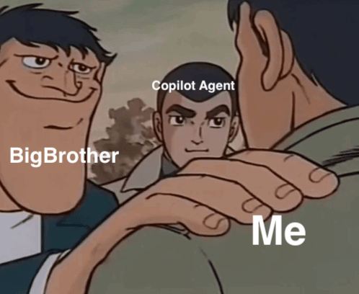
BigBrother is an AI implementation-planning dashboard that collapses this loop into a few button clicks and makes it trivially parallel. A developer runs BigBrother, sees their tickets (from GitHub Issues or JIRA) on the Dashboard, and:
• Presses Create plan — a read-only Copilot CLI agent clones the real codebase and produces an implementation plan asynchronously. It physically cannot modify code ( write / commit / push denied), so a human always reviews before anything is written. The token / AI-Unit cost of every plan is tracked.
• Reviews the plan — if it matches what they already expected, they approve immediately; otherwise they edit inline or Regenerate with feedback, with full version history.
• Presses Execute — the Copilot cloud agent implements the approved plan and opens a draft pull request, linked back on the dashboard.
Crucially, planning is decoupled from execution, and everything runs server-side in isolated clones. The developer never manages branches or reconstructs code context locally, and multiple tickets can be planned and executed concurrently. If the plan matches the developer's expectation, the whole "branch → prompt → plan → execute → test" cycle becomes a short, reviewable, parallel workflow.
Also provides a price estimation based on token usage to help developers track their footprint.

Impact & Next Steps
Impact:
BigBrother optimises a developer's time by removing the manual, serial overhead of feature work. Well-understood tickets can be planned, approved, and turned into draft PRs in a handful of clicks, freeing developers to run many issues in parallel and focus their judgement on reviewing plans rather than driving tooling. The human stays in the loop for safety, and per-plan cost tracking gives a clear business case for AI spend.
What needs to happen next:
- Playwright screenshots of the implemented feature, embedded in the draft PR to give reviewers more confidence the change works.
- Code conflict resolution, since heavy parallel work across tickets will inevitably collide.
- Customisable planning/implementation prompts, so project-specific rules and conventions are consistently applied.
- Live deployment on a shared database, so every developer on a project can revisit past issues, review the implementation plans, and reuse them — a powerful aid for diagnosing bugs and understanding existing solutions.
- Production hardening already scoped: BullMQ + Redis for the job queue, Postgres for durability, and pull_request webhooks for automatic PR status updates.
- Hook in implementation costs also to give a complete dollar figure to each feature from planning to completion.

