Language, Structure, and Medical Knowledge: Why Homeopathic Repertorization Remains English-Dominant in Bengali-Speaking Regions

[A Problem Analysis Paper for the challenges of repertorization in Bangla]

Author: Dr. Shahin Mahmud

Abstract
Homeopathy maintains significant institutional presence in Bangladesh, yet despite thousands of Bengali-speaking practitioners, all repertories—comprehensive reference volumes containing tens of thousands of symptom entries—remain exclusively in English. This paper examines why repertorization resists translation into Bangla, revealing an "alphabetical paradox": repertories depend on alphabetical organization for rapid clinical navigation, but translation necessarily disrupts this entire structure. Maintaining English alphabetical order renders Bangla translations functionally useless for monolingual speakers, while reorganizing by Bangla alphabet destroys international compatibility and two centuries of established navigational frameworks. Additional challenges include medical terminology gaps, regional dialect variations, and software development barriers for digital tools. English dominance thus reflects not merely historical inertia but fundamental structural incompatibility in organizing complex medical knowledge across linguistic boundaries. Viable solutions require reconceptualizing knowledge organization through semantic search technologies, conceptual categorization, or hybrid cross-lingual systems—demanding institutional support, interdisciplinary collaboration, sustained funding, and years of clinical validation.
Keywords: homeopathy, repertorization, repertorial translation, medical knowledge organization, alphabetical indexing, healthcare linguistics

1. Introduction

1.1 Background
Homeopathy occupies a significant position in Bangladesh's healthcare landscape, with thousands of registered practitioners serving millions of patients annually. The Bangladesh Homeopathic Medical Education Council oversees colleges and training institutions, producing graduates who integrate into both urban and rural healthcare systems. Yet despite this robust institutional presence and the predominance of Bangla as the native language for practitioners and patients alike, homeopathic practice operates under a peculiar linguistic constraint: all fundamental reference materials, particularly repertories, remain exclusively in English.

1.2 Understanding Repertorization
Repertorization represents the systematic methodology at the heart of homeopathic practice. When a patient presents with symptoms, the practitioner must identify the constitutional remedy by matching the complete symptom picture against thousands of documented remedy provings. This matching process relies on repertories—comprehensive reference volumes that catalog symptoms with extraordinary specificity and link each to remedies known to produce similar symptoms.
The major repertories used globally include Kent's Repertory, Morphy’s Repertory, Boger's Repertory, the Synthesis Repertory, and the Complete Repertory. These texts represent over two centuries of clinical observation and systematic documentation, examining tens of thousands of rubrics (symptom entries) organized in hierarchical structures. A single repertory may contain 50,000 or more distinct symptom descriptions, each associated with multiple remedies graded by the strength of indication.

1.3 The Language Barrier
For Bengali-speaking practitioners, this English-only landscape creates substantial challenges. Practitioners must navigate complex medical terminology in a non-native language, accurately interpret nuanced symptom descriptions, and perform rapid cross-referencing during clinical consultations. Students learning homeopathy face the dual burden of mastering clinical concepts while simultaneously developing English proficiency sufficient for professional practice.
The obvious solution—translating repertories into Bangla—appears straightforward. However, as this paper demonstrates, the challenge extends far beyond simple linguistic conversion. The fundamental organizational structure of repertories proves incompatible with translation in ways that question whether meaningful vernacular versions are achievable without radical reconceptualization of how medical knowledge is organized and accessed.

2. The Alphabetical Paradox: A Structural Impossibility

2.1 The Foundation of Repertory Organization
All major homeopathic repertories share a common organizational principle: alphabetical ordering. Symptoms are categorized first by broad anatomical or psychological categories (Abdomen, Head, Mind, Extremities, etc.), then within each category, symptoms are listed alphabetically. This alphabetical structure serves multiple critical functions that have made it indispensable to clinical practice. First, it enables rapid location of specific symptoms during the time-pressured environment of clinical consultations, where practitioners must quickly navigate through thousands of potential rubrics while the patient waits. Second, this universal ordering provides standardization that enables consistent teaching and communication across institutions and generations of practitioners. Third, the predictable alphabetical navigation allows for systematic cross-referencing, so that related symptoms can be methodically explored and compared during case analysis. Finally, this shared organizational framework creates international compatibility, allowing practitioners worldwide to reference the same rubric locations when discussing cases, publishing research, or consulting educational materials.

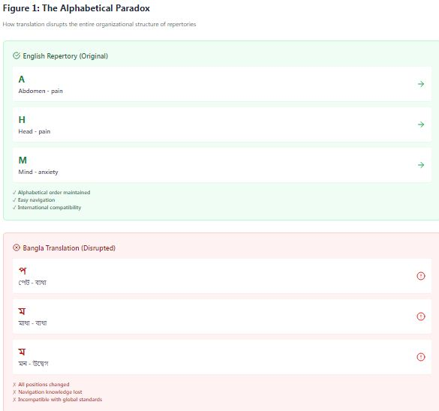

2.2 The Translation Disruption
The problem emerges when symptoms are translated from English to Bangla. Consider a simple example: the rubric "Head - pain" appears under "H" in English repertories. When translated to Bangla as "মাথা - ব্যথা," this rubric must now appear under "ম" (ma) in a Bangla alphabetical system. Similarly, "Abdomen - pain" moves from "A" to "প" (pa) when translated as "পেট - ব্যথা."
This is not merely a minor reorganization. Virtually every rubric in the repertory shifts to a new location. The entire organizational structure—carefully developed over 200 years and memorized through clinical practice—becomes completely disrupted. Practitioners familiar with English repertories cannot transfer their navigational knowledge to Bangla versions. The mental map built through years of practice becomes useless.

2.3 The Impossible Choice
This creates a fundamental dilemma with no satisfactory resolution:
Option 1: Maintain English Alphabetical Order
If a Bangla translation preserves the original English alphabetical sequence, practitioners must still search using English terms to locate rubrics. For example, to find "মাথা - ব্যথা" (Head - pain), one must search under "H" rather than "ম." This renders the translation essentially meaningless—practitioners still need English proficiency to navigate the text. The Bangla becomes merely a translated label rather than a functional tool for monolingual Bengali speakers.
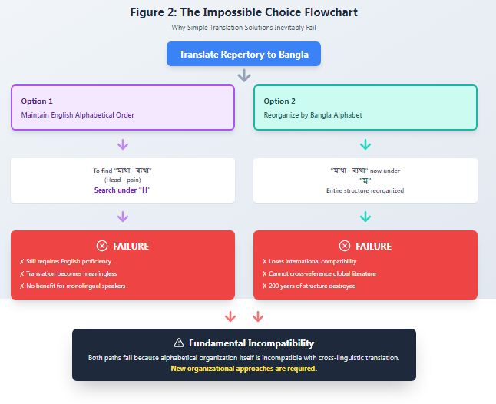
Option 2: Reorganize by Bangla Alphabet
If the repertory is reorganized alphabetically according to Bangla conventions, the entire structure becomes incompatible with international standards. Practitioners cannot cross-reference with original texts, cannot follow case analyses published in international literature, and cannot access the broader global knowledge base. The carefully structured relationships between symptoms—often referenced by their traditional locations—become impossible to maintain. Educational materials, software tools, and clinical literature all become incompatible.

2.4 Why This Matters
This is not a mere organizational inconvenience. The alphabetical structure represents the fundamental indexing system through which practitioners access clinical knowledge under time pressure. During patient consultations, rapid symptom lookup is essential. The disruption of this structure fundamentally undermines the usability of the repertory as a clinical tool.
Moreover, this challenge is unique to repertories specifically because of their massive scale and detailed hierarchical organization. Simple medical dictionaries or materia medica texts can be translated more successfully because they don't rely as heavily on rapid alphabetical navigation of such vast symptom databases during active clinical use.

3. Linguistic Barriers Beyond Structure

3.1 Medical Terminology Gaps
Even setting aside the alphabetical challenge, homeopathic terminology presents substantial translation difficulties rooted in the specialized evolution of clinical language. Many technical terms lack precise Bangla equivalents, and the challenge deepens when considering how word meanings shift across practical and theoretical contexts. Consider the terms "amelioration" and "aggravation," which describe how symptoms improve or worsen under specific conditions. While Bangla possesses common words for "better" (ভালো) and "worse" (খারাপ), these everyday terms cannot capture the technical homeopathic meaning that carries specific implications for remedy selection. In theoretical homeopathic texts, these terms denote systematic patterns of symptom behavior, while in practical clinical application, they guide the practitioner's questioning strategy and remedy differentiation—nuances that simple Bangla equivalents fail to preserve across both contexts.
Similarly, the term "modalities" refers to factors that modify symptoms such as time, temperature, position, and circumstance. This encompasses a specific clinical concept that functions differently when discussed in educational settings versus when applied during patient examination. The word meaning becomes different in different practical and theoretical contexts—in the classroom, modalities represent a taxonomic category for organizing symptom knowledge, while at the bedside, they become dynamic investigative tools for eliciting precise symptom pictures. Bangla lacks a single term that preserves this conceptual flexibility across contexts.
The challenge extends to symptom descriptors themselves. English repertories employ precise terms like "tearing," "stitching," "burning," and "pressing" to characterize pain qualities. While Bangla certainly has pain descriptors, they don't map one-to-one with homeopathic technical usage, where specific English terms correspond to specific remedy indications developed through centuries of provings and clinical verification. A "stitching" pain in homeopathic parlance carries theoretical associations with particular remedy families in materia medica study, yet in practical case-taking, the same term guides specific questioning techniques to differentiate between similar remedies. This dual functionality—operating simultaneously as theoretical category and practical diagnostic tool—makes translation particularly treacherous, as the word meaning becomes different in different practical and theoretical contexts, and any Bangla equivalent must somehow preserve both dimensions of clinical utility.

3.2 Standardization Challenges
Translation introduces dangerous variability. Different translators might render the same symptom differently, creating inconsistencies that could lead to incorrect remedy selection. For example, a symptom describing "anxiety" might be translated using different Bangla terms by different translators, potentially splitting what should be a unified rubric into multiple entries or creating ambiguity about which rubric to consult.
Achieving consensus on terminology requires extensive collaboration among expert homeopaths, linguists, and clinicians—a resource-intensive process requiring institutional coordination that has not yet materialized.

3.3 Nuance and Clinical Precision
Homeopathic symptom descriptions often rely on subtle distinctions. A headache might be "throbbing" versus "hammering" versus "bursting"—distinctions that guide remedy differentiation. Translation risks losing these nuances or introducing unintended connotations. Since remedy selection depends on precise symptom matching, even small translation inaccuracies can have clinical consequences.

4. Technical and Software Challenges

4.1 Database Architecture

Modern repertorization increasingly relies on software tools like RADAR, MacRepertory, and Complete Repertory software, which have transformed clinical practice by enabling rapid multi-symptom analysis and complex case management. Creating Bangla versions of these sophisticated systems presents challenges that extend far beyond simple interface translation. The first requirement involves complete database translation, which means converting tens of thousands of rubrics while maintaining rigorous internal consistency across the entire knowledge base—a single terminological inconsistency could lead practitioners to miss critical remedy indications or create false symptom associations. The second technical hurdle centers on Bangla script integration, requiring developers to ensure proper Unicode support, flawless font rendering, and intuitive text input methods that function reliably across diverse devices and operating systems, from desktop computers in urban clinics to mobile devices in rural practice settings. The third and perhaps most complex requirement involves search algorithm modification, necessitating the development of sophisticated search capabilities specifically designed for Bangla language processing. Unlike English, Bangla presents unique computational challenges including the handling of compound words that form through complex morphological rules, the recognition of regional synonyms that vary across Bangladesh and West Bengal, and the accommodation of dialectical variations that affect how patients describe their symptoms in different geographic and socioeconomic contexts.

4.2 The Search Problem

Computerized repertorization depends heavily on search functionality, where practitioners must rapidly locate symptoms by entering partial descriptions or keywords during active patient consultations. English search algorithms have benefited from decades of refinement and optimization, but Bangla presents unique challenges that resist straightforward adaptation of existing technologies. The structure of compound word formation in Bangla differs substantially from English, with multiple root words combining through complex morphological rules that alter meanings in ways English search systems cannot anticipate. A search algorithm must recognize that a patient describing "মাথাব্যথা" (headache as one compound word) may use different word combinations than what appears in the repertory, which might list it as "মাথা ব্যথা" (head pain as separate words) or various other legitimate constructions. Dialectical variations compound this complexity, as Bengali-speaking regions spanning Bangladesh, West Bengal, Tripura, and diaspora communities employ different vocabulary and pronunciation patterns for identical symptoms—what one patient calls "পেটের গোলমাল" another might describe as "উদরের অসুবিধা," both referring to abdominal complaints but requiring the search system to recognize their equivalence. Effective synonym handling therefore requires building language-specific databases that capture not merely direct translations but the rich variation in how patients across different regions, educational backgrounds, and age groups articulate their suffering. Beyond these linguistic complexities, the Bangla script itself requires different character encoding and rendering systems than Latin alphabets, introducing technical challenges in how text is stored, indexed, and displayed across platforms. Creating effective search functionality that addresses all these dimensions requires significant software development expertise combined with deep linguistic knowledge of Bangla's structure, regional variations, and clinical usage patterns—a rare combination of skills that exists at the intersection of computer science, linguistics, and homeopathic medicine, and which has not yet been assembled for this specific purpose.

4.3 Hierarchical Structure Preservation
Repertories contain complex hierarchical relationships that extend far beyond simple lists of symptoms and remedies. The architecture begins with main categories such as Head, Abdomen, Mind, and Extremities, each containing hundreds of sub-rubrics with increasingly specific symptom descriptions that branch into finer distinctions—a headache rubric might subdivide into location-specific entries (frontal, occipital, temporal), which further divide by character (throbbing, pressing, burning), which may further specify modifying factors (worse from motion, better from pressure).
Throughout this elaborate structure, cross-references link related symptoms across different sections, allowing practitioners to follow symptom patterns that span multiple body systems or mental states—for instance, a headache entry might cross-reference anxiety symptoms, digestive complaints, or menstrual irregularities that commonly appear together in certain remedy pictures. Additionally, remedy gradation systems use typographical conventions such as bold typeface for strongly indicated remedies, italic for moderate indications, and plain text for weaker associations, creating a visual hierarchy that guides clinical decision-making at a glance. When the fundamental alphabetical organization is disrupted through translation, maintaining these extraordinarily complex interconnected relationships while ensuring accurate remedy listings becomes a challenge that multiplies with every layer of the hierarchy. The software must preserve precise clinical meaning while operating in an entirely reorganized informational architecture where the familiar structural landmarks have shifted, cross-references point to relocated destinations, and the intuitive navigation patterns developed through years of English-language practice no longer apply.

5. Practical Implementation Barriers

5.1 Resource Constraints

Developing a comprehensive, clinically validated Bangla repertory requires an extraordinary convergence of specialized expertise and sustained resources that has yet to materialize. The project would demand expert homeopaths who possess not only clinical mastery but genuine fluency in both English and Bangla, capable of navigating the subtle distinctions in symptom terminology across both linguistic frameworks. These clinical experts would need to work alongside professional translators who bring specialized medical terminology expertise rather than general language skills, understanding how technical terms function differently in educational versus clinical contexts.

The translation team would then need to collaborate closely with software developers possessing specific healthcare informatics experience, who understand both the technical requirements of medical database architecture and the unique demands of clinical workflow optimization. Beyond this rare combination of human expertise, the endeavor requires significant financial investment to sustain multi-year development cycles, including iterative testing, refinement, and validation phases that cannot be rushed without compromising clinical safety. Perhaps most critically, the project demands institutional support from organizations like the Bangladesh Homeopathic Medical Education Council to provide legitimacy, coordination, and ongoing resources for validation and standardization efforts that would need to continue long after initial development.

These diverse resources—clinical expertise, linguistic specialization, technical capability, financial backing, and institutional commitment—have not been mobilized in any coordinated way across Bengali-speaking regions. This absence of coordinated effort stems partly from the inherent difficulty of assembling such varied expertise, but perhaps more fundamentally because the structural challenges outlined in this paper make the outcome's practical utility uncertain, creating a chicken-and-egg problem where investment is hindered by uncertainty about whether a truly functional solution is even achievable given the alphabetical paradox and other fundamental barriers.

5.2 Educational and Professional Training
Homeopathic education in Bangladesh, while conducted locally, relies heavily on English-language source materials. International repertories serve as standard references. Textbooks, case studies, and research literature overwhelmingly exist in English. Even if Bangla repertories existed, practitioners would still need English proficiency to engage with the broader knowledge base.
This creates a circular challenge: without Bangla materials, English remains necessary; but investment in Bangla materials is hindered because English competency is already required for professional advancement.

5.3 The Challenge of Clinical Validation
The translation of a homeopathic repertory into Bengali represents only the beginning of a complex journey. Before such a tool could be responsibly used in clinical practice, it would demand a rigorous, multifaceted validation process that extends far beyond linguistic accuracy.
At the heart of this challenge lies the question of clinical fidelity. Each symptom description must be carefully examined to ensure it genuinely reflects how patients present in Bengali clinical contexts. Language carries cultural nuances—the way a Bengali-speaking patient describes pain, expresses emotional distress, or articulates physical sensations may differ subtly but significantly from descriptions rooted in Western medical traditions. A translated repertory must bridge not just languages, but clinical realities.
Equally critical is verifying the integrity of remedy-symptom associations. Every remedy recommendation must be traced back through the translation to confirm that no connections were distorted or lost. A single misalignment could cascade through clinical use, leading practitioners toward inappropriate prescriptions.
The translation process itself, however meticulous, carries inherent risks. Systematic errors—perhaps stemming from consistent mistranslation of particular terms, or from subtle shifts in meaning across the entire text—could weave through the repertory like invisible threads. Identifying and correcting such patterns requires comprehensive testing that goes beyond spot-checking individual entries.
Perhaps most demanding is the requirement for broad clinical reliability. A repertory must function accurately across the full spectrum of cases a practitioner encounters: acute and chronic conditions, simple and complex presentations, patients of different ages and backgrounds. This diversity demands validation across equally diverse clinical scenarios.
This validation process cannot be rushed. It would require years of systematic clinical testing with large, representative patient populations. Practitioners would need to use the translated repertory alongside established tools, documenting outcomes, identifying discrepancies, and gradually building confidence—or revealing problems—through accumulated evidence. Only through this patient, resource-intensive process could the medical community determine whether a translated repertory truly serves the needs of Bengali-speaking patients and practitioners.

6. Why English Dominance Persists

6.1 Historical Momentum
Over 200 years of homeopathic literature and clinical experience have been documented in English. This represents an enormous investment of intellectual effort that creates strong path dependence. The accumulated knowledge, standardized terminology, and established organizational systems create powerful incentives to maintain English as the lingua franca of homeopathic practice.

6.2 International Standardization
Homeopathy is practiced globally, with significant communities in Europe, North America, South Asia, and Latin America. English serves as the common language enabling international collaboration, research publication, and knowledge exchange. A practitioner in Bangladesh can communicate with colleagues in Germany, India, or Brazil using standardized English terminology and repertory references.
This network effect creates value beyond simple linguistic convenience—it enables participation in a global professional community.

6.3 The Structural Incompatibility
Perhaps most fundamentally, the alphabetical paradox reveals that English dominance is not merely historical accident or colonial legacy. The organizational structure of medical knowledge itself proves resistant to simple translation across scripts. This suggests that overcoming language barriers in homeopathic practice may require not just translation, but fundamental reconceptualization of how symptom knowledge is organized and accessed.

7. Charting a Path Forward
7.1 Alternative Organizational Systems
The alphabetical paradox that haunts repertory translation doesn't signal an insurmountable barrier—rather, it illuminates the need for fundamental reimagining. Solutions cannot simply transplant Western organizational logic into Bengali linguistic soil; they must cultivate entirely new approaches that transcend the limitations of alphabetical ordering.
One promising avenue lies in conceptual categorization. Instead of forcing symptoms into the rigid march of alphabetical sequence, this approach groups them by their underlying meanings and relationships. Symptoms of anxiety, for instance, might cluster together regardless of whether they begin with different letters or sounds. This method mirrors how clinicians actually think—not alphabetically, but associatively, moving from concept to related concept as they build a picture of their patient's condition.
Symptom-type hierarchies offer another path, organizing the repertory by the intrinsic characteristics of symptoms themselves rather than the accidents of language. Physical sensations might be grouped by location, quality, or timing; emotional states by their intensity or triggers. Such structures exist independent of whether one is working in English, Bengali, or any other tongue, creating an organizational framework that translates more cleanly across linguistic boundaries.
The digital age presents particularly fertile ground through digital-first approaches. Modern search algorithms can liberate practitioners from alphabetical navigation entirely. A digital repertory could allow practitioners to search by multiple criteria simultaneously—typing partial descriptions, selecting from categorical filters, or even using voice input in their natural language. The computer's ability to cross-reference and retrieve information renders alphabetical ordering nearly obsolete, though this requires reimagining the repertory not as a bound book but as an interactive database.
Perhaps most pragmatic are hybrid systems that acknowledge the reality of working across languages. These maintain parallel structures in both English and Bengali, with sophisticated cross-referencing that allows practitioners to move fluidly between linguistic frameworks. A symptom might appear in Bengali alphabetical order while simultaneously linking to its English counterpart and to conceptually related symptoms in both languages. Such systems demand greater complexity in design but offer flexibility in practice.
Each of these alternatives shares a common recognition: the future of repertory organization lies not in perfecting translation within old constraints, but in building new structures that honor both linguistic diversity and clinical utility. The question is not whether there is a path forward, but which path—or combination of paths—the homeopathic community will choose to walk.

7.2 Technology-Enabled Solutions
As the limitations of traditional translation approaches become increasingly apparent, artificial intelligence emerges not merely as a tool but as a potential paradigm shift in how we might bridge linguistic divides in homeopathic practice.
At the forefront stands natural language processing tailored specifically for Bangla. Unlike simple translation engines, sophisticated NLP systems can parse the nuances of how Bengali-speaking patients actually describe their symptoms—the particular phrases they use, the grammatical structures that carry meaning, the cultural contexts embedded in their language. Such systems could interpret a patient's description in natural Bengali and connect it to the appropriate repertory entries without forcing either the patient's words or the repertory's structure into unnatural configurations.
Semantic search represents an even deeper intelligence. Rather than matching words mechanically, these systems grasp clinical meaning—understanding that a patient describing "মনে হয় বুকে পাথর চাপা" (feeling like a stone pressing on the chest) is expressing something clinically similar to English descriptions of chest oppression, even when no words directly correspond. This technology looks beyond surface vocabulary to the underlying symptom experiences themselves, creating bridges of meaning that transcend literal translation.

Figure 3: Stakeholder Ecosystem Map
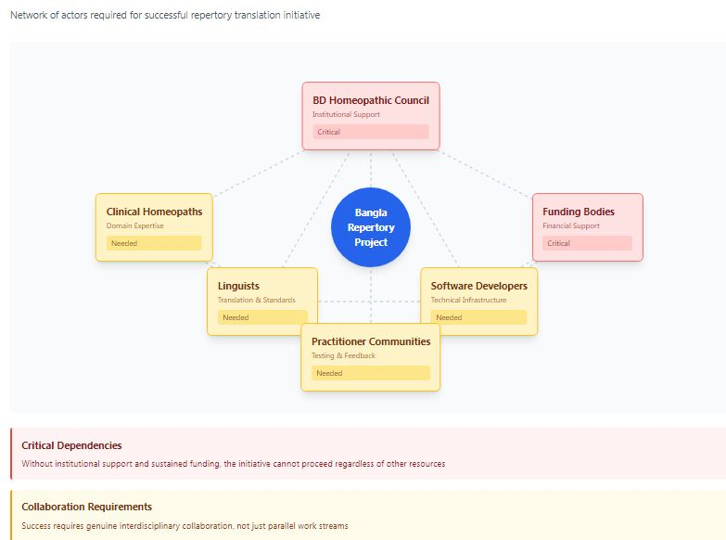
The reality of linguistic diversity within Bengali itself—spanning regional dialects, generational variations, and individual expression—demands machine learning systems sophisticated enough to handle this complexity. These systems can learn to recognize that multiple phrasings, synonyms, and dialectical variations all point toward the same clinical phenomenon. Where a human translator might struggle to anticipate every possible way a symptom could be expressed, machine learning can continuously evolve its understanding through exposure to actual clinical language use.
Perhaps most crucial are cross-lingual alignment systems that preserve the hard-won connections to the extensive English knowledge base. Rather than attempting to recreate centuries of homeopathic literature in Bengali isolation, these systems maintain living links between languages—allowing practitioners to leverage the depth of English repertories and materia medicas while working primarily in Bengali. The system becomes a bridge rather than a replacement, honoring both linguistic authenticity and accumulated clinical wisdom.
Yet these technological promises carry their own uncertainties. They require substantial development resources, ongoing refinement through clinical use, and the delicate balance of algorithmic precision with human judgment. The question is not whether AI offers solutions, but whether the homeopathic community can marshal the resources and expertise to develop these tools—and whether, once developed, they can truly serve the nuanced demands of clinical practice.

7.3 Institutional Requirements
The path forward, however promising in theory, cannot materialize through individual effort or institutional goodwill alone. It demands a coordinated architecture of support, expertise, and resources—a constellation of actors working in sustained concert toward a shared vision.
Central to any viable initiative stands the Bangladesh Homeopathic Medical Education Council. Without the backing of this governing body, even the most sophisticated translation or technological solution risks remaining marginal—used by enthusiasts perhaps, but never achieving the legitimacy and widespread adoption necessary for genuine impact. The Council's support provides not just official sanction but the institutional framework within which standards can be set, curricula adapted, and new tools integrated into the fabric of homeopathic education and practice across Bangladesh.
Yet institutional endorsement alone cannot bridge the technical and linguistic chasms at hand. Success requires collaborative initiatives that bring together disparate forms of expertise: linguists who understand Bengali's grammatical structures and semantic nuances, homeopaths who grasp the clinical realities of symptom presentation and remedy selection, and software developers capable of building the technological infrastructure these ambitions demand. Each group speaks a different professional language, operates within different paradigms of knowledge. The challenge lies not just in assembling these experts but in creating genuine collaboration—shared understanding that transcends disciplinary boundaries.
None of this happens without money, and not just initial seed funding but sustained financial commitment stretching across years. Development cannot be rushed; validation cannot be shortcut. Technology must be built, tested, refined, and rebuilt. Clinical trials must enroll patients, gather data, analyze outcomes. Linguistic standards must be debated, revised, and eventually codified. This timeline measures not in months but in years, perhaps a decade or more, and funding must flow consistently throughout.
Before any system reaches widespread implementation, it must prove itself through pilot testing programs designed with scientific rigor. Small-scale trials in diverse clinical settings—urban and rural, treating various patient populations and condition types—must systematically evaluate whether the tools actually work. Do practitioners find them clinically useful? Do patient outcomes improve? What problems emerge in real-world use? Only through honest evaluation, with mechanisms to capture both successes and failures, can the homeopathic community make informed decisions about broader adoption.
Perhaps most delicate of all is the consensus-building required for terminology standardization. Homeopaths across Bangladesh likely use varied terms for the same symptoms, influenced by regional dialects, training backgrounds, and personal practice styles. Creating standardized Bengali medical terminology means negotiating these differences, building agreement among practitioners who may have strong attachments to their existing vocabulary. This is fundamentally political work—requiring diplomatic skill, patience, and processes that allow diverse voices to be heard while ultimately moving toward workable consensus.
These requirements interlock and reinforce one another. Institutional support facilitates funding; funding enables collaboration; collaboration produces tools that can be pilot tested; pilot results inform consensus-building; and consensus strengthens institutional commitment. Yet any weak link threatens the entire chain. The question facing the homeopathic community in Bangladesh is whether the collective will exists to forge and maintain these connections over the long journey ahead.

8. Implications and Conclusion
This analysis reveals that the challenge of homeopathic repertorization in Bangla extends far beyond simple translation. The alphabetical paradox—where preserving either linguistic accessibility or structural utility requires sacrificing the other—represents a fundamental incompatibility between how medical knowledge is organized in English-language repertories and the requirements of cross-linguistic accessibility.
For Bengali-speaking practitioners, this means continuing linguistic burden, educational challenges, and barriers to full professional participation. Students must develop English proficiency not merely as an enhancement but as a prerequisite for basic clinical practice. Practitioners face cognitive load from operating in a non-native language during consultations, potentially affecting clinical efficiency and accuracy.
Yet the persistence of English dominance reflects not merely historical inertia but genuine structural challenges that resist straightforward solutions. The alphabetical organization that enables rapid clinical access to vast symptom databases proves incompatible with translation in ways that simple linguistic conversion cannot overcome.
This suggests broader implications for medical knowledge organization across linguistic boundaries. When specialized fields develop elaborate indexing and organizational systems optimized for one language, the challenge of multilingual accessibility may require not just translation but fundamental reconceptualization of knowledge architecture.
Future research should explore alternative organizational paradigms that transcend alphabetical limitations, investigate technology-enabled approaches to cross-lingual medical knowledge access, and develop hybrid systems that maintain international compatibility while enabling vernacular practice. Until such solutions emerge, homeopathic repertorization will likely remain English-dominant, regardless of practitioners' native languages—a testament to the deep structural challenges in organizing and accessing complex medical knowledge across linguistic boundaries.

References:
- Boger, C.M. (1935). Boenninghausen's Characteristics and Repertory. Parkersburg, PA: Boericke & Tafel.
- Kent, J.T. (1897). Repertory of the Homœopathic Materia Medica. Chicago: Ehrhart & Karl.
- Schroyens, F. (2009). Synthesis Repertory. London: Homeopathic Book Publishers.
- Van Zandvoort, R. (2005). The Complete Repertory. Leidschendam: Institute for Research in Homeopathic Information and Symptomatology.
- Murphy, R. (2005). Homeopathic Medical Repertory: A Modern Alphabetical and Practical Repertory. Blacksburg, VA: Lotus Health Institute.

