Analyzing the Mapping between Non-analogous Structured Inventories using Cognitive Grammar Framework
Abstract
This paper analyzes the mapping between two types of categories belonging to distinct structured inventories related within a single conception in a text; to demonstrate that mapping between two types of structured inventory does not occur between cognitively analogous structures. The relational architecture of one system affects the characteristics of the mapping asymmetrically. This paper maps interactions of scope with respect to linking structures at three schematic levels relative to the schematic levels of the decimal system through cognitive grammar (Langacker, 1987, 1990, 2006) analysis of the text Tractatus Logico-philosophicus (Wittgenstein, Pears & McGuiness (Trans.), 1921/ 2002) as primary data. This paper demonstrates that natural language categories do not interact symmetrically. Such mapping asymmetrically adheres to the relational architecture of any one structured inventory in any specific instance of posited correlation.
Keywords: Cognitive grammar, Schematicity levels, Category relations, non-analogous structured inventory, mapping

1. Introduction
Ramat (1990), defines a category as a set of objects which have common features such that some features can be shared by other categories but all features cannot be shared at the same time. Structuralists have defined the object of linguistic study to be a system and not the terms within. Ferdinand de Saussure suggested that meaning is the function of the value of the sign within a system; where the system is the object of the study of linguistics. Chomskyan approach to language separated linguistic knowledge from non linguistic knowledge; the dictionary from the encyclopedia. (Taylor, 2003, pp. 1–18) However, cognitive linguistics operates with generalization of category at a schematic level which neutralizes this contrast (Taylor, 2003, pp. 19–40). The meaning value of any category is given by the profile in relation to the conceptual base with respect to the relational organization of the specific structured inventory(Langacker, 1987, 1990, 2006).
Reasoning by analogy, as a domain general reasoning process, involves the identification of commonalities and generating inferences driven by commonalities (Gentner, 1983; Holyoak & Thagard, 1989; Hummel & Holyoak, 1997; Kokinov & French, 2003). This is supported by the ubiquitous cognitive process of standard to target comparison ( Langacker, 1987, 1990, 2006) . In the structure mapping theory, the process of comparison aims to achieve a structural alignment between two domains.(Falkenhainer, Forbus & Gentner, 1989; Gentner, 1983; Gentner & Markman, 1997).
While deductive reasoning has traditionally been regarded as a principal governed process; experiments have shown that judgments of logical validity have been influenced by domain which is categorised as specific content reasoned about, in the studies of Cheng & Holyoak, 1985; Cummins, Lubart, Alksinis, & Rist, 1991; Rips, 2001; Thompson, 1994. These studies however take into account content conceptualised outside human conception. Thus the character of participants as students of a specific university, do not factor into the structure of the conclusions about considerations of structural consistency having weight over real world plausibility. This is mapped from analogy being a domain general reasoning process(Smith & Gentner, 2010). While the cognitive routine of comparison remains independent of the specific conception; this does not apply to generalization patterns.
Set theoretic and formal logic mechanisms analyse a world or a situation as a set of entities related in a consistent manner without considering the impact of referential architecture(Lakoff & Sweetser, 1994). Thus one orange added to one orange would result quite easily at the inference of two oranges while one river added to another river would either result in one big river or two rivers depending on the conception of adding which further depends on the nature and categorization of the quantified entity and as argued in this paper; the relational architecture having greater impact in the mapping between the cardinal number quantifier and the quantified entity coded using a natural language system.
Within the canonical domain of logic and more specifically with respect to the objects of mathematical language as categories characterized by artifactual regularity and consistency; with respect to specific relations holding between premise and inference: which are determined by canonical structure and properties of the domain and a specific type of structured inventory; there exists a method to quantify the likelihood of the occurrence of an event. This method is called probability calculation. It provides a method to quantify likelihood such that there is a specific correlation established between two types of magnitude (based on quantified entity being two different types of things) along a consistent scale id est the number quantifying all possible events that can occur and the likelihood of one of them occurring such that the greater the number of possible events, the lesser becomes the likelihood of any single one of the events occurring. In the Tractatus Logico-philosophicus itself, as a seminal text in logic, Wittgenstein himself categorically states in proposition 2.012 that nothing within the canonical boundary of logic is accidental. Every possibility of a particular thing occurring in any state of affairs must be written within the thing itself (Wittgenstein, Pears & McGuiness (Trans.), 1921/ 2002, p.6). This is a defining character of the structured inventory to which this relation between premise and inference belongs as a component. However, natural language presents several alternatives to the number of all possible events, within any bounded domain, having a correlation with the likelihood of something specific occurring: because the number of possible events is not the only determining or motivating factor with respect to any particular event among them occurring unless any specific relation is categorically stated for a specific case. Thus the relation between something happening because other things are not happening is a schematic relation with respect to the natural coding system which provides elaborated alternatives to the schematic type id est different causes of an event, that is not provided by the other structured inventory. Yet questions about probability, framed through natural language are used interchangeably with an assessment about the likelihood or chance of an event occurring.
“A problem is given to three students whose chances of solving it are 1/2, 1/3 and 1/4 respectively. What is the probability that the problem will be solved?’’ (Sawaal, n.d.)
The delimitation of the boundaries of the unit itself, whether causal or the occurring event remain outside the scope of this paper. This paper will try to understand the nature of this discrepancy as a linguistic matter of the interaction between two types of structured inventory. It will demonstrate a systematic analysis of the schema and instance relation within a text, as an instance where a relation between two types of structures are established within a single conception. It will attempt a cognitive grammar analysis of relative extent of ‘scope’(langacker, 1987,1991) of linking nominals with respect to the text of Tractatus Logico-philosophicus by Ludwig Wittgenstein translated in English by Pears and McGuiness in 1961. It will examine the architecture involving addition of information within the natural language in the text with respect to addition within the categorising decimal system. Correlations between types coded in natural language are also sensitive to levels of schematicity along with change of domain. It is not analogous to the part to whole relationship of the categories of the decimal system where increment is construed differently . This has significant impact on delimitation of structures which are compared and typological considerations when there is interaction between two or more non-analogous frameworks for any specified purposes.
This paper adopts the assumptions and descriptive constructs of the cognitive grammar framework considering that no natural language description can be used without adopting any specific vantage point or shorn of prominence to any structure at the cost of others; this being the character of natural language within the adopted framework. This affects the characterization of the nature of data, the conception of category and the conception of rule when describing any particular structured inventory.

2. Literature review
2.1 Unit of structured inventory and canon may not be equivalent
In The sound pattern of English, the nature of representation is discussed. Within the structured inventory of the generative tradition, the ‘term’ grammar refers both to theory constructed by the linguist as describing the competence of the speaker and it also refers to the notion of competence itself(Chomsky, Halle, 1968/1968,p.3). Within the canon of linguistics, the Chomskyan tradition is a sub-canon. The cognitive grammar sub-canon, recognises the features of grammar within the Chomskyan tradition; as only an aspect of grammar. Andrew Carnie defines “…..the group of hypotheses that describe a language’s syntax is called grammar” (Carnie, 2021, p.6). A framework like cognitive grammar ascribes to the system three kinds of structure which is the semantic, the phonological and the symbolic and thus grammar is conceptualized as a “structured inventory” of relations, things and constructional schemas. Distinction between domains (canon, theoretical framework) may be founded upon any dimension of interest exempli gratia the formal and the functional paradigm that focuses on object of inquiry where language is conceptualized as an abstract object in the former paradigm and language is conceptualized as an instrument in the latter (Dik, 2021). Since categories are complex in nature and have elaboration and extensional relations with other categories; the notion of structured inventory should not be directly equated with the notion of a canon or specific sub canon as the embodiment of distinct or unified, divergent or analogous relational framework between items solely on the basis of some common conceptual structures exempli gratia the same phonological form.
2.2 Cognition of Structural Consistency is Independent of Real-World Plausibility Conception
In an experiment done on 19 northwestern university undergraduates, the effect of structural consistency on acceptance rates and correlation with plausibility was measured in deduction task based on analogy. It was found that ratings were higher for structurally consistent analogies regardless of how plausible or implausible the inference was outside the artifactual bounds of the linguistic structure categorized real world “plausibility”. It was also found that people were able to separate the notion of consistent structure from something being plausible in the real world especially when instructed to do so. (Smith & Gentner, 2010) Thus the process of mapping is independent of the conception of what is plausible and implausible outside linguistic systems.
2.2.1 The Cognition of canonical Linguistic Rules and Asymmetric Mapping
The difference between the correlations between entities at different schematic levels and the importance of rule cognition is demonstrated by Peter Ludlow. Ludlow( Ludlow, 2025) elaborates on the notion of a rule that is nearly always violated in practice id est the scenario where the rule is followed is the rarest scenario or the rule itself is never actualized at all. This is in exact opposition to the part of the phenomenon considered as relevant data about the regular nature of a particular system within the generative tradition. Ludlow provides an example of central embedding to explicate the issue where the sentence “The dog the cat the mouse annoyed startled barked” is hard to categorise as either unacceptable or ungrammatical. Grammar has the potential to theoretically allow sentences of infinite words beyond the capacity of either human or machine while natural language created by human beings is susceptible to specific factors like the human being losing trains of thought, sneezing, mispronouncing or pragmatic considerations could prevent a form from being applicable in a context while being grammatical and acceptable. The important question, raised by Ludlow in this context, is how this distinction is anchored to any existing system of a human being that can be empirically observed. Ludlow discusses an idea proposed by him in 2013 where rules are individual norms or the function of the psychology of the agent which may not be “consciously accessible” to them. So we do not talk about the agent knowing rules but rather “cognizing” rules. (Ludlow, 2025) This demonstrates the asymmetric mapping between two non analogous relational architectures.
2.3 One relational architecture as mapped on Different Systems
In the introduction to Periphrasis: The Role of Syntax and Morphology in Paradigms (Chumakina, 2012), Marina Chumakina discusses periphrasis as a phenomenon involving separate levels of language architecture assuming a theoretical framework based on independent principles for levels. Morphology deals with rules of inflexion or regular realizations of word forms. Syntax provides rules for phrases; not words. When semantic function of inflection is realized by a phrasal structure, a classificational complication arises due to a non analogous framework. This theoretical inadequacy is based on structural expectation feature of criterial attribute models like a complete paradigm and a gap in the system whether a paradigm is viewed as a pattern or a property or a whole system depending on the approach. In Sanskrit, it is argued, that some verb types have a periphrastic perfect form. There is no semantic coherence nor a phonological reason that categorizes these verbs. They are grouped together on the basis of one type of conjugation therefore the classification inclines towards periphrasis being a morphological phenomenon for the instance of sanskrit. In English, however it becomes a morpho-semantic phenomenon. This situation categorised as theoretical inadequacy demonstrates asymmetric mapping between two non-analogous relational architectures.
2.4 Levels within a Unit having Distinct Relational Organisation
Categorization of grammaticality and acceptability are separate within the generative canon. Two schematic levels constrain the relations between component items.
The same rules which form the first 4 sentences form the unacceptable 5th sentence
- Bill had left. It was clear.
- [That bill had left] was clear.
- It was clear [that Bill had left].
- Once that it was clear [that Bill had left], we gave up.
- Once that [that bill had left] was clear, we gave up
(Haegemann, 1991/1994,p.7)
In lexical decision tasks, participants separate “legal nonwords” from actual symbols but a correlation is found between faster access of recognized words and lexeme characterization categories like number of syllables, phonological neighbours etc (Dussias, Kroll, Fricke, & Johns, 2021).
2.4.1 Categorizing as Immanent schematic level or a completely different Type of Unit
In a study conducted by Jey Han Lau, Alexander Clark, Shalom Lappin, modelling human judgments of acceptability (Lau, Clark, Lappin, 2016); the methodological separation of the notions of competence and performance was based on output shorn of grammatical knowledge or linguistic knowledge in accordance with the assumptions of the generative tradition and production and interpretation of such outputs would embody a separate mechanism. Therefore acceptability judgement would follow from grammaticality and grammaticality would rest on theoretical competence which underlies performance phenomena.
Consistent with the modular approach; the study took account of both graded judgments and categorical judgments however insisting on a qualitative difference on the probability of a string belonging to a particular language as a grammatical string and the graded acceptability measures. Regardless of whether it is a categorical judgement or the slider scale with two extremes; the determining factors for the judgement like a high acceptability rating of 3.69 on a scale of 1-4, could possibly be attributed both to internal and external factors with respect to any relevant canon ranging from any phenomenon of the human body to contextual or even environmental factors as standard factors to even extremely non standard considerations.
This study specifically accounts for sentence length and lexical frequency. It does not however specify the relevant criteria if one had to delimit the exact set of the same. While canonical linguistic constructs for discipline specific taxonomy often overlap with respect to designation, especially within interdisciplinary and transdisciplinary approaches; modes of inference often vary greatly depending on the specific relationship between premise and inference with respect to a particular canon. If a smaller set of determining factors is taken to amount to the phenomenon at an earlier stage but at a later stage correlations amounting to the phenomenon showing less than 100 percent of times is attributed to not accounting for all relevant determining factors; then can we say that it is not the case that it is the same phenomenon that we are identifying or is it the case that the earlier stages did not include sufficient variety in the values of the determining factors that were unaccounted for in order to register their existence. A different organisation of substructures following from a different construal of the mapping process between complex categories results in the conception of completely different relational architectures.
2.4.2 Mapping affects conception of unit
In a study conducted by Andrew Peter Fleming(Fleming, 2021), he stresses the role of structural continuity in the identification of the variable. The important question is raised by Fleming as to the interpretation of the difference by the perceiver, as contrasting from what they know about the sound as part of their own system, in accordance with Rácz (2013) who also questioned about the violation of an expectation by the socially salient linguistic feature. Since the oral cavity has the structure of a continua within which sounds are made through articulation therefore reduction of the coda sound within a syllable is not a binary decision. This involves not just breaking of the sound into a feature matrix but also taking into account what happens to the feature matrix in the environment of other sounds. Thus the idea of the sociolinguistic variable as a choice between variants is problematized. It no longer remains an empirical description of the phenomena but rather a matter of methodology. Methodological assumptions as shown by Fleming when discussing a study conducted on US Spanish does affect the patterns found in the result. Whether speakers are stratified or a structural continuity is assumed where considerations, when using language, are not different for different groups but speaker data is placed in a single group.
Artifactual structural units are delimited over region in geographical space, social group markers, style variations, jargons, registers, ethnolects, identity markers etcetera. Cook and Bassetti in 2010, as noted by Dewaele (Daewaele, 2015), argue that combinations of various languages in one mind have effect “beyond the linguistic realm” such that categorization assessment by biliguals of same objects differs in two different languages. There is however no discussion about the threshold of difference that one must register for this phenomenon to show considering that language is a unit delimited over several different types of criteria.
2.5.1 Mapping of Type to Instance
Schnitzer, 1990 refers to a study presented in 1972 of a subject with mild aphasia and a subdural hematoma. A mispronunciation data is discussed. Schnitzer writes “the words in column A are represented phonetically in column B. Column C represents the corresponding phonetic forms produced by the patient” (Schnitzer, 1990, p.10) While the Aphasic’s mispronunciation is being judged by using many factors such as syllable deletion and changing consonants, vowels and stress patterns, Goodglass and Blumstein suggests sensitivity to even whether there are mental representations of phonology utilised for different tasks like reading aloud or any special purpose as against a “natural system”; the column A, boundaries, segments, stem forming augments and the concept of underlying representation itself contains as component structure generalisations over many specific factors thus being far more schematically considered for the purposes of evaluating relatively much more specific considerations. Bever and Rossenbaum in 1970 and Cruz in 1979 discussed the relative felicity of sentences with “have”.(Langacker, 1987, p.119)
2.7 Relational architecture and conception of logical entailment
Within the criterial attribute model, a term x applies if there is a number of necessary and sufficient condition for something to be x. Schematicity hierarchies and generalisations are formed in dominant traditions in logic based on this category conception. Thus the set of animals contains the set of tigers and the set of tigers contains the set of Royal Bengal Tigers. However generalisation shows another way of conceptualising containment.
Big (Royal Bengal Tiger) entails Big (Tiger) which entails big (animal).
The entailment relation only holds when the entailing and the given contain the same information. However this unspecific or the schematic as pointed out by Russell is not the same type of thing as the most specific because the schematic involves many entities in an inclusive disjunction relation. So while Big (Royal Bengal Tiger) is definitely true, Big (animal) may or may not be true depending on which entity in the type space this operator is applying to. Within the cognitive grammar canon this would be understood as a virtual entity . Both as demonstrated in figure 1 are conceivable structures of category, both exist at once within category conception but it is only the specific instance at which only one applies for two entities.
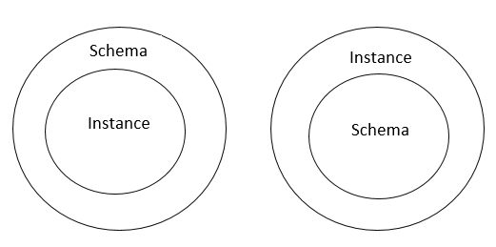 Fig.1 Types of category assessment
While if X is studying DNA, then it entails that they are studying biology but if they are studying biology it does not entail that they are studying DNA. There is a very specific directionality at this level. However if they are studying biology it does not entail that they are studying all disciplines that can be studied but if they are studying all disciplines that can be studied then it entails that they are studying biology as shown in figure 2.
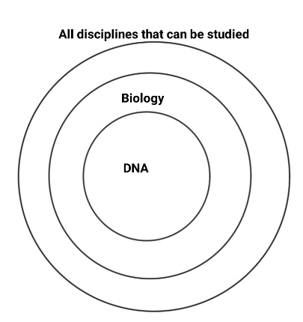Fig.2 Category relations and directionality
2.8 Conception of Code switching as mapping between Structured inventories
In code switching literature, where the notion of code is delimited by different dimensions of social criteria, and understood as a pattern through assumptions of separate levels of representation within the relational architecture of semi-autonomous syntax; the notion of frame and matrix language present a case for asymmetry in the interaction of two types of unit in contact where equivalence constraints(Poplack, 1980) may be recognised as the limiting case. (Bullock, Toribio,Serigos & Guzmán, 2021)
Within models which separate levels of representation as having distinct but connected relational architecture, the notion of L1 and L2 are conceptually separated as two units in a conception independent domain and are then found to seamlessly interact in the domain of human conception where the impact of one independent unit is assessed on another within a single form. Morford et al., 2011 presents this for the semantic level of represented, Loebell and Bock, 2003 for the syntactic level, Goldrick, Runnqvist and Costa, 2014, for the phonological level, Kroll and Gollan, 2014 for language production and Kroll and Dussias, 2012 for language comprehension. Grossjean in 1989 argued that the languages of a multilingual person are fundamentally intertwined.
3. Methodology
The unique structure of Wittgenstein’s text divides the entire text into components which are explicitly categorised. Component structures are mapped to each other with the help of nominal linking structures. The linking structure is then analysed for extension and comparison of scope using cognitive grammar framework which has a structured inventory of units informed by how human cognition works. Systemic context is assessed by restricting the scope of the text to the artifactual boundary suggested by the beginning and end of the numbering categories by the author.
4. Analysis of scope
Concentric circles are used as notation to model the comparison of scope extension of structures with respect to the common structure as the relating element in figure 4. The structure of the text is organised into seven sections where each is numbered from 1 to 7.

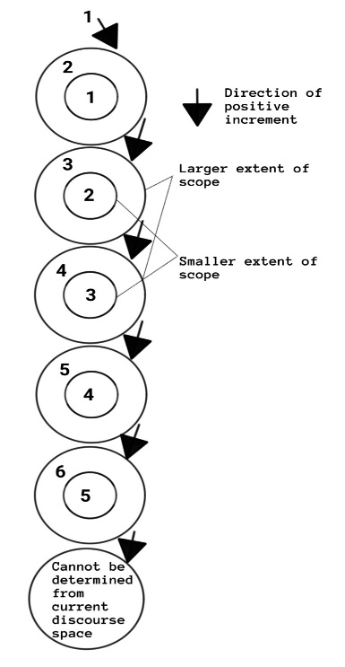
Fig.3 Relations between structures categorised by main unit space

The structure associated with 1(Wittgenstein, Pears & McGuiness (Trans.), 1921/ 2002, p.5) has the structure of a predicate nominative construction. The copula establishes identity inclusion relation between 2 entities. The trajector is the contextually unique instance “world”. The landmark is a universally quantified relativizer that specifies the schematic noun that it internally refers to. The trajector of the relative that-clause is the maximally schematic noun relativizing entity, ‘that’. This entity has an identity inclusion relation with the contextually unique instance of ‘case’. By logical relation of transitivity an identity inclusion relation forms between the contextually unique instance ‘world’ and the contextually unique instance ‘case’. The complement clause interpretation is not taken into account because the universal quantifier with a maximally schematic entity as scope is a marked structure in the standardized English variety system taking into account the time, medium (written) of the translation and the nature of the subject matter. This structure is the elaboration of the contextually unique instance “world”.
This scope is subsumed in the structure categorised as 2(p.5). The maximally schematic noun “what” is the trajector in a predicate nominative construction structure. The landmark is construed as one conceptual structure associated with two different representing structures. One representing structure is the contextually unique instance “case” and the other is the arbitrary instance of “fact” which makes internal reference to the maximal extension R_{T}. Thus there is the identity inclusion relation of the maximally schematic noun to a contextually unique instance and an arbitrary instance together. This clause is embedded as a compliment clause which is the trajector in a predicate nominative construction. An identity inclusion relation is established between this nominalized structure and the contextually unique instance of “existence”. The replicate mass affairs is situated within the dominion of the noun “state” as reference point with respect to the reference point model. “State of affairs” is situated within the dominion of “the existence”.
From one of the elaborated instances of 2, 2.141(p.10) forming the systemic context, we find a predicate nominative construction which relates the arbitrary instance of “picture” with internal reference to the maximal extension, to an arbitrary instance of “fact” with respect to the maximal extension. This is subsumed by the scope of 3(p.12). 3.0 establishes an identity inclusion relation between an arbitrary instance of “logical picture” within whose dominion is situated the replicate mass “facts” to the arbitrary instance of “thought”. This elaboration of the arbitrary instance of “thought” is subsumed by the scope of 4(p.22). 4 establishes an identity inclusion relation between an arbitrary instance of thought and an arbitrary instance of “proposition” which is modified by a prepositional phrase with a sense. This is again subsumed by the scope of 5(p.43). 5 establishes an identity inclusion relation between an arbitrary instance of “proposition” and an arbitrary instance of “truth function”. The replicate mass “elementary propositions” is situated in the dominion of truth function. The contextually unique instance of the general form acts as a dominion in which is situated the arbitrary instance of a “truth function” in 6(p.70). This establishes an identity inclusion relation with mathematical objects. This structure contains another clause which is also a predicate nominative construction establishing an identity inclusion relation between the maximally schematic noun, “this” and the contextually unique structure “general form of a proposition”.
The restricted scope of the units used for this analysis due to the type of mapping prevents any further analysis that can derive the scope of 7(p.116) from the current discourse space.
This directly maps to the progression of numbers. 2 has a scope which subsumes 1 and 3 has a scope that subsumes 2 and 4 has a scope with subsumes 3 and so on, if numbers are conceptualised as markers of scalar magnitude. The elaboration of the structures maps to the direction of increment at this schematic level.
5. Scope at parts of unit space
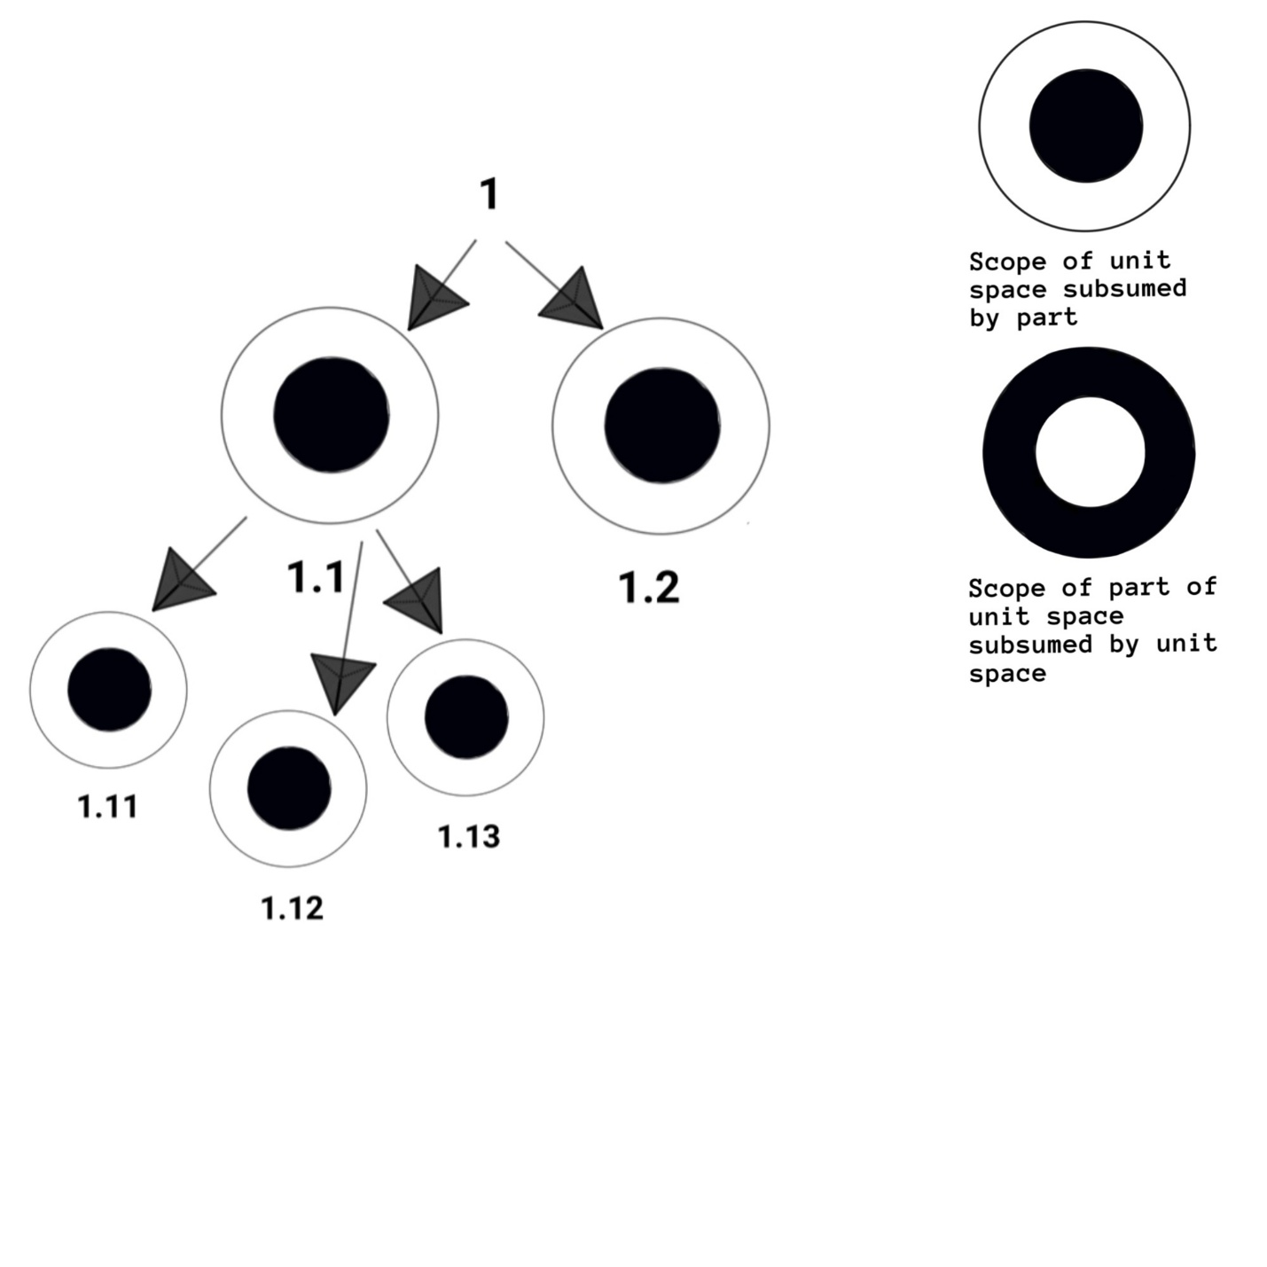
This situation changes when we consider the parts of the unit space and the relationship to the type.
Fig.4 Relations of unit space to fractions of unit space unmodified part 1
The relation changes in accordance with whether we consider that 2.01(p.5) modifies the structure categorised by the unit space 2, and 2.02 adds information to the modified and specified structure or whether we are assessing the relation of every specification independent of the specified increment categorised by the preceding fraction to strictly assess relations between structures belonging to two schematic levels. Figure 5 and figure 6 show the latter type of relation. Figure 7 shows the former type of relation. This entails that figure 6 assumes that 2.025 has a pronoun form “it” which refers to the type “objects” while figure 7 assumes that in 2.025, the pronoun refers to “substance” from the preceding structure categorised as 2.024(p.8).

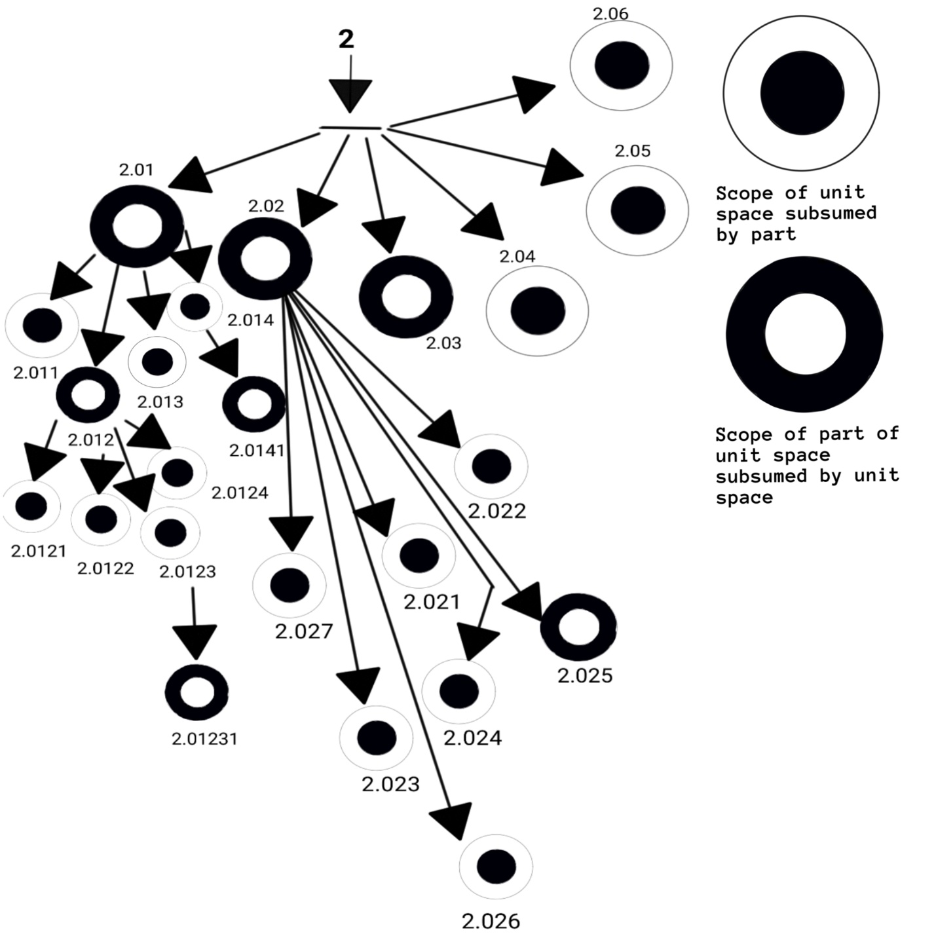
Fig.5 Relations of unit space to fractions of unit space unmodified part 2
In figure 6, 2.011(p.5-6) specifies that the arbitrary instance internally referring to the maximal extension R_{T} within the type space “State of affairs” in 2.01; has an expanded scope in 2.011 due to specification of an additional participation in another relationship. The scope of the arbitrary instance, “a state of affairs” is also subsumed by the scope of the replicate mass “states of affairs”. This is same for figure 7.Without considering 2.011, an arbitrary instance with reference to the maximal extension of “thing” in 2.012 has a scope which is subsumed by the type 2.01 because it contains the replicate mass “things”. In figure 7, this changes because 2.012 two simply expands the scope by specifying an additional relationship involving a modified form of both the nominal structures. Without considering 2.012 and 2.011, in figure 7, the proportional quantifier ‘each’ in 2.013(p.7) individuates the replicate mass “things” where it is no longer construed as an abstract substance but cognitive salience is rendered onto every instance of thing such that the difference between them is not neutralised and each is involved separately in a relationship with the replicate mass “states of affairs”. Although this entity is a virtual entity it invokes the maximal extension of the category. This relationship, it is important to note, changes because the schematic level at which it is construed has changed even though the type of entities involved remain the same. In 2.01(p.5) an arbitrary instance of “state of affairs” has an identity inclusion relation with an arbitrary instance of “combination”. It has a specified noun within its dominion which is the replicate mass “objects” or “things”. Since meaning is given by both systemic and syntagmatic contexts together, we are able to infer an association inclusion relation between the arbitrary instance of “state of affairs” and “things”. 2.013(p.7) has a scope that internally refers to the maximal extension of the type “thing”. The scope is shown as expanded due to 2.01, 2.011, 2.012 and the internal reference to the maximal extension in figure 6 and due to internal reference to the maximal extension in figure 7. It is important to note here that the proportional quantifier “each” individuates the components of the replicate mass where cognitive salience is rendered on individual participation of every component in a relationship but it is also a part of the construal that every component does take part in the relationship. In figure 6, 2.014 expands on the information in 2.01 and in figure 7, it expands on the information of 2.01, 2 .011, 2.012 and 2.013.
In figure 6, 2.021, 2.022, 2.023, 2.024, 2.026, 2.027(p.34-35) without consideration of the information in the preceding instances of structures, all expand on the scope of 2.02. 2.021(p.7), involves the contextually unique instance of “world”. 2(p.5) establishes an identity inclusion relation between the maximally schematic noun structure, “what” and the contextually unique instance of “case”. The structures “the case” and an arbitrary instance of “fact” are shown to have an identity inclusion relation with a contextually unique instance “existence”. The type “state of affairs” is situated within the dominion of the contextually unique instance “existence” with respect to the reference point model with the contextually unique instance “existence” as the reference point. 1(p.5) establishes an identity inclusion relation between the maximal extension of the contextually unique instance “case” and the contextually unique instance “world”. In 2.03(p.9) “objects” participates in a relationship with an arbitrary instance of “state of affairs” construed as abstract setting. 2.0141(p.7) shows the “object” participating in a relation in a that-clause “…its occurring in states of affairs” in pronoun form which is placed in the dominion of the contextually unique instance possibility id est “the possibility of its occurring”. This structure is contained within “state of affairs” as abstract setting by the preposition “in”. This shows that state of affairs has a bigger scope which can subsume the scope of “object” with respect to the systemic context provided by the restricted current discourse space. This indicates that 2.021(p.7) has a scope that subsumes 2.02. This is the same reason why 2.022, 2.024 has a scope which subsumes 2.02. 2.023, 2.026 and 2.027 expand on 2.02 by specifying an additional relationships in which the linking structure participates. 2.025 however without consideration of the preceding structures has a pronoun “it” which refers to the type and only a single instance of the type where 2.02 specifies a relationship in which the replicate mass participates. Therefore the scope of 2.025 is subsumed by the scope of 2.02.
In figure 7 however where we are considering the preceding structures as modifying the type, 2.021, 2.023, 2.024, 2.026, 2.027; has a more expansive scope than 2.02. 2.021 refers to “the world” and systemic context within the artifactually restricted current discourse space shows that the world has larger scope than the replicate mass objects. 2.022 refers to an arbitrary instance of a modified form of the instance world. The specific instance 2.021 subsumes the arbitrary instance and the type subsumes the modified instance. Therefore the scope of 2.022 is subsumed by the scope of 2.02 and 2.021 together. 2.023 has the replicate mass of 2.02 and 2.021 participating in another relationship therefore expanding the scope further. The structure of 2.024 refers to “what is the case” which already has an identity inclusion relationship established with “the world” and thus expands the scope by specifying another relationship in which this participates. This is the same for 2.026 and 2.027. 2.025(p.8) however refers to only a single instance of the replicate mass which has been referred to, in the type and the preceding instances. Thus the scope of 2.025 is subsumed by the scope of the type which is modified by all the preceding instances.
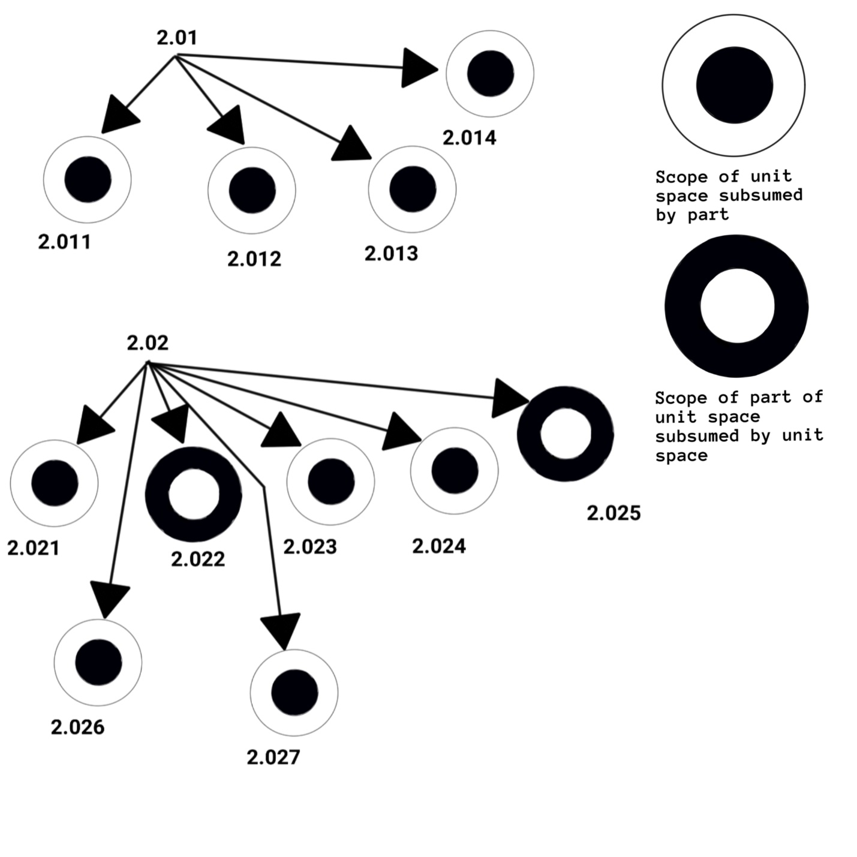
Fig.6 Relations of unit space modified to fractions of unit space
The assessment of relative expanse of scope relies on-
- Scope of the instance is established as expanding because a component is participating in another relationship. This shows in the greatest number of cases whether we consider the type modified by preceding instances or not, exempli gratia 3(p.12) is a predicate nominative construction where the trajector is an arbitrary instance of “picture” which is modified by the adjective “logical” and has a replicate mass facts situated within its dominion while the landmark is an arbitrary instance of “thought” with respect to the maximal extension. 3.02 specifies another relation within which this arbitrary instance of “thought” participates and so does 3.03, 3 .04 and 3.05(p.12-13). This is also seen for 4(p.22). 4.01, 4.03, 4.04, 4.06(p.23-27) have a structure with the component of 4 which is an arbitrary instance of proposition and specifies other relations in which this component participates. These are instances where we are considering that the type is unmodified by the preceding instances.
If the type is modified by the preceding instances then 4.111(p.29) expands on the scope of 4.11 because it specifies that the replicate mass “natural sciences” is participating in an additional relationship. It also establishes a separation inclusion relationship between this replicate mass and the type “philosophy”. 4.112 thus expands on the type “philosophy” by specifying additional relationships within which this type participates. This type is not present in 4.11. This type is further expanded by 4.113(p.30) along with the type “natural science”. The pronoun “it”, refers to the type of 4.113 since we are considering that the type is modified by the preceding instance structure. This is also true for 4.115. 4.116 expands on the type “thought”. This type is introduced in 4.114 and is not contained in the structure of 4.11.
- Replicate mass subsumes the profile of the instance exempli gratia 4.1, 4.2, 4.3 and 4.4(p.29-38) contains the replicate mass “propositions” while the 4 contains an arbitrary instance of the type “proposition”. Therefore 4.1, 4.2, 4.3 and 4.4 subsumes the scope of 4.0. 3.142, 3.144(p.14) have the replicate mass “facts” While 3.14 has an arbitrary instance of “fact”. This causes the instance or comment to have a wider scope. 3.202(p.15) has the replicate mass “signs” which 3.2 does not have. Thus 3.203 has a scope which is subsumed by 3.2. The structure of 3.2 refers to the replicate mass “objects” while the structure of 3.203 refers to a single arbitrary instance of the type. It also has a single instance of the type “sign” in modified form. Therefore even with consideration of the previous instances modifying the type, 3.202 is subsumed by the scope of 3.2 since all the previous instances contain replicate mass “signs” in modified form.45
Without consideration of preceding comment instances modifying the type 3.318(p.18) has a scope which is subsumed by 3.31(p.16) because 3.31 contains a replicate mass propositions while 3.318 contains only a single instance of the type. This is an example of the structure categorised by unit space having a wider scope than the structure categorised by a fraction of the unit space unlike the instances discussed previously. This changes if we consider the previous instances of comment modifying the comment categorised by the unit space. 3.314 and 3.315(p.17) refer to an arbitrary instance of “proposition” therefore 3.318 only expands on the scope of proposition by specifying additional participation in a relationship. This shows two kind of things happening at two different schematic levels. The scope of 2.03 which contains an arbitrary instance of “state of affairs” with respect to the maximal extension is subsumed by the scope of 2(p.5) containing “states of affairs”. 2.01 containing the structure a state of affairs is also subsumed by the scope of 2 containing “states of affairs”.
- The universal quantifier and the proportional quantifier that internally refers to the maximal extension, within any structure subsumes the single instance or the scope of the type exempli gratia 3.261(p.16) has the structure “every sign” and therefore a more expansive scope than 3.26 which contains an arbitrary instance of the modified type “sign”. It is important to note that if we consider that previous instances modify the structure categorised by the unit space then once any previous comment has a universal quantifier for a particular structure then all successive comments having that structure will be subsumed by the type because now the scope of the type has been expanded to include that scope. 3.261(p.16) contains the universal quantifier quantifying the structure “sign” and once this modifies 3.26 by adding information to the arbitrary instance of a modified type of “sign” then the scope of 3.26 becomes bigger and even though 3.262 and 3.263 contain a replicate mass and would otherwise have wider scopes than 3.26, with this consideration they will be subsumed by the scope of 3.26 and 3.261 together.
This is also true for 3.311(p.16) where the structure “all the propositions” has a scope that subsumes the scope of 3.312 and 3.313 which contains “the propositions” and the replicate mass “propositions”. While 3.311 has a scope that is subsumed by 3.31 considering that the former has the universal quantifier quantifying a contextually unique replicate mass, “all the propositions” and a contextually unique replicate mass is subsumed by the type of the replicate mass “propositions”; once 3.311 modifies 3.31; 3.312, 3.313, 3.314, 3.316, 3.317, 3.318(p.16-18) are all subsumed by the structure categorized by the unit space. 3.315 however, has the structure “propositions” which expands on the scope of 3.31.
If the structure associated with the unit space contains a universal or proportional quantifier that internally refers to the maximal extension R_{T} then the scope of all the comments containing that structure will be subsumed. The scopes of both 5.31(p.52) and 5.32 are subsumed by 5.3.

- The scope of the arbitrary instance is subsumed by the scope of the type space. This is not assumed because the scope is more expansive considering that both take into consideration the same type space. The arbitrary instance internally refers to the type space, however the profile of the arbitrary instance within the immediate scope is only one within the type space (unlike the proportional quantifier “each” which is discussed above or “any” instead of “any one”). What it takes into account is subsumed by the scope of the type space which is also participating in some relationship. Both the arbitrary instance of the type with respect to the maximal extension and the contextually unique instance belong to the type space while the scope of the arbitrary instance is subsumed by the scope of the specific instance.
In the structure categorised as 6.32(p.81) the scope of both the specific and the contextually unique instance of “law” is subsumed by the structure categorized by the unit space in 6.3(p.80). This is also true for 6.33. The specific or contextually unique structure “the propositions” in 3.312(p.16) is subsumed by “propositions” in 3.31 if considered independently. This is however not going to be the case if 3.311 modifies 3.31 because 3.311 has a structure quantified by the universal quantifier. 4.031(p.26) contains the structure ‘this proposition’ indicating a contextually unique instance. The scope of this instance subsumes the scope of “a proposition” present in 4.03 becoming wider than it. With and without consideration of modification by previous instance 3.322(p.18) has a scope which subsumes the scope of 3.32. 3.321 contains the structure “the same sign” which is a modified form of “the sign” and is subsumed by the scope of “the sign” but not “a sign”. The scope of 3.321 is subsumed by the scope of 3.32. 3.322 thus has a larger scope than 3.32 and 3.321.2.1511(p.10) however has a scope that is subsumed by the structure categorised by the unit space 2.151. The structure ‘the picture’ subsumes the scope of “a picture”.

- The scope of a modified type is subsumed by the scope of a type space exempli gratia 3.141(p.14) categorises a structure which contains “a proposition”. This structure contained in the comment has a bigger scope than “a propositional sign” therefore the scope of 3.141 subsumes the scope of 3.14.
This is also true for 4.21(p.36) and the relation to the type 4.2. Independently 4. 2 contains a modified form of the arbitrary instance of “proposition”. This is subsumed by the scope of “a proposition” in 4.2. 4.2 has a bigger scope than 4.22 4.21 contains the modified form of an arbitrary instance of “proposition”. The modified form is subsumed by the type “a proposition” which is contained in 4.2. However 4.21 contains the type “proposition”. This has a wider scope than the type “a proposition”. Therefore 4.21 has a wider scope. Once 4.21 modifies 4.2, then the scope of 4.22 is subsumed. This also shows two different kind of outcomes depending on the schematic level being considered.

- The scope expands due to systemic context within the artifactually restricted current discourse space.
2.17(p.11) has a wider scope than 2.1(p.9) because it contains the structure “facts” whose scope we can compare with the structure “reality”. 2(p.5) establishes an identity inclusion relation between the contextually unique instance of “case” and the maximally schematic noun “what”. The contextually unique instance of “case” is attributed the same identity inclusion relation with the structure “the existence of state of affairs” as an arbitrary instance of “fact”. Thus there is an identity inclusion relation between an arbitrary instance of “fact” and “the existence of state of affairs”.
In 2.06, both “the existence of states of affairs” and the “non-existence of states of affairs” together has an identity inclusion relation with the structure “reality”. Thus reality has a wider scope than fact because it is has identity inclusion relation with the replicate mass “states of affairs” in two instances together. Similarly 3.31 Establishes an identity inclusion relation between an arbitrary instance of “proposition” and an arbitrary instance of “expression”. It also establishes an identity inclusion relation between an arbitrary instance of “expression” and an arbitrary instance of “symbol.”
Therefore the scope of the comment 3.32 is subsumed by the scope of 3.3. 6.4 contains the structure “all propositions”.
These examples show that the directionality of increment which is maintained in the categorising structure at all schematic levels using the objects of mathematical language is not maintained in the structure of natural language at all schematic levels in any consistent manner. The relationship of the structure categorised by the unit space to the structure categorised by the immediate part of the unit space (since it has been judged closest in the domain of “significance” by the author) is not consistent. With respect to a single category of judgement whether replicate mass subsuming type or an arbitrary instance being subsumed by type etcetera; we are able to see instances of both the structure categorised by the unit space having a relatively bigger scope over the structure categorised by part of the unit space and the structure categorised by part of the unit space having a relatively bigger scope over the structure categorised by the unit space.
We see a different set of outcomes if we consider judging the scope of an instance at 3 schematic levels id est the scope of the structure categorised by the part of the unit space with respect to the scope of the structure categorised by the unit space modified by the preceding parts of the unit space or independently of the preceding structure categorized by the preceding part of the unit space or the relationship of structures within the unit space.
At the highest level of unit space 2 expands on the scope of 1 and 3 expands on the scope of 2 and 4 expands on the scope of 3 etcetera. Independent of the immediate unit space above; this does not apply to all successive structures categorised by parts of a single unit space. 5.521 does not have any structure that links it to 5.522. 5.523 expands on 5.522 because the contextually unique structure “generality sign” is specified for participation in another relationship. 5.524 expands on the scope of 5.523 because of systemic context in the current discourse space. However 5.525 is subsumed by the scope of 5.524(p.61).
These examples show that if the scope of the structures are considered over the range of which relationships are established between entities to express information; not only do the scope of the structures not map to the increment patterns of the categorising structure; but also with respect to linking structures which we can consider over even association inclusion relations. 1.21 does not contain a linking structure with respect to 1.2 unless we consider 1.2 modified by 1.1. This links the replicate mass with the contextually unique instance of “case” through systemic context in the artifactually restricted current discourse space. Therefore the nature of relationship changes depending on which schematic level we are constructing the artifactual boundary to limit the examination.
6.02 contains no linking structure with 6 or 6.01(p.70). 6.01 however contains the linking structure “proposition” and “the general form” with 6.0. 6.03 does not contain any linking structure with 6.02 but it contains a linking structure with 6.01 and 6.0. 6.03 appears to expand the scope of 6.0 and 6.01 by specifying another relationship that “the general form” participates in. The linking structure however is present in 6.021 and 6.022. 4.128(p.35) specifies a separation inclusion relation between the replicate mass “logical forms” and the type “number”. In 4.442(p.40) the situation of number within the dominion of “proposition” is negated in the systemic context; however in 4.45(p.40) a modified instance of “number” acts as a reference point within which a modified instance of “propositions” is situated, this is also the case for 5.101(p.44). In 5.11 the replicate mass “propositions”(p.45) is situated within an arbitrary instance of “number” as reference point. The contextually unique instance of “number” is used in 5.15(p.48) to situate the contextually unique instance of the replicate mass “truth grounds” within its domain. This replicate mass is modified such that an arbitrary instance of proposition is situated within its dominion. 5.151(p.48) contains an association inclusion relation between a modified form of number and a modified form of proposition. In 5.2521(p.51) again the replicate mass propositions is situated within the dominion of the arbitrary instance of number.
In 5.453 the replicate mass numbers is used independently and situated as contained within the type “logic”. In 5.553 also it is used independently. It is important to note that this word number has meanings ranging between grammatical and lexical in the English code. An entity situated within the arbitrary instance of number as reference point usually indicates a grammatical lexeme that indicates a quantity of something without internally referring to the maximal extension. There is no association inclusion relation directly established between an arbitrary or a single instance of the type “proposition” and the replicate mass “numbers” in the systemic context.
The linking structure between 6.431 and 6.4311 and 6.4312, ‘death’ is not present in the type 6.43. Systemic context links “world” to “propositions”. The scope of “all propositions” is bigger than the scope of the “world”. This is the way in which 6.43 has a scope which is subsumed by 6.4. 6.5 has no linking structure to 6.0 or 6.4 or 6.3 or 6.2 or 6.1. 6.5 is linked to 6.51 and 6.52 by the replicate mass “questions”. 6.522 has no linking structure to either 6.5 to one or 6.52 or 6.51 or 6.5, but it has a linking structure to 6.0 through systemic context.
Usually it is the nominal structure which forms the linking structure but it is an exceptional case for 2.1 where a temporal relation structuring is the linking structure construed as a noun in 2.11, 2.12, 2.13, 2.14, 2.15, 2.16, 2.17, 2.18 and 2.19. This does not pose a problem for cognitive grammar because it views a noun and a verb as simply alternate ways of construing a concept rather than posit any notional definition.

6. Discussion
The behavior of the categorizing relationships between the structures at the largest unit space, is not like the behavior of the categorizing relationship between the structures at smaller unit spaces for the concepts coded using natural language inventory . While a correlation is posited by the agent, the categorizing relationships between the structures for the artificial code remains consistent.
Artificially regular codes are non-analogous to natural language codes with respect to many critical aspects especially consistency. Natural language coding in all its forms showing correlations or associations between entities are not only sensitive to domain but also sensitive to schematic relations regardless of variety. When the human mind is mapping between two structures, such mapping is biased towards any one. This demonstrates the limits of structural analogical mapping assessed in a domain general manner rather than domain specific manner.
Wittgenstein posits a correlation between to two relational architectures having different characteristics yet the mapping itself adheres asymmetrically to schemas of one of them.
7. Conclusion
The human mind can conceptualise containment in varied ways, not restricted to the logical domain and simultaneously within the same complex structure. Part whole relationship is instantiated in multiple ways. Conceptualising a group of things does not entail cognitive salience to elements within a group. The reference point idealised cognitive model posited within the cognitive grammar framework (Langacker, 1987, 1990, 2006, 2012) considers the owner of the room as a conceptual anchor within the dominion of which is located the room as a target. At the level of instance, a person may be located outside the room among other locations while the relation of the person to the room remains constant schematically. Categories and correlations between categories in natural language coding are sensitive to levels of schematicity and domain. It is possible to conceptualise relations with or without posited point of increment as demonstrated in this study. This is the nature of the Relational architecture nature language coding.
There is significant difference with the structure of the decimal system and how increment is realised within the structured inventory. At every schematic level, the preceding schematic level must be consistently contained as immanent for the existence of the subsequent. One cannot establish a relation with the whole at any level without considering the preceding increment. This is not an obligatory requirement for the decoding of natural language. However correlations between entities are sensitive to schematic levels for natural language. The type and character of the construal changes depending on this. This has an impact on analysis when there is contact between non-analogous systems.
Mapping between non analogous structured inventories do not occur between cognitively analogous structures. Mapping by a single agent does not prioritize the degree to which mapped structures are analogous to each other based on shared substructures or attributes. Mapping asymmetrically imposes the relational architecture of a single inventory over the other where symmetry is the rare and limiting case of asymmetry.

List of figures and tables
Figure 1 Types of category assessment
Figure 2 Category relations and directionality
Figure 3 relations between structures categorised by main unit space
Figure 4 relations of unit space to fractions of unit space unmodified part 1
Figure 5 Relations of unit space to fractions of unit space unmodified part 2
Figure 6 relations of unit space modified to fractions of unit space

References
Bullock, B. E., Toribio, A. J., Serigos, J., & Guzmán, G. (2021). Processing multilingual data. In E. Adamou & Y. Matras (Eds.), The Routledge Handbook of Language Contact (pp. 7–27). Routledge.

Carnie, A. (2021). Syntax (4th ed.). Wiley. Retrieved from https://www.perlego.com/book/2322412/syntax-a-generative-introduction-pdf (Original work published 2021)

Chomsky, N. (1968). The Sound Pattern of English (M. Halle, Ed.) [Review of The Sound Pattern of English]. Harper & Row. https://archive.org/details/soundpatternofen0000chom/page/n6/mode/1up (Original work published 1968)

Chumakina, M. (2012). Introduction. In Periphrasis: The role of syntax and morphology in paradigms (pp. 1–24). British Academy/Oxford University Press. https://doi.org/10.5871/bacad/9780197265253.003.0001

Dewaele, Jean-Marc. “Bilingualism and Multilingualism.” The International Encyclopedia of Language and Social Interaction, edited by K Tracy et al., Oxford, UK, John Wiley & Sons., May 2015, www.researchgate.net/publication/284640256_Bilingualism_and_Multilingualism.

Dik,S.C.(2021).Functional Grammar.Germany:De Gruyter.

Dussias, P. E., Kroll, J. F., Fricke, M., & Johns, M. A. (2021). Language contact in the lab. In E. Adamou & Y. Matras (Eds.), The Routledge handbook of language contact (pp. 45–63). Routledge. https://doi.org/10.4324/9781351109154-4

Fleming, Andrew Peter. “The Sociolinguistic Variable: Where Is It?” Proceedings of the 44th Annual Penn Linguistics Conference, vol. University of Pennsylvania Working Papers in Linguistics, 9 July 2021. Penn collections, repository.upenn.edu/handle/20.500.14332/45333. Accessed 30 Apr. 2025.

Haegeman, L. (1994). Introduction to Government and Binding Theory (Second edition) [Review of Introduction to Government and Binding Theory]. Blackwell Publishers Inc, Oxford UK and Cambridge USA. (Original work published 1991)

Kalin, Laura, and Philipp Weisser. “Minimalism and Morphology∗.” Cambridge Handbook of Minimalism, May 2023, static1.squarespace.com/static/586960e5197aea52834230a2/t/646cc1c40048e236afbef29b/1684849092630/Kalin+and+Weisser+May+2023+-+spacing+fixed.pdf . Accessed 1 May 2025.

Langacker, R. W., & Stanford University Press. (1987). Foundations of cognitive grammar. Vol. 1, Theoretical prerequisites. Stanford University Press.

Langacker, R. W. (1990). Concept, Image, and Symbol. Walter de Gruyter.

Langacker, R. W. (2006/2012). Descriptive application : Ronald W. Langacker. Stanford University Press.

Langacker, Ronald W. Investigations in Cognitive Grammar. New York, N.Y., Mouton De Gruyter, 2009.

Lakoff, G., & Sweetser, E. (1994). Foreword. In G. Fauconnier, Mental Spaces: Aspects of Meaning Construction in Natural Language (pp. ix–xvi). Cambridge University Press
‌Lau, Jey Han, et al. “Grammaticality, Acceptability, and Probability: A Probabilistic View of Linguistic Knowledge.” Cognitive Science, vol. 41, no. 5, 12 Oct. 2016, pp. 1202–1241, https://doi.org/10.1111/cogs.12414. Accessed 9 June 2020.
‌Ludlow, Peter . Competence/ Performance. 2025, d1wqtxts1xzle7.cloudfront.net/122004517/Proof_Central_Online_proofing._Trusted_by_millions_of_authors.-libre.pdf?1742929260=&response-content-disposition=inline%3B+filename%3DCompetence_Performance.pdf&Expires=1745747114&Signature=BB8l1fM-5884f3KF9hWbDC5j0lFcA-Mr8JzHKx8B6EitOogKjSBaBxWuyInW3GFaDN1vqoizwKVA-8FWMRsHDGoMz3CC9CCyoSoQNHINxpec8tNvdwgvR0wRzrQV3L-~aq6-j7z5lljVcbMPSedOUuNiv0DVFqVM7nDLtF14iOIHfDWuRfwJcDEF4M5XRLY~T-g~v5-uB~7SDSitbxQ6pFutFc9X-08olgOZWE2QPpVAyiNdfUysEunIlqumi-jooMXRQxIM8bgzl6iwMmFLj9MCFWi82dnrrXkPZ0ti-KJx16YatpJ4znv0lJzBdIogDllF07uxOVUwA2Vl3Ma7Lw__&Key-Pair-Id=APKAJLOHF5GGSLRBV4ZA Accessed Apr. 27AD.

Meyerhoff, Miriam. Introducing Sociolinguistics. Taylor & Francis, 11 May 2015.Sarvaiya, A. (2022). Meaning and metaphors. Interdisciplinary Journal of Linguistics, 15(1), 151-160. Retrieved from University of Kashmir

Ramat, P. (1999). Linguistic categories and linguists’ categorizations. Linguistics, 37(1), 157–180. https://doi.org/10.1515/ling.1999.002

Sawaal. (n.d.). Probability questions and answers,149+ Solved Probability Questions and Answers With Explanation, Retrieved June 7, 2025, from Sawaal.

Schnitzer, Mark . L. “Critique of Linguistic Knowledge.” Language & Communication, vol. 10, no. No. 2, 1990, pp. 95–125.

Smith, L. A., & Gentner, D. (2010). Structural constraints and real-world plausibility in analogical inference. In R. Catrambone & S. Ohlsson (Eds.), Proceedings of the 32nd Annual Conference of the Cognitive Science Society (pp. 712–717). Cognitive Science Society. https://escholarship.org/uc/item/1sv3p6ck

Taylor, J. R. (2003). The categorization of colour. In Linguistic categorization (3rd ed., pp. 1–18). Oxford University Press.

Wittgenstein, L. (2002). Tractatus Logico-Philosophicus (K. Paul, Ed.; D. F. Pears & B. F. McGuiness, Trans.; 1961st, 1974th ed.) [Review of Tractatus Logico-Philosophicus]. (Original work published 1974)

