Phonological and Lexical Inconsistencies in the 10th Edition of the Oxford Advanced Learner's Dictionary (OALD): A Study of Omissions and Errors

ABSTRACT
By acknowledging efforts or contributing to improvements, researchers have a basic responsibility to dictionary writers and readers of research. This study investigates phonological and lexical inconsistencies in the 10th edition of the Oxford Advanced Learner’s Dictionary (OALD), focusing on transcription errors, incomplete lexical entries, and lexicographic formatting issues. Adopting Tarp and Bergenholtz's (2003) Communicative Lexicography, it evaluates phonological precision in the OALD and analyzes errors in selected lexical items, identifying deviations from standard linguistic and lexicographic expectations. Using a qualitative, comparative approach, data were collected by analyzing OALD entries and cross-referencing them with authoritative sources. Findings reveal omissions of phrasal lemma parts in phonemic representation, inconsistencies in transcriptions across lemmas, and inaccuracies in the pronunciation of anglicized words based on their origins. Additionally, some grammatical information does not align with common English usage, while proper nouns are not alphabetized using the surname-first inversion. These inconsistencies raise concerns about OALD's reliability as a reference for learners and educators. The study contributes to morphophonological and lexicographic research by highlighting the need for improved linguistic validation in monolingual learner dictionaries.
Keywords: The OALD, Transcriptions, Lexical entries, Misrepresentation, Lexicography

INTRODUCTION
Confucius observed, “If the language is not correct… what ought to be done remains undone”. This principle emphasizes the need for precise language to ensure effective communication. When two people do not share a common language, the one seeking to communicate will adjust to be understood. However, as Somba and Widyaningrum (2024) note, “the ability to communicate and understand a language is often hampered by a limited vocabulary”. This challenge led early lexicographers to systematically document and update language, and English was no exception.
Although “the practice of defining words… is probably as old as linguistic communication itself and... is far more ancient than lexicography” (Mel’cuk & Polguère, 2018, p. 440), dictionaries have long served as key tools for word description. The compilation of English words has evolved over time, with some dictionaries enduring while others faded. Today, English dictionaries rank among the most widely sold books.
The Oxford Advanced Learner’s Dictionary (OALD), originally created by Hornby—an English-studies teacher in Japan—was later accepted by Oxford University Press (OUP) and became a trusted resource for non-native English speakers. Hornby’s expertise in teaching English as a second language contributed to its success, and with OUP’s backing, it gained widespread recognition. The OALD’s reputation is rooted in its depth, structured approach, regular updates, and contributions from renowned English authorities worldwide.
Laufer (2008, p. 213) highlights the importance of learner dictionaries, stating that “one possible source of information about a totally new word or a partially learnt word is the learner’s dictionary”. Rundell (2006) describes monolingual dictionaries for non-native speakers—exemplified by the OALD—as featuring “simplified defining language, detailed syntactic information, a focus on phraseology, and the extensive use of example sentences”. He further notes that these characteristics quickly became defining features of learner dictionaries. Meanwhile, De Caluwe and Van Santen (2003) point out that major monolingual dictionaries prioritize standard pronunciation—mainly Received Pronunciation and sometimes General American—over regional or social variations. Pronunciation editors focus on ensuring accurate phonetic data, while grammarians navigate the complexities of evolving syntax and lexis.
Examining the OALD’s structural development, Ivančič and Fabijanić (2017) affirm that each edition provides headword spellings and notes variations. The dictionary has expanded with each update, accommodating new words and usages for both native and non-native speakers. Its learner-friendly guides, clear explanations, and defining vocabulary set it apart. Now available in print and digital formats, the OALD has also influenced amateur dictionary makers targeting non-native learners.
The 10th edition—the latest at the time of this study—represents a significant advancement, continuing OUP’s tradition of excellence. It includes contemporary words from various English-speaking regions, reflecting English’s global nature and the role of diverse speakers in its growth. The addition of new words, simplified definitions, pronunciation variants, expanded thesaurus entries, and collocation boxes further enhances its usability. These features are especially effective in digital and online versions, where improved navigation, pronunciation, and sentence readings are available.
Atkins and Varantola (2008, p. 337) emphasize that improving dictionary use requires refining both the dictionary and its users. They also note (p. 353) that lexicographers rarely study how successfully users navigate dictionaries, though this should be a priority. Despite its status as a best-selling learner’s dictionary and its esteemed editorial reputation, the OALD contains notable inconsistencies—surprising for a work of its caliber. Gous (2010, p. 56) stresses that “the lexicographer should realise that the specific dictionary has a pedagogical assignment. The presentation and treatment should be done accordingly”. Given the trust placed in the OALD by native and non-native users alike, addressing these inconsistencies is essential to maintaining its long-standing reputation.

Statement of Research Problem
In many parts of the world, the OALD is the most widely used dictionary, trusted for its credibility and long-standing reputation. However, it is concerning that a dictionary of its stature contains omissions and inconsistencies—some appearing as mistakes, others as outright errors. Students and scholars familiar with comparable dictionaries find these inconsistencies disturbing. While some students hesitate to acknowledge errors in the OALD and consequently fail their English tests, some scholars question whether it adheres to its objectives or simply distinguishes itself uniquely. Thus, this study addresses users' concerns and dispels doubts.
Atkins and Varantola (2008, p. 349) emphasize that if lexicographers wish to create more helpful entries, they must “have some idea of what users most frequently need to find out from their dictionaries”. Similarly, McCourt (1996, p. 333) observes of one such dictionary, “the people who wrote the dictionary don’t want the likes of me to know anything”. This is unfortunate, given that dictionaries are meant to solve users’ linguistic problems (Bogaards, 2003, p. 26). Ivančič and Fabijanić (2017) highlight the challenges faced by foreign users and suggest that lexicographers employ labels to indicate “the stylistic values of words or the technical fields in which they are used”.
Laufer (2008, p. 214) explains that users expect “dictionaries to clarify the meaning of new words in the best possible way and to help the learners use these words in speech and writing of their own”. Dictionaries are not beyond critique; they should inspire confidence rather than exclusion. Nielsen (2018, p. 78) notes that “criticism is an activity that goes back many years and has been exercised by a wide range of different people”. However, “reviewers should have an open mind and adopt a wide and complex ontological position when they critique dictionaries” (p. 80). Hence, this study fills a research gap arising from the limited scrutiny of the authoritative OALD.
The errors in OALD warrant critical evaluation; as a human-made publication, it is neither impeccable nor beyond critique. According to Tarp (2018, p. 30), “dictionaries have a core of aspects and elements that are common to all of them and different from those of other disciplines”. As one of the most widely used dictionaries among advanced English learners, the OALD serves as a key resource for study and test preparation. Its transcriptions and entry patterns are crucial references for pronunciation and word structuring. Consequently, errors in the OALD mislead its users and must be directly addressed. A study of this nature will “guide readers to find the dictionaries that can best satisfy lexicographically relevant user needs and to guide lexicographers in improving the qualities of dictionaries” (Swanepoel, 2008, p. 209). It will also prompt OALD’s lexicographers and editors to address overlooked issues. The findings should motivate the editorial board to enhance future editions.
This study examines the print, digital, and online versions of the 10th edition of the Oxford Advanced Learner’s Dictionary, analyzing its inconsistencies, errors, and omissions. Comparisons with other editions or dictionaries are made where necessary. The specific objectives of this study are to:
i. Evaluate the level of phonological precision in the OALD.
ii. Analyze the errors in selected lexical items in the OALD.
Guided by the research objectives and problem statement, this study answers the following questions:
i. What is the level of phonological precision in the OALD?
ii. What are the categories of lexical errors observable in the OALD?
LITERATURE REVIEW
Practical Lexicography
The making of dictionaries follows structured processes guided by lexicographic principles. According to Atkins and Varantola (2008, p. 371), “dictionary skills must be taught, carefully and thoroughly, if dictionary users are to extract from their dictionaries the information lexicographers have put into them”. Gous (2010, p. 68) similarly emphasizes that dictionaries must be planned according to lexicographic criteria, considering the needs of their users and involving subject-field and language-teaching experts. Theories applied in lexicography ensure that words are systematically collected, clearly explained, and appropriately structured. These theories support objectives such as preserving linguistic integrity (Johnson, 1747, p. 4), enforcing language policy (Fuertes-Olivera & Tarp, 2014, p. 77), transmitting knowledge (Tarp, 2018, p. 21), and guiding learners toward linguistic autonomy (Ma & Yan, 2022).
While dictionaries may appear prescriptive, lexicography is fundamentally descriptive, reflecting real language use and accounting for different linguistic variants (Fuertes-Olivera & Tarp, 2014, p. 80). The proscriptive approach, which offers recommendations rather than rigid rules, allows for variation while indicating preferred forms (Fuertes-Olivera & Tarp, 2014, p. 81). As Rundell (2008, p. 222) explains, dictionary descriptions are based on empirical evidence of actual language use rather than imposed norms. Corpora play a crucial role in this process, informing word frequency and ensuring dictionaries reflect how language is spoken and written.
Dictionaries serve a range of users, from specialized fields to general learners, aligning content with specific needs. A well-designed dictionary fosters user trust by closely approximating real communicative language patterns (Atkins & Rundell, 2008, p. 45). Fuertes-Olivera and Tarp (2014, p. 100) further highlight that lexicographers and subject-field experts remain essential in validating and maintaining reliable lexical data.
Bergenholtz (2018, p. 41) emphasizes that “good dictionary making means planning, planning, and planning, combined with dictionary functions related to deciding, deciding, and deciding”. For a global language like English—the most spoken second language and the second most spoken first language—dictionary makers must keep pace with its rapid evolution while meeting users' needs. To enhance lexicography, digital versions with engaging graphical features complement hard copies, which are less portable. However, digital versions should faithfully reflect the content of printed editions. Highlighting the importance of planning and expertise, Bergenholtz (2018, p. 34) notes that numerous “failed dictionary projects” indicate significant mismanagement in lexicography.
Dictionaries are designed for specific user groups, particularly learners of English. Learners’ dictionaries prioritize clarity and accessibility, aligning with the objectives of the OALD. According to Laufer (2008, p. 213), knowing a word involves recognizing its pronunciation, spelling, and morphological components. Monolingual learners' dictionaries serve both native and non-native users by providing essential phonological information. Booij (2003, p. 252) states that lexical units should include “the phonetic form in isolation, in careful speech”, using the International Phonetic Alphabet. Shah and Mashori (2015, p. 77) discuss dictionary respelling, highlighting the role of diacritics and digraphs in pronunciation. Since learners rely on dictionaries for pronunciation guidance, lexicographers must ensure accuracy. While native speakers may not need phonetic transcriptions, learners depend on them. Agerbo (2018, p. 63) stresses that “the data must be lexicographically relevant… correct and reliable”,
This study assesses the OALD’s adherence to lexicographic best practices in representing pronunciation and meaning. It evaluates whether the phonemic transcriptions are comprehensive and whether pronunciation variants in standard usage are adequately captured. By analyzing editorial choices in transcriptions and the inclusion or omission of pronunciation variants, this research highlights the dictionary’s phonological precision.

Lexicographic Definition
Lexicographic definition is a key concept in this study. According to Ladislav (1971, p. 253), “the lexicographic definition enumerates only the most important semantic features of the defined lexical unit which suffice to differentiate it from other units”. It captures meaning in common use—simple, natural language—avoiding the formal rigor of logical descriptions. Fuertes-Olivera and Tarp (2014, p. 4) highlight a recurring issue in lexicography: “the use of various terms to denote one and the same phenomenon, as well as the use of one and the same term to denote various, completely different phenomena”. This underscores the need for consistency in lexicographic definitions while adhering to core principles. Additionally, Bogaards (2003, pp. 26–27) notes that dictionaries are “most used for reading tasks, mostly in order to find out about meanings of unknown words”.
Agerbo (2018, p. 63) outlines principles for crafting lexicographic definitions, emphasizing their centrality to both users and lexicographers. He further asserts that “the explanation must be easily understandable for the intended user type” (p. 59). Clarity is crucial in monolingual learners’ dictionaries. Miller (2018, p. 353) warns that dictionaries designed for native speakers “may be too complicated for a learner, as they commonly include words in definitions that the learner does not understand”. Practical lexicography addresses this concern by ensuring definitions align with natural word use and user comprehension.
Ladislav (1971, p. 252) describes lexicographic definition as a fundamental tool “for the description of lexical meaning”. Given its role in structuring dictionary meanings, this study applies the concept to analyze inconsistencies in the tenth edition of the OALD. By critically examining the dataset, it evaluates the OALD’s accuracy in lexical representation.

Word Sense Disambiguation (WSD)
In lexicography, Word Sense Disambiguation (WSD) involves specifying a word’s meaning in a given context. External indicators (text type) and internal indicators (lexico-grammatical environment) together form a WSD methodology to resolve ambiguities (Atkins & Rundell, 2008, p. 296). Effective WSD also requires lexicographers to provide sufficient textual examples. According to Laufer (2008, p. 214), “authentic examples are not only grammatically correct but also situationally appropriate, as they were actually used in real life, unlike made-up examples”. Thus, “the lexicographer’s best source of information about dictionary examples is a large corpus of real language used by native speakers”.
Dictionaries function as “consultation tools that provide quick and easy access to the data from which the required information can be retrieved” (Fuertes-Olivera & Tarp, 2014, p. 100), distinguishing them from other lexicographical works. Given the polysemy of English words, WSD must not be hurried, especially in dictionaries requiring precise definitions and usage clarifications. Ladislav (1971, p. 88) affirms that homonymy is crucial in descriptive lexicography when aiming to provide a true and precise account of lexical units. For monolingual dictionaries, Albus et al. (2005) note that they offer more in-depth explanations of vocabulary function in context.
WSD also applies to phonological entries, ensuring homophones and homographs are clearly distinguished. Phonological and phonetic transcriptions must accurately reflect sound properties, as spelling alone can be misleading. De Caluwe and Van Santen (2003, p. 71) emphasize that a stress marker always precedes the stressed syllable.
This study applies WSD to evaluate whether phonological and lexical inconsistencies in the OALD contribute to ambiguity or misinterpretation. For instance, failure to differentiate between British and American pronunciations of schedule or provide distinct phonetic transcriptions for words with multiple pronunciations may confuse users. By analyzing how effectively the OALD applies WSD principles, this study investigates whether pronunciation variants and lexical meanings are adequately clarified to enhance user comprehension.

Lexical Revision
As words evolve in meaning over time, lexicographers must carefully update word lists, considering spelling, definitions, usage, pronunciation, and variations. Ladislav (1972, p. 171) states that “the lexicographer must know the development of ‘his’ language in great detail, at least as far as those periods which he intends to cover are concerned”. This is especially relevant for mobile and online dictionaries, as print editions remain unchanged until their next release. If mobile dictionary apps mirror online versions, regular synchronization should be ensured.
Bergenholtz (2018, p. 41) highlights the growing role of IT experts in e-lexicography, noting that in some cases, they design dictionaries independently, limiting project managers' influence and restricting access to full lemma lists. To maintain quality, dictionary managers must oversee content presentation to ensure it meets users’ informational needs and aligns with the dictionary’s intended function.
Since dictionaries are expected to be reliable linguistic resources, identifying and correcting phonological and lexical inconsistencies must be an ongoing lexicographic process. The concept of Lexical Revision, with its principles in practical lexicography, supports this study’s framework for analyzing omissions and errors in the 10th edition of the OALD.

Theoretical Framework
This study is grounded in Communicative Lexicography (CL), developed by Tarp and Bergenholtz (2003) as part of their Function Theory of Lexicography. CL emphasizes that dictionaries should prioritize users' needs over mere word documentation, applying practical lexicography principles to enhance real-life communication. According to Tarp and Bergenholtz (2003, p. 172), “dictionaries are considered utility products that are made in order to satisfy certain human needs”. This approach examines dictionaries’ impact on users and explores ways to improve their efficiency.
Tarp and Bergenholtz (2003) distinguish two primary user situations in lexicography: knowledge-oriented and communication-oriented. The knowledge-oriented situation arises when users seek additional information—whether cultural, encyclopedic, subject-specific, or linguistic (e.g., while learning a foreign language). Lexicographers identify and address these informational needs by selecting relevant data for inclusion. Here, the only communication involved is between the user and the lexicographer, as “the users want knowledge and the lexicographers provide it, nothing more” (2003, p. 174).
The communication-oriented situation, however, involves an actual or planned interaction—written or oral—between individuals. The lexicographer's role is indirect, intervening only when a communication problem arises that the dictionary can resolve. Within this model, CL views communication as the production and reception of texts and, in some cases, their translation. Tarp and Bergenholtz (2003, p. 172) assert that “as any researchers or producers of utility products, lexicographers study – or ought to study – human activities in order to detect possible needs that can be satisfied by means of a dictionary”.
This framework aligns with the study’s theoretical foundation. Therefore, any failure in phonological accuracy or lexical representation in the OALD compromises its communicative function as a learner's dictionary.

METHODOLOGY
This interpretative study adopts a qualitative research method, which, according to Creswell (2009), involves an inquiry that interprets observed or understood phenomena. The approach purposefully selects visual materials to address the research objectives. While qualitative research requires significant time and resources, it is essential when, as Creswell and Poth (2017, p. 68) state, “a complex, detailed understanding of the issue” is needed. They further note that qualitative research “is for the researcher who is willing to engage in the complex, time-consuming process of data analysis”. This method’s examination of texts and images, supported by detailed descriptions, provides clear insights into the problem and informs stakeholders.
This study also employs a comparative approach, identifying peculiarities, similarities, or differences between juxtaposed data to reach valid conclusions. Miri and Shahrokh (2019, p. 2) state that comparison “can serve a heuristic purpose by identifying aspects and facets that would otherwise be missed or neglected”.
The dataset consists of twenty-seven snapshots from the printed edition and screenshots from the mobile and online versions of the OALD. These are purposively selected to align with the research questions, ensuring they reflect phonological consistencies and lexical representation. The dataset is stratified for analysis, grouping samples based on shared features or thematic relevance. Only essential screenshots are included, avoiding excessive reproduction of content. Additionally, all screenshots are presented in their original form, without modifications that could distort their content or mislead stakeholders.

DATA ANALYSIS
This section analyzes the dataset to address the research objectives. Having organized, reviewed, and categorized the data by themes, their descriptions are presented below.

Redundancies in Phonemic Representation
This is an incorrect depiction of pronunciation in the phonemic transcription of an expression in a particular language or dialect. It may involve using a phoneme that does not align with the established standard, omitting necessary phonemes, or adding unnecessary ones. Examples of incorrect transcriptions in the tenth edition of the OALD are presented below:
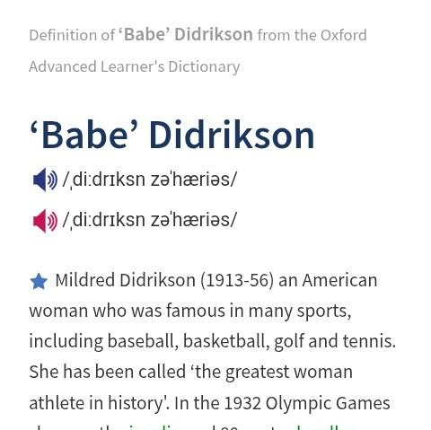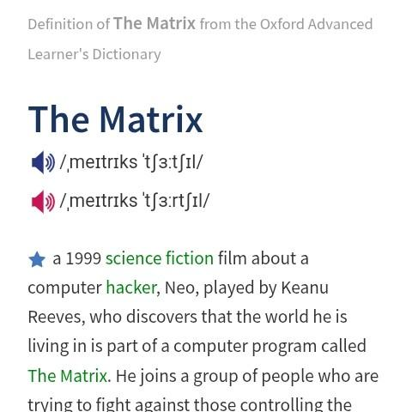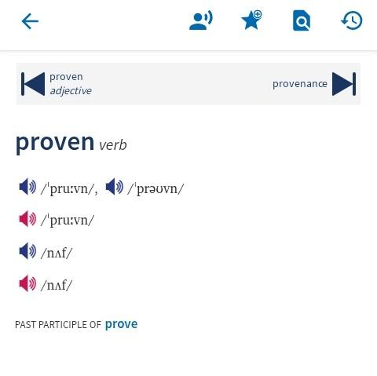
Image 1. ‘Babe’ Didrikson Image 2. The Matrix Image 3. Proven

Images 1 and 2 are screenshots of the online OALD, while Image 3 captures a screen from the offline mobile app of the OALD.
In Image 1, the phonemic transcription fails to capture the correct pronunciation of the compound proper noun. Although the first part of the phonemic target is highlighted, neither the correct transcription of the entire word is represented nor are the single inverted commas observed. The correct transcription should be /ˌbeɪb ˈdiːdrɪksn/. Thus, the phonemic representation includes redundant phonemes.
Image 2 exhibits a similar phonemic deviation. The transcription is incorrect as it omits part of the target word—the definite article—while incorporating transcription for an unrelated word. When properly transcribed, it should read /ðə ˈmeɪtrɪks/. The actual phonemic representation in the image corresponds to Matrix Churchill rather than the intended target word.
In image 3, additional transcriptions are shown but not the target words. This transcription is supposedly for the word, ‘nuff, which however is neither a part of the phonemic target nor introduced anywhere on the page, thereby resulting in phonemic redundancy, confusing or misleading the dictionary user.
In image 3, two additional transcriptions appear below, but not for the target words. Both transcriptions seem to represent ‘nuff,’ which, however, is neither part of the phonemic target nor introduced anywhere on the page, leading to phonemic redundancy that may confuse or mislead the dictionary user.

Incompleteness in Phonemic Representation
The OALD provides incomplete transcriptions for certain words. As shown below, this may involve omitting part of the target word in the transcription, failing to transcribe an introduced word variant, or excluding a phoneme in the phonemic representation.
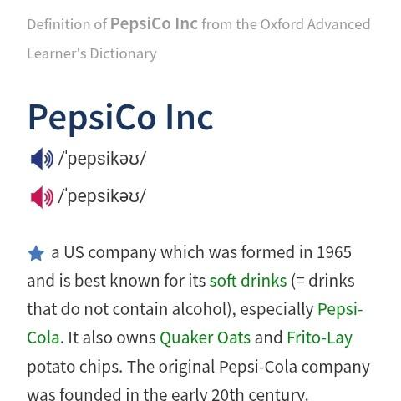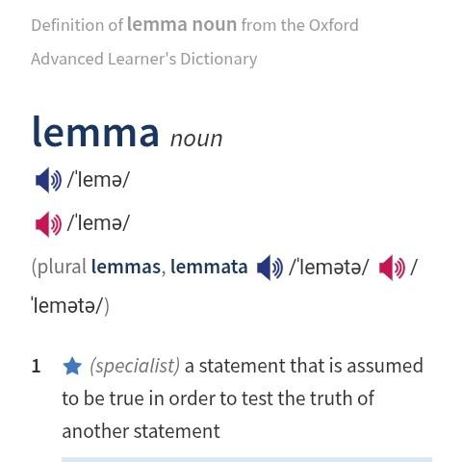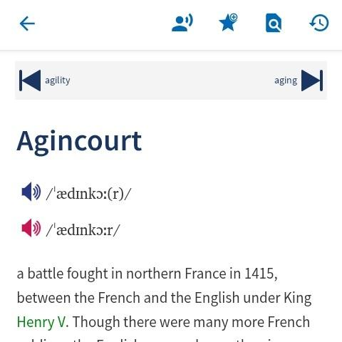
Image 4. PepsiCo Inc Image 5. Lemma Image 6. Agincourt

Images 4 and 5 are screenshots from the online OALD, while Image 6 is from the offline mobile version, as the online OALD provides the correct transcription.
In Image 4, a brand name formed as a portmanteau (Pepsi + Company + Incorporated) is not fully transcribed, leaving out the final part of the word, which is commonly pronounced as part of the brand name when written.
Image 5 displays a word with structurally varied plural forms, but the phonemic transcription of the first plural is missing, leaving users to make successful or failed guesses. Since structurally similar English words are not always pronounced alike, the phonemic transcription of the omitted word is necessary for all levels of English learners.
In Image 6, the transcription of the headword is incomplete and, therefore, incorrect. Although the correct pronunciation is played, and the online OALD provides the accurate transcription /ˈædʒɪnkɔː(r)/, the offline mobile version which captured Image 6 does not. Here, the voiced palato-alveolar affricate /dʒ/, present in the pronunciation, is incorrectly replaced or incompletely transcribed as a voiced alveolar plosive /d/.

Omissions of the Phonemic Representation of Determiners
These are additional instances of incompleteness in the phonemic representation of words in the OALD, particularly affecting determiners and making these lexical items seem silent in phonological rendition.
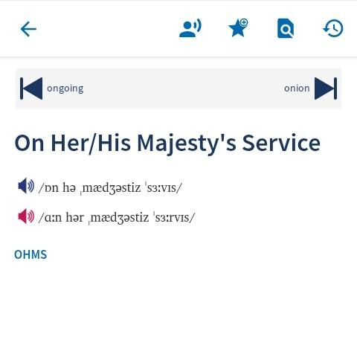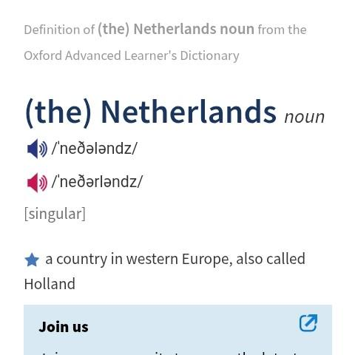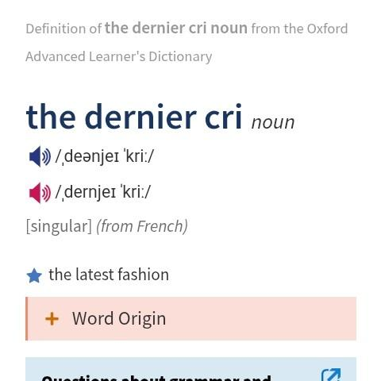
Image 7. OHHMS Image 8. (the) Netherlands Image 9. The Dernier Cri

In image 7, a screenshot of the offline mobile OALD app shows an incomplete phonetic objective, omitting the determiner ‘his’ in the phonemic target. Users might overlook this omission and misinterpret the transcription. This contradicts Gous’s (2010, p. 55) assertion that “structures should be selected and used in such a way that they can enhance the access to the desired data and ensure an optimal retrieval of information by the intended target user.” Consequently, the omitted determiner appears redundant or unnecessary in speech, except in writing.
In image 8, another determiner in the transcribed word, this time bracketed, is also omitted, leaving users uncertain whether it is solely a written element or if the brackets indicate optional pronunciation. However, no explicit clarification is provided. This applies to all bracketed determiners in OALD’s transcription. For instance, in entries such as (the) Arctic Ocean, (the) Atlantic Ocean, (the) Central African Republic, (the) Czech Republic, (the) Democratic Republic of the Congo, (the) Dominican Republic, (the) Indian Ocean, (the) Ivory Coast, and (the) Northwest Territories, the determiner is bracketed. Notably, this occurs only in the mobile offline and online versions of OALD.
Similar to image 8, image 9 presents another instance where a determiner is excluded from the transcription. However, here, the determiner is neither highlighted nor bracketed. The same issue appears in the entry for ‘the CSA’, where the determiner is also omitted. Notably, only two cases of non-bracketed determiners being ignored in transcription were found in the dictionary.

Inconsistencies in the Transcription of Dialectal Entries Appearing Multiple Times
Some words were not transcribed uniformly across all appearances and entries, while others were consistently transcribed.
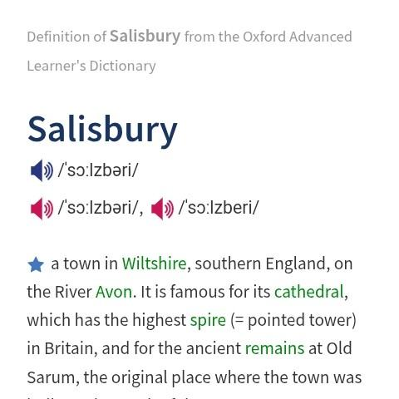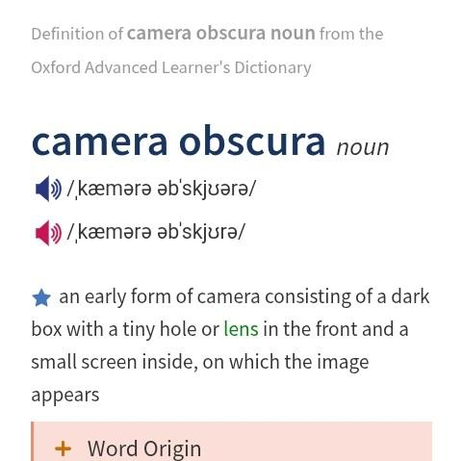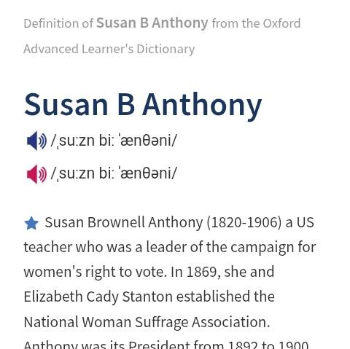
Image 10. Salisbury Image 11. Camera Obscura Image 12. Susan B. Anthony

In image 10, the British transcription of Salisbury differs from its entries: Lord Salisbury (/ˌ‍lɔːd ˈ‍sɔːlzbri/), Salisbury Plain (/ˌ‍sɔːlzbri ˈ‍pleɪn/), and Salisbury steak (/ˌ‍sɔːlzbri ˈ‍steɪk/). Image 10 introduces a schwa /ə/, making it trisyllabic, whereas the listed entries are disyllabic, omitting the schwa.
Similarly, in image 11, camera is rendered trisyllabic, unlike its consistent disyllabic transcription (/ˈ‍kæmrə/) in camera operator, camerawoman, camerawork, Candid Camera, pinhole camera, speed camera, and video camera. Image 11 instead records it as /ˌ‍kæmərə/.
In image 12, the British transcription of Anthony features the voiceless dental fricative, /θ/, instead of the voiceless alveolar plosive, /t/, unlike other entries such as Anthony Blunt (/ˌ‍æntəni ˈ‍blʌnt/), Anthony Caro (/ˌ‍æntəni ˈ‍kɑːrəʊ/), Anthony Dollar (/ˈ‍æntəni dɒlə(r)/), and Anthony Powell (/ˌ‍æntəni ˈ‍pəʊəl/).
This inconsistency is concerning, especially given the uniformity in transcriptions for words like ‘clothes’ and ‘digestive’ across all entries.

Inconsistencies in Pronunciation Representation Based on Word Origin.
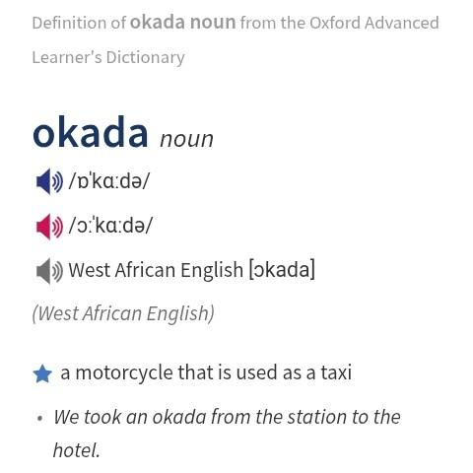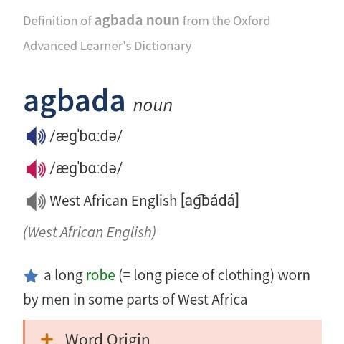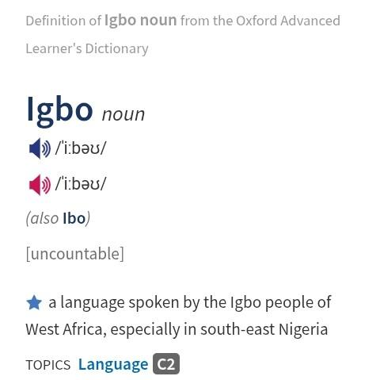
Image 13. Okada Image 14. Agbada Image 15. Igbo

In images 13 and 14, the West African pronunciation variants for the lemmas are shown, whereas in image 15, this is not the case for another word of West African origin.
Misleading Grammatical Information
There are additional omissions and errors in the OALD beyond phonological aspects. The lexical representations of certain words reflect either conscious or unintentional omissions, misleading users. When intentional, these representations are overly prescriptive, despite evident word usages disproving them.
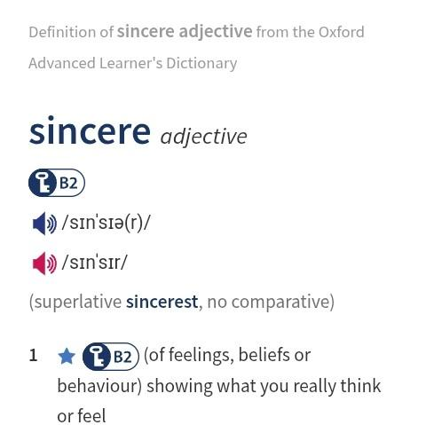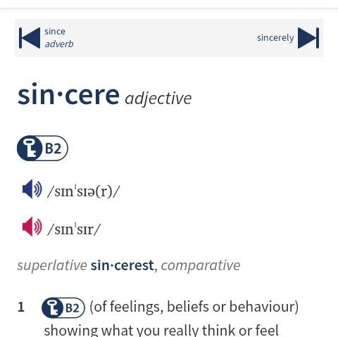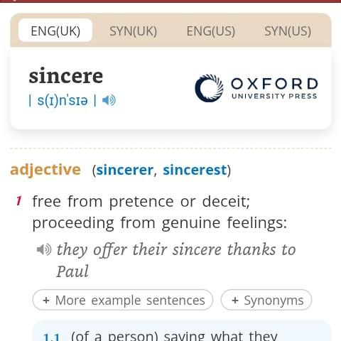
Image 16. Sincere, OALD Image 17. Sincere, OALD Image 18. Sincere, ODE

In Image 16, the online version of the OALD states that the adjective sincere has no comparative degree, though it provides the superlative. Image 17, a screenshot of the offline mobile OALD app, presents incomplete information about the adjective’s comparative degree. Image 18, a screenshot of the offline mobile Oxford Dictionary of English (ODE), explicitly specifies both the comparative and superlative forms of sincere. The omission in Image 16 likely stems from an editorial or linguistic oversight, while the issue in Image 17 may be a lexicographical error—failing to fully state the absence of a comparative form. Image 18, from the ODE, contradicts the OALD’s assertion. While no dictionary can fully meet every user’s lexicographic needs, this contradicts Gouwsh (2018), who emphasizes that lexicographers should carefully consider their users and usage contexts, as these factors should shape the structures, contents, and functions of dictionaries.

Morpho-lexical Misrepresentation of Lemmas
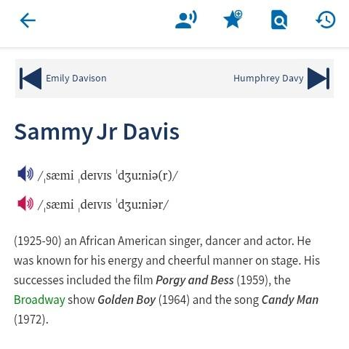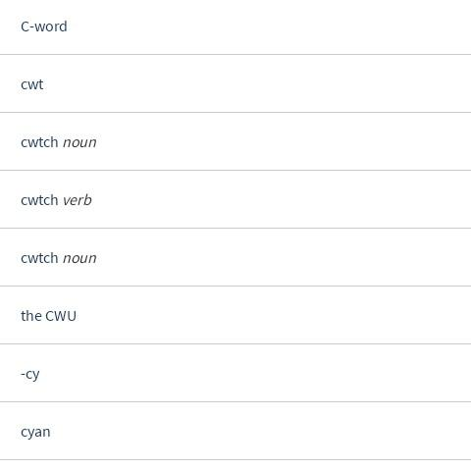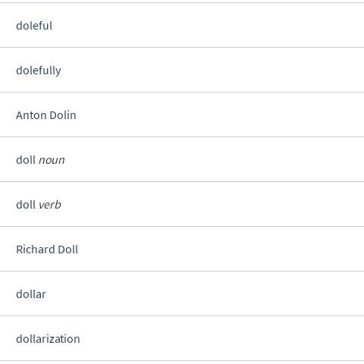
Image 19. Sammy Jr Davis Image 20. Cwtch Image 21. Anton Dolin…
Images 19, 20, and 21 further illustrate lexical structuring errors in the OALD. Image 19 highlights an error in the ordering of the structural components of a lemma—the proper noun Sammy Davis Jr—which is correctly written in the online OALD but misrepresented in the offline mobile version. Image 20 reveals a duplication error where the lemma ‘Cwtch’ appears twice with the same grammatical category and description, an issue present in both the offline mobile and online OALD, indicating a lexicographical oversight. Image 21 demonstrates inconsistent alphabetization in the OALD, as the screen intended to display words under the letter P erroneously includes entries beginning with ‘A’ and ‘R’. A strict surname-first inversion would benefit users unfamiliar with the prominence given to different name components. Addressing such irregularities, Gous (2010) emphasizes that lexicographers, having determined their target users and the data to include, must carefully design dictionary structures to facilitate effective consultation procedures.

Syntactic and Formatting Errors in Descriptions and Sample Sentences
The categorization of lexical errors in the OALD is broad, with each category deserving attention and time. While images 19 to 21 highlight discrepancies at the lemma level, this subsection identifies some grammatical and mechanical errors in OALD's definitions and examples.
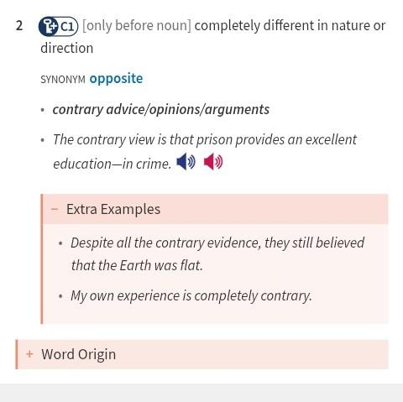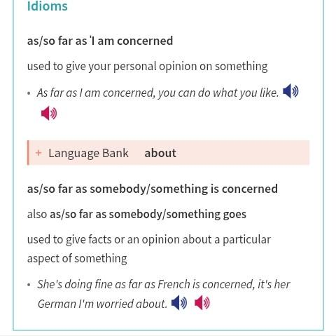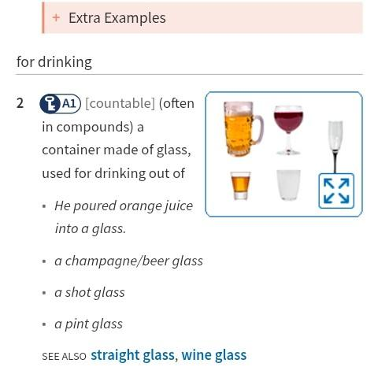
Image 22. Contrary Image 23. Concerned Image 24. Glass

In Image 22, the definitions and sentential use of ‘contrary’ are captured. The second sense is marked as ‘only before noun’, indicating its use as an attributive adjective. However, the last example sentence violates this rule by using ‘contrary’ predicatively after a linking verb instead of placing it before the noun it describes.
In Image 23, the last sentence contains a punctuation error. The comma between two independent clauses creates a comma splice. A coordinating conjunction, semicolon (;), dash (—), or a full stop would be more appropriate, as the first clause already forms a complete thought.
In Image 24, the definition of the second sense of glass is awkwardly phrased: a container made of glass, used for drinking out of. This construction is unnatural and stylistically unrefined. While sentence-final prepositions are becoming more accepted, a clearer and more natural structure would be ‘a glass container used for drinking’ or ‘a container made of glass, used for drinking’. These shortcomings align with Gous’s (2010) observation that meaning explanations must be shaped by “the language proficiency, needs, and reference skills of the intended target users” (p. 63).

Omissions of Necessary Details and Loose Formulation
Although Jackson (2018, p. 544) notes that “The structure and presentation of articles in printed dictionaries are constrained by limitations on space and the need to keep the dictionary to a reasonable size and cost”, it is difficult to understand why digital dictionaries still contract rather than broaden their descriptions. It is understandable why the OALD's printed version does not contain all the words and word senses found in the digital and online versions, but it is difficult to tell why the electronic and online versions still economize words in providing descriptions and word usage. In fact, Atkins (2008, p. 32) rightly notes that many lexicographic “problems discussed by Johnson persist to this day”. Indeed, the OALD is meant for advanced users, but these are still learners who require guidance and precision. The following images illustrate how the OALD leaves learners to deduce or assume meanings from its entries or become frustrated after an unsatisfactory dictionary consultation, ultimately placing them at the mercy of lexicographers. Tarp’s (2018, p. 21) assertion that dictionaries should “assist their users with advice and instructions in order to perform various types of actions” is, as demonstrated by the following photo presentations, not heeded.
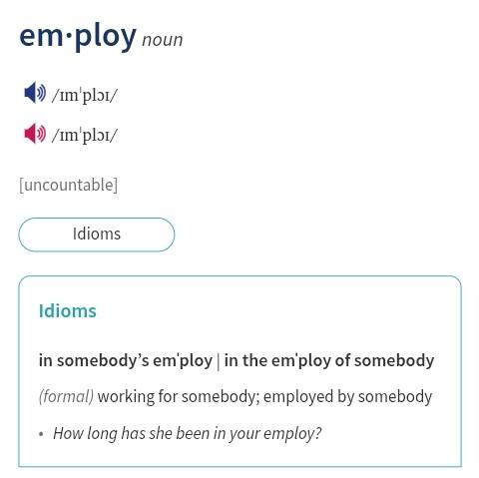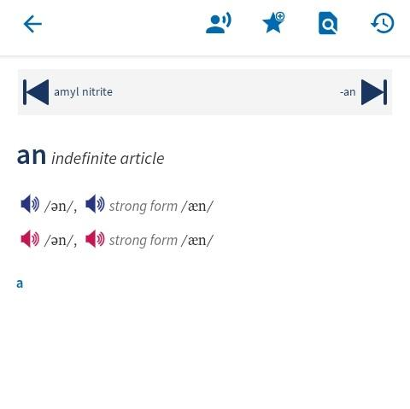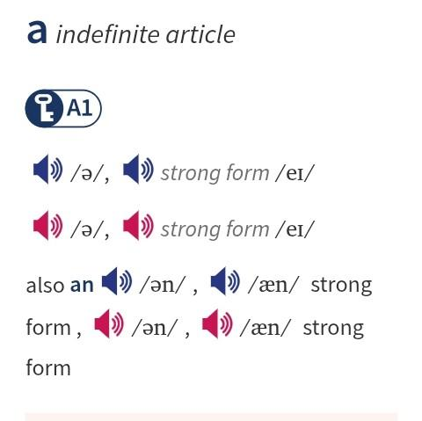
Image 25. Employ Image 26. An Image 27. A

Image 25 shows the OALD's vague description and usage of the nominal form of ‘employ’. The information provided prescribes only two collocations or uses for employ, which may mislead certain learners who rely solely on the OALD for guidance on word use. While no initial description is given for the word, the guidance on usage is insufficient. ‘In somebody's employ’ or ‘in the employ of somebody’ does not reveal other structural variations of the nominal ‘employ’, as seen in the following examples from the ODE:
i. In June I was told that the helpful Mr. Partridge had left the employ of the council.
ii. However, there is a reason that people are leaving your employ.
iii. Shortly after, my visitor, the one-time employee, left their employ.
Although words are contextually defined, the ODE defines the nominal ‘employ’ as “the state of being employed for wages or a salary,” and based on this, the above three examples are grammatically justified. The collocations in Image 25, however, create the impression that the nominal ‘employ’ must always be preceded by ‘in’.
Image 26 also highlights the OALD's vague and ambiguous entry for the indefinite article ‘an’. The information presents ‘a’ as also ‘an’, suggesting that both articles are interchangeably synonymous. Again, no detailed description is provided for ‘an’. While cross-referencing is a common lexicographic feature, the circular definition seen here is exhausting for learners, who may ultimately give up on the dictionary.
In Image 27, the entry for ‘a’ once again specifies that ‘an’ is also ‘a’, reinforcing the lexical approximation or near-synonym misrepresentation seen in Image 26. This misrepresentation leads learners who rely on precision into confusion and an incomplete or misleading understanding.

FINDINGS
The study found that certain errors in both phonemic and lexical representation in the OALD are lexicographic slips—mistakes made by lexicographers, not the linguists who participated in the making and formatting of the dictionary’s electronic versions. These errors are shown in images 1, 2, 3, 6, 9, 19, and 20.
Certain bits of phrasal lemmas are omitted in phonemic representation when considered widely known and too common an expression to warrant description. This manifests in image 7. The OALD has no transcription for ‘the’ in a word where it is bracketed, a pattern evident only in the offline mobile OALD app and the online version. Image 9 represents this reality.
The OALD lacks consistency in phonemically representing a word across various lemmas. It transcribes a word one way in one instance and differently elsewhere, especially when no indication is given that this is a free variation of the word. Images 10 to 13 depict this inconsistency, which confuses learners and heightens their apathy toward English as a language with inconsistencies.
The OALD does not consistently capture the pronunciations of already anglicized words based on their origins. Images 13 and 14 show the West African pronunciation of certain words, but image 15 does not for another word of West African origin. Some grammatical information in the OALD is misleading as it does not reflect common English usage. While dictionaries for native speakers show that ‘sincere’ has a comparative degree, OALD, a dictionary for learners, openly contradicts this.
The surname-first inversion is not applied when entering proper nouns alphabetically. Phrasal proper nouns are listed in their normal positions as though inverted, but they are not. Image 21 supports this finding. Grammatical rules are violated in sample examples, as seen in image 22, where an adjective is entered as attributive but used in a sample sentence as predicative.
Punctuation errors, circularity, and definitional opacity also manifest in the OALD, as shown in images 23 to 27. These findings align with Bergenholtz’s (2018, p. 34) observation of “failed dictionary projects”, for which he affirms that “it seems likely that we have a big scope of mismanagement in practical lexicography”.
The OALD does not prove, according to these findings, to be an impeccable dictionary, though it is uncertain if any dictionary would claim to be. It may be one of the learners’ dictionaries that prompted Tarp (2011, p. 190) to affirm that many LSP dictionaries especially “do not live up to the standards of modern lexicographic works”.

CONCLUSION
Lexicographers provide an invaluable service to humanity. Language development and documentation are not merely human tasks but a divine assignment. The art of book writing is demanding, requiring significant effort and resources. Although lexicography is a complex field involving many professionals, it can be perfected—what is worth doing is worth doing well.
The OALD, the focus of this study, is a highly reputable reference book, distinguished by its longevity, unique features, and continuous improvements. However, despite its scholarly stature, it has shortcomings—flaws that suggest negligence. These must not be overlooked simply because they appear in such a prestigious dictionary.
This study highlights inconsistencies that challenge both non-native learners and native users, underscoring the need for improved lexicographic review. Additionally, with digital dictionaries becoming more prevalent, discrepancies between digital and print versions necessitate uniformity in future updates. All OALD versions should be synchronized to maintain consistency.
Tarp (2011, p. 192) rightly notes that “linguistics and lexicography must be viewed as two independent disciplines”. Each department involved in dictionary-making must uphold rigorous diligence to ensure the OALD remains a widely trusted resource for English learners and users alike.

REFERENCES
Bergenholtz, H., & Tarp, S. (2003). Two opposing theories: On H. E. Wiegand's recent discovery
of lexicographic functions. HERMES - Journal of Language and Communication in
Business, 16(31). https://doi.org/10.7146/hjlcb.v16i31.25743
Creswell, J. W. (2009). Research design: Qualitative, quantitative, and mixed methods
approaches (3rd ed.). SAGE Publications Ltd.
Creswell, J. W., & Poth, C. N. (2017). Qualitative inquiry & research design: Choosing among
five approaches (4th ed.). SAGE Publications Ltd.
Fuertes-Olivera, P. A. (2009). The function theory of lexicography and electronic dictionaries:
Wiktionary as a prototype of collective multiple-language internet dictionary.
Fuertes-Olivera, P. A. (Ed.). (2010). Specialised dictionaries for learners. The Deutsche
Nationalbibliothek.
Fuertes-Olivera, P. A., & Tarp, S. (2014). Theory and practice of specialised online dictionaries:
Lexicography versus terminography. John Benjamins Publishing Company.
Fuertes-Olivera, P. A. (Ed.). (2018). The Routledge handbook of lexicography. Routledge.
Gouws, R. H. (2004). Monolingual and bilingual learners' dictionaries. Lexikos, 14, 264–274.
AFRILEX.
Huang, S., & Eslami, Z. (2013). The use of dictionary and contextual guessing strategies for
vocabulary learning by advanced English-language learners. English Language and
Literature Studies, 3(3), 1-10. https://doi.org/10.5539/ells.v3n3p1
Ivančič, I., & Fabijanić, I. (2017). Structural development of Oxford Advanced Learners’
Dictionary. Journal of Literature and Art Studies, 7(5),
https://doi.org/10.17265/2159-5836/2017.05.012
Jackson, H. (2002). Lexicography: An introduction. Taylor & Francis Routledge.
Ma, Q., & Yan, J. (2022). How do university L2 learners make use of mobile dictionary apps to
become autonomous learners? (Chapter 9).
https://doi.org/10.4018/978-1-7998-8981-6.ch009
Miri, S. M., & Shahrokh, Z. D. (2019). A short introduction to comparative research.
Mtallo, G. R. (2015). A critical study of the word meanings in dictionaries: A case of Oxford
Advanced Learner’s Dictionary, seventh edition. Journal of Literature, Languages and
Linguistics, 11.
Somba, S., & Widyaningrum, W. (2024). Visual dictionary for learning vocabulary for young
English learners. DE_JOURNAL (Dharmas Education Journal), 5(2),
http://ejournal.undhari.ac.id/index.php/de_journal
Tarp, S. (2011). Theoretical challenges to practical specialised lexicography. Lexikos, 21.
https://doi.org/10.5788/10--894
ten Hacken, P. (2022). Lexicographic and logical definitions for terms. Lingue e Linguaggi, 49,
13–29. https://doi.org/10.1285/i22390359v49p13
Zgusta, L. (1971). Manual of lexicography. Academia, Publishing House of the Czechoslovak
Academy of Sciences.

