The Phonological Structure of Words:
Evidence from Aphasia

Shanti Ulfsbjorninn

Department of Linguistics
Trinity Hall,
University of Cambridge

June 2008

Thesis in Partial Fulfilment of the MPhil in Linguistics
19’988 words

Per la mia dolce Leah,

Contents

0. Introduction/Abstract

1. The State of the Art of Phonology
  - Lexicon
  - The Phonological Module
    - Validating Phonology as a Whole
    - How does Phonology Work?
  - Markedness
  - Compounds
    - Testing for Phonological Constituency
1.4.1.1. Method
1.4.1.2. The Stimulus
1.4.1.3. Prediction/Motivation
1.4.1.4. Results
1.4.1.5. Discussion
  - Phonological Short Term Memory Buffer (pSTM)

- The Experiment, Context, Practice, Results
  - The Patient: Establishing a Diagnosis for specific pSTM deficit
  - Predictions for Phonology
    - Previous Experiment with RC on this Topic
  - Method
    - Subject
    - Materials
    - Error Analysis
    - Combining with Previous Data
  - Results
    - Errors in Preparatory Studies and Combined
    - Errors in CC Clusters
    - Phonological Nature of Errors

- Discussion
  - Markedness and the Responses, what’s the first to go
  - Compounds and their Immunity
    - Possible outcome one, and what it tells us
    - Possible outcome two, and what it tells us
    - Possible outcome three, and what it tells us
  - What is the Link Between Compound Immunity and RC’s Errors?
  - Procedural Account for Simplex and Compound Processing
  - Problems and Future Research

- Conclusion

Appendix 1 – Materials relating to the /shm-/ experiment (1.4.1.)

Appendix 2 – a) Complexity matrix for compounds
b) Complexity matrix for long words
c) Collected all productions + matrix + results for CC and VV deletion

Appendix 3 – Word-List for experiment in (2.)

Appendix 4 – Some samples of error productions

Appendix 5 – The Non-Words and results

I would like to thank Michele Miozzo for all the generosity he has shown me in completing this project and thanks also to the RC who patiently allowed himself to be frustratingly tested. During this first year at Cambridge, Bert Vaux has become an invaluable source of wisdom and generally a great guy. This year has also been made possible at various points thanks to the help from all these people: Adam Ledgeway, Deborah Anderson, Sarah Hawkins, Francis Nolan, Ian Roberts, and Theresa Biberauer. Lastly thanks to those who discussed little or large parts of this thesis outside of Cambridge, Pablo Scagani, Ryosuke Shibagaki and Lameen Souag. As always thanks go to Monik Charette, Jonathan Kaye and Markus Pochtrager for introducing me to and expanding my views of phonology and mostly for just being there. As always, the people named here do not necessarily agree with any or all of the contents of this thesis, all errors are my own.

“This dissertation is the result of my own work and includes nothing which is the outcome of work done in collaboration except where specifically indicated in the text”

0. Introduction

Neurological disorders can inform on the internal computation of certain processes on inspection of what is damaged. In this study we will use the data patterns gained from our, anomic, aphasic patient, RC, to demonstrate the correctness of certain phonological hypotheses about the representation and processing of transparent compounds compared to these same factors in simplex long words of equal length and syllabic complexity. Specifically we will demonstrate that RC’s production of errors and lack thereof is consistent with an analysis based on the principle of phonological licensing. These conclusions, furthermore, will bind the theory of representations of compounds with their distinct licensing characteristics to a general theory of non-typologically informed markedness; a view of markedness which is based on cognitively sourced behaviour and noticed early by Jakobson (1941). We will conclude our thesis with a novel procedural account of the mapping between phonology and the phonological short term memory buffer (pSTM). We will base this on the observations that the patient’s production of two-syllable words (2σ-ω) are near perfect, indicating a largely intact phonological module; and that the immunity of compounds of equal length and complexity to long- words, indicates that a simple pSTM ‘limited capacity’ account would also not be sufficient. Together, these observations, we will argue, demonstrate that neither a phonological deficit nor a simple pSTM deficit can completely account for the data; therefore we turn to a procedural account in the discussion of our results where the compound’s special representation interacts with our proposed phonology-pSTM mapping. The specifics of this mapping will link the phonological environment of RC’s errors: contiguous consonants and long vowels and initial unstressed syllables, with the compound’s special representation. The link, we will claim, comes from phonological licensing, specifically: a-licensing (Harris 1997). Our proposal, quickly stated, is that phonology is an exercise in licensing (cf. Calabrese 2005) and that once licensed phonological objects are mapped to the pSTM buffer to await articulation. We follow (Kaye et al. 1990) in stating that licensing is a phonological operation carried out by the domain-head, the primary stressed nucleus, therefore, in difference to a long word, a compound underlyingly contains two such domain heads (Kaye 1995), we argue, therefore, that compounds are processed in parallel, from each domain-head, which makes compounds doubly efficient in phonology to pSTM mapping compared to a long word of equivalent length and complexity. This novel processing model, sensitive to phonological licensing considerations, could only be positively revealed by a patient with a highly specific pSTM deficit and so it is with evidence from aphasia that we support our phonological hypothecations.

Part one has many roles. Primarily it will be focussed on providing a literature review for the matters the thesis deals with, the section on pSTM and compounds for instance. Part one however also serves to justifying the phonological tack we adopt in this paper and serve as an explanation for why certain disparate phonological approaches were not offered in our discussion in part three as competing models. Also, part one is used for setting up a justified mental architecture for the processing of lexical items, from the lexicon to phonology to the pSTM and extensively arguing for the independence and mode of functioning of each, contrasting alternate theories and situating the thesis in phonological perspective; specifically, this is used in combination to preliminary studies run by Michele Miozzo’s Sound to Sense laboratory to make a precision diagnosis as to the depth and type of the patient’s deficit.

Part two, will begin with exploring what RC’s preliminary results indicate and what these might mean for phonology. We then describe an experiment, mostly assembled by the author and incorporate these findings to the preliminary studies made available to the author by Dr Miozzo and present the results.

Part three, attempts to construct an inference to the best explanation hypothesis based on the results collected in part two and link the phonological environments which are prone to error with the special representation of compounds (as argued for in part one) in line with Harris’ (1997) view of a-licensing, specifically, in differentiation of long words. We also, (based on our discussion in part one) construct a novel procedural account for the mapping of phonology to pSTM and show how it can explain the error data in long words, crucially the fragments, and the immunity of compounds and short words.

1. The State of the Art of Phonology

Modern Phonological thought has come in many guises since it began with earnest with Chomsky’s (1951) Morphophonemics of Modern Hebrew, Halle’s (1959) The Sound Pattern of Russian and Chomsky and Halle’s (1968) Sound Pattern of English. This early work which grew into the nomenclature of generative phonology was, from a modern point of view, was often concerned with descriptive adequacy.

From a global view, however, the importance to all phonology which follows is an at least partial detachment of the behaviour and interaction of sounds from their physical acoustic characteristics. This detachment, however, limits itself to claiming that in any particular phonological process only a number of the distinctive features of the segments involved will be triggers or targets of this process and as such any and all other features of that segment will be irrelevant to the discussion of the process. Halle claims explicitly that any such approach to phonology would be toxic to a parsimonious theory: “[it would be] an unwarranted complication which has no place in a scientific description of language” (Halle 1959:24).

It is in this statement that modern phonological frameworks which purport to be truly scientific, such as Government Phonology which claims ‘popperian adequacy’ (Ploch 2003), can discuss phonological phenomena without allusions to the physics of speech-sounds (Kaye 1989; Hale and Reiss 2000). A cognitive Occam’s razor, Frustra fit per plura quod potest fieri per pauciora, (Hyman and Walsh 1983:649) allows the phonologist to discuss sound phenomena without necessarily mentioning the phonetic character of these sounds. It is in this freedom of analysis which renders phonology an abstract entity in the language faculty of the Homo sapiens sapiens mind/brain (Chomsky 1975).

The debate of abstractness in phonology was a prominent feature of 70’s phonology. Kiparsky’s (1968) How Abstract is Phonology and Hyman’s (1970) How Concrete is Phonology are cases in point. Although the camp that phonology should be as concrete as possible was prominent (Hooper 1976; Vennemann 1974a/b). Many had noticed effects that showed the physics of sound were deceptive to phonological behaviour validating abstract phonology (Dell 1973; Schane 1974; Selkirk and Vergnaud 1974) which only had to be constrained by ‘learnability’ and other nascient bio-linguistic considerations (Lennenberg 1967; Curtiss 1977).

As Segeral and Scheer (2001:312) rightly note, during the 80s discussion of the abstractness or concreteness of phonology was overtaken by work on the internal representations of segments and syllabic typology. However, Segeral and Scheer seem to underestimate the point to which abstractness in phonology has permeated 90’s phonological thought, although, granted, in a marginally different sense. The advent of Optimality Theory (Prince and Smolensky 1993; McCarthy and Prince 1995) relies on the notion of abstractness as its operations are characterised by selecting the most optimal version of the lexical input with respect to a strictly ordered list of often non-concrete constraints.

Abstractness lies at the heart of much of OT’s working, although this may not be immediately obvious, especially considering the often phonetically biased approaches of a number of its seminal papers (Steriade 1997, 2000; Yip 1993). This abstractness comes from the operations that OT performs and the very constraints that OT uses to judge its outputs. Although we note that some may have phonetic characterisations such as Pater’s (1999) *NC (although this is challenged in Hyman 2001):

*NC
No nasal plus voiceless obstruent sequences

Where Kager (1999:61) describes it as “grounded in articulatory mechanisms” (emphasis in the original) and further claims that it: “directly encodes the phonetic basis of the effect” (ibid.); a great many OT constraints (from the years 1993-1999) made explicit reference to abstract units without even a suggestion of physicalist factors, such as Borowsky and Harvey (1997):

*Final-C-μ
The final consonant is weightless

Associations of phonological objects to abstract boundaries, syllables, morae and feet pepper the OT literature such as the whole family of alignment constraints and many prosodic markedness constraints (Kager 1999:452).

Furthermore, Gen a primary and essential piece of OT machinery shared by all variations of the theory in roughly the same form (except for Candidate Chains (McCarthy 2006)), is, by definition not barred from any transformation of an input.

Gen
Generates output candidates for some input, and submits these to… [Eval]

Gen (Freedom and Analysis)
Any amount of structure may be posited (Kager 1999:20)

In fact, Gen is purported to modify any input into every conceivable variation of that initial input with no upper bound in the amount of structure added. The importance of this is that any and all changes that Gen makes to a specific input which then survive Eval and therefore outputted will be classed as phonological changes. Inherently, therefore, all phonological changes from input to output in OT are generated inherently abstractly, as even if a change may later be seen as phonetically plausible:

Word-Final Devoicing

[rad] -> [rat]

The cognitive source of that particular phonological change was made in abstraction to any phonetic considerations as Gen, the sole trigger of all sound change from input to output, and therefore the causal agent in the change of a sound, generated more phonetically unnatural changes than phonetically natural ones. Gen, by virtue of it being unselective, makes OT posit that all phonological changes are originally abstract (cf. Hale and Reiss 2008).

Although, as we argued at the beginning of this introduction abstractness in phonology is required if we are not to be thought of as simply phoneticians who cannot count, it is not true that the more abstract the theory of phonology the more it is validated as an independent field. To become charmed entirely by abstractness leads to loosing what Halle himself thought was highly important to complement his morphophonemics: the reality of the signal (Anderson 1985:319). In fact, Government Phonology’s recent sub-branch, Minimalist Phonology (Pöchtrager 2006; Ulfsbjorninn 2008; Schwartz 2008), combines abstract categories and processes while exploring the phonetic surface of our targets with concrete measurements.

In a similar vein, Bromberger and Halle (2000:21) in their philosophical treatise on phonology state that:

“Phonology is about concrete mental events and states that occur in real time, real space, have causes, have effects, are finite in number, in other words they are what metaphysicians would call CONCRETE PARTICULARS” (emphasis in the original)

Andrea Calabrese demonstrates the sense of the above quote by likening a phonological derivation to a bat’s hunting habits. Arguing that organisms do not evaluate all possibilities before making decisions, a bat does not calculate all possible trajectories (which would be infinite) to reach its desired prey, he concludes that whatever biological, electro-chemical, process unfold as the brain (say) palatalises a stop this operation was not carried out after considering all the other manipulations the phonology could have theoretically carried out.

Optimality theory, especially the ‘free-Gen models’ (McCarthy 2006), should naturally feel threatened by these arguments as Eval’s function is to individually consider and then holistically rank an infinite set of candidates to determine which one is the most optimal. The contradiction to Bromberger and Halle’s ontology is obvious and Alan Prince’s (1994) objection, as reported in Kager (1999:26), is as follows:

“Turning now to computational plausibility, the fact that candidate space is infinite does not imply that the problem is logically unsolvable. You may convince yourselves of this […] a unique solution to 3n² -3 = 45, which you will be able to find after a moment’s thought, even though the candidate set (let us say all the integers) is infinite […] therefore no simple argument against OT as being ‘computationally intractable’ can be based on the observation that candidate space is infinite”

Unfortunately for OT, it does not seem that their argumentation can withstand the logical problem of positing that a human brain makes a decision under time constraints. The objection from OT, a wholly abstract- or to use Calabrese’s (2005) term- unrealistic phonological theory, is that the solution to any addition of two integers is a unique answer out of an infinity of other possible (though wrong) answers. The conceit in this rather clever point is that it, presumably intentionally, neglects to mention that in OT it is not only the number of possible answers which is infinite, but the operation’s steps are similarly infinite. In generating [po:] from [po], Eval must specifically check each and every candidate which Gen produces. As Gen produces an infinity of candidates Eval must similarly check each of these infinite candidates to find the most optimal. There can be no legitimate short cuts specifically because the next candidate that Gen produces could hypothetically be better than the previous three million and forty two thousand candidates and so on ad infinitum literally. Furthermore, as OT defines its own constraints as universal principles (arranged as a factoral typology) there could also never be a theoretically perfect candidate, that is a possible way for Eval to inform Gen to stop generating ‘junk’ and signalling the end of that particular derivation.

For these reasons amongst others, see Rennison (2000), Vaux (2000) and Ploch (2003) we cannot agree that the most popular theory of phonology since the early nineties is correct even in its most basic assumed axioms. Rather it is in an as yet unspecified realistic view of phonology that we set our thesis (cf. Calabrese 2005).

1.1. Lexicon

The hypotheses we will posit for the patient’s data patterns have to have some psychological bearing and so to be at all reliable, we must establish a working view of the mental architecture for lexical production. It is with the knowledge of what is there and how it operates that we can diagnose the depth of the patient’s deficit. The beginning of all lexical derivations in any framework is the lexicon and as we will see there is very little consensus in phonology as to how this module operates.

The lexicon and specifically its interrelation with phonology seems rather neglected in much of phonological theory. Although the term lexicon is frequently used in all frameworks of phonology the specific information that the lexicon holds is usually specified but not argued for in any detail. Peculiarly, Anderson (1985) does not devote a section of any size to the developments in the concept of the lexicon while Kenstowicz (1994) has little more to say nine-years later.

What is common to all mainstream views of the lexicon is its conception as a long term memory storage. This seems self-evident, but as I shall reveal in this short literature review it may be the only common thread to well known phonological frameworks.

Being a long term memory store, all information stored in the lexicon is bound to be costly to some degree (may this eventually turn out to be negligible or not). These physicalist assumptions most likely lead SPE phonology to constrain the lexicon by the criterion of economy:

“[human brain is] designed in such a way as to minimize the amount of information that must be stored in the speaker’s mental lexicon” (Kenstowicz 1994:60).

Optimality Theory, as we have already explained in the introduction, not a great believer in parsimony and as a number of influential figures in OT, from the mid-nineties on, have explicitly counteracted the notion that the lexicon requires as little information as possible; Kenstowicz’s (1996) Uniform Exponence and Yip’s (1996) views of the lexicon are paradigm examples of this shift:

“[The]… paper argues against a rule-based model with a commitment to
lexical economy in favour of an output-based approach in which it is possible to remain non-committal about the nature of the underlying representation because any starting point will lead to the output that best satisfies these constraints” (Yip 1996)

At around this same period, Government Phonology, was also challenging the notion that only irregular information should be stored in the lexicon. In Derivations and Interfaces Kaye (1995) explicitly states that based on the projection principle, where licensing relationships may not be created post-lexically, that all irregular forms are listed separately in the lexicon. However, in GP starts with the premise that all positions in a lexical item, the material dominated by the skeletal points (Kaye and Lowenstamm 1984; Levin 1985), must be licensed and it is the role of phonology to check these licensing arrangements to convert the lexical information into an output. As such Government Phonology believes in lexical underlying syllabification (Kaye 1989; Charette 1991; Harris 1994; Vaux 2003). Government Phonology likewise believes in the uniformity principle:

Uniformity Principle

Contiguous consonant sequences in governing relationships will have a unified syllabification (Kaye 1992)

Therefore, GP is bound to claim that, at least cognitively, that syllabification is un-ambiguous. Ergo, as syllabic information is stored in the lexicon, a claim solidly backed at least up to the skeleton and nuclei, based on facts of liaison in French (Ulfsbjorninn 2007), we note that GP makes the claim that the lexicon stores both completely predictable information which is occasionally termed ‘hardware’ (Scheer 2004), and memorised along with completely unpredictable information (Kaye 1995) which must be holistically memorised. What is left over is what one may term the operations.

What is important for aphasia and for phonology generally is that the state of lexicon does have effects on phonological computation. GP takes for granted the fact lexical representations affect phonological computation, see Charette (forth.), for a classic example. In her paper Charette takes two nominal roots which are phonetically identical, however, on the addition of the possessive suffix the two words have different outputs. The explanation for this effect is that the two phonetically identical roots are in fact disparate phonologically, this difference only becoming apparent when morphology is added to the word. Once an environment for the difference in syllabification to the surface has been created.

Other work in representational phonology which exemplifies this fact also lies in underlying syllabifications, which are assumed to be lexical, and the effects these produce on phonological processes. In French, word-final consonant clusters have differing underlying syllabifications, this is demonstrated by their interaction with a process called proper government (Kaye 1990; Scheer 1998; van der Hulst 2008).

Proper government is a binary relationship between nuclear projections where one is obligatorily strong and the other is obligatorily weak.

Proper government

A nuclear position, alpha, properly governs a nuclear positions, beta, iff
a) alpha is adjacent to beta on its projection
b) alpha is not itself licensed (ie. empty and un-interpreted)
c) no governing domain separates alpha from beta (Kaye 1990:313)

It is claimed that proper government is a feature of grammar as a way of satisfying the universal which guards against empty and un-interpreted constituents, such as nuclei, the empty category principle.

Because of the projection principle re-syllabification is prohibited and therefore only an underlying difference in syllabification can account for the following data.

French (Charette 1990:80-81)

A)
[parl] ‘to talk’ Imperative: [parl] Infinitive: [parle]
[pelt] ‘to shovel’ Imperative: [pelt] Infinitive: [pelte]
[rakl] ‘to scrape’ Imperative: [rakl] Infinitive: [rakle]

B)
[at] ‘to buy’ Imperative: [at] Infinitive: [ate]
[alt] ‘to gasp’ Imperative: [alt] Infinitive: [alte]
[apl] ‘to call’ Imperative: [apl] Infinitive: [aple]

The analysis proposed and endorsed by Government Phonology is that the words in group A end in a bonafide branching onset or rhyme-onset sequence. Whereas, words in group B end in a onset, empty nucleus, onset sequence:

A-type word:

Infinitive Imperative
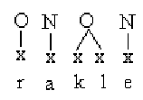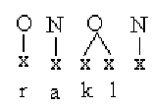

B-type word:

Infinitive Imperative
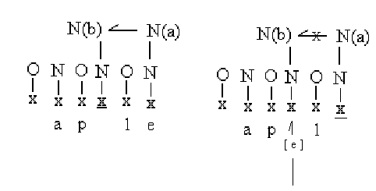
What we see above is that the B words’s word-final consonants are intervened by an empty nucleus, this nucleus would violate the ECP if it was not in a good proper-government relationship with its adjacent proper governor. As N(b) is properly governed it is licensed to be empty (p-licensed). When, however, the word-final nucleus is itself p-licensed this nucleus may not properly govern its adjacent empty nucleus. This leaves N(b) with no source of proper government, this leaves a category which is both empty and not governed, therefore the empty nucleus gains phonetic interpretation, as a schwa (Charette 1991:81).

What the above is designed to illustrate for this study is that there must be cues to phonology in the lexical representation of any given token. As both [kl] and [pl] are potential branching onsets in French, the phonology would not be able to distinguish a real branching onset and a bogus cluster. As such, the lexical representation of /rakl/ cannot be just a sequence of phonemes as is thought in both containment and correspondence theories of classical OT or connectionist conceptions of the lexicon (Martin et al. 1999:6 and references therein; Dell and O’Seaghdha 1992).

OT Input (ie. lexical representation)

/k a t/

Connectionist ‘lexicon’

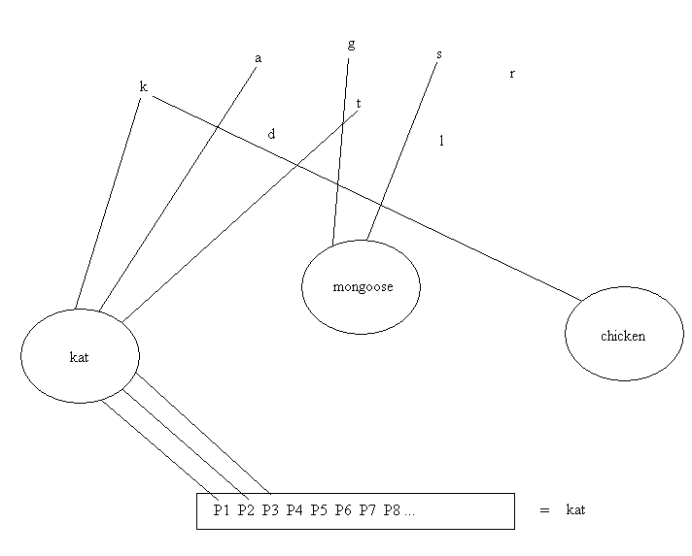

(based on Dell and O’Seaghdha 1992)

What the French data show quite clearly is that at least a modicum of syllabic information must be present in the lexicon, this may not be full syllabification (contra GP, strict-CV and Minimalist Phonology literature), but at the very least a diacritic of syllabification is necessary. An indication perhaps that two segments belong in a head and dependent relationship here signalled with the diacritic H ‘head’ and D ‘dependent’.

Lexical Diacritics for Syllabification

/r a k^{H} l^{D}/

Diacritics in the lexicon are actually not particularly new even for the surface oriented OT. One example is the OT treatment of Latinate stems in English which undergo the following phonological process:

K# ---> s / __ + ity

/lkt◻k/ + /ti/ → /lkt◻sti/.

As this phonological process is restricted to Latinate stems, or at least, perceived Latinate stems, a diacritic in the lexicon indicating its derivation or some analogue (Lee 2004:85) is essential if one is to explain the outputs of English speakers.

A further argument that the lexicon contains more information that classical OT is made by Ulfsbjorninn (2007). This talk presented at Surface Based Generalisatins at the CNRS Paris VIII, we argued that lexical syllabic information must be crucial to the operation of phonology. In French, the masculine word for small ‘petit’ behaves differently to the feminine form for ‘small’ /petit/ and also from a class of adjectives represented by /net/ ‘clean’. The feminine /petit/ and the /net/-adjective class retain the word-final /-t/ in all contexts while the masculine for small looses the word-final /-t/ before vowel initial words and utterance finally:

French
A)
/pti/ ‘small.m’

/pti a:/ ‘small cat.m’

/mõ pti – t – ami/ ‘my small friend.m’

B)
/ptit/ ‘small.f’

/ptit a:/ ‘small cat.f’

/ma ptit ami/ ‘my small friend.f’

The above are well known data and the adjectives that pattern with group A are said to end in a floating consonant while the adjectives that pattern with group B have lexically ‘anchored’ word-final consonants. The phonological effect in the A class cannot even be regarded as epenthesis (which would indicate a process of the phonological module only) as this class also lists: ‘am’ /suis/ and ‘my’ /mon/ amongst others. Therefore, the /t/ which surfaces in the intervocalic context in French must in some way lexically specified, and therein lies the problem. If we adopted classical Optimality Theoretic input conventions and the strong hypothesis of the lexicon optimisation axiom, the underlying form for feminine ‘small’ would be /p  t i t/, however, the masculine form would likewise be: /p  t i t/. From these two raw inputs the phonology would have no ability to discern the floating /-t/ from the anchored /-t/.

However, if skeletal points, the basics of syllabification (Lowenstamm 1996), were included in the lexical representation it would be possible to distinguish between a lexically floating consonant and a lexically anchored consonant.

Anchored vs. floating consonant representations
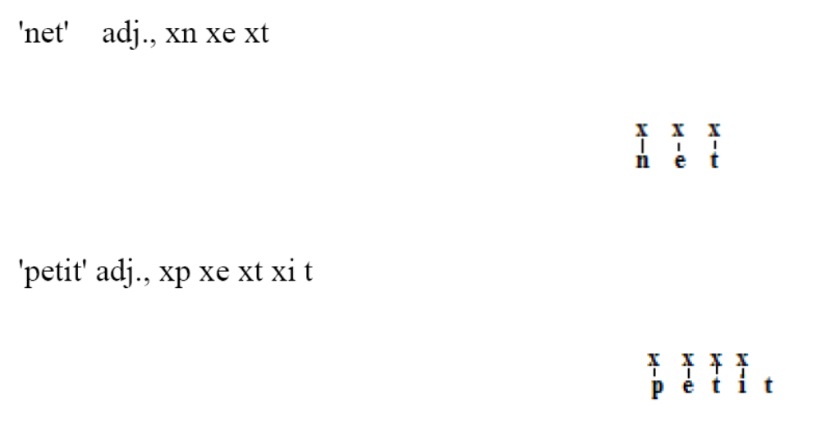
(Ulfsbjorninn 2007:7)

The above arguments seem convincing for the claim that the lexicon is endowed with at least more informational cues for phonology than classical OT or classical connectionist models allow for.

Also concerning the architecture of the phonological portion of the mind/brain we conclude that the lexicon does still contain information which is only made use of by phonology (such as the Latinate diacritic) but which are not themselves objects which are introduced by the phonological module (such as the floating consonants). We argue, therefore, for a lexical module independent of phonology (contra Martin et al. 1999; Dell and O’Seaghdha 1992).

Beginnings of the architecture of lexical derivation

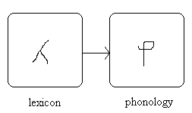

The notion that phonology is independent of the lexicon will be highly important for our diagnosis of RC as our explanation will revolve around the specific mapping from phonology to the pSTM. We argue that the lexical information in RC’s cannot be proved to be damaged in this case of anomia specifically because the patient, in cases where there is ambiguity in the picture stimulus, responds to both semantic and phonological prompting. Also the acceptance that the lexicon contains syllabic information gives phonology the job of applying the operations to this lexical information, for instance licensing the structure for interpretability (which we will discuss at length in part three). We can diagnose from this point that, most probably, the patient does not seem to demonstrate any lexical deficit and therefore, most likely, the syllabic structure and segmental content is correctly fed to phonology, which we will discuss in the following section.

1.2. The Phonological Module

1.2.1 validating phonology as a whole

Arguments in support for a phonological module were briefly mentioned in the introduction and in (1.1.). We wish to briefly diverge from our topic to explain why we believe a phonological account of the patient’s data can be made in abstraction from phonetic hypotheses, which are not offered as competing analyses. The philosophical implications of phonology as a cognitive module has been made in Bermudez-Otero (2006) who argues for and against the school of thought known as reductionism in phonological circles.

The argument runs that if a phonological process is grounded in phonetics, and thus could be given a satisfactory account in terms of either ease of articulation or ease of perception, one need not posit a competing phonological account. In this world view, phonologists could only justify their science by pointing to ‘crazy rules’ (Bach and Harm’s (1972) term) which appear to be sound changes which act in opposition to well known phonetic principles; if the aerodynamics of the vocal tract are insufficient to motivate the sound change it is taken as evidence for an independent phonological module.

Proponents of phonology, however, may well argue that this is not a valid characterisation of the motivations of phonology. Although, of course, processes which are seemingly abstract of phonetics are taken as evidence for indepenedent phonology such as the virtual geminate in Köln German (Segeral and Scheer 2001), it is not logical to claim that if a process can be understood in terms of ease of articulation or ease of perception they are not phonological processes rather phonetic ones.

The major problem with this claim lies in the thesis of falsifyability (Popper 1935). We can construct a thought experiment to this end, starting with the hypothesis (absurda) that, unbeknownst to scientists, all synchronic, linguistic, sound change occurred completely randomly, that is, by pure chance.

In this world take scientists attempting to tackle process X. If process X happened to occur in environment Y and by chance environment Y was what could be hypothetically deemed to be a catalyst for this change the scientists would refer to this as a phonetically grounded assimilation. If, however, that process X was to occur in environment Y and that environment was hypothetically deemed to be contrary to the phonetics of process X, the same scientist would term this process a phonetically grounded dissimilation.

This thought experiment is designed to illustrate that by construing both ease of articulation and ease of perception as motivations for sound change and for phonological processes there is, crucially, no way to at least exclude sound changes occurring for ‘physically abstract’, phonological, reasons and which contingently are located in environments which coincidentally phonetically suit either an articulation or perception account.

Word-final de-vocing is a case in point; this highly common sound change occurring in an environment which happens to suit a phonetic hypothesis, simplistically, the vocal chords ‘assimilate to the ensuing silence’ (Trask 1997). However, from independent phonological evidence (Kaye 1990) we note that word-final consonants will always for strictly cognitive reasons be located in a unified and abstract phonological environment: preceding an empty nucleus. To phonologists, constituents such as onsets and nuclei are concrete particulars and, as such, they can be perceived to have real and independent effects, however, as the empty nucleus is, by definition silent, it will mean that a word-final obstruent, because of onset licensing, will always be in an environment where it is followed by a phonologically conditioned silence. When attempting, therefore, to understand the cause of a change to a word-final obstruent it will not be possible, in isolation at least, to unpick the phonological from the phonetic.

The point of this diversion is not to get lost in Hume’s (1748) constant conjunction, rather, to emphasise that the reductionist thesis in phonetic-phonology is not any more rational as a starting point to establish a causal link to a process than formal phonology, simply because the objects and values they deal with can be measured directly (Kaye 1989; Ploch 1999, 2003; contra Shariatmadari (2006) and references therein). Our thesis, therefore, will unashamedly and scientifically attempt to explain data patterns from what we believe to be a rational and rigorous although frequently qualitative, formal phonology.

1.2.2. How does phonology work

As we will be creating a hypothesis about RC’s data patterns we must first locate ourselves in a framework of phonology from which to do so and then let the data explain itself. Furthermore, we need a view of the functioning of phonology in order to diagnose the depth of the patient’s deficit. We assume it is not as deep as the lexicon, could it then be as deep as the phonology?

SPE’s lead up to generative phonology produced a vast quantity of work probably best summarised in Kenstowicz and Kisseberth (1979). The work concerns itself with the key themes of generative phonology, processes. Generative phonology in the 1970s could be, possibly contentiously, be considered to be the beginnings of a natural history of phonology. What occurs in natural language, what seems not to occur and the beginnings of a discussion of phonological restrictions was inevitable. Once one crates a typology of phonological processes these immediately become clues as to the architecture of phonology itself (note in particular Kenstowicz and Kisseberth’s (1979) discussion of the theoretical possibilities of certain kinds of rules and opacity.

The generative approach, which is enjoying a small but solid renaissance at the beginning of the 21st century, operates under the notion that Homo sapiens sapiens constructs generalisations, call them rules, about sound input during (but maybe not limited to) the critical period, even when these are not garnered statistically. This framework, as we will show in contrast to OT, although not GP, lies firmly in the belief that generalisations may be produced from natural processes of sound change and organisation but also from custom. Calabrese (2005) states in his self-labelled generative phonology monograph that as language is invariably used as a device of communication, any convention of a speaker’s community will have to be (at least attempted to be) acquired by children of that community irregardless of the phonological ‘naturalness’ of this process. Information for generative phonology must be stored in two ways, long term memory (Calabrese 2005:ch1) or as part of a phonologically natural ‘grammar’.

There is, however, a significant change in Calabrese’s (2005) generative work and the work of generative phonologists from the 1970s. It would appear that early generative work did not concern itself with the shape of grammar as an independent entity in the brain. Unlike recent work in microparameters in syntax, where presence of feature x can be explained by the lack of feature y (Kayne 2005), generative phonology did not seem to attempt to create naturalistic rule-based maps, at least not theory internally. However, this is exactly what a parametric theory of language begins to construct.

Calabrese’s (2005) generative model, we believe, contains an implicit parametric design. Chapter two of Calabrese’s book concerns itself with a model for repairs, these can be described as the grammar of a language moving an unsatisfactorily marked construction (created by the syntax or by morphology) towards a state of unmarkedness. The repair operations can be termed as rules or generalisations and in a classic model of generative phonology one would simply list and order the rules creating marked states and then list and order the rules which move a construction out of a marked state. Calabrese on the other hand, clearly influenced by the language of optimality theory, states:

“Universal grammar provides a universal ranking of repair operations ofr a given active constraint… thus for each active constraint there is a set of basic repair operations that can be applied to a configuration violating it” (Calabrese 2005:77)

The example Calabrese uses is Chicano Spanish hiatus:

Chicano Spanish Hiatus

A)
mi ultima → myultima ‘my last’
su omero → swomero ‘his Homer’

B)
tengo ipo → tengwipo ‘I have hiccups’
como eva → komwea ‘like Eva’
esta ixa → estixa ‘this girl’

Calabrese then defines the markedness state or negative constraint which is violated in the underlying forms of the data:

NOHIATUS
No adjacent nuclear skeletal points or nuclei (inferring from his diagram)

Then he lists a set of set of repair operations which are “universally fixed across languages” (Calabrese 2005:78):

NOHIATUS universal repair ranking
glide formation > vowel deletion > glide insertion

Here however, Calabrese is forced into positing that languages may only contain a subset of the universally ranked repairs. This is fallacious, however, in the sense that unlike models of creating violations, the repairs must be grounded in phonology. Clearly stated, a repair operation which changes the word-final onset as a response to vocalic hiatus will not be a suitable repair, ergo, repairs if they are to be called repairs at all, are exclusively phonologically internal and responding directly to the trigger of a violation. There is therefore, no sense in which a group of speakers would not have the phonological option of performing a certain repair as this repair will always invariably be a phonological ‘natural’ to the violation. What this means is that all repairs are always available in every language (in as much as they do not create language specific marking statements). Therefore, in a system where repairs are hierarchically organised one cannot select a lower ranked repair without violating a higher ranked repair.

So let us take a concrete example, the possible repairs for NOHIATUS violation are as stated above. Glide formation, MAX and DEP (reflecting OT’s dichotomy or deletion and insertion). The shift towards parameters is as follows, the glide formation is a seemingly economic method of utilising a feature, element in the vowel which if inserted into a vacant onset position will satisfy NOHIATUS. If however, the vowel in question is a low-vowel and therefore may not form a glide. It is clear that a different repair operation will be required. There was a naturalistic reason why the first repair operation could not be implemented. However, coming to the second option there is not this same naturalistic choice of repair. Unlike being unable to form a glide from a low vowel, it will always be possible to delete the segment in question, just as it will always (particularly under a CV- or empty category theory of phonology) be an option for an epenthetic onset. Therefore, the choice between vowel deletion and consonant insertion is phonologically speaking equal. In fact, Lombardi (2002) lists many languages where when the glide formation rule fails to apply an epenthetic consonant is used over the hypothetical deletion of a vowel.

Furthermore, it is unclear from Calabrese (2005:78) when glide formation should fail when it is active in the language. In Chicano Spanish, for instance, a mid vowel which contains the feature [+high] or element [I] (Kaye et al. 1985), will spread from the mid vowel into the following onset position creating a glide:

Chicano Spanish

Lo abla → lwala ‘he/she speaks it’

This, as we have discussed, is explicable in terms of glide formation. However, the situation becomes more complicated in Maremmano Italian and an especially complex in Cilungu (Bickmore 2007:89).

In Maremmano Italian hiatus is not tolerated and must be repaired. This may be done by glide formation of vowel deletion.

Maremmano Italian

A)
la mi + a → la mija ‘my one.f (exclamative)’
pe lu + i → pel:uji ‘for him (exclamative’

B)
anatre armene → anatrarmene ‘Armenian ducks’
ortixe ombreze → ortixombroze ‘shady nettles’

C)
kavolo antixo → kavolantixo ‘ancient cabbage’
poz:o artificiale → poz:artifiale ‘artificial pond’

D)
paza infelice → kazanfeli:e ‘unhappy home’
pexora imbambita → pexo:rambambita ‘stupefied sheep’
cit:a ubriaxa → cit:abria:xa ‘drunk girly’

A words show the familiar Chicano Spanish pattern of glide formation confirming that in Maremmano Italian it is the most highly ranked repair operation. Maremmano Italian, however, also has vowel deletion, the B and C words, however, glide formation, at least in principle is not excluded here as the vocalic complex is V[mid] –V[low]. Thus the mid vowel would have a [+high] feature to spread (like it does in Chicano). The fact it does not must be perplexing to, at least, a straightforward reading, of Calabrese (2005). Maremmano Italian has glide formation as a repair strategy but it seemingly does not come into effect with mid-vowels. Only pure high vowels. The repair strategies in Chicano Spanish and Maremmano Italian according to Calabrese (2005) would be identical, and in the former the phonologically ‘natural’ reason stops glide formation from occurring and the need for a lower ranked repair strategy. However, in Maremmano Italian the language switches from a higher ranked repair strategy to a lower one without a naturalistic need to do so.

This does not in formal terms remind a phonologist of a universal ranking of repair strategies; rather it is more reminiscent of a parametric set up of repair strategies.

Cilungo, a Bantu language of Zambia and Tanzania, also provides evidence for a more parametric account of hiatus repair. Like Chicano Spanish and Maremmano Italian, Cilungo has a process of glide formation to repair hiatus configurations; when however, a mid-vowel and a low-vowel form a hiatus complex if the mid vowel is an /e/ this vowel will be deleted, while if the vowel is an /o/ there will be glide formation (Bickmore 2007:89).

Cilungo

A)
te a → ta ‘release’

B)
mo a → mwa ‘drink’

In this language again it would appear that the phonological system applies vowel deletion, not only where the system could otherwise have the supposedly more highly ranked repair: glide formation, but also the system is not symmetrical, unlike in Maremmano Italian. Simplex high vowels and back mid-vowels hiatus complexes are repaired in a phonologically economic way while this repair applied to a vowel where it would be just as economic and possible is disallowed.

Generally speaking what we seem to be seeing by examining more repair operations is that the repair operations which Calabrese (2005) claims are universally ranked are actually seem to be in a parametric organisation with certain languages opting for supposedly lower ranked repair strategies over ‘higher ranked’ repair strategies even when these are unambiguously part of the grammar of these languages.

We could claim therefore, that the phonological universal grammar’s generalisations are arranged more in terms of possible parameters rather than OT like universal rankings. This is not, however, unrestricted or arbitrary for the reasons espoused at the beginning of this section, as the repair strategy has to be phonologically rational with regards to what it is repairing. Also, Calabrese’s (2005) notion that repair strategies might be preferred cross-linguistically to others is not disputed by this fact, although a much more careful examination of the interaction of these parameters would be needed.

What we have attempted to prove is that, firstly, parametric accounts can give good account of phonological phenomena and secondly, that parametric views are positively beneficial to these analyses and are even unconsciously present in accounts of phonological processes in frameworks which do not claim to be parametric (Calabrese 2005). This claim, however, has massive implications for the analysis we might provide for RC’s data. If phonology, as a module, is parametric in operation it stands to reason that the damage to this phonological faculty should produce data consistent with a parametric analysis. As we will show in section two, RC’s data is not at all consistent with a deficit of phonology as we have discussed it, the production of di-syllabic words reveals a near-target production, which means that the patient’s deficit is not consistent with a parametric analysis as the parameter which guards for consonant clusters (seen above) should not apply selectively in short words while penalising long words. We will discuss these deep implications of this in section two, however, presently, we wish to illustrate that this section makes clear predictions about what a purely phonological deficit would entail; at least in a classical parametric view where operations are either switched on or off and structures therefore are either licensed or unlicensed.

1.3. Markedness

Having established the general shape of the lexicon and motivated a more parametric view to the functioning of phonology we can turn to an analysis of markedness. This will have clear implications for our patient when we reveal that his error types cluster around structures which are deemed, by most phonological frameworks, to be marked. We must illustrate with this section, however, how markedness is judged in phonology and the general inadequacy of typologically informed markedness, which we believe to be essentially contingent (cf. Samuels and Vaux 2005). We will discuss specifically how markedness relates to other psycholinguistic studies on other forms of pathology and especially critically discuss Calabrese’s (2005) markedness account of an aphasic patient, D.B., based on his earlier work with Cristina Romani (1998).

Generative notions of markedness such as the views of Roger Lass (1975) will be at least somewhat challenged in this thesis, which however, is a return to the old observation made by Jakobson (1941) (mentioned in the introduction). Lass’s observation was that markedness statements are not particularly useful for phonological theory because the markedness conventions required to motivate a certain group of languages will be of little utility in other language groups. While this has a kernel of truth when it comes to finegrained markedness statements and particularly as a motivation for the complete absence of supposedly marked phonological objects, it does not seem true that markedness statements cannot be generalised over languages to a significant degree, particularly when one examines language development and language pathology.

Turning back to Jakobson (1941)’s observation that marked characteristics are late acquired in L1 acquisition and the most likely to be destroyed by brain trauma we do see a surprising match between these facts and typology.

When it comes to the acquisition of consonant clusters branching onsets are almost always acquired after rhyme-onset sequences (Barlow 2001; Fikkert 1994; Kehoe and Lleo 2003); which mirrors the implicational universal that in languages with true consonant clusters (see, 1.1.) one commonly finds languages with rhyme-onset sequences without branching onsets but never the reverse (Charette 1991:ch5).

In fact, the relationship between acquisition and syllabic licensing seems rather strong. Although not mentioned explicitly, Gallon, Harris and van der Lely’s (2007) inspect the correlation between phonological complexity and specific language impairment (SLI) phonological deficit creates a set of marked structures:

Syllabic Markedness and Structures

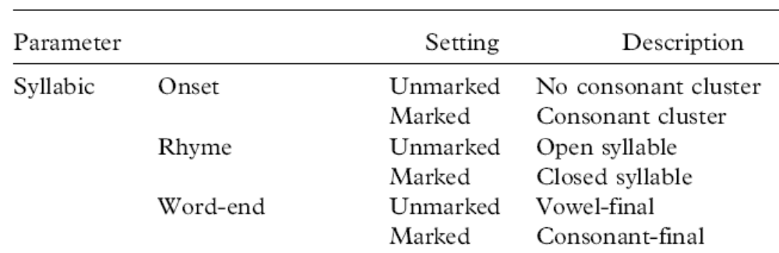
(Gallon, Harris and van der Lely 2007:440)

Word-final consonants, rhyme-onset sequences and branching onsets are listed as marked structures and Gallon, Harris and van der Lely’s paper shows that SLI child subjects produced significantly more errors with the marked tokens than the unmarked. What is crucial for this study, however, is that marked structures in typology are exactly the structures which suffer the most damage in pathology.

We will talk specifically about consonant clusters as these are rather well understood in representational frameworks of phonology and also amply studied across a wide range of disorders and development types, SLI (van der Lely 2005; Babyonyshev and Kavitskaya 2008), down syndrome (Hamilton 1993) and autism (Wolk and Edwards 1993).

Consonant clusters, particularly those involving branching constituents (as opposed to contiguous but non-related segments (ie. Arabic, McCarthy 1985; Lowenstamm 1996) seem to be affected and late acquired across the board of pathology. This reflects their marked status in typology of language which refutes, at least in principle, the notion that markedness statements are without use outside the language families they were originally claimed for (contra Lass 1975). In fact, as the work of the mid-nineties and early part of this century shows, markedness seems to be a crucial factor in phonology, in as far as it relates to cognitive processes.

Although markedness supposedly drives ones half of the constraint machinery of OT, we believe it is fair claim that OT has not, in of itself, as a framework, contributed to the understanding of markedness; rather it borrowed concepts of markedness directly from generative phonology. However, the methodology in the application of markedness has changed significantly with the advent of OT and its relationship with understanding mental processes and aphasia seems chaotic as we will shortly illustrate.

As McCarthy (2008:134) states, the emergence of the unmarked (TETU):

“[TETU is] …the most distinctive property of OT. No other linguistic theory has anything quite like it since it follows from constraint variability under domination. […] TETU gives OT a consistent account of defaults in phonology and syntax, and it establishes a direct connection, via ranking permutation, between defaults and language typology”

TETU is an effect of OT phonology where unmarked structures emerge from otherwise marked inputs. If, in OT, a number of candidates’ violations tie on the highly marked constraints then, because OT requires an optimal candidate, the lower constraints which would usually be overshadowed by the higher ranked constraints come into effect. This means that when all candidates violate a highly ranked constraint the most unmarked, that which violates the least markedness constraints, will be selected as the winner:

Emergence of the Unmarked in Nootka

cims-i:h → ci-cims-i:h

The argument with this data lies with the observation that the reduplicant is less marked than the base, this was achieved in OT by the following ranking: MAX-IO >> NO-CODA >> MAX-BR (McCarthy and Prince 1994).

Although it is true that in the method of implementation TETU is an OT phenomenon it is not true that TETU, as an effect, is not attested as a by-product of other linguistic frameworks (contra McCarthy 2008:134) as we will show when we attempt to refute Calabrese’s account of TETU in aphasia.

The problem with TETU in classical OT for generating unmarked input in language pathology is that, like any constraint based theory of phonology, it will have to posit that the constraint ranking has become subverted from its first acquired state.

Relative ranking of non-pathological ‘mongoose’

/m o  g u : s / | MAX-IO | IDENT-IO(s#) | NOCODA | *GU:S
mogu:s | *! |  | * | ****
mogu: | **! | * |  | ***
ogu: | ***! | * |  | **
→ mogu:s |  |  | ** | ****

Relative ranking of hypothetical pathological case ‘mongoose’

/m o  g u : s / | NOCODA | IDENT-IO(s#) | MAX-IO | *GU:S
mogu:s | *! | * |  | ****
→ mogu: |  | ** | * | ***
ogu: |  | ***! | * | ***
mogu:s | **! |  |  | ****

Above we see the reduction of consonant clusters similar to what we might observe in many types of language pathology. It was arrived at by subverting typical rankings such as one might find in English: MAX-IO ranked higher than NOCODA. However, because OT is a factoral typology, no subversion of ordering in ranking which would give us atypical English input can reflect a damaged phonological capacity expressly because OT predicts that such grammars could firstly, exist and secondly, exist as a typically developed and non-pathological natural language. So to re-order constraints in OT is no different to the acquisition of a new dialect of an unspoken, unknown language.

Although this is probably one of the least crucial shortcomings of OT there is a sense in which a hypothesis to explain the output of a brain trauma victim in any particular theory of phonology should somehow reflect the fact that the phonological faculty received, in fact, a trauma. It seems to follow from a realistic view of phonology (Bromberger and Halle 2000; Calabrese 2005) that damage to brains should incur damage of the concrete particulars and events of the phonological computation itself; rather than OT’s presumed explanation for aphasic outputs (to our knowledge not yet applied to aphasia) which is formally identically to learning a recently unknown but hypothetically existent language.

A different tack, to which we will apply the same (ideological) criticism is Calabrese (2005), based on his work with Romani (1998). They posited that syllabic markedness had an effect on the outputs of an Italian anomic aphasic patient D.B. In particular, Calabrese gives a novel analysis for the motivation of one aspect of the phonological deficit of D.B. by examining hiatus configurations.

It has previously been noted by Buckingham (1990) that hiatus configurations are particularly problematic for aphasic patients and considering the link we have re-enforced between markedness and pathological output this should not seem un-expected. In fact, D.B’s error profile appears to be a classic phonological deficit, unlike the patient we will present later. In this section on markedness we will argue that Calabrese’s (2005) interpretation for the cause of the error types in D.B. seems unnecessary; the only objection to his analysis, however, comes from the representation of markedness.

Calabrese states that markedness statements are deactivated in languages which allow the universal marked statements to be supervened. For instance, the markedness statement NOCODA (one presumes there is such a markedness constraint) would have to be deactivated in languages like Lakhota which have bonafide codas, however in Lakhota the NO-COMPLEX-ONSET (again we assume there is one in Calabrese’s system) markedness constraint would still be active because Lakhota has no branching onsets. If Lakhota was to be like Romanian with both branching onsets and coda’s then this markedness constraint, previously active, would have to be deactivated just like the NOCODA markedness statement already is.

What this means, in Calabrese’s (2005) view of markedness, is that the allowing of a marked object in phonology comes from the deactivation of a statement. This is exactly opposite to a parametric analysis where in order to allow a marked phonological object one has to activate a parameter which licenses its interpretability.
In his model of markedness Calabrese (2005:108) is forced to state that brain damage activates marked statements in the brain and as this produces an increase in active statements, repair operations are issued to deal with the violations of these constraints now activated by brain damage.

In the GP view, however, parameters such as those which govern consonant clusters are by most authors who use parameters default switched off and must be switched on to be active. This is the process of language acquisition in a principle and parameter framework of phonological acquisition (Pan and Snyder 2003, 2004; Ulfsbjorninn 2005).

Government Licensing Parameters

A) A nucleus may government license an adjacent onset [Yes/No]
B) A nucleus may indirectly government license [Yes/No]

In this model of phonology, as every position (excluding the head of the domain) needs to be licensed, the basic underlying skeleton of syllabic structure is the default without all complements and appendixes. So, damage to the phonological faculty will undo the learning process in that it may irrevocably damage the parameter settings, or the switch of these parameters. In the common parameter view, therefore, brain damage un-sets parameters, which is to say de-active them.

Although the matter here is not empirical, as both views give us similar results, if one of the aims of theoretical and formal linguistics is to construct a view of the mind/brain, this view therefore, should be contended and argued for even if it garners the same results. To this aim Chomsky’s (2004) Beyond Explanatory Adequacy shattered the Chomsky (1965) shield which theories like OT, for instance, used to justify their more peculiar axioms:

“a model of grammar is adequate to the extent that it explains systematicities in the data” (Kager 1999:26)

This point, however, is not valid, which we can demonstrate (unfaithfully) using Kripke’s (1982) sceptical argument against Wittgenstein; here rephrased.

The process of addition requires the human brain to perform 2 + 2, to which the unique answer is 4. A sceptic, however, may challenge this belief by insisting that you were not adding, you were schmadding. Schmadding, the sceptic informs you is the process of taking {[(n + n) – 56] + 56}. If this was the formula for all additions, the answer to the summation of your integers would not change, therefore, this style of addition is a perfectly adequate model which generates and explains the systematicity of the data. The only problem with this model would be that it is totally un-parsimonious. Calabrese’s (2005) explanation for the emergence of the unmarked is not particularly flawed; however, from our point of view, special objects require activation special conditions, while the lack or loss of special objects is a property of loss of these conditions. Although this may not seem like a large difference, we believe that it is more parsimonious in that the parametric view, contra Calabrese (2005), has less marked phonological objects as a direct result of the absence, through damage, of special phonological conditions. In Calabrese’s system, however, the absence of marked structures is characterised by the activation of special phonological conditions, that is to say, to have less material is to have more laws.

As we have emphasised, although this difference is not crucial in an empirical sense, it is certainly conceptually important if the goal of phonology is to understand the cognitive architecture of phonological representations and derivations (contra Kager 1999:26). For our thesis, this goes to giving the most rational solution to the observed data patterns we observe in our patient’s production.

1.4. Compounds

This section presents some of the phonological theory of compounds, regards their compositionality and internal representation, which will inform the discussion of their differing behaviour that we observe in section two and attempt to explain in section three.

As we have already stated, here, we specifically refer to semantically transparent, adj/noun-noun, compounds of the: ‘black bird’ [blákb:d] type; and lines of investigation into these compounds reveals some conflicting behaviour.

On the one hand, compounds behave like holistic items which pattern just like ordinary simplex lexical items; this, we might term, the surface state. Berent et al.’s (2007) study on compounds revealed a general dislike for regular morphology to be concatenated with the first compound member; crucially, in the same context where an irregular plural is not permitted:

First Compound Member Plurals

a) Regular b) Irregular

*ratscatcher micecatcher
*ratsinfested miceinfested
*clawsmarks teethmarks
*guysbashing menbashing
(Berent et al. 2007:4)

This dis-preference for regular morphology within the compound seems to illustrate their phonologically surface, holistic, nature; explicable through the generally accepted notion that syntax cannot ‘see into’ morphology. In a similar fashion the above data illustrates that morphology, to some degree, is also blind to the phonology (also a familiar notion from the strict-cycle condition of Lexical Phonology (Kean 1974; Mascaro 1983) and Stratal OT (Kiparsky 2000), and strict cyclicity of GP (Kaye 1995). As far as phonology is concerned, however, compounds display effects which are highly unlike the simplex lexical items of the language.

Dinka, a Nilo-Saharan language spoken in Sudan, has no consonant clusters in its simplex native vocabulary and presents an overall lexical template of CVC, CV: and also rarer cases of CV (Malou 1988:15). These conditions hold for the simplex native vocabulary but not for its compounds which are not phonologically accommodated to the constraints which hold for these simplex items. Compounds of Dinka may have consonant clusters and, in particular, highly marked non-homorganic nasal-stop sequences.

Dinka Compounds

t^{w}o-ja ‘Dinka language’
nan-co:l ‘black calf’
n^{y}ak-dur ‘early morning’
(Malou 1988:18)

These clusters are totally unattested in native simplex lexical items of Dinka, however, this cannot be explained by appealing to the Dinka preference for a monosyllabic word template. In cases where there are lexical polysyllabic words (proper names excluded) these form the template: V.CVC (for a more in depth discussion see Ulfsbjorninn 2008b).

Dinka Polysyllabic Native Words

arop ‘ashes of dung fire’
ajor ‘joke’
aloc ‘voting’
ayol ‘grass of the first spring rain’
(Malou 1988:18)

Clearly therefore, the polysyllabic compounds, phonotactically resemble syntactic phrases more than the simplex words of the language and these compounds are not accommodated by the array of ‘solutions’ (to use an OT term) available to phonology.

Similarly in English, a language which allows consonant clusters, we notice sequences in compounds which are not attested in native simplex words:

English Compounds

*atk rat-kat ‘rat catcher’
*kba sk-ba:g ‘sick bag’
*anko man-k: ‘man-car’

What we see, therefore, is that, phonologically, compounds phonotactically match word-junctures in syntactic phrases or morphological boundaries more than they do lexical items.

It is this lack of accommodation which provides circumstantial evidence that compounds are, in many senses, synchronically handled by the phonology as two separate units. There is also further evidence to support this thesis.

In GP there are a number of processes which can be said to apply domain-finally, before an empty nucleus before a lexical domain boundary. A domain is the phonological border of the syllabic structure which characterises a lexical item: a constituent. The first domain will apply to the bare stem, then, for every successive layer of morphology, a further domain is added (Kaye 1995). We use domain-final as a more accurate way of describing the context ‘word-final’: __#; a highly common environment for phonological processes to occur in (Khan 1976; Kenstowicz and Kisseberth 1979).

Consider the process below:

{ n → ø / __ ]ω }

Assuming that the underlying representation for ‘hymn’ is /hmn/ leads to the observation that in non-analytic morphological complexes, the L1 analogues from Lexical Phonology (Durand 1990:178), which Kaye argues must be holistically lexically stored, the word-final /n/ would no longer be domain final, it would be domain-medial within an item such as ‘hymnal’. Ceteris paribus, in such environments, the n-deletion rule would not apply:

(L1) lexically stored suffix

/h  m n , a l/ → φ [h  m n , l ] → [hmnl]

This would contrast with an L2 suffix, which Kaye claims are concatenated from separate parts in the lexicon, in such cases the /n/ in ‘hymn’ would be domain final and as such the rule would apply deleting the domain-final /n/:

(L2) intervening root-domain

/[h  m n] , full/ → φ [ concat φ [h  m n] full ] → [hmf]

This is exactly what one would find when ‘hymn’ is definitely its own lexical domain, such as in isolation before another word in a phrase:

/hymn/ before V-initial unconnected word

/hymn/ + /attack/ → φ[h  m n] , φ[tak] → [hmtak] *[hmntak]

When phonology is applied to ‘hymn’s domain, the rule applies and deletes the domain-final /-n/; subsequently, even when morphology is added, the /-n/ remains unparsed as strict-cyclicity dictates it invisible to the morphology.

The link between this and compounds is that in certain morphology types, the L2, we see bonafide domain-final phonological behaviours applying domain-medially. Nasalisation in French is another case in point. The relevant rule is as follows:

V [oral] → V [nasal] / __ ]φ

In isolation, both /bon/ ‘good’ and /son/ ‘his’ are pronounced with a domain-final nasal vowel. Reflecting both its environment and the product of the rule:

Lexical Representation of ‘son’ and ‘bon’

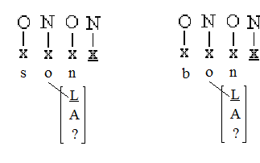
(modified from Kaye 1995:307)

As the lexical items are word-final the /-n/ induces nasalisation on the vowel, presumably via the element L’s attachment to the nucleus (for [+nasal] Ploch 1999).

However, the concatenation of ‘bon’ and ‘son’ in French appears to be different in nature. With one being affected by the above rule while others are not, Kaye (1995) concludes, therefore, that as the ‘son’ and ‘bon’ representations are virtually identical, and pattern identically in isolation: [sõ] ‘his’, [bõ] ‘good’, the difference must come from the manner of their concatenation.

Morphological Representation for /son-/ and /bon-/ /ami/ ‘his/good friend’

φ[ concat φ[son] , φ[ami]]] → [sõ ami]

φ[ concat [bon , ami]] → [bonami]

What we see in the former example is a word-final effect which occurs in a non-final context.

What we take from Kaye (1995) are clues which seem to point to compounds demonstrating an identical pattern to analytic morphology with seemingly domain-medial- domain-final effects; presumably evidensing the presence of a domain-final juncture after the first part of transparent compounds. We can exemplify this with Southern British English dialect variation:

[C l] → [ C l ] / __ ]φ

Southern British English

a) Standard Register b)N.W London Register Both

/batl/ [ba.tl] /batl/ [ba.t] *[ba.tl]
/skl/ [s.kl] /skl/ [s.k]

/atls/ [at.ls] /atls/ [a.ls]

/makl/ [makl] /makl/ [ma.k]
/makli/ [mak.li] /makli/ [ma.kli]

What we see is that a stop and a liquid, when domain-final, must have that lateral either syllabic or vocalised. In N.W London register, however, when the /tl/ sequence is word-internal the /t/ debuccalises while the /l/ remains ‘clear’. These contexts illustrate a case of domain-final behaviour and a diagnostic to see whether the first member of a transparent compound is, phonologically, attributed its own domain:

c) N.W London Register

Input Output meaning

/mtlpot/ [ma.t.po] ‘mettle pot’
/katlprod/ [ka.t.prod] ‘cattle prod’
/metlearm/ [m.t.:m] ‘mettle-arm’

[mtl:di] ‘metallurgy’

What the above examples show is that the first part of compounds does indeed behave as if it were in isolation; the domain-final rule applying in domain-medial context.
Contrastingly, the control word ‘metallurgy’, based on irregular morphology, behaves more similarly to the medial /-tl-/ we see in the previous examples where the /tl/ sequence is not domain-final.

From the phonological evidence, we review and provide in this paper, we assume a GP like line of argumentation where compounds are most probably concatenations of two lexical domains:

/blackb:d/ φ[ concat φ[blak] , φ[b:d]]]

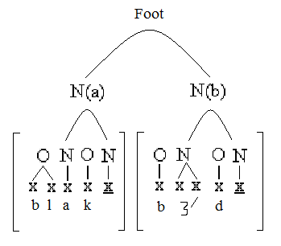
(based loosely on Kaye 1995:303)

Concurrently, on the psycholinguistics front there is a literature of evidence for what is known as the compositionality of compounds. Many of these experiments have relied on the lexical decision task in order to determine difference in behaviours between compounds and simplex words.

Taft and Forster (1975; 1976) pioneered the early experimental examination of compounds by measuring response times to random strings and recognisable words. They showed that, in fact, compounds are seemingly stored in separate chunks, at least if lexical decision tasks’ methodology is reliable (for dissenting views: Balota and Chumbley 1984; Seidenberg et al. 1984 and Monsell et al. 1989).

Contrasting views are also reported in the literature, notably by Butterworth’s (1983) and Bybee (1995) who’s models of lexical production and comprehension both suggest a holistic lexical storage even for transparent compounds. These theses, however, are challenged quite significantly by findings from priming tasks where, largely, masked priming has been demonstrated to quicken response time in subjects exposed to compounds. Interestingly, however, opaque compounds did not show similar effects (Marlsen-Wilson et al. 1994; cf. Longtin et al. 2003).

Recently also, an MEG study performed by Fiorentino and Poeppel (2007) demonstrated that, in a lexical decision task, transparent compounds were found to be compositional:

“The findings of the current study are also compatible with some parallel dual-route or segmentation-through-recognition models which posit a stored representation with internal morphological structure which can be accessed via initial activation of morphemic constituents” (Fiorentino and Poeppel 2007:993).

Based on our phonological evidence and the previous psycholinguistic studies we will assume that if RC’s data pattern does show compounds behaving differently to long words (see results in section two), we can assume it may have something to do with their compositionality and representational structure, as shown above. We will see later, in fact, that it is perfectly rational to assume that it is exactly their unique representation which can explain their immunity to RC’s deficit.

1.4.1 Testing for Phonological Constituency

We include this short experiment as novel convergent evidence for the compositionality of compounds in a manner which speaks to phonology. Serendipitously, when testing the experiment (described in section two) on a control subject we accidentally revealed an interesting effect in the compounds.

The subject quickly tired of the easy but long picture naming task and proceeded to undermine the experimentation by prefixing /shm-/ to all words. Crucially, a number of times transparent compounds were doubly merged with the supposedly word-initial prefix: /shmuper-shman/. Being a highly exciting purely phonological method to determine compositionality in compounds, we drew up a quick experiment to test this pattern in five typically developed, non-pathological subjects, all students at the School of Oriental and African Studies, University of London.

1.4.1.1. Method

Working individually with our subjects, we presented them with 10 pairs of tokens from which to form the generalisation:

Replace first onset constituent with /shm-/ [m-].

After having been ‘taught’ this rule we provided the subjects with an input and recorded the output.

1.4.1.2. The Stimulus

The learning stimulus were word pairs:

Cat shm-at
Oil shm-oil
Otter shm-otter

The words used to learn the generalisation were half consonant initial and half vowel initial in an attempt to demonstrate that even when the onset of a lexical item was lexically empty, the prefix was nonetheless merged with it, unlike the consonant initial words, where one requires melodic substitution; this was designed to guard against a hypothetical analysis such as: ‘replace the first filled onset in the lexical domain with /shm-/’:

All words used for learning the generalisation were simplex and no negative stimulus was given. Of the 15 tokens used for testing, 5 were simplex words (not repeated from the learning stage), 5 were transparent compounds and 5 were opaque or semi-opaque compounds (see appendix 1). We specifically did not include words beginning with complex onsets to hopefully limit the speaker variation reported in similar tests (Nevins and Vaux 2003).

1.4.1.3. Prediction/motivation

From our previous discussion of compounds and rules which apply to domain-final position while appearing to be domain-internal it seems logical that we could exploit a prefix which applies domain-initially in a position which appears domain-medially.

Prefixes in English, however, have well defined grammatical roles, just as suffixes do: (*rat-s-chaser (Berent et al. 2007), *rat-pre-chaser). However, there is a possibility that a non-British English grammatical suffix could be manipulated into a domain-initial boundary marker. /Shm-/ serving this purpose would, by the speakers with the appropriate generalisationg: merge /shm-/ with domain-initial onset, act as a domain diagnostic. For speakers with this generalisation it could be predicted that simplex lexical items would only have one domain-initial onset, this would also be true considering the lexical decision tests (reviewed earlier this section) that consider opaque compounds as lexical items. Meanwhile, compounds, contain two domain-initial boundaries ,so given the appropriate generalisation would generate a compound with two /shm-/ attachments, one per each domain-initial boundary. Our prediction will be that transparent compounds should have multiple /shm-/ merger while simplex and opaque compound words must have only a single /shm-/ merger.

1.4.1.4 Results

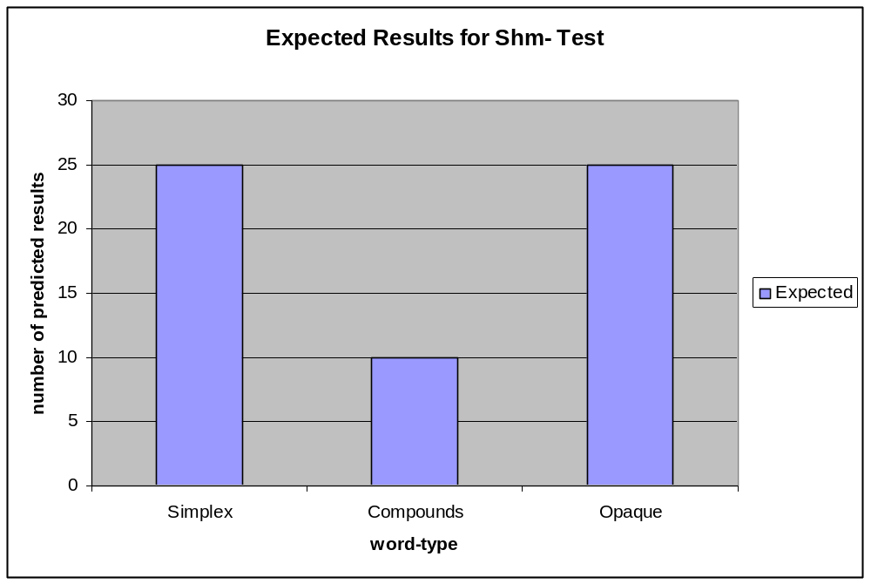

1.4.1.5. Discussion

The results on this small but decisive set of controls is that although it is not true that all transparent compounds were doubly merged with /shm-/, this was the case in 10 times out of 25 [40%], producing compounds such as: [shm9li:s shm9n] ‘police-man’.

The remaining 60% of not expected answers can be explained by the fact that (in order not to prejudice the subjects) there was no double merger of /shm-/ provided to the subjects so some subjects must have created a ‘word-initial’ generalisation over a ‘domain-initial one’. This difference, although from a small sample, turns out to be highly statistically significant (z test, p <. 000).

Crucially, opaque compounds did not have a single instance of double merger: *[shmi:shmine] ‘bee line’. Although the numbers in this experiment are small, from a phonological, primarily- qualitative analysis, it is important that simplex and opaque compounds pattern alike while transparent compounds demonstrate speaker variability; most likely demonstrating their already (phonologically) well-motivated complex structure.

1.4.2. Conclusions on Compounds

From phonological evidence we provided both old and original to this study and the literature review of psycholinguistic literature on compounds compounded by our small study we believe that reasonably strong evidence is present to motivate the above representation of compounds (see, 1.3.). This is different to that of simplex words as compounds, we believe, are comprised of two domains, with two sets of domain boundaries and crucially for our later analysis two domain heads (Kaye et al. 1990) the phonological item which supposedly licenses the syllabic structure and melody to be a lexical domain in the first place (ibid.).

1.5. Phonological Short Term Memory Buffer

Having established that the lexicon is probably not the locus of RC’s deficit and that most probably phonology is not either; we turn to the following module in our mental architecture, the phonological short term memory buffer (pSTM). Primarily, we will argue that the pSTM acts as a reverse analogue of the lexicon, a short term store of information. In this section we also discuss the pSTM’s association to language specific phonologies (Dupoux et al. 2001; 2008) which tells of the pSTM’s tight interaction with phonology, a topic which will become crucial in our analysis of the patient’s data.

Baddeley et al. (1984) first used the term to describe a holding bay for the information that was fed from higher mental processes, just before this information was to be issued to the motor-articulatory interface.

In contrast to psycholinguistics, mainstream phonological literature demonstrates an almost complete lack of study on this part of lexical production. However, as a buffer which transfers information from phonology to the articulators. Considering its role of phonological information carrier and maintainer (ibid.; Nimmo and Roodenrys 2002) its role is vital to its lexical computation and its interaction with phonology as a distinct module seems completely un-understood, perhaps because most of the seminal work on phonology and pSTM do not differentiate between the phonology and the lexicon (see, 1.1., 1.2.) (Martin et al. 1999, and references therein). In Martin et al. (1999)’s work on pSTM in aphasia no consideration is made as to explain what specific information is issued from the phonology to the buffer or at what stage or even in what order. Instead, psycholinguistics literature has thoroughly investigated whether the input and output buffer are the same entity (Monsell 1987; Romani 2002), and establishing a link between phonological complexity (virtually undefined from a phonological perspective) and recall ability (Caplan et al. 1992).

We also know the pSTM’s deficit signature. As a short term store of information, length effects, with the higher the word-length and more information, are a natural consequence as a damage to the pSTM can directly entail a damage to this store’s maximum capacity (cf. Baddeley et al. 1984).

Tantalisingly for phonologists, there have also been explicit claims in the literature that the pSTM bears some link with the specific language it operates with. In an ingenious experiment, Dupoux et al. (2001) demonstrated that French children’s ability to recall stress assignment in non-final position of non-words was markedly worse than Spanish children of similar ages. The observation that, in French, stress is completely predictable and always final, in contrast to the lexical stress assignment of Spanish is exploited as an explanation (cf. Dupoux et al. 2008). The claim in its entirety is that the pSTM’s abilites are inescapably tied to the language of the user.

Although Dupoux et al.’s (2001) experiment has much to offer phonology in hope of understanding and manipulating the pSTM in our theories of phonological derivation virtually no information is provided by Dupoux et al. (2001) as to explain in what way the phonology specifically interacts with the pSTM. The association between the two is simply observed.

Here we do not claim, at least based on the evidence we will provide in this study, that the pSTM is itself coloured by phonology. Rather we maintain the simplistic notion, until further evidence is brought to bear, that the phonological short term memory buffer’s interaction with the phonological module may be language specific in as much as the language’s phonology is specific but no more so. We hold, from an admittedly primitive stand point, that, ceteris paribus, all human pSTM are essentially in-variant holding bays. Supported perhaps by Chomsky’s (1975) early observation that children of any genetic origin may acquire native competence of any language irrespective of any particular stimulus (except the obvious linguistic exposure, food, air etc…). This observation may be simple but it is certainly effective in that it shows that as far at least as the functioning of language is concerned, a person from an unspecified ethnic origin is not prejudiced from acquiring any other. Therefore, as far as the mental architecture of language is concerned, it should be virtually identical across all typically developed individuals. We do not, therefore, stand by the notion that the pSTM can be coloured by the language that we speak. Although of course, an interaction between pSTM and phonology (depending on the nature of this interaction will be possibly divergent and specific to the language in question).

What we wish to highlight from this brief literature review is that psycholinguistics research, especially connectionist studies, have brought about a fair understanding of the pSTM regards its interfaces and its roles in production and also recently in perception (Jacquemot and Scott 2006). What has not been investigated sufficiently, from a phonological point of view, are the phonological details of what information is relevant in pSTM mapping and in what order this information is mapped. This last point, as far as we are aware, remains completely un-explored. With Martin et al. (1999)’s being a paradigm example of the arbitrary left to right mapping of phonemes to position slots in the pSTM (see 1.1. for a similar arbitrary mapping).

How compounds are treated by pSTM is also a matter, as far as we have been able to establish, which has gone un-researched from a phonological view. This however, seems to be a startling omission considering three facts.

- The pSTM is primarily an informational store (Baddeley et al. 1984) and it is therefore susceptible to the informational size of its content.

- Compounds may be as long as long words on the surface but in many regards they pattern as two short words eventhough they may be just as phonologically complex.

- The pSTM has been claimed to be specifically tuned to the phonology of the language of its host brain.

Together these factors are of vital interest to phonology due to the fact that the above list creates seemingly disparate predictions all of which could be tested with a patient with a specific pSTM deficit.

One prediction would be that compounds and long words, if matched for complexity and length, would be treated identically by a patient with a pSTM deficit, its status of the pSTM as a bare holder of phonological information would be confirmed.

On the other hand, the converse could also be expected. If the pSTM was in a specific feeding relationship with phonology then the compounds highly divergent representational structure could either make compounds more susceptible to damage (by a faulty pSTM) or less susceptible by the damaging effects of this pSTM due to their patterning as complexes of short words.

A prediction could be hatched based the assumption, widely held from proponents of the uniformity principle (Kaye 1992), that if the compounds’ phonological representation was responsible for their divergent behaviour it would create a polarised, rather than gradient, distribution of errors.

2.0 The Experiment, context, practice and results

2.1. The patient: Establishing a diagnosis for specific pSTM deficit

In order to unpick the phonological progression of information between phonology and the phonological short term memory buffer we will be continuing experimentation originally set up and performed by Dr Michele Miozzo.

The patient, RC, is an older man and a Cambridge native. He is anomic and could be diagnosed as suffering from broca’s aphasia. His linguistic type is characterised by inability to produce syntactically coherent sentences short of stock phrases such as: ‘ya know’ and ‘cripe’s me’ and ‘fucken’ sake’. However, his comprehension of everyday language does not seem to be impaired. His accent is distinctly native-like and the patient’s target-appropriate production of stock phrases reveals that he does not have any pronounced or observable motor-articulatory deficit.

Preliminary experimentation with RC revealed that the patient produced undefined errors in longer words (aver. 3σ) while making hardly any errors on words of less than 3σ: 31.3% vs. 5.8% (respectively).

What was poignant was that in these preliminary experiments complex consonant clusters were part of the tested words (appendix 2a/b) and, as we will observe later, CC clusters are a specific locus of error in RC’s production.

Based on the preparatory word lists, we constructed a matrix and revealed that long words were as phonologically complex as the short words (short words 56%, long words 71% (z test: p <.89)) when parameters such as presence of contiguous consonant and vowels were considered.

However, the patient made errors in 30 out of the 96 targets (31.3%). While in the short words the patient produced 23 errors out of 399 targets (5.8%) error rate (z test: p < .000).

What the above results show is that the number of syllables is a significant factor in RCs error production. In words that are shorter than 3σ his errors are significantly lower than in words longer than 3σ even if, as demonstrated above, the words have roughly equal complexity of phonological parameters.
In order to eliminate frequency based effects that may have interfered with the previous study we decided, for this study, to test non-words of 1, 2 and 3 syllables. In this experiment we were forced to rely on repetition for the obvious reason that it is impossible to know the target of the non-word from spontaneous production. Considering this caveat we found that the patient produced 5 errors in the 2σ set /64 [7.8%] while he produced 15 errors in the 3σ set /64 (z test, p <. 0.02).

The patient can be argued to have a decent semantic knowledge of lexical items, this can be observed by his telling of (disjointed but appropriate) stories in connection with many of the items. For instance when shown a picture of a Pomeranian (breed of dog), although he did not know the specific breed, he attempted to tell a story based on his own dog, ‘Bella’. From this and examples like it we can garner that the lexical store of information has not suffered substantial damage. Meanwhile the observation that RC does not produce errors with short words while he does with long words illustrates that his deficit is most probably not purely phonological. Let us take an error type, the consonant cluster deletion:

Error Type

CC → C

From the preliminary tests ran by Dr Michele Miozzo, we analysed this error type for the first time for this patient. We confirmed that between these two studies the long words had an average of 0.65 clusters per word (CC/ω) (n = 62) while the short words presented 0.53 (CC/ω) (n = 218), we took these ratios to be roughly equal.

The percentage of CC clusters to which the above deletion rule was applied was 12/62 (19.4%). While in the short words the deletion rule was applied 3 of the 218 opportunities (1.4%). A z-test proved this distribution was very highly significant at the confidence level of 99% (p > .000).

What the above proves beyond reasonable doubt is that long words are affected by the above rule while short words are not; but what this means to phonology is that the patient’s deficit is almost certainly not purely phonological.

Specifically, a rule that is applied in contexts such as long / short word is not a characteristically phonological generalisation. The reason for this can be demonstrated with three phonological frameworks and their hypothetical response to the above data.

Generative phonology would presumably handle the above data with rules such as that offered beneath. Crucially, as far as this author is concerned, such rules are never found in undamaged, natural phonological system:

*CC → C / #__# ^{long}ω

The situation would then worsen if other errors were included and combined to this rule it would look all the more unnatural and unattested in natural phonological systems:

*Target → Error / #__# ^{long}ω

Furthermore, one would have to posit a new feature in the lexicon which would be interpreted by phonology: [+long].

*[+long]
Words of more than 3σ are long

OT would not be able to account for this data without positing two distinct grammars, one for words of more than 3σ where *CC is highly ranked and another for the words of less than 3σ where *CC is lower ranked. Again length would have to be included as a lexical specification for more sophisticated versions of OT to keep a single grammar for this data pattern; but it is not inflammatory to say that OTists would not locate this patient’s deficit in the phonology.

Similarly, Government Phonology could not, using its axioms and tools, understand the above data as purely phonological. As discussed at length in section one, GP is a parametric theory and, as such, the parameters which specify for CCs would operate regardless of the length of the word. In fact, GP would not be able to accommodate the following generalisation.

*Stipulation
CC reduction applies in words of more than 3 syllables [yes, no]

This is due to GPs desired eradication of ad-hoc stipulations (Kaye 2001; Pochtrager 2006).

The conclusion we take from these three theoretical approaches it that in no mainstream framework of phonology would categorise this patient’s deficit as phonology. As the deficit was also not lexical, we turn to the pSTM buffer.
The signature of pSTM buffer deficits specifically lies with errors triggered by length of lists or items which are inputted into it (Baddeley et al. 1984 and following research). As the data fits exactly this pattern, we would diagnose this patient with an impaired pSTM buffer and generally speaking intact lexical and phonological levels:

Location of possible deficit in mental architecture

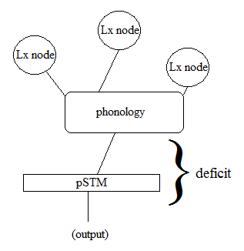

2.2. Predictions for Phonology

Generally speaking, a patient with a pure pSTM deficit will allow phonology to investigate what nature of information survives throughout the phonological information up until the very last stage of its cognitive manifestation, i.e. before it is interfaced with the articulators. From investigating what phonological information is primarily affected by a buffer deficit we can further start to illuminate the issue of how information is fed to the buffer. What allows us to do this is our general conception of how the buffer operates (see: 1.4.). As a store of information, damage to the buffer could be understood to entail that its capacity has been damaged (inline with degradation of information in psycholinguistics literature). Therefore, by observing what triggers an overload of this damaged buffer we may garner a picture of what is informationally costly to the phonological computation. We would argue that there should be a link between the costly and the marked. Although cost or economy are perennial consideration in linguistics (see: 1; Chomsky 1995), an internally motivated theory of how costly certain information is and what information is costly but negligible seems to be completely absent from linguistic theory (Biberauer p.c.). However, by exploring a deficit in an area of the computation which is specifically sensitive to the cost of information we could certainly create a more informed view of what phonological objects are marked because they are cognitive costly, as opposed to what phonological objects are marked because they are rare, as the latter is certainly not a logical entailment (cf. Vaux and Samuels 2005 for the inadequateness of this typological approach).

What will also concentrate on with this experiment is to explore the phonological observations that compounds do not pattern with simplex words (see: 1.3.1.) even when these are of equal length and complexity. The opportunity to study this phenomenon with this patient arises because ceteris paribus a long word and a compound of equal length and complexity should be treated identically by a buffer whose only concern is with the amount of information held in it at any particular time.

Compounds, as we have seen with our /shm-/ study (see: 1.3.1.5) generally pattern unlike simplex words. However, with RC, we can test whether compounds retain compositional characteristics up until they interface. As we have located the deficit in the pSTM, any differential treatment of compounds must be explained in a way consistent with the pSTM. However, unlike with our discussion of markedness, this differential treatment of compounds cannot come exclusively from the pSTM; and it is in this that it gets very interesting to phonology. The pSTM, we have described is a fairly crude store of information. A compound of equal length and complexity as a long word will therefore, by definition, contain the same amount of phonological information as a long word, if not more (considering the boundaries and empty nuclei in their representation (see, 1.3).

This means that, without considering anything but the buffer’s top-capacity, compounds should pattern identically with long words. However, if compounds are treated differently in RC’s data, they could be treated differently in two ways, both of which elicit different hypotheses.

Compounds could be far more prone to error than long words. This would probably lead to the rather un-stimulating observation that domains and empty nuclei, licensing and stress clashes, all of which characterise the transparent compound would quickly exhaust the buffer’s top capacity and as such be prone to quick degradation.

Another logical possibility is that compounds are less prone to error than long words of equal length and complexity. This result would be tremendously interesting considering what we know about RC. The preparatory preliminary experiments reveal that the phonological module in RC is largely intact (target appropriate 2-syllable words). It would also be impossible to claim that this pattern could be caused by compounds being less complex than long words. Therefore, the aetiology of this data pattern would be located neither in the buffer itself or in phonology itself; the problem would have to be procedural. If this result was to be found, RC would illustrate that it is in the way which phonology supplies the pSTM buffer that compounds differ from long words.

So, as far as we are aware this is to be the first study which, from a phonological point of view, explores this topic of compounds and how their representation could affect not the capacity of the buffer but the procedural steps from phonology to the buffer.

2.2.1 Previous Experiments with RC on this topic

Miozzo’s lab had already started to explore compounds in RC and compared to long words. They found that compounds were patterning differently to long words and, furthermore, compounds were less prone to error than long words. The preparatory study’s metric for scoring the results, however, was inadequate from a phonological point of view as it was a standard: 1 = error, 0 = correct, these were without any observation of the locations of error in the responses, without marking of multiple errors in the word or even the type of phonological error. All the results from the previous experiments had to be analysed from the viewpoint of phonology. This lead to the creation of a phonological matrix (appendix 2a/b), where all the target words were marked for number of syllables, number of phonemes, number of CC sequences in the word, number of VV sequences and number of skeletal slots (eventually turning out to be useless).

 | target | σ n | p n | CC | VV | x’s | tot
1 | barrel | 2 | 5 |  |  | 5 | 12
n(+1) | … | … | … | … | … | … | …

From this more specifically phonological matrix we were able to show that the complexity of compound and long word targets was not equal, with the compounds being nearly doubly as complex as the long words (1.6 - 0.7, z test: p <.000). This had lead to a complication in the preparatory experiments which had to be corrected for another experiment we ran on RC (originally prepared for this study but not included).

In order also to increase the number of RCs responses many long words and compounds were incorporated into the preliminary word-lists in order to create a phonologically even and large word-list for the subsequent experimentation, the complete word lists are listed as appendix 3.

2.3. Method

We ran a picture naming task which has been used extensively in the field of aphasia (Snodgrass and Vanderwart 1980; Ferrand et al. 1994) and previously used by Miozzo’s Sound to Sense laboratory (Columbia University, University of Cambridge). The patient is presented with a set of pictures set on A4 paper and asked to individuate and utter the name of the pictured object. Semantic clues were supplied in cases of ambiguity as this was not deemed to affect the matter under study. Priming of the initial consonant accompanied by a schwa was supplied in some cases although these were discounted from our study on the basis that phonological activation may be affected in unknown and thus possibly undesirable ways. In most cases, the utterances were also transcribed by hand by the author. All experimental sessions were recorded by audio and transferred to a media player for analysis. On average there would two breaks per naming where the patient would sip tea.

2.3.1. Subject

The patient was a broca’s aphasic who was also anomic and tentatively diagnosed with a selective pSTM deficit (in lieu of phonology or lexical). The patient had already qualified entry into the Sound to Sense research program as an aphasic outpatient sourced from a local aphasic meeting group. He is in late middle age and has lost all use of his right arm and although is right leg is also still affected; he can walk, aided by a stick. He seems to have no facial paralysis or obvious motor-articulatory deficit. He is a Cambridge native with a working class accent.

2.3.2. Materials

The materials used for testing are a set of long word and compound pictures taken partly from the Snodgrass and Vanderwalt’s (1980) standardised set and supplemented by public domain images taken from Google searches. All the pictures are black and white and number 207. Recording was done by a SONY Digital Voice Recorder.

2.3.3. Error Analysis

All errors were scored once as erroneous and correct (1, 0) and then scored using the phonological metric devised by the author for this study; specifically examining CC and VV reductions in the responses. Non-responses were excluded permanently from the analysis and responses as a result of phonological, initial, priming were also discounted. When the patient produced non-target words which are semantically related, clearly interpretable and have an error (the patient sees a pyramid and says: [fks] ‘sphynx’) these errors will be incorporated into the analysis.

2.3.4. Combining with Previous Experimental Data

Although all experiments were analysed separately by the author the number of responses for this study were increased by the combining of previous experimental results of the same type. As two of these sessions were not the result of work with the author and as yet unpublished they go acknowledged with thanks. The previous studies’ data was analysed in all cases by the author for the purposes of this study.

2.4. Results

In the preparatory experiments, analysed by the author, we discovered that the error rate for long words and compounds produced a polarised distribution; with long words suffering many errors and compounds largely phonologically unaffected. The results beneath are the number of errors for each word-type out of the total number of word types in our sample.

2.4.1. Errors in Preparatory Studies and Combined

30 / 96 [31.3%]

3 / 51 [5.8%]

Similarly the short words were almost errorless:

1 / 60 [1.6%]

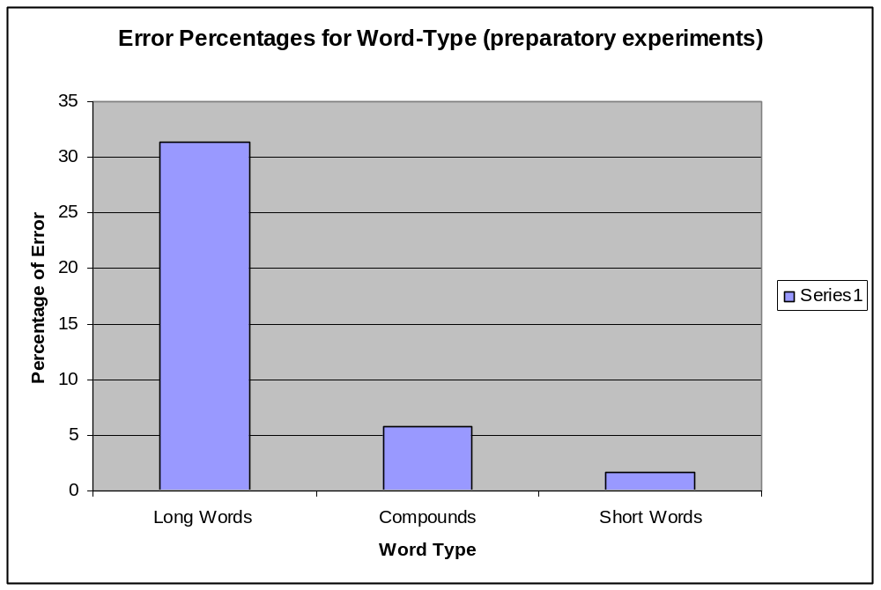

A z-test confirms that the error difference between long words and compounds is highly statistically significant (p < .0001), while the difference between compound and short words was not statistically significant (p < .075).

When we add the results from the experiments performed for this thesis by the author we notice that the trend is not modified.

Errors in New Study

Long words: 43 / 84 [51.2%]

Compounds: 2 / 43 [4.6%]

Short Words: 1 / 25 [4%]

As we can see the new experiments are remarkably similar to the preparatory experiments and when these are combined we observe the same pattern as before with an even less marked distinction between short words and compounds, which conforms to the prediction where compounds and fillers would pattern against long words.

Combined Errors from Study

Long Words: 73 / 180 [40.5%]

Compounds: 5 / 94 [5.3%]

Short Words: 2 / 85 [2.4%]

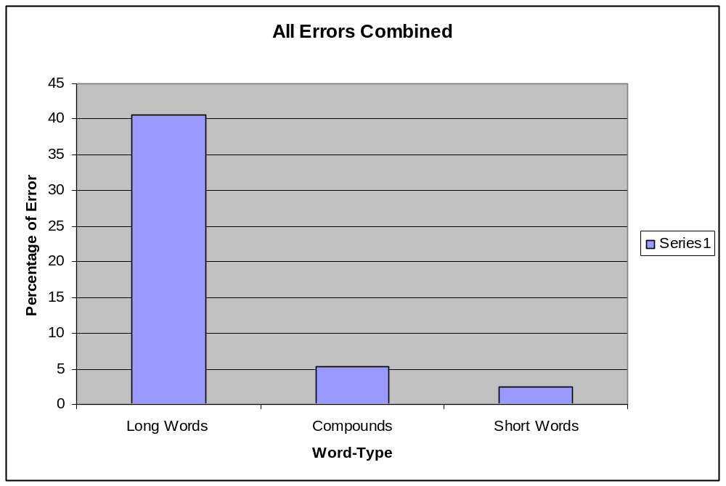

Again what we see is that long words pattern differently from compounds and short words and this difference is very highly statistically significant (z-test: p < .000).

2.4.2 Errors in CC clusters

As a further analysis we can observe that CC errors were a locus of phonological error. Their incidence in the data sample (combined) was, 0.7 CC/ω for the long words, 1.6 CC/ω for compounds and 0.5 CC/ω for short words, while the error rates combined are as follows:

Preparatory studies combined:

Long Words: 27 / 112 [22.1%]

Compounds: 1 / 91 [1.09%]

Fillers: 2 / 66 [3 %]

New Study:

Long Words: 19 / 62 [31%]

Compounds: 0 / 52 [0 %]

Fillers: 0 / 13 [0%]

All CC Errors Combined:

Long Words: 46 / 124 [37.1%]

Compounds: 1 / 143 [0.69%]

Fillers: 2 / 79 [2.5%]

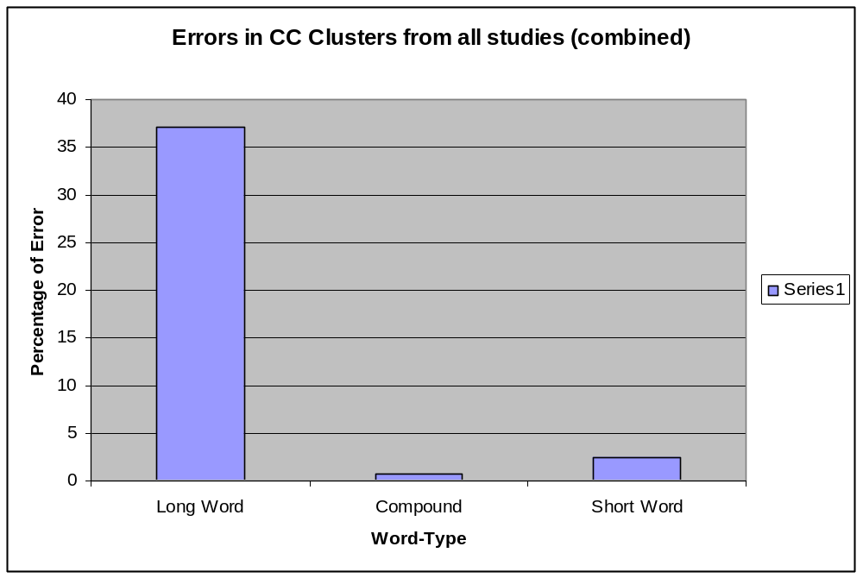

A z-test again confirms (p < .000) that CC errors are significantly more common in long words than in either compounds and short words; and that short words are not statistically more likely to suffer CC errors than compounds (p < .07).

2.4.3. Phonological Nature of Errors

We do not just observe CC errors, similarly and possible due to the phonological notion of the OCP (the obligatory contour principle (Goldsmith 1979)), VV errors are also common 7 / 44 [15.9%] (cf. Calabrese (2005) (see 1.3.)).

We also see a number of perseverations, metathesis and segment deletion and epenthesis, but none of these are at all systematic in the data. In fact, we decided for this study to ignore these error types due to time constraints, following Shattuck-Hufnagel’s (2008) observation that such fine grained error analysis also suffers from the ‘too many solutions problem’ where the hypothetical insertion of a [t] in [kapa(t)] would be analysed as epenthesis while in [ka(t)pa] it would be termed fusion and where the target was [kapat], the fusion of the A-element with the dorsal stop and deletion of a [t] would be termed: ‘metathesis’. In CC and VV targets however, we can construct a more reliable hypothesis for the errors that occur in them simply because phonological causes and effects of contiguous similar/identical items have been very well studied in phonology; especially autosegmental phonology (Leben 1973; Goldsmith 1979) and GP during the mid-80’s and 90s.

A further error type produced by the patient is the deletion of unstressed initial syllables. Although there were not many targets of this shape in the word-lists some were included:

Unstressed Initial Syllable Deletion

/dkant/ [kant] ‘decanter’
/k❷:din/ [k❷:dnn] ‘accordion’

As there were not many targets of the above shape and to test that this issue was not lexically unique we decided to include a number of words beginning with an initial unstressed syllable in our non-word task. The patient’s overall error rate (considering all parameters) in the non-word task was 21 / 64 [33%], however, the error rate in a subset of the non-words which all begin with an unstressed initial syllable have an 8 / 8 [100%] error rate. Although these are very low numbers, it is clear that the patient produces errors with unstressed initial syllables. The error types in these non-word data points are identical to the production in lexical words:

Non-Word Initial Syllable Deletion

/k:pm/ [k:pm]
/lpandu/ [panau]
/psf❷:t/ [s❷:]

What the above data show is that the initial unstressed syllable becomes deleted, but also, in fragments we can demonstrate that the stressed nucleus tends to survive. Crucially, these fragments cannot be explained as the patient stopping a word as the initial syllable in these fragments is deleted.

RC’s response to these contiguous segments is to delete one of the members of the contiguous sequence or epenthetically insert a vowel or a consonant between the opposite contiguous pair.

CC Deletion

/klarnt/ [karlt] ‘clarinet’
/prpl/ [ppl] ‘propeller’
/kkl❷:r/ [kk❷:r] ‘non-word’
/s❷:ntk/ [su:tk] ‘non-word’

VV Deletion

/daumin/ [damn] ‘dalmatian’
/ambjlns/ [amblns] ‘ambulance’
/gloknpi/ [glokspi] ‘glockenspiel’

Epenthesis into CC

/gloknpi/ [doknspi] ‘glockenspiel’
/mikrwiv/ [mikrwivz] ‘microwave’

Epenthesis into VV

/kolsi:m/ [kolsi:m9n] ‘coliseum’
/k❷:din/ [k❷:dnn] ‘accordion’

The above error types are all sporadic so no realiable quantitive analysis is possible. However, from a phonological, and more qualitative view, much can be said about the type of errors we see in the data and their relationships to the phonological issues we discussed in part one, starting with markedness and then our discussion of RC’s deficit in the face of what we discussed in part one of phonology and pSTM. Lastly of all, we will bind the issue with the results obtained from RC in our experiments and in the preliminary experiments with what we discussed in part one about compounds and their phonological representation and behaviour. All together we will use the above results to form a procedural account of RC’s pSTM – phonology deficit.

3. Discussion

3.1. Markedness and the Rsponses, what’s the first to go?

To sum up, one notices that the there is a commonality in error types across other linguistic disorders and in language acquisition. For clarity’s sake we can summarise the patient’s errors by context:

RC Errors

Consonant clusters | Vocalic clusters
Unstressed initial syllables

These contexts clearly speak to our previous discussion of markedness (see 1.4.) where we stated Jakobson’s (1941) observation and briefly discussed Gallon, Harris and van der Lely (2007)’s experiment on phonological markedness and error rates in SLI. The contexts which exacerbate error rates in SLI, and in aphasia, correspond precisely to phonological claims about licensing; in particular Harris’ (1997) notion of A- and P-licensing.

Generally in GP, licensing is the cognitive mechanism to ensure parsability of a phonological object in a word-domain. The content of the constituents, termed melody in (Pöchtrager 2006), is dependent on A-licensing as each element of a representation requires some form of licensing. If it does not receive this licensing it must be left unparsed (seemingly deleted from a surface standpoint). As this licensing issues from the head of the domain ‘the only unlicensed position in the word-domain’ (Kaye et al. 1990), we automatically create a core and a periphery to word-domains; the head and everything else. Harris uses this notion to unify the explanation of position neutralisation, however, our for our study, this notion can also be used to explain predominate contexts for error in our patient and incidentally many other pathologies as well.

A-licensing is as follows (Harris 1997):

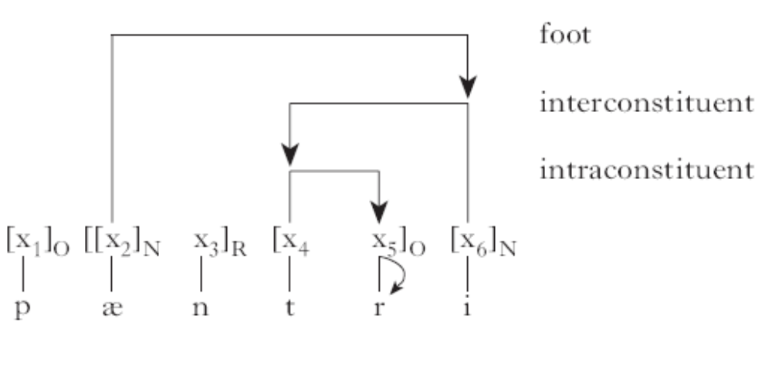
The above diagram, however, is inadequate for our purposes as it only illustrates one full relationship between the head of the domain and its edges, however, if all the relationships were incorporated into this graph, the nucleus, the core, would be the most buried constituent and its surrounding elements would be second most buried with licensing and so on, creating a weakening effect as you moved towards (in the above case) the right periphery of the word-domain. Crucially however, is the notion that contiguous consonants may not exist if intra-constituent government does not hold. Intra-constituent government is a mechanism whereby a ‘stronger’ skeletal point may govern a ‘weaker’ point (Charette 1990).

What we want to illustrate with the above graph is that in phonological theory, for independent reasons, it has been posited (also by Dependency phonology (Anderson and Jones 1977; Anderson and Ewen 1987) and other papers (Liberman and Prince 1977)) that relationships between melody and prosodic constituents are regulated within the word domain and naturalistically produce a hierarchy of strength going from the highly parsable nuclear core to the weaker and weaker periphery (crucially not in relation to the domain-edges, but in relation to the head of the domain, the stressed nucleus). The most licensed position we note is what one could term the least marked, while the weakest in terms of licensing (the furthest from the core) we could think of as most marked (cf. Scheer 2004 for his view of ‘core’ in his CVCV framework).

We believe this link has not been made before, eventhough Harris himself has contributed to a phonological investigation of SLI in relation to markedness (Gallon, Harris and van der Lely 2007). Consider the a-licensing diagram and the following from van der Lely (2005:54):

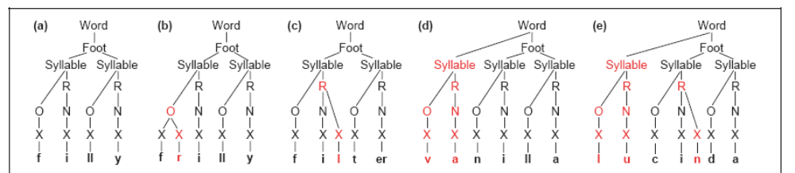

The above shows what van der Lely (2005:54) refers to as marked structures, the phonological reason as to why is attributable to Harris (1997). However, in van der Lely’s and Harris’ extensive psycholinguistics research in phonological reduction in SLI the principle of a-licensing is not invoked; although this is not particularly suprising as if one has a working definition of markedness one needs not invoke the cognitive principle that underlies it. However, for this study, the results we gained with the compounds will make a-licensing essential to the analysis of the relationship between phonology and pSTM with evidence taken from RC’s aphasia.

3.2. Compounds and their immunity

The results of our experiment which are possibly quite surprising involve the compounds. As we discussed in the prolegomenon to section two, there were three logical outcomes for the experiment and each had a different hypothesis attached to it.

3.2.1. Possible outcome one and what it tells us

The first hypothesis could have been that both word-types would be equally affected. This turned out not to be the case, and therefore, immediately shows the investigator that the surface representation is not enough to explain the facts and therefore a deeper than surface account is required (clearly damaging to classical OT which exclusively attempts to account for surface well-formedness). This data would also be completely impossible to model for proponents of a non-compositional lexical storage of compounds (Butterworth 1984; Bybee 1995) who, ceteris paribus, should expect errors to be roughly equally distributed between words of equal length and complexity.
Lastly it adds to Fiorentino and Poeppel’s (2007) study which demonstrates that compounds have early compositionality, compounded to this a patient with a specifically pSTM deficit treating compounds differently to long words shows that compounds’ compositionality must be ‘readable’ all the way from the lexicon to the pSTM where the information is ready to be issued to the motor-articulatory interface. So, this hypothesis failing leads to a total rejection of the thesis of holistically stored compounds.

3.2.2. Possible outcome two and what it tells us

The second logical possibility could have been that compounds would suffer greater phonological damage than long words of equal length and complexity. If this did turn out to be the case a number of factors would have been used to account for it which, in the eventuality of this outcome not occurring are revealed to be negligible. The compound’s more complex representation (see 1.3) could have been argued to require more information and, as such, be more affected by the pSTM deficit. However, it turns out that these factors can be determined to either be costly but negligible (in the eventuality of outcome one transpiring), or that these factors are actually beneficial in some way (in the eventuality of the third outcome transpiring), for this particular patient.

3.2.3. Possible outcome three and what it tells us

The third hypothetical outcome could have been where compounds were spared the punitive acts of the damaged pSTM while long words would not be. This is possibly the least expected but most interesting outcome. Meaning that something about the complex, compositional, representation of compounds aids their survival in a damaged pSTM.

The clue which reveals that the key to compound survival comes from the compounds representation is that all transparent compounds seem to be equally un-affected by the patient’s deficit, while opaque compounds such as: /r:zbri/ and /btfli/ pattern just like long words. Furthermore, long words such as: ‘micro-phone’ are treated just as long words even though they are more semantically decomposable than ‘raspberry’. In short, we see no gradient effects in the production data of this patient. Which supports a representational account which is likewise: essentially binary. This outcome leads to the hypothesis that either a token’s representation is felicitous to RC’s mental architecture or it is not in which case it suffers errors.

Most interestingly and crucially for our analysis, RC’s data forces the investigator to assume that his deficit is not exclusively located in the (reduced) capacity of the pSTM (see 2.2.). Concomitantly, 2 syllable words are pronounced without difficulty and generally target appropriately so we must assume that the general parts of his phonological faculty are basically unimpaired (even including foot structure). This is why we located the patient’s deficit in the pSTM. However, although the pSTM as we characterised it (see 1.4.) could well be suffering from a destruction of its holding capacity, this could not explain the overall data patterns because the compounds we selected were to be as phonologically complex as the long words. Therefore, if information is information, the effects of this maximal capacity should be equally applicable to both long words and compounds. Therefore, we claim that the issue in RC’s data is procedural. That is, something about the representation of compounds makes the pSTM treat compounds differently from long words and, in some way, spares it phonological damage.

What we will elaborate on next, is which representational characteristic of compounds could be naturalistically used as an anchor for a procedural effect which shields compounds from pSTM damage in RC. Furthermore, we will also attempt to explain the data patterns (see 2.4.3.) as a direct result of our hypothesis.

3.3. What is the link between compound immunity and RC’s errors?

We have previously located RC’s errors in contexts, unstressed syllables and contiguous sequences of similar phonological items. A comparison between those environments and the issuing of licensing from the head of the domain is made with the following diagram. In it, the asterisk represents a troublesome environment for RC (and for other pathologies see van der Lely 2005:54):

A-Licensing and Problem environment for RC

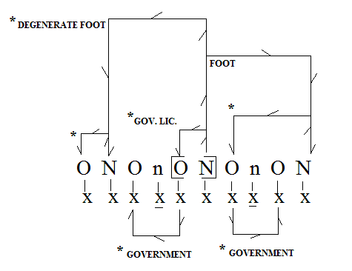
The above diagram would stand for a hypothetical word such as: [tntákr]. What we want to demonstrate is that the further away licensing emanates from the central core of the stressed nucleus the weaker the licensing strength (for phonological arguments see Harris 1997). The difference of Harris’ system over standard GP is that onset licensing of the stressed nucleus’ onset will be stronger than the onset licensing of another onset at the margins of the word. So what we have with Harris (1997) is a ready made account of what phonological reasoning could explain the overall pattern of errors in RC (and indeed in Harris’ own work: in SLI).

To illustrate the above perhaps more clearly, we can construct a venn-diagram of licensing strength in a word domain, each bracket representing a type of licensing and its distance from the domain-head. In the following diagram the colour is strongest where the licensing is most pronounced, the core of the word-domain, as the colour fades this is representing the weakening of licensing from this core into the periphery.

Weakening of Licensing Strength
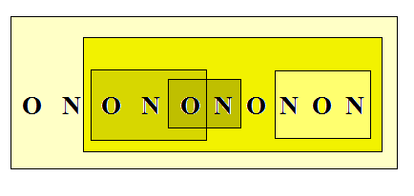
What we hope to have illustrated is how the phonological principle of a-licensing is a natural ally in explaining rather than describing the patient’s environment of errors. Also, it gives us a way to understand markedness in a non ad-hoc way (contra Calabrese 2005 (see, 1.4.). Essentially, the weaker the licensing the more marked the licensed structure will be, as it requires more ‘effort’ to parse something which is marked less avidly for its parsing. The most unmarked structure, therefore, would be claimed to be CV́; which is barely refuted (contra Ulfsbjorninn 2008b).

Exactly because this licensing is claimed to be universal, we can expect to find the environments CC, VV, and #σ-σ́ as loci of errors in a broader array of phonological pathology (which is what we find: for SLI (van der Lely 2005; Babyonyshev and Kavitskaya 2008); for down syndrome (Hamilton 1993), for autism (Wolk and Edwards 1993); for autism (Calabrese and Romani 1998)) and also in developmental language acquisition (for prosodic structure see and for Demuth 1995; Fikkert 1994; for syllabic acquisition Pan and Snyder (2003, 2004) for a parametric view). In short what we have achieved by linking a-licensing to RC’s data is twofold:

- provide a phonologically-internal motivation of markedness
- provide some explication of Jakobson’s (1941) observation (see, 1.4.)

Having located a phonological motivation for the location and type of RC’s errors, the next step is to attempt to link these facts with the representation of compounds which, combined, can produce a naturalistic explanation for compound immunity in RC’s lexical production. Luckily, this objective seems straightforward and truly very interesting to notions of phonological processing. The link lies indeed between a compound’s representation vs. the phonological reason for that representation and the effects it produces.

Comparing a compound’s licensing representation to a long word’s reveals a crucial difference between the two structures. If we take for example the structure we motivated in our introductory section (see, 1.3.), we notice that as there are two independent lexical-domains, these domains require phonological heads which issue their licensing-potential across the span of their lexical domain. Compounds, having two domains, have two heads and thus the licensing for the word-final consonant in ‘black bird’ is derived from the nucleus holding the ‘i’, while the licensing covering the domain-final ‘k’ is derived from the nucleus holding ‘a’. What this means in real terms, is that in a word like ‘blackbird’: [[blák] [b:d]], even though the overall stress is initial, underlyingly contains two nuclei, both heads of their domain (handled by a stress clash rule (Hayes 1995), and as such, the licensing to the periphery of the compound are actually peripheries in the compound parts. Essentially the two parts of the compound are licensed in a manner consistent with a simplex word:

Licensing strength distribution in compounds (cf. Kaye 1995; Harris 1997)
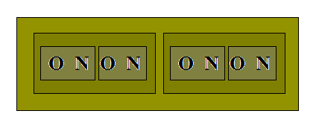
Licensing strength distribution in long words (cf. Kaye et al. 1990; Harris 1997)

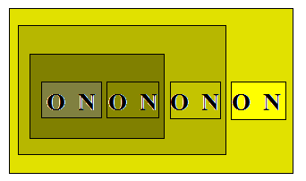

The above is also only a demonstration of the licensing principle and Harris’ (1997) a-licensing on the least marked syllable type. But as we can show with the above diagrams, no matter how simplex the syllabic structure, as long as the words are matched for length, there is no way that a transparent compound will loose licensing strength to its periphery faster than a simplex long word. This is exclusively because the licensing in compounds is performed per chunk, rather than per word, the result is that the compounds can be processed with twice as much parsing interpretability as long words of comparable length and complexity.
This is what, we believe, holds the clue to what phonologically underlyingly differentiates compounds from long words, however, this is only what would trigger a procedural account of phonology- pSTM mapping which will explain the data.

3.4. Procedural account for simplex and compound processing

When it comes to the interaction between phonology and short-term memory we will assume the following for considerations of parsimony.

- Phonology is about checking licensing relationships in information issued by the lexicon (GP literature).
- In a realistic view of phonology, computation should be made as quick as possible to maximise the organism’s advantage in the environment (Calabrese 2005:ch2).

The above two conditions create the parsimonious hypothesis (similar to phase theory in syntax (Chomsky 1999; 2001), that when information has been licensed and considered interpretable or un-parsable there is no longer a need to retain the information at that level of mental architecture. Therefore, as we know that this information must eventually be sent to the pSTM in any case, we would argue that mapping does not delay. So, information, is sent to te pSTM immediately as it is licensed. This would mean that stressed nuclei and their immediate licensees would be mapped to the pSTM before its later licensees.

Phonology to pSTM mapping 5 steps

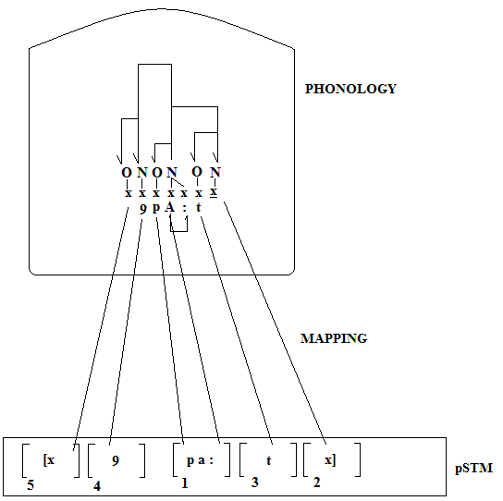

This model, in fact, correctly makes the prediction that true error fragments in pathological speech should begin with the initial CV of the head of the word-domain even in cases where this domain-head CV is not initial. This, in fact, is exactly what we see with the patient’s production of non-words with an unstressed initial syllable:

Fragment errors predicted

/psf❷:t/ [s❷:]
/lpandu/ [panau]
/k:pm/ [k:pm]

Beyond the various comments one could make about these pieces of data from a phonological point of view; what we can see is that the fragments are not cases of RC not finishing a word. The first example is just the domain-head CV́, which from our diagram of the procedure of phonology to pSTM mapping corresponds to the computation having stopped at point 1. The second word completely justifies our interpretation of the use of Harris’ (1997) version of the licensing principle, as we can see, this example not only shows step 1 but also step 2 which precedes the final step (the inclusion of word-initial unstressed syllables). Paradoxically, the beginning of the word is added after the end of the word when it is unstressed. Consider the target and the outcome.

Target for RC

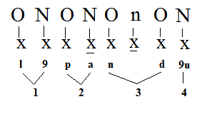
Outcome for RC

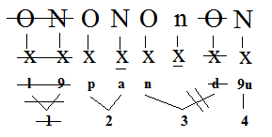

From a licensing point of view this process is consistent with our model of phonology-pSTM interaction (minus the ‘d’ deleting in place of the ‘n’). Crucially, the core of the lexical item has been preserved in RC’s production, as has the step 2, which in this case is the creation of the basic foot for the word (cf. Harris 1997; and see, 3.3.). The result is a response where the word final nucleus survives with the second syllable of the word, and virtually nothing of the periphery. Clearly this pattern is largely consistent with our model, however, in a system where phonology to pSTM mapping is done, for want of a better system, from the beginning of the word to the end of the word one would not explain this pattern, it would to merely be described (cf. Martin et al. 1999). What the above three examples provide is some phonologically compatible evidence that phonology maps the structures it has licensed and/or repaired (ie. carried phonology out on) to the pSTM in the order that the word-parts get licensed by this very same phonology. As far as we are aware, this is the very first account, based on a phonological hypothesis, that both specifies the order by which elements from phonology are inputted into the pSTM and gives some form of explicative account.

Crucially for this thesis this account of phonology to pSTM mapping can explain the pattern we observe with the compounds. Earlier we suggested that the parsimony principles as stated in (3.4.) motivates an immediate mapping from being licensed in the phonology to being mapped to the pSTM. As discussed at length, compounds have two phonological heads and as such the licensing in compounds is section by section. This, we believe, suggests that compounds are subject to parallel processing. If the reason we get phonology issuing information as soon as it is licensed to the pSTM is one of parsimony then it should hold for long words as well as compounds as this would be a consideration for the whole architecture of the grammar (and also links to phases in syntax (Chomsky 1999; 2001). One would, in fact, be forced to posit that compounds are handled in this way which results in compounds being doubly efficient to process (compared to their overall length):

Parallel processing and mapping in compounds, three steps

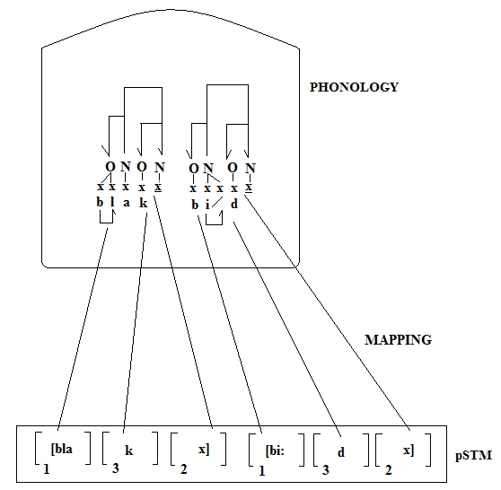

Although our steps may not be the correct ones, they are at least consistent between the two sample words: ‘apart’ and ‘blackbird’ and do in fact generate the appropriate generalisation, that compounds are more efficient to process as far as the pSTM is concerned, this becoming visible when the pSTM’s capacity is reduced in a pathological case. What we discover by applying our system is that a simplex word with four phonemes may take up to five steps to complete all its necessary licensing, conversely, a compound with seven phonemes, because of parallel processing could take only three steps to complete.

Our hypothesis, drawn from phonologically-internal principles, produces a harmonious result with what we observe in RC’s data. Long words and compounds even though they may be of comparable overall length and phonological complexity involve very different levels of efficiency (at the phonology - pSTM stage at least) and, more crucially, the parsability of compounds will be greatly higher than long words exactly because they are more strongly licensed and require less time sitting in the buffer before they can be issued to the motor-articulatory interface.

To conclude this section, we argue that it is the compositionality and representation of the compound which evidences the operation of the meta-linguistic principle of parsimony (see, 1.) and its role in dictating the handling of information between phonology and the pSTM, motivating parallel processing. As a consequence of this, to some degree, the processing of compounds will be more efficient than long-words specifically because information must sit in the buffer for longer, waiting to be issued to the motor-articulatory interface. We assume that this processing is ubiquitous across the Homo sapiens sapiens’ population but it is in an aphasic patient with a specifically pSTM deficit that this pattern (dichotomy between compounds and long words- in terms of processing efficaciousness) could be revealed. After all, this discovery seems to illustrate the procedural processing of phonological information between phonology and the pSTM and, as such, a very specific surface deficit is required to allow the observation of deeper effects of lexical representation on phonological computation and mapping to the pSTM. The relationship between licensing and issuing of information from the phonology to the pSTM, we believe, has never been investigated and could present a new line of phonological research into the link between phonological complexity and pSTM mapping (see 1.2.).

Furthermore, we believe that the link between the motivation for markedness and the licensing strength at the core and periphery has also never been made explicitly although we believe the highly tenable.

3.5. Problems and Future research

One prediction we would make, to be validated by future research is whether opaque compounds behave like long words or like compounds. We would expect them to behave one way or the other and not in some intermediate way. This is because our theory really only tells the difference between composit-words, with two separate underlying phonological heads, and non-composit words. And as such, no matter what the history of a lexical item is, it should behave either like the former or the latter. Our short /shm-/ experiment would indicate perhaps that opaque compounds will be treated like long words and if tokens such as /raspberry/, /pineapple/ and /microphone/ are valid examples our current data shows that they do, indeed, pattern like long words; however, a systematic study would be required to verify this fact.

Another prediction that is made by our results and that could be tested in future research is that our phonology-pSTM mapping and pSTM deficit diagnosed in this thesis leads to the conclusion that longer and fully transparent compounds should pattern like long simplex words. More specifically, if the transparent compound is composed of parts of three and two syllables we might predict that we would find errors only with the long part of the compound in the same proportion that we find with long words: [newspaper stand] → [error – fine]. However, as the final step in compound licensing is the concatenation of the two compound’s parts we could expect this to lead to overall errors for all parts of these very long compounds most probably at the same level of error found in tri-syllabic words. We believe that this would be the most fruitful area of research after this study on this same topic.

The problem with our conclusion lies with an alternate explanation of lexical support. In this phonologically based thesis we showed how a phonological account can more than adequately explain the errors in RC’s data. However, in order to truly exclude the non-phonological lexical support hypothesis, where the compounds are kept stronger in the pSTM due to multiple strong activation levels, it would be required to test the patient on his production of non-word compounds (ie. no lexical support), the problem however, lying in the fact that we cannot know the attempted production of a non-word. We were also not able to exploit repetition as this added extra layers of complication to our data which could not be excluded if looking exclusively at production. However, some way of eliciting the pseudo-compound could be attempted in future research; for instance, the presentation of two non-words said to represent semantically compoundable concepts. Although the non-words in question would be listed in the patient’s lexicon (at least temporarily) their connections to phonology and pSTM would certainly not be as enforced as those in [blackbird]. Therefore, the connectionist thesis, the lexical support hypothesis, would predict that these pseudo-words should pattern with long words, while a phonologically informed prediction such as that presented in this thesis would be that these should pattern like compounds. Having spent many research hours working on repetition this method of eradicating or validating the lexical support hypothesis was not included into the research, although it should have, although now it currently stands as a clear research area following the claims and discovery within this thesis, which like any scientific hypothesis should be considered to be temporary.

4. Conclusions

We end with the following conclusions. We diagnosed RC with a specific pSTM deficit where length and complexity of targets were the most significant factors in RC’s lexical production. We noted that compounds of equal length and complexity to problematic long words were unaffected by errors. We state that it is impossible to explain RC’s data patterns with either a deficit to a realistic phonological module or a pSTM with its capacity reduced; we conclude, therefore, that RC’s deficit must be procedural in nature, involving the mapping from phonology to the pSTM. We claim that this phonology-pSTM mapping is ordered in accordance to the phonological licensing and subsequent interpretability of the parts of a given token. Compounds being comprised of multiple sources of this licensing are therefore claimed to be processed in parallel starting from two parts of the token, while compounds of equal length and complexity must begin at a singular point in the span of that token. As such, processing of compounds is far more efficient than the processing of long words of equal length and complexity. This processing module relies on a-licensing, a principle we believe showed to be inexorably linked to the status of compounds, contiguous consonants and vowels and unstressed initial syllables – thus tying together the reason for efficient compound processing with predominant observed error types in our aphasic patient.

Bibliography

Anderson, S. R. (1985), “Phonology in the Twentieth Century: theories of rules and theories of representations”, University of Chicago Press.

Anderson, J. M. and C. Jones, (1977), “Phonological Structure and the History of English”, North-Holland.

Anderson, J. M. and C. Ewen, (1987), “Principles of Dependency Phonology”, Cambridge University Press.

Babyonyshev, M. and D. Kavitskaya, “Syllable Structure and Sonority: the case of Russian-speaking children with SLI”, paper presented at CUNY Phonology Forum on the Syllable, City University of New York.

Bach, E. and R. T. Harms, (1972), “How do Languages get Crazy Rules?”, in Stockwell and Macaulay (eds.), Linguistic change and generative typology, 1-21, Indiana University Press.

Baddeley, A., Lewis, V. and G. Vallar, (1984), “Exploring the Articulatory Loop”, in Journal of Experimental Psychology, 36:233-252.

Balota, D. and J. Chumbley, (1984), “Are Lexical Decisions good Measures of Lexical Access? The role of word frequency in the neglected decision stage”, in Journal of Experimental Psychology: Human perception and performance, 10:340-357.

Barlow, J. (2001), “The Structure of /s/- Sequences: Evidence from a Disordered System”, in Journal of Child Language, 28:291-324.

Berent, I., Pinker, S., Ghavami, G. and S. Murphy, (2007), “The Dislike of Regular Plurals in Compounds: Phonological Familiarity or Morphological Constraint?”, (ms.), Florida Atlantic University and Harvard University. Published in: The Mental Lexicon, 2(2):129-181, John Benjamins Publishing Company.

Bermundez-Otero, R. (2006), “Phonological Change in Optimality Theory”, in Brown (ed.), Encyclopedia of Language and Linguistics, 9:457-505.

Bickmore, L. (2007), “High Tone Mora Insertion between Onsetless Morphemes in Cilungu”, in Payne and Pena (eds.), Selected Proceedings of the 37th Annual Conference on African Linguistics, 88-95, Cascadilla Press.

Borowsky, T. and M. Harvey, (1997), “Vowel Length in Warray and Weight Identity”, in Phonology, 14:161-175.

Bromberger, S. and M. Halle, (2000), “On the Ontology of Phonology”, 19-37, CSLI.

Butterworth, B. (1983), “Lexical Representation”, in Butterworth (ed.), Language Production, 2:257-294.

Bybee, J. (1995), “Regular Morphology and the Lexicon” in Language and Cognitive Process, 10:425-455.

Calabrese, A. (2005), “Markedness and Economy in a Derivational Model of Phonology”, Mouton de Gruyter.

Calabrese, A. and C. Romani, (1998), “Syllabic constraints on the phonological errors of an aphasic patient”, in Brain and Language, 64:83-121.

Caplan, D., Rochon, E. and G. S. Waters, (1992), “Articulatory and Phonological Determinants of Word Length Effects in Span Tasks”, in Quarterly Journal of Experimental Psychology: human experimental psychology, 45(2):177-192.

Charette, M. (1990), “License to Govern”, in Phonology, 7:233-253.

Charette, M. (1991), “Conditions on Phonological Government”, Cambridge University Press.

Charette, M. (forth), “Turkish Domains”, in Proceedings of the Workshop on Altaic
Formal Linguistics, MIT Press.

Chomsky, N. (1951), “The Morphophonemics of Modern Hebrew”, Master’s Thesis, University of Pennsylvania. [1979] Garland Publishers.

Chomsky, N. (1975), “Reflections on Language”, Pantheon.

Chomsky, N. (1995), “The Minimalist Program”, MIT Press.

Chomsky, N. (2004), “Beyond explanatory adequacy”, in Belletti (ed.), The Cartography of Syntactic Structures, 3:104-131

Chomsky, N. and M. Halle, (1968), “The Sound Pattern of English”, Harper Row.

Curtiss, S. (1977), “Genie: a psycholinguistic study of a modern day ‘wild child’”, Academic Press.

Dell, F. (1973), “Les Regles et les Sons”, Hermann.

Dell, G. S. and, P. G. O’Seaghdha, (1992), “Stages of Lexical Access in Language Production”, in Cognition, 42:287-314.

Demuth, K. (1995), “Markedness and the Development of Prosodic Structure”, in Proceedings of NELS, 25:13-25.

Dupoux, E., Peperkamp, S. and Sebastian, (2001), “A Robust Method to Study Stress ‘Deafness’”, in Journal of Acoustical Society of America, 110:1606-1618.

Dupoux, E., Sebastian-Galles, Navarete, N. and S. Peperkamp, (2008), “Persistent Stress ‘Deafness’: the case of French Learners of Spanish”, in Cognition, 106:682-706.

Durand, J. (1990), “Generative and Non-Linear Phonology”, Longman.

Ferrand, L., Grainger, J., and J. Segui, (1994), “A Study of Masked Form Priming in Picture and Word Naming”, in Memory and Cognition, 22(4):431-441.

Fikkert, P. (1994), “On the Acquisition of Prosodic Structure”, PhD. Dissertation, Leiden University.

Fiorentino, R. and D. Poeppel, (2007), “Compound Words and Structure in the Lexicon”, in Language and Cognitive Process, 22(7):953-1000.

Freud, S. (1891), “Zur Auffassung der Aphasien”, Deuticke.

Gallon, N., Harris, J. and H. van der Lely, (2007), “Non-Word-Repetition: an investigation of phonological complexity in children with grammatical SLI”, in Clinical Linguistics and Phonetics, 21:435-455.

Goldsmith, J. A. (1979), “Autosegmental Phonology”, Garland Press. [1976] PhD Thesis, MIT.

Hale, M. and C. Reiss, (2000), “Substance Abuse and dysfunctionalism”, in Linguistic Inquiry, 31:157-169.

Hale, M. and C. Reiss, (2008), “The Phonological Enterprise”, Oxford University Press.

Halle, M. (1959), “The Sound Pattern of Russian”, Mouton and Co.

Hamilton, C. (1993), “Investigation of the Articulatory Patterns of Young Adults with Down Syndrome Using Electropalatography”, in Down syndrome research and practice, 1(1):15-28.

Harris, J. (1994), “English Sound Structure”, Blackwell.

Harris, J. (1997), “Licensing Inheritance: an integrated theory of neutralisation”, in Phonology, 14:315-370.

Hayes, B. (1995), “Metrical Stress Theory: principles and case studies”, Chicago University Press. [1980] PhD Dissertation, MIT.

Hooper, J. (1976), “An Introduction to Natural Generative Phonology”, Academic Press.

Hume, D. (1748), “An Enquiry Concerning Human Understanding”, in Beauchamp (ed.), An enquiry concerning human understanding: a critical edition, Oxford University Press.

Hyman, L. (1970), “How Concrete is Phonology”, in Language, 46:58-76.

Hyman, L. (2001), “The Limits of Phonetic Determinism in Phonology: *NC Revisited”, in Hume and Johnson (eds.), The Role of Speech Perception in Phonology, Academic Press.

Hyman, A. and J. J. Walsh, (1983), “Philosophy in the Middle Ages”, Hackett Publishing.

Jacquemot, C. and S. K. Scott, (2006), “What is the Relationship Between Phonological Short Term Memory and Speech Processing”, in Trends in Cognitive Sciences, 10(11):480-486.

Jakobson, R. (1941), “Kindesprache, Aphasie, und Allgemeine Lautgesetze”, Uppsala Universitets Aarskrift.

Kager, R. (1999), “Optimality Theory”, Cambridge University Press.

Kaye, J. D. (1989), “Phonology: A cognitive view”, Laurence Erlbaum Associates.

Kaye, J. D. (1990), “‘Coda’ Licensing”, in Phonology Yearbook, 7:301-3.

Kaye, J. D. (1992), “Do you Believe in Magic: the story of s+C(C) sequences”, in A Festschrift for Edmund Gussmann, 155-176, Lublin University Press.

Kaye, J. D. (1995), “Derivations and Interfaces”, in Katamba and Durand (eds.), Frontiers in Phonology, 289-332, Longman.

Kaye, J. D. (2001), “A Fresh Look at Putonghua Onset-Rime Pairs”, (ms.), Guangdong University.

Kaye, J. D. and J. Lowenstamm, (1984), “De la Syllabicite”, in Dell, Hirst and Vergnaud (eds.), Forme Sonore du Langage, 123-159, Hermann.

Kaye, J., Lowenstamm, J. and J. R. Vergnaud, (1985), “The internal structure of phonological representations: a theory of Charm and Government”, in Phonology Yearbook, 2:305-328.

Kaye, J., Lowenstamm, J. and J. R. Vergnaud, (1990), “Constituent structure and government in phonology”, in Phonology Yearbook, 7:193-231.

Kayne, R. S. (2005), “Movement and Silence”, Oxford University Press.

Kean, M. L. (1974), “The Strict-Cycle in Phonology”, Linguistic Inquiry, 5:179-203.

Kehoe and Lleo, (2003), “On the Acquisition of Syllable Types in Monolingual and Bilingual German and Spanish Children”, in Proceedings of the 27th Annual Boston University Conference on Language Development, Cascadilla Press.

Kenstowicz, M (1994), “Phonology in Generative Grammar”, Blackwell.

Kenstowicz, M. and C. Kisseberth, (1979), “Generative Phonology”, Academic Press.

Khan, D. (1976), “Syllable-based Generalizations in English Phonology”, PhD Dissertation, MIT.

Kiparsky, P. (1968), “How Abstract is Phonology”, Indiana University Linguistics Club.

Kiparsky, P. (2000), “Opacity and Cyclicity”, in Linguistic Review, 17: 351-365.

Kripke, S. (1982), “Wittgenstein on Rule-Following and Private Language”, Harvard University Press.

Lass, R. (1975), “How Intrinsic is Content? Markedness, Sound Change and ‘Family Universals’”, in Goyvaerts and Pullum (eds.), Essays on the sound pattern of English, 475-504, Story-Scientia.

Lee, J. Y., (2004), “Lexicon-dependent Optimality Theory”, in Studies in Phonetics, Phonology and Morphology, 10(1):69-88.

Lennenberg, E. H. (1967), “Biological Foundations of Language”, Wiley.

Levin, B. (1985), “A metrical theory of syllabicity”, PhD dissertation, MIT.

Liberman, M. and A. Prince, (1977), “On Stress and Linguistic Rhythm”, in Linguistic Inquiry, 8:249-336.

Longtin, C-M., Segui, J. and P.A. Halle, (2003), “Morphological priming without morphological relationship”, in Language and Cognitive Processes, 18:313-334.

Lowenstamm, J. (1996), “CV As the Only Syllable Type”, in Durand and Laks (eds.), Current trends in Phonology: Models and Methods, 419-441.

Malou, J. (1988), “Dinka Vowel System”, SIL and University of Texas at Arlington Press.

Marslen-Wilson, W., Tyler, L., Waksler, R. and L. Older, (1994), “Morphology and Meaning in the Mental Lexicon”, in Psychological Review, 101:3-33.

Martin, R., Lesch, M. and M. Bartha, (1999), “Independence of Input and Output Phonology in Word Processing and Short Term Memory”, in Journal of Memory and Language, 41:3-29.

Mascaro, J. (1983), “La Fonologia Catalana I el Cicle Fonologic”, Bellaterra. (PhD Thesis, MIT [1976]).

Monsell, S. (1987), “On the relation between lexical input and output pathways of speech. In Language Perception and Production: Relationships Between Listening, Speaking, Reading and Writing”, in Allport et al. (eds.), 273–311, Academic Press.

McCarthy, J. J. (1985), “Formal Problems in Semitic Phonology and Morphology”, in Outstanding Dissertations in Linguistics Series, Garland Publishing.

McCarthy, J. J. (2006), “Hidden Generalisations: Phonological opacity in optimality theory”, Equinox Publishing.

McCarthy, J. J. (2008), “A Thematic Guide to Optimality Theory”, Cambridge University Press.

McCarthy, J. J. and A. Prince, (1994), “The Emergence of the Unmarked: optimality in prosodic morphology”, Proceedings of the North-East Linguistics Society, 24:333-379.

McCarthy, J. J. and A. Prince, (1995), “Faithfulness and Reduplicative Identity” in University of Massachusetts Occasional Papers in Linguistics, 18:333-379, GLSA.

Monsell, S., Doyle, M. C. and P. N. Haggard, (1989), “Effects of Frequency on Visual Word Recognition Tasks: where are they?”, in Journal of Experimental Psychology: General, 118:43-71.

Nevins, A. I. and B. Vaux, (2003), “Metalinguistic Shmetalinguistic”, (ms.), Harvard University and MIT.

Nimmo, L. M., and, S. Roodenrys, (2002), “Syllable frequency effects on phonological short-term memory tasks”, in Applied Psycholinguistics, 23:643-659.

Pan, N. and W. Snyder, (2003), “Setting the Parameters of Syllable Structure in Early Dutch”, in Proceedings of the 27th Annual Boston University Conference on Language Development, 2:614-625.

Pan, N. and W. Snyder, (2004), “Acquisition of /s/-initial Clusters: A Parametric Approach”, in Proceedings of the 28th Annual Boston University Conference on Language Development, 436-446, Cascadilla Press.

Pater, J. (1999), “Austronesian Nasal Substitution and Other *NC Effects”, in Kager, van der Hulst and Zonneveld (eds.), the Prosody-Morphology Interface, 310-343, Cambridge University Press.

Ploch, S. (1999), “Nasals on my Mind: The phonetic and the cognitive approach to
Nasality”, PhD Thesis, the School of Oriental and African Studies.

Pöchtrager, M. (2006), “The Structure of Length”, PhD Dissertation, University of Vienna.

Popper, K. (1935), “Logik der Foschung”, Julius Springer.

Prince, A. and P. Smolensky, (1993), “Optimality Theory: constraint interaction in generative grammar”, ms. Rutgers University and University of Colorado at Boulder.

Rennison, J. (2000), “OT and TO: On the status of OT as a theory and a formalism”, in The Linguistic Review, 17(2-4):135-142.

Romani, C. (2002), “Are There Distinct Input and Output Buffers: evidence from an aphasic patient with an impaired output buffer”, in Language Cognitive Processes, 7:131-162.

Schane, S. (1974), “How Abstract is Abstract”, in Bruck, Fox and La Galy (eds.), Papers from the parasession on natural phonology, 297-317, University of Chicago Press.

Scheer, T. (1998), “A Unified Model of Proper Government”, in The Linguistic Review, 15:41-67.

Scheer, T. (2004), “Why parameters should be encoded in the software, rather than in the hardware”, Paper presented at 12th Manchester Phonology Meeting, University of Manchester, available at: http://www.unice.fr/dsl/tobias.htm.

Scheer, T. (2004), “A Lateral Theory of Phonology: What is CVCV and why should it be?”, Mouton de Gruyter.

Schwartz, G. (forth.), “Phonetic Gestures and Minimalist Phonology”, Poznan University.

Segeral, P and T. Scheer, (2001), “Abstractness in Phonology: the case of virtual geminates”, in Dziubalska-Kolaczyk (ed.), Constraints and Preferences, 311-337, Mouton de Gruyter.

Seidenberg, M. S., Waters, G. S. Sanders, M. and P. Langer, (1984), “Pre-and Postlexical Loci of Contextual Effects on Word Recognition”, in Memory and Cognition, 12:315-328.

Selkirk, E. and J. R. Vergnaud, (1973), “How Abstract is French Phonology?”, in Foundations of Language, 10:249-254.

Snodgrass, J. G. and M. Vanderwart, (1980), “A Standardized Set of 260 Pictures: norms for name agreement, image agreement, familiarity, and visual complexity”, in Journal of Experimental Psychology: Human Learning and Memory, 6(3):174-215.

Steriade, D. (1997), “Phonetics in Phonology: The case of laryngeal neutralization”, ms. University of California Los Angeles.

Steriade, D. (2000), “Paradigm Uniformity and the Phonetics/Phonology Boundary”, in Pierrehumbert and Broe (eds.), Papers in Laboratory Phonology, 6, Cambridge University Press.

Taft, M. and K. I. Forster, (1975), “Lexical Storage and the Retrieval of Prefixed Words”, in Journal of Learning Behaviour, 14:17-26.

Taft, M. and K. I. Forster, (1979), “Lexical Storage and Retrieval of Polymorphemic Words and Polysyllabic Words”, in Journal of Verbal Learning and Verbal Behaviour, 15:607-620.

Trask, L. (1997), “Historical Linguistics”, Arnold.

Ulfsbjorninn, S. (2005), “A Principle and Parameter Approach to the Acquisition of Consonant Clusters”, ms., The School of Oriental and African Studies, (in process of submission).

Ulfsbjorninn, S. (2007), “Scratching the Surface: Floating consonants in French, the need for the skeleton at input and PARSE-X understood”, paper presented at, Problems with Surface Based Generalisations, University of Paris VIII.

Ulfsbjorninn, S. (2008), “The Formal Dynamism of Categories: stops vs. fricatives, primitivity vs. simplicity”, in Dziubalska-Kolaczyk (ed.), Poznan Contemporary Studies in Linguistics, 44(1):121-146.

Ulfsbjorninn, S. (2008b), “Monosyllabic Templates, Universal Grammar and Stress Domains: Minimalist Phonology in Vietnamese and Maremmano Italian”, paper to be presented at the Linguistics Association of Great Britain Annual Meeting, Essex University.

van der Hulst, H. (2008), “Syllabic Structure and Licensing”, paper presented at CUNY Phonology Forum on the Syllable, City University of New York.

van der Lely, H. (2005), “Domain Specific Cognitive Systems: insight from Grammatical-SLI”, Trends in Cognitive Sciences, 9(2):53-59.

Vaux, B. (2000), “Disharmony and Derived Transparency in Uyghur Vowel Harmony”, in Preceedings of NELS, 30:671-698, GLSA.

Vaux, B. (2003), “Syllabification in Armenian, Universal Grammar and the Lexicon”, in Linguistic Inquiry, 31:94-125.

Vaux, B. and B. Samuels, (2005), “Laryngeal Markedness and Aspiration”, in Phonology, 22:395-436.

Vennemann, T. (1974a), “Phonological Concreteness in Natural Generative Grammar”, in Shuy and Bailey (eds.), Towards tomorrow’s linguistics, Georgetown University Press.

Vennemann, T. (1974b), “Words and Syllables in Natural Generative Grammar”, in Bruck, Fox and La Galy (eds.), Papers from the parasession on natural phonology, 346-374 Chicago Linguistics Society.

Wolk, L. and M. L. Edwards, (1993), “The Emerging Phonological System of an Autistic Child”, in Journal of Communicative Disorders, 26:161-177.

Yip, M. (1993), “Cantonese Loanword Phonology and Optimality Theory” in Journal of East Asian Linguistics, 2(3):261-293.

Yip, M. (1996), “Lexical Optimization in Languages without Alternations”, in Durand and Laks (eds.), Current Trends in Phonology: Models and methods, 757-788, University of Salford Publications.

Appendix 1

Words used for learning generalisation

1) Cat
2) Oil
3) Otter
4) Butter
5) Owl
6) Bath
7) Sloth
8) Printer
9) arm
10) antique

Words used for testing

S C O

1) carpet 1) policeman 1) butterfly
2) markee 2) arm-chair 2) soapbox
3) badger 3) rocking chair 3) beeline
4) pen 4) rose water 4) logjam
5) skunk 5) oil painting 5) fanfare

Results

(1 for each expected answer (ie. shm-arpet, shm-olise shm-an, shm-utterfly))

A B C D E
S 5 5 5 5 5 → 25/25 (targets out of all responses)

C 2 3 0 5 0 → 10/25

O 5 5 5 5 5 → 25/25

Appendix 2,

- Phonological Complexity for tested Compounds

Compounds Tested in Production for RC, Complexity Matrix |  |  |  |  | Ulfsbjorninn
 |  |  |  |  | RC, 17/04/2008
 |  | N of sylls | N of phon. | CCs | VV
1 | alarm clock | 3 | 8 | 2 | 1
2 | apple tree | 3 | 6 | 2 | 1
3 | baseball bat | 3 | 11 | 1 | 1
4 | basket ball | 3 | 8 | 2 | 1
5 | bottle cap | 3 | 7 | 1
6 | butterfly | 3 | 8 |  | 1
7 | candle stick | 3 | 9 | 2
8 | doorhandle | 3 | 8 | 1 | 1
9 | fisherman | 3 | 7
10 | green grocer | 3 | 10 | 2 | 2
11 | ironing board | 4 | 9 | 1 | 3
12 | jigsaw puzzle | 4 | 6 | 2
13 | ladybird | 3 | 8 |  | 2
14 | lightswitch | 2 | 9 | 2 | 1
15 | money box | 3 | 8
16 | motorbike | 3 | 9 |  | 2
17 | mouth organ | 3 | 8 |  | 2
18 | newspaper | 3 | 8 | 1 | 2
19 | picture frame | 3 | 11 | 2 | 1
20 | piggy bank | 3 | 8 | 1
21 | pineapple | 3 | 7 | 1 | 1
22 | policecar | 3 | 7 | 1 | 1
23 | policeman | 3 | 8 | 1
24 | rocking chair | 3 | 7 | 1 | 1
25 | rolling pin | 3 | 8 | 1 | 1
26 | sailing boat | 3 | 10 | 1 | 2
27 | sewing machine | 4 | 11 | 1 | 2
28 | shaving brush | 3 | 10 | 1 | 1
29 | step ladder | 3 | 8 | 2
30 | strawberry | 3 | 7 | 3 | 1
31 | sunflower | 3 | 8 | 2 | 1
32 | superman | 3 | 7 |  | 1
33 | swimming pool | 3 | 8 | 2 | 1
34 | table cloth | 3 | 9 | 2 | 1
35 | tape measure | 3 | 8 | 1 | 1
36 | traffic lights | 3 | 12 | 2 | 1
37 | unicycle | 4 | 9 | 1 | 1
38 | walking stick | 3 | 9 | 2 | 1
39 | washing machine | 4 | 9 | 1 | 1
40 | waterfall | 3 | 7 |  | 1
41 | watermelon | 4 | 9 |  | 1
42 | wheelbarrow | 3 | 9 | 1 | 3
43 | zimmer frame | 3 | 9 | 1 | 1
tot in set |  | 134 | 362 | 50 | 46
in words |  | 3.1 | 8.4 | 1.16 / | 1.07 /

- Complexity for Long Words

Long Words for RC, Matched for Complexity |  |  |  |  | Shanti Ulfsbjorninn
 |  |  |  |  | RC, 17/04/08
 |  | N of sylls | N of phon. | CCs | VV
1 | abacus | 3 | 6
2 | accordion | 4 | 7 |  | 1
3 | ambulance | 3 | 9 | 2 | 1
4 | aubergine | 3 | 8 |  | 2
5 | avocado | 4 | 8 |  | 1
6 | badminton | 3 | 9 | 1
7 | banana | 3 | 6 |  | 1
8 | barbecue | 3 | 7 |  | 2
9 | bicycle | 3 | 7 | 1 | 1
10 | binoculars | 4 | 10 |  | 1
11 | boomerang | 3 | 7 |  | 1
12 | broccoli | 3 | 6
13 | bungalow | 3 | 8 | 1 | 1
14 | canada | 3 | 6
15 | canary | 3 | 6 |  | 1
16 | catapult | 3 | 8 | 1
17 | caterpiller | 4 | 8
18 | cathedral | 3 | 8 | 1 | 1
19 | cauliflower | 4 | 9 | 1 | 1
20 | celery | 3 | 6
21 | cemetary | 3 | 8 | 1
22 | cigarette | 3 | 7
23 | clarinet | 3 | 8 | 1
24 | coconut | 3 | 8 |  | 1
25 | colander | 3 | 7 | 1
26 | coliseum | 4 | 8 |  | 1
27 | conductor | 3 | 8 | 2
28 | crocodile | 4 | 9 | 1 | 1
29 | cucumber | 3 | 8 | 1 | 1
30 | daffodil | 3 | 7
31 | decanter | 3 | 7 | 1
32 | dinosaur | 3 | 7 |  | 2
33 | domino | 3 | 7 |  | 1
34 | elephant | 3 | 7 | 1
35 | envelope | 3 | 8 | 1 | 1
36 | escalator | 4 | 9 | 1
37 | flamingo | 3 | 9 | 2 | 1
38 | galaxy | 3 | 7 | 1
39 | germany | 3 | 7 |  | 1
40 | glockenspiel | 3 | 11 | 3 | 1
41 | gondola | 3 | 7 | 1
42 | gorilla | 3 | 6
43 | handkerchief | 3 | 9 | 1
44 | harmonica | 4 | 8 |  | 1
45 | lavender | 3 | 7 | 1
46 | lemonade | 3 | 8 |  | 1
47 | library | 3 | 8 | 1 | 1
48 | limousine | 3 | 7 |  | 1
49 | magician | 3 | 7
50 | margarine | 3 | 7 |  | 2
51 | mechanic | 3 | 7
52 | microphone | 3 | 10 | 1 | 2
53 | microscope | 3 | 11 | 2 | 2
54 | microwaive | 3 | 10 | 1 | 2
55 | mistletoe | 3 | 7 | 1 | 1
56 | monocle | 3 | 6 | 1
57 | mosquito | 3 | 8 | 1 | 1
58 | pelican | 3 | 7
59 | pentagon | 3 | 8 | 1
60 | pineapple | 3 | 7 | 1 | 1
61 | porcupine | 3 | 9 | 1 | 2
62 | potato | 3 | 8 |  | 2
63 | propeller | 3 | 7 | 1
64 | protracter | 3 | 9 | 3
65 | pyramid | 3 | 7
66 | rectangle | 3 | 8 | 2
67 | referee | 3 | 6 |  | 1
68 | saxophone | 3 | 8 | 1 | 1
69 | scorpion | 3 | 7 | 1 | 1
70 | skeleton | 3 | 8 | 1
71 | sombrero | 3 | 9 | 2 | 1
72 | spaghetti | 3 | 7 | 1
73 | stethoscope | 3 | 10 | 2 | 1
74 | switzerland | 3 | 10 | 3
75 | tambourine | 3 | 8 | 1 | 1
76 | telephone | 3 | 8 |  | 1
77 | television | 4 | 9
78 | thermometer | 4 | 8
79 | tomato | 3 | 7 |  | 1
80 | tornado | 3 | 8 |  | 3
81 | umbrella | 3 | 7 | 2
82 | unicorn | 3 | 7 |  | 2
83 | volcano | 3 | 9 | 1 | 2
84 | xylophone | 3 | 9 |  | 2
tot in set |  | 267 | 661 | 60 | 62
in words |  | 3.2 | 7.77 | 0.7 / | 0.7 /

- All productions collected matched for complexity (+ results for CC and VV deletion) for compounds vs. long words.

 |  | N of sylls | N of phon. | CCs | VV | x's | tot per word
abacus |  | 3 | 6 |  |  | 6 | 15
accordion |  | 4 | 7 |  | 1 | 8 | 20
ambulance |  | 3 | 9 | 2 | 1 | 9 | 24
aubergine |  | 3 | 8 |  | 2 | 10 | 23
avocado |  | 4 | 8 |  | 1 | 9 | 22
badminton |  | 3 | 9 | 1 |  | 9 | 22
banana |  | 3 | 6 |  | 1 | 6 | 16
barbecue |  | 3 | 7 |  | 2 | 8 | 20
bicycle |  | 3 | 7 | 1 | 1 | 7 | 19
binoculars |  | 4 | 10 |  | 1 | 10 | 25
boomerang |  | 3 | 7 |  | 1 | 8 | 19
broccoli |  | 3 | 6 |  |  | 7 | 16
bungalow |  | 3 | 8 | 1 | 1 | 8 | 21
canada |  | 3 | 6 |  |  | 6 | 15
canary |  | 3 | 6 |  | 1 | 6 | 16
catapult |  | 3 | 8 | 1 |  | 8 | 20
caterpiller |  | 4 | 8 |  |  | 8 | 20
cathedral |  | 3 | 8 | 1 | 1 | 9 | 22
cauliflower |  | 4 | 9 | 1 | 1 | 9 | 24
celery |  | 3 | 6 |  |  | 6 | 15
cemetary |  | 3 | 8 | 1 |  | 8 | 20
cigarette |  | 3 | 7 |  |  | 7 | 17
clarinet |  | 3 | 8 | 1 |  | 8 | 20
coconut |  | 3 | 8 |  | 1 | 8 | 20
colander |  | 3 | 7 | 1 |  | 7 | 18
coliseum |  | 4 | 8 |  | 1 | 9 | 22
conductor |  | 3 | 8 | 2 |  | 8 | 21
crocodile |  | 4 | 9 | 1 | 1 | 9 | 24
cucumber |  | 3 | 8 | 1 | 1 | 9 | 22
daffodil |  | 3 | 7 |  |  | 7 | 17
decanter |  | 3 | 7 | 1 |  | 8 | 19
 |  |  | 7 |  |  | 7 | 14
dinosaur |  | 3 | 7 |  | 2 | 8 | 20
domino |  | 3 | 7 |  | 1 | 7 | 18
elephant |  | 3 | 7 | 1 |  | 7 | 18
envelope |  | 3 | 8 | 1 | 1 | 8 | 21
escalator |  | 4 | 9 | 1 |  | 10 | 24
flamingo |  | 3 | 9 | 2 | 1 | 9 | 24
galaxy |  | 3 | 7 | 1 |  | 8 | 19
germany |  | 3 | 7 |  | 1 | 8 | 19
glockenspiel |  | 3 | 11 | 3 | 1 | 12 | 30
gondola |  | 3 | 7 | 1 |  | 7 | 18
gorilla |  | 3 | 6 |  |  | 6 | 15
handkerchief |  | 3 | 9 | 1 |  | 9 | 22
harmonica |  | 4 | 8 |  | 1 | 9 | 22
lavender |  | 3 | 7 | 1 |  | 7 | 18
lemonade |  | 3 | 8 |  | 1 | 8 | 20
library |  | 3 | 8 | 1 | 1 | 8 | 21
limousine |  | 3 | 7 |  | 1 | 8 | 19
magician |  | 3 | 7 |  |  | 7 | 17
margarine |  | 3 | 7 |  | 2 | 9 | 21
mechanic |  | 3 | 7 |  |  | 7 | 17
microphone |  | 3 | 10 | 1 | 2 | 10 | 26
microscope |  | 3 | 11 | 2 | 2 | 12 | 30
microwaive |  | 3 | 10 | 1 | 2 | 10 | 26
mistletoe |  | 3 | 7 | 1 | 1 | 7 | 19
monocle |  | 3 | 6 | 1 |  | 6 | 16
mosquito |  | 3 | 8 | 1 | 1 | 10 | 23
pelican |  | 3 | 7 |  |  | 7 | 17
pentagon |  | 3 | 8 | 1 |  | 8 | 20
pineapple |  | 3 | 7 | 1 | 1 | 7 | 19
porcupine |  | 3 | 9 | 1 | 2 | 10 | 25
potato |  | 3 | 8 |  | 2 | 8 | 21
propeller |  | 3 | 7 | 1 |  | 7 | 18
protracter |  | 3 | 9 | 3 |  | 9 | 24
pyramid |  | 3 | 7 |  |  | 7 | 17
rectangle |  | 3 | 8 | 2 |  | 8 | 21
referee |  | 3 | 6 |  | 1 | 7 | 17
saxophone |  | 3 | 8 | 1 | 1 | 8 | 21
scorpion |  | 3 | 7 | 1 | 1 | 8 | 20
skeleton |  | 3 | 8 | 1 |  | 9 | 21
sombrero |  | 3 | 9 | 2 | 1 | 9 | 24
spaghetti |  | 3 | 7 | 1 |  | 8 | 19
stethoscope |  | 3 | 10 | 2 | 1 | 12 | 28
switzerland |  | 3 | 10 | 3 |  | 12 | 28
tambourine |  | 3 | 8 | 1 | 1 | 9 | 22
telephone |  | 3 | 8 |  | 1 | 8 | 20
television |  | 4 | 9 |  |  | 9 | 22
thermometer |  | 4 | 8 |  |  | 8 | 20
tomato |  | 3 | 7 |  | 1 | 7 | 18
tornado |  | 3 | 8 |  | 3 | 9 | 23
umbrella |  | 3 | 7 | 2 |  | 7 | 19
unicorn |  | 3 | 7 |  | 2 | 9 | 21
volcano |  | 3 | 9 | 1 | 2 | 9 | 24
xylophone |  | 3 | 9 |  | 2 | 9 | 23
This is where the repeats start
abacus |  | 3 | 6 |  |  | 6 | 15
accordion |  | 4 | 7 |  | 1 | 8 | 20
ambulance |  | 3 | 9 | 2 | 1 | 9 | 24
aubergine |  | 3 | 8 |  | 2 | 10 | 23
aubergine |  | 3 | 8 |  | 2 | 10 | 23
aubergine |  | 3 | 8 |  | 2 | 10 | 23
avocado |  | 4 | 8 |  | 1 | 9 | 22
badminton |  | 3 | 9 | 1 |  | 9 | 22
badminton |  | 3 | 9 | 1 |  | 9 | 22
banana |  | 3 | 6 |  | 1 | 6 | 16
banana |  | 3 | 6 |  | 1 | 6 | 16
barbecue |  | 3 | 7 |  | 2 | 8 | 20
barbecue |  | 3 | 7 |  | 2 | 8 | 20
bicycle |  | 3 | 7 | 1 | 1 | 7 | 19
bicycle |  | 3 | 7 | 1 | 1 | 7 | 19
binoculars |  | 4 | 10 |  | 1 | 10 | 25
binoculars |  | 4 | 10 |  | 1 | 10 | 25
binoculars |  | 4 | 10 |  | 1 | 10 | 25
boomerang |  | 3 | 7 |  | 1 | 8 | 19
boomerang |  | 3 | 7 |  | 1 | 8 | 19
broccoli |  | 3 | 6 |  |  | 7 | 16
bungalow |  | 3 | 8 | 1 | 1 | 8 | 21
bungalow |  | 3 | 8 | 1 | 1 | 8 | 21
canada |  | 3 | 6 |  |  | 6 | 15
canada |  | 3 | 6 |  |  | 6 | 15
canary |  | 3 | 6 |  | 1 | 6 | 16
canary |  | 3 | 6 |  | 1 | 6 | 16
canary |  | 3 | 6 |  | 1 | 6 | 16
catapult |  | 3 | 8 | 1 |  | 8 | 20
catapult |  | 3 | 8 | 1 |  | 8 | 20
catapult |  | 3 | 8 | 1 |  | 8 | 20
caterpiller |  | 4 | 8 |  |  | 8 | 20
caterpiller |  | 4 | 8 |  |  | 8 | 20
cathedral |  | 3 | 8 | 1 | 1 | 9 | 22
cauliflower |  | 4 | 9 | 1 | 1 | 9 | 24
cauliflower |  | 4 | 9 | 1 | 1 | 9 | 24
celery |  | 3 | 6 |  |  | 6 | 15
celery |  | 3 | 6 |  |  | 6 | 15
cemetary |  | 3 | 8 | 1 |  | 8 | 20
cemetary |  | 3 | 8 | 1 |  | 8 | 20
cigarette |  | 3 | 7 |  |  | 7 | 17
cigarette |  | 3 | 7 |  |  | 7 | 17
clarinet |  | 3 | 8 | 1 |  | 8 | 20
clarinet |  | 3 | 8 | 1 |  | 8 | 20
clarinet |  | 3 | 8 | 1 |  | 8 | 20
coconut |  | 3 | 8 |  | 1 | 8 | 20
colander |  | 3 | 7 | 1 |  | 7 | 18
colander |  | 3 | 7 | 1 |  | 7 | 18
coliseum |  | 4 | 8 |  | 1 | 9 | 22
coliseum |  | 4 | 8 |  | 1 | 9 | 22
conductor |  | 3 | 8 | 2 |  | 8 | 21
conductor |  | 3 | 8 | 2 |  | 8 | 21
crocodile |  | 4 | 9 | 1 | 1 | 9 | 24
crocodile |  | 4 | 9 | 1 | 1 | 9 | 24
cucumber |  | 3 | 8 | 1 | 1 | 9 | 22
cucumber |  | 3 | 8 | 1 | 1 | 9 | 22
daffodil |  | 3 | 7 |  |  | 7 | 17
daffodil |  | 3 | 7 |  |  | 7 | 17
decanter |  | 3 | 7 | 1 |  | 8 | 19
dinosaur |  | 3 | 7 |  | 2 | 8 | 20
dinosaur |  | 3 | 7 |  | 2 | 8 | 20
domino |  | 3 | 7 |  | 1 | 7 | 18
domino |  | 3 | 7 |  | 1 | 7 | 18
elephant |  | 3 | 7 | 1 |  | 7 | 18
elephant |  | 3 | 7 | 1 |  | 7 | 18
envelope |  | 3 | 8 | 1 | 1 | 8 | 21
escalator |  | 4 | 9 | 1 |  | 10 | 24
flamingo |  | 3 | 9 | 2 | 1 | 9 | 24
flamingo |  | 3 | 9 | 2 | 1 | 9 | 24
galaxy |  | 3 | 7 | 1 |  | 8 | 19
galaxy |  | 3 | 7 | 1 |  | 8 | 19
germany |  | 3 | 7 |  | 1 | 8 | 19
glockenspiel |  | 3 | 11 | 3 | 1 | 12 | 30
gondola |  | 3 | 7 | 1 |  | 7 | 18
gondola |  | 3 | 7 | 1 |  | 7 | 18
gondola |  | 3 | 7 | 1 |  | 7 | 18
gorilla |  | 3 | 6 |  |  | 6 | 15
gorilla |  | 3 | 6 |  |  | 6 | 15
handkerchief |  | 3 | 9 | 1 |  | 9 | 22
harmonica |  | 4 | 8 |  | 1 | 9 | 22
harmonica |  | 4 | 8 |  | 1 | 9 | 22
lavender |  | 3 | 7 | 1 |  | 7 | 18
lavender |  | 3 | 7 | 1 |  | 7 | 18
lemonade |  | 3 | 8 |  | 1 | 8 | 20
lemonade |  | 3 | 8 |  | 1 | 8 | 20
library |  | 3 | 8 | 1 | 1 | 8 | 21
library |  | 3 | 8 | 1 | 1 | 8 | 21
limousine |  | 3 | 7 |  | 1 | 8 | 19
limousine |  | 3 | 7 |  | 1 | 8 | 19
limousine |  | 3 | 7 |  | 1 | 8 | 19
magician |  | 3 | 7 |  |  | 7 | 17
margarine |  | 3 | 7 |  | 2 | 9 | 21
margarine |  | 3 | 7 |  | 2 | 9 | 21
mechanic |  | 3 | 7 |  |  | 7 | 17
microphone |  | 3 | 10 | 1 | 2 | 10 | 26
microphone |  | 3 | 10 | 1 | 2 | 10 | 26
microphone |  | 3 | 10 | 1 | 2 | 10 | 26
microscope |  | 3 | 11 | 2 | 2 | 12 | 30
microscope |  | 3 | 11 | 2 | 2 | 12 | 30
microwaive |  | 3 | 10 | 1 | 2 | 10 | 26
microwave |  | 3 | 10 | 1 | 2 | 10 | 26
microwave |  | 3 | 10 | 1 | 2 | 10 | 26
mistletoe |  | 3 | 7 | 1 | 1 | 7 | 19
mistletoe |  | 3 | 7 | 1 | 1 | 7 | 19
monocle |  | 3 | 6 | 1 |  | 6 | 16
monocle |  | 3 | 6 | 1 |  | 6 | 16
monocle |  | 3 | 6 | 1 |  | 6 | 16
mosquito |  | 3 | 8 | 1 | 1 | 10 | 23
mosquito |  | 3 | 8 | 1 | 1 | 10 | 23
pelican |  | 3 | 7 |  |  | 7 | 17
pelican |  | 3 | 7 |  |  | 7 | 17
pentagon |  | 3 | 8 | 1 |  | 8 | 20
porcupine |  | 3 | 9 | 1 | 2 | 10 | 25
porcupine |  | 3 | 9 | 1 | 2 | 10 | 25
potato |  | 3 | 8 |  | 2 | 8 | 21
potato |  | 3 | 8 |  | 2 | 8 | 21
propeller |  | 3 | 7 | 1 |  | 7 | 18
protracter |  | 3 | 9 | 3 |  | 9 | 24
pyramid |  | 3 | 7 |  |  | 7 | 17
pyramid |  | 3 | 7 |  |  | 7 | 17
rectangle |  | 3 | 8 | 2 |  | 8 | 21
rectangle |  | 3 | 8 | 2 |  | 8 | 21
referee |  | 3 | 6 |  | 1 | 7 | 17
referee |  | 3 | 6 |  | 1 | 7 | 17
saxophone |  | 3 | 8 | 1 | 1 | 8 | 21
saxophone |  | 3 | 8 | 1 | 1 | 8 | 21
saxophone |  | 3 | 8 | 1 | 1 | 8 | 21
scorpion |  | 3 | 7 | 1 | 1 | 8 | 20
skeleton |  | 3 | 8 | 1 |  | 9 | 21
skeleton |  | 3 | 8 | 1 |  | 9 | 21
skeleton |  | 3 | 8 | 1 |  | 9 | 21
sombrero |  | 3 | 9 | 2 | 1 | 9 | 24
sombrero |  | 3 | 9 | 2 | 1 | 9 | 24
spaghetti |  | 3 | 7 | 1 |  | 8 | 19
spaghetti |  | 3 | 7 | 1 |  | 8 | 19
stethoscope |  | 3 | 10 | 2 | 1 | 12 | 28
switzerland |  | 3 | 10 | 3 |  | 12 | 28
switzerland |  | 3 | 10 | 3 |  | 12 | 28
tambourine |  | 3 | 8 | 1 | 1 | 9 | 22
tambourine |  | 3 | 8 | 1 | 1 | 9 | 22
tambourine |  | 3 | 8 | 1 | 1 | 9 | 22
telephone |  | 3 | 8 |  | 1 | 8 | 20
telephone |  | 3 | 8 |  | 1 | 8 | 20
television |  | 4 | 9 |  |  | 9 | 22
television |  | 4 | 9 |  |  | 9 | 22
thermometer |  | 4 | 8 |  |  | 8 | 20
thermometer |  | 4 | 8 |  |  | 8 | 20
thermometer |  | 4 | 8 |  |  | 8 | 20
tomato |  | 3 | 7 |  | 1 | 7 | 18
tomato |  | 3 | 7 |  | 1 | 7 | 18
tornado |  | 3 | 8 |  | 3 | 9 | 23
tornado |  | 3 | 8 |  | 3 | 9 | 23
umbrella |  | 3 | 7 | 2 |  | 7 | 19
umbrella |  | 3 | 7 | 2 |  | 7 | 19
unicorn |  | 3 | 7 |  | 2 | 9 | 21
volcano |  | 3 | 9 | 1 | 2 | 9 | 24
xylophone |  | 3 | 9 |  | 2 | 9 | 23
xylophone |  | 3 | 9 |  | 2 | 9 | 23
 |  |  |  |  |  |  | 158 reps
This is + philly |  |  |  |  |  |  | 244 tot
octopus |  | 3 | 7 | 1 |  | 7 | 18
dinosaur |  | 3 | 7 |  | 2 | 8 | 20
 |  | 764 | 1907 | 169 | 183 | 2008
 |  | 3.13 | 7.82 | 0.69 | 0.75 | 8.23
CC Errors |  |  | out of targets |  | CC correct |  | Out of Target
27 error in long word |  |  | 15.90% |  | 142 in long word |  | 84.20%
VV Errors
10 error in long word |  |  | 5.46% |  | 173 in long word |  | 94.50%
Compounds All
 |  | N of sylls | N of phon. | CCs | VV | x's | tot per word
alarm clock |  | 3 | 8 | 2 | 1 | 9 | 23
apple tree |  | 3 | 6 | 2 | 1 | 7 | 19
baseball bat |  | 3 | 11 | 1 | 1 | 12 | 28
basket ball |  | 3 | 8 | 2 | 1 | 9 | 23
bottle cap |  | 3 | 7 | 1 |  | 7 | 18
butterfly |  | 3 | 8 |  | 1 | 8 | 20
candle stick |  | 3 | 9 | 2 |  | 9 | 23
doorhandle |  | 3 | 8 | 1 | 1 | 9 | 22
fisherman |  | 3 | 7 |  |  | 8 | 18
green grocer |  | 3 | 10 | 2 | 2 | 11 | 28
ironing board |  | 4 | 9 | 1 | 3 | 10 | 27
jigsaw puzzle |  | 4 | 6 | 2 |  | 7 | 19
ladybird |  | 3 | 8 |  | 2 | 9 | 22
lightswitch |  | 2 | 9 | 2 | 1 | 10 | 24
money box |  | 3 | 8 |  |  | 8 | 19
motorbike |  | 3 | 9 |  | 2 | 9 | 23
mouth organ |  | 3 | 8 |  | 2 | 9 | 22
newspaper |  | 3 | 8 | 1 | 2 | 9 | 23
picture frame |  | 3 | 11 | 2 | 1 | 11 | 28
piggy bank |  | 3 | 8 | 1 |  | 8 | 20
pineapple |  | 3 | 7 | 1 | 1 | 7 | 19
policecar |  | 3 | 7 | 1 | 1 | 8 | 20
policeman |  | 3 | 8 | 1 |  | 8 | 20
rocking chair |  | 3 | 7 | 1 | 1 | 8 | 20
rolling pin |  | 3 | 8 | 1 | 1 | 8 | 21
sailing boat |  | 3 | 10 | 1 | 2 | 10 | 26
sewing machine |  | 4 | 11 | 1 | 2 | 12 | 30
shaving brush |  | 3 | 10 | 1 | 1 | 10 | 25
step ladder |  | 3 | 8 | 2 |  | 8 | 21
strawberry |  | 3 | 7 | 3 | 1 | 9 | 23
sunflower |  | 3 | 8 | 2 | 1 | 8 | 22
superman |  | 3 | 7 |  | 1 | 8 | 19
swimming pool |  | 3 | 8 | 2 | 1 | 9 | 23
table cloth |  | 3 | 9 | 2 | 1 | 9 | 24
tape measure |  | 3 | 8 | 1 | 1 | 8 | 21
traffic lights |  | 3 | 12 | 2 | 1 | 12 | 30
unicycle |  | 4 | 9 | 1 | 1 | 10 | 25
walking stick |  | 3 | 9 | 2 | 1 | 10 | 25
washing machine |  | 4 | 9 | 1 | 1 | 10 | 25
waterfall |  | 3 | 7 |  | 1 | 8 | 19
watermelon |  | 4 | 9 |  | 1 | 10 | 24
wheelbarrow |  | 3 | 9 | 1 | 3 | 9 | 25
zimmer frame |  | 3 | 9 | 1 | 1 | 9 | 23
type writer |  | 3 | 8 | 1 | 2 | 9 | 23
added repeats
alarm clock |  | 3 | 8 | 2 | 1 | 9 | 23
apple tree |  | 3 | 6 | 2 | 1 | 7 | 19
apple tree |  | 3 | 6 | 2 | 1 | 7 | 19
baseball bat |  | 3 | 11 | 1 | 1 | 12 | 28
basket ball |  | 3 | 8 | 2 | 1 | 9 | 23
basket ball |  | 3 | 8 | 2 | 1 | 9 | 23
bottle cap |  | 3 | 7 | 1 |  | 7 | 18
butterfly |  | 3 | 8 |  | 1 | 8 | 20
butterfly |  | 3 | 8 |  | 1 | 8 | 20
butterfly |  | 3 | 8 |  | 1 | 8 | 20
butterfly |  | 3 | 8 |  | 1 | 8 | 20
candle stick |  | 3 | 9 | 2 |  | 9 | 23
doorhandle |  | 3 | 8 | 1 | 1 | 9 | 22
doorhandle |  | 3 | 8 | 1 | 1 | 9 | 22
fisherman |  | 3 | 7 |  |  | 8 | 18
fisherman |  | 3 | 7 |  |  | 8 | 18
green grocer |  | 3 | 10 | 2 | 2 | 11 | 28
ironing board |  | 4 | 9 | 1 | 3 | 10 | 27
ironing board |  | 4 | 9 | 1 | 3 | 10 | 27
ironing board |  | 4 | 9 | 1 | 3 | 10 | 27
jigsaw puzzle |  | 4 | 6 | 2 |  | 7 | 19
ladybird |  | 3 | 8 |  | 2 | 9 | 22
ladybird |  | 3 | 8 |  | 2 | 9 | 22
ladybird |  | 3 | 8 |  | 2 | 9 | 22
lightswitch |  | 2 | 9 | 2 | 1 | 10 | 24
money box |  | 3 | 8 |  |  | 8 | 19
money box |  | 3 | 8 |  |  | 8 | 19
motorbike |  | 3 | 9 |  | 2 | 9 | 23
motorbike |  | 3 | 9 |  | 2 | 9 | 23
mouth organ |  | 3 | 8 |  | 2 | 9 | 22
mouth organ |  | 3 | 8 |  | 2 | 9 | 22
newspaper |  | 3 | 8 | 1 | 2 | 9 | 23
newspaper |  | 3 | 8 | 1 | 2 | 9 | 23
picture frame |  | 3 | 11 | 2 | 1 | 11 | 28
piggy bank |  | 3 | 8 | 1 |  | 8 | 20
piggy bank |  | 3 | 8 | 1 |  | 8 | 20
pineapple |  | 3 | 7 | 1 | 1 | 7 | 19
pineapple |  | 3 | 7 | 1 | 1 | 7 | 19
pineapple |  | 3 | 7 | 1 | 1 | 7 | 19
pineapple |  | 3 | 7 | 1 | 1 | 7 | 19
pineapple |  | 3 | 7 | 1 | 1 | 7 | 19
pineapple |  | 3 | 7 | 1 | 1 | 7 | 19
police man |  | 3 | 8 | 1 |  | 8 | 20
policecar |  | 3 | 7 | 1 | 1 | 8 | 20
policeman |  | 3 | 8 | 1 |  | 8 | 20
policeman |  | 3 | 8 | 1 |  | 8 | 20
policeman |  | 3 | 8 | 1 |  | 8 | 20
policeman |  | 3 | 8 | 1 |  | 8 | 20
rocking chair |  | 3 | 7 | 1 | 1 | 8 | 20
rocking chair |  | 3 | 7 | 1 | 1 | 8 | 20
rolling pin |  | 3 | 8 | 1 | 1 | 8 | 21
rolling pin |  | 3 | 8 | 1 | 1 | 8 | 21
sailing boat |  | 3 | 10 | 1 | 2 | 10 | 26
sewing machine |  | 4 | 11 | 1 | 2 | 12 | 30
sewing machine |  | 4 | 11 | 1 | 2 | 12 | 30
shaving brush |  | 3 | 10 | 1 | 1 | 10 | 25
step ladder |  | 3 | 8 | 2 |  | 8 | 21
strawberry |  | 3 | 7 | 3 | 1 | 9 | 23
strawberry |  | 3 | 7 | 3 | 1 | 9 | 23
strawberry |  | 3 | 7 | 3 | 1 | 9 | 23
strawberry |  | 3 | 7 | 3 | 1 | 9 | 23
sunflower |  | 3 | 8 | 2 | 1 | 8 | 22
sunflower |  | 3 | 8 | 2 | 1 | 8 | 22
superman |  | 3 | 7 |  | 1 | 8 | 19
superman |  | 3 | 7 |  | 1 | 8 | 19
swimming pool |  | 3 | 8 | 2 | 1 | 9 | 23
swimming pool |  | 3 | 8 | 2 | 1 | 9 | 23
table cloth |  | 3 | 9 | 2 | 1 | 9 | 24
table cloth |  | 3 | 9 | 2 | 1 | 9 | 24
tape measure |  | 3 | 8 | 1 | 1 | 8 | 21
traffic lights |  | 3 | 12 | 2 | 1 | 12 | 30
typewriter |  | 3 | 8 | 1 | 2 | 9 | 23
unicycle |  | 4 | 9 | 1 | 1 | 10 | 25
walking stick |  | 3 | 9 | 2 | 1 | 10 | 25
walking stick |  | 3 | 9 | 2 | 1 | 10 | 25
washing machine |  | 4 | 9 | 1 | 1 | 10 | 25
washing machine |  | 4 | 9 | 1 | 1 | 10 | 25
waterfall |  | 3 | 7 |  | 1 | 8 | 19
waterfall |  | 3 | 7 |  | 1 | 8 | 19
waterfall |  | 3 | 7 |  | 1 | 8 | 19
waterfall |  | 3 | 7 |  | 1 | 8 | 19
watermelon |  | 4 | 9 |  | 1 | 10 | 24
wheelbarrow |  | 3 | 9 | 1 | 3 | 9 | 25
wheelbarrow |  | 3 | 9 | 1 | 3 | 9 | 25
zimmer frame |  | 3 | 9 | 1 | 1 | 9 | 23
 |  |  |  |  |  |  | 85
 |  |  |  |  |  |  | 129 tot
Added compounds from other spontaneous production
sealion |  | 3 | 7 |  | 1 | 8
tawny owl |  | 3 | 7 |  | 2 | 8
milk bottle |  | 3 | 8 | 2 | 1 | 8
camper van |  | 3 | 8 | 1 |  | 8
cheer leader |  | 3 | 6 |  | 2 | 8
fireplace |  | 3 | 9 | 1 | 2 | 9
birdhouse |  | 3 | 7 |  | 1 | 8
grasshopper |  | 3 | 8 | 1 | 1 | 9
dumper truck |  | 3 | 9 | 2 |  | 9
lawnmower |  | 3 | 8 | 1 | 1 | 9
 |  | 431 | 1139 | 150 | 153 | 1223
 |  | 3.32 | 8.76 | 1.15 | 1.8 | 9.4
 |  |  |  |  |  |  | 130 tot
CC Errors |  |  | out of targets |  | CC correct |  | out of targets
1 error in long word |  |  | 0.60% |  | 149 in comp |  | 99.30%
VV Errors
4 error in long word |  |  | 2.60% |  | 149 in comp |  | 97.40%
CC Errors |  |  | out of targets |  | CC correct |  | out of targets
27 error in long word |  |  | 15.90% |  | 142 in long word |  | 84.20%
1 error in comp |  |  | 0.60% |  | 149 in comp |  | 99.30%
 |  |  |  |  | VV Correct |  | out of targets
VV Errors |  |  | out of targets |  | 173 in long word |  | 94.50%
 |  |  |  |  | 149 in comp |  | 97.40%
10 error in long word |  |  | 5.46%
4 error in comp |  |  | 2.60%

Appendix 3.

List of words for visual stimulus given to RC for production (n= 207).

Production, Long Words and Compounds
 | Target | Type | Response
 | barn yard | C
 | referee | L
 | watering can | C
 | mushroom
 | elephant | L
 | buttercup | C
 | ironing board | C
 | blockbuster | C
 | corridor | L
 | toothbrush | C
 | handicap | L
 | milk powder | C
 | bull fighter | C
 | optician | L
 | milk bottle | C
 | tobacco | L
 | glass
 | countdown | C
 | christmas cracker | C
 | director | L
 | parmesan | L
 | secretery | L
 | pomeranian | L
 | cheese cloth | C
 | skunk
 | toilet paper | C
 | corner stone | C
 | swing
 | basket
 | feather weight | C
 | fingernail | C
 | parchment | L
 | armadillo | L
 | enamel ware | C
 | golliwog | L
 | zebra
 | dandelion | L
 | celery | L
 | rocking chair | C
 | light socket | C
 | ostrich
 | spinning top | C
 | penguin
 | rhinocerous | L
 | accordion | L
 | thimble
 | crocodile | L
 | sombrero | L
 | fingerprint | C
 | australia | L
 | id card | C
 | silver fish | C
 | cambridgeshire | L
 | firecracker | C
 | apple tree | C
 | snow man | C
 | sledge
 | television | L
 | snail
 | envelope | L
 | gorilla | L
 | cockrel
 | asparagus | L
 | bicycle | L
 | barrel
 | alarm clock | C
 | flower
 | trumpet
 | traffic lights | C
 | kettle
 | light switch | C
 | butterfly | C
 | duck
 | fisherman | C
 | swan
 | basket ball | C
 | candle stick | C
 | kangaroo | L
 | bottle cap | C
 | motorbike | C
 | camel
 | gingerbread | C
 | squirrel
 | fly swatter | C
 | pineapple | C
 | rolling pin | C
 | pumpkin | L
 | hairbrush | C
 | fire wood | C
 | decanter | L
 | strawberry | C
 | dinosaur | L
 | domino | L
 | water melon | C
 | escalator | L
 | sailing ship | C
 | lightbulb | C
 | flamingo | L
 | tomato | L
 | galaxy | L
 | corner shop | C
 | germany | L
 | glockenspiel | L
 | jigsaw puzzle | C
 | lady bird | C
 | harmonica | L
 | money box | C
 | lavender | L
 | harmonica | L
 | lemonade | L
 | library | L
 | cigarette | L
 | owl
 | potato | L
 | caterpiller | L
 | baseball bat | C
 | needle
 | umbrella | L
 | violin
 | grandparents | C
 | newspapers | C
 | picture frame | C
 | skeleton | L
 | piggy bank | C
 | octopus | L
 | banana | L
 | frog
 | police car | C
 | catapault | L
 | pretzel
 | cathedral | L
 | tornado | L
 | sunflower | C
 | graveyard | C
 | colander | L
 | superman | C
 | coliseum | L
 | door handle | C
 | spaghetti | L
 | composer | L
 | coliflower | L
 | daffodil | L
 | policeman | C
 | sewing machine | C
 | shaving brush | C
 | funnel
 | canada | L
 | step ladder | C
 | canary | L
 | wheel barrow | C
 | pyramid | L
 | swimming pool | C
 | table cloth | C
 | limousine | L
 | scorpion | L
 | microphone | L
 | wig
 | tape measure | C
 | handkercheif | L
 | unicycle | L
 | compass
 | clarinet | L
 | desk
 | aubergine | L
 | saddle
 | avocado | L
 | badminton | L
 | gondola | L
 | walking stick | C
 | trombone | L
 | stethoscope | L
 | pelican | L
 | washing machine | C
 | microscope | L
 | waterfall | L
 | stadium | L
 | zimmer frame | C
 | barbecue | L
 | volcano | L
 | saxophone | L
 | panda
 | binoculars | L
 | boomerang | L
 | moustache
 | broccoli | L
 | trombone | L
 | thermometer | L
 | bungalow | L
 | muzzle
 | unicorn | L
 | abacus | L
 | xylophone | L
 | canoe
 | ambulance | L
 | switzerland | L
 | cassette
 | tambourine | L
 | parrot
 | rulette
 | cucumber | L
 | tattoo

Appendix 4 – Sample Errors

Some Errors in Long Words (17/03/08) |  | 9 = Schwa, (if symbols are not obvious please email the author).
escalator | long word | esk9, esk9klei9
mechanic | " | kanek
pentagon | " | penktegon
cathedral | " | k9fe:dGrOL
magician | " | mOuGeS9n
abacus | " | ab9k9
coconut | " | k9ug9nAt
pineapple | " | pA:enapL
strawberries | " | stSrO:be:z
decanter | " | kant9
porcupine | " | pOkeneNpAi, pO:keNpAin
flamingo | " | f9meng9u
volcano | " | vOLkEin9u
propeller | " | p9pEl9
tambourine | " | tamb9li:n
protracter | " | pr9takt9, pr9taks9
spaghetti | " | ske:bEt, skimEti, skebEt9
sombrero | " | sombrEl9u
microscope | " | mAik9skr9up
coliseum | " | kOm9nsil9, kom9nsil9
broccoli | " | brokli
scorpion | " | skObi9n
handkerchief | " | hank9tSi:f
ambulance | " | ambl9ns
envelope | " | ovenl9up
microwaive | " | mAik=9wEiv
canary | " | kenEri
avocado | " | av9kA:
saxophone | " | saks9zf9un
limousine | " | zim, zim9
thermometer | " | Timom
aubergine | " | 9um9dGi:nz
catapult | " | katO:pout
microphone | " | mAikr9sf9un
germany | " | dz9nimi
porcupine | " | pO:kenpAin
flamingo | " | f9meng9u
binoculars | " | b9noki:l9z
spaghetti | " | skAbEt, skAbEti,
stethoscope | " | sEskev9up, stEf9sl9up
unicorn | " | junikO:
sombrero | " | sombrEl9
microscope | " | mAik9skr9up, mAik9sk9up
coliseum | " | konimsi9
gondola | " | goli…,
glockenspiel | " | glOk9spi:l
clarinet | " | kari…, karin, kan9
skeleton | " | skelent9n
monocle | " | monik9
accordion | " | 9kO:denen
dinosaur | " | dAin9stO:
porcupine | " | pO:pOi
Errors in Compounds
ironing board | " | OnibO:d
typewriter | " | write - typer
cannon | filler | m9kan9n

Appendix 5 – The non-words and the responses

Non Words, Error with these Parameters that we test for
target | response | error | BR | BO | BR , BO | s+C | CVCV
kAp9m
stap
skat
rAmbi | rambri | 1 | 1
krApet
pri:sEt | pri:stEt | 1 |  | 1
sUget
krAmi:n | krAmen | 1
9kAp9m | kA:p9m | 1
p9tok9n |  |  |  |  |  |  | 1
stA9lem
lEswot | lEs-swot | 1 |  |  |  | 1
p9brEipot | pr9pEipot | 1 |  | 1
sOntAk9 | sukAt9 | 1 | 1
lAm9n
bOlap
klOr9k
swOn
swoft
kOpi:
sO:tE:
ti:ki:
lEsO
pramb9
klaNkOn
frOmbei
toktOt | tottOk | 1 | 1
noNk9n
prit9u
tSrA:ki:
fl9mEi
blAit9u
s9bOlap | s9bOla | 1
9lAm9n | le:Am9n | 1
lAprisEt | lApristEt | 1 |  | 1
k9klOr9k | k9kOr9k | 1 |  | 1
l9pand9u | p9nau, | 1
tOk9L kot | ko, kok9 klak, | 1
stOp9
mAskat
p9sfOt | s9, | 1
kOp9len
sAp9kEt
kOm9ntEt
kron9kEt
krOm9nkan
blAipontEt
tSrAk9m bA: | tSrAk9 mA: | 1 |  |  | 1
plOn9L paN | pon, pOn9 pan | 1 |  |  | 1
taket pos | tAke post | 1 | 1
fim9n kon
bAip9ron
tSrak9 sAn | krak9n stAn | 1 |  |  | 1
losp9t
nAiswO:n
from9k to:
skO:b9 pen
slAn9 ko: | saN9 ko: | 1 |  |  |  | 1
spOk9 tot | spOk9 tok | 1 |  |  |  | 1
swonakEt
 |  | 21 | 4 | 4 | 3 | 3 | 1
22 total errors, 36% (long words and compounds error rate 26.6%
BR, BO, BR-BO, s+C, v-V roughly equal: 15.9% of error tot. (with equal incidence)
3 syll | 68.2% (error)
2 syll | 18%
1 syll | 4.50%

Hence, compound (unless stated otherwise)
Where there are certain phonological objects and events which are the ‘last to acquire’ in the typically developing child and ‘first to dissolution’ in aphasia
Where structures must be licensed to render them interpretatble (ch2).
Loose translation: ‘it’s baseless to do with more what you can do with less’.
Emphasis my own to stress a later point that OT demands for each candidate to be submitted to Eval for ranking.
Eval simply gets to rank Gen’s proposed changes. So, although in a sense Gen and Eval both contribute to all sound changes in solido, cognitively speaking the operation that changed segment x for segment y was in fact doing so completely abstractly of any phonetic considerations.
Ie. Gen produced the few phonetically natural changes from input to output, but because it also generated every other possible change from input to output, it must also have generated the exact opposite to a phonetically natural change, and everything else (ie. presumably all either unnatural or neutral).
Which are always active (on any organism).
Here used in the technical sense.
As far we can make out, Lexicon Optimisation (Prince and Smolensky 1993:192)
We will explore these issues in depth later, currently only the effect of this principle are crucial.
Thanks to Harry van der Hulst (p.c.) for pointing this caveat to me.
Rules, derivation etc… but structure would be hardware.
Using only sounds and objects which are linguistic.
Who granted was not a specialist in phonetic sciences and may not be phonetically correct.
Obstruents in languages like Italian or Japanese must be followed by vowels. This is particularly evidenced by the epenthetic vowel or deletion of word-final consonant in English loan words into (Maremmano) Italian: ‘goal’ [gol:e].
Where nothing can realistically be proven to be the real cause of anything else; rather we simply observe constant conjunctions of events and infer (for instance) that bad smells cause disease (for a real medical example of constant conjunction).
This is not including a broad typological set of implicational universals such as if a language has nasal vowels it will have oral vowels etc…
We will discuss markedness in much more detail in the next section
Which in the example we discuss it will not. Marking statements are Calabrese’s term for OT’s constraint violation or GP’s principle violation.
Ie. with no evidence of empty nuclei breaking up the consonants
For want of a better term.
As Dr Barry C Smith in his lectures on the philosophy of language (2008) Birkbeck College, University of London, “Chomsky, inserted a dash between mind and brain in an unprecedented move never mind the 2’000 years of philosophy on this topic, those were all gone with this little dash”.
Colour, sex and age of a bull, cow, calf, feeds a cattle jargon distinct from adj- black and noun- calf, see: ma-car ‘black bull’ vs. mwo-di ‘tawny bull’ (Malou 1987:18).
Such as epenthesis or deletion.
Notice the homorganicity, ‘that’s not a girly car, that’s a man-car’.
One can constrast this with L1 suffix –otic, or the simple simplex lexical item: ‘hymnotic’.
Kaye (1995:302) notes in his paper that certain compound phonotactics are only found in a) morphology and b) on word-junctures in connected speech.
This dialect seems to differ from other London varieties as the /t/ only goes to glottal stop word-finally and in coda position, never intervocally: *[b❶], [bt] ‘butter’.
From here down, these are non-words.
From here on known simply as ‘the preparatory experiments’, those which concern our study are two sets of picture naming tasks and two sets of repetition (from two sessions with RC) and a further set of short word repetition, these are known as ‘preparatory’ and the author had no involvement with them short of analysis the data from all of these experiments in order to conform to the standards of this thesis. The author was involved with two experiments, one of which was compiled by Miozzo’s lab and the second, or main experiment for our purposes, was compiled exclusively by the author, obviously with guidance from Dr Miozzo.
At least not with a capital P.
Scoring supplied, analysis original to this study.
#__# ω is our method of describing, ‘inside this phonological word’
Although we do not posit this feature for this data, it does remind the author of the markedness of word-length and languages where only ‘short’ native, lexical, words are to be found (Sino-Tibetan, Mayan, Austroasiatic, Nilo-Saharan).
We assume in this study that Lexical Phonology has become reclassified as Stratal-OT and as such not an independent active framework.
Which are correct in every point including metrically.
For the reasons just stated in the above paragraph.
Preparation original to this study, under guidance from Dr Miozzo.
on request the separate data analyses may be obtained by the author if these are not in an appendix.
If once counts the consonant clusters across the putative domain-edges, which strictly speaking are bogus clusters (discussed in 1.1.).
Possibly erroneously the author uses the palato-alveolar fricative instead of the alveolar fricative.
Which is not typological or phonetically motivated, although clearly these still relate to the issue.
phonological MAX-IO, PARSE-x.
I’ve included the boundaries also because of phonetic effects which are argued to be induced by domain edges, such as overlength in Berwick (Scottish) English (Aitken 1981; Watt and Ingham 2000).
As opposed to words simply not finished.
The /s/ here may either be the /s/ of the original token. Although it could also be an abnormal pronunciation of /f/ which has a number of times been substituted for /s/: [smgu] ‘flamingo’ and [st] ‘effort’.

