# Executive Summary

Very important information here.

## Level 2 Heading

Details about that first section.

You can do *italics* and **bold**. Here's a [link](https://www.duckduckgo.com).

## Lists

You can do numbered lists like:

1. My item
2. Another item

You can do bullets like:

* Bullet 1
* Bullet 2

## Figures

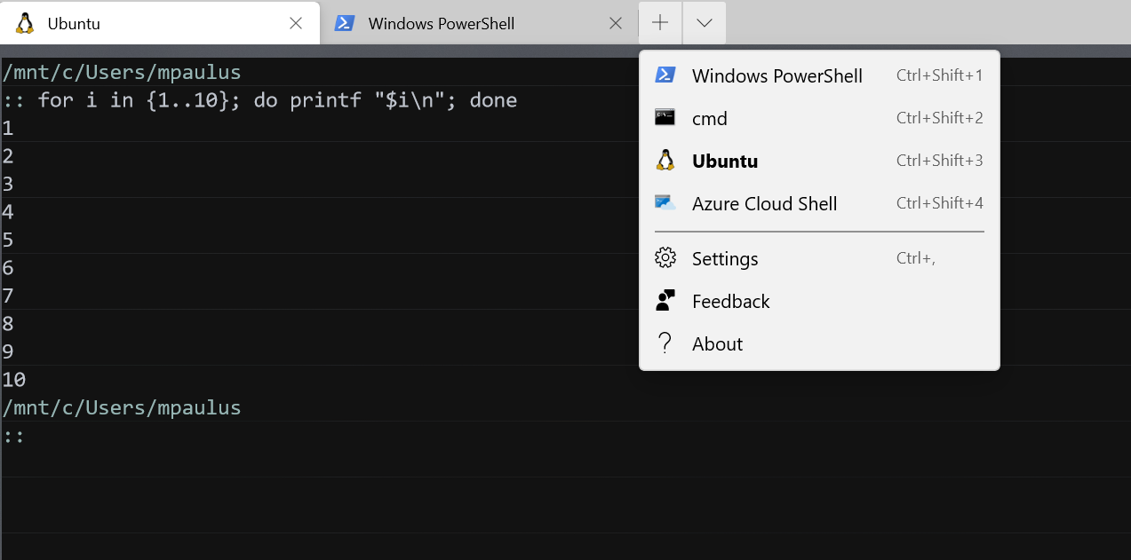

Caption goes here.

## Tables

|  |  |
| --- | --- |
| Field 1 | Field 2 |
| Data 1 | Data 2 |
| Data 3 | Data 4 |

## Mathematics

$$e^{πi}+1=0$$