**Mitchell Post**

**FEB-14-2020**

**IT FDN 110 A**

**MOD 5**

# **Introduction**

This week’s task was to take last weeks project core code provided by the instructor and modify it to utilize dictionary 2d lists. As well as inserting additional capabilities to include a delete utility and a load from file utility. I used the load function by opening a target filename define in my variables then printing the 1stble within.

# **Assignment 2**

* Using provided CDInventory.py starter perform the following tasks
  + Modify the 2D data structure to use dictionaries as the inner data type, list of dictionaries, while allowing users to input this data
  + Complete “TODO’ 1 load text from a file
  + Complete “TODO” 2 Delete row from table from user input
  + Test Functionality of program as whole

**Modify the 2D data structure to use dictionaries as the inner data type, list of dictionaries, while allowing users to input this data.**

Below in figure 1 you can see the first work to re organize the provide code to make use of dictionary files. I first only had the blank ‘dicRow’ without providing the sample first line ‘dicRow1’ but this was making me unable to delete properly using the method I chose for option ‘D’ in the program.

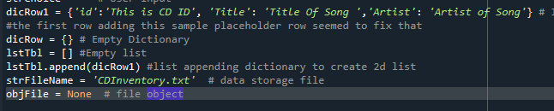

Figure1 – Updated Variables

Below in Figure 2 You can see where the input section for the date provided by the user then updated in the dictionary file takes place. Key value strID is converted into an integer, and the rest of the key get matched with there values in the dictionary then appended as a row to the dictionary with list lstTbl

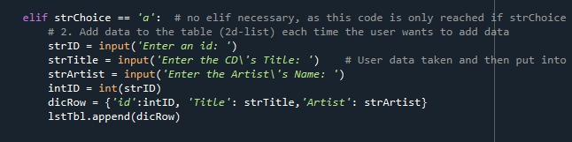

Figure2 – User input, append, dicRow - lstTbl

**Complete “TODO’ 1 load text from a file**

For the first To Do section of the code (loading from a file) I chose to read data from the file defined as strFilename = ‘CDInventory.txt’ using the method learned during instruction for lab 5. This functionality does work but I could not get it to write to the persistent memory of the dictionary file. I am not sure if this was required for the assignment of or not. I also added row strip to eliminate unneeded separators. See figure 3 below.

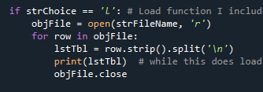

Figure 3 – Load from File

**Complete “TODO’ 2 Delete row from table from user input.**

This portion gave me a really hard time. I Tried several different methods including pop, remove, and del. I could not get the entire row to delete based on the key input from the user. Several different time I deleted just the key pair attached to ‘id’ but was unable to delete corresponding row. I found the dictionary utility ‘.clear’ and that seemed to complete the task. Weird thing was that it would not clear the first entry of the table. So, I added a table in the defined variable section dicRow1 as a placeholder re iterating the selections. This worked. I do not believe this Is the best way to do this but using the methods in the book and material I could not get it to delete the entire row. See figure 4 below

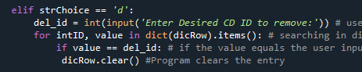

Figure 3 – Delete row by ID

**Test Functionality of program as whole**

This program seems to run as attended for the target tasks for this assignment. As mentioned in the previous task for deletion this gave me the most issues, but functions now as intended. The read from file option does load and read appropriately but does not save the information to the 2d lists.

**References**

Dawson, M. (2009). *Python® Programming for the Absolute Beginner, Third Edition*. Course Technology PTR.

Python list clear(). (n.d.). Retrieved February 12, 2021, from https://www.programiz.com/python-programming/methods/list/clear

Collaboration Saduq Rahman

# **Appendix**

CDInventory.py

#------------------------------------------#

# Title: CDInventory.py

# Desc: Updated Starter Script for Assignment completing "TODOs" and adding dictionary lists

# Change Log: (Who, When, What)

# Mpost, 1100-FEB-12, Created File

#------------------------------------------#

#Modified Variables from starter script to include dictionary structure

strChoice = '' # User input

dicRow1 = {'id':'This is CD ID', 'Title': 'Title Of Song ','Artist': 'Artist of Song'} # I was having issues with the delete function not deleting

#the first row adding this sample placeholder row seemed to fix that

dicRow = {} # Empty Dictionary

lstTbl = [] #Empty list

lstTbl.append(dicRow1) #list appending dictionary to create 2d list

strFileName = 'CDInventory.txt' # data storage file

objFile = None # file object

print('The Magic CD Inventory\n')

while True:

print('[l] load Inventory from file\n[a] Add CD\n[i] Display Current Inventory') # this information unchanged from Starter

print('[d] delete CD from Inventory\n[s] Save Inventory to file\n[x] exit')

strChoice = input('l, a, i, d, s or x: ').lower() # convert choice to lower case at time of input

print()

if strChoice == 'x': # No need to change from Starter

# 5. Exit the program if the user chooses so

break

if strChoice == 'l': # Load function I included the strip utility from the example in lab 5 and added '\n' it does no

objFile = open(strFileName, 'r')

for row in objFile:

lstTbl = row.strip().split('\n')

print(lstTbl) # while this does load and print correctly i cant seem to get it to be persitent in memory

objFile.close

elif strChoice == 'a': # no elif necessary, as this code is only reached if strChoice is not 'exit'

# 2. Add data to the table (2d-list) each time the user wants to add data

strID = input('Enter an id: ')

strTitle = input('Enter the CD\'s Title: ') # User data taken and then put into dictionary and appended into dicRow list.

strArtist = input('Enter the Artist\'s Name: ')

intID = int(strID)

dicRow = {'id':intID, 'Title': strTitle,'Artist': strArtist}

lstTbl.append(dicRow)

elif strChoice == 'i': # No need to change from Starter

print('Current Inventory')

for row in lstTbl:

print(row, sep = ',')

elif strChoice == 'd':

del_id = int(input('Enter Desired CD ID to remove:')) # user input ID selection

for intID, value in dict(dicRow).items(): # searching in dicRow for del_id then matching with key value "intId"

if value == del_id: # if the value equals the user inputed selection

dicRow.clear() #Program clears the entry

elif strChoice == 's': # Save function to file

objFile = open(strFileName, 'a')

objFile.write(str(lstTbl)+'\n')

objFile.close()

else:

print('Please choose either l, a, i, d, s or x!')