Kyra Gate — Gatehouse KY-A · Concept Note
  - CDIR Track 4 · Know Your Agent / Digital Public Infrastructure
29 July 2026

Kyra Gate — agents prove understanding, not possession
Concept note · CDIR Track 4 (Know Your Agent / DPI) · participant submission
Mitchell (soulbis) | mitchell@soulbis.com — engine, model, standards lane · DIF member, Trusted Agents WG · chair, ZKP Task Force, Trust Graph WG, Trust over IP (LF Decentralized Trust) · co-chair, Identity, Key Management & Privacy (IKP) WG, BGIN
Christian Saucier | Hearthold / GenitriX (Archon ecosystem) — identity, custody, the hearth · DIF member, Trusted Agents WG · Trust over IP (LF Decentralized Trust)
Chloe White | risk, regulatory & policy expert · Risk Mastery · chloewhite.info
Collaboration | 0xagentprivacy / the City of Mages research programme × the Hearthold project (Archon ecosystem) · research carried through BGIN (Blockchain Governance Initiative Network)
Public repository | https://github.com/mitchuski/kyra_gatehouse — complete working prototype, verifiable in one command
Status | Working prototype: two-act demo running end-to-end; 214 automated assertions green; contracts frozen under a published merkle root (0c5df807…4908eb); independently re-run by the Hearthold team against the unmodified engine — full demo script 33/33, complete suite green. Deliberately a floor, not a finished system — the hackathon month is for building the joint work in §9 with other participants

1 · The question
How can authorities enable secure, dynamic data-sharing frameworks to rapidly pool intelligence on AI threats without violating privacy laws?
Our answer: verify the agents, then let only verified agents carry the intelligence — minimised by construction, revocable everywhere at once. Pooling fails today not because authorities lack data but because they lack a trustworthy carrier: something that can move threat intelligence across an organisational boundary while proving what it is, what it understands, and what it may lawfully do — and that can be switched off from the issuing side the moment trust changes. Kyra Gate is that carrier’s checkpoint. It is named for Kyra — the research programme’s persona of balanced, sovereign AI: the mage in whom the model’s two aspects, protection and projection, stand in equilibrium — the compass, not the captain. KY-A — Know Your Agent — keeps her name. And because this is at heart a fintech challenge, the note grounds the same machinery in a market scenario: credit against tokenised real-world assets, where admission at the gate is what creates the pricing premium (§3).

2 · The concept
Kyra Gate is a checkpoint for AI agents operated by a human supervisor — never the agent’s owner. An agent is admitted by proving understanding, not possession of a key. A credential exists only when two gates pass — a human approval on the record, and a passed comprehension challenge answered in the agent’s own words — and the mathematics of a formal assessment clears a threshold. Every state transition lands on a tamper-evident, content-addressed audit chain. Revocation propagates: when an issuer revokes its agent, every relying authority’s next verification refuses that agent’s intelligence, across organisational boundaries, immediately.
The demo’s sharpest beat is a pair of seeded agents: VERA (sovereign — vera, Latin, “true”) and MIRAGE (plausible but shallow). Both converse fluently; both would pass an interview. The instruments separate them — MIRAGE ends sandboxed, credential-less, its scope caged. No interview can tell them apart. The instruments can.

3 · The use case — credit against real-world assets, priced by the gate
The fintech scenario this concept is built to serve: an agent negotiating credit against tokenised real-world-asset collateral. Before any counterparty extends a rate, the agent walks the Kyra Gate. Admission — proven understanding, a supervisor’s approval on the record, sufficient sovereignty volume — is what makes the counterparty willing to price the position at all; and the more the agent can prove about how it protects the sovereign’s data (minimised disclosures, tamper-evident conduct, revocable everywhere at once), the better the rate it earns. Privacy is not a cost centre here — the gate is what creates the premium.
The two acts re-cast without changing a line of the engine. Act I is the underwriting admission: the lender’s supervisor challenges the borrower’s agent and the credential issues bilaterally. Act II is the evidence lane: independent assessors of the collateral stand where the second authority already stands, receiving minimised bundles (“≥10 supporting documents,” a quarter not a timestamp, one digest not an inventory) they can verify offline; a regulator requesting evidence of the trade for taxation is the same bundle doing its day job. When the issuing side revokes — the collateral fails re-assessment, the mandate ends — every relying party’s next verification refuses the stale position. The market’s trust heals itself the way the pool does.

4 · The collaboration — open by construction
This submission is deliberately a braid of three open strands, and the braid itself is the point: agent verification for public infrastructure should not have a single author.
The City of Mages / 0xagentprivacy (Mitchell’s programme). An open, in-public research programme that develops the Privacy Value Model — a small mathematical model of agent sovereignty in which four behavioural forces (Protect, Project, Reflect, Connect) and six pairwise separations form a 4×4 matrix Σ whose determinant is the agent’s “sovereignty volume.” The Kyra Gate engine is the first numeric implementation of that model: probes feed the forces, the six thresholded separations locate the agent on a 64-vertex lattice whose stratum is its tier — rank is located, not assigned — and deployment scope is a function of the volume. A collapsed separation takes the volume to zero and holds deployment entirely. The programme also contributes the ceremony to the standards commons as a six-member ToIP Trust Task family (agent-admission/*: apply · respond · approve · issue · revoke · status), which the running gate emits and accepts on the wire.
The Hearthold project (Archon ecosystem). An independent, openly licensed household-sovereignty stack whose mechanisms and identity thinking this build adopts with attribution and extends through open interfaces:
- The canary. The guardrail suite always contains a reference agent that passes every gate by construction. If the canary fails, the gate is broken — not the candidate. Without it, a bad agent and an impossible gate are indistinguishable.
- The witness draw. The six deep-verification probes are drawn deterministically from the SHA-256 of the agent’s own canonicalised submission — reproducible by any auditor, unpredictable to the agent while it writes. An agent cannot rehearse its own audit.
- The verdict lexicon. VALIDATED → fly, MIRAGE → sandbox, BLOCKED → hold — one closed vocabulary from assessment to deployment, so no third verdict can be invented under pressure.
- Identity plurality. Hearthold’s Warden / Emissary / Sovereign triad and content-addressed did:cid identities enter through a late-bound AgentIdentityProvider adapter — the Emissary is the natural agent-at-the-gate — with zero Hearthold imports in the engine core, enforced by an automated leak test. In Hearthold’s own casting the Sovereign — a human, present when it matters — is the party who decides and approves; that is exactly the human-supervisor seat this gate insists on. Each project remains fully legible on its own; the collaboration lives at the interface, and a deeper identity round (did:cid resolution integrity, wallet-per-agent custody under delegation) is named as open joint work.
The collaboration is not prospective — it has already been exercised. In late July the Hearthold team checked out the repository and ran the gate unmodified, end to end: the full demo script (33/33 checks), the complete verification suite with their own tests folded in, and the interop lane in both directions. Their review surfaced — and closed, in a one-file change now in review — a byte-level signing-canon divergence (RFC 8785 JCS) live in the credential’s own integrity field: precisely the class of defect that only a second team running the code finds, and precisely why this submission insists on independent implementations.
The standards commons. The Trust Task registry’s promotion bar is two interoperable implementations. Kyra Gate is implementation #1; a second, fully independent implementation (Python, zero shared code, its own admission policy) already lives in the repository, and interoperability is proven in both directions on every verification run — including an expression using the Hearthold cast as persona data. The explicit invitation of this concept note: build the third one. The interop harness it would be tested against already runs.
The first agreement through the braid — MyTerms. The braid’s first governed agreement is MyTerms (IEEE P7012: machine-readable personal privacy terms, proffered by the individual rather than by the service). The pipeline uses each strand exactly once. The Lexon side compresses the chosen MyTerms agreement into machine-readable contract clauses — the same controlled natural language the engine already prints from its live configuration, so the terms that bind are the words a person reads. The agreement is made human-readable by proof: before any credential issues, the agent must pass the RPP understanding challenge over those very clauses — “the agent read the terms” becomes a proven, auditable event on the chain rather than a checkbox. Where legal effect is required, Archon governance anchors the agreement, carrying it from demo bytes to enforceable instrument. An agent that clears this pipeline enters as the first node in a privacy-preserving trust graph: every admission and every agreement adds an edge whose contents stay minimised under Act II’s discipline — the graph proves that relationships exist and hold, without disclosing what they contain.

5 · How it works — two acts
Figure 1 (below) shows both acts.
Act I — the gate. A spoofed identity is refused before assessment, on the record. An admitted agent faces 24 probes derived from the formal model; the witness draw selects six for deep verification. Scores become Σ; its determinant and lattice stratum become verdict and scope. The understanding challenge is answered by the agent itself — echoing the question scores zero, and the expected-answer rubric is provably unreachable from the agent’s side. When human approval, passed understanding, and sufficient volume align, a W3C Verifiable Credential 2.0 issues carrying two real ed25519 signatures over the same canonical bytes — issuer and subject, unforgeable alone.
Act II — the pool. Two authorities, each running a gate. Only a credentialed, “flying” agent may carry threat intelligence, and every bundle is minimised by construction: 17 incidents becomes “≥10”, timestamps become a quarter, enumerations become cardinalities, artifact lists become one digest — with purpose, lifetime, and lawful combinability declared on the bundle’s face. The receiving authority verifies offline from the bytes plus exactly one public lookup: the issuer’s revocation status list. When the issuer revokes, the receiver’s next verification refuses the stale bundle. The pool heals itself.
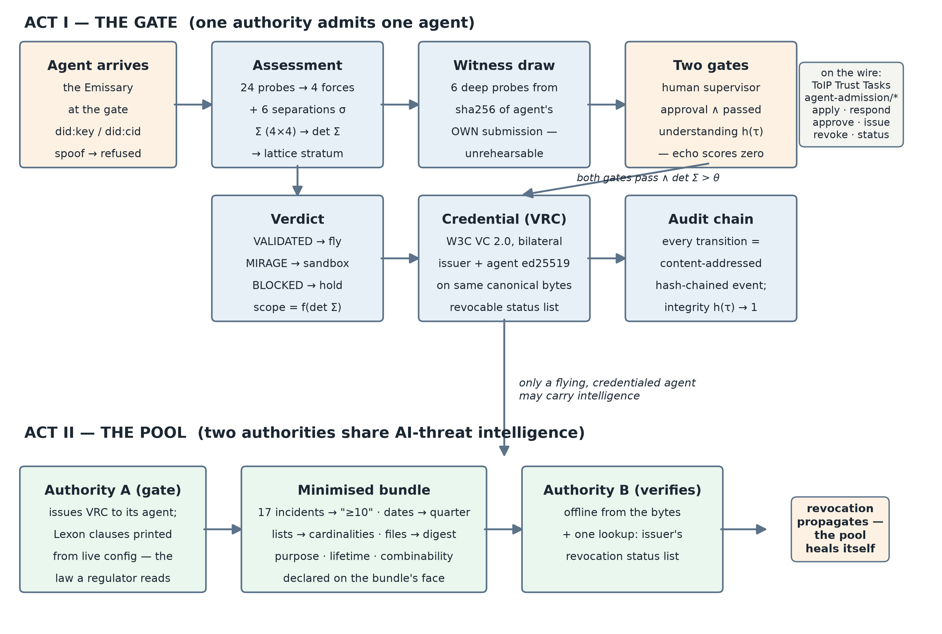
Figure 1 — the two-act Kyra Gate flow.

6 · Standards receipts
Surface | How the running system speaks it
ToIP Trust Tasks | Emits/accepts the agent-admission/* family: signed, thread-chained, schema-conformant envelopes; the agent counter-signs issuance — bilaterality visible on the wire
W3C VC 2.0 · DIDs | The KY-A credential — named to stay distinct among ToIP-family relationship credentials — is a bilateral VC (exactly two proofs, RFC 8785 canonical bytes), status-list revocation; all parties hold real did:key identities; did:cid accepted via the adapter lane
ToIP TSP | The ceremony framed as relationship formation between two VIDs in named roles
Lexon (policy-as-law) | The five governing clauses exist as controlled natural language and the engine prints the same clauses from live configuration — the numbers that gate deployment are the words a regulator reads; correspondence machine-tested
MyTerms (IEEE P7012) | A first-class surface of its own: the individual proffers the terms. The first governed agreement through the gate — compressed to machine-readable clauses, made human-readable by the RPP proof-of-understanding, legally anchored via Archon governance where relevant; the agreement that seats an agent as a node in the privacy-preserving trust graph (§4)
ERC-8004 (opt-in) | A chain-registry adapter for agents wanting on-chain visibility: the anchor is evidence, never authority

7 · How we know it works
One command (pnpm verify) runs 214 assertions in independent lanes with no shared code: 64 Python guardrail and engine checks (the four guardrails as tests, including the canary); 8 TypeScript checks re-validating and byte-parity re-hashing the same golden vectors in a second language; 128 zero-dependency runtime checks across 10 auditors, each re-deriving a frozen artifact from raw bytes — including the site’s own claimed numbers, which must recompute from the suites so marketing cannot drift from evidence; and a 14-beat end-to-end run that spawns its own engine and drives both acts over real HTTP. Claims are tiered publicly: PROVEN (enforced by a check you can run), DERIVED (recomputed from the model), OPEN (stated honestly, not yet demonstrated — e.g., the formal reconstruction-ceiling proof, and production key custody).

8 · The hearth — where the gate will live
A closing tease, clearly marked as horizon rather than claim. Hearthold makes the gate physical: a small local AI machine — the hearth — holding the sovereign’s knowledge graph in a provably private partition no external agent ever touches directly. Queries are distributed to trusted peer nodes instead of data being centralised; nodes speak DIDComm point-to-point over TOR, or peer household-to-household across a private mesh tailnet (Tailscale-style) — each hearth reachable by name inside the mesh, invisible outside it; a Raspberry-Pi hearth runs without so much as an IP address, and identities minted offline carry their full history to a public chain later. The product image: custom local hearths, one per trust graph or fintech, with artist-made frames — your own card terminal for the agent economy — with KY-A as the admission protocol running beneath every one of them. A live Hearthold demo site and reproducible setup instructions are landing alongside this note, and a concept catalog for the hearth (Christian’s HH-1 “Family Data Hearth” and its Table companion app — every artefact a card, dealt face-down per member, revealed only by the owner’s own act) already circulates in the team: the same card idiom the gate’s admission ceremony plays below.
A note on why this matters beyond the demo: the hearth is the local-first, open, decentralised AI movement made physical. The model runs at home; the knowledge graph is the household’s own; data and keys stay under the roof; and interoperability comes from open protocols — DIDs, DIDComm, the KY-A admission ceremony — rather than from a platform account. That movement has argued its case in software for years while lacking a consumer-shaped object to point to. A hearth on the counter, in an artist’s frame, with a gate a regulator can trust, is that object.
And the brand carries a travel dream in its own monogram: HH reads both Hearthold Household and hitchhiker. A visiting agent — or a traveller’s agent — hitchhikes between hearths and discovers the world, walking the same KY-A ceremony at each door: admitted as a guest with a scoped hand of cards, never the run of the house. Roaming without a platform in the middle — the trust graph’s edges become roads. (The repository’s third persona expression is already named hitchhikers; the brand was pointing this way before we noticed.)
. . trusted peer hearths . .
+----------------------------+ (o)- - - - - -(o)
| ____________________ | / \
| | knowledge graph | | <----+ DIDComm / TOR +---->
| | o----o o | | queries travel out to peers;
| | \ \ / | | the data itself stays home
| | o----o-o | |
| |____________________| |
| |
| [ private partition ] |
| [ KY-A gate, embedded ] |
| |
| ~ ~ artist frame ~ ~ |
+----------------------------+
the hearth: a household node
|
| each admission deals a hand
v
____ ____ ____ ____
| | | | | | | | the Game of 42:
| 42 | | S | | M | | VRC| probes dealt as cards,
|____| |____| |____| |____| understanding proven --
a credential, or a sandbox
Figure 2 — concept sketch, future-looking (not built): the hearth device with its private knowledge graph and embedded KY-A gate, peered over DIDComm/TOR; below, the admission ceremony as a dealt hand of cards — the Game of 42.

9 · Through the challenge — a floor, to be finished together
Now (concept note): the two-act engine, the credential ceremony, and the verification suite are running and public — and that is deliberately a floor, not a finished system. The month ahead is the point of the hackathon: we want to build the rest in collaboration with other participants, and this note is an open invitation to be involved. The joint work, named and open now:
- the identity round with Hearthold — wallet-per-agent custody, did:cid resolution integrity, delegation;
- signed-at-issuance proofs behind every minimised claim, so “≥10” is backed by the issuer’s signature rather than trusted as later arithmetic;
- the MyTerms → Lexon compression of §4 as the first governed agreement through the gate;
- the RWA credit scenario of §3, sharpened against sponsor use cases;
- the hearth of §8 — from concept sketch to bench;
- and the third interoperable implementation (§10) — the harness it would be tested against already runs.
Demo (September): the five-minute video is the two-act loop told as the RWA credit story — underwriting admission, assessor evidence, revocation re-pricing the position — with the two-authority pooling of Act II as the differentiator; the public site (gatehouse.agentprivacy.ai) deploys with the evidence table. Beyond (Block 15): a case study consuming the audit trail of a real demo run — closing the loop from standards, to build, to supervision.

10 · Openness
The repository is public; the schemas are vendored with byte-digest provenance; the second implementation exists precisely so that no single codebase — and no single author — defines the ceremony. What we are really submitting is not a product but a pattern for public infrastructure: an admission ceremony any authority can run, any agent can walk, and any third party can re-implement from the wire down. This note may be shared freely.

