**Assessment**

Q2. Design a scheduling application where a patient schedules an appointment with a doctor.

**High Level Design using UML:**

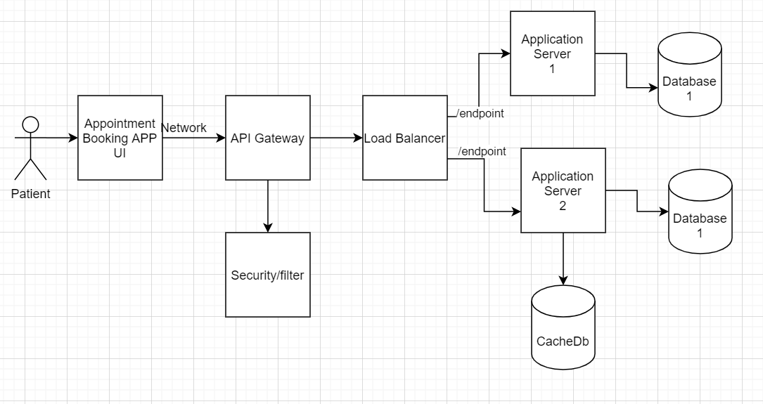

**Data Flow Diagram:**

**Level1: Context Level**

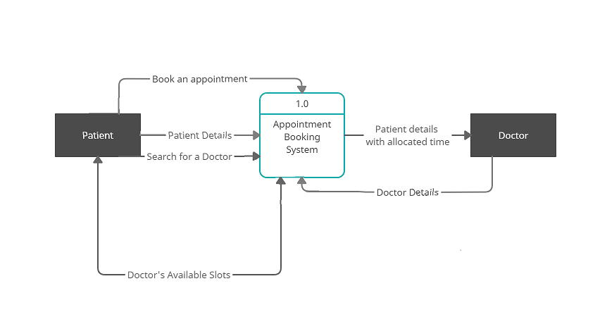

**Level 2:**

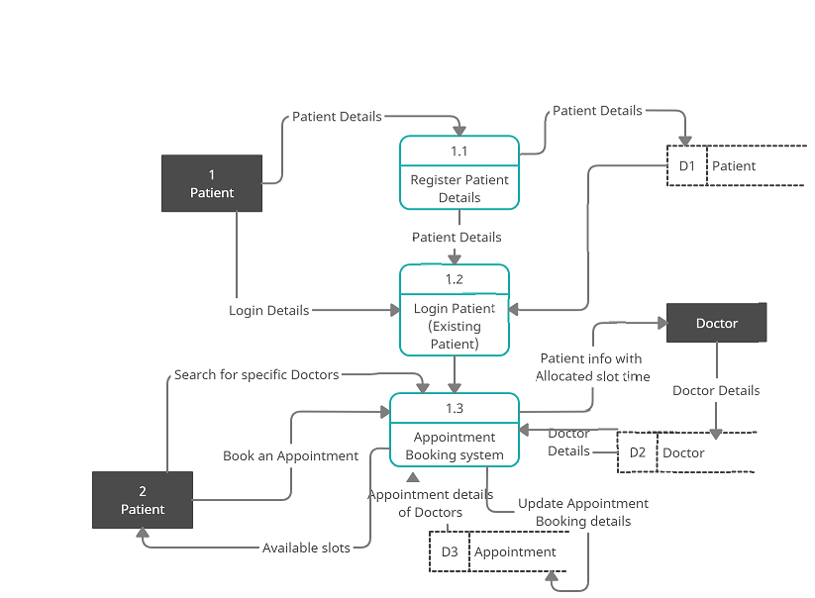

**Level 3:**

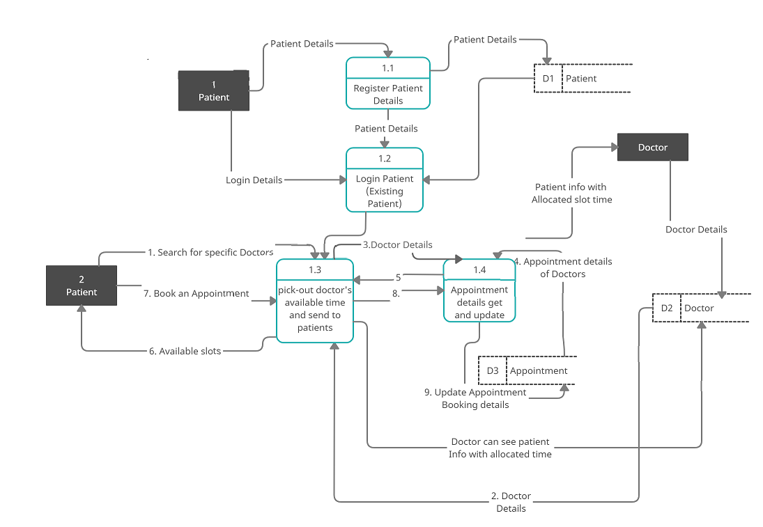

**Deployment UML Diagram**

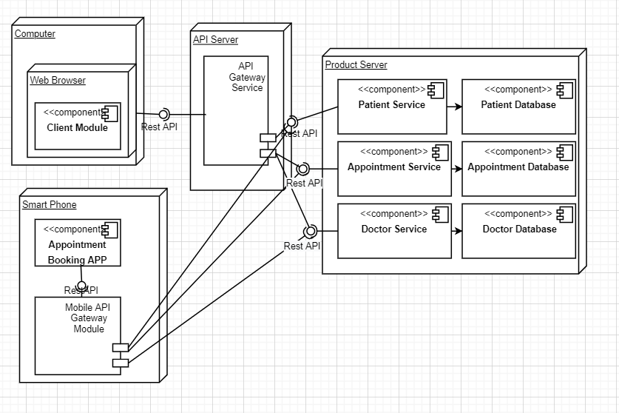

Req:



Res:

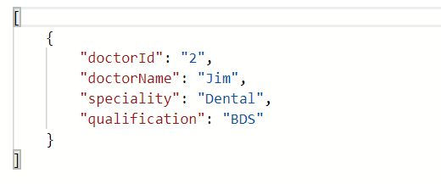

Req:



Res:

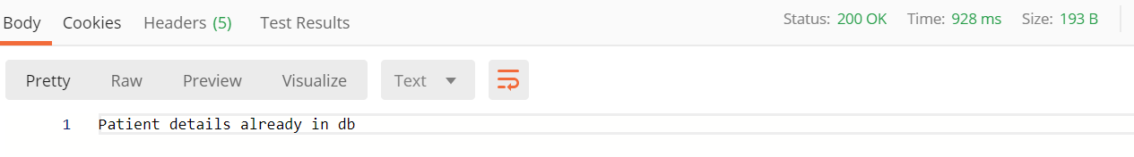

Req:

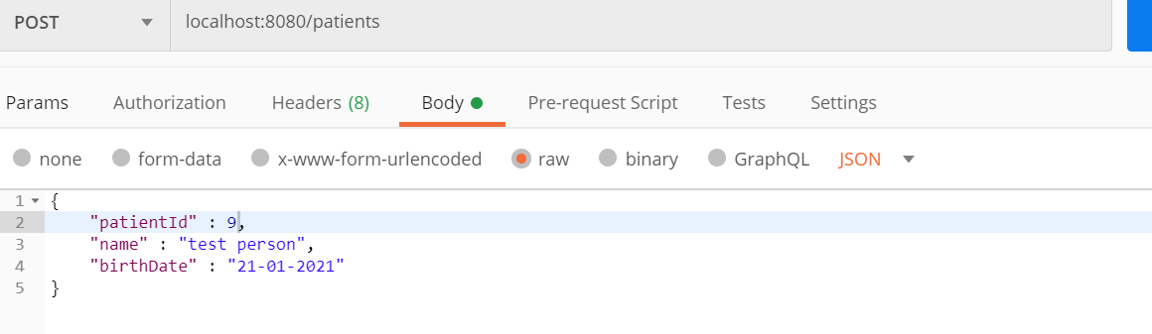

Res:

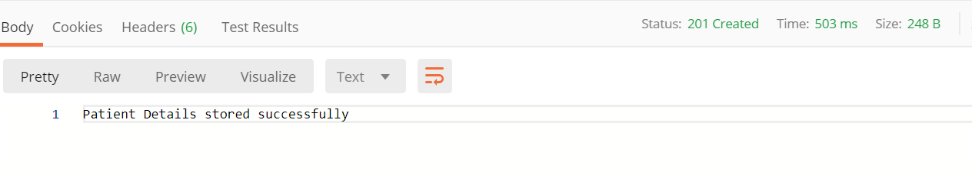

Req:



Res:

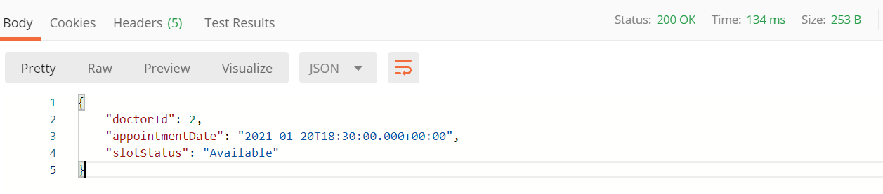

* Created Swagger documents: Once we deploy this application we can see swagger document using this below url.

<http://localhost:8080/v2/api-docs>

* Used H2 in-memory database to store data, Please find screenshots of data below.

