Share your experiences with students from all over the world!

Ratings create trust – especially among like-minded people. Thanks to genuine experience reports students share with one another, prospective students in particular are provided with decision-making aid in discovering the right university city in Germany, Austria or Switzerland as well as the proper university and study program. Do you think your study program is particularly cool or are you rather disappointed? Benefit from each other’s experiences through a rating!

**Before starting to rate, please first Log in or Register.**

This is required in order to ensure that only credible reviews are published on our platform.

Your data privacy is very important for us. Your personal information will not be published or passed on to third parties.

Selection of study program

#### Rating

Please rate your study program now!

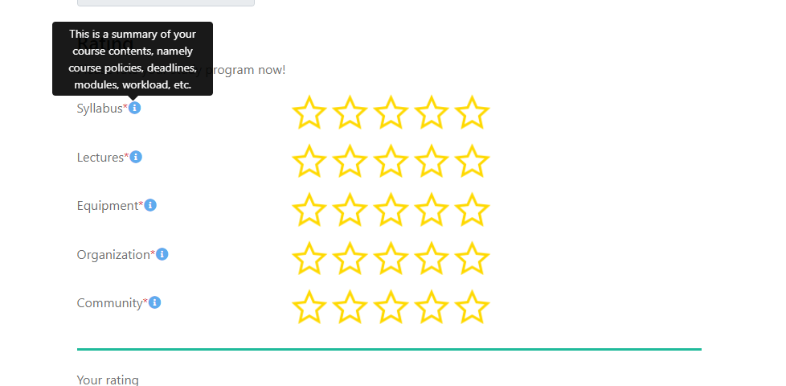

Syllabus* (This is a summary of your course contents, namely course policies, deadlines, modules, workload, etc.)

Lectures (Covers not only the quality of your lectures i.e., structure, clarity, difficulty but also your professors’ instructional skills.)

Equipment (On-site facilities and the quality of the technologies they are equipped with: computers, multimedia technology, lab equipment, machinery, and others.)

Organization (Organization of study experience in terms of well-managed schedules, courses, seminars, and exams.)

Community (Interaction with other students and the ability to learn, share, and debate values, issues, and ideas with other participants).

------------------------------------------------------------------

#### Written evaluation (optional)

Share the individual experiences you have made with your study program!

Write down a specific eyecatcher.

You have to log in or register in order to submit your review.

We always strive to provide credible reviews. One of the ways we use to ensure that is by allowing only registered users to submit reviews.

Your review has been submitted successfully!

The winner will be contacted at the beginning of the next week.