1) RISK_LEVEL_INVT_PORTFOLIO_PERCENTAGE table created in H2 database.

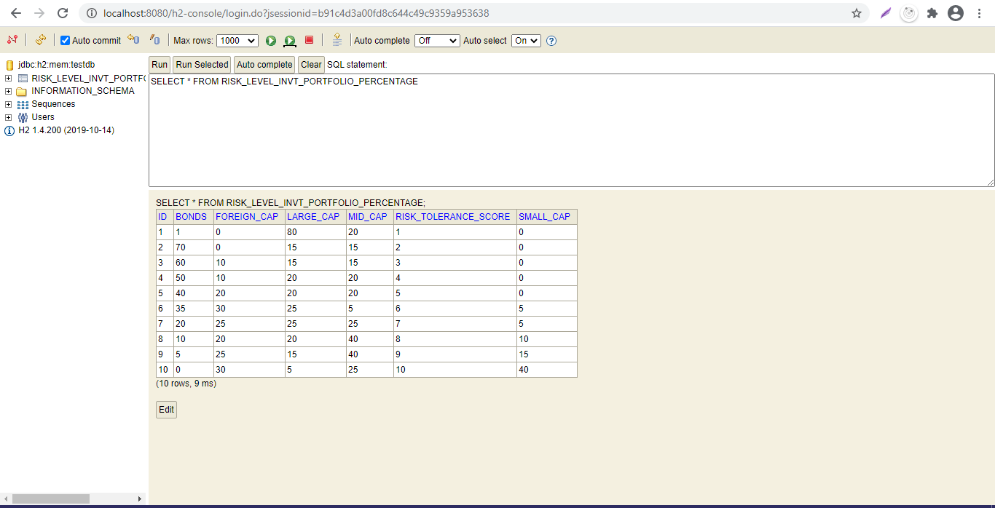

Part 1)

Based in user input risk prefrance score ,response json based on match recommendation portfolio

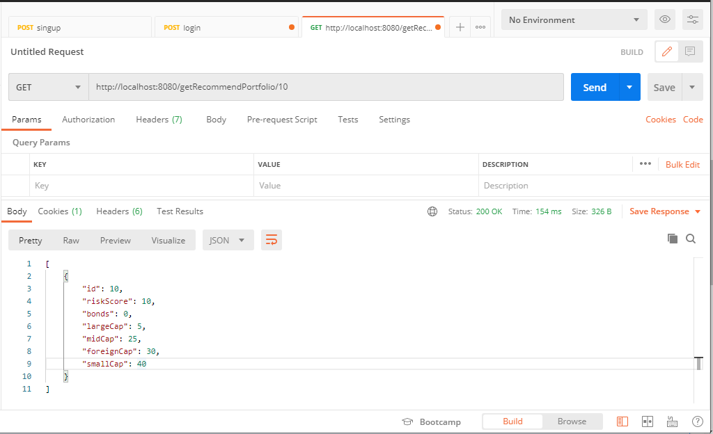

2) success/fail message in response header

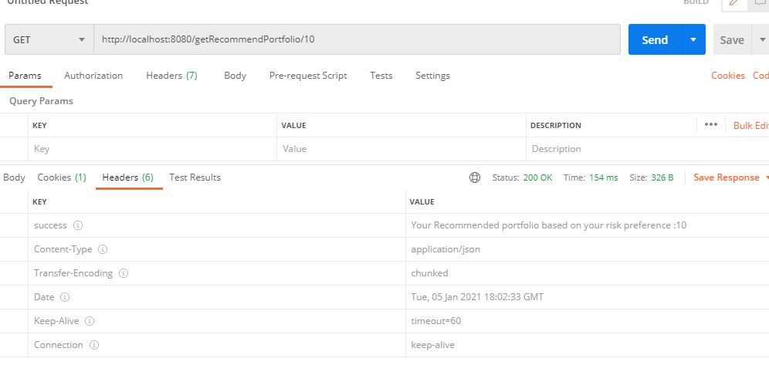

Failed header

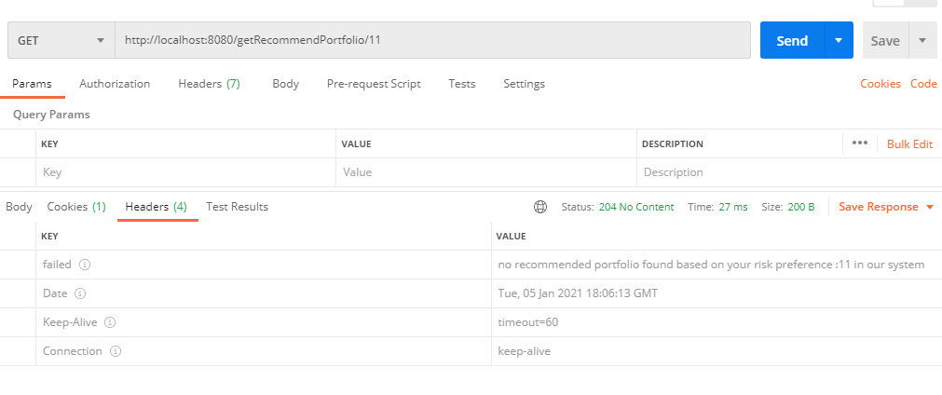

Part 2

<http://localhost:8080/reBalancePortfolioAsPerRecommended>

request pay load

{

        "id": 6,

        "riskScore": 6,

        "bonds": "50$",

        "largeCap": "20$",

        "midCap": "10$",

        "foreignCap": "5$",

        "smallCap": "15$"

    }

//response payload

{

    "newRecommendPortfolio": {

        "bonds": 35,

        "largeCap": 25,

        "midCap": 5,

        "foreignCap": 30,

        "smallCap": 5

    },

    "differencePortfolio": {

        "bonds": -15,

        "largeCap": 5,

        "midCap": -5,

        "foreignCap": 25,

        "smallCap": -10

    },

    "recommendedTransfers": **null**

}