Execution Report - simo_tc_acq

Step 1: Basket Page
Timestamp: 2026-06-25 19:02:18
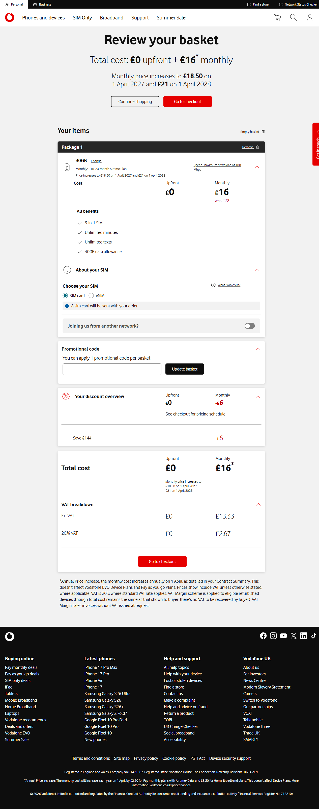

Step 2: Checkout Page
Timestamp: 2026-06-25 19:02:38
