Execution Report - handsetpaym_tc_acq

Step 1: Landing Page
Timestamp: 2026-09-02 22:20:04
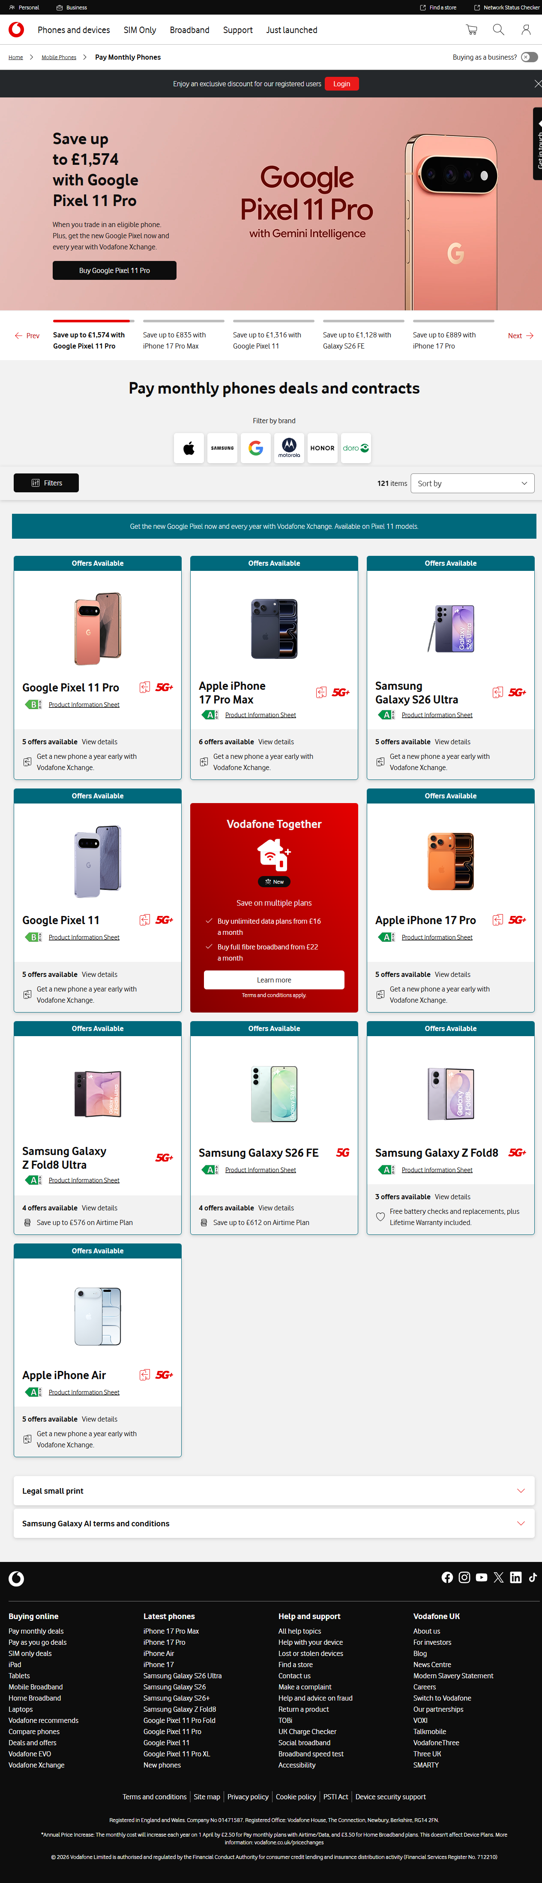

Step 2: Plan Details
Timestamp: 2026-09-02 22:20:15
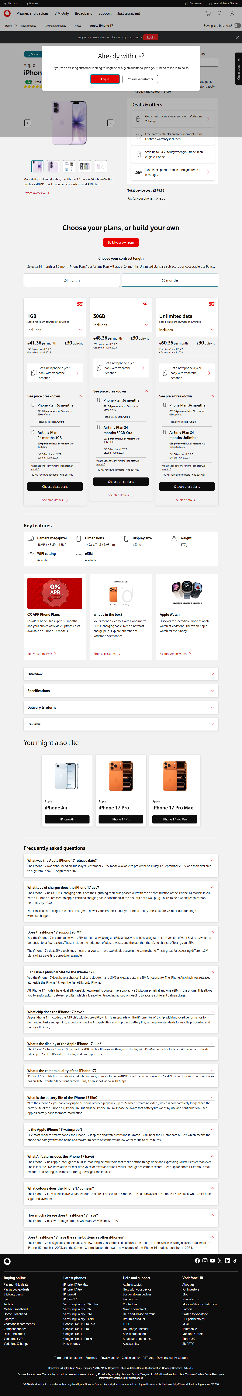

Step 3: Device Variant Details
Timestamp: 2026-09-02 22:20:25
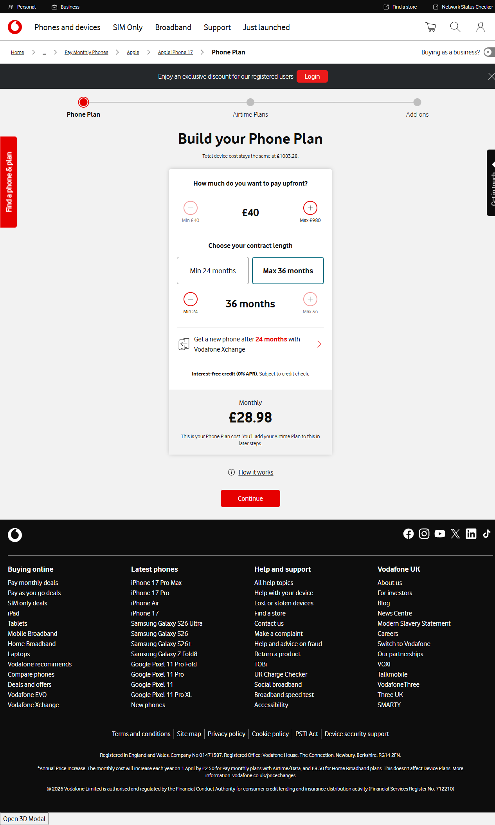

Step 4: Phone Plan tenure
Timestamp: 2026-09-02 22:20:32
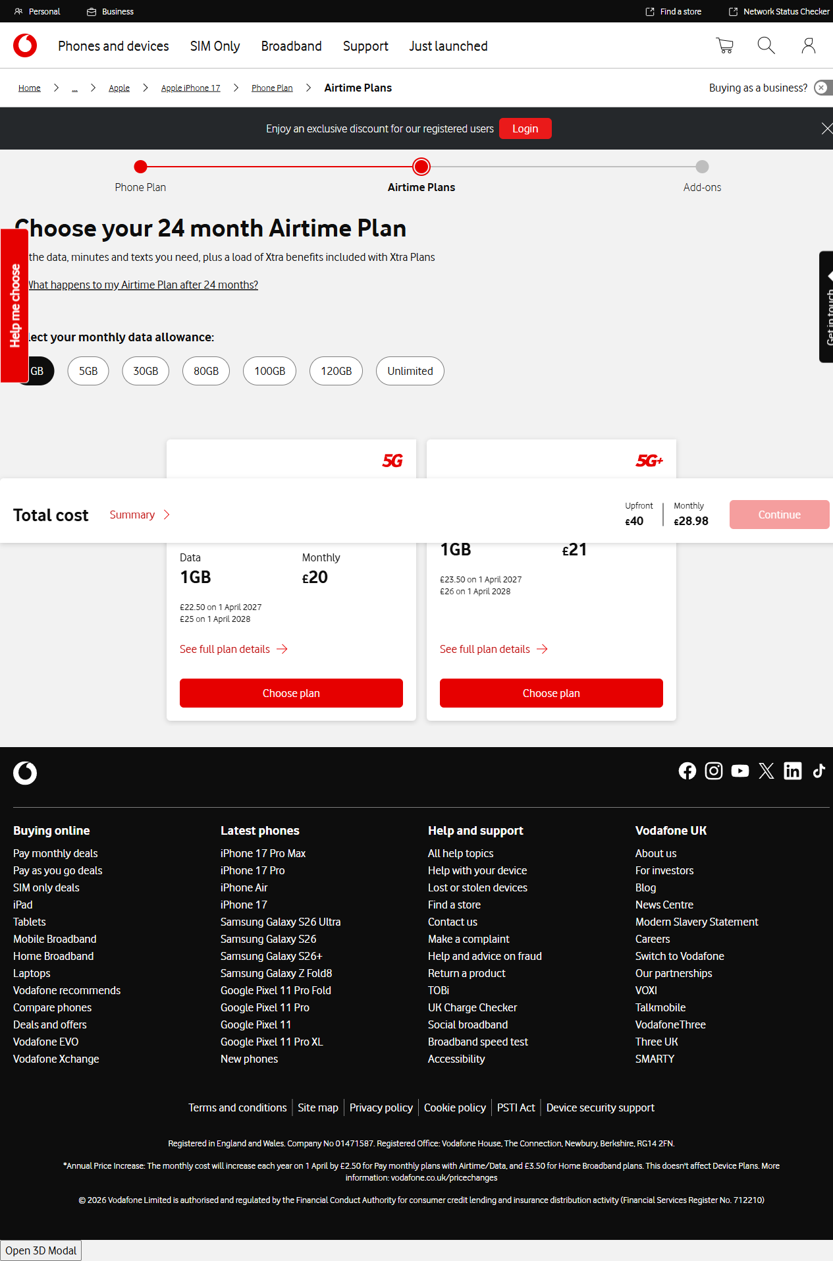

Step 5: Airtime Plan Details
Timestamp: 2026-09-02 22:20:40
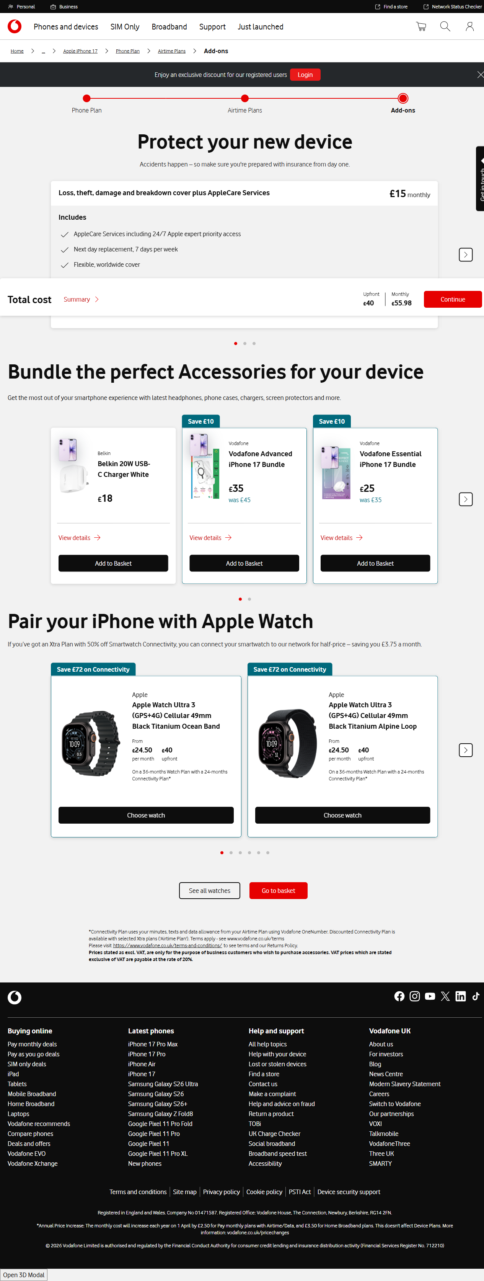

Step 6: Basket Page
Timestamp: 2026-09-02 22:20:56
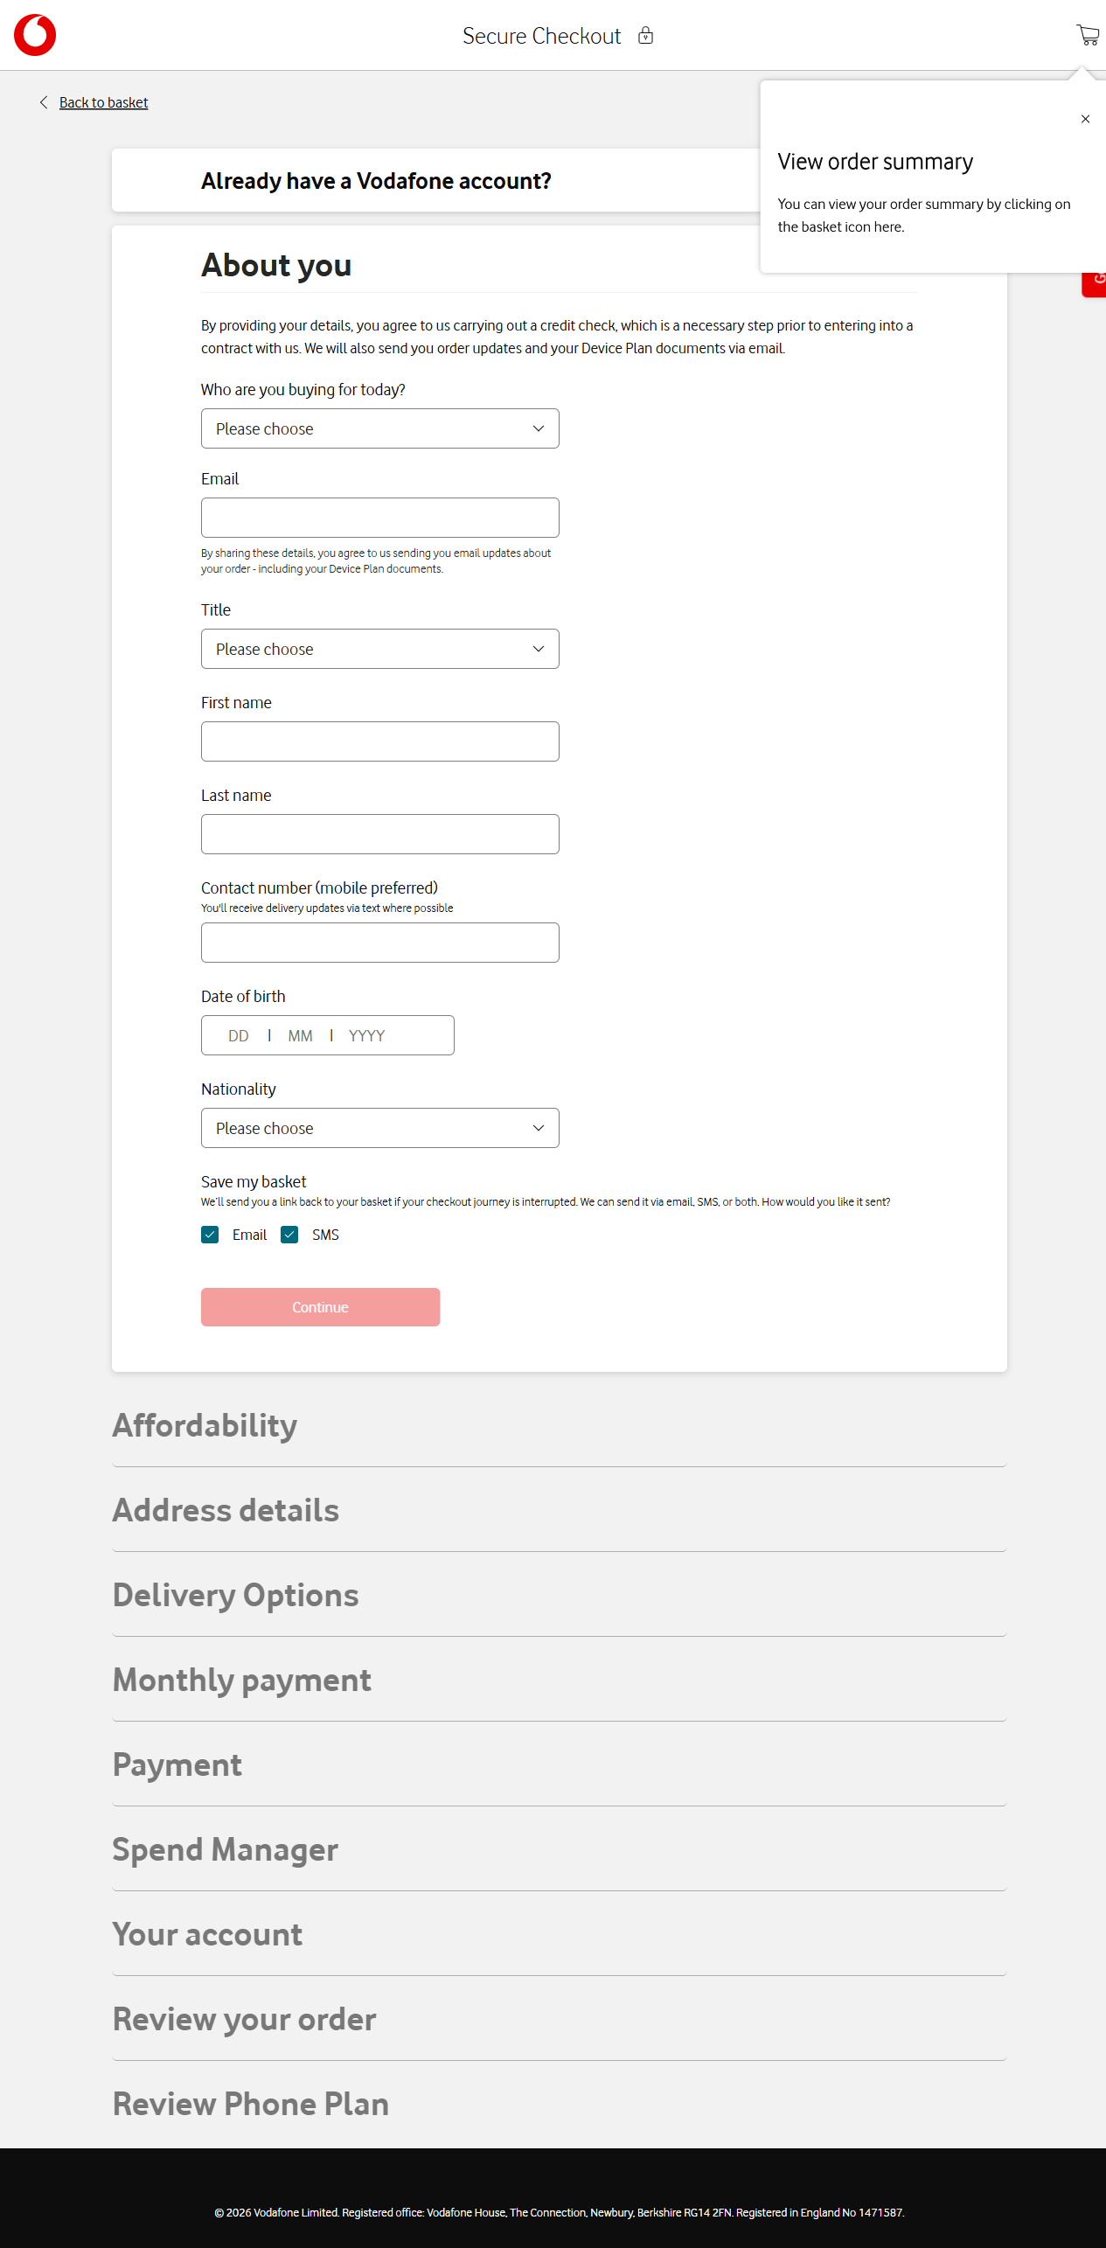

Step 7: FAILED - page = <Page url='https://www.vodafone.co.uk/secure-checkout'>
report = <utils.screenshot_manager.ScreenshotManager object at 0x00000203FE0074D0>
def test_handsetpaym_tc_acq(page:Page, report):
# json reader and report
test_case_name = "handsetpaym_tc_acq"
report.start_test(test_case_name)
data = get_test_data(test_case_name)
# landing page
landing = LandingPage(page,data)
landing.accept_cookies()
report.capture(page, "Landing Page")
# plans page
plan = PlansPage(page, data)
plan.select_plan()
report.capture(page, "Plan Details")
# DeviceVariantsPage
devicevarient = DeviceVariantsPage(page, data)
devicevarient.configure_device()
report.capture(page, "Device Variant Details")
# phoneplan page
phoneplan= PhonePlanPage(page, data)
phoneplan.select_contract()
report.capture(page, "Phone Plan tenure")
# AirtimePlansPage
airtimeplan=AirtimePlansPage(page, data)
airtimeplan.select_airtime_plan()
report.capture(page, "Airtime Plan Details")
#Add on page
addon= AddonPage(page, data)
addon.select_handset_addon()
# Basket page
basket = BasketPage(page, data)
basket.basket_expand_arrows()
basket.go_to_checkout()
report.capture(page, "Basket Page")
# CheckOut page
checkout = CheckoutPage(page, data)
> checkout.checkout()
Tests\test_handset.py:62:
_ _ _ _ _ _ _ _ _ _ _ _ _ _ _ _ _ _ _ _ _ _ _ _ _ _ _ _ _ _ _ _ _ _ _ _ _ _ _ _
pageobject\checkout_page.py:37: in checkout
self.__bank_acc_details_and_continue()
pageobject\checkout_page.py:121: in __bank_acc_details_and_continue
self.page.get_by_role("textbox", name="Account holder name").fill(self.data["checkout_account_holder_name"])
..\..\AppData\Local\Python\pythoncore-3.14-64\Lib\site-packages\playwright\sync_api\_generated.py:15983: in fill
self._sync(
..\..\AppData\Local\Python\pythoncore-3.14-64\Lib\site-packages\playwright\_impl\_locator.py:215: in fill
return await self._frame.fill(self._selector, strict=True, **params)
^^^^^^^^^^^^^^^^^^^^^^^^^^^^^^^^^^^^^^^^^^^^^^^^^^^^^^^^^^^^^
..\..\AppData\Local\Python\pythoncore-3.14-64\Lib\site-packages\playwright\_impl\_frame.py:607: in fill
await self._fill(**locals_to_params(locals()))
..\..\AppData\Local\Python\pythoncore-3.14-64\Lib\site-packages\playwright\_impl\_frame.py:619: in _fill
await self._channel.send("fill", self._timeout, locals_to_params(locals()))
..\..\AppData\Local\Python\pythoncore-3.14-64\Lib\site-packages\playwright\_impl\_connection.py:69: in send
return await self._connection.wrap_api_call(
_ _ _ _ _ _ _ _ _ _ _ _ _ _ _ _ _ _ _ _ _ _ _ _ _ _ _ _ _ _ _ _ _ _ _ _ _ _ _ _
self = <playwright._impl._connection.Connection object at 0x00000203FDEE7620>
cb = <function Channel.send.<locals>.<lambda> at 0x00000203FEAA3690>
is_internal = False, title = None
async def wrap_api_call(
self, cb: Callable[[], Any], is_internal: bool = False, title: str = None
) -> Any:
if self._api_zone.get():
return await cb()
task = asyncio.current_task(self._loop)
st: List[inspect.FrameInfo] = getattr(
task, "__pw_stack__", None
) or inspect.stack(0)
parsed_st = _extract_stack_trace_information_from_stack(st, is_internal, title)
self._api_zone.set(parsed_st)
try:
return await cb()
except Exception as error:
> raise rewrite_error(error, f"{parsed_st['apiName']}: {error}") from None
E playwright._impl._errors.TimeoutError: Locator.fill: Timeout 30000ms exceeded.
E Call log:
E - waiting for get_by_role("textbox", name="Account holder name")
..\..\AppData\Local\Python\pythoncore-3.14-64\Lib\site-packages\playwright\_impl\_connection.py:559: TimeoutError
Timestamp: 2026-09-02 22:21:33
