Execution Report - fttp_tc_acq

Step 1: Landing Page
Timestamp: 2026-06-27 21:37:32
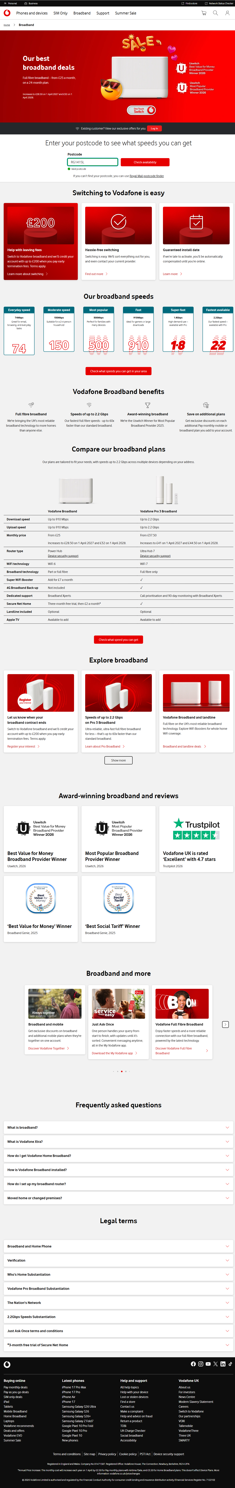

Step 2: Address Page
Timestamp: 2026-06-27 21:37:47
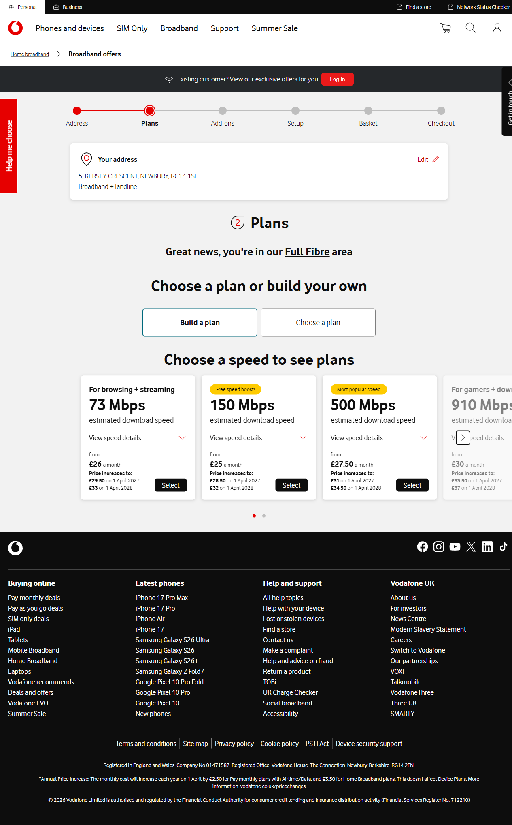

Step 3: Plans Page
Timestamp: 2026-06-27 21:37:55
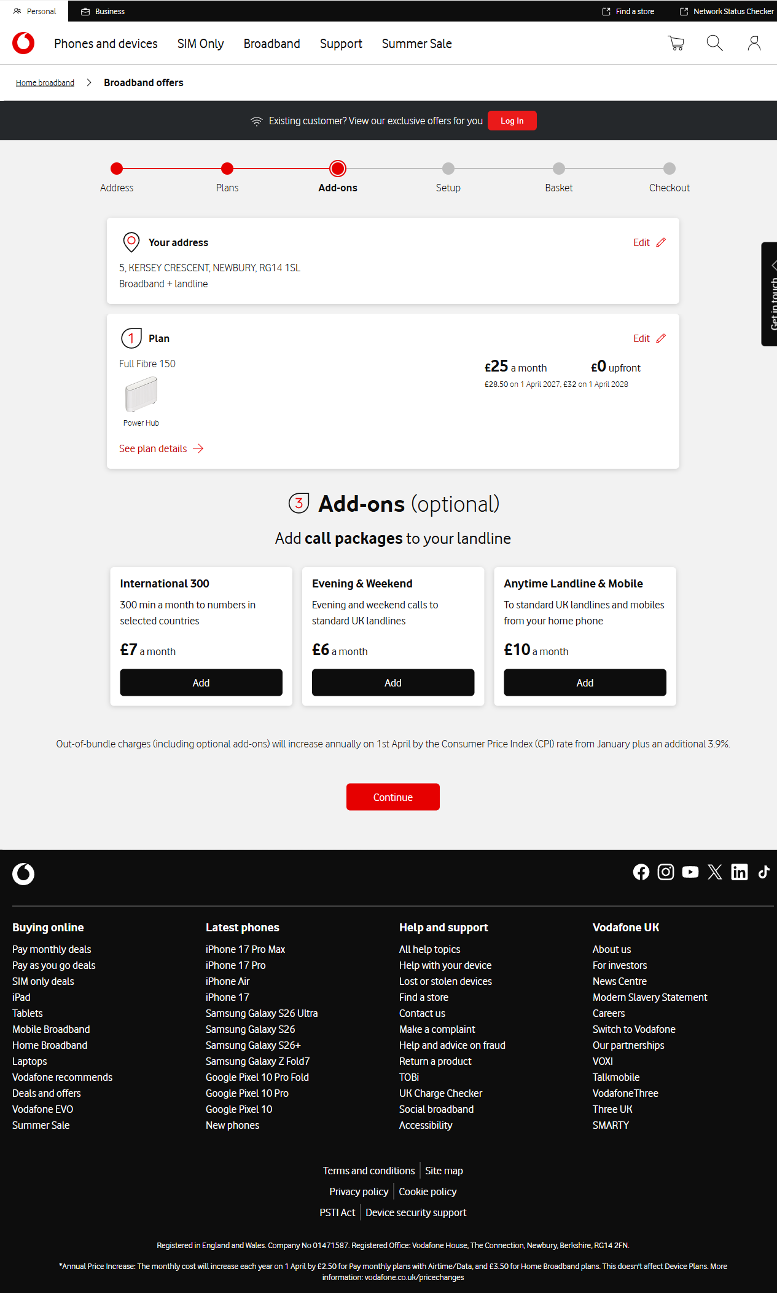

Step 4: Addons Page
Timestamp: 2026-06-27 21:38:05
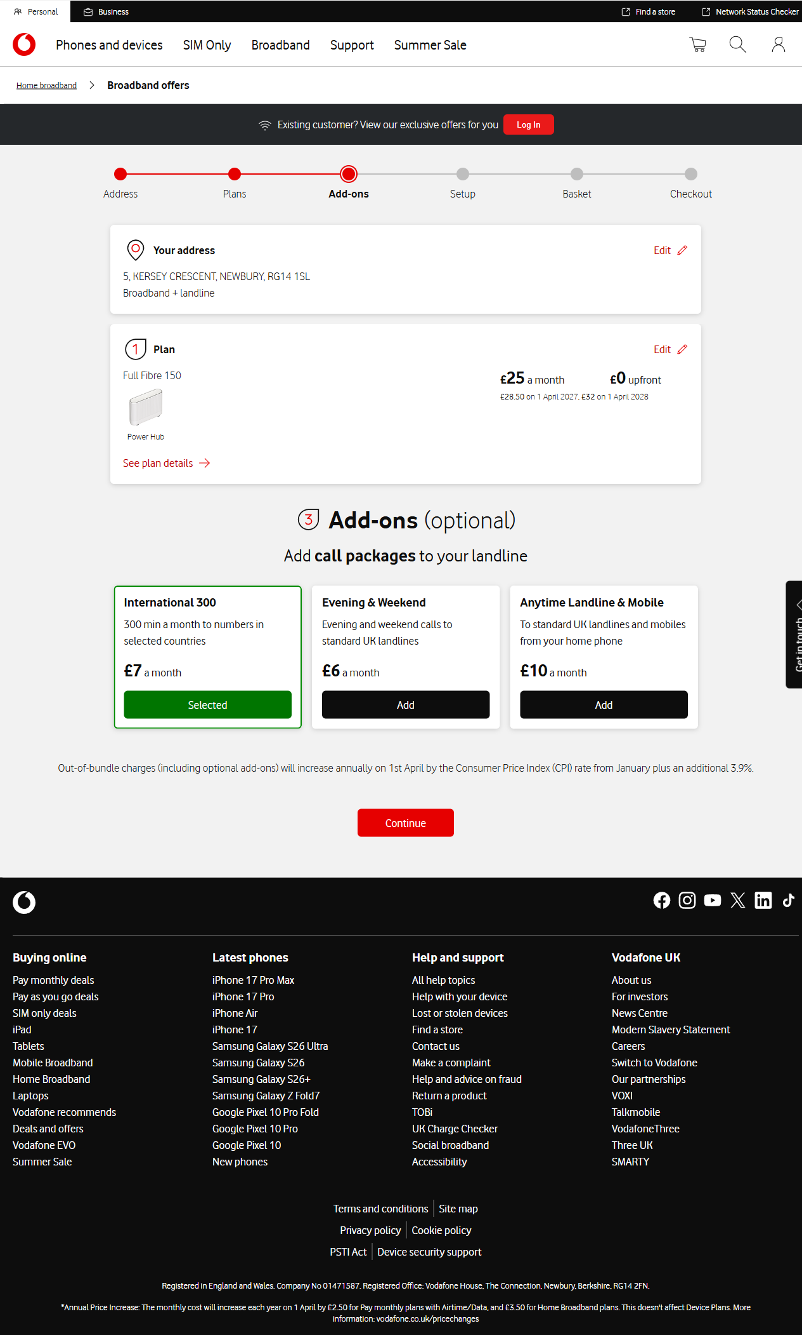

Step 5: Setup Page
Timestamp: 2026-06-27 21:38:18
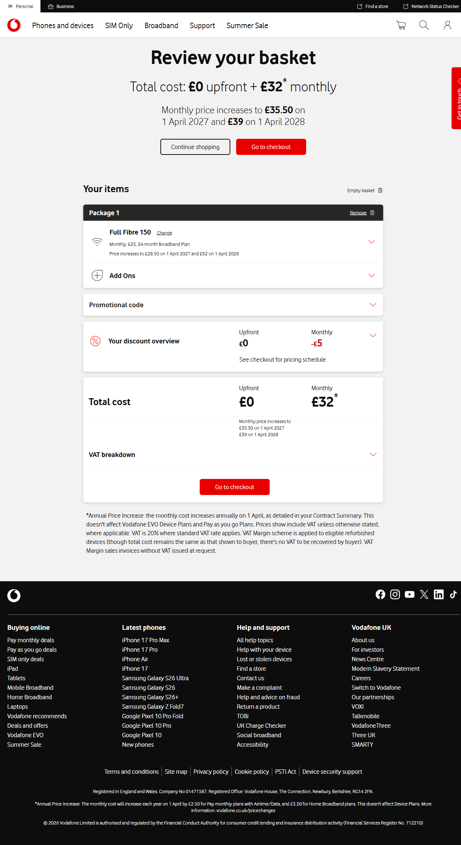

Step 6: Basket Page
Timestamp: 2026-06-27 21:38:27
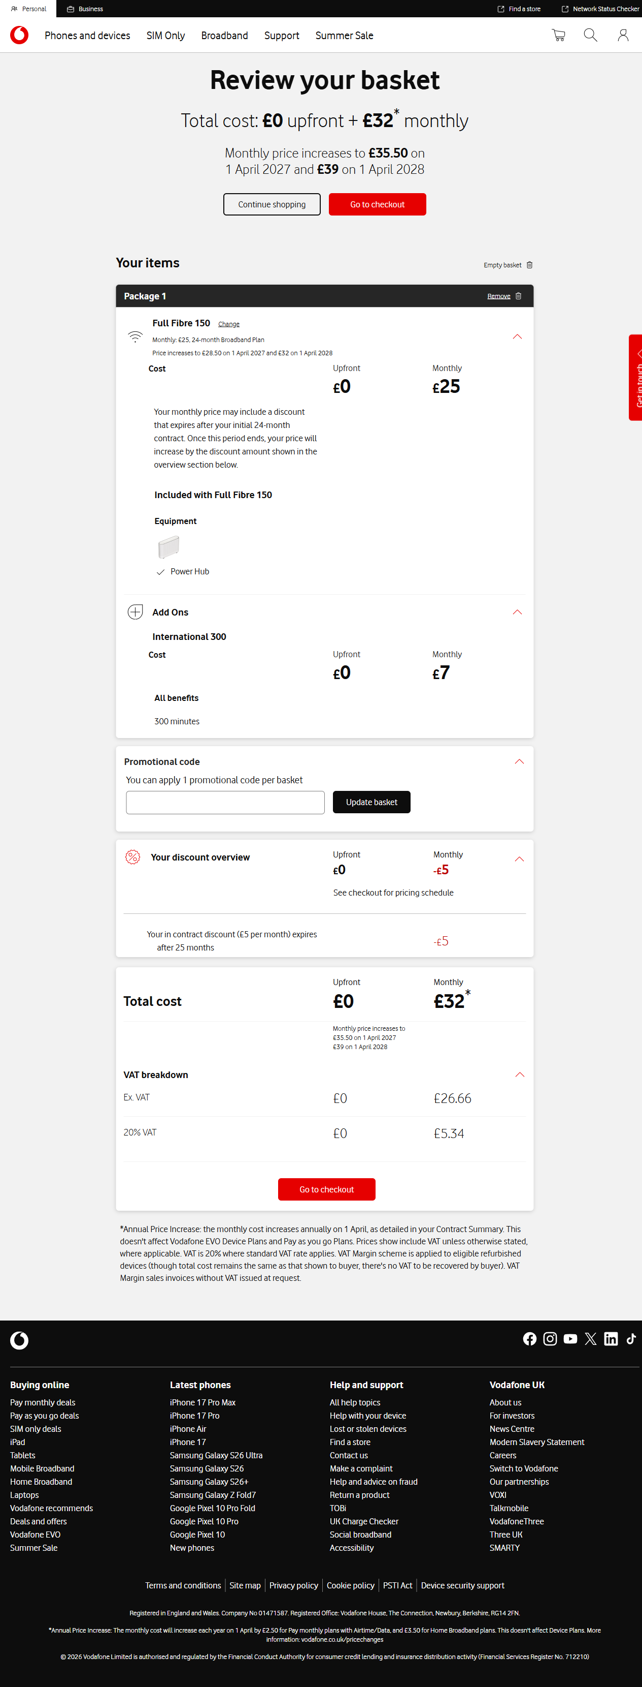

Step 7: Checkout Page
Timestamp: 2026-06-27 21:38:47
