Execution Report - FTTH_TC_Acq

Step 1: Landing Page
Timestamp: 2026-06-12 19:54:41
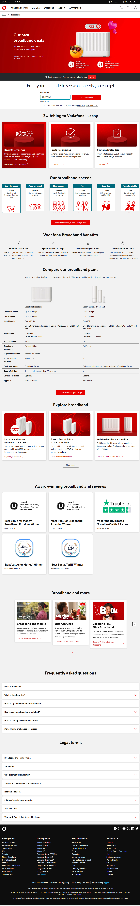

Step 2: Address Page
Timestamp: 2026-06-12 19:54:55
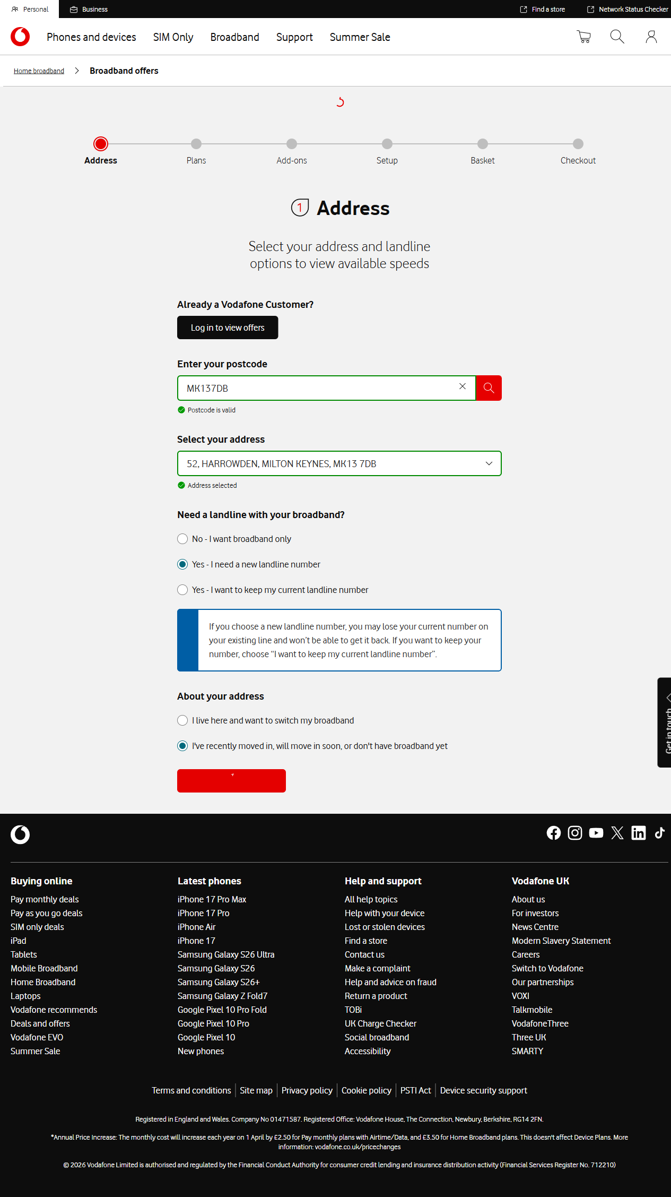

Step 3: Plans Page
Timestamp: 2026-06-12 19:55:03
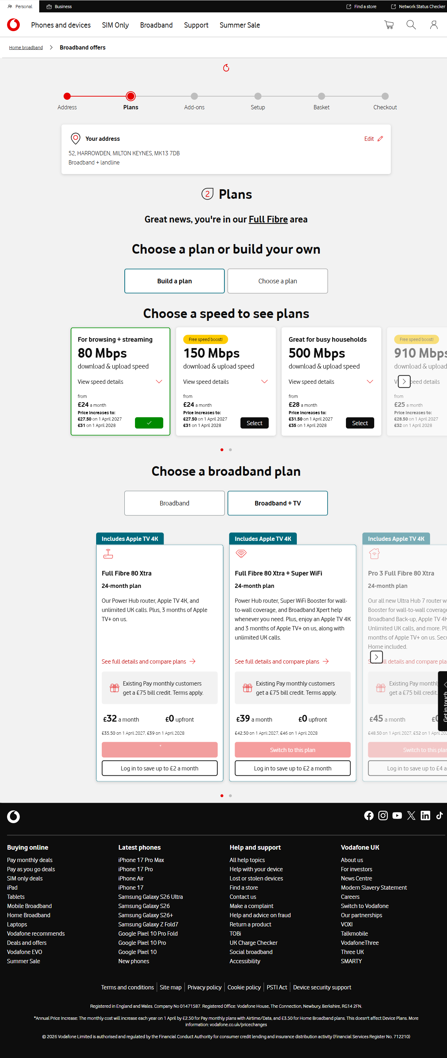

Step 4: Addons Page
Timestamp: 2026-06-12 19:55:04
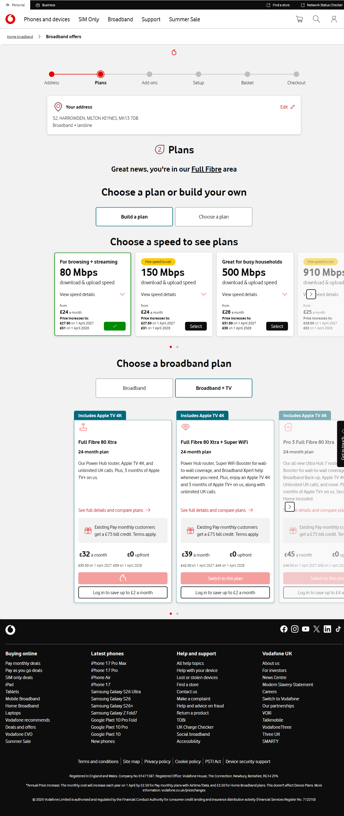

Step 5: Setup Page
Timestamp: 2026-06-12 19:55:17
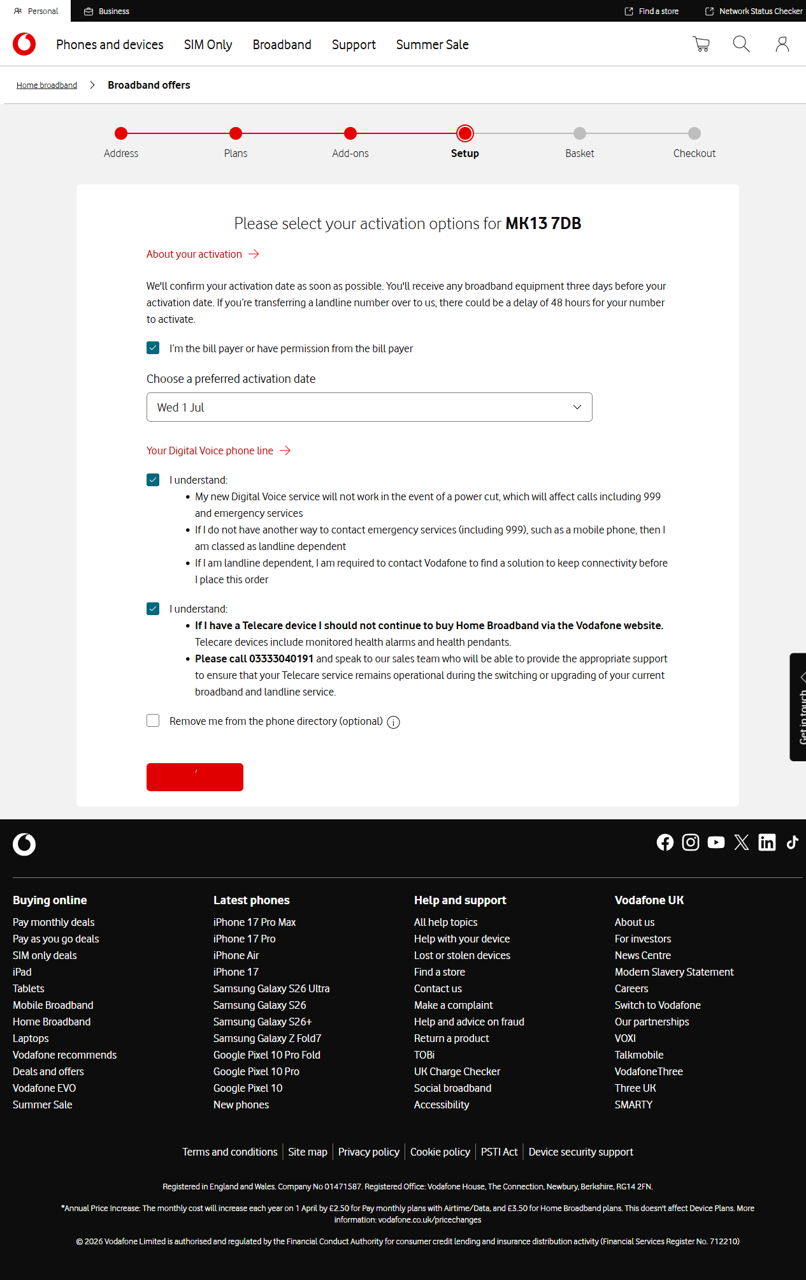

Step 6: Basket Page
Timestamp: 2026-06-12 19:55:37
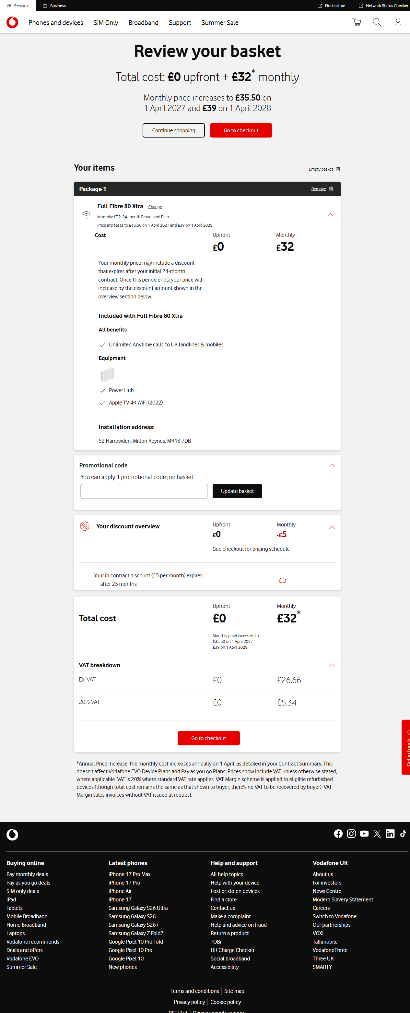

Step 7: Checkout Page Customer Details
Timestamp: 2026-06-12 19:55:55
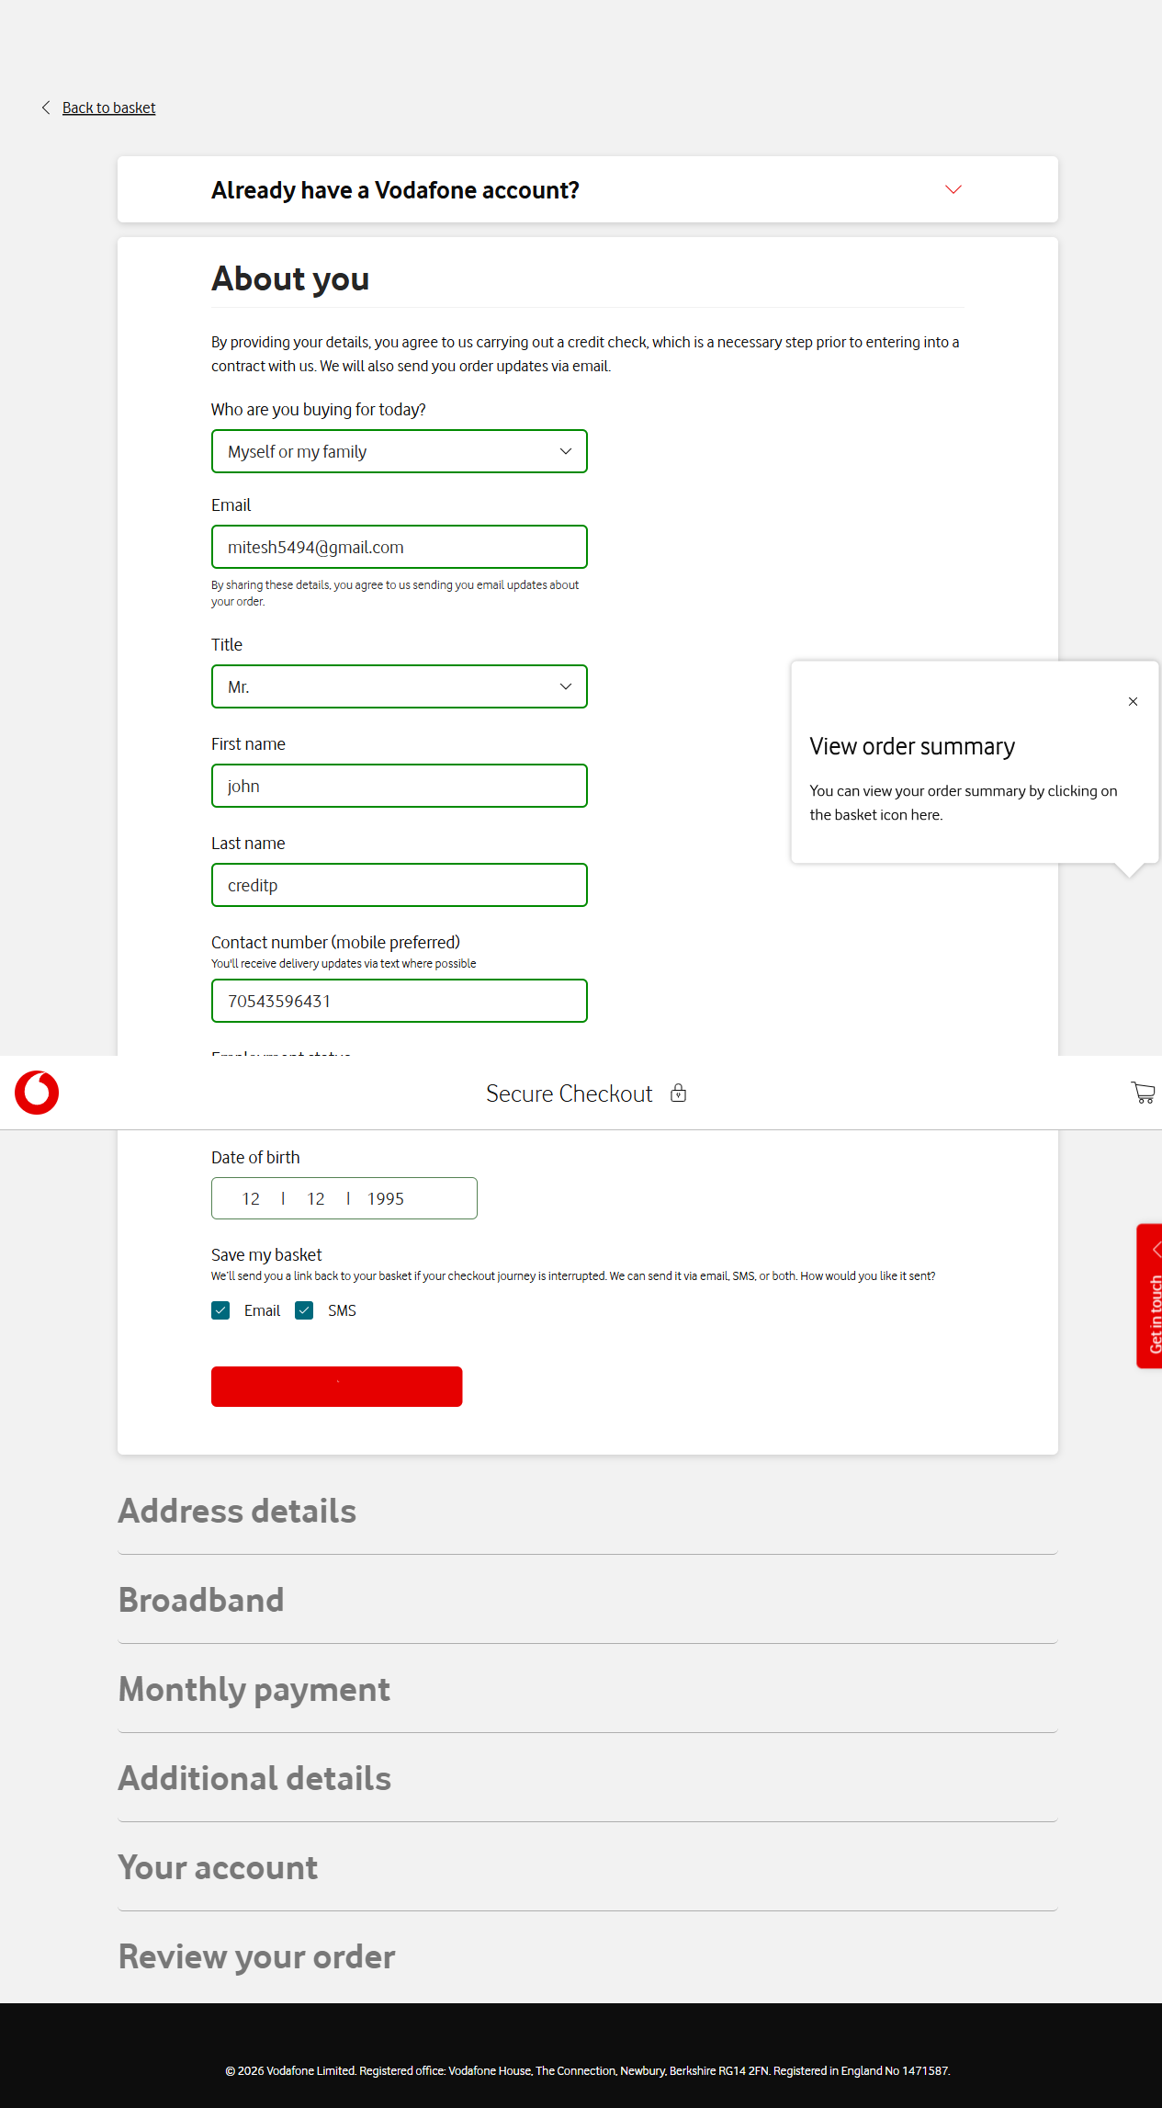

Step 8: Checkout Page Address Details
Timestamp: 2026-06-12 19:55:57
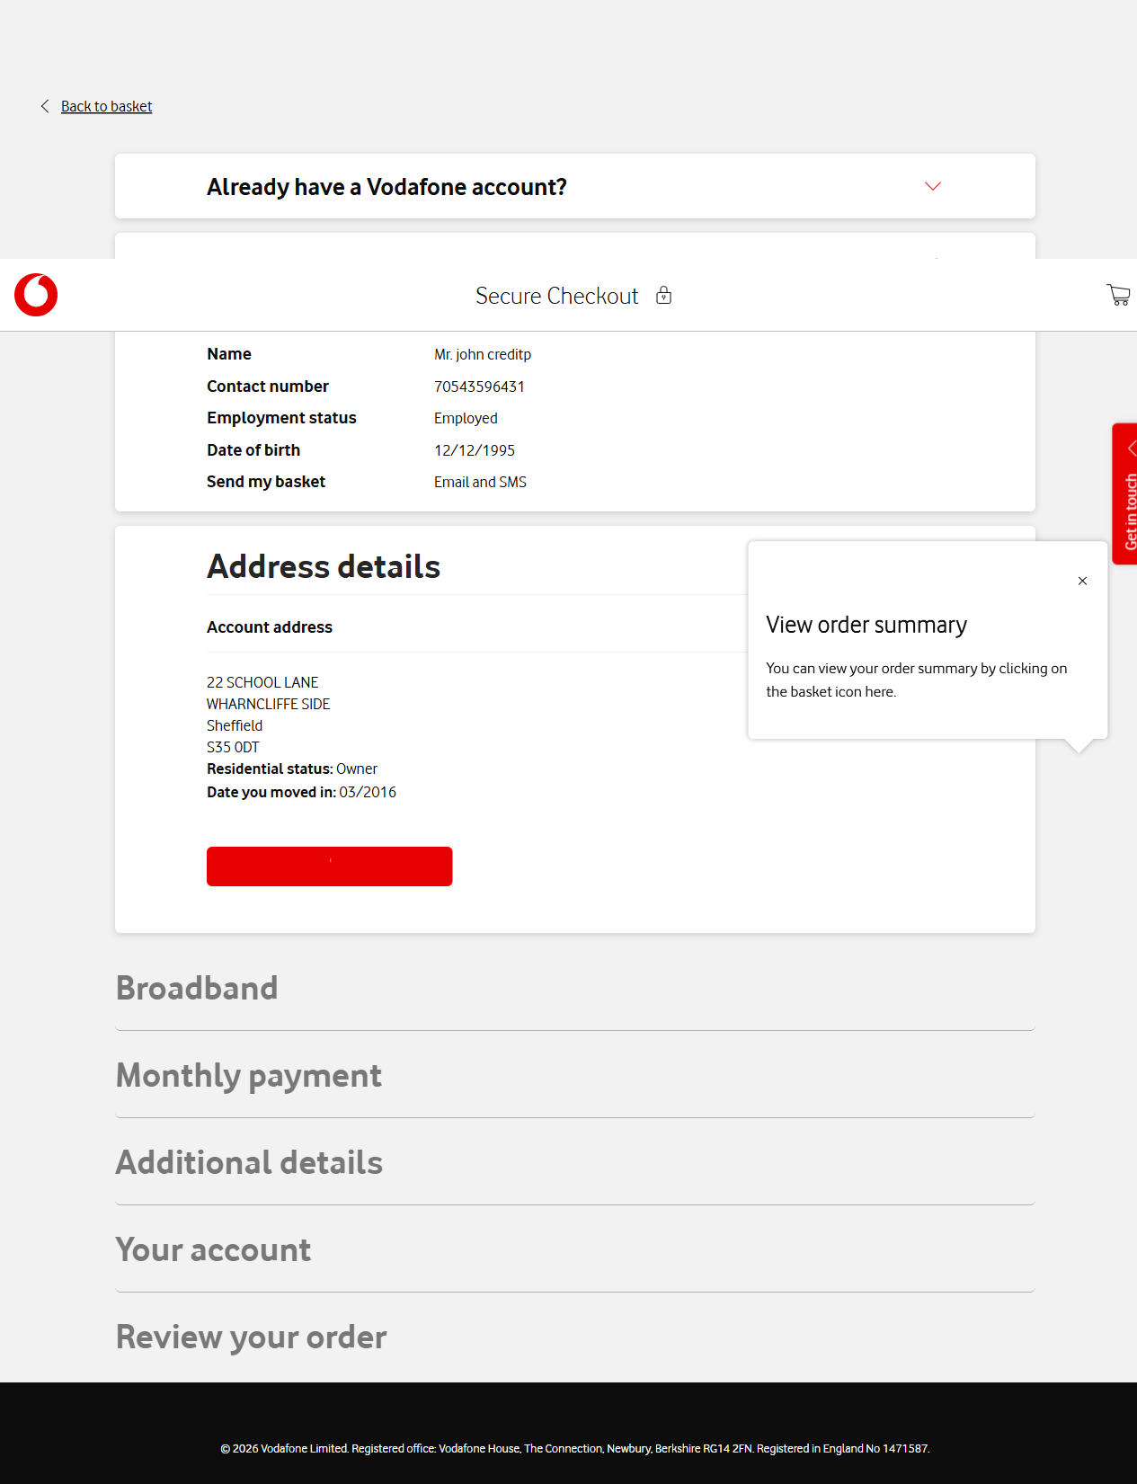

Step 9: Checkout Page Delivery Details
Timestamp: 2026-06-12 19:56:00
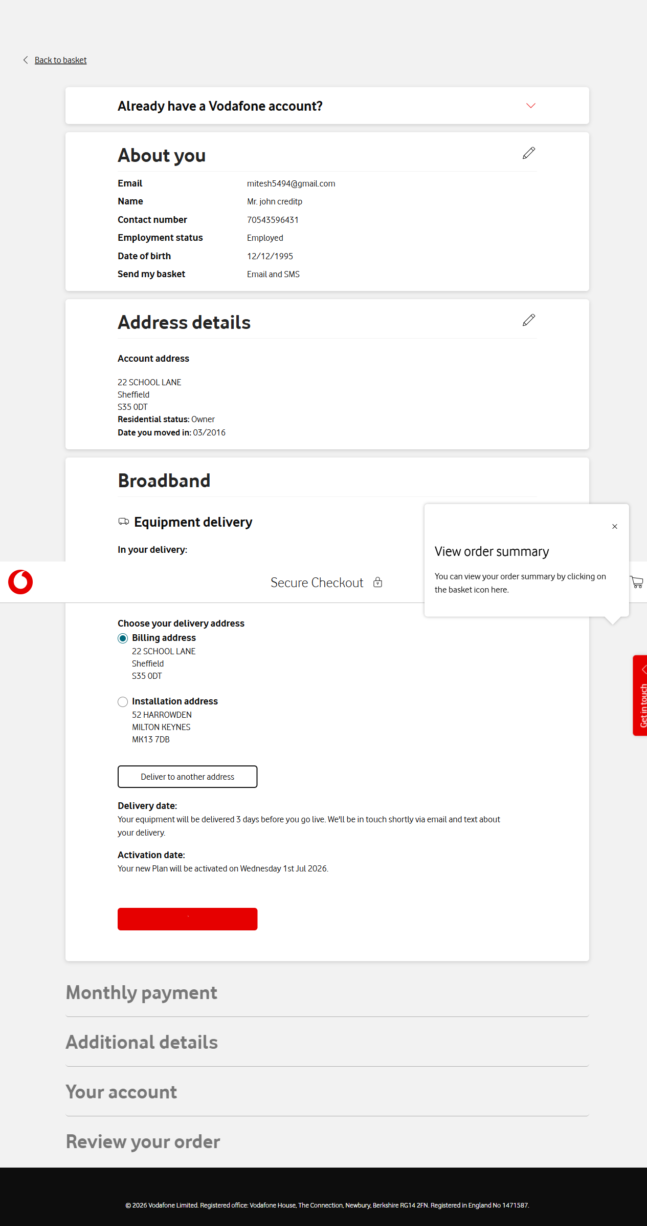

Step 10: Checkout Page Bank Details
Timestamp: 2026-06-12 19:56:04
