Execution Report - FTTP_TC_Acq

Step 1: Landing Page
Timestamp: 2026-06-12 19:52:49
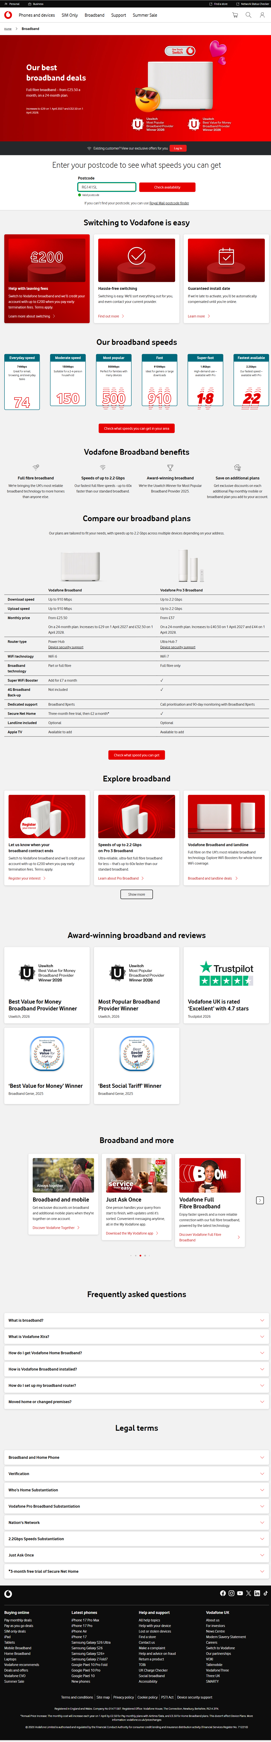

Step 2: Address Page
Timestamp: 2026-06-12 19:52:59
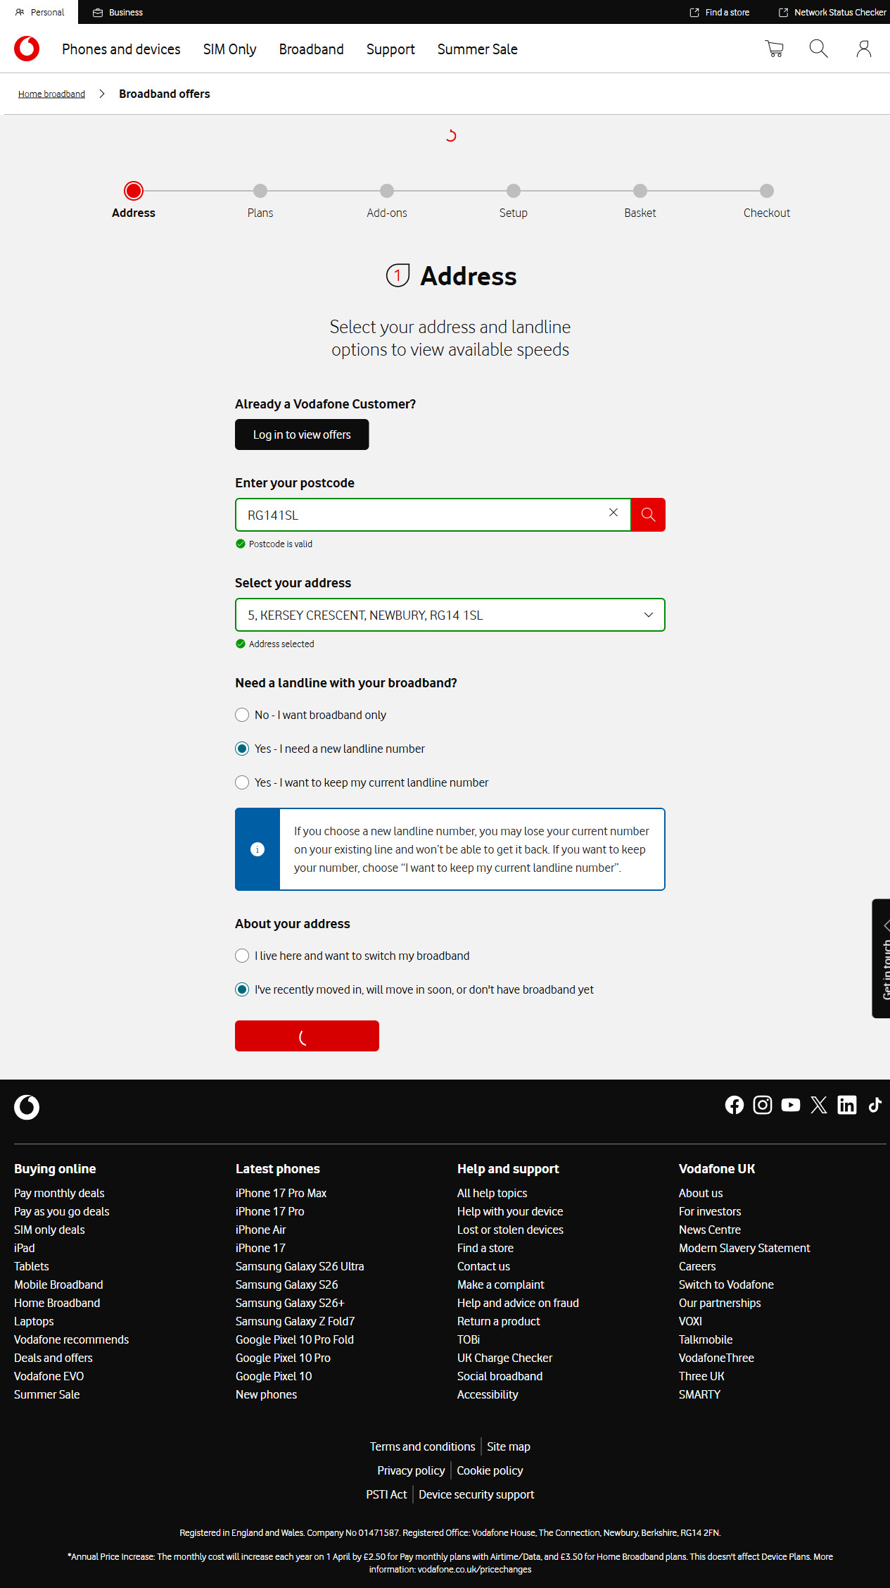

Step 3: Plans Page
Timestamp: 2026-06-12 19:53:08
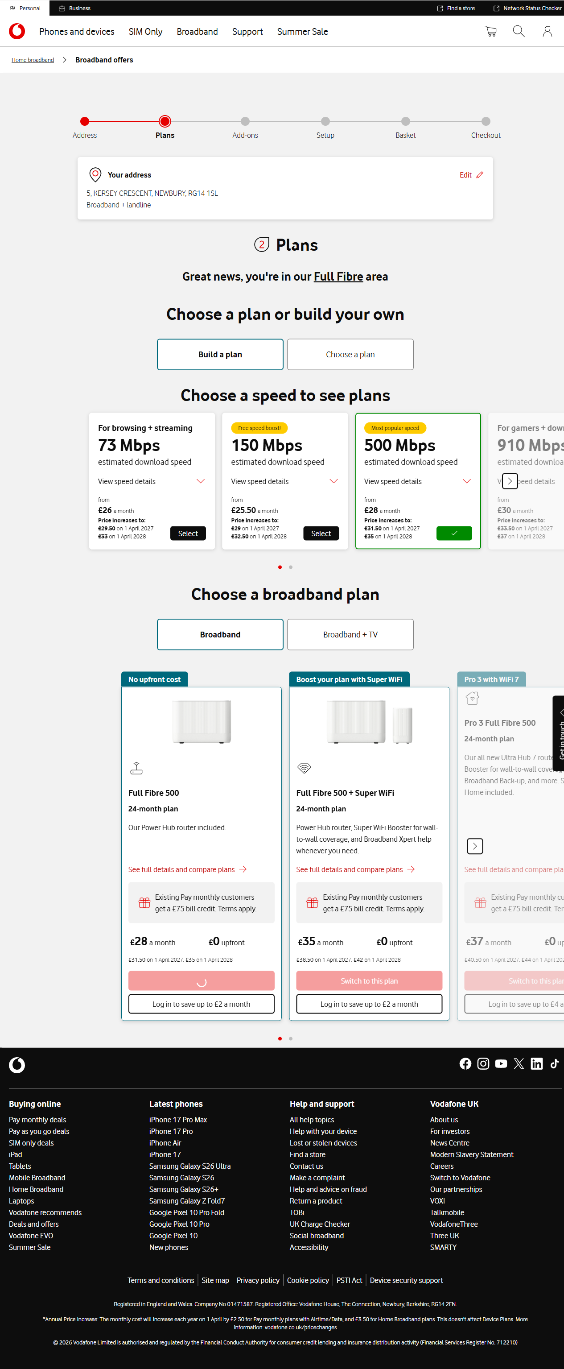

Step 4: Addons Page
Timestamp: 2026-06-12 19:53:09
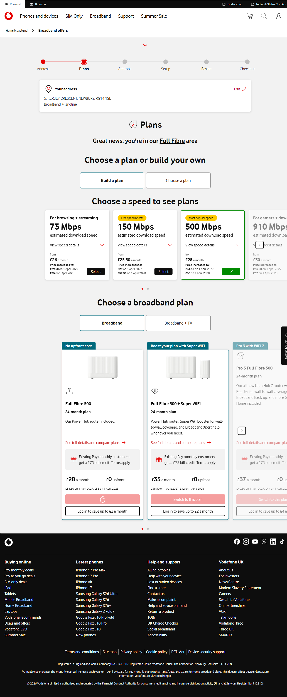

Step 5: Setup Page
Timestamp: 2026-06-12 19:53:32
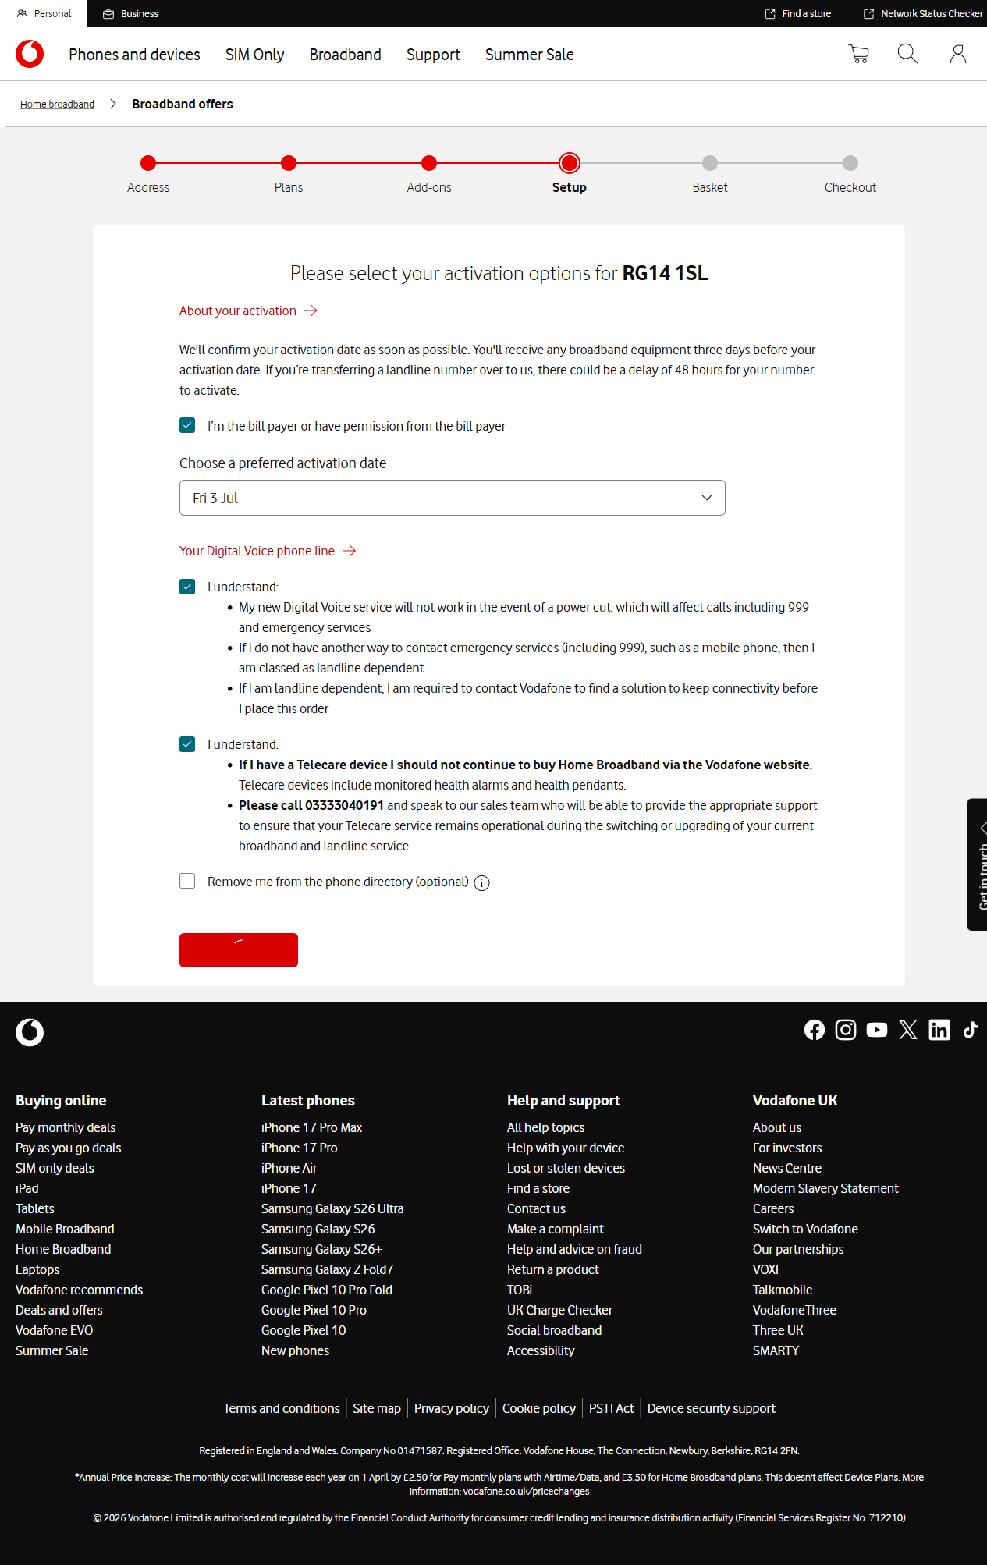

Step 6: Basket Page
Timestamp: 2026-06-12 19:53:45
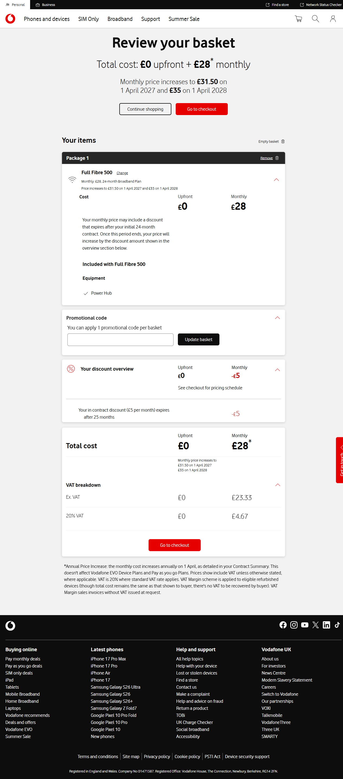

Step 7: Checkout Page Customer Details
Timestamp: 2026-06-12 19:53:58
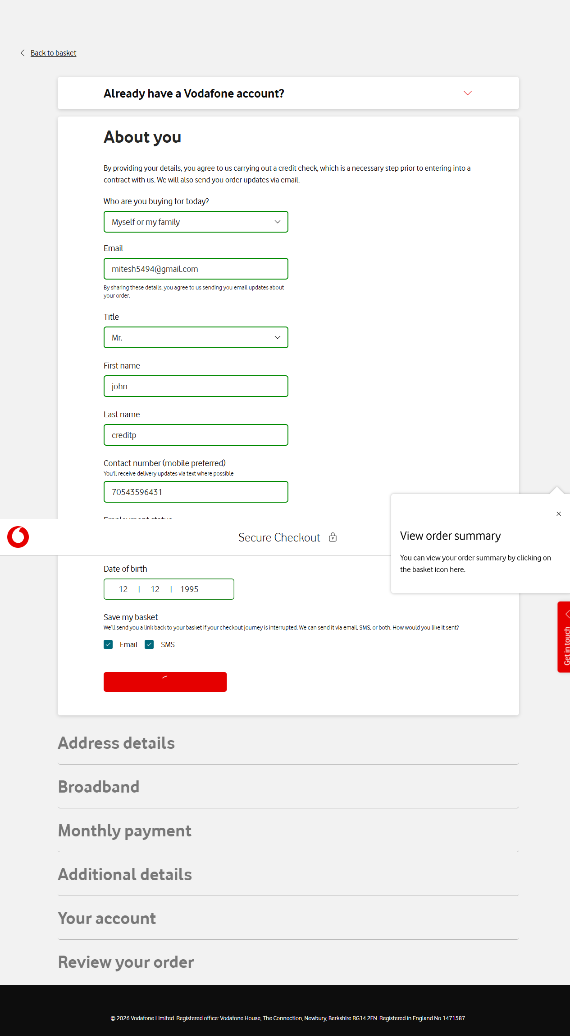

Step 8: Checkout Page Address Details
Timestamp: 2026-06-12 19:54:02
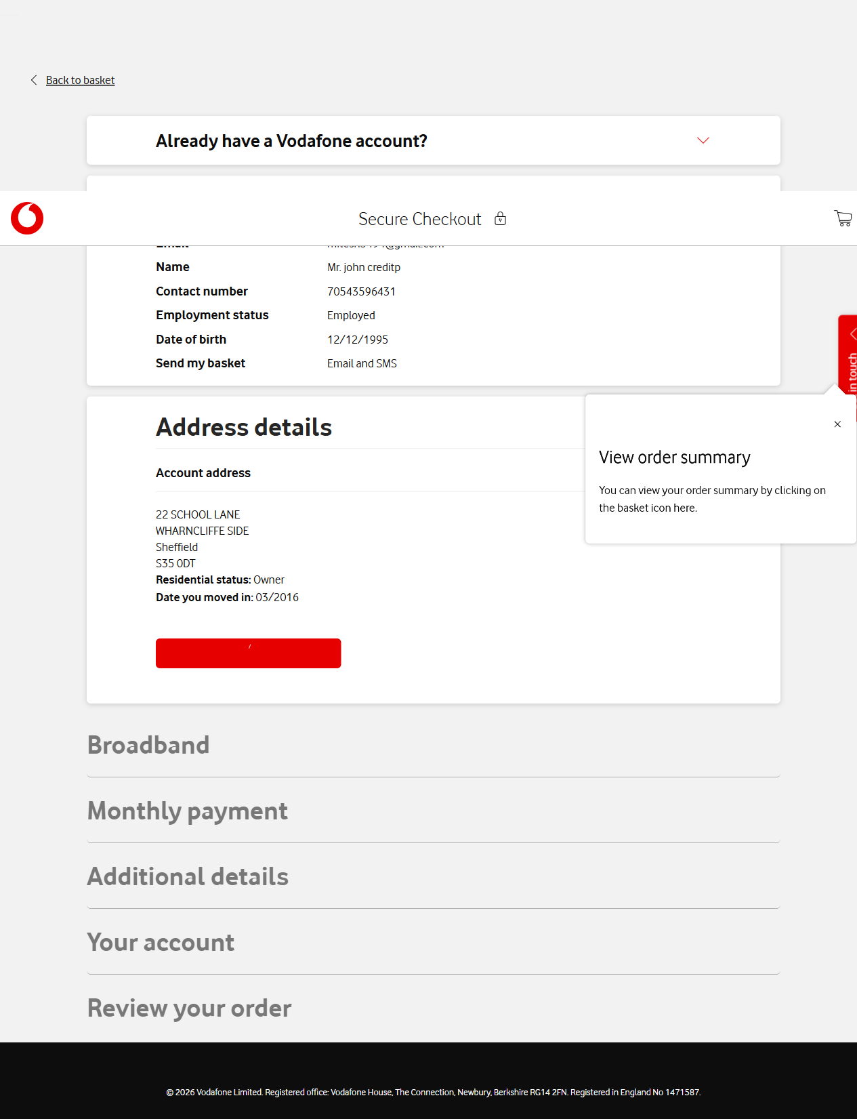

Step 9: Checkout Page Delivery Details
Timestamp: 2026-06-12 19:54:05
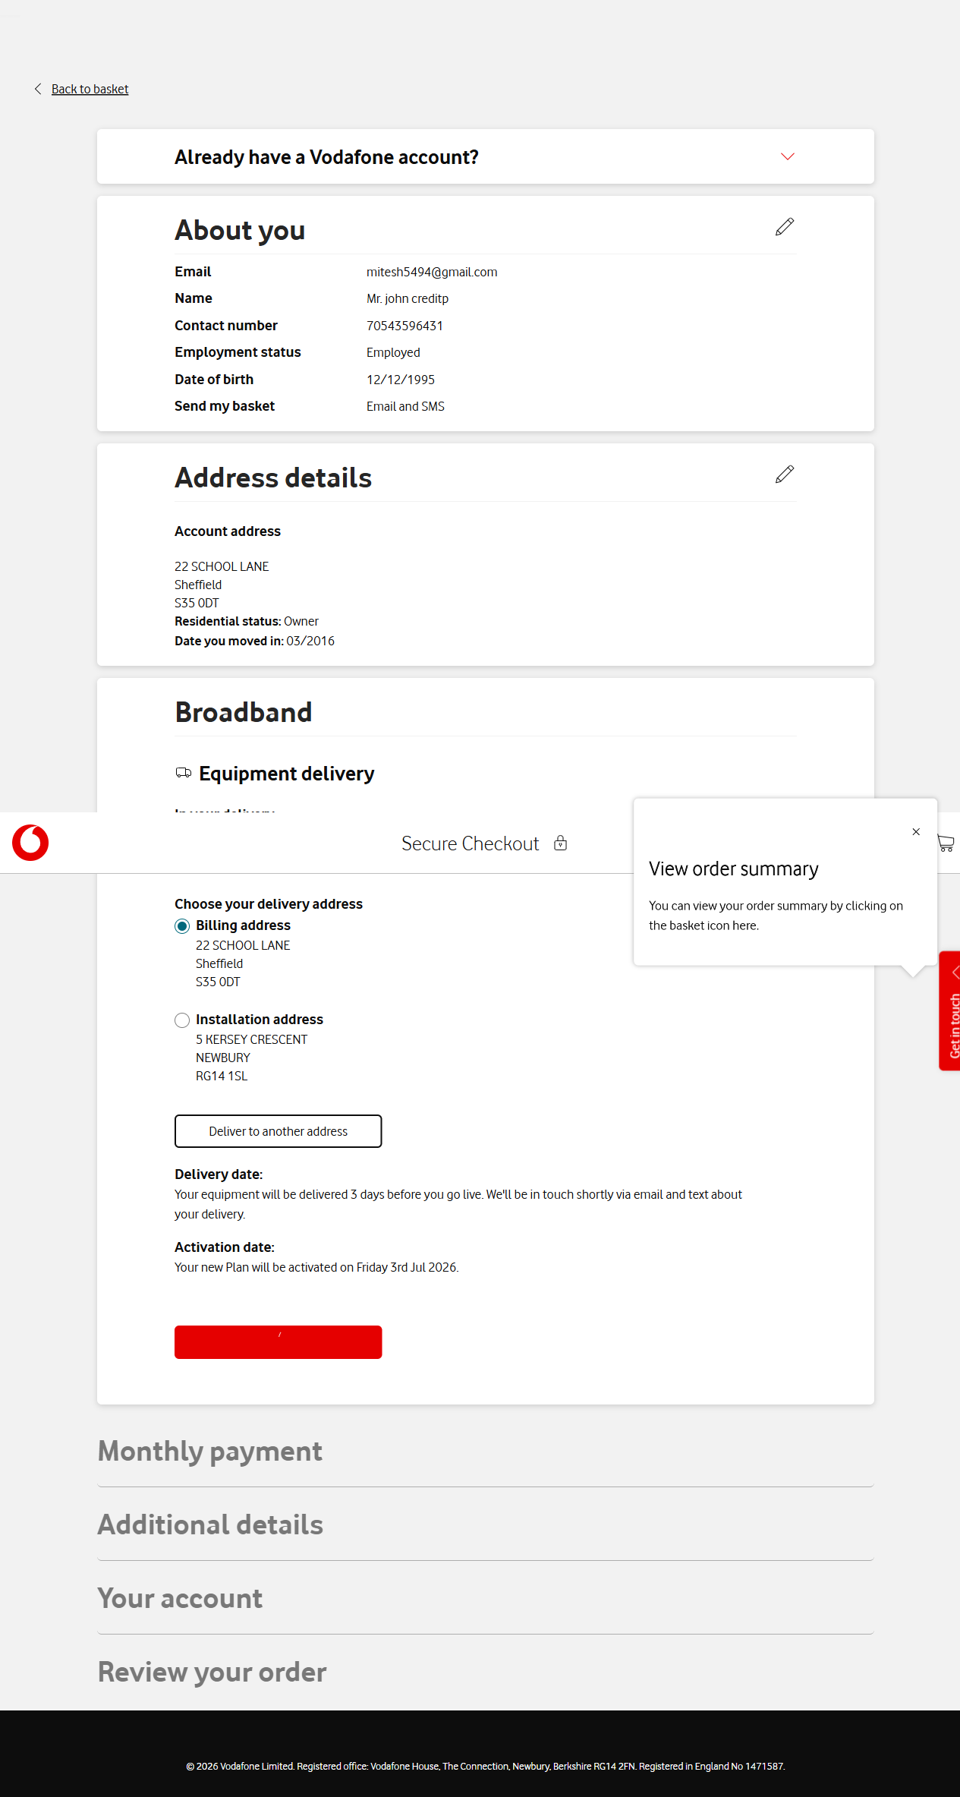

Step 10: Checkout Page Bank Details
Timestamp: 2026-06-12 19:54:08
