Execution Report - SOGEA_TC_Acq

Step 1: Landing Page
Timestamp: 2026-06-12 19:56:34
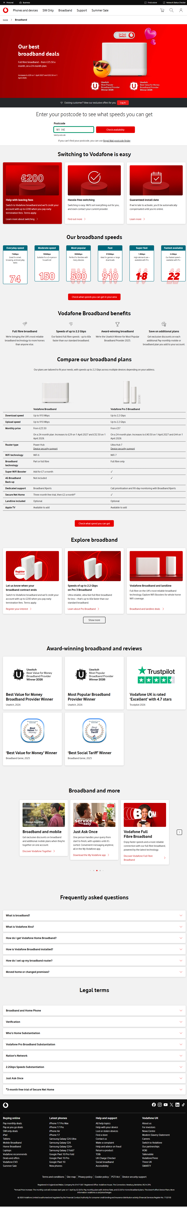

Step 2: Address Page
Timestamp: 2026-06-12 19:56:55
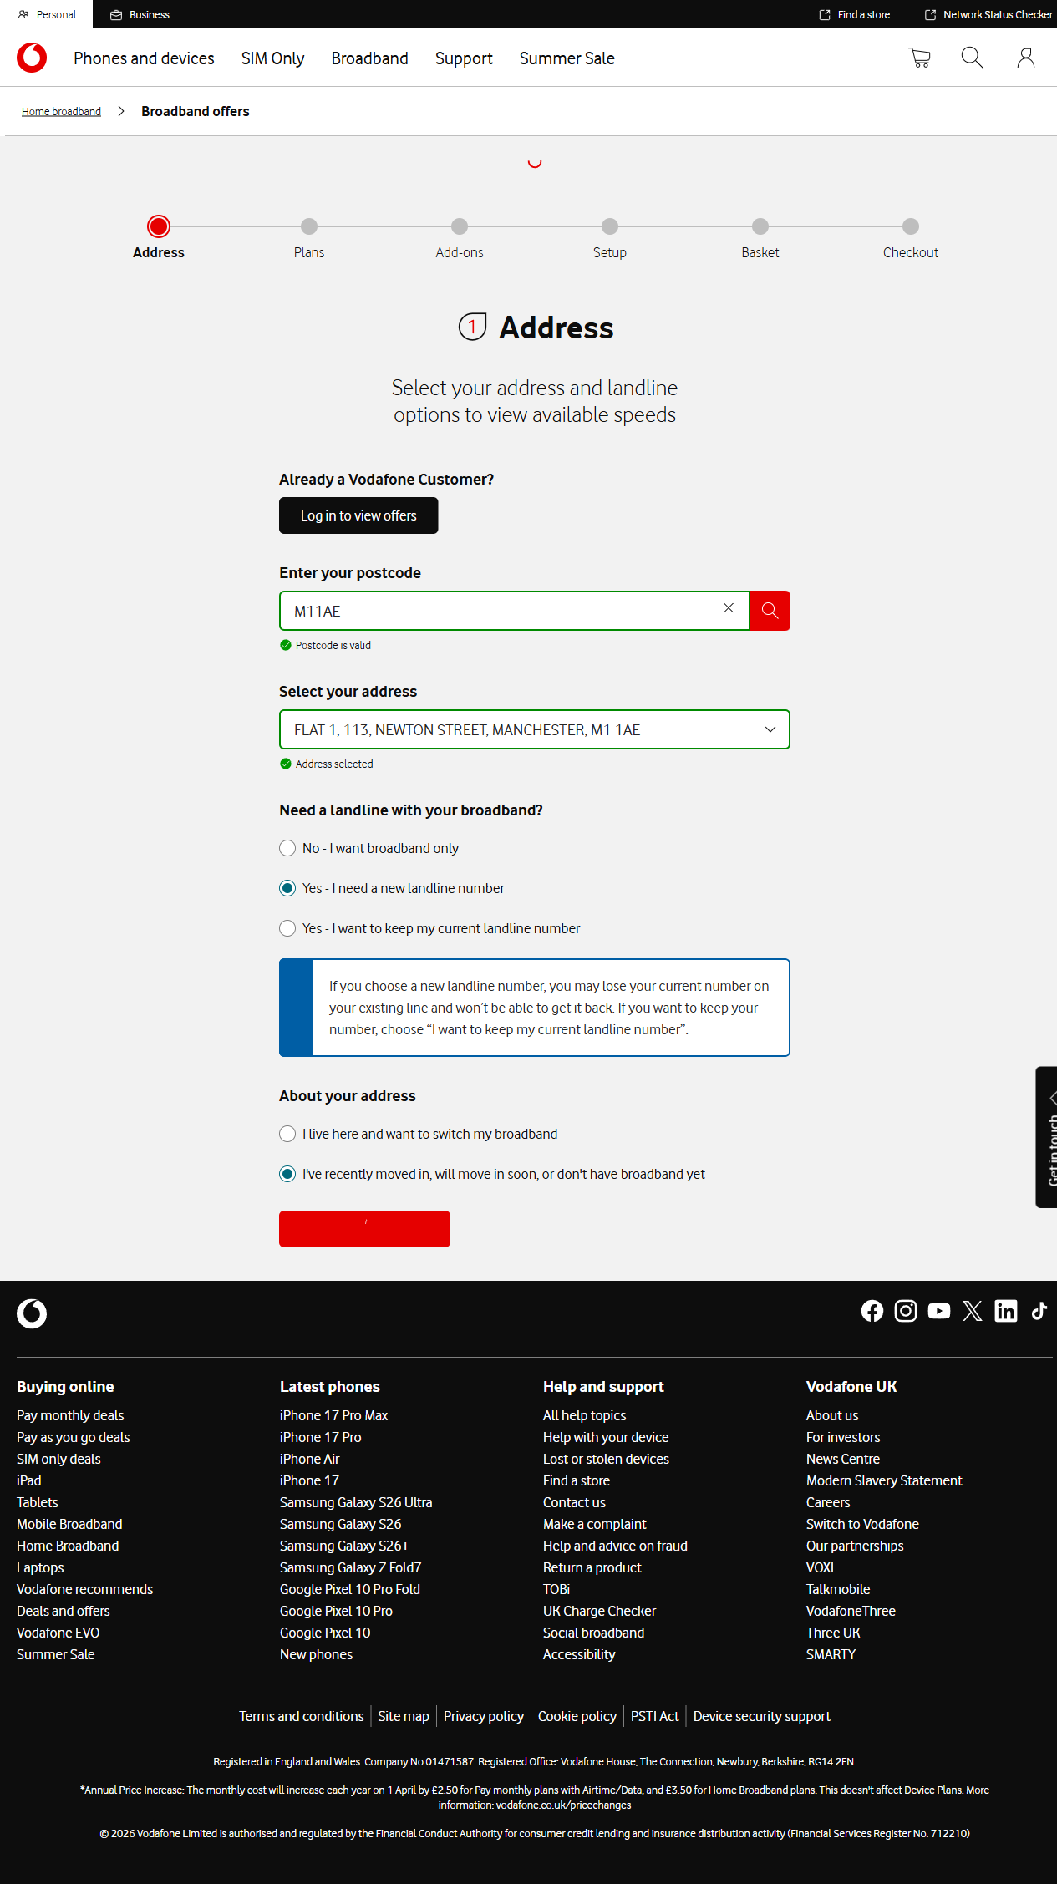

Step 3: Plans Page
Timestamp: 2026-06-12 19:57:09
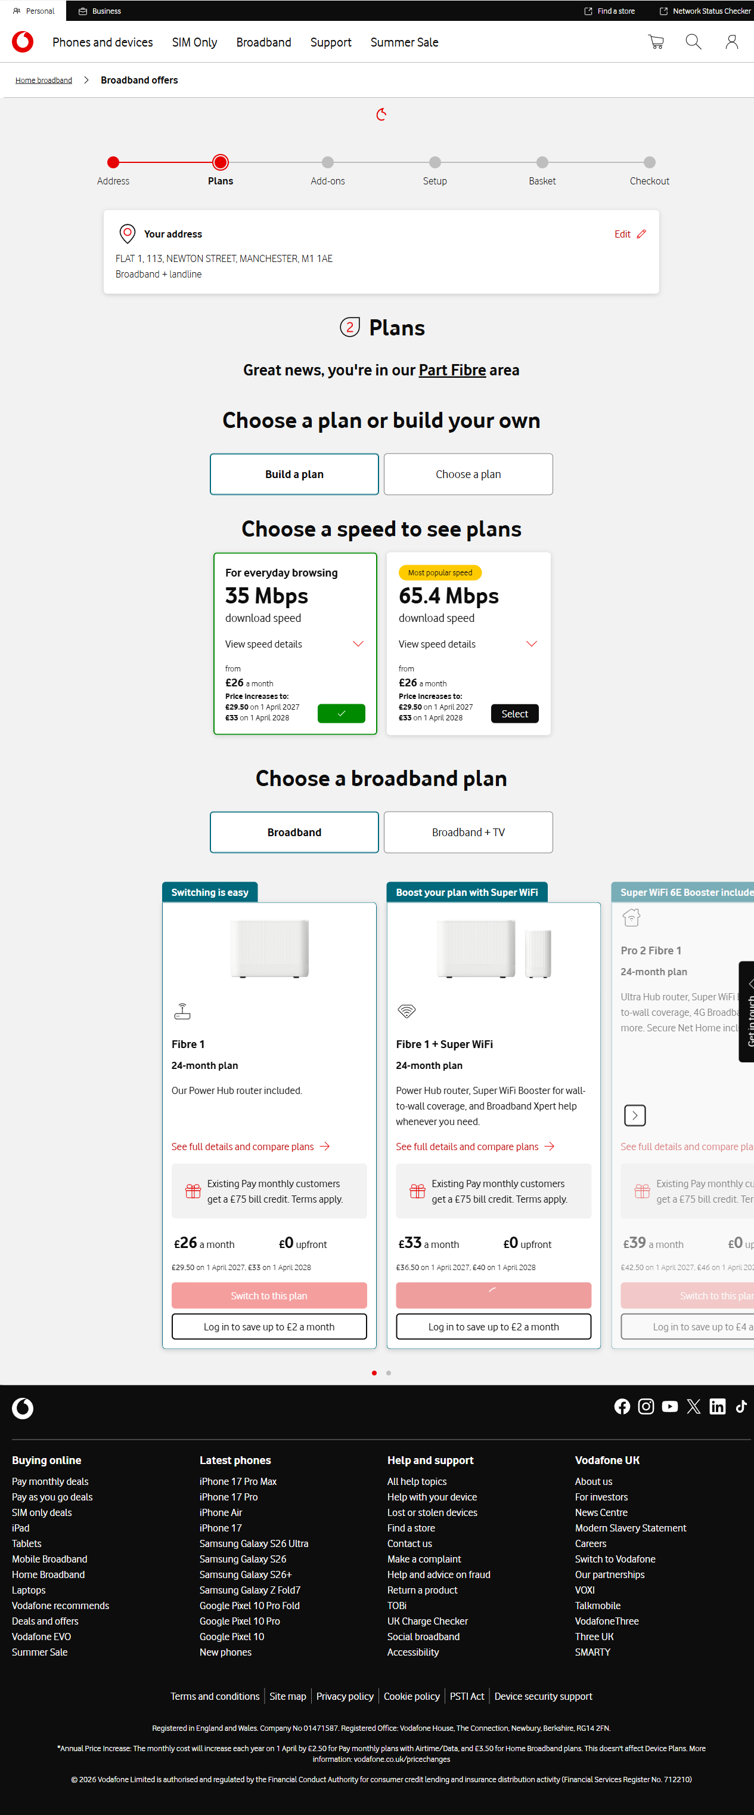

Step 4: Addons Page
Timestamp: 2026-06-12 19:57:09
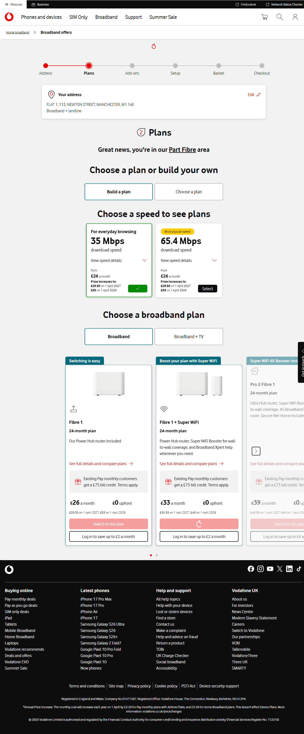

Step 5: Setup Page
Timestamp: 2026-06-12 19:57:27
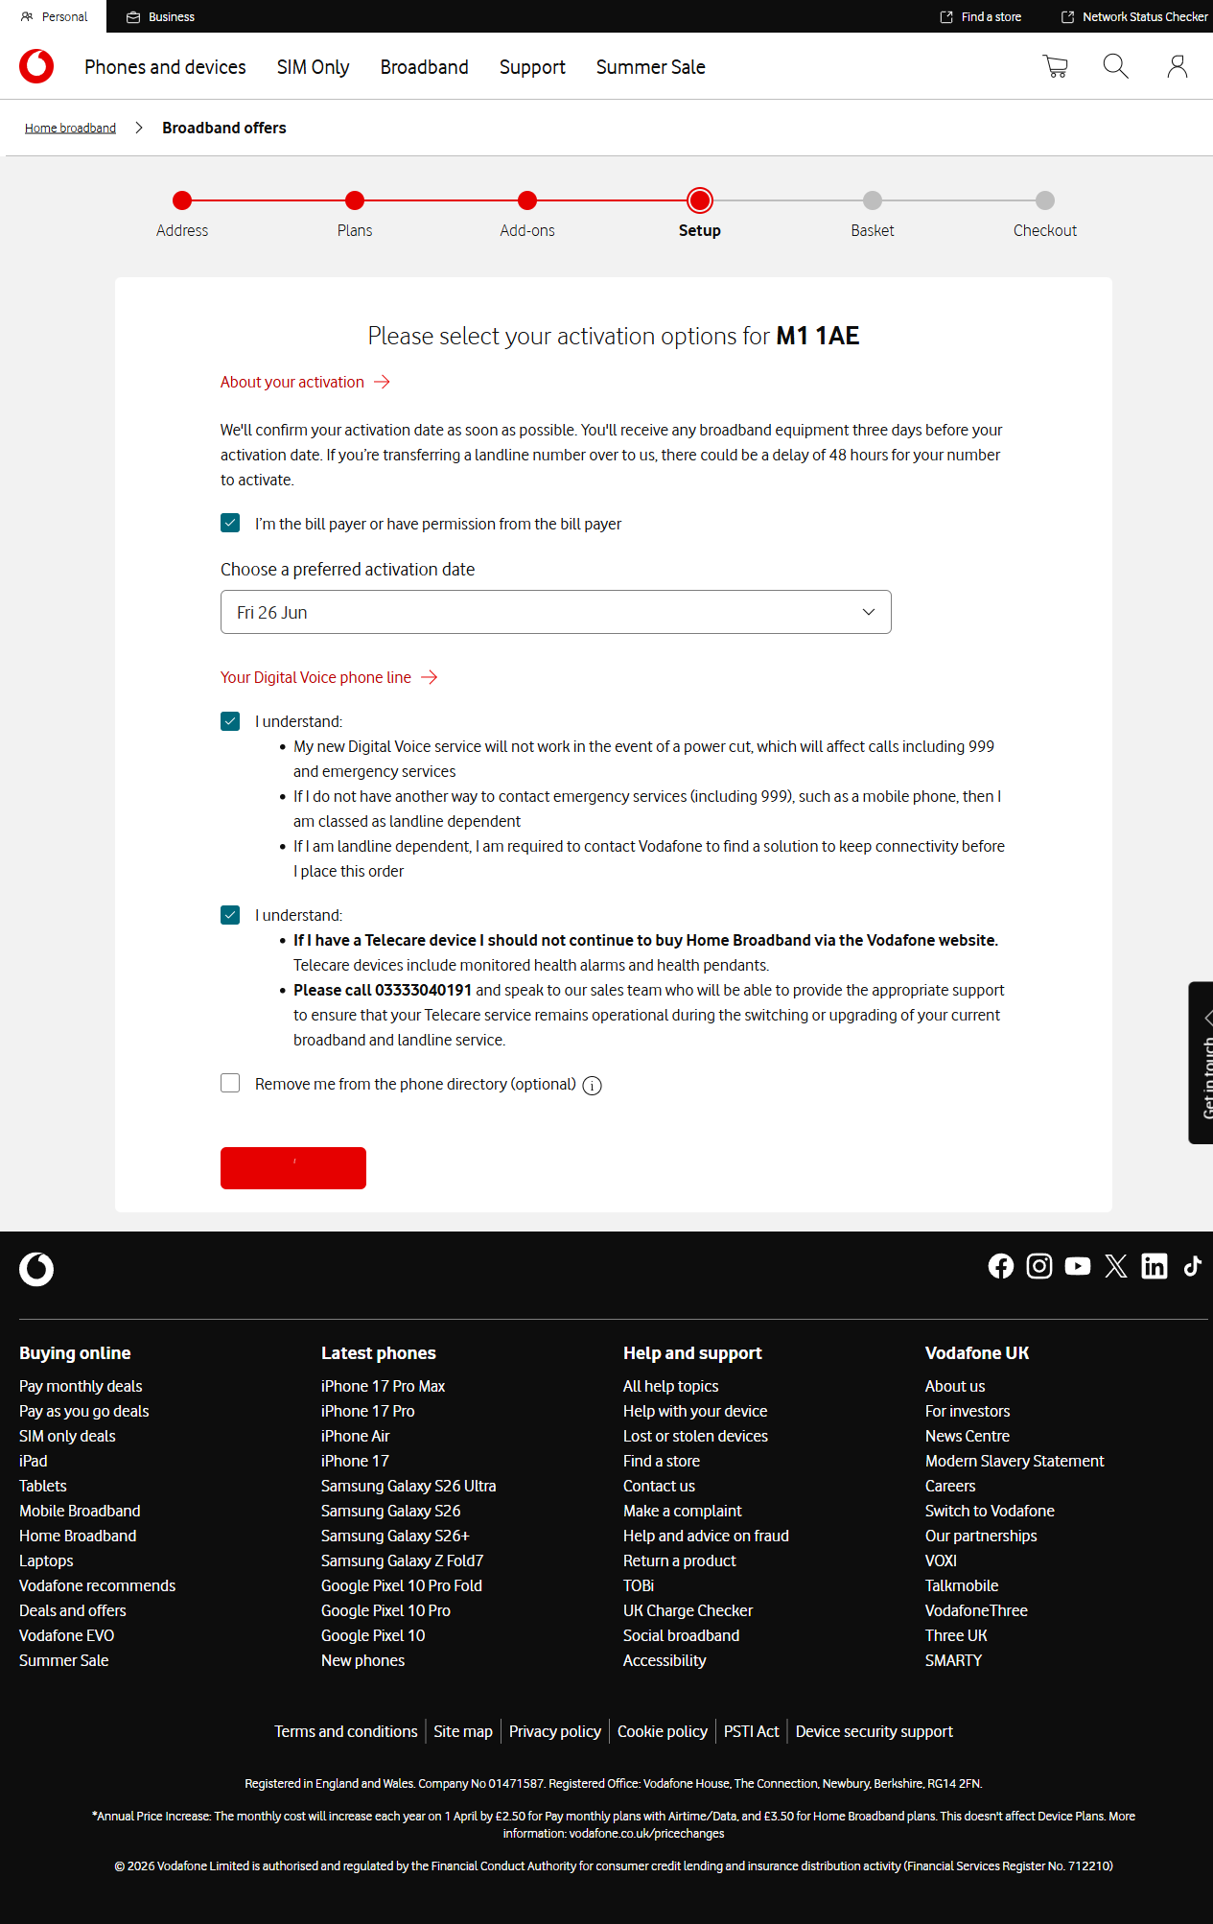

Step 6: Basket Page
Timestamp: 2026-06-12 19:57:48
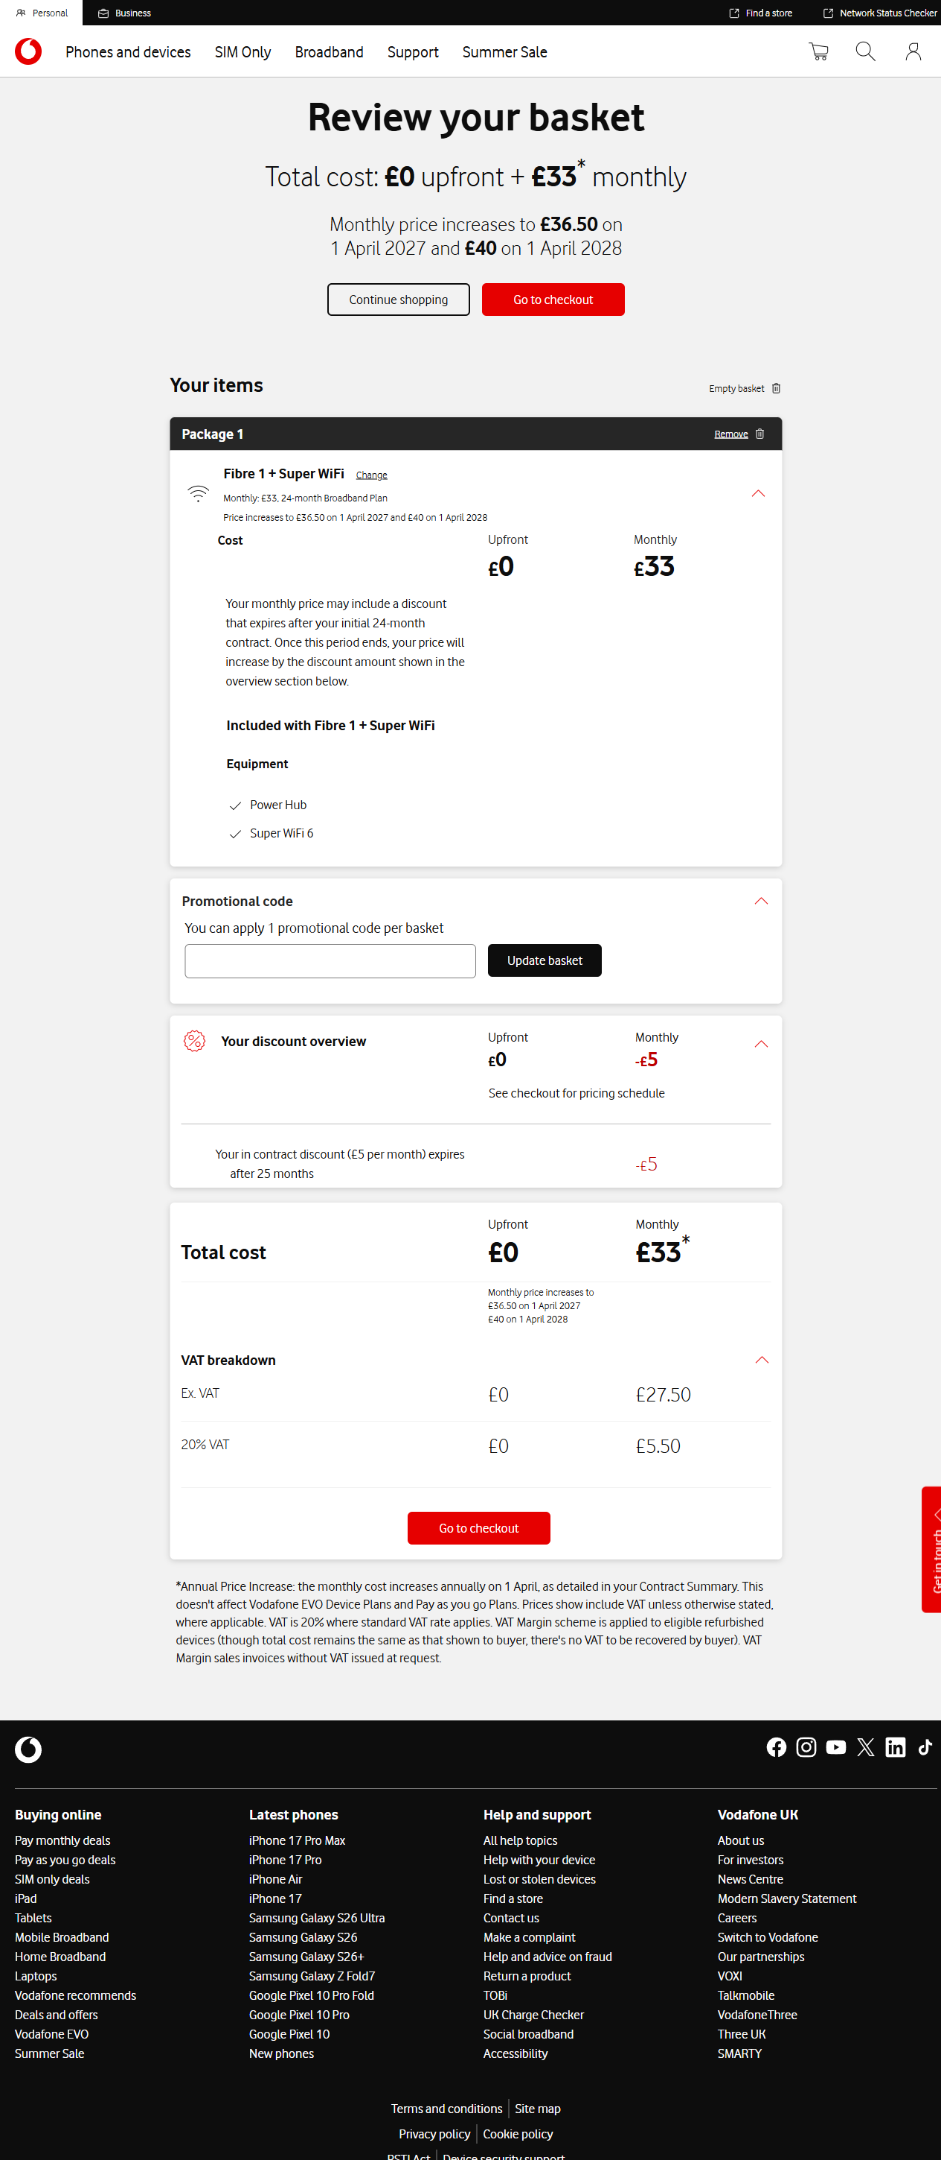

Step 7: Checkout Page Customer Details
Timestamp: 2026-06-12 19:58:11
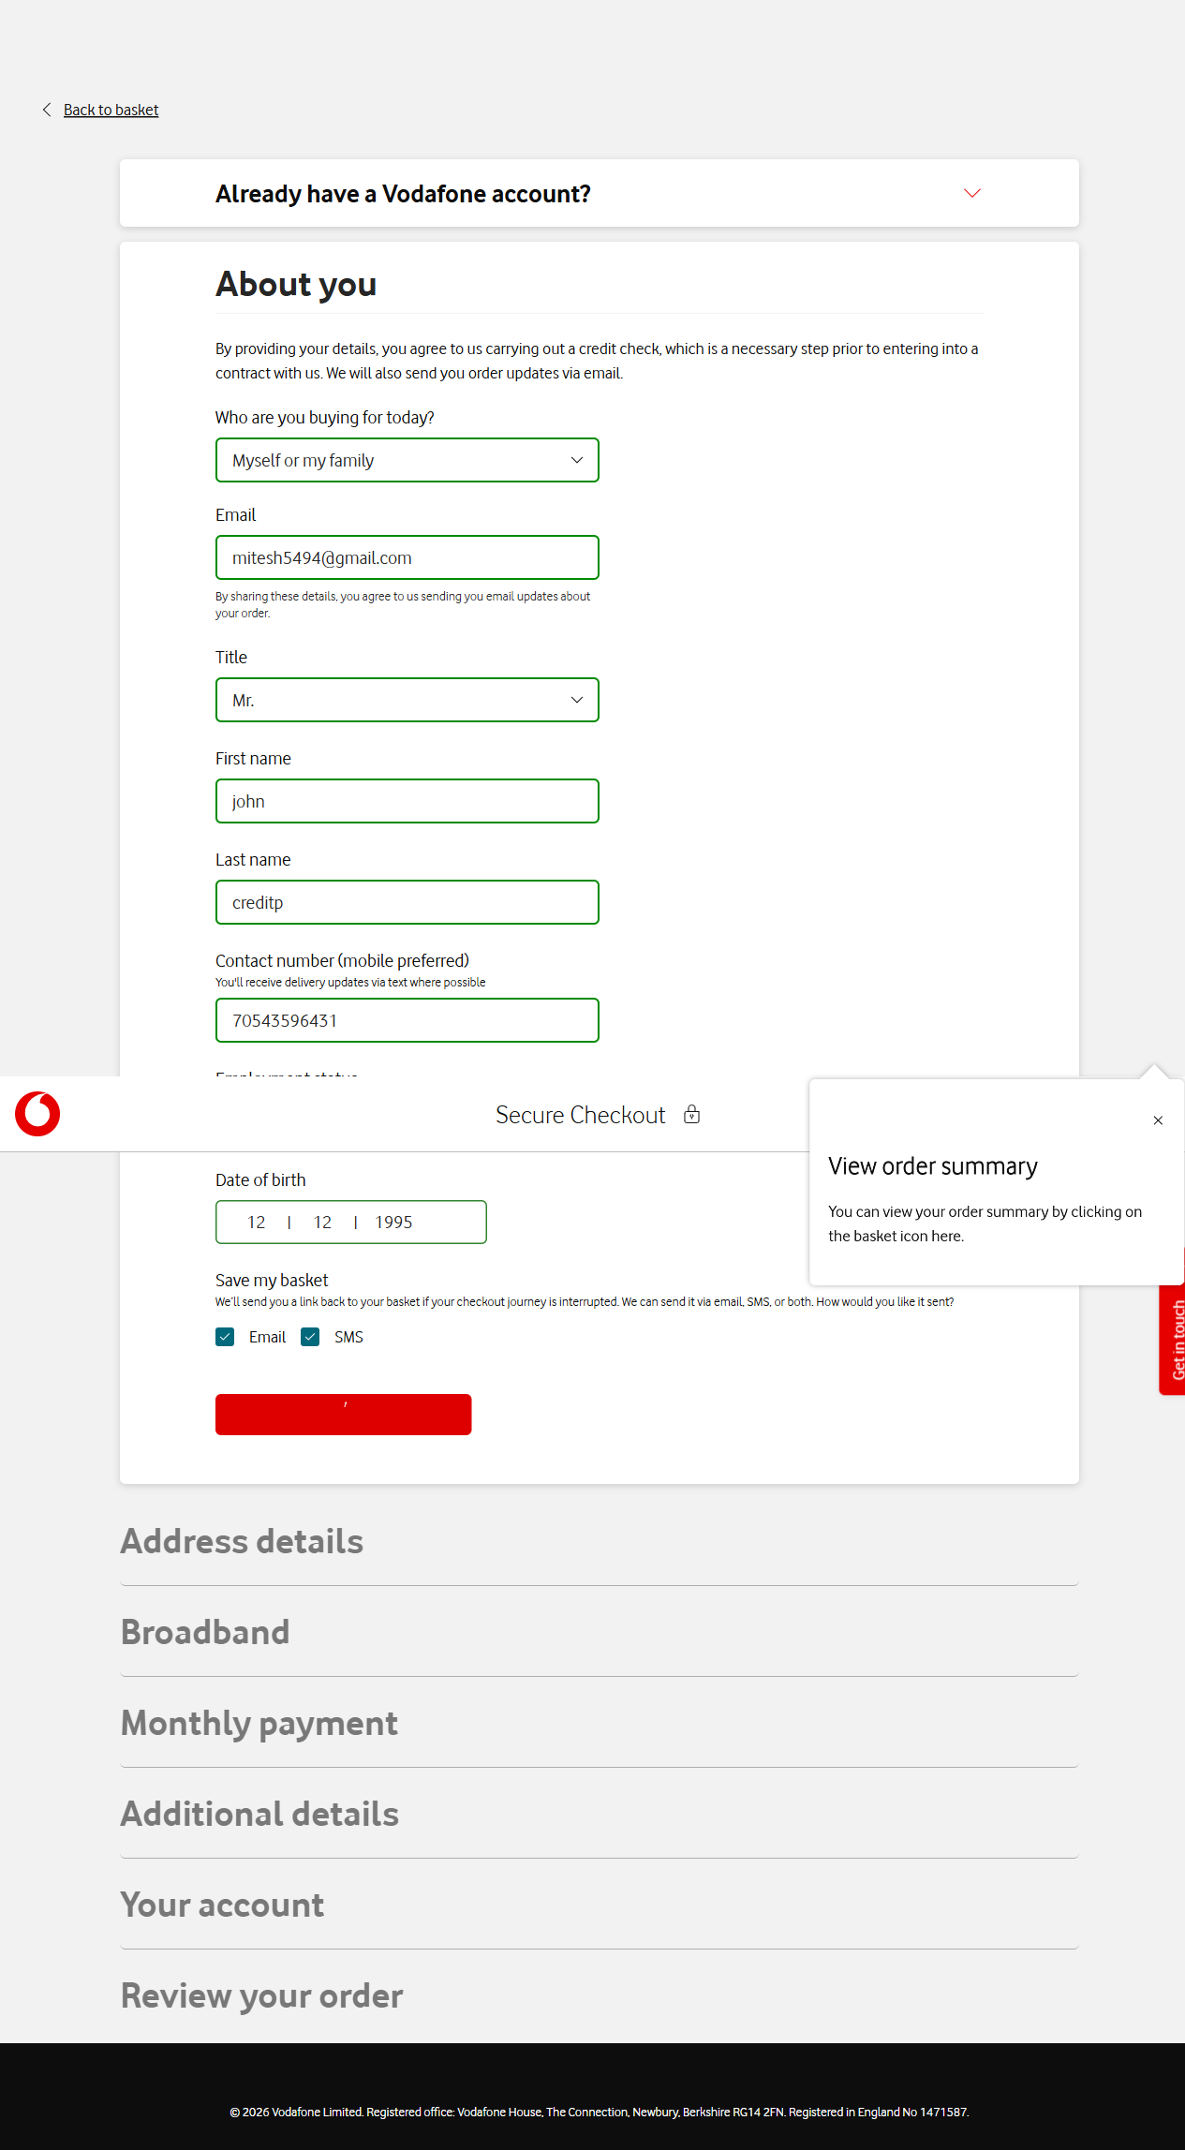

Step 8: Checkout Page Address Details
Timestamp: 2026-06-12 19:58:17
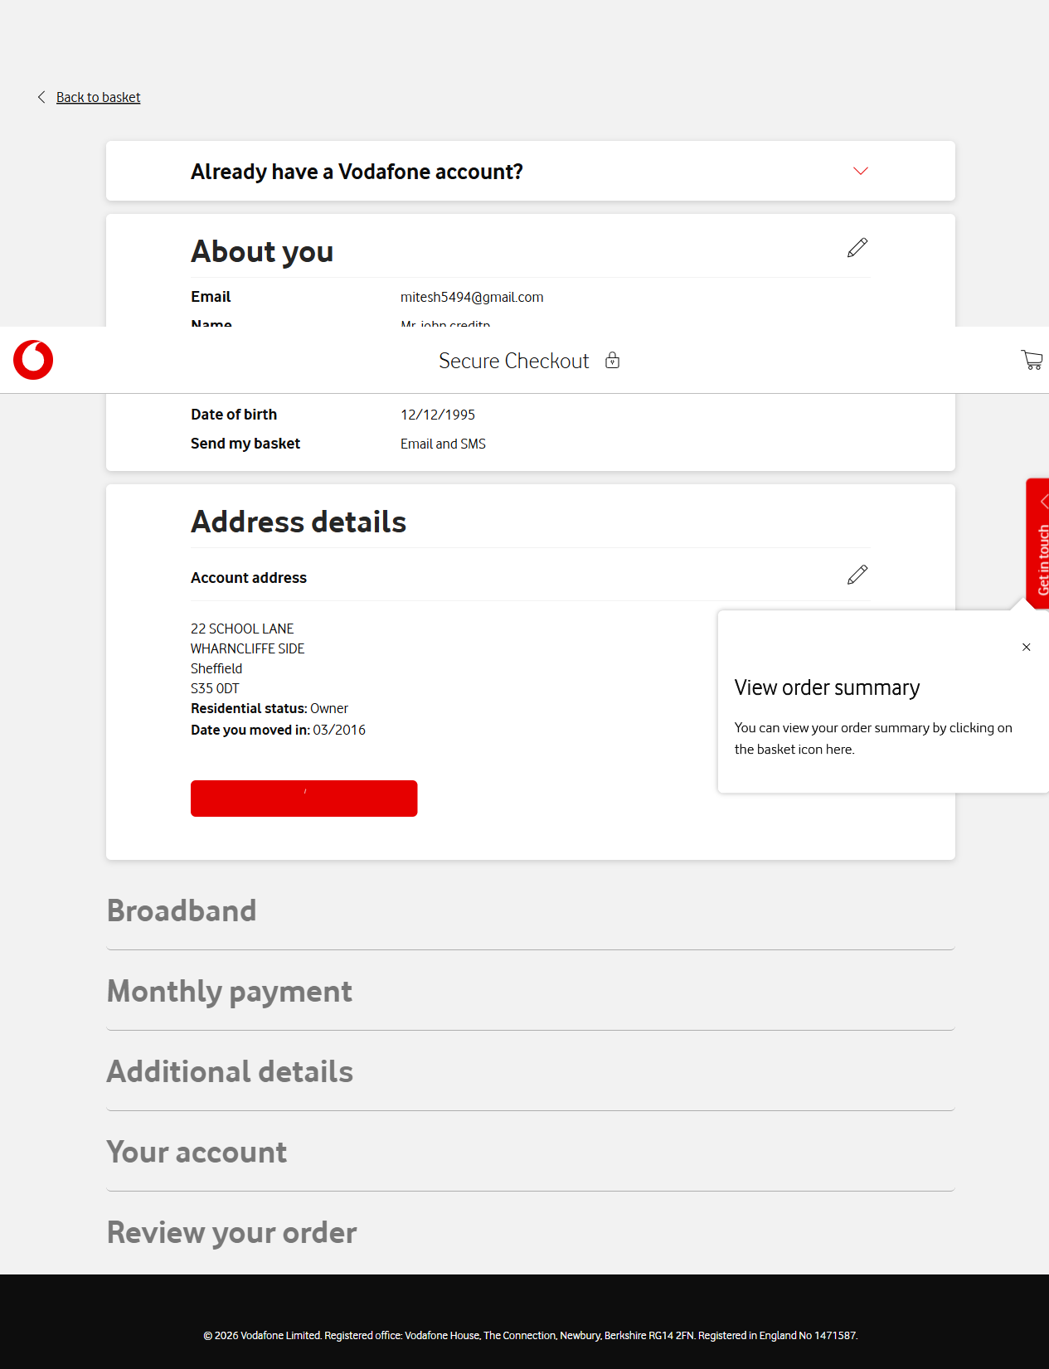

Step 9: Checkout Page Delivery Details
Timestamp: 2026-06-12 19:58:22
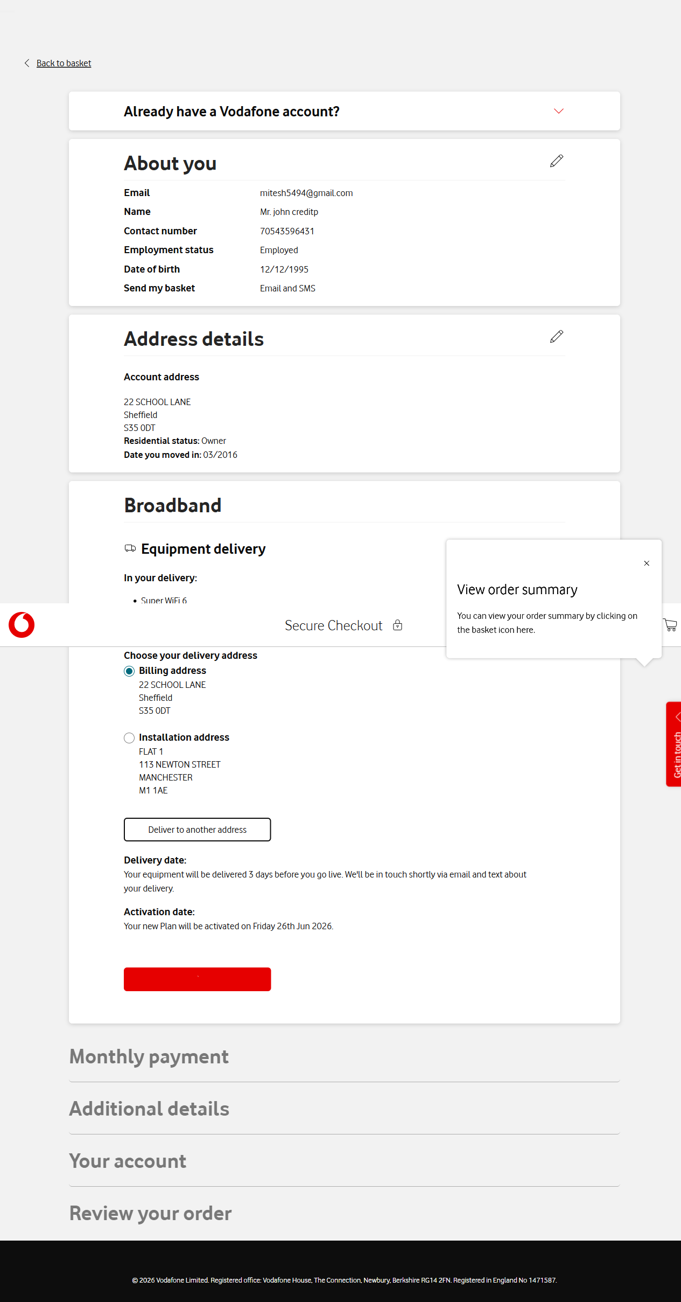

Step 10: Checkout Page Bank Details
Timestamp: 2026-06-12 19:58:26
