A Project Report on

Al CHAT BOT

SUBMITTED BY

Vishal Kumar
Batch Year - 2024-2026
Div:- G Roll No:-43
Enrollment No.-24004401110210

Shruti Surve
Batch Year - 2024-2026
Div:- G Roll No:-46
Enrollment No.-24004401110338

Mitesh Sharma
Batch Year - 2024-2026
Div:- G Roll No:-45
Enrollment No.-24004401110210

Group No- 06

Guided By
Mamad Minapara

LOK JAGRUTI KENDRA UNIVERSITY


Certificate
This is certified that work, which is being presented in the project entitled Simple Chat Bot submitted by undersigned student of Master of Computer Application 3rd Semester in partial fulfillment for of 3rd Semester main project for Master of Computer Application is a record of our own work carried out under guidance and supervision of
Mamad Minapara.
This work has not submitted elsewhere for award of any other degree.

Date: 26/09/2025 Name and Signature of Student:
Place: Ahmedabad, Gujarat Vishal Kumar
Shruti Surve
Mitesh Sharma

CONTENTS
Certificate
Acknowledgment
Contents
- Introduction
I. Abstract
Il. Motivation
Ill. Problem Definition
IV. Objective
- Requirements
- Objective
- Architecture
- Flow Chart
- Important Terminology
- Prototype
- Testing and findings
8.1 Result from testing
- Decision & Conclusion
- Implementation
- Future scope & conclusion
- Screenshots
- Code Overview
References

1. Introduction
I. Abstract

In this project, we introduce "AI Chatbot", developed using Google's TensorFlow framework. The goal is to create a universal system capable of assisting customers efficiently, thereby saving time and reducing the need for human intervention.

Chatbots are becoming essential in areas such as:

Customer Service

Sales and Marketing

Their 24×7 availability makes them an economical and reliable solution for businesses. The core technology behind chatbots is Natural Language Processing (NLP), and recent advancements in Machine Learning have significantly improved their accuracy and effectiveness. As NLP continues to evolve, chatbots will become even more powerful and capable of handling complex tasks for organizations worldwide.

Il. Motivation
The rise of social media has transformed customer service. Nearly half of internet users now prefer seeking help via messaging platforms like Twitter and Facebook Messenger rather than calling helplines or sending emails.
However, businesses face challenges:
- High volume of user requests
- Expectation for instant responses (Studies show 72% of users expect replies within an hour, but the average response time is 6.5 hours)
Manual handling by human agents is time-consuming, expensive, and limited by working hours. This motivated us to explore AI-powered chatbots that can provide real-time customer service, reduce workload, and meet user expectations efficiently.

Ill. Problem Definition

E-commerce websites handle thousands of customer interactions daily. Over 75% of these are complaints or concerns. Delayed or unresolved issues can harm customer satisfaction and the business's reputation.

Challenges faced by businesses:

Limited human resources for 24×7 support

High cost of maintaining large support teams

Delay in responding to customer queries
An AI-powered chatbot can address these challenges by automating responses, reducing human workload, and ensuring 24×7 availability at minimal cost.

2. Requirements

2.1 Software Requirements
- Operating System: Windows / Linux
- Technology: Python, AIML, TensorFlow
- IDE: PyCharm / VS Code
- Database: MySQL / SQLite (if needed)

2.2 Hardware Requirements
- Processor: Intel Pentium IV or above
- RAM: 2 GB (Recommended)
- Hard Disk: Minimum 128 GB

3. Objective
The main goal of this project is to develop an AI-powered chatbot capable of real-time communication with users, reducing workload and providing quick responses. With the help of Artificial Intelligence (AI) and a knowledgeable database, the chatbot can:
- Interact with users naturally and efficiently.
- Handle queries intelligently using NLP and Machine Learning.
- Minimize the workload on college administrative staff by automating responses.
- Reduce the average response time to user queries.
- Keep users updated with the latest information and trends.
The chatbot is designed for Android systems, integrating AI, pattern matching, and virtual assistance to create a human-like conversational experience between users and machines.
3.1 Background and related work:

Existing Systems
- Staples – An online retailer that uses Facebook Messenger to recommend products based on users’ previous behavior patterns.
- H&M – A popular clothing retailer that uses chatbots to interact with customers, ask style-related questions, and provide recommendations.

Disadvantages of Existing Systems
- Pushes too many advertisements.
- Often provides irrelevant suggestions.
- Requires well-structured input; cannot handle natural, conversational queries effectively.
4. Chat bot system Architecture
The Customer Service Chatbot leverages Deep Learning to map a user’s input (sequence of words) to an appropriate output (response). This is achieved using the Sequence-to-Sequence Learning Model with LSTM (Long Short-Term Memory) networks.
- Encoder: Converts the input query into a fixed-length vector representation.
- Decoder: Generates a relevant response from the encoded vector.
This approach enables the chatbot to handle contextual conversations rather than simple keyword-based replies

Sequence-to-Sequence Learning Process:
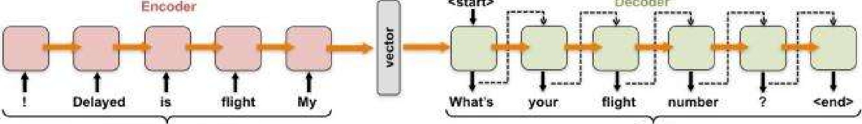
«gtar-t>
Decoder
Request in Reverse Order Reply

  - Flow Chart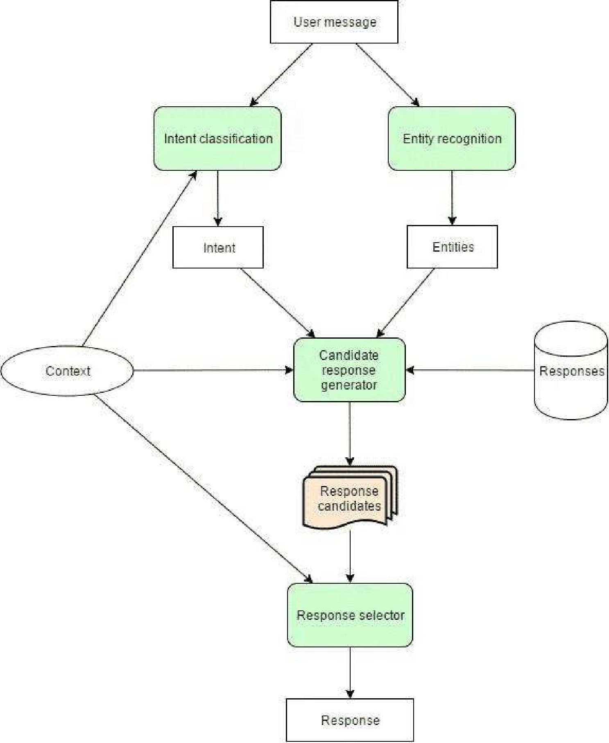
Figure 2 (Flow chart)

  - Some Important Terms:
- Tokenization: Breaking text into individual words or sentences.
- Lemmatization: Converting inflected forms of a word into a single base form. It helps in analyzing words uniformly.
- Spell Checker: Used to detect and correct spelling mistakes in user queries.
- Sentence Similarity & WordNet Algorithm:
  - WordNet is a lexical database grouping English words into synonym sets (synsets).
  - It provides definitions, usage examples, and relations among words.
  - If a response exists in the database, it is displayed; otherwise, the system notifies the admin to add the missing response for future use.
Users can:
- Ask queries
- Provide feedback
- Help improve system efficiency
7. Prototype:
• Developed using Flask (Python framework) for backend and HTML for front-end.

• The chatbot was designed with a persona: friendly, engaging, humorous, and interactive (e.g., GIFs for fun).

• Multiple iterations were conducted to improve usability.

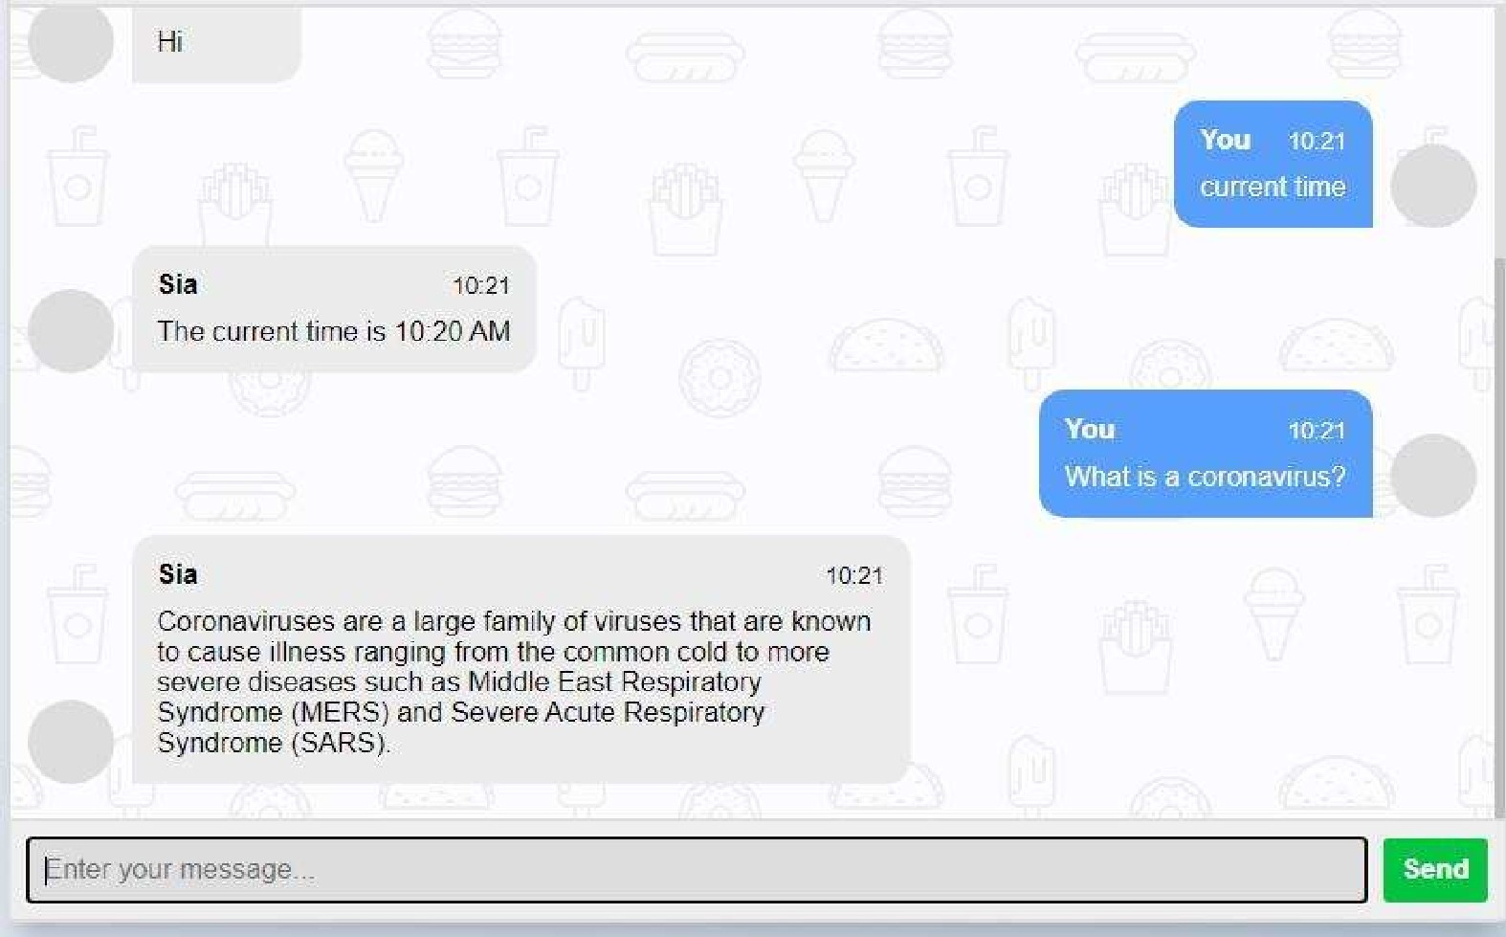
Inbox

8. Testing and Findings

Testing Process

Initial version tested with first-year students.

Feedback gathered through short interviews after use.

Pilot testing was done to identify immediate flaws.

8.1 Results from Testing
Participant | Feedback Summary | Suggested Improvements
1 | Liked the bot but had to use simple queries for it to understand. | More natural language processing capability.
2 | Frustrated due to lack of instructions and flexibility. | Clearer instructions for users.
3 | Confused about chatbot features until hints were provided; system needed restarting sometimes. | Add welcome guide & error handling features.

9. Discussion and Future work
- Over 40% of user requests on social media are emotional, not informational.
- Deep learning chatbots can handle emotional and informational requests together, reducing the need for human agents.
- Future improvements:
  - Detect emotional vs informational queries automatically.
  - Filter training data by writing styles for improved responses.
  - Enable long-term user-brand interaction tracking for better personalization.

10. Implementation
• Data Cleaning – Removed irrelevant data and non-English requests.
• Tokenization – Built vocabulary of frequent words.
• Word Embeddings – Used Word2Vec for vector representation (640-dimensions).
• Model Training – Used Deep LSTM networks with 5 layers × 640 cells, trained via stochastic gradient descent.

11. Deployment
- Target Platform: Heroku
- Deployment Options: GitHub, Docker, Terraform
- 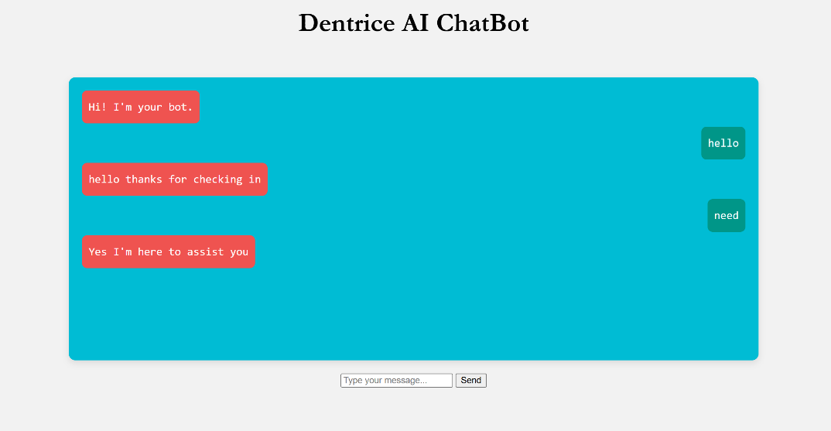Issue: GitHub deployment failed due to missing dependencies; needs debugging.
Release phase

11. Future Scope and conclusion
- Can be integrated with university websites for real-time query handling.
- Future improvements:
  - Better NLP understanding
  - Multi-language support
  - Voice-based interaction
  - Seamless deployment with cloud platforms
The project shows the potential of AI chatbots in reducing manual workload and improving user satisfaction through instant, automated responses.
12. Screenshots:
User Interface:
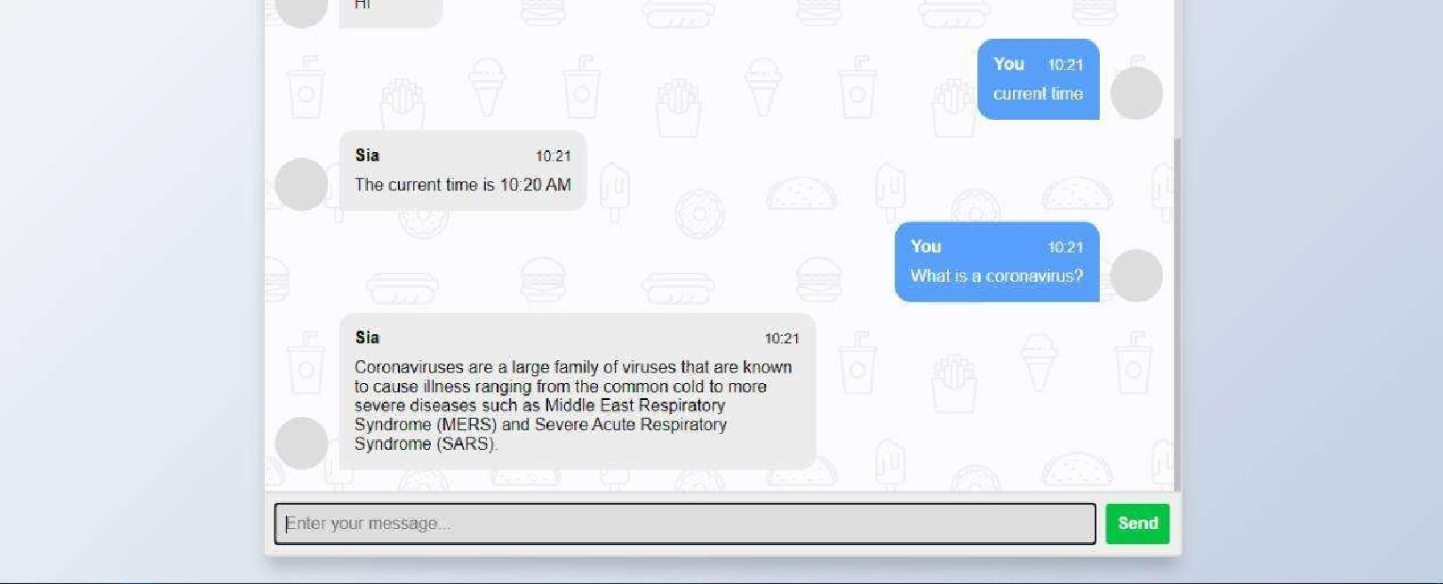
Hi
Inbox
Figure 5 (user interface)
Data sets:
File Edit Selection View GO Run Terminal Help - Visual Studio Code
 | C) job intents.json X
 | C: Users  1  2  3 | > Beeha ) Desktop > Bot Final > 1)  " intents" : |  |  | > .
 | C: Users  1  2  3 | { | "tag" "greeting"  "patterns • . ["Hi there", "How are you", "Is anyone there?" , "Hey" , "Hola", "Hello", "Good day", "Hey" , Ekse" ,
 | 5  6  7 | { | "responses"3 1 "Hi strangen% "Yebo yes, how can I help", "Ey watsuVp% "Ekse Hoezit", "Hold "Hey dude "You again"]  "tag" "goodbye"
 | g |  | "patterns " •See you later" J •'GOödbye% "Ok bye" "Bye Bye"] J  "responses" [ "See you! "Have a nice day". "Sure Bye" • "Later dude", "Sayoonara", "Peace Out "sure -ciao"]
 | 11 |  | {"tag" "thanks " ,  "patterns " anks" , "Thank yol_j••. "That •s helpful % "Awesome, thanks", "Thanks for helping me"],
 | 13 |  | ["Th  "responses": l"Happy to help!" , "Any time: "s "My pleasure" "You ape welcome"s "Sure dude" ]
 | 15 16  17 | { | "tag" : " noanswer" ,  "patterns
 | 15 16  17 | { | •responses" • ["Sorry. can understand you". "Please give me more info" w •ruot sure I underst and". "I am still here dude"]
 | 18  20  21  22 |  | {"tag": "name"  •
 | 18  20  21  22 |  | "patterns" ["What is your name", "Whats your name". "Tell me your name" "Who are you", "Ungubani" "Tell me about yourself" "You are" L  "responses": ["I an Sia", "My name is Sia'% "You can "call me KB for* short", "I am Sia, my friends call rue Sia" "Sid is my name"
 | 23 |  | {"tag": "options %
 | 24  25  25 |  | "patterns" [ "What do you do", "How Can you help", "What do you know", " What is your puéposé", "How can you help"].  "responses": ["I can tell you about India". "I can give you interesting facts about India"]
 | 27  28 |  | {"tag": "india^{n} ,  "patterns : [ "India" "about India". do you know India"],
 | 29  30  31 |  | responses" ["India is one of the oldest civilizations in the world witti a kaleidoscopic variety and rich cultural heritage. It has ach
22
23
Spaces: 2 IJTF-:g
Figure 6 (Sample Indents for basic training)
* *Other data set has been downloaded from reddit data set for training purposes .
13. Code Overview

• Chatbot.py
References:
49

