Wildfire Spread Simulation and Agentic Evacuation Route Planner (wf052)
Project Description:
Wildfire Spread Simulation and Agentic Evacuation Route Planner is an offline, research-only prototype for investigating physics-based wildfire spread simulation, deep-surrogate arrival-time emulation, risk-aware evacuation routing, and tool-augmented agentic coordination, developed and audited on the 2018 Camp Fire (Butte County, California) as an unseen development case. This software is for academic research and post-incident replay only and is not for operational use — it does not certify safe evacuation routes and must never be used for real-time emergency navigation or life-safety decisions.
The project pairs a calibrated 60 m cellular-automaton physics teacher (PyTorchFire contact spread plus a switchable non-local ember-spotting kernel) with a 4,094,852-parameter wind-conditioned FiLM U-Net surrogate that predicts arrival-time quantiles (q10 / q50 / q90) and a horizon burn probability, a time-dependent FIFO Dijkstra router with point-queue and BPR congestion models, and a LangGraph EvacuationAgent whose typed tools — never the language model — compute every route, margin and metric. A causal replay harness steps the Camp Fire forward in 10-minute intervals against 436 NIST ground-truth hazards (23 burnovers, 178 roadblocks and 235 abandoned vehicles) and compares seven routing methods, and a standalone offline dashboard (INCIDENT-052) exposes the precomputed replay for interactive inspection.
Repository: github.com/miteshsingh7/wildfire_simulation

Scenarios
Scenario 1: Offline Fire-Arrival Forecasting and Safety-Margin Routing: A researcher loads a 256 x 256 terrain tile (60 m cells, 15.36 km x 15.36 km) and its 12-hour hourly wind series into the WindConditionedUNet. The surrogate returns arrival-time quantiles (q10 / q50 / q90, in minutes since ignition) and a burn-probability logit for every cell; an adapter wraps them as an ArrivalField, and the TimeDependentRouter returns, for each origin block, the fastest route whose every edge keeps at least a 15-minute margin between vehicle exit time and the conservative q10 fire-arrival time — or, when no such route exists, the route that maximizes the minimum margin — before an independent validator re-checks it.
Scenario 2: Causal Replay of the 2018 Camp Fire Against NIST Hazards: An evaluator wants to know whether routes planned from a forecast fire field and delayed observations would have avoided the hazards that actually occurred. The CausalReplayHarness steps from the 06:33 PST ignition in 10-minute intervals to a 6-hour horizon, exposes only observations whose timestamp is at or before t minus latency and roadblocks whose onset has passed, and routes 200 sampled block origins with seven comparative methods. Each route is scored against 436 NIST hazards, reporting encounters, trapped origins and safety margins with both plain and corridor-clustered bootstrap intervals.
Scenario 3: Claims Governance and Offline Dashboard Verification: A reviewer opens the INCIDENT-052 dashboard by double-clicking web/dist/index.html. Every figure on screen cites the CSV row it came from, the Status & Limitations tab separates what the system can and cannot claim, and a persistent strip states that the surrogate runs on untrained stand-in weights and that the tool is research-only. A headless Playwright script (scripts/verify_web_demo.py) re-asserts those phrases, confirms zero external network requests and zero console errors, and checks that the Zones table renders exactly 17 rows (14 zones and 3 corridors).

Technical Architecture:
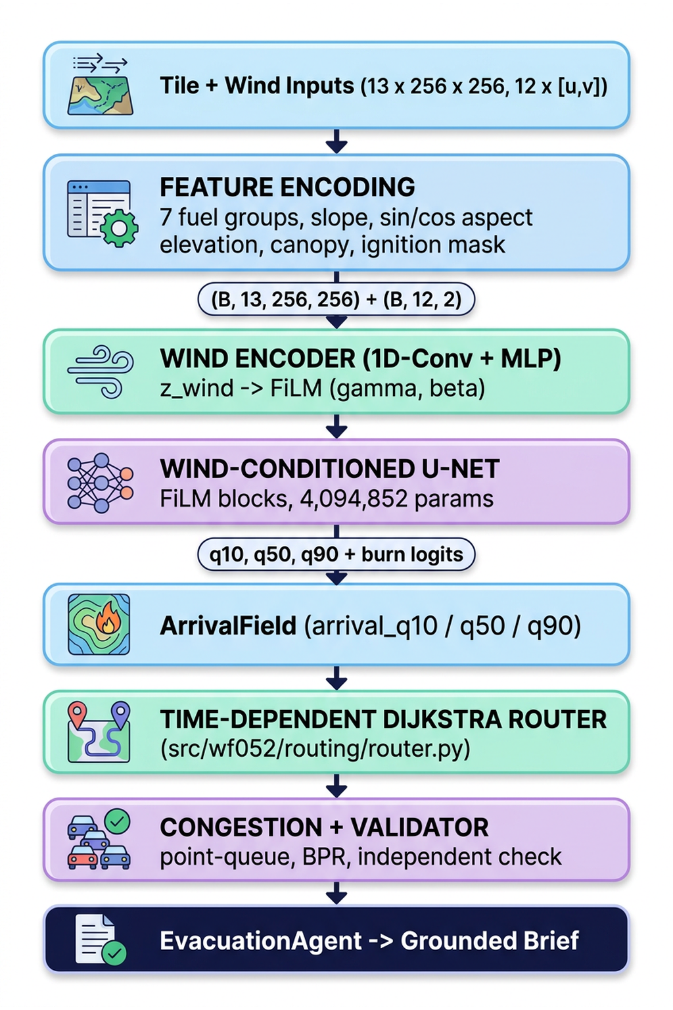
Figure: wf052 Surrogate-to-Evacuation-Route Pipeline (from src/wf052/surrogate/model.py, src/wf052/routing/router.py, src/wf052/agent/graph.py)
The technical architecture consists of five interconnected subsystems: the data ingestion layer, the physics teacher simulator, the wind-conditioned neural surrogate, the risk-aware routing engine, and the agentic coordination layer together with its causal replay harness and offline dashboard.
- Data Ingestion & Canonical Grid: Aligns LANDFIRE 2016 Remap fuels and topography, 12 hourly NOAA HRRR wind analyses (cross-checked against the Jarbo Gap RAWS station), NIST TN 2135 fire-progression observations and an OpenStreetMap drive network onto one EPSG:32610 grid (30 m, 1,128 x 1,124 cells for the Phase 0 domain; 60 m for the operating teacher), persisted as GeoTIFF and GeoParquet with a written data card.
- Physics Teacher (wf052.sim): A calibrated 60 m cellular-automaton model (PyTorchFire contact spread, p_base = 0.22) with a switchable non-local ember-spotting kernel (alpha_launch = 0.004, lognormal landing distance capped at 6,000 m, p_urban_wui = 0.15), frozen as configs/teacher_v2.yaml under a SHA-256 hash; calibrated on Kincade, Glass and Zogg and never tuned on the Camp Fire.
- Wind-Conditioned Surrogate (wf052.surrogate): A 4,094,852-parameter U-Net that consumes a 13-channel spatial tensor and a 12 x 2 hourly wind series, conditions every convolutional block on the wind embedding through FiLM, and emits q10 / q50 / q90 arrival rasters plus a burn logit; trained with a pinball + quantile-ordering + BCE multi-task loss under a trainer that refuses any split placing one fire in two sets.
- Risk-Aware Routing (wf052.routing): A time-dependent FIFO Dijkstra router constrained by exit_time + buffer <= fire arrival with a binary-search max-min-margin fallback, a point-queue / BPR congestion and demand model, a re-plan engine, an independent route validator and a hazard-miss scorer, all reading only the ArrivalField contract.
- Agent, Replay Harness & Dashboard (wf052.agent, wf052.replay, web/): A LangGraph EvacuationAgent whose typed tools compute every route and number and whose briefs pass a grounding checker; a causal replay harness scoring seven methods against NIST hazards; and a single-file offline HTML dashboard, INCIDENT-052, that replays the precomputed results.

Pre-requisites:
- Python Environment: Python 3.11 (pyproject.toml pins >=3.11,<3.12) with PyTorch 2.14.1 as the only deep learning framework (no TensorFlow or Keras), managed with uv. Python Documentation | PyTorch Documentation
- Geospatial & Data Libraries: NumPy, pandas, Rasterio, GeoPandas, Shapely, PyProj, PyArrow (GeoParquet), Zarr, NetworkX, Pydantic and PyYAML (run configurations in configs/*.yaml); OSMnx and Herbie are used by the road and HRRR ingestion modules. Docs: NumPy | pandas | Rasterio | GeoPandas | Shapely | NetworkX | PyArrow
- Simulation Engines: PyTorchFire 1.0.3.post2 (the selected differentiable cellular-automaton engine) and Cell2Fire (C++, evaluated in the Phase 0 spike and deprioritized because it cannot run native Scott & Burgan FBFM40 fuels). Docs: PyTorchFire | Cell2Fire
- Agent Orchestration: LangGraph (>=0.2.0) for the seven-node evacuation state machine, with a MockLLMClient and a deterministic template brief so that no external LLM key is required. Docs: LangGraph Documentation
- Data Sources: USGS LANDFIRE 2016 Remap (FBFM40, canopy, topography), NOAA HRRR surface analyses through Herbie, NIST TN 2135 and TN 2252 for fire-progression and hazard records, GOFER and FEDS satellite perimeters, GeoMAC overflight perimeters and OpenStreetMap. Docs: LANDFIRE | Herbie | NIST TN 2135 | OSMnx
- Testing & Linting: pytest 9.1.1 (184 test functions across 23 test files, slow tests deselected by default) and Ruff 0.16.10 (target py311, line length 100). Docs: pytest Documentation | Ruff Documentation
- Compute: Local CPU (Apple M1) for ingestion, graph construction, routing, agent tools and tests; Apple M1 MPS for the measured latency benchmarks; Kaggle GPU notebooks (notebooks/*.ipynb) for bulk teacher runs and surrogate training.
- Version Control: Git, with frozen configurations and the precomputed demo assets under out/demo/ (19 MB, 100% tracked) committed so the dashboard replays without untracked files. Docs: Git Documentation

Project Workflow:
Milestone | Activities & Core Focus
Milestone 1: Data Ingestion, Canonical Grid & Provenance | Activity 1.1: LANDFIRE fuels & topography on a canonical UTM grid  Activity 1.2: HRRR wind with RAWS cross-check & NIST observation rasterization  Activity 1.3: OpenStreetMap road network & data-card provenance
Milestone 2: Physics Teacher Simulation & Calibration | Activity 2.1: PyTorchFire engine & FBFM40 fuel-model mapping  Activity 2.2: Leave-one-fire-out calibration & frozen, hashed teacher configs  Activity 2.3: Switchable ember-spotting kernel & assimilation mode
Milestone 3: Wind-Conditioned U-Net Surrogate | Activity 3.1: Data contract, leakage guards & shard pipeline  Activity 3.2: FiLM U-Net architecture & multi-task quantile loss  Activity 3.3: Base-rate initialization, evaluation & latency benchmark
Milestone 4: Risk-Aware Evacuation Routing | Activity 4.1: Road graph & ArrivalField contract  Activity 4.2: Time-dependent FIFO Dijkstra with max-min-margin fallback  Activity 4.3: Congestion, demand & independent route validation  Activity 4.4: Re-plan engine & hazard-miss scoring
Milestone 5: Agentic Coordination & Causal Replay | Activity 5.1: LangGraph EvacuationAgent with typed tools  Activity 5.2: Re-plan policy with hysteresis & grounded briefs  Activity 5.3: Causal replay harness against NIST hazards
Milestone 6: Dashboard, Claims Audit & Testing | Activity 6.1: Standalone offline dashboard (INCIDENT-052) & Streamlit demo  Activity 6.2: Claims audit, limitations & retractions  Activity 6.3: Test suite, lint gate & reproducibility hashes

Milestone 1: Data Ingestion, Canonical Grid and Provenance
Milestone 1 builds the data foundation: every environmental layer, observation and road network is aligned to one canonical projected grid, persisted in GIS-native formats, and documented in a data card that records vintage, source and any fallback so that downstream results trace back to verifiable inputs.

Activity 1.1: LANDFIRE Fuels and Topography on a Canonical Grid
Step 1: Request Pre-Fire Layers: landfire.py downloads eight LANDFIRE layers (fbfm40, elevation, slope, aspect, canopy_cover, canopy_height, canopy_base_height, canopy_bulk_density) from the official USGS ImageServer, using the LF 2016 Remap vintage for fuels and canopy and deliberately avoiding the 2023/2024 products whose burn scars would leak post-fire information into a 2018 case.
Step 2: Force the Canonical Grid: align_and_save_layer resamples any layer whose shape differs from the configured grid (nearest-neighbor for the categorical fbfm40, linear otherwise) and writes an LZW-compressed GeoTIFF in EPSG:32610 (int32 for fuels, float32 for everything else) so that every raster shares one transform.
Source Code: src/wf052/data/landfire.py (LANDFIRE_SERVICES and align_and_save_layer, abridged):
LANDFIRE_SERVICES = {
"fbfm40": "https://lfps.usgs.gov/arcgis/rest/services/Landfire_LF2016/LF2016_FBFM40_CONUS/ImageServer/exportImage",
"elevation": "https://lfps.usgs.gov/arcgis/rest/services/Landfire_Topo/LF2020_Elev_CONUS/ImageServer/exportImage",
# ... slope, aspect, canopy_cover, canopy_height, canopy_base_height, canopy_bulk_density
}

# align_and_save_layer (excerpt): force every layer onto the exact canonical grid
# Validate or resize to exact grid dimensions
rows, cols = grid["rows"], grid["cols"]
if data.shape != (rows, cols):
from scipy.ndimage import zoom

zoom_y = rows / data.shape[0]
zoom_x = cols / data.shape[1]
order = 0 if layer_name == "fbfm40" else 1
data = zoom(data, (zoom_y, zoom_x), order=order)

Activity 1.2: HRRR Wind with RAWS Cross-Check and NIST Observation Rasterization
Step 1: Ingest Hourly HRRR Wind: weather.py retrieves 12 hourly HRRR surface analyses (fxx = 0) from 2018-11-08 14:00 UTC through Herbie, averages 10 m U/V wind, gust and 2 m temperature over the domain, converts them to speed and direction, and cross-checks them against Jarbo Gap RAWS observations (sustained 25-31 mph, gusts 43-50 mph, direction 35-44 degrees). A synthetic Diablo-wind fallback exists in the code for any hour whose retrieval fails.
Step 2: Rasterize NIST Progression Points: observations.py parses Appendix F of NIST TN 2135 into roughly 2,800 timestamped, geolocated points (2,817 per the Phase 0 report, 2,818 per the data card), converts clock times to minutes after the 06:25 PST first record, reprojects them to UTM 10N, persists them as GeoParquet, and rasterizes the minimum arrival time per 30 m cell within the 12-hour window.
Note (governance): the GOFER hourly satellite-progression dataset was examined and set aside for the Camp Fire because it covers 28 California fires from 2019-2021 and does not include 2018; FEDS 375 m VIIRS detections and GeoMAC infrared overflight perimeters are used instead, and GOFER is used only for the seven training fires.
Source Code: src/wf052/data/weather.py and observations.py (excerpts):
# src/wf052/data/weather.py (fetch_hrrr_hourly, excerpt)
ws_ms = float(np.sqrt(u_val**2 + v_val**2))
wind_dir_math = float(np.degrees(np.arctan2(-u_val, -v_val)) % 360)
temp_c = temp_k - 273.15

# src/wf052/data/observations.py (parse_nist_appendix_f, excerpt)
# Elapsed minutes from ignition on Nov 8
if date_str == "11/8":
elapsed_min = (th - base_hour) * 60 + (tm - base_min)
else:
# Nov 9
elapsed_min = (th + 24 - base_hour) * 60 + (tm - base_min)

utm_x, utm_y = transformer.transform(lon, lat)

Activity 1.3: OpenStreetMap Road Network and the Data Card
Step 1: Attempt a Historical Snapshot, Flag the Fallback: roads.py asks the Overpass API for the network as of 2018-11-01 and, if that query fails or times out, falls back to the current OSM network and returns is_historical = False so the substitution is explicit rather than silent. The Phase 0 attempt timed out, so the current drive network was used and flagged.
Step 2: Project, Export and Document: the graph is projected to EPSG:32610, list-valued attributes are flattened for Arrow compatibility, and nodes and edges are written as GeoParquet; reports/data_card.md records the domain, vintage, source, license and flags of each of its six layers.
Source Code: src/wf052/data/roads.py (fetch_road_graph, abridged):
# 1. Attempt historical snapshot
try:
ox.settings.overpass_settings = (
f'[out:json][timeout:{{timeout}}][date:"{historical_date}T00:00:00Z"]'
)
logger.info("Attempting Overpass historical snapshot for %s...", historical_date)
graph = ox.graph_from_bbox(bbox=bbox_tuple, network_type=network_type)
is_historical = True
logger.info("Historical snapshot succeeded (%d nodes)", len(graph.nodes))
except Exception as exc:
logger.warning(
"Historical Overpass query failed or timed out (%s). Falling back to current OSM.", exc
)
ox.settings.overpass_settings = "[out:json][timeout:{timeout}]"
graph = ox.graph_from_bbox(bbox=bbox_tuple, network_type=network_type)
is_historical = False
logger.info("Current OSM query succeeded (%d nodes)", len(graph.nodes))

Milestone 2: Physics Teacher Simulation, Calibration and Ember Spotting
Milestone 2 turns the raw layers into a trustworthy physics teacher: a PyTorch cellular-automaton engine, a leave-one-fire-out calibration that freezes a single configuration before the Camp Fire is touched, and a switchable ember-spotting kernel that addresses the long-range spotting the contact model cannot reproduce.

Activity 2.1: PyTorchFire Engine and Fuel-Model Mapping
Step 1: Map Fuels to Spread Probabilities: pytorchfire_engine.py maps each Scott & Burgan FBFM40 code to PyTorchFire's p_veg: non-burnable classes (91 Developed, 92 Snow/Ice, 93 Agriculture, 98 Water, 99 Barren) get -1.0 so the automaton cannot spread through them, while grass, shrub, timber-understory, litter and slash models map to 0.15-0.60 by fuel-bed depth, load and spread rate; canopy cover becomes a density factor p_den in [-0.2, +0.2].
Step 2: Benchmark Two Engines: a 10-seed Phase 0 benchmark ran PyTorchFire and Cell2Fire on the Camp Fire domain. PyTorchFire completed the 12-hour run on 1.27 million cells in 47.93 s (mean of 10 seeds), whereas Cell2Fire burned only 364 cells before contact spread stalled at non-burnable barriers. Phase 1A then re-audited the perimeter timeline, finding that GeoMAC epoch timestamps are local Pacific time, which places the first infrared overflight at +11.4 h (684 min) after ignition.
Source Code: src/wf052/sim/pytorchfire_engine.py (FBFM40_TO_P_VEG and p_den mapping, abridged):
FBFM40_TO_P_VEG: dict[int, float] = {
# Non-burnable
91: -1.0, # Urban / Developed
92: -1.0, # Snow / Ice
# ... 98 Open Water and 99 Barren (-1.0); GR 101-108 (0.30-0.60); GS 121-124; SH 141-147;
# ... TU 161-165; TL 181-189 (0.15-0.45); SB 201-204 (0.30-0.60)
}

# 2. Map Canopy Cover to p_den (density factor between -0.2 and +0.2)
p_den_arr = np.clip((cc_arr / 100.0) * 0.4 - 0.2, -0.2, 0.2).astype(np.float32)

Activity 2.2: Leave-One-Fire-Out Calibration and Frozen Teacher Configurations
Step 1: Calibrate Without Touching the Camp Fire: Phase 1A standardizes seven training fires (Kincade, Bobcat, Glass, Creek, Zogg, Caldor, Tamarack) onto a 720 x 720, 60 m grid with one LANDFIRE 2016 vintage and real HRRR wind, runs an 82-simulation one-at-a-time sensitivity sweep, and compares an uncalibrated model, a 1-parameter global slowdown, a 6-parameter fit and a wind-only fit under leave-one-fire-out validation, keeping the simplest model within 0.02 IoU of the best (+12 h IoU 0.2436 for the 1-parameter model versus 0.1036 uncalibrated).
Step 2: Freeze and Hash: configs/teacher_v1.yaml (p_base = 0.21) and teacher_v1_1.yaml (p_base = 0.22) are written to disk with SHA-256 hashes recorded before any Camp Fire evaluation; configs/teacher_v2.yaml adds the ember kernel and is verified against hash a6a92f81...2b4e85a5, with a bit-identical copy kept for the Kaggle notebooks.
Source Code: configs/teacher_v2.yaml (frozen contact and ember parameters, abridged):
version: teacher_v2
phase: 1B_frozen
operating_resolution_m: 60
steps_per_hour: 30
dt_seconds: 120.0
crs: EPSG:32610
landfire_vintage: LANDFIRE 2016 Remap (LF 2.0.0)

contact_parameters:
p_base: 0.22
a: 0.06
c_1: 0.045
c_2: 0.15
p_continue: 0.30
fuel_scale_grass_shrub: 1.0
fuel_scale_timber: 1.0
canopy_den_scale: 1.0
wind_moisture_damping: 0.0

ember_parameters:
use_ember_kernel: true
alpha_launch: 0.0040
beta_dist_m_per_ms: 110.0
p_urban_wui: 0.15
spotting_max_dist_m: 6000.0
lateral_scatter_deg: 18.0
log_std_distance: 0.65
wind_lofting_threshold_mps: 4.0

Activity 2.3: Switchable Ember Spotting and Assimilation Mode
Step 1: Add Non-Local Spotting With Three Free Parameters: ember_kernel.py samples per-cell launches (alpha_launch scaled by a fuel spotting potential and by wind above a 4 m/s lofting threshold), lands them downwind with a lognormal distance (median beta_dist x wind speed, sigma 0.65, capped at 6,000 m) and 18-degree lateral scatter, and ignites receptive cells. A static-shape scatter_add_ avoids CPU-GPU synchronization inside the time-step loop, and the three parameters are fitted only on the wind-driven fires Kincade, Glass and Zogg.
Step 2: Attribute the Gain and Test Assimilation: embers account for 75.5% of the simulated burned-area gain and 87.0% of the IoU gain from teacher_v1 to teacher_v2 over 20 seeds (Camp Fire median IoU 0.3147 against the 22,158 ha GeoMAC perimeter at +11.4 h), and an assimilation mode initializes the fire from an observed extent at T0 (+1, +2 or +3 h) to forecast the next three hours.
Source Code: src/wf052/sim/ember_kernel.py (sample_ember_spotting_step, abridged):
v_eff = max(float(wind_speed_ms), 0.75 * float(wind_gust_ms))
v_excess = max(0.0, v_eff - 4.0)
if v_excess <= 0.0 or ember_params.alpha_launch <= 0.0:
return torch.zeros_like(burning)

if grid_r is None or grid_c is None:
grid_r, grid_c = torch.meshgrid(
torch.arange(h, dtype=torch.long, device=device),
torch.arange(w, dtype=torch.long, device=device),
indexing="ij",
)

# 1. Per-burning-cell launch probability
rate_launch = ember_params.alpha_launch * phi_spot * v_excess
p_launch = 1.0 - torch.exp(-rate_launch)
launched_mask = burning & (torch.rand((h, w), device=device) < p_launch)

# 2. Lognormal landing distance (median = beta_dist * v_eff, capped at 6,000 m)
d_med_m = min(6000.0, max(res_m, ember_params.beta_dist_m_per_ms * v_eff))
dist_m = torch.clamp(d_med_m * torch.exp(0.65 * torch.randn((h, w), device=device)), min=res_m, max=6000.0)
dist_cells = dist_m / res_m

hit_counts = torch.zeros(h * w, dtype=torch.float32, device=device)
hit_counts.scatter_add_(0, flat_idx, valid_launch.float().view(-1))
hit_mask = hit_counts.view(h, w) > 0.5

Milestone 3: Wind-Conditioned U-Net Surrogate
Milestone 3 distills the teacher into a fast neural emulator. The pipeline is built and verified on stand-in and dry-run data under a strict data contract, so every reported number measures fidelity to the teacher rather than to ground truth, and no trained-surrogate accuracy is claimed in this version.

Activity 3.1: Data Contract, Leakage Guards and Shard Pipeline
Step 1: Fix the Tensor Contract: each sample is a (13, 256, 256) spatial tensor — seven one-hot Scott & Burgan fuel groups (NB, GR, GS, SH, TU, TL, SB), slope, sin and cos of aspect, z-scored elevation, normalized canopy cover and a binary ignition mask — plus a (12, 2) hourly wind series, with arrival time in minutes [0, 720] and a censor mask as targets. The 62-sample dry-run shard splits by whole fire: 34 train (kincade, glass, zogg, creek), 10 validation (bobcat) and 18 test (caldor, tamarack).
Step 2: Make Leakage Impossible to Do Silently: the generator raises ProhibitedFireError for the Camp Fire and the three fresh held-out fires (Slater and Devil, Walker, W-5 Cold Springs), the trainer raises a ValueError if any fire appears in more than one split, and analytic wind-ellipse samples are flagged baseline_only and rejected as training data.
Source Code: src/wf052/surrogate/standin_generator.py and trainer.py (leakage guards, abridged):
PROHIBITED_OR_HELD_OUT_FIRES: list[str] = [
"camp_fire_2018",
"slater_and_devil_2020",
"walker_2019",
"w5_cold_springs_2020",
]

# src/wf052/surrogate/trainer.py (SurrogateTrainer.__init__, excerpt)
train_fires = _extract_fires(train_samples)
val_fires = _extract_fires(val_samples)
shared_fires = train_fires.intersection(val_fires)

if shared_fires:
leak_msg = (
f"Data leakage detected! Leaking fire(s) {sorted(list(shared_fires))} placed in more than one split "
f"(found in both train={sorted(list(train_fires))} and val={sorted(list(val_fires))})."
)
if not self.allow_same_fire_leak:
raise ValueError(
f"{leak_msg} The trainer strictly refuses splits that place the same fire in more than one split. "
"Set allow_same_fire_leak=True to override with explicit warning."
)

Activity 3.2: FiLM U-Net Architecture and Multi-Task Quantile Loss
Step 1: Condition Every Block on Wind: a 1D-convolution + MLP WindEncoder turns the 12-hour wind series into a 64-dimensional embedding; each residual FiLMBlock projects it to (gamma, beta) and applies (1 + gamma) x GroupNorm(h) + beta, with the projection zero-initialized so training starts from identity modulation. Three encoder stages, two bottleneck blocks and three decoder stages with skip connections total 4,094,852 trainable parameters, inside the 2-6 M design band.
Step 2: Bound the Outputs and Train Three Tasks: quantile arrival times are a sigmoid scaled to [0, 720] minutes, the burn head emits unconstrained logits, and the loss is the mean of pinball losses at tau = 0.1, 0.5 and 0.9 on uncensored cells plus a non-crossing ordering penalty (lambda = 1.0) and a binary cross-entropy burn term (lambda = 0.5).
Source Code: src/wf052/surrogate/model.py (FiLMBlock.forward, abridged):
def forward(self, x: torch.Tensor, z_wind: torch.Tensor) -> torch.Tensor:
residual = self.skip(x)

h = self.conv1(x)
h = self.norm1(h)

# FiLM modulation: project z_wind -> (gamma, beta)
film_params = self.film_proj(z_wind) # (B, 2 * out_channels)
gamma, beta = film_params.chunk(2, dim=1)
gamma = gamma.unsqueeze(-1).unsqueeze(-1)
beta = beta.unsqueeze(-1).unsqueeze(-1)

h = (1.0 + gamma) * h + beta
h = F.silu(h)

h = self.conv2(h)
h = self.norm2(h)
h = F.silu(h + residual)
return h
Source Code: src/wf052/surrogate/losses.py (SurrogateMultiTaskLoss.forward, abridged):
pinball_total = (l_q10 + l_q50 + l_q90) / 3.0

# 2. Non-crossing quantile ordering constraint (evaluated on normalized scale)
l_order = self.ordering_loss_fn(pred_norm)

# 3. Burn classification loss (BCEWithLogits)
l_bce = F.binary_cross_entropy_with_logits(pred_burn_logits, target_burned)

# Combined total loss
total = pinball_total + self.lambda_order * l_order + self.lambda_bce * l_bce

Activity 3.3: Base-Rate Initialization, Evaluation and Latency Benchmark
Step 1: Start the Burn Head at the Training Base Rate: init_burn_prob_bias sets the final bias of the burn-probability head to logit(clip(mean training burn rate, 1e-4, 0.5)), computed from training shards only, so the head begins at the observed base rate instead of 0.5; evaluation reports per-bin quantile error, Brier score and IoU per split and per fire.
Step 2: Measure Latency, Not Accuracy: a 100-run benchmark on Apple M1 MPS measures 34.51 ms per 256 x 256 tile (p50 34.43 ms, p95 35.42 ms) and 310.59 ms across the nine tiles that cover the Camp Fire domain, against a 2,747.21 ms mean for the full teacher simulation over five seeds. Because the checkpoints are 2-epoch stand-in or 1-epoch dry-run weights these are inference-time figures only, and the earlier 24.1 ms and 56.4x narrative figures were retracted as unmeasured estimates.
Source Code: src/wf052/surrogate/model.py (output heads and init_burn_prob_bias, abridged):
# Quantile predictions: bounded strictly in [0, max_horizon_min] using sigmoid
raw_quantiles = self.quantiles_head(y1)
quantiles = torch.sigmoid(raw_quantiles) * self.max_horizon_min

# Burn logits: unconstrained logits
burn_logits = self.burn_logit_head(y1)

def init_burn_prob_bias(self, mean_burn_prob: float) -> float:
"""Initialise the bias of the burn-probability head to logit(clip(mean, 1e-4, 0.5)).

Computed from training shards only.
Returns the initialised scalar bias value.
"""
clipped = min(max(float(mean_burn_prob), 1e-4), 0.5)
bias_val = float(math.log(clipped / (1.0 - clipped)))
with torch.no_grad():
nn.init.constant_(self.burn_logit_head[2].bias, bias_val)
return bias_val

Milestone 4: Risk-Aware Evacuation Routing
Milestone 4 converts a fire-arrival field into evacuation decisions. A road graph, a strict ArrivalField contract, a time-dependent router with a safety-margin guarantee, a congestion model and an independent validator are built so that every route can be checked against the fire field without trusting the planner.

Activity 4.1: Road Graph and the ArrivalField Contract
Step 1: Define One Input Contract: the router reads only an xarray Dataset holding arrival_q10, arrival_q50 and arrival_q90 rasters (minutes since ignition, +inf where the fire never arrives) with y / x coordinates and crs and ignition_time attributes; validate_arrival_field rejects anything else, so teacher outputs, surrogate outputs (via surrogate_output_to_arrival_field and stitch_tiles_to_arrival_field) and synthetic fire fields are interchangeable.
Step 2: Build the Graph: graph.py builds the drive network with per-edge traversal times and projects the field onto edges; the full rebuilt graph used in the replay has 14,691 edges, with named origin landmarks and boundary destination exits grouped into three egress corridors (Skyway, Clark Rd, Pentz/Hwy 70).
Source Code: src/wf052/routing/contracts.py (routing modes and contract validation, abridged):
class RoutingMode(StrEnum):
"""Routing optimization modes."""

FASTEST_SAFE = "fastest_safe" # (a) Fastest route with margin >= B minutes
MAX_MIN_MARGIN = "max_min_margin" # (b) Route that maximizes the minimum margin

class RouteStatus(StrEnum):
"""Evacuation route feasibility status."""

SAFE = "safe" # Route satisfies margin >= buffer minutes on all edges
BEST_EFFORT = "best_effort" # Route maximizes minimum margin (margin < buffer)
NO_ROUTE = "no_route" # Graph disconnected or completely impassable

required_vars = ("arrival_q10", "arrival_q50", "arrival_q90")
for var in required_vars:
if var not in ds.data_vars:
raise ValueError(f"ArrivalField missing required data variable: '{var}'")

Activity 4.2: Time-Dependent FIFO Dijkstra with a Max-Min-Margin Fallback
Step 1: Enforce the Safety Condition on Every Edge: _run_constrained_dijkstra relaxes an edge only if exit_time + buffer <= the edge's fire-arrival time, with exit_time = entry_time + traversal time (strict FIFO). The default buffer is 15 minutes, and traversal times can be replaced by congested times and by destination exit-queue delays.
Step 2: Fall Back to the Safest Feasible Route: if no route meets the buffer, find_route first checks physical reachability with the fire constraint removed, then binary-searches the achievable minimum margin between -1,440 minutes and the buffer (16 iterations, precision under 0.05 min) and returns a BEST_EFFORT route, or None when the graph is disconnected.
Source Code: src/wf052/routing/router.py (edge relaxation and Mode b search, abridged):
for v, _k, dt_min, edge_idx in road_graph.adj.get(u, []):
dt = (
float(dynamic_edge_traversal_times[edge_idx])
if dynamic_edge_traversal_times is not None
else dt_min
)
t_exit = t_u + dt
fire_arr = float(edge_fire_arrivals[edge_idx])

# FIFO Safety Condition: exit_time + buffer <= edge fire arrival
if t_exit + buffer_minutes <= fire_arr:
if t_exit < earliest_arrival.get(v, float("inf")):
earliest_arrival[v] = t_exit
parent[v] = (u, edge_idx)
heapq.heappush(pq, (t_exit, v))

# TimeDependentRouter.find_route (Mode b, excerpt)
# Binary search over achievable safety margin M in [M_low, M_high]
m_low = -1440.0 # -24 hours
m_high = float(buffer_minutes)

best_found_dest: int | None = unconstrained_dest
best_found_parent = unconstrained_parent

# 16 iterations gives precision < 0.05 minutes
for _ in range(16):
m_mid = 0.5 * (m_low + m_high)
test_dest, _test_arr, test_parent = _run_constrained_dijkstra(
road_graph=self.road_graph,
origin_node=origin_node,
destination_nodes=dest_set,
t0=t0,
buffer_minutes=m_mid,
edge_fire_arrivals=edge_fire_arrivals,
dynamic_edge_traversal_times=dynamic_edge_traversal_times,
destination_exit_delays=destination_exit_delays,
)
if test_dest is not None:
m_low = m_mid
best_found_dest = test_dest
best_found_parent = test_parent
else:
m_high = m_mid

Activity 4.3: Congestion, Demand and Independent Validation
Step 1: Model Capacity and Delay Without Double Counting: congestion.py assigns each edge a Highway Capacity Manual planning capacity by highway class and lane count (scaled, minus inbound emergency traffic on Skyway, Clark, Neal, Pentz and Hwy 70) and a physical storage of length x lanes x jam density (130 veh/km/lane by default). Delay is either a point-queue bottleneck or a BPR volume-delay function (alpha 0.15, beta 4.0), never both on one edge, with 5-minute time-sliced assignment, finite boundary exit outflow and entrapment metrics.
Step 2: Re-Check Every Route Independently: ReplanEngine.replan runs IndependentRouteValidator on every returned route against the original arrival field and raises an AssertionError if any route fails; the measured end-to-end cost is 2,115.74 ms for all 200 origins (10.58 ms per origin) per 30-minute re-plan event.
Source Code: src/wf052/routing/congestion.py (edge capacity and storage, abridged):
nominal_cap = float(cap_per_lane * lanes)

# Inbound emergency deduction applies strictly to named corridors (Skyway, Clark, Neal, Pentz, Hwy 70)
is_corridor = any(c in name_lower for c in self.inbound_corridors)
inbound_deduction = self.inbound_traffic_veh_per_hr if is_corridor else 0.0

effective_cap = max(10.0, (nominal_cap * self.capacity_scale) - inbound_deduction)

# Physical link vehicle storage: (length_m / 1000) * lanes * jam_density
storage = max(
1.0, (edge.length_m / 1000.0) * lanes * self.jam_density_veh_per_km_per_lane
)

Activity 4.4: Re-Plan Engine and Hazard-Miss Scoring
Step 1: Re-Plan Against a New Field: replan() validates the field, hashes arrival_q10 with SHA-256 for provenance, recomputes edge fire arrivals once, resolves origin and destination names, optionally drops destinations the fire reaches within a safety buffer, and routes every origin to its best reachable exit.
Step 2: Score Routes Against Ground-Truth Hazards: score_route_against_hazards skips any edge the vehicle exits before a hazard's onset time and counts a hazard as encountered when an edge passes within the hazard radius (60 m by default), which is how the replay turns routes into burnover, roadblock and abandoned-vehicle encounters.
Source Code: src/wf052/routing/replan.py and hazard_check.py (excerpts):
# 1. Update edge fire arrival times across the entire road network
edge_fire_arrivals = self.road_graph.compute_edge_fire_arrivals(arrival_field)

# If vehicle passed this edge entirely before hazard became active, it is safe
if edge.exit_time_min < h.time_min:
continue

h_pt = shapely.geometry.Point(h.x, h.y)
if geom is not None and not geom.is_empty:
dist = float(geom.distance(h_pt))
else:
# Fallback to endpoint proxy
dist = np.hypot(h.x - float(edge.u), h.y - float(edge.v))

if dist < global_min_dist:
global_min_dist = dist

if dist <= h.radius_m + spatial_tolerance_m:
encountered_ids.add(h.hazard_id)

Milestone 5: Agentic Coordination and Causal Replay
Milestone 5 wraps the routing stack in an agent that may decide and narrate but never calculate, and then evaluates that agent under a causal replay that cannot peek at the future.

Activity 5.1: LangGraph EvacuationAgent with Typed Tools
Step 1: Run a Fixed Seven-Node State Machine: EvacuationAgent compiles a LangGraph StateGraph — ingest_update, get_arrival_field, plan_routes, validate_routes, compute_exposure, decide_replan and brief — in which every numeric result comes from plain typed tools in tools.py (get_weather, get_arrival_field, plan_routes, validate_routes, compute_exposure, compute_k_star); the module rules state that the LLM never computes routes, geometry or numbers.
Step 2: Fall Back When the Field Is Not Credible: check_field_vs_observations flags an arrival field as low-confidence when a detection arrives more than 15 minutes earlier than arrival_q10 or lies where the field predicts no arrival, and the planner then switches to conservative settings (a 30-minute buffer).
Source Code: src/wf052/agent/graph.py (EvacuationAgent._build_graph):
def _build_graph(self) -> Any:
builder = StateGraph(AgentState)

builder.add_node("ingest_update", self._node_ingest_update)
builder.add_node("get_arrival_field", self._node_get_arrival_field)
builder.add_node("plan_routes", self._node_plan_routes)
builder.add_node("validate_routes", self._node_validate_routes)
builder.add_node("compute_exposure", self._node_compute_exposure)
builder.add_node("decide_replan", self._node_decide_replan)
builder.add_node("brief", self._node_brief)

builder.add_edge(START, "ingest_update")
builder.add_edge("ingest_update", "get_arrival_field")
builder.add_edge("get_arrival_field", "plan_routes")
builder.add_edge("plan_routes", "validate_routes")
builder.add_edge("validate_routes", "compute_exposure")
builder.add_edge("compute_exposure", "decide_replan")
builder.add_edge("decide_replan", "brief")
builder.add_edge("brief", END)

return builder.compile()

Activity 5.2: Re-Plan Policy with Hysteresis and Grounded Briefs
Step 1: Re-Plan With Hysteresis: ReplanPolicy.decide re-plans when the largest arrival change on an active route edge or the domain-mean arrival shift reaches 15 minutes, when confidence is low, when a road on an active route is cut, or when a route's margin under the new field falls below the buffer; a different physical path replaces the current one only if it gains at least 5 minutes of margin or saves at least 10% travel time, so near-equal options do not flap.
Step 2: Reject Hallucinated Briefs: GroundingChecker extracts every allowed number, road name and zone name from tool outputs and rejects a brief that states an unsupported figure, an unknown road or zone, or any quantitative clearance time (CLEARANCE_HOURS_PATTERN). On rejection the agent regenerates once with feedback and then falls back to a deterministic template brief, which is what the dashboard shows ("LLM NOT RUN").
Source Code: src/wf052/agent/policy.py and grounding.py (excerpts):
class ReplanPolicy:
"""Policy engine deciding when to trigger evacuation route replanning with hysteresis."""

def __init__(
self,
buffer_minutes: float = 15.0,
arrival_field_change_threshold: float = 15.0,
max_active_edge_change_threshold: float = 15.0,
hysteresis_margin_min: float = 5.0,
hysteresis_time_pct: float = 0.10,
) -> None:
self.buffer_minutes = buffer_minutes
self.arrival_field_change_threshold = arrival_field_change_threshold
self.max_active_edge_change_threshold = max_active_edge_change_threshold
self.hysteresis_margin_min = hysteresis_margin_min
self.hysteresis_time_pct = hysteresis_time_pct

# src/wf052/agent/grounding.py (excerpt)
# Prohibited quantitative clearance regex (e.g. "clearance time is estimated at 3.5 hours", "cleared in 3 hrs")
CLEARANCE_HOURS_PATTERN = re.compile(
r"(?:clearance|clear)[\w\s]{0,35}?\d+(?:\.\d+)?\s*(?:hours|hrs|hr\b|h\b)|(?:\d+(?:\.\d+)?)\s*(?:hours|hrs|hr\b|h\b)[\w\s]{0,35}?(?:clearance|to clear)",
re.IGNORECASE,
)

Activity 5.3: Causal Replay Harness Against NIST Hazards
Step 1: Hide the Future: CausalReplayHarness.step(t) returns only observations with timestamp <= t - latency and roadblocks whose onset <= t. NIST observation clocks are shifted by 8 minutes because elapsed_minutes = 0 is the 06:25 PST first dispatch record while ignition was 06:33 PST; the offset was specified a priori from NIST TN 2252 and not tuned post hoc.
Step 2: Compare Seven Methods and Report the Null Result: seven comparative methods (A1, A2, A2-assim, A3, B, static and live) route 200 sampled block origins. A plain bootstrap suggests nominal gains over the static baseline (for example -13.5% combined hazard misses for Agent B on A2), but zero comparisons survive a cluster bootstrap by static egress corridor (K = 3), whose intervals are 1.8x to 2.3x wider; A2 and B-on-A2 results are identical across five teacher seeds spanning 2,437 to 25,683 ha.
Source Code: src/wf052/replay/harness.py (causal filtering and clock alignment, abridged):
# In observations_nist.parquet, elapsed_minutes=0.0 corresponds to 06:25 PST.
# Ignition is 06:33 PST (8 minutes later).
# Adjust elapsed minutes to align with 06:33 PST ignition:
gdf["elapsed_minutes_adj"] = gdf["elapsed_minutes"] - 8.0

t_now = float(current_step_min)
t_obs_limit = t_now - self.latency_min

# Filter observations to timestamp <= t_now - latency_min
if len(self._raw_observations) > 0 and t_obs_limit >= 0.0:
visible_obs = self._raw_observations[
self._raw_observations["elapsed_minutes_adj"] <= t_obs_limit
].copy()

Milestone 6: Offline Dashboard, Claims Audit and Testing
Milestone 6 packages the results for inspection and keeps them honest: an offline dashboard that cannot make network calls, a claims-and-limitations audit that retracts unsupported statements, and a test and reproducibility layer.

Activity 6.1: Standalone Offline Dashboard (INCIDENT-052) and Streamlit Demo
Step 1: Inline Everything Into One File: scripts/build_web_demo.py reads the precomputed assets in out/demo/ (routes.json, hazards.geojson, updates.geojson, zones.geojson, isochrones and perimeters), simplifies geometries with Douglas-Peucker (0.0001 degrees, about 11 m, coordinates rounded to 5 decimals), and inlines the CSS tokens, ES6 logic, bundled Latin WOFF2 fonts and JSON payloads into web/dist/index.html (5.85 MB, under a 10 MB limit).
Step 2: Open It or Serve It: the file opens by double-click or through scripts/serve_web.py on http://localhost:8000, and app/demo.py provides an equivalent Streamlit replay (PYTHONPATH=src streamlit run app/demo.py). Routes are precomputed across the seven methods — the dashboard never runs Dijkstra or A* live, and its Re-plan button only redraws the stored route cards.
Source Code: scripts/serve_web.py (local server for web/dist, abridged):
PORT = 8000

def main() -> None:
repo_root = Path(__file__).resolve().parent.parent
dist_dir = repo_root / "web" / "dist"

if not (dist_dir / "index.html").exists():
print(f"Error: {dist_dir / 'index.html'} does not exist. Run 'python scripts/build_web_demo.py' first.")
sys.exit(1)

class CustomHandler(http.server.SimpleHTTPRequestHandler):
def __init__(self, *args, **kwargs):
super().__init__(*args, directory=str(dist_dir), **kwargs)

socketserver.TCPServer.allow_reuse_address = True
with socketserver.TCPServer(("", PORT), CustomHandler) as httpd:
print(f"Stitch Evacuation Replay Dashboard serving at http://localhost:{PORT}")
print("Press Ctrl+C to stop.")
...

Activity 6.2: Claims Audit, Limitations and Retractions
Step 1: State What the System Can and Cannot Claim: REPORT.md and the dashboard's Status & Limitations tab list four supported claims (inference time of an untrained architecture, interactive re-planning, inconclusive burnover margins, burnover timing error in the teacher) and four unsupported ones (no safety guarantees, no superiority of A2-assim in overall margins, no independent real-time ground truth, no production readiness from stand-in weights).
Step 2: Retract Rather Than Defend: thirteen audited limitations are recorded, including post-event HRRR analysis instead of a forecast, NIST-reconstructed hazard timestamps, K = 3 corridor clusters, a teacher that under-burns the Camp Fire by about 2x yet over-burns most training fires, shared provenance between assimilated observations and evaluation hazards, and the retraction of the 24.1 ms forward-pass and 56.4x speedup figures as unmeasured estimates.

Activity 6.3: Test Suite, Lint Gate and Reproducibility Hashes
Step 1: Test Every Phase as It Landed: the repository carries 184 test functions in 23 files — surrogate contract, model and evaluation tests per phase (94), router, congestion and k* slowdown tests (32), the agent pipeline (31), the causal replay harness (12), ember, engine and calibrator tests (11), scaffold tests (3) and a headless demo test (1) — with slow tests deselected by default.
Step 2: Hash What Was Frozen: README.md and REPORT.md list SHA-256 checksums for teacher_v2.yaml, the 62-sample dry-run shard, the dry-run and stand-in checkpoints, the NIST hazards GeoJSON, routes.json and metadata.json, every claim in the dashboard cites the CSV and row it came from, and Ruff (py311, line length 100) gates style.
Source Code: pyproject.toml (pytest and Ruff configuration, abridged):
[tool.pytest.ini_options]
minversion = "9.0"
testpaths = ["tests"]
pythonpath = ["src"]
addopts = "-m 'not slow'"
markers = [
"slow: marks tests as slow (deselect with '-m \"not slow\"')",
]

[tool.ruff]
target-version = "py311"
line-length = 100
src = ["src", "tests"]

Important Notes:
- Non-Operational Research Prototype: this software must never be used for real-time emergency navigation or life-safety decisions; it does not certify safe evacuation routes, and every dashboard view carries a persistent research-only strip.
- Stand-In Surrogate Weights, Not a Trained Result: every surrogate (A3) field and route shown comes from a 2-epoch stand-in checkpoint trained on 66 smoke shards or a 1-epoch dry run; the stand-in A3-reignite tile burned 85.5% of its area, so no trained-surrogate result is reported and no fidelity claim is made.
- Camp Fire Is a Development Case, Never Training Data: it is excluded from all surrogate training and tuning (only the criticality sweep and the assimilation test mode use it), and the teacher under-burns it by about 2x while over-burning most training fires.
- Honest Null Result on Routing Benefit: no comparison against the static baseline survives the corridor-clustered bootstrap, and A2-assim does not eliminate negative margins — its median truth margin over all 436 NIST hazards is -37.0 min versus -31.5 min for A0 static (cause not tested).
- Modelled, Not Observed, Abandoned-Vehicle Onset: the 235 abandoned vehicles are given a constant 87.0-minute onset (08:00 PST) in harness.py; the input file has no timestamp column, so this is a harness assumption and every related figure is labelled as modelled.
- Vacuous Predicted Margins: evacuation vehicles finish before the simulated fire reaches Paradise (smallest positive predicted margin 149.8 min), which is why the dashboard labels such cells "No predicted fire arrival on route" instead of presenting them as safety margins.
- Documentation Discrepancy (Unresolved): reports/data_card.md lists 3,396 road nodes, 7,583 edges and 2,818 NIST points, while reports/phase_0.md lists 3,627 nodes, 8,085 edges and 2,817 points; both figures were found verbatim in the current repository and the discrepancy has not been reconciled as of this documentation pass.

Exploring the Web Application:
The INCIDENT-052 Wildfire Spread & Evacuation Routing dashboard (web/index.html, web/app.js, web/style.css, built into web/dist/index.html) is opened by double-clicking web/dist/index.html or by running "python scripts/serve_web.py" and visiting http://localhost:8000. It organizes around four tabs — Tactical Command Console, Evacuation Zones (14 Zones), System Latency & Brief, and Status & Limitations — with a persistent disclaimer strip and a replay timeline, described below.

Tactical Command Console and Route Evaluation Views
The Tactical Command Console renders a GIS canvas in Web Mercator (EPSG:3857) with the observed +11.4 h GeoMAC perimeter, NIST burnover, roadblock and abandoned-vehicle markers and the evacuation-zone outlines. A layer panel toggles the predicted fire perimeter, 1-6 h arrival isochrones, hazards, routes and 30-minute update markers and switches the field source between Surrogate and Teacher v2, while a routing-algorithm legend toggles A3 surrogate stand-in, B on A3, A2-assim, A2-pure and A0 static. Selecting one of 193 origin blocks (dropdown or Previous / Next Origin) fills the Route Evaluation Summary: each method's card reports route length from path geometry, the predicted margin on the agent's own field, whether the route hits a NIST hazard, and "Margin to NIST burnovers: NOT AVAILABLE", citing the source line (src/wf052/routing/router.py:174).
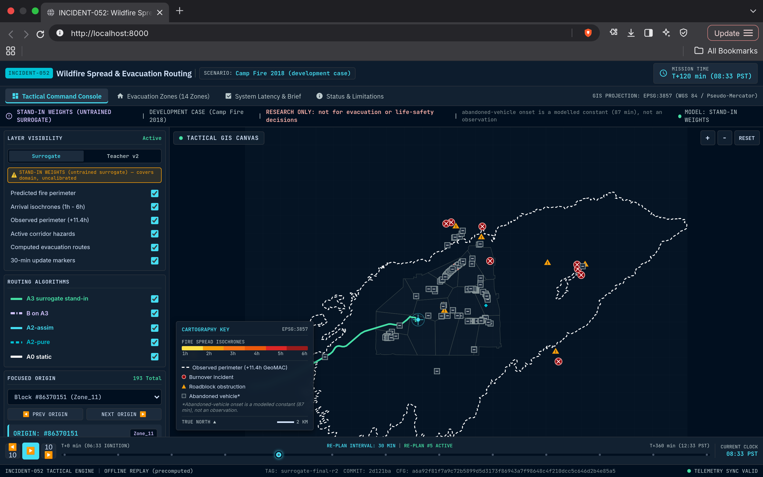
Figure: INCIDENT-052 Dashboard — Tactical Command Console view
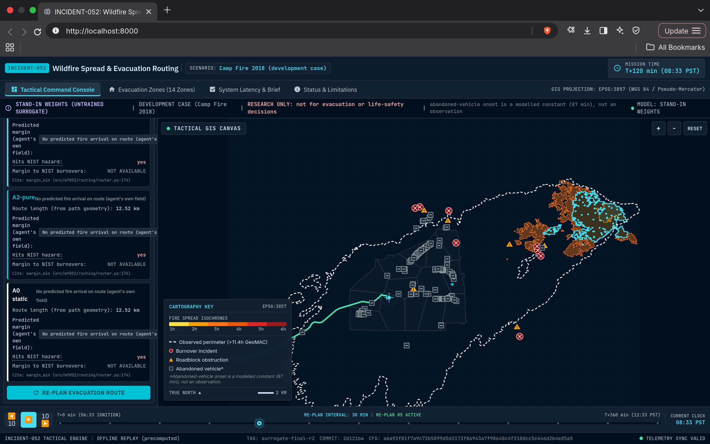
Figure: INCIDENT-052 Dashboard — Route Evaluation view (Teacher v2 field source)

Evacuation Zones, System Latency and Status & Limitations
The Evacuation Zones tab lists 14 evacuation zones and 3 egress corridors (17 sortable rows) from reports/step5d_per_zone_metrics.csv with origin counts, route changes versus the static baseline, P10 margin on the A3 field and trapped counts — for example Clark_Rd covers 93 origins with 63 route changes (67.7%), a 49.6 min P10 margin and 1 trapped origin — under a caveat that the stand-in A3 field was used. The System Latency & Brief tab shows three cards (2,115.74 ms router plus validator per re-plan across 200 origins, 34.51 ms per surrogate tile, 2,747.21 ms mean Teacher v2 simulation), each citing its CSV row, above a deterministic template Evacuation Operations Brief badged "LLM NOT RUN". The Status & Limitations tab tabulates specification metrics and splits what the system can claim from what it cannot, followed by the audited limitations.
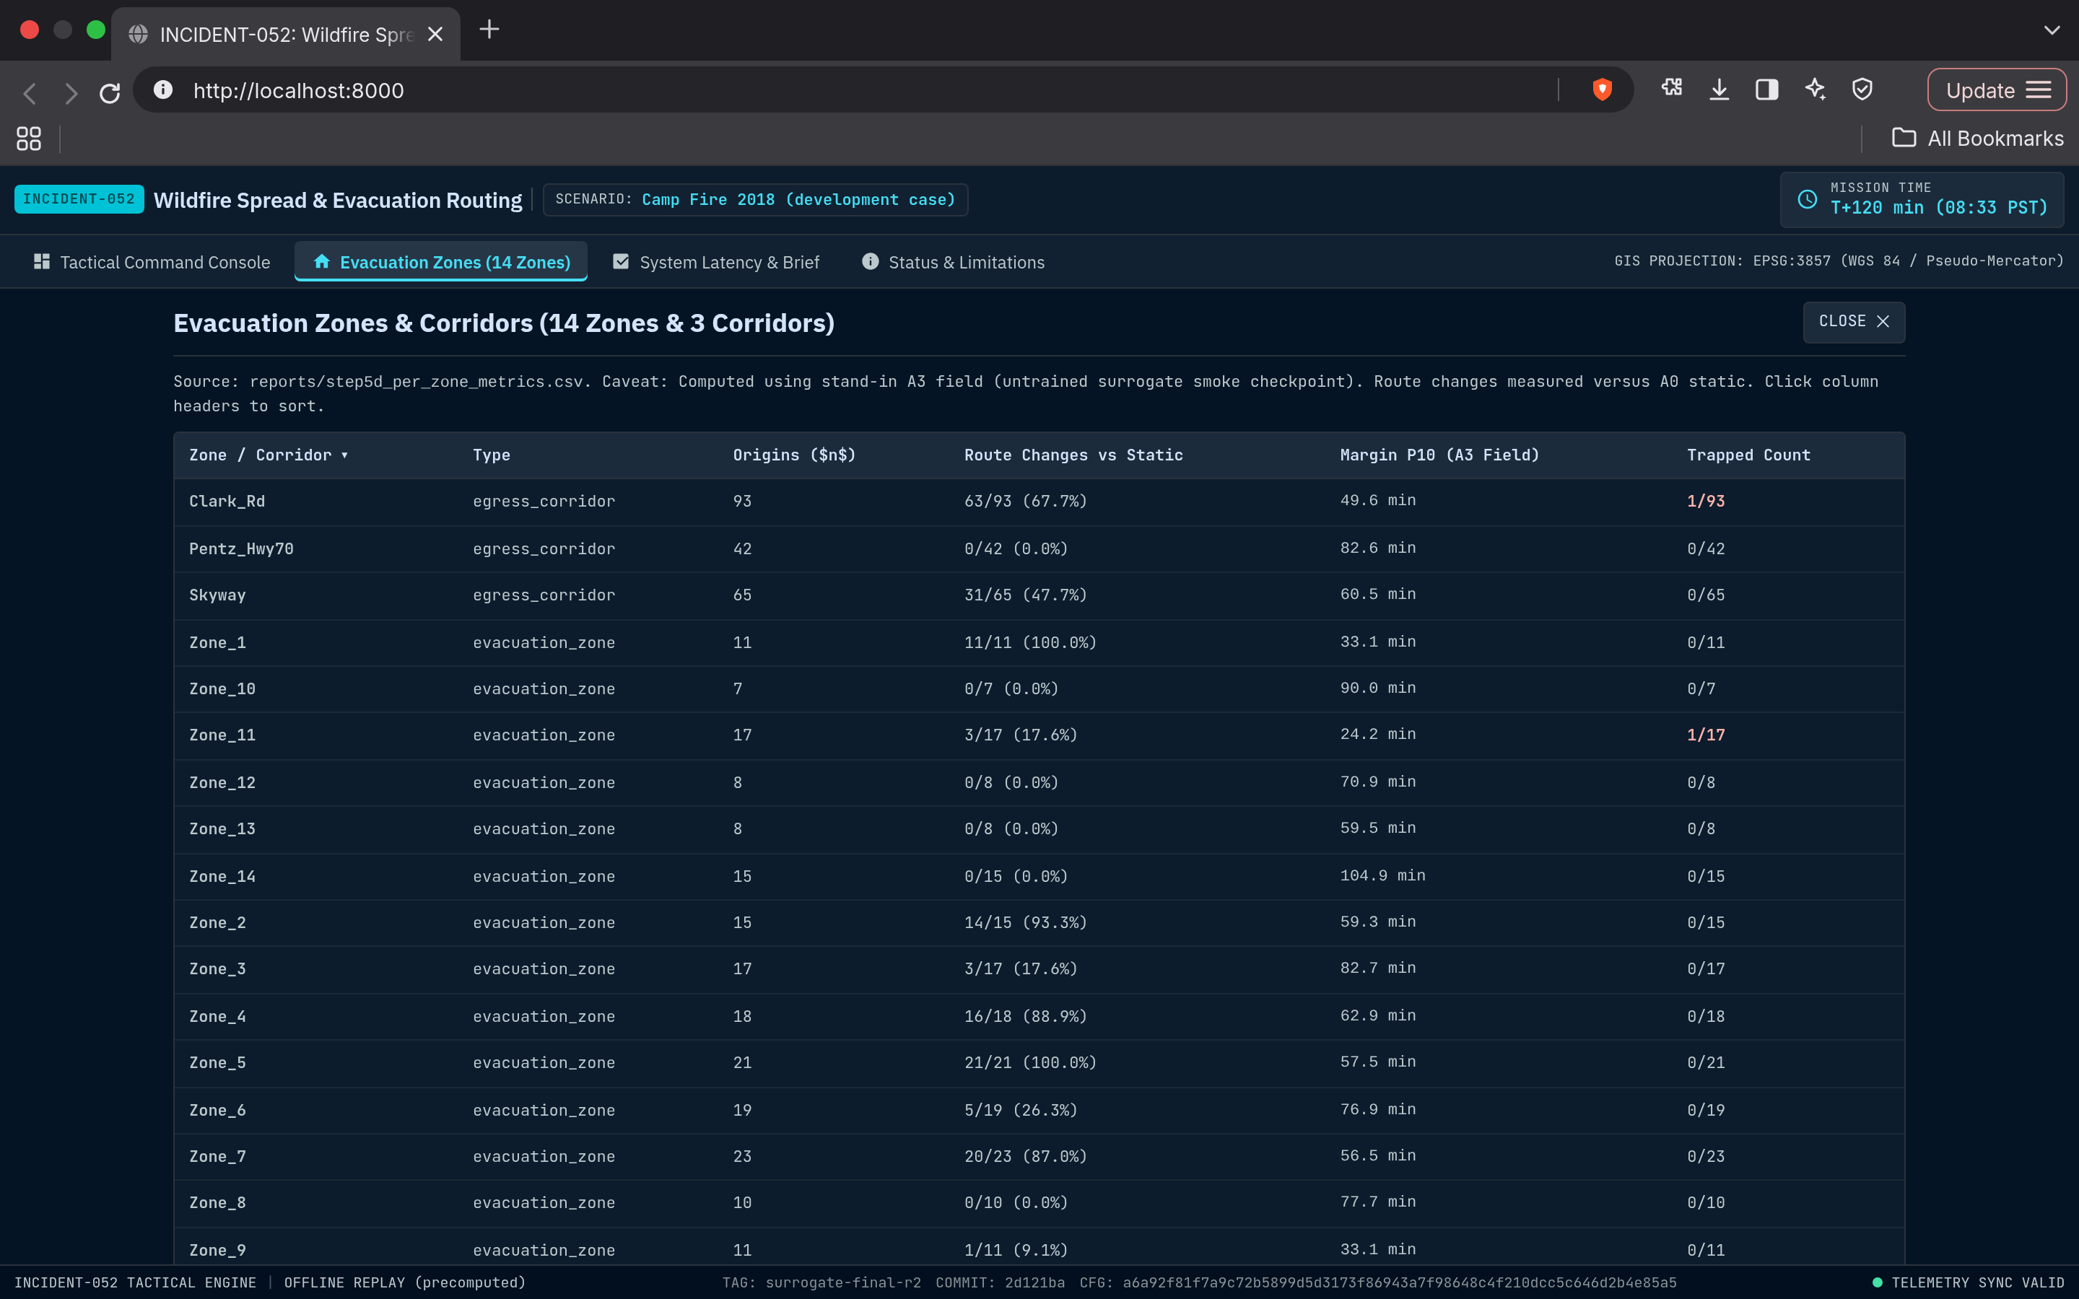
Figure: INCIDENT-052 Dashboard — Evacuation Zones view
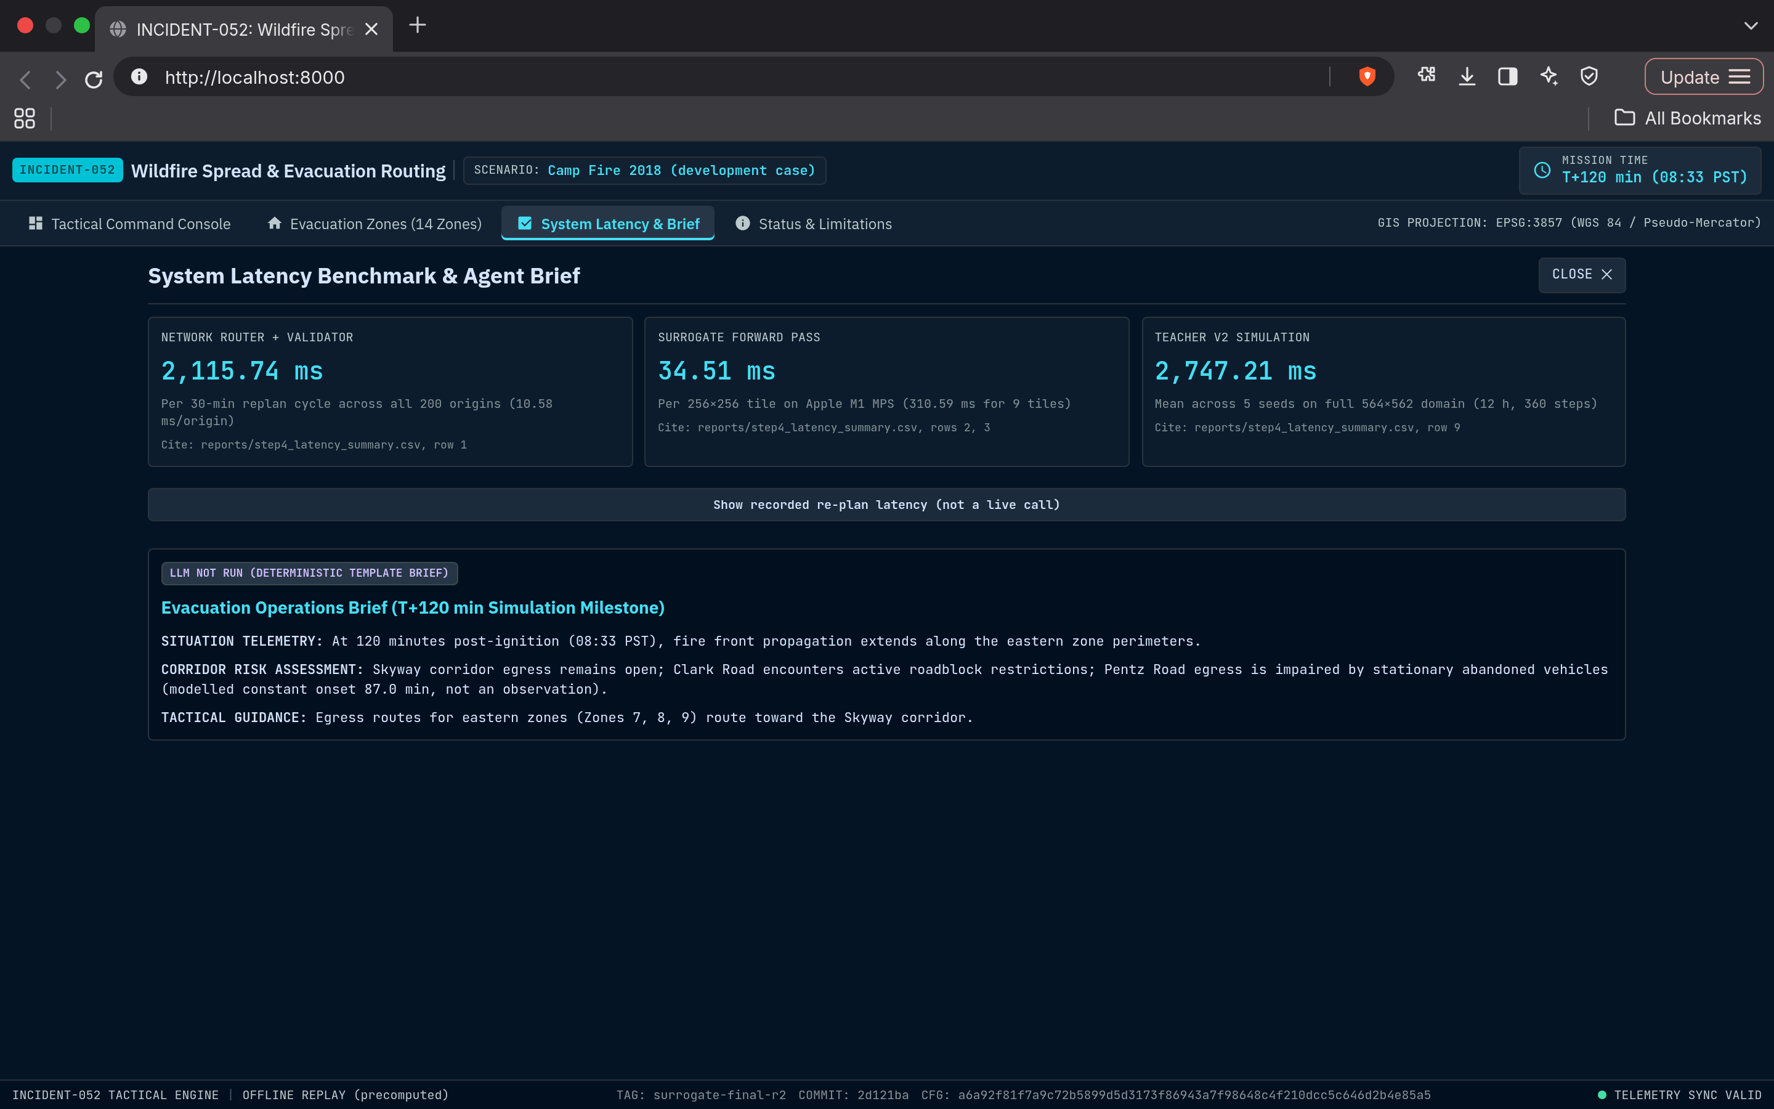
Figure: INCIDENT-052 Dashboard — System Latency & Brief view
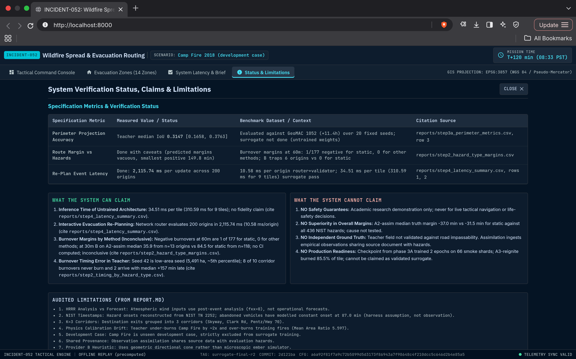
Figure: INCIDENT-052 Dashboard — Status & Limitations view

Navigation: Replay Timeline and the Research-Only Disclaimer
A persistent transport strip drives a 0-360 minute replay timeline (06:33 PST ignition to 12:33 PST) shared by every tab: Play auto-advances 10 minutes every 1.2 seconds, the previous-10 and next-10 buttons and the Left / Right arrow keys step 10 minutes, the Space key toggles playback, and a 30-minute re-plan interval is annotated on the slider (RE-PLAN #5 ACTIVE at T+120). A fixed strip across the top of every view states the stand-in weights, the Camp Fire development-case status, "RESEARCH ONLY: not for evacuation or life-safety decisions" and the modelled abandoned-vehicle onset, carrying the README and REPORT.md safety framing into the interactive surface, while the footer shows the build tag, commit and configuration hash.

Time Taken at Different Project Stages
The timeline below is reconstructed directly from the repository's own commit history (git log), in keeping with a preference for traceable, verifiable records over a separately kept time log. All times are IST (UTC+05:30) and the repository holds 47 commits. The first commit contains only the repository scaffold, so it is reported as a single foundational commit with no prior commit to measure elapsed time against; every stage after it is timestamped directly from individual commits.
Stage | Window | Elapsed
Foundational commit: repository scaffold (pyproject.toml, package layout, tests) | 09 Oct 12:12 | N/A (first commit)
Phase 0: seeding utilities, data ingestion pipelines, data card, PyTorchFire and Cell2Fire runners, feasibility report | 09 Oct 12:12 – 13:41 | ~1h 29m
Phase 0.5 audit of the feasibility spike | 09 Oct 13:41 – 14:35 | ~54m
Phase 1A steps 0-2: perimeter timeline audit, resolution sensitivity, training-fire selection | 09 Oct 14:35 – 17:05 | ~2h 30m
Phase 1A step 3: leave-one-fire-out calibration, teacher_v1 freeze, held-out Camp Fire evaluation | 09 Oct 17:05 – 10 Oct 18:21 | ~1d 1h 15m
Phase 1B: criticality sweep, assimilation mode, ember kernel, fresh held-out fire proposal | 10 Oct 18:21 – 13 Oct 10:04 | ~2d 15h 43m
Time-aware evacuation router and synthetic-fire tests | 13 Oct 10:04 – 15 Oct 10:35 | ~2d 0h 31m
Phases 4b-4f: demand, congestion assignment, en-route re-planning, graph audit, k* slowdown module | 15 Oct 10:35 – 16 Oct 20:03 | ~1d 9h 28m
Wind-conditioned FiLM U-Net pipeline with stand-in data contract | 16 Oct 20:03 – 21:15 | ~1h 12m
Surrogate Phases 2B-2C: diagnostics, compact storage, router adapter, conformal calibration, Kaggle packaging | 16 Oct 21:15 – 22 Oct 17:48 | ~5d 20h 33m
Agent Phases 5A-5B: LangGraph state machine, typed tools, re-plan policy, grounded briefs, full-graph benchmark | 22 Oct 17:48 – 25 Oct 22:02 | ~3d 4h 14m
Causal replay harness, Phase 6A evaluation and Phase 6B leakage audit | 25 Oct 22:02 – 26 Oct 00:43 | ~2h 41m
teacher_v2 freeze, Phase 6C-6D replay integrity audits and teacher attribution | 26 Oct 00:43 – 13:19 | ~12h 36m
Surrogate Phases 2D-2I: teacher_v2 ensemble labels, hardening, loss normalization, sampler fixes | 26 Oct 13:19 – 27 Oct 11:27 | ~22h 7m
Surrogate training and evaluation (Phases 3A, 3C) with surrogate-driven replay and Streamlit demo (Phases 4A-4C) | 27 Oct 11:27 – 20:33 | ~9h 7m
Claims audit and freeze (Phases 4D-4F): hazard-type margins, limitations, dependency audit | 27 Oct 20:33 – 28 Oct 11:28 | ~14h 54m
Offline Stitch dashboard UI (Phases 5A-UI to 5C-UI-LITE): INCIDENT-052 web app, content audit, zone table proof | 28 Oct 11:28 – 12:34 | ~1h 7m
TOTAL (first commit → latest commit) | 09 Oct 12:12 – 28 Oct 12:34 | ~19d 0h 22m
Note: "Window" and "Elapsed" are wall-clock spans between commits, not continuous active-coding time — the ~5d 18h gap between c8993f2 (16 Oct 21:15) and f932c39 (22 Oct 15:37) is the longest in the history and mostly reflects time away from the repository, and the bulk surrogate training and simulation runs executed off-repository on Kaggle GPUs are not captured by these timestamps.

Conclusion
This project investigates how far a physics-grounded, tool-constrained pipeline can go in turning a wildfire spread forecast into auditable evacuation routing for a real, well-documented event. It delivers a calibrated and hash-frozen physics teacher whose ember kernel accounts for roughly three quarters of its burned-area gain; a 4.09 M-parameter wind-conditioned U-Net that runs a 256 x 256 tile in 34.51 ms (architecture verified, weights untrained); a time-dependent router that re-plans 200 origins in 2.1 s with an independently validated safety margin; and an agent whose briefs are grounded against tool outputs and presented through an offline dashboard. Just as importantly, it reports what it could not show: no trained-surrogate fidelity, no routing benefit that survives corridor-clustered bootstrap, and no safety claim. The next steps follow directly from those gaps — full-data surrogate training on GPU, evaluation on the fresh held-out fires (Slater and Devil, Walker and W-5 Cold Springs), and validation of the teacher field against road impassability on the western exit corridors.

