Explain Redux:

Redux is a predictable state container for JavaScript apps. In this redux use the big application. If we are using redux then it will reduce the line of code . and easily use any component of react

First of all use the redux then install in the terminal –

npm install @reduxjs/toolkit

Redux +TypeScript template

Npx create-react-app (appname) –template redux -typescript

React redux Architecture diagram

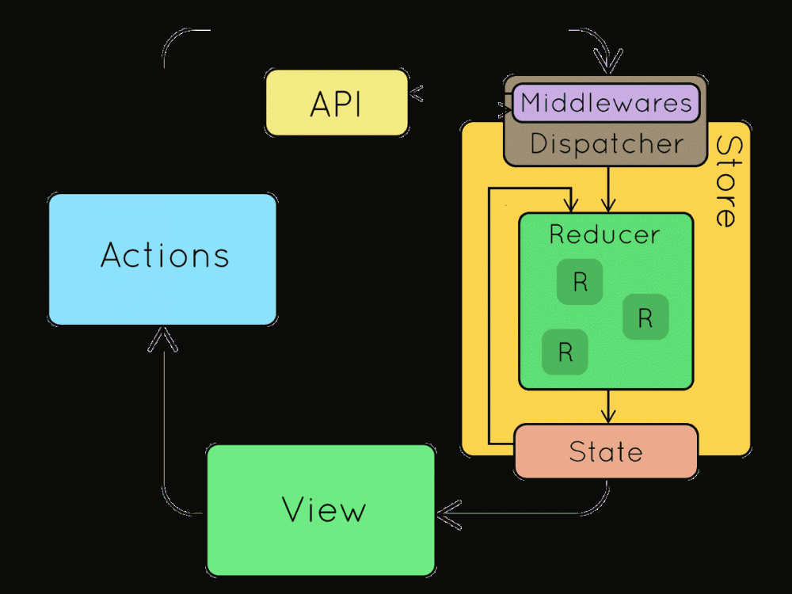

[This Photo](https://www.techug.com/post/why-im-switching-from-angular-to-react-and-redux-in-2018.html) by Unknown Author is licensed under [CC BY-SA-NC](https://creativecommons.org/licenses/by-nc-sa/3.0/)

React redux Part-

1.Action- if any perform a task then define the type in the action component

Example: const incNumber = (num:number) => {

    return {

        type: 'INCREMENT',

        payload: num

    }

2.Multiple Readucer – In reducer use the use reducer hook and it take a initial state and action, and how tp perform then we can use a Reducer and pass the reducer in the root reducer . we can create multiple reducer file and all the reducer file pass in the root reducer .

Example;

reducerName = (state, action):

3. Root Reducer-in root reducer all the reducer file pass in this file .

3.Create store- create a store globally and used any file of the react application in this file firstly import the root reducer then easily access the all components.

Example:

const store = Redux.createStore(counterReducer)

4.Any Component use the file using the store – firstly we used the any data which is available in the reducer then we used the

5. UseSelector and useDispatch-:

UseSelector and useDispatch are a set of hooks to use as alternatives to the existing connect() higher-order component.

It takes in a function argument that returns the part of the state that you want .

The equivalent of map dispatch to props is useDispatch.

Dispatch Example=

store.dispatch({ type: 'typename' })

useselector example:

const stateName = useSelector(state => state.stateName)