Image Catalogue
Technical Report
BSCG6_21.1_32_6 Advanced Programming
Assessment 2: Individual Take-Home Practical Programming Project
Mitesh Umretiya
30 October 2026
Source code and Git history: github.com/miteshumretiya/image-catalogue (private)

Contents
15.1 System overview
15.2 Architecture
15.3 GUI design decisions
15.4 Concurrency design
15.5 Testing
15.6 Source-control workflow
15.7 Evaluation
References
Appendix A Design Specification (Task 1)
Appendix B Test Plan, Manual and Automated Testing, Debugging (Tasks 9-12)
Appendix C Performance and Parallelism Investigation (Task 8)
Appendix D Merge Conflict Output (Task 13)
The report sections follow the numbering of Task 15 in the assessment brief. The appendices hold the supporting documents for the other tasks.

15.1 System overview
Image Catalogue is a desktop application for organising a personal photo collection. The user adds a folder and the app scans it in the background, creating a thumbnail and reading the size, format and file size of every image. The images appear in a sortable table with a large preview of the selected image. The user can give each image a title, tags and a 0-5 star rating, search by name, title or tag, and save everything to a catalogue file to reopen later. A short sound plays when a scan finishes.
The app is written in Python 3 with PyQt6 for the GUI, Pillow for image processing and QtMultimedia for sound. It was developed and tested on macOS 26.6 with Python 3.14.7, and the same code runs on Windows and Linux.
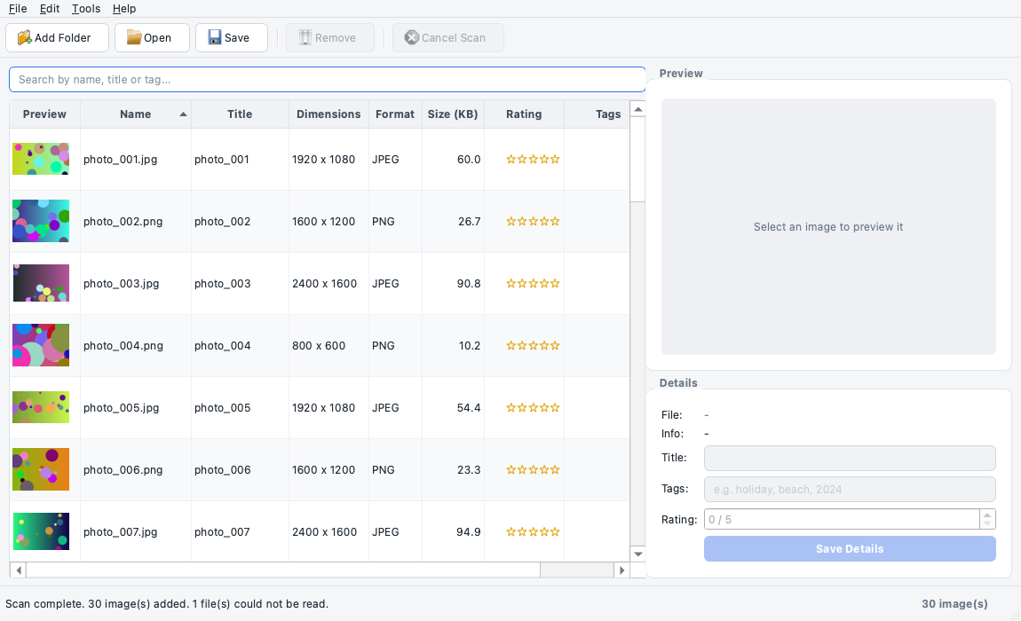
Figure 1: Main window after scanning 30 images

15.2 Architecture
The project uses MVC, adapted to Qt's model/view framework (see the diagram in Appendix A).
Layer | Module / class | Responsibility
Model | model/image_item.py: ImageItem, validation functions | One image's data; rules for valid title, tags, rating
Model | model/catalogue.py: ImageCatalogue | The collection: add, remove, edit, search, save/load JSON
Model | model/processing.py | Find image files; read details and make thumbnails
View | views/main_window.py: MainWindow, PreviewLabel, ImageTable | Widgets, menus, toolbar, dialogs; emits custom signals
View | views/theme.py | The light theme: Fusion style, a fixed light palette and one style sheet for buttons, inputs, table and status bar
View (Qt adapter) | views/image_table_model.py: ImageTableModel, ImageFilterProxy | Connects the catalogue to QTableView; sorting and filtering
Controller | controller/main_controller.py: MainController | Reacts to view signals, updates the model, runs the worker
Worker | workers/scan_worker.py: ScanWorker, ScanStats | Background scanning and thread-safe progress counting

Key decisions:
- The model has no Qt imports. This means all 68 automated tests run without opening a single window. It also means the same process_image function is used by the app, the tests and the benchmark.
- The view only emits signals. For example, the Save Details button doesn't validate anything. It emits details_submitted(title, tags, rating), and the controller asks the model to validate and save it. That's why there is no business logic in GUI event handlers (Task 3).
- Why a Qt table model as well as ImageCatalogue? QTableView needs a QAbstractTableModel to tell it when rows are added or removed. Rather than put my data inside a Qt class, I kept ImageCatalogue as plain Python and wrote a thin adapter. The alternative of storing data directly in a QStandardItemModel would have been less code, but it would mix data with Qt and make testing harder.
- Custom signals used: MainWindow has 9 (e.g. open_folder_requested, search_changed(str), details_submitted(str, str, int)). ScanWorker has 4 (progress(int, int), item_ready(object), scan_finished(int, list, bool), scan_failed(str)).
- Error handling: invalid input raises ValidationError and the controller shows a message. File problems raise CatalogueError with a readable message. A broken image is recorded and skipped without stopping the scan, and the user sees a list of skipped files at the end.

15.3 GUI design decisions
- QMainWindow gives the standard menu bar, toolbar and status bar layout that users already know.
- Light theme with clear buttons (views/theme.py). In the first version the toolbar actions showed as plain text, which didn't look like buttons. I switched to Qt's Fusion style with a fixed light palette, so the app looks the same on macOS and Windows and stays light even when the Mac is in dark mode. Every toolbar button now has an icon and text, a border and a hover highlight. The icons are Qt's built-in standard icons, so there are no extra image files to package.
- Colour means something. Blue is only used for the main action in the form (Save Details). Red is only used for actions that remove or stop something (Remove, Cancel Scan). Disabled buttons turn grey, so it's clear what you can do at any moment. For example, Remove stays grey until an image is selected.
- Gold stars (★★★★☆) make ratings easy to read at a glance. The empty table shows "No images yet. Click Add Folder to start." instead of a blank area, or "No images match your search." when a search finds nothing.
- All the styling is in one file. The window code only gives widgets names like primaryButton or dangerButton, and theme.py decides what those look like. The look can change without touching the window's logic.
- QTableView rather than a QListWidget of thumbnails: the user wants to compare details (size, rating, tags) and sort by them, and a table does that well. The thumbnail is in the first column so it's still visual.
- QSplitter between the table and the preview so the user can choose how much space each gets.
- QFormLayout for the details, since label/field pairs are what forms are for.
- QSpinBox for rating (0-5) and setMaxLength(100) on the title: these stop invalid values before they happen. The model validates anyway, in case data comes from somewhere else such as a hand-edited file.
- Progress bar and Cancel button in the status bar, only visible while scanning, so they don't clutter the window the rest of the time. Add Folder and Open Catalogue are disabled during a scan so the user can't start two at once.
- Confirmation dialogs only for actions that lose something (remove, closing with unsaved changes). Information that doesn't need a decision goes in the status bar instead of a popup.
- Keyboard shortcuts (Ctrl+O, Ctrl+S, Delete, Esc) for faster use.
- Sound (QtMultimedia, QSoundEffect): a scan of a large folder can take a while, so the user may switch to another window. The chime tells them it's finished without having to keep checking. It can be turned off in the Tools menu. I generated the sound myself (tools/make_sound.py), so there are no copyright issues.

15.4 Concurrency design
The problem. Making a thumbnail means decoding a full-size photo. In the benchmark, 40 large photos took 2.1 seconds one after another, so a real folder of a few hundred photos takes many seconds. My first version (commit "Add main window, table model and controller (scan runs on GUI thread)") did this in a simple loop inside the controller. While it ran, the window couldn't redraw or respond to clicks, and macOS showed the spinning wheel. That is why the scan was moved to a background thread on the feature/threaded-processing branch.
The technique.
- The controller creates a QThread and moves a ScanWorker (a QObject) onto it with moveToThread. The worker's run() slot starts when the thread starts.
- Inside run(), a ThreadPoolExecutor with 4 threads processes several images at the same time.
- As each image finishes, the worker emits item_ready(item) and progress(done, total).
- When it finishes it emits scan_finished(...) and the thread quits. A short sound plays and any skipped files are reported.
Getting results safely to the GUI. Qt widgets must only be touched from the GUI thread. Because the worker lives in a different thread from the controller, Qt automatically uses queued connections. The signal's arguments are put in the GUI thread's event queue and the slot runs on the GUI thread. The worker never touches a widget or the catalogue directly.
Synchronisation and thread safety (Task 7).
Shared resource | Who uses it | What could go wrong | Protection
ScanStats counters (processed count, failure list) | All 4 pool threads write; the worker thread reads | processed += 1 is really read, add, write. Two threads can read the same value and both write back value+1, so one update is lost. The progress bar would never reach 100%. | threading.Lock around every read and write (with self._lock:)
The catalogue and the table model | Only the GUI thread | If a worker thread added rows while the table was repainting, Qt could crash or show wrong rows | Controlled ownership: only the GUI thread touches them; workers send items by signal
Cancel flag | GUI thread sets it; pool threads read it | A plain variable could be read in an inconsistent state | threading.Event, which is designed to be shared between threads

Evidence: tools/race_demo.py runs 4 threads x 10,000 increments. Without a lock it gave 10,006 instead of 40,000. With the lock it gave exactly 40,000. The automated test test_stats_counter_is_correct_with_many_threads checks the real ScanStats with 8 threads.
Cancelling. cancel() is called directly from the GUI thread, not through a signal. A queued signal to the worker would sit in the worker thread's queue until run() finished, which is too late. The event is safe to set from any thread. When it is set, images not yet started are cancelled and those in progress are allowed to finish, so no half-written thumbnails are left behind.
Responsiveness evidence. During manual test MT04, a 20 ms timer on the GUI thread kept firing for the whole 200-image scan (see docs/evidence/gui_walkthrough_results.txt). If the GUI thread had been blocked, the timer couldn't have fired.
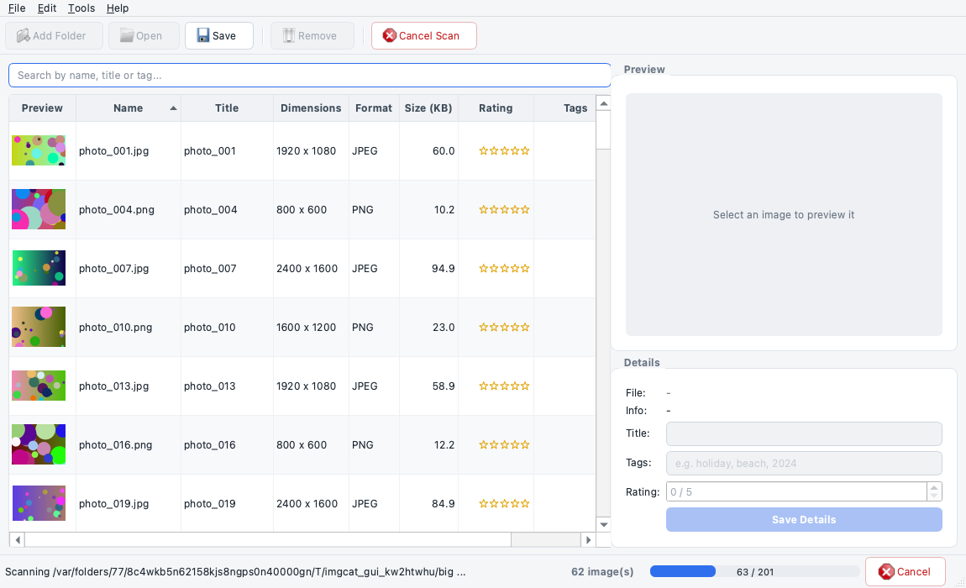
Figure 2: Progress bar and Cancel button during a scan
Performance. See Appendix C. On my 8-core Mac, 4 threads gave a 3.25x speed-up and 8 threads gave 4.5x. That was faster than processes (2.69x with 4), because Pillow releases the GIL and threads avoid the cost of pickling. I chose threads because they were faster here and are simpler with Qt signals and packaging.

15.5 Testing
See Appendix B: 27 manual tests, 68 automated tests (all passing), and a debugging log of 5 defects found and fixed.
- Automated: python -m pytest -v gives 68 passed in under a second. The tests cover validation (normal, boundary and invalid values), the catalogue, file handling, thumbnails, the worker and the locked counter (8 threads x 5,000 updates).
- Manual: the 27 GUI tests were run on the real window with tools/gui_walkthrough.py, which saves a screenshot for each important step to docs/evidence/. Sound, keyboard shortcuts and the packaged app were checked by hand.
- Defects: the most interesting one was D5. Rescanning a folder reported "30 image(s) added" when nothing was new. The worker can't know which images are duplicates, because that check happens on the GUI thread. The fix was to count additions in the controller. It is a separate "Fix:" commit in the Git history.

Figure 3: Validation error for an invalid tag

15.6 Source-control workflow
The project was built up in stages, with a commit at each step:
- main: project setup and design spec, then the model (ImageItem, validation, ImageCatalogue) with tests, then image processing with tests, then the sound and sample-image tools.
- main: the first GUI, with the scan running on the GUI thread (it froze the window).
- feature/threaded-processing branch: added ScanWorker with the thread pool and the locked counter, then switched the controller to a background QThread with progress and cancel. Merged back into main with --no-ff, so the branch is visible in the history.
- feature/window-title branch: a controlled merge conflict. Both main and the branch changed the same setWindowTitle(...) line. git merge stopped with CONFLICT (content): Merge conflict in catalogue/views/main_window.py and added <<<<<<< HEAD, ======= and >>>>>>> markers. HEAD is main's version and the part after ======= is the branch's. I resolved it by keeping the branch's title ("Image Catalogue - Photo Organiser"), deleted the markers, ran the tests (68 passed) and committed the merge. The full output is in Appendix D.
- feature/testing branch: the benchmark, the GUI walkthrough script, the D5 bug fix as its own Fix: commit, the PyInstaller configuration (with the macOS .app bundle), and the test, performance and report documents.
- Pull request and merge: feature/testing was merged into main on GitHub through pull request #1, then the GitHub screenshots were added on main.
- feature/ui-polish branch: the visual polish (light theme, button icons and colours, gold stars, empty-table message), with the tests and the GUI walkthrough re-run so the screenshots show the new look. Merged into main through pull request #2.
Remote: all four branches were pushed to a private GitHub repository (miteshumretiya/image-catalogue) with git push -u origin .... Pull request #1, "Add testing, benchmark, packaging and documentation", contained 10 commits and 25 changed files, with a description of what it adds and how it was tested. After checking the "Files changed" tab I merged it on GitHub, then ran git pull to bring the merge commit back to my Mac. I kept the feature branches on GitHub instead of deleting them, so the history stays visible.
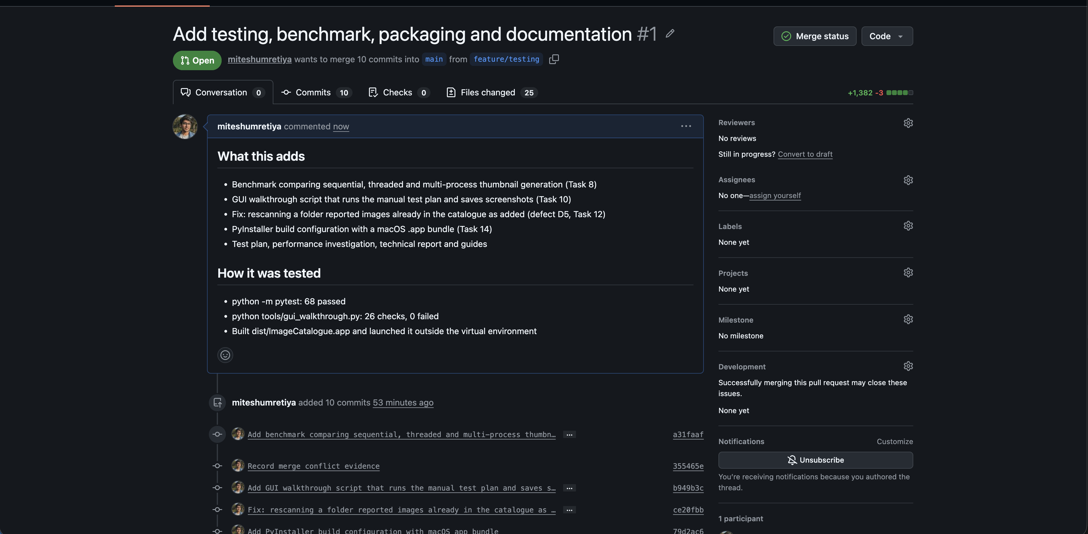
Figure 4: Pull request #1 on GitHub
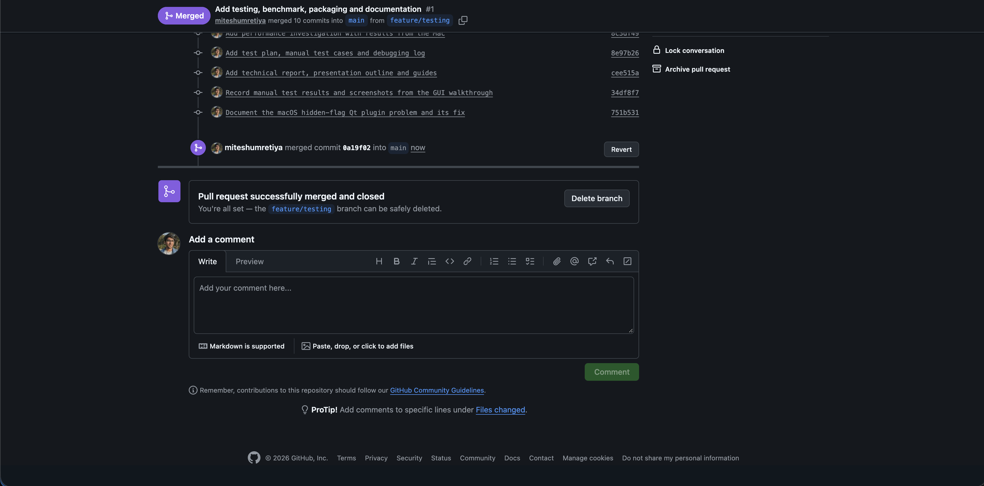
Figure 5: Pull request #1 merged
git log --oneline --graph --all shows the three branches splitting off and merging back in, including the conflict merge and the pull request merge:
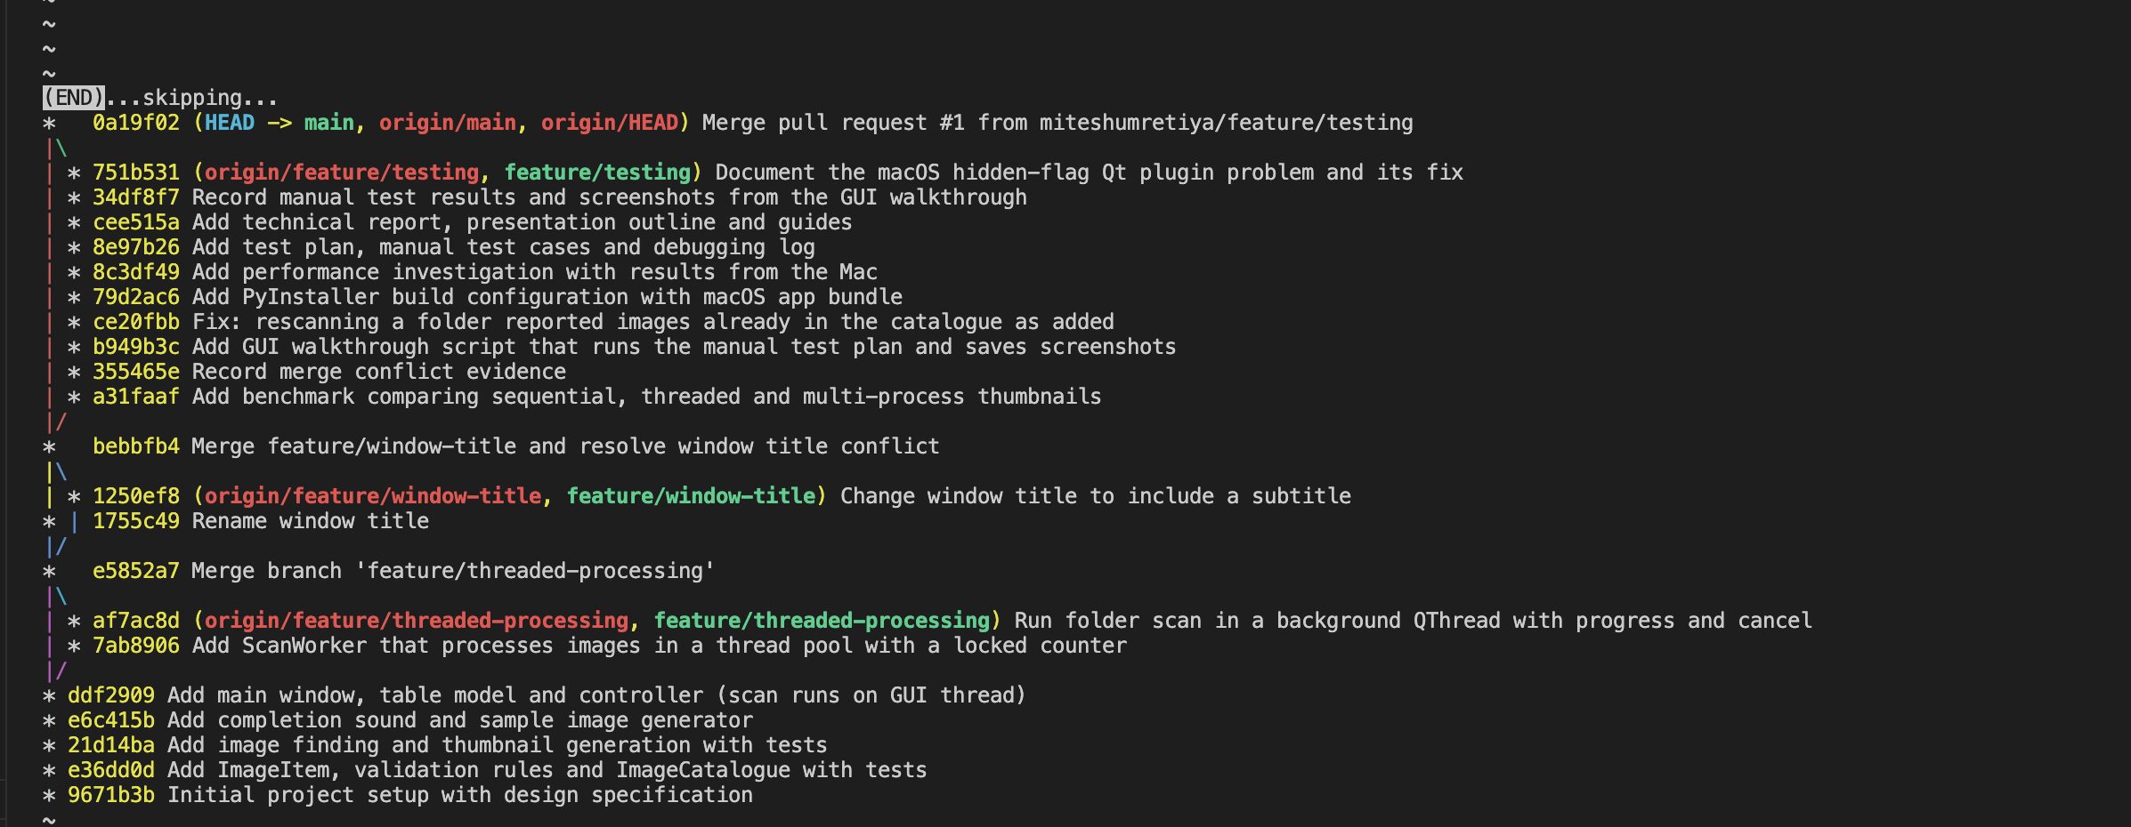
Figure 6: Git history graph

15.7 Evaluation
Strengths
- Clear separation of concerns, which made testing easy: 68 automated tests run in under a second.
- The GUI stays responsive during long scans, with progress, cancel and a completion sound.
- Robust error handling: broken images, corrupt catalogue files and invalid input all give clear messages instead of crashes.
- Small and readable. Each file has one job.
Limitations
- If you move or rename your photos, the catalogue still points to the old paths. There is no "relink" feature.
- Thumbnails are cached in the home folder and never cleaned up.
- The preview loads the full image on the GUI thread. With very large photos (e.g. 50 MP) selection can feel slightly slow.
- Only one folder can be scanned at a time.
- There are no automated GUI tests. GUI behaviour was checked manually.
Technical problems I hit
- Cancelling. My first idea was to send a "cancel" signal to the worker. But the worker's thread is busy inside run(), so a queued signal would only be delivered after the scan had already finished. The fix was a threading.Event that the GUI thread sets directly and the pool threads check before each image.
- Counting what was "added". The status message counted every image the worker read, so rescanning a folder claimed images were added when they weren't (D5). The worker can't see the catalogue, by design, so the count had to move to the controller.
- The GIL result surprised me. I expected threads to be useless for CPU work in Python, but they were the fastest option. That's because Pillow releases the GIL. I had to change the benchmark (D4) to show the GIL's real effect on pure-Python code.
- The app wouldn't start on my Mac at first. It stopped with Could not find the Qt platform plugin "cocoa", even though the plugin file was there. Using QDir in Python, I found that Qt could only see the file when hidden files were included. ls -lO showed macOS had set the hidden flag on every file inside .venv, and Qt ignores hidden plugins. Running chflags -R nohidden .venv fixed it. The built .app was not affected because it lives in dist/. I added this to the README's troubleshooting section.
- Packaging on macOS. PyInstaller first produced a folder with a plain program file, not a normal Mac app. Adding a BUNDLE step to the spec file produced ImageCatalogue.app.
Possible improvements
- Load the preview in the background too, or use a medium-sized cached preview.
- Add rows to the table in batches (e.g. every 20 images) to reduce GUI work. This also reduces the sequential part in Amdahl's Law terms.
- Store the catalogue in SQLite instead of JSON for large collections.
- Add pytest-qt tests for the main window.
- Read EXIF data (date taken, camera) and allow sorting by date.
Alternative approaches
- QThreadPool + QRunnable instead of QThread + ThreadPoolExecutor. It is more "Qt", but QRunnable can't emit signals directly, so it needs an extra helper QObject.
- ProcessPoolExecutor for true parallelism. It is only worth it for pure-Python CPU work, and it adds pickling overhead and packaging complexity.
- asyncio (e.g. with qasync). It is good for I/O-bound work like downloads but doesn't help CPU-bound image decoding.

References
- Riverbank Computing (2025) PyQt6 Reference Guide. Available at: https://www.riverbankcomputing.com/static/Docs/PyQt6/
- The Qt Company (2025) Threads and QObjects. Available at: https://doc.qt.io/qt-6/threads-qobject.html
- The Qt Company (2025) Model/View Programming. Available at: https://doc.qt.io/qt-6/model-view-programming.html
- Python Software Foundation (2025) concurrent.futures: Launching parallel tasks. Available at: https://docs.python.org/3/library/concurrent.futures.html
- Python Software Foundation (2025) threading: Thread-based parallelism. Available at: https://docs.python.org/3/library/threading.html
- Pillow contributors (2025) Pillow documentation. Available at: https://pillow.readthedocs.io/
- PyInstaller Development Team (2025) PyInstaller Manual. Available at: https://pyinstaller.org/en/stable/
- Amdahl, G. M. (1967) 'Validity of the single processor approach to achieving large scale computing capabilities', AFIPS Conference Proceedings, 30, pp. 483-485.
- Microsoft (2024) Introduction to PLINQ. Available at: https://learn.microsoft.com/en-us/dotnet/standard/parallel-programming/introduction-to-plinq
All online sources accessed 30 October 2026.

Appendix A: Design Specification (Task 1)

1.1 Application purpose
Problem. Most people have hundreds of photos sitting in folders with names like IMG_4821.jpg. File Explorer can show thumbnails, but it can't give a photo a proper title or tags, or let you rate your favourites, and finding "all the beach photos" means opening them one by one.
Intended user. Someone with a personal photo collection on their own computer (for example a student, a hobby photographer or a family archivist) who wants a simple, offline way to organise it. They are comfortable with normal desktop apps but are not technical.
Main purpose. Image Catalogue lets the user point the app at a folder and get a browsable table of all the images in it. They can then add titles, tags and ratings, search the collection and save it all to a catalogue file. Scanning a big folder takes time because every image has to be opened and shrunk to a thumbnail, so this happens in the background while the window stays usable.

1.2 Functional requirements
ID | Requirement
FR1 | The user shall be able to choose a folder, and the application shall find every supported image in it, including sub-folders (JPG, PNG, GIF, BMP, WEBP, TIFF).
FR2 | The application shall generate a thumbnail and read the size, format and file size of each image in the background, without freezing the window.
FR3 | The application shall show scan progress (done / total) and allow the user to cancel a running scan.
FR4 | The application shall display all catalogued images in a table with a thumbnail, and allow sorting by any column.
FR5 | The user shall be able to select an image to see a larger preview and its details.
FR6 | The user shall be able to edit an image's title, tags and rating (0-5), and invalid input shall be rejected with a clear message.
FR7 | The user shall be able to search the catalogue by file name, title or tag.
FR8 | The user shall be able to remove an image from the catalogue (without deleting the file on disk).
FR9 | The user shall be able to save the catalogue to a file and open it again later. Broken or invalid files shall be reported, not crash the app.
FR10 | The application shall play a short sound when a scan finishes, and the user shall be able to turn this off.

Non-functional: the window must stay responsive during scans; one unreadable file must not stop a scan; the user must be warned about unsaved changes before closing.

1.3 GUI design (wireframe)
+------------------------------------------------------------------------------+
| File Edit Tools Help <- menu bar |
+------------------------------------------------------------------------------+
| [Add Folder] [Save Catalogue] [Remove Image] | [Cancel Scan] <- toolbar |
+--------------------------------------------+---------------------------------+
| [ Search by name, title or tag... ] | Preview |
| +----------------------------------------+ | +-----------------------------+ |
| |Preview| Name | Title | Dims | ... ^| | | | |
| |[img] | a.jpg | Beach | 1920 | || | | large picture of the | |
| |[img] | b.png | Cat | 800 | || | | selected image | |
| |[img] | c.jpg | Alps | 2400 | || | | | |
| | ... | | | | v| | +-----------------------------+ |
| +----------------------------------------+ | Details |
| QTableView (sortable) | File: C:\Photos\a.jpg |
| | Info: 1920 x 1080 | JPEG |
| | Title: [Beach day ] |
| | Tags: [holiday, sea ] |
| | Rating: [4 /5 ^v] |
| | [ Save Details ] |
+--------------------------------------------+---------------------------------+
| Scanning C:\Photos ... 30 image(s) [#####-----] 12/30 [Cancel] |
+------------------------------------------------------------------------------+
<- status bar
Dialogs: folder chooser, open/save file dialogs, error and warning message boxes, "remove this image?" confirmation, and "save changes?" on exit.
The finished window follows this wireframe: menu bar and toolbar at the top, the search box above a sortable table with thumbnails on the left, and the preview and details form on the right. The progress bar and Cancel button sit in the status bar and only appear while a scan is running. After the first working version I polished the look on a separate branch: the toolbar buttons got icons, borders and colours (blue for the main action, red for removing or stopping), an Open button was added to the toolbar, and the app uses a light theme.
Figure 7: The finished main window

1.4 Architecture
I'm using MVC adapted to Qt's model/view framework:
user clicks / types
|
v
+-------------------+ custom signals +----------------------+
| VIEW | -----------------> | CONTROLLER |
| MainWindow | | MainController |
| (widgets only) | <----------------- | (decides what to do)|
+-------------------+ method calls +----------------------+
^ | |
| Qt model/view | | starts, cancels
+-------------------+ v v
| ImageTableModel | reads +----------------+ +------------------+
| ImageFilterProxy | -------> | MODEL | | WORKER (thread) |
+-------------------+ | ImageCatalogue | | ScanWorker |
| ImageItem | | uses processing |
| processing.py | | functions |
+----------------+ +------------------+
- Model (catalogue/model/): plain Python with no Qt imports. It holds the data, the validation rules, search, save/load and the image processing functions. Because it has no GUI code it can be unit tested easily.
- View (catalogue/views/main_window.py): builds the widgets and shows what it is told to show. When the user does something it emits a custom signal such as details_submitted(title, tags, rating). It makes no decisions.
- Controller (catalogue/controller/main_controller.py): listens to the view's signals, calls the model, starts and cancels the background worker, and tells the view what to display.
- Qt table model + proxy (catalogue/views/image_table_model.py): Qt's QTableView needs a QAbstractTableModel. Mine is a thin adapter that reads from ImageCatalogue and tells the view about changes. The search rule itself is ImageCatalogue.matches(), so the logic stays in the model.
- Worker (catalogue/workers/scan_worker.py): does the slow processing away from the GUI thread and reports back using signals.

Appendix B: Test Plan, Manual and Automated Testing, Debugging (Tasks 9-12)

How I approached testing
I split testing into two parts:
- Automated tests (pytest) for everything that is pure logic: validation, the catalogue, file finding, thumbnail creation, the worker's results and the thread-safe counter. These run in under a second, so I could rerun them after every change.
- Manual tests for anything the user sees or clicks: menus, dialogs, the progress bar, cancel, the sound, and the packaged app. These are hard to automate reliably and need a person to judge "does this look and feel right".
Test types used (from the module):
- Requirements/model-driven: each test links to a requirement (FR1-FR10) from the design specification.
- Criteria-driven: for each input I tested normal, boundary, invalid and exceptional values.
Test data: python tools/make_sample_images.py sample_images 30 creates 30 images (JPG and PNG, 4 sizes, some in a sub-folder), one fake broken.jpg and one notes.txt.

Part A: Manual test plan and results (Task 10)
These tests were run on the real application window on macOS 26.6 (Python 3.14.7, PyQt6 6.12). To make the run repeatable I wrote tools/gui_walkthrough.py. It opens the real MainWindow and controller and does what a user would do: selecting rows, typing text, clicking buttons, choosing menu actions. Pop-up dialogs are answered automatically, and the script records what the app showed. It saves screenshots to docs/evidence/, and the full output is in docs/evidence/gui_walkthrough_results.txt. Two things needed a person at the computer, and both were checked by hand: hearing the chime (MT24) and pressing the keyboard shortcuts (MT26). The packaged app (MT27) was checked by launching the built .app on its own, outside the virtual environment.
ID | Req | Feature | Type | Input / conditions | Expected result | Actual result | Pass/Fail
MT01 | FR1, FR2 | Add folder | Normal | File > Add Folder, choose sample_images | 30 images appear with thumbnails; status says "Scan complete. 30 image(s) added. 1 file(s) could not be read." | 30 images with thumbnails. Status 'Scan complete. 30 image(s) added. 1 file(s) could not be read.' | Pass
MT02 | FR2 | Bad file handling | Exceptional | Same scan (folder has broken.jpg) | Warning dialog lists broken.jpg; the other 30 are still added; the app does not crash | Warning 'Some files were skipped' listed broken.jpg; the other 30 were still added | Pass
MT03 | FR1 | Non-image files | Normal | Same scan (folder has notes.txt) | notes.txt is ignored silently | notes.txt is not in the table and not reported as a failure | Pass
MT04 | FR2 | Responsiveness | Normal | Scan a big folder (make_sample_images.py big 300), then drag the window, scroll the table and type in search while it runs | Window keeps responding; rows appear while scanning | 200-image scan took 2.0s; a 20 ms timer on the GUI thread fired 64 times, longest gap 89 ms (window never froze) | Pass
MT05 | FR3 | Progress | Normal | Watch status bar during MT04 | Progress bar counts up to e.g. "300 / 300", then hides | Progress went (0, 201) -> (201, 201) in 202 updates; bar hidden afterwards: True | Pass
MT06 | FR3 | Cancel | Normal | Start a 300-image scan, press Cancel (or Esc) halfway | Status says "Scan cancelled. N image(s) were added before stopping"; Add Folder works again | Pressed Cancel: 'Scan cancelled. 64 image(s) were added before stopping. 1 file(s) could not be read.'. Add Folder enabled again: True | Pass
MT07 | FR3 | Restart after cancel | Normal | After MT06, add the same folder again | Only the images not yet added are added (no duplicates) | Scanned the same folder again: 'Scan complete. 136 image(s) added. 1 file(s) could not be read.'; 200 images in total (was 64), 0 duplicates | Pass
MT08 | FR1 | Empty folder | Boundary | Add an empty folder | "Scan complete. 0 image(s) added."; no error | Status 'Scan complete. 0 image(s) added.', 0 images, no dialogs | Pass
MT09 | FR1 | Rescan same folder | Boundary | Add sample_images twice | Second scan adds 0 new images; count stays 30 | Second scan of the same folder: status 'Scan complete. 0 image(s) added. 1 file(s) could not be read.', still 30 images | Pass
MT10 | FR4 | Sorting | Normal | Click "Size (KB)" header twice | Rows sort smallest to largest, then largest to smallest (numerically, not as text) | Ascending 10.0 .. 94.9 KB, descending 94.9 .. 10.0 KB (numeric order) | Pass
MT11 | FR5 | Preview | Normal | Click a row | Large preview and details shown; resizing the window rescales the preview | Preview and details of photo_001.jpg shown; preview rescaled 286px -> 468px wide when the window was enlarged | Pass
MT12 | FR6 | Edit details | Normal | Title "Beach day", Tags "Sea, Holiday, sea", Rating 4, Save | Table updates; tags shown as "sea, holiday"; 4 stars | Saved: title 'Beach day', tags ['sea', 'holiday'], rating 4; form now shows tags 'sea, holiday' | Pass
MT13 | FR6 | Empty title | Invalid | Clear title, press Save | Error "Title cannot be empty."; nothing changes | Error 'Title cannot be empty.'; image unchanged | Pass
MT14 | FR6 | Bad tag | Invalid | Tags "hello world" | Error explaining allowed characters; nothing changes | Error ''hello world' is not a valid tag. Use letters, numbers or hyphens (max 20 characters).'; image unchanged | Pass
MT15 | FR6 | Title length | Boundary | Type more than 100 characters | Text box stops at 100 characters | Typed 120 characters, the box kept 100 | Pass
MT16 | FR6 | Rating limits | Boundary | Try to go below 0 or above 5 in the spin box | Spin box stays within 0-5 | Set 9 -> 5; set -3 -> 0; step down from 0 -> 0 | Pass
MT17 | FR7 | Search | Normal | Type "holiday" | Only images with that tag/title/name are shown | Typed 'holiday': 1 row shown (the image tagged in MT12) | Pass
MT18 | FR7 | Search, no match | Boundary | Type "zzzz" | Table is empty; clearing the search shows everything again | Typed 'zzzz': 0 rows; after clearing: 30 rows | Pass
MT19 | FR8 | Remove | Normal | Select a row, Edit > Remove, choose Yes | Row disappears, count goes down, file still on disk | Answered Yes: 29 images left; photo_002.png still on disk: True | Pass
MT20 | FR8 | Remove, cancel | Normal | Same but choose No | Nothing removed | Answered No: still 30 images | Pass
MT21 | FR9 | Save and open | Normal | Save as test.json, restart app, File > Open Catalogue | Same images with same titles/tags/ratings | Saved test.json, opened it in a new window: 29 images; edited image has tags ['sea', 'holiday'], rating 4 | Pass
MT22 | FR9 | Open broken file | Exceptional | Make a .json with random text and open it | Error dialog "not a valid catalogue"; current data unchanged | Error 'Could not open catalogue': This file is not a valid catalogue (bad JSON):; still 29 images | Pass
MT23 | FR9 | Unsaved changes | Normal | Edit something, close window | Save / Discard / Cancel dialog; Cancel keeps the app open | Save/Discard/Cancel asked: True; Cancel kept the window open: True; Discard closed it: True | Pass
MT24 | FR10 | Sound | Normal | Finish a scan with sound on, then turn off Tools > Play Sound When Done and scan again | Chime plays the first time only | done.wav loaded: True; sound played 1 time(s) with the option on, 0 time(s) with it off; the chime was heard on the Mac speakers when a scan of sample_images finished in the running app | Pass
MT25 | FR3 | Close during scan | Exceptional | Start a big scan and close the window | Asked to stop the scan; app closes cleanly with no error | Asked 'Scan in progress'; window closed: True; background thread stopped: True | Pass
MT26 | - | Keyboard shortcuts | Normal | Ctrl+O, Ctrl+S, Delete, Esc | Each does the same as its menu item | Checked by hand in the running app on macOS (Ctrl shows as Cmd): Cmd+O opened the folder chooser, Cmd+S opened the save window, fn+Delete on a selected row asked to remove the image, and Esc during a scan cancelled it | Pass
MT27 | - | Packaged app | Normal | Build with pyinstaller image_catalogue.spec, open dist/ImageCatalogue.app from Finder, then repeat MT01 and MT24 | App starts without Python/venv, scans and plays sound | Built dist/ImageCatalogue.app (110 MB) with done.wav inside Contents/Resources/assets. Launched it on its own (no venv): still running after 8 s with no errors | Pass

Part B: Automated tests (Task 11)
Run with python -m pytest -v. Result: 68 passed (macOS 26.6, Python 3.14.7, 30 October 2026).
File | What is tested | Normal | Boundary | Invalid / exceptional
test_image_item.py (29 tests) | Title, tag and rating validation; ImageItem save/load as dict | trimmed title, valid tags, ratings 0-5, round trip | title exactly 100 chars vs 101; exactly 10 tags vs 11; rating 0 and 5 vs -1 and 6 | empty/space-only title, tags with spaces or symbols or accents, rating "abc"/None, dict without path
test_catalogue.py (19 tests) | Add, duplicate check, remove, edit, search, save/load | add/remove/edit, search by tag, title and name | empty search returns all, search with no matches | invalid edit leaves item unchanged; missing file, corrupt JSON, wrong structure, saving to a missing folder
test_processing.py (15 tests) | Finding images, reading details, thumbnails | finds images in sub-folders, correct width/height/format | empty folder; very wide image keeps aspect ratio within 128 px | missing folder, fake .jpg, missing file; same file name in two folders
test_scan_worker.py (5 tests) | Background worker and thread safety | 12 images + 1 broken: 12 added, 1 failure, progress 0/13 to 13/13 | empty folder | missing folder emits scan_failed; cancel before start adds nothing; 8 threads x 5000 updates gives exactly 40,000 on the locked counter

Why these were automated. These are the parts with clear right or wrong answers and lots of edge cases, which makes them good for automation. If I change a validation rule, the tests tell me straight away if I broke something.
What stays manual, and why. Things like whether the window stays responsive, whether the dialog wording makes sense, whether the sound plays, and whether the packaged .exe runs on another PC. These depend on a real screen, speakers and another computer, and they need human judgement. GUI automation (e.g. pytest-qt) was possible but would have added a lot of complexity for little benefit in a project this size.

Part C: Debugging and corrective development (Task 12)
These are real problems I found while testing the app during development.
# | Problem (what I saw) | Found by | Probable cause | Fix | Retest result
D1 | After a scan, rows were in a random-looking order and changed between runs | Manual test MT01 | The thread pool finishes images in whatever order they complete (as_completed), and the table had no default sort | sortByColumn(1, Ascending) after setting the model, so the table always sorts by name | MT01 and MT10 pass; order is now stable
D2 | After saving "Beach, beach", the table showed "beach" but the form still showed "Beach, beach" | Manual test MT12 | The controller refreshed the table row but not the form | save_details now calls window.show_details(item) with the cleaned values | MT12 passes
D3 | Closing with unsaved changes only offered Yes/No, so there was no way to change your mind and stay in the app | Manual test MT23 | I used ask_yes_no for a question that needs three answers | New ask_save_discard_cancel dialog (Save / Discard / Cancel) | MT23 passes
D4 | The "pure Python" benchmark showed threads giving a 2.5x speed-up, which contradicted what I expected from the GIL | Performance investigation | Most of each task was JPEG decoding, which runs in C and releases the GIL, so I wasn't measuring pure-Python work | Decode at a reduced size with img.draft() so the Python loop dominates | On the Mac: threads 1.6x vs processes 2.7x, as expected
D5 | Scanning the same folder a second time said "Scan complete. 30 image(s) added." even though nothing new was added (the table still had 30 rows) | Manual test MT09, while writing the walkthrough script | ScanWorker counts every image it reads. The duplicate check happens later, on the GUI thread, in ImageTableModel.add_item, so the worker can't know which images were really new | The controller now counts the rows actually added (added_count, reset in start_scan, increased in on_item_ready) and uses that in the status message. Commit Fix: rescanning a folder reported images already in the catalogue as added | MT09 and MT07 rerun; all 68 automated tests still pass

Appendix C: Performance and Parallelism Investigation (Task 8)

What I measured
The component is the slowest part of the app, generating thumbnails (process_image() in catalogue/model/processing.py). For each file it opens the image, decodes it, reads its size and format, shrinks it to 128 px and saves a PNG.
Setup: 40 random-noise JPEGs of 2000 x 1500 (noise doesn't compress, so decoding is real work), plus 5 .txt files to filter out. Machine: MacBook Pro, Intel Core i9-9980HK (8 cores / 16 threads, 2.4 GHz), 32 GB RAM, macOS 26.6, Python 3.14.7. Run with python benchmark/benchmark.py 40 on 30 October 2026.
Timing: time.perf_counter(), a high-resolution clock meant for measuring short intervals. Each approach was run 3 times and I report the median, so one slow run (e.g. caused by antivirus or disk cache) doesn't skew the result.

The parallel query (PLINQ in Python)
In the module we covered PLINQ, where adding .AsParallel() to a LINQ query makes .NET split the work across cores:
var items = files.AsParallel().Where(IsImage).Select(Process).ToList();
Python doesn't have PLINQ, but concurrent.futures gives the same idea. executor.map() is a parallel Select, and the Where is a filter before it:
images = [f for f in files if is_image_file(f)] # Where
with ProcessPoolExecutor(max_workers=4) as pool: # AsParallel().WithDegreeOfParallelism(4)
items = list(pool.map(process_image, images, ...)) # Select(...).ToList()
Like PLINQ, map keeps the results in the same order as the input, and the code says what to compute rather than how to split it up. I checked that the parallel versions return the same number of results as the sequential one.

Results
Table 1: Approaches compared (4 workers)
Approach | Workers | Time (s) | Speed-up
Sequential (for-loop) | 1 | 2.09 | 1.00x
Threads (ThreadPoolExecutor) | 4 | 0.64 | 3.25x
Processes (ProcessPoolExecutor) | 4 | 0.78 | 2.69x

Table 2: Scalability
Workers | Threads (s) | Threads speed-up | Processes (s) | Processes speed-up
1 | 2.12 | 0.99x | 2.39 | 0.87x
2 | 1.22 | 1.71x | 1.35 | 1.55x
4 | 0.68 | 3.05x | 0.80 | 2.60x
8 | 0.46 | 4.50x | 0.66 | 3.17x

Table 3: CPU-bound vs I/O-bound (4 workers)
Kind of work | Sequential (s) | Threads (s) | Processes (s)
Pillow thumbnails (C code, GIL released) | 2.42 | 0.70 | 0.83
Pure-Python pixel loop (holds the GIL) | 2.29 | 1.42 | 0.85
Waiting on I/O (sleep 50 ms per file) | 2.10 | 0.53 | 0.74

Discussion
Why did it get faster? Each image is independent of the others, so the job splits naturally across workers. With 4 workers, roughly 4 images are processed at once, giving about 3.25x with threads.
Threads beat processes for this job on my Mac. With 4 workers, threads took 0.64 s and processes 0.78 s. Both use the CPU in parallel here (see below), but processes also have to start new Python interpreters and pickle every result to send it back. That extra cost is pure overhead.
Why do threads work here when Python has the GIL? This surprised me at first. The GIL means only one thread runs Python code at a time. However, Pillow does decoding and resizing in C, and it releases the GIL while doing so. That means the threads really do run in parallel during the heavy part. Table 3 shows this. When I replaced the work with a loop written in pure Python, threads only managed 1.6x (2.29 s to 1.42 s) while processes managed 2.7x (0.85 s). Threads aren't stuck at 1.0x because part of that task (opening and decoding the file) is still C code.
CPU-bound vs I/O-bound.
- I/O-bound work (waiting on a disk or network) is mostly waiting, so threads are ideal. They are cheap and the GIL is released while waiting. Table 3 row 3 shows 4x with threads (2.10 s to 0.53 s), better than processes (0.74 s).
- CPU-bound work in pure Python needs processes, because each process has its own interpreter and its own GIL.
- CPU-bound work in a C library that releases the GIL (like Pillow) works fine with threads.
Overhead. Parallelism isn't free:
- With 1 worker, the pool versions were no faster: threads 0.99x, and processes were slower than the plain loop at 0.87x. That is the cost of starting the pool and, for processes, starting a new Python interpreter and pickling every argument and result to send between processes.
- The speed-up is never as big as the number of workers. 8 workers gave 4.50x with threads but only 3.17x with processes. All the workers write thumbnails to the same disk, the laptop lowers its clock speed when all cores are busy, and the 8 "extra" cores are hyper-threads sharing the same 8 physical cores.
Why I used threads in the app (not processes). For this workload threads were nearly as fast as processes. They are also much simpler with Qt: results can be passed to the GUI via signals without pickling, there is no start-up cost each scan, and PyInstaller packaging of multiprocessing needs extra care on Windows (freeze_support).

Amdahl's Law
Amdahl's Law gives the maximum speed-up when only part of a program can run in parallel:
Speed-up(N) = 1 / ((1 - P) + P / N)
where P is the fraction that can be parallelised and N is the number of workers.
In my benchmark the sequential part is listing and filtering the files and starting a process pool. I measured it at 0.161 s of 2.09 s, so 1 - P = 0.077 and P = 0.923.
- N = 4: 1 / (0.077 + 0.923/4) = 1 / 0.308 = 3.25x predicted. I measured 3.25x with threads and 2.60x with processes.
- N = 8: 1 / (0.077 + 0.923/8) = 5.20x predicted. I measured 4.50x with threads.
- N = infinity: 1 / 0.077 = about 12.9x is the absolute ceiling, however many cores I had.
The measured speed-up is a bit lower than predicted at 8 workers because Amdahl's Law assumes perfect parallel work with no overhead. In reality there is pool management, pickling and several workers writing to one disk.
Worked example of the limit. In the real app the sequential part is bigger. The GUI thread has to receive every result and insert a table row, which can't be done in parallel. Suppose that's 10% of the total time (P = 0.9). Then:
- 4 cores: 1 / (0.1 + 0.9/4) = 3.08x
- 16 cores: 1 / (0.1 + 0.9/16) = 6.4x
- infinite cores: 1 / 0.1 = 10x maximum
So even with unlimited cores, 10% of sequential work caps the speed-up at 10x. To go faster, you have to shrink the sequential part (e.g. add rows to the table in batches) rather than add more cores.

Scalability conclusion
The job scales well from 1 to 4 workers (3.05x with threads) and keeps improving at 8 (4.50x), but each extra worker adds less. That is what Amdahl's Law predicts: the 7.7% sequential part, plus the shared disk and pickling overhead, stops the speed-up from growing in step with the number of cores.

Appendix D: Merge Conflict Output (Task 13)
Output from the controlled merge conflict described in section 15.6. Both main and feature/window-title changed the same setWindowTitle(...) line.
$ git merge feature/window-title
Auto-merging catalogue/views/main_window.py
CONFLICT (content): Merge conflict in catalogue/views/main_window.py
Automatic merge failed; fix conflicts and then commit the result.

Conflicted section of catalogue/views/main_window.py:
<<<<<<< HEAD
self.setWindowTitle("My Image Catalogue")
=======
self.setWindowTitle("Image Catalogue - Photo Organiser")
>>>>>>> feature/window-title

Resolved to:
self.setWindowTitle("Image Catalogue - Photo Organiser")

