# COVER PAGE

# Title: -

Detailed Study of Jagriti: Mascot for Consumer Rights.

# Students Name: - Nimisha Atmaram Chogale.

Roll no: - 1202

Division: - B

Contact: - 8856927785

Email ID: - nimishachogale@gmail.com

PAGE OF CONTENT

|  |  |  |
| --- | --- | --- |
| SR NO. | Particulars | Page No. |
|  |  |  |
| 1 | Introduction Of Topic | 3 |
|  |  |  |
| 2 | Objectives | 4 |
|  |  |  |
| 3 | Legal initiative adopted by Government | 5 |
|  |  |  |
| 4 | Advantages and Disadvantages | 6 |
|  |  |  |
| 5 | Impact of the topic on society | 7 |
|  |  |  |
| 6 | Observations | 8 |
|  |  |  |
| 7 | Conclusion | 9 |
|  |  |  |

INTRODUCTION: -

Jagriti is a mascot created by the Department of Consumer Affairs (DoCA) with the goal of empowering customers and raising awareness of their rights. Jagriti will be shown as an educated consumer who is advocating for her rights and finding answers to the issues she encounters. The Jagriti mascot will be employed to raise consumer awareness of a variety of Departmental topics, including the provisions of the 2019 Consumer Protection Act, hallmarking, the National Consumer Helpline toll-free number 1915, provisions of the Weights and Measures Act, decisions of the Central Consumer Protection Authority, and consumer testimonies regarding grievance redressal.

Jagriti Mascot will help in empowering consumers and generating awareness among them about “consumer rights”. The Mascot will be presented as an empowered consumer, mushrooming awareness on consumer rights and addressing solutions for the problems faced by consumers. It will raise consumer awareness on several themes of the Department such as, Hallmarking, provisions of Consumer Protection Act 2019, provisions of weights & measures Act, National Consumer Helpline toll free number 1915, decisions of Central Consumer Protection Authority besides the consumers’ testimonials on grievance redressal.

Jagriti mascot will be displayed along with tagline “Jago Grahak Jago” across all the media campaigns.

Jagriti Mascot and “Jago Grahak Jago tagline” are new synonymous with young aware consumers. Both of these seek to bring sharp focus towards consumer rights knowledge and movement.

[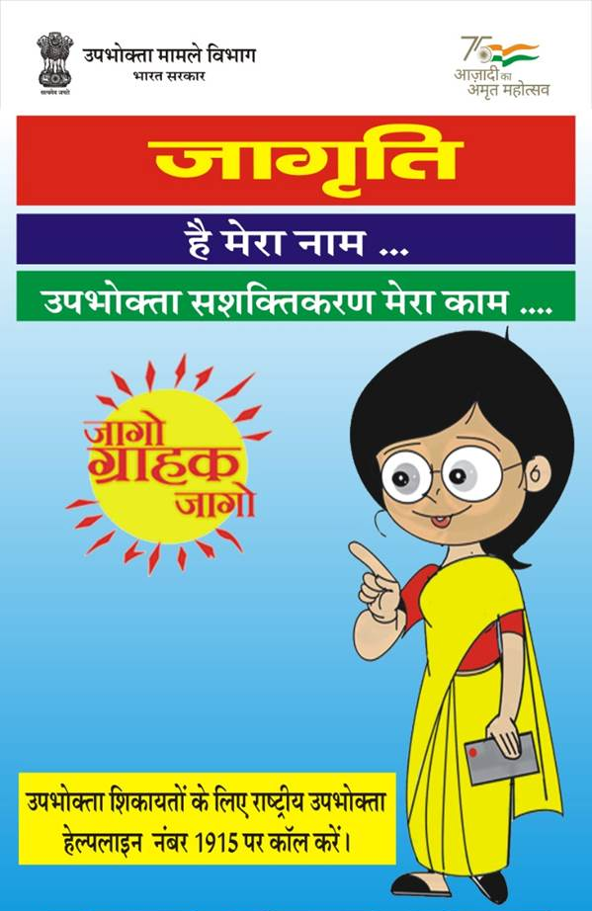](http://drishtiias.com/images/uploads/1658218922_Jagriti_Mascot_Drishti_IAS_English.png)

OBJECTIVES: -

* Jagriti Mascot aims to strengthen consumer awareness campaign presence in digital and multimedia.
* It would be **projected as an empowered consumer** who is spreading awareness about consumer rights & addressing solutions to the problems faced by the consumers.
* It would help to generate consumer awareness about the various government initiatives like:
  1. Provisions of [**Consumer Protection Act 2019**](https://www.bing.com/ck/a?!&&p=abd6a5dae0eba276b490f86b4f0470c5058b35d66f275bccda85d41d4d9d0131JmltdHM9MTY1Nzk3MzE3NCZpZ3VpZD01NGQyNGMxOS02NTczLTRhYWUtOTI5OS1iN2JiZGI1ZTcxMzMmaW5zaWQ9NTIwNw&ptn=3&fclid=b02f7ea4-04ff-11ed-822a-f9baa1db495f&u=a1aHR0cHM6Ly93d3cuZHJpc2h0aWlhcy5jb20vZGFpbHktdXBkYXRlcy9kYWlseS1uZXdzLWFuYWx5c2lzL2NvbnN1bWVyLXByb3RlY3Rpb24tYWN0LTIwMTk&ntb=1)
  2. [**Hallmarking**](https://www.drishtiias.com/daily-updates/daily-news-analysis/new-norms-on-hallmarking-of-gold)
  3. National Consumer Helpline toll free number 1915
  4. Provisions of weights & measures Act
  5. Decisions of the Central Consumer Protection Authority
  6. Testimonials by consumers on grievance redressal

LEGAL INITIATIVES ADAPTED BY THE GOVERNMENT: -

* Jagriti will be projected as an empowered consumer who is spreading awareness about consumer rights & addressing solutions to the problems faced by the consumers.
* Consumer Protection Act 1986
  1. Consumer Protection Act 1986 was enacted in 1986, for the protection of consumers’ interests in India. It came into effect on December 24, 1986. Consumer Protection Act, 2019 has now replaced the 1986 act.
* Jago Grahak Jago is consumer awareness campaign. Department of Food has launched in 2005. Government used different mediums to raise awareness among consumers including- Media advertisements, Printings, Audio campaigns, Video campaigns and Posters.

• Consumer Protection Act 2019

* 1. Consumer Protection Bill, 2019 was introduced in Lok Sabha on July 8, 2019. The act came into force from July 20, 2020. In line with the Consumer Protection Act 2019, the e-commerce entity is mandated to display the country of origin, on every product.
* Central Government has notified the Consumer Protection (Direct Selling) Rules, 2021.

1. Under the notified rules, direct selling entity and direct sellers have been prohibited from:
   1. Promoting a Pyramid Scheme or enroll any person to these
   2. Participating in money circulation scheme
2. State Governments have been mandated to do monitoring to ensure compliance of these rules.
3. Rules provides certain obligation upon Direct Selling Entities, including:
   1. They should have a at least one physical location as registered office within India.
   2. They should make self-declaration that Direct Selling Entity has complied with provisions of these rules and are not a part of Pyramid Scheme or money circulation scheme.
4. All products of a direct selling entity are mandated to comply with the declarations made under Legal Metrology Act, 2009.
5. Direct selling entity will have to establish an adequate grievance redressal mechanism. They will have to display the current and updated name, and other details on their website. Details of the website will have to be prominently printed on product information sheet or pamphlet

**ADVANTAGES: -**

• Jagriti Mascot will help in empowering consumers and generating awareness among them about “consumer rights”.

• The Mascot will be presented as an empowered consumer, mushrooming awareness on consumer rights and addressing solutions for the problems faced by consumers.

• It will raise consumer awareness on several themes of the Department such as, Hallmarking, provisions of Consumer Protection Act 2019, provisions of weights & measures Act, National Consumer Helpline toll free number 1915, decisions of Central Consumer Protection Authority besides the consumers’ testimonials on grievance redressal.

• Jagriti mascot will be displayed along with tagline “Jago Grahak Jago” across all the media campaigns.

• Jagriti Mascot and “Jago Grahak Jago tagline” are new synonymous with young aware consumers. Both of these seek to bring sharp focus towards consumer rights knowledge and movement.

DISADVANTAGES: -

The Consumer Protection Act in India has numerous restrictions and drawbacks, which are listed in this article.

* Only services for which a particular payment has been made are covered under the consumer protection act. However, it does not protect medical professionals, or hospitals, and covers cases when this act does not apply to free medical care.
* This act does not apply to mandatory services, such as water supply, that are provided by state agencies.
* Only two clauses related to the supply of hazardous materials are covered by this act. Consumer redress is not given any power by the consumer protection act.
* The consumer protection act focuses on the supply of ineffective products, but there are no strict regulations for those who produce it.

IMPACT OF THE TOPIC ON THE SOCIETY: -

The Department of Consumer Affairs has launched “Jagriti”, a mascot for empowering consumers and generating awareness towards their rights. Jagriti will be projected as an empowered consumer who is spreading awareness about consumer rights and addressing solutions to the problems faced by the consumers.

The “Jagriti” mascot will be used to generate consumer awareness about various themes of the Department. The Themes include provisions of Consumer Protection Act 2019, Hallmarking, National Consumer Helpline toll-free number 1915, provisions of weights and measures Act, decisions of the Central Consumer Protection Authority and testimonials by consumers on grievance redressal.

Jagriti will be projected as an empowered consumer who is spreading awareness about consumer rights and addressing solutions to the problems faced by the consumers.

OBSERVATION: -

Jagriti will be projected as an **empowered consumer**who is spreading awareness about consumer rights and addressing solutions to the problems faced by the consumers. Jago Grahak Jago is consumer awareness campaign. Department of Food has launched in 2005. Government used different mediums to raise awareness among consumers including- Media advertisements, Printings, Audio campaigns, Video campaigns and consumer.

Will be projected as an empowered consumer who is spreading awareness about consumer rights and addressing solutions to the problems faced by the consumers. The “Jagriti” mascot will be used to generate consumer awareness about various themes of the Department. The Themes include provisions of Consumer Protection Act 2019, Hallmarking, National Consumer Helpline toll-free number 1915, provisions of weights and measures Act, decisions of the Central Consumer Protection Authority and testimonials by consumers on grievance redressal. Jagriti mascot shall be shown along with tagline “Jago Grahak Jago” in all its media campaigns.

CONCLUSION: -

Jagriti is a mascot created by the Department of Consumer Affairs (DoCA) with the goal of empowering customers and raising awareness of their rights. Jagriti will be shown as an educated consumer who is advocating for her rights and finding answers to the issues she encounters. The Jagriti mascot will be employed to raise consumer awareness of a variety of Departmental topics, including the provisions of the 2019 Consumer Protection Act, hallmarking, the National Consumer Helpline toll-free number 1915, provisions of the Weights and Measures Act, decisions of the Central Consumer Protection Authority, and consumer testimonies regarding grievance redressal.