Homework Submission System Installation Guide

# Database setup

* Please create a Database named "HomeworkSubmission" in MS SQL Server
* You can either:
  + Use the SQL file: **SQL_Dump\20Feb12_Schema_only.sql** creating the DB schema
  + Or use the SQL file: **SQL_Dump\20Feb12_Schema_and_Data.sql** for both DB schema and insert data

# Generating Test User Data

If you need to create additional Test User Data please open the solution at location **HomeworkSubmission\HomeworkSubmission.sln** and run the project **HomeworkSubmission.TestData**

This is a console application that by default will create additional test data:

* 400 Academy Students
* 30 Courses
* 15 Topics per Course
* 10 Courses per student

You can modify the number of generated entities. It should take less than 10 seconds for generating this depending on the performance on your machine. Always a user with user "test123" and pass "test123" is created – so you can use this for testing.

# Testing the System

After running the project HomeworkSubmission.MVC the default student login screen is loaded. You can use the randomly generated StudentAcademyID to perfrom a testing.

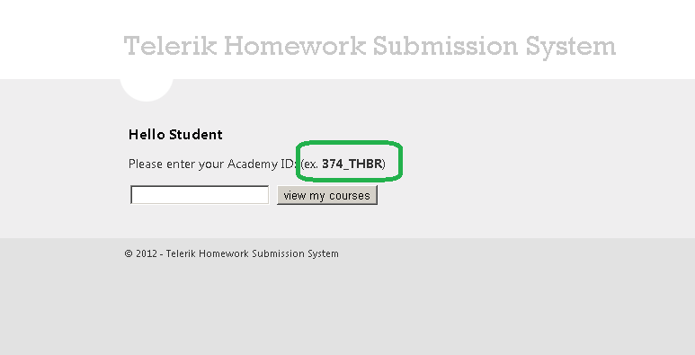

Before testing the system – please make sure that you submit several home works (zip or rar files).

After you submit those you can login as Administrator (user: test123, pass: test123) and then download the individual submissions for a student: Submissions-> Download or download all the Submissions for a certain Course: Courses-> Download All (only active courses that already have submissions will show the download button). A zip file will be generated with all the submissions for this course, and passed to your browser.

You can Edit any Topic / Course / Student in the admin panel and change the state of Topics and Courses to active / disabled. Also you can add a New Student / Course / Topic as administrator if required.

Additionally the download archives (Submissions per Course) are kept at:   
**HomeworkSubmission.MVC\Archive\COURSE_ID\Date.zip**

The upload files (Submissions) are kept also physically at:  
**HomeworkSubmission.MVC\Uploads\ID_COURSE\ID_TOPIC\ID_ACAD**