INSTRUCTIONS FOR SETTING UP THE COGNITIVE GRAPHS ANDROID APPLICATION

Thank you for volunteering to take part in our study on early Alzheimer’s disease diagnostics through outdoor navigation sensing.

In order to get the system started, please perform the steps described below. If you have any questions or experience any problem, please e-mail the following person with a number where they can call you back on.

Dr Sandra Servia-Rodríguez at ss2138@cam.ac.uk

If you do not have access to e-mail, please phone your local study coordinator who will be able to request a call back to you from our engineers.

Set up the smartphone for outdoor sensing

To download, install and open the location tracking application on an android device please complete the following steps:

1) Open a browser and **download** the application from the following link:

<https://pizza.cl.cam.ac.uk/locationApp/app-release.apk>

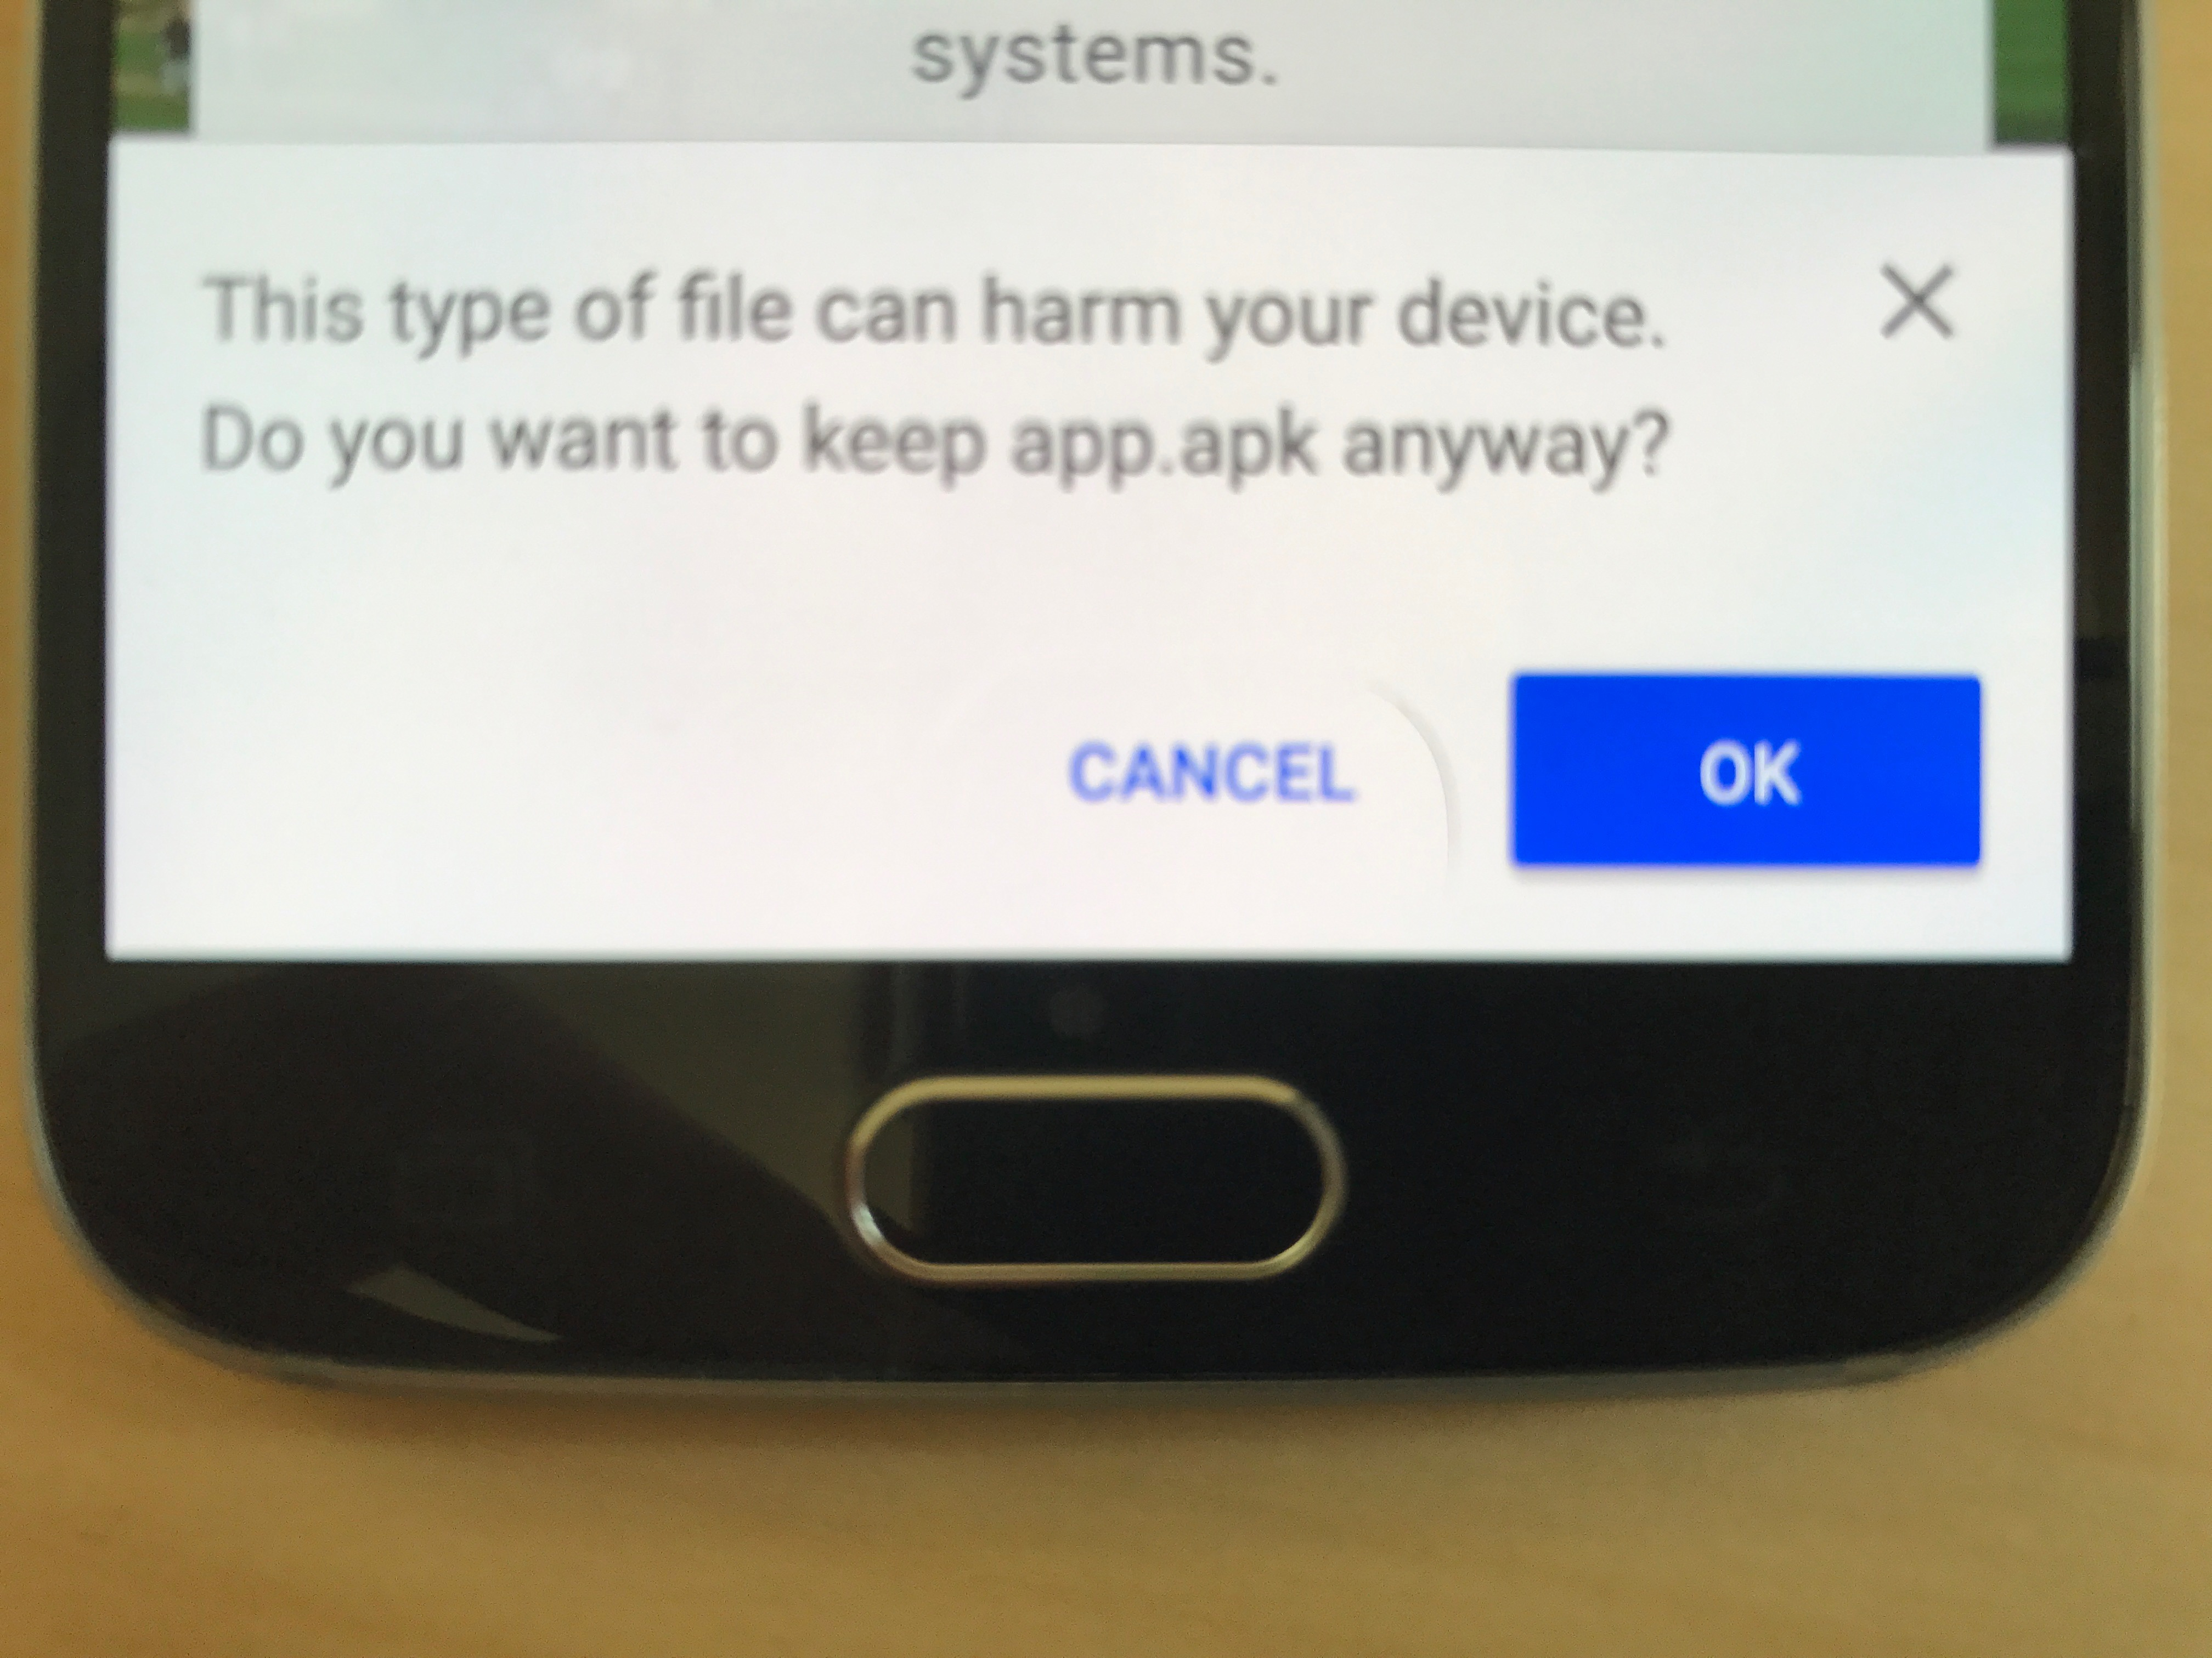If you receive a warning message that this type of file might be harmful, proceed by selecting OK

2.a) Press on the downloaded file. This will start the **installation** process. If you receive the following message, select ‘*SETTINGS’*

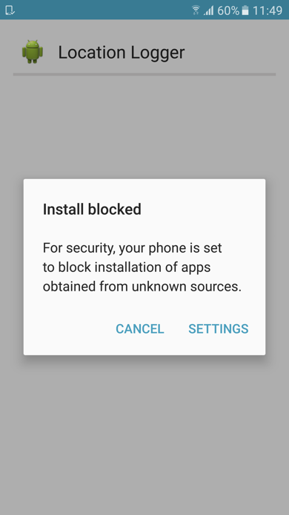

2.b) At the lock screen and security, activate ‘*Unknown sources, allowing installation of apps from sources other than the Play Store.*’ And then, OK

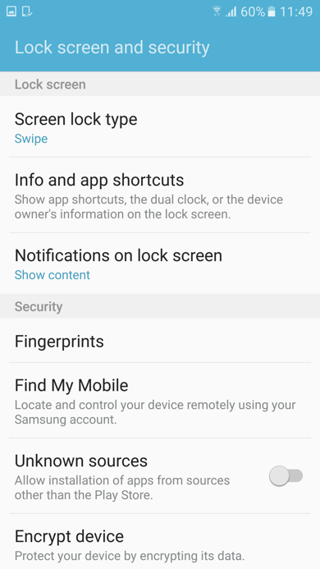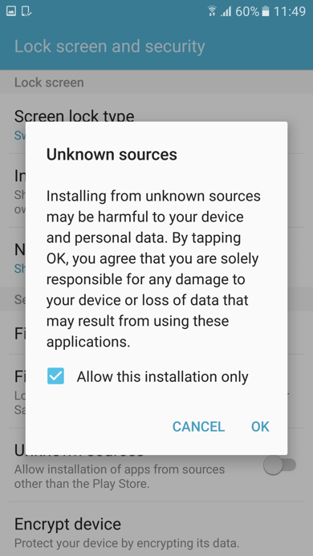

2.c) Next you will see the following window asking you permission to install the application. Select ‘*Install’.* Then, you will be notified that the application has been installed on the device

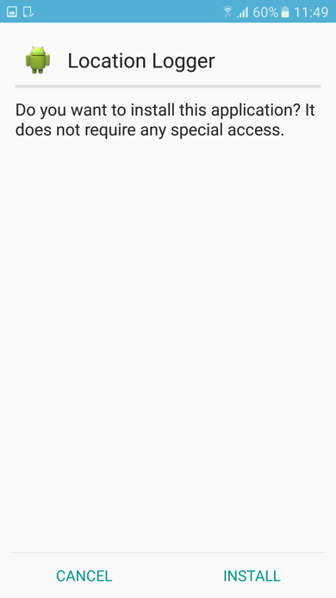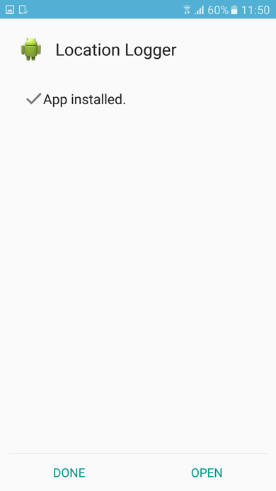

3) Participant **authentication**. You should carefully input the corresponding 6-digit user identifier and press ‘*Login’*. Please, refer to the list of available identifiers we provide you at the end of this document. You should keep a list with pairs identifier-patient.

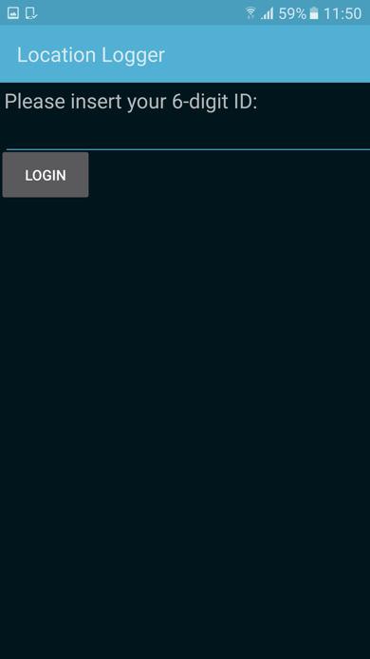 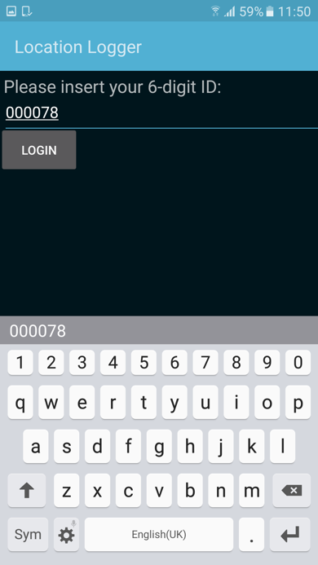

4) Finally, you will see the following window showing the **services** to which the application will have **access**. Select “*Allow*”.

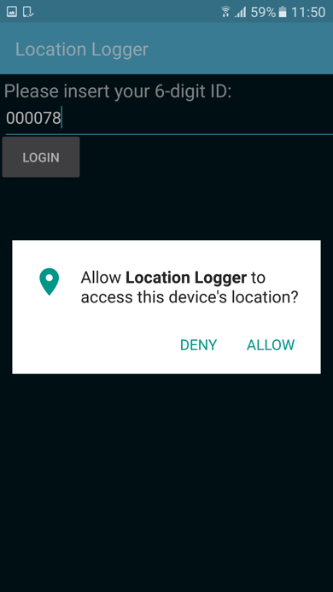

5) User **account** has been **created** and the app will start logging directly. You can also open it by pressing on its icon. Each time you activate it the message “*location logging now active*” will be displayed, as in the following picture.

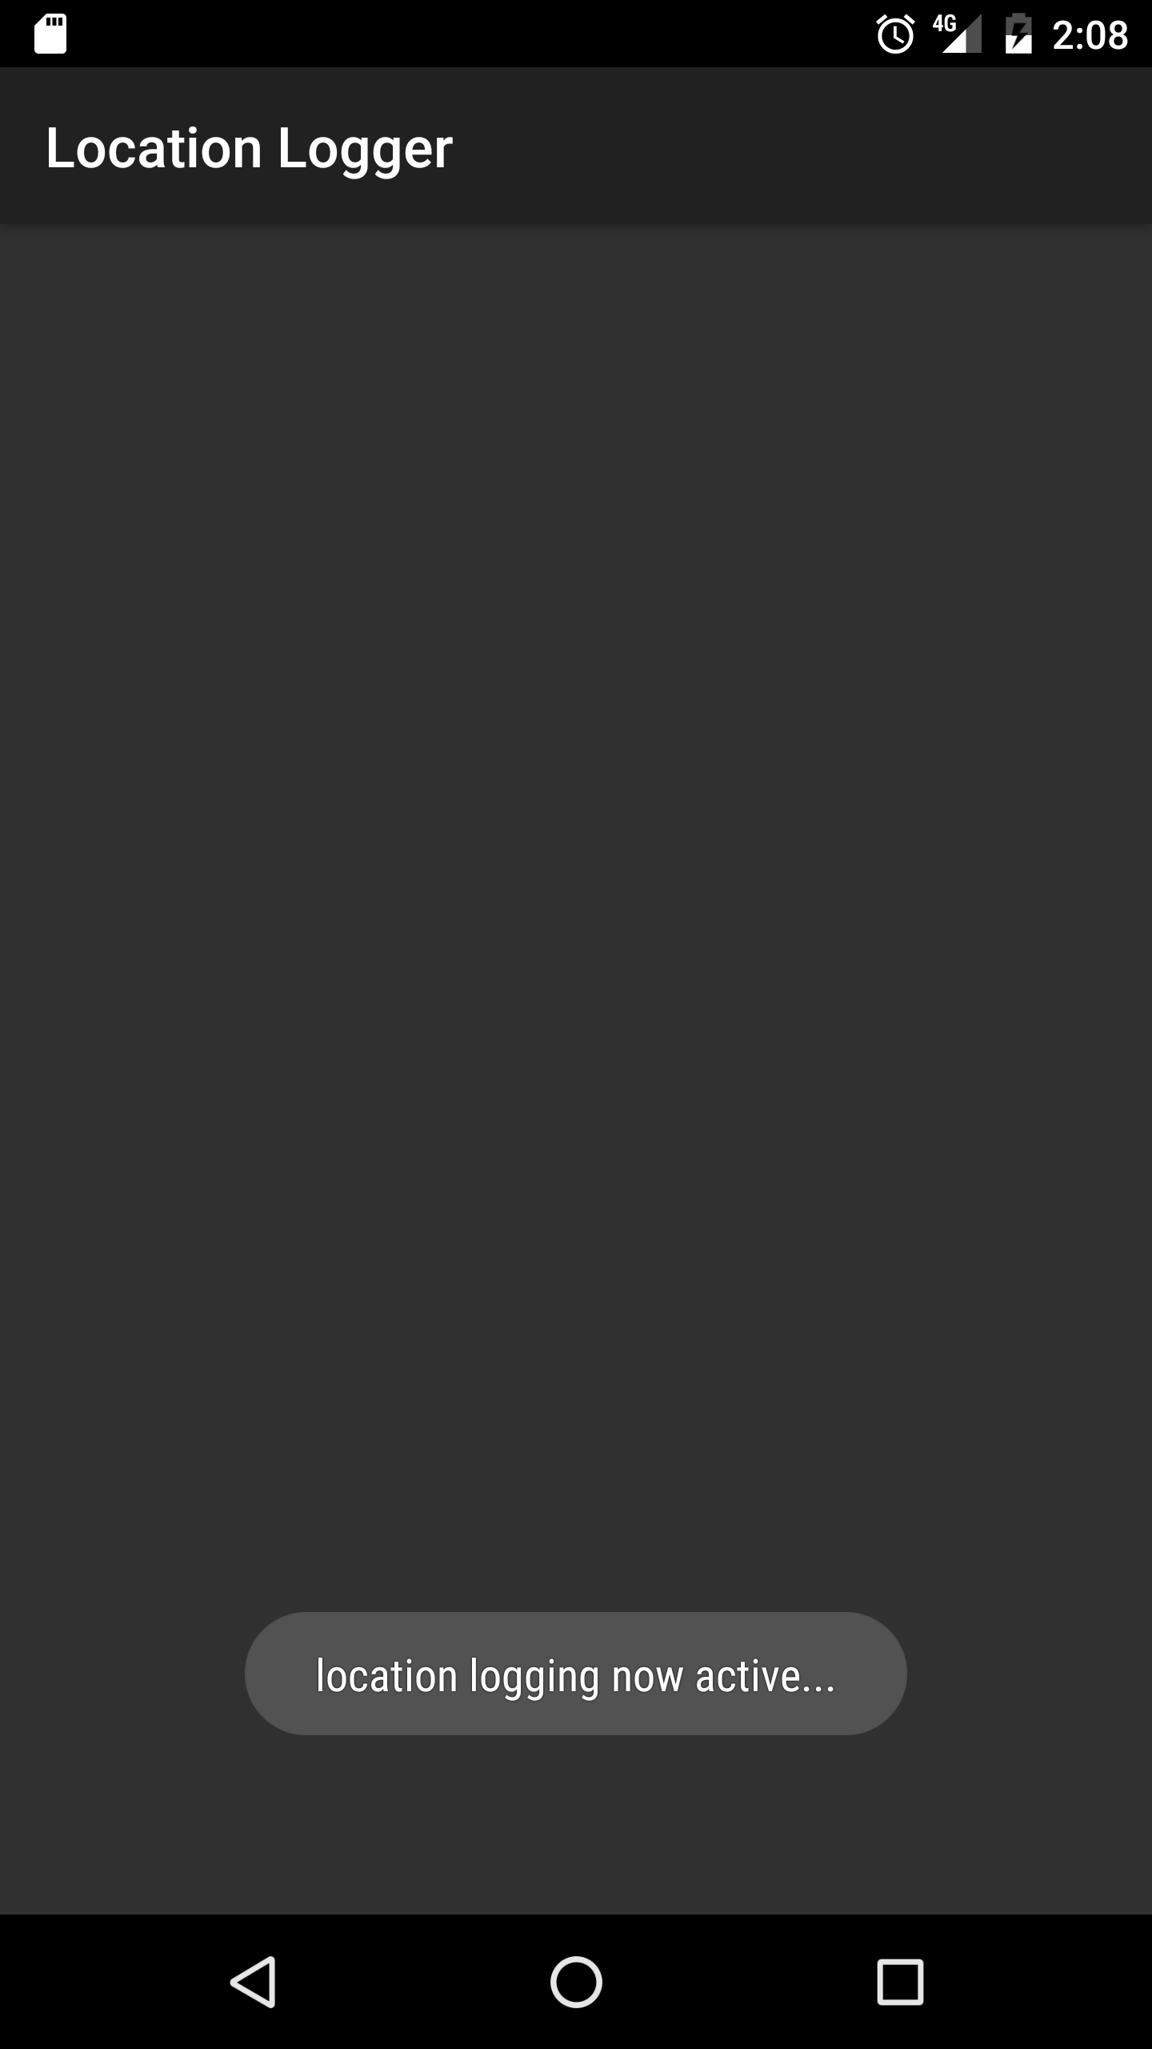

Daily Step: Recharging the smartphone

Please, remember users to recharge their smartphone as usual.

**Battery consumption warning (Samsung devices only)**

Samsung users might see a warning from the “device maintenance” app about our app and its battery consumption. Please, advise them to take no action to sleep, stop or close the app.

Samsung, Android 7: In order to avoid getting this warning, users can turn off the “App power monitor”. They can do so by clicking on “Settings” -> “Device maintenance” -> “Battery”. Then click on the three vertical dots at the top right -> “Advance settings” and deactivate the option “App power monitor”.

Samsung, Android 6: In order to avoid getting battery-related warnings, users can turn off the “Power saving mode” option. They can do so by clicking on “Settings” -> “Battery” -> “Power saving mode”. Then, below “Power saving mode”, they should set the bar to “off”. Also, in the menu under “Battery”, they should have “App power saving” off (“Settings” -> “Battery” -> “App power saving” -> “DETAILS” and have it “Off”.

