For all property pages, set configuration to “All Configurations.”

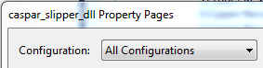

This ensures that the directories are used for debug and release modes.

1. caspar_input (no additional include directories)

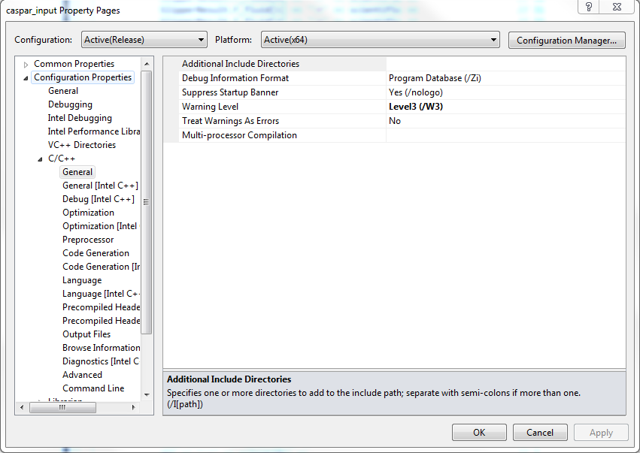

1. caspar_slipper_dll
   1. C:\Jeremy\ThirdPartyLibraries
   2. C:\Jeremy\ThirdPartyLibraries\ANN
   3. C:\Jeremy\ThirdPartyLibraries\blitz-0.9\64bit\Blitz-VS.NET
   4. C:\Jeremy\ThirdPartyLibraries\blitz-0.9\64bit
   5. C:\Jeremy\ThirdPartyLibraries\gsl-1.15
   6. C:\Jeremy\ThirdPartyLibraries\gsl-1.15\gsl

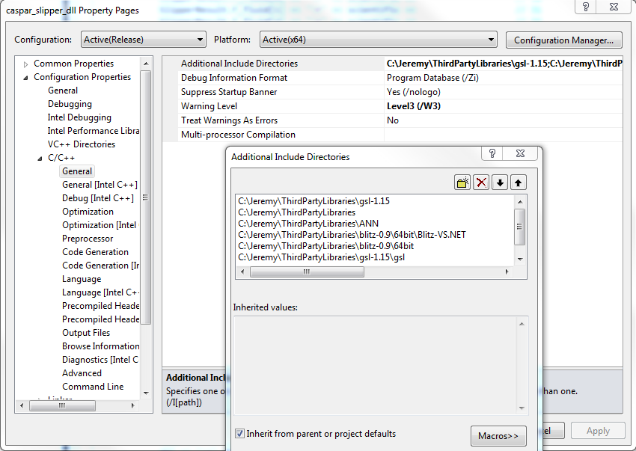

1. C:\Jeremy\ThirdPartyLibraries\ANN\lib64
2. C:\Jeremy\ThirdPartyLibraries\gsl-1.15\x64
3. C:\Jeremy\ThirdPartyLibraries\blitz-0.9\64bit\Blitz-VS.NET\lib
4. C:\Jeremy\ThirdPartyLibraries\FSTI_Authorization\x64

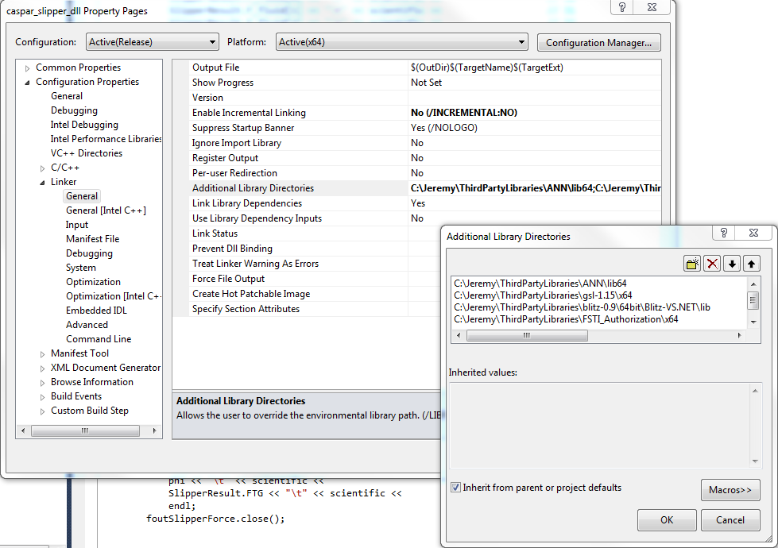

Command line:

/MP /D_SCL_SECURE_NO_DEPRECATE /D _SECURE_SCL=0

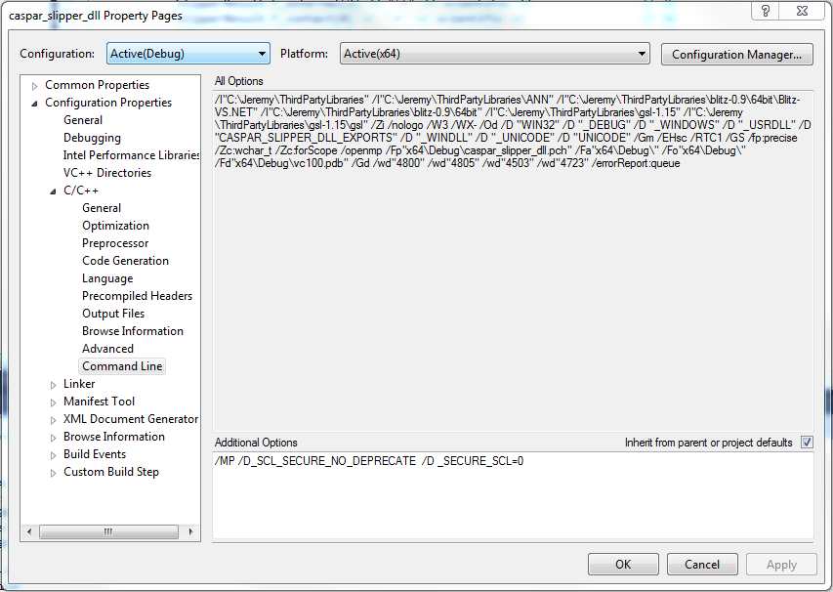

1. caspar_slipper_exe
   1. C:\Jeremy\ThirdPartyLibraries
   2. C:\Jeremy\ThirdPartyLibraries\blitz-0.9\64bit

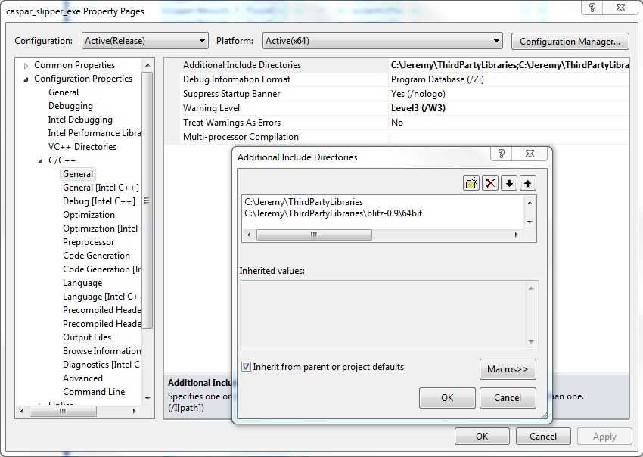

1. C:\Jeremy\ThirdPartyLibraries\blitz-0.9\64bit\Blitz-VS.NET\lib

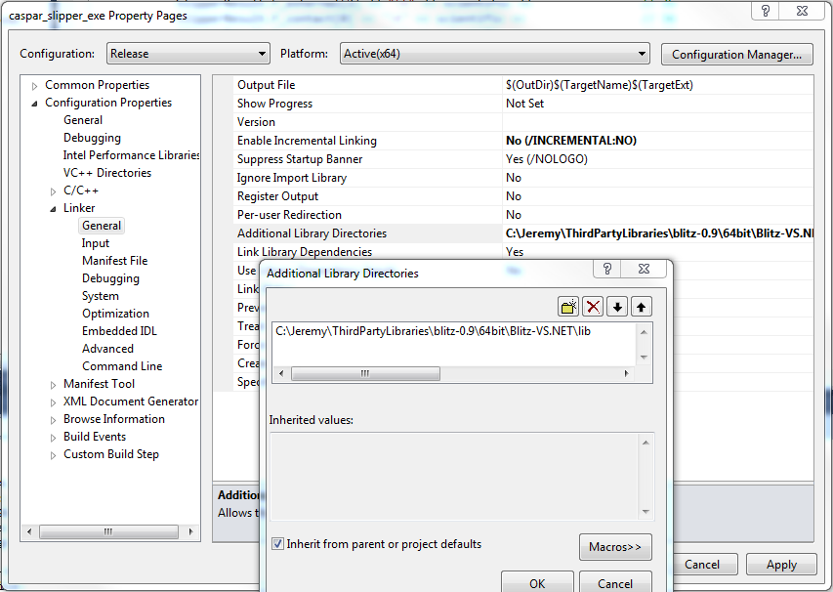

1. caspar_slipper_fem
   1. C:\Jeremy\ThirdPartyLibraries

