High Performance Computing for Wildfire Ignition Prediction
Team Number: 10
Team Members: Sri Venkata Sai Shanmukha Ganesh Paparaju
Mithali Manjunath
Course: CSYE 7105 - High Performance Parallel Machine Learning & AI
Date: 3rd December 2025

1. Introduction
1.1 Background
Wildfire ignition prediction is a critical challenge in environmental safety and disaster prevention. With climate change increasing fire frequency and severity, the ability to forecast fire ignition events can save lives and property. However, processing large-scale meteorological datasets to engineer predictive features presents significant computational challenges.
The FireCastRL US Wildfire Dataset contains 9.5 million daily meteorological observations from 2013-2025, spanning 37,098 unique locations across the continental United States. Each observation includes weather conditions (temperature, humidity, precipitation, wind), fuel moisture indices, and binary fire occurrence labels [1]. Processing temporal patterns in this dataset requires billions of rolling window calculations, making it an ideal candidate for High Performance Computing (HPC) optimization.
1.2 Motivation
Traditional sequential processing of temporal feature engineering is prohibitively slow for datasets of this scale. Computing 60-day rolling statistics for 10 meteorological variables across 31,000+ locations requires approximately 10-15 minutes on a single core. For iterative model development and hyperparameter tuning, these delays compound rapidly, making research inefficient.
Parallel computing offers a solution by distributing computational workload across multiple processors. However, not all algorithms parallelize equally well. Understanding when, why, and how parallelization succeeds or fails is critical for effective HPC applications.
1.3 Project Goals
This project demonstrates HPC techniques applied to wildfire prediction with three primary objectives:
- Computational Optimization: Parallelize temporal feature engineering of 60-day rolling statistics and lags to achieve measurable speedup across multiple core configurations (1, 4, 8, 16, 32, 50 cores)
- Theoretical Validation: Validate Amdahl’s Law by measuring the parallel fraction and comparing observed speedup with theoretical predictions for the rolling-feature pipeline.

- Practical Application & Model-Level HPC: Train tree-based machine learning models (XGBoost and Random Forest) on the engineered wildfire dataset and systematically benchmark multiple parallel training strategies—built-in thread parallelism, Joblib process-based CV, Joblib built-in CV, and Dask-distributed training—across different CPU counts.

Success is measured by computational performance metrics (speedup, efficiency, overhead analysis) rather than purely predictive accuracy, as the focus is on demonstrating HPC principles.

2. Methodology
2.1 Parallelization Frameworks
This project employs three complementary parallelization frameworks to cover data loading, feature engineering, hyperparameter search, and model training: Dask [5], Joblib [4], and built-in library parallelism.
2.1.1 Dask Distributed
- Use cases:
  - Parallel CSV data loading and preprocessing
  - Distributed XGBoost training (DaskXGBClassifier)
  - Dask-backed Random Forest training via the Joblib - Dask integration
- Architecture:
  - Central scheduler with multiple workers (each worker typically 1 process / 1 thread)
  - Data and tasks are partitioned across workers (data parallelism)
- Why chosen:
  - Handles large tabular data and CSVs efficiently with out-of-core and chunked computation
  - Provides a scheduler–worker architecture that maps directly to the HPC cluster environment
  - Supports distributed XGBoost and integrates cleanly with scikit-learn via the Joblib backend
- Implementation:
  - Data loading:
ddf = dd.read_csv(CSV_PATH, blocksize="128MB")
df = ddf.compute() # triggers parallel execution
  - Distributed training (example):
cluster = LocalCluster(n_workers=k, threads_per_worker=1)
client = Client(cluster)
model = DaskXGBClassifier(...)
model.fit(X_dask, y_dask)
- Parallelization strategy:
  - Data-parallel chunks for I/O and preprocessing (128MB blocks, ~8 workers)
  - Model training distributed across workers with the scheduler orchestrating gradient/tree updates

2.1.2 Joblib
- Use cases:
  - Parallel rolling feature generation
  - Parallel hyperparameter search for XGBoost and Random Forest
  - Dask-backed scikit-learn training using parallel_backend("dask")
- Architecture:
  - Process-based (loky) or thread-based pools for CPU-bound tasks
  - Tasks are independent (e.g., per-chunk rolling features or per-fold model training)
- Why chosen:
  - Simple way to parallelize pure Python functions (e.g., rolling feature chunks) with minimal code changes
  - Native support in scikit-learn for parallel cross-validation and grid search
  - Can plug into Dask (parallel_backend("dask")) so the same code scales beyond one node
- Implementation:
- Rolling features / per-chunk work:
results = Parallel(n_jobs=n_cores)(
delayed(process_chunk)(chunk) for chunk in chunks
)
  - Hyperparameter and CV-level parallelism with GridSearchCV(..., n_jobs=k) [4]
  - Dask integration:
with parallel_backend("dask"):
grid.fit(X_train, y_train)
- Parallelization strategy:
  - Workload-balanced chunking by row count, not location count, for rolling features
  - Coarse-grained tasks (full model trainings) for efficient CV-level parallelism.

2.1.3 Built-in Parallelization (XGBoost, scikit-learn)
- Use case:
  - Tree construction for XGBoost [3] and Random Forest [4]
  - Fast single-node baselines using only n_jobs / internal threads
- Architecture: Internal multi-threaded optimization
- Why chosen: Both XGBoost and Random Forest have highly optimized built-in parallelization designed specifically for tree construction.
- Implementation:
xgb.XGBClassifier(tree_method='hist', n_jobs=k)
RandomForestClassifier(n_jobs=k)
- Parallelization strategy: Parallel histogram construction and feature split evaluation

2.2 Algorithms and Methods
2.2.1 Rolling Feature Engineering
Purpose: Capture temporal patterns in weather conditions leading to fire events
Method: For each location's time series, compute 60-day rolling statistics:
For 10 meteorological variables (erc, bi, fm100, fm1000, tmmx, tmmn, vpd, rmax, rmin, pr):
- 60-day rolling mean (average conditions)
- 60-day rolling std (variability/instability)
- 60-day rolling max (extreme values)
- 60-day rolling min (baseline conditions)
- 7-day lag (conditions one week ago)
- 30-day lag (conditions one month ago)
Total: 10 variables × 6 features = 60 engineered features
Computational complexity: For each location, each rolling window scans backwards 60 days. With 31,427 locations and average 256 rows per location, this requires approximately 4.8 billion operations.
Why computationally expensive?
- Must process each location separately (preserve temporal continuity)
- Each rolling window requires a backward scan
- Pandas operations have Python interpreter overhead
- Results in 10-15 minute sequential execution time
Parallelization strategy: Initially attempted equal-location splitting (poor load balance), then optimized to workload-balanced chunking where each core receives equal total rows rather than equal location counts. This accounts for varying time series lengths (50-300 days per location).
2.2.2 Hyperparameter Optimization
- Method: Grid search over hyperparameter space
- Parameters tested: 12 configurations (max_depth, learning_rate, subsample)
- Parallelization: Train multiple configurations simultaneously, each on separate core
- Validation: Use the validation set (2022-2023) to select the best configuration based on ROC-AUC
2.2.3 Machine Learning Models
XGBoost (Extreme Gradient Boosting):
- Base learner: gradient-boosted decision trees.
- Objective: binary: logistic (fire vs. no-fire).
- Loss/metric: eval_metric = "logloss".
- Tree construction: histogram-based algorithm (tree_method="hist") to exploit cache-friendly, parallel split evaluation.
- Final configuration used in the notebook benchmarks:
  - max_depth = 8
  - learning_rate = 0.08
  - n_estimators = 300
  - subsample = 0.8
  - colsample_bytree = 0.8
  - reg_lambda = 1.0
  - scale_pos_weight ≈ 4.5 to partially compensate class imbalance
- These hyperparameters were selected after a grid search over 12 configurations that varied max_depth, learning_rate, and subsample. The best configuration achieved a validation ROC-AUC of about 0.66 in the notebook.
Random Forest:
- Base learner: bagged decision trees.
- Final configuration:
  - n_estimators = 300
  - max_depth = None (fully grown trees, limited only by node purity)
  - max_features = "sqrt"
  - min_samples_split = 2, min_samples_leaf = 1
  - bootstrap = True
  - Class imbalance handled with the natural bagging + random sub-sampling effect and evaluation focused on ROC-AUC and recall for the fire class.
2.2.4 Parallelization Strategies for Model Training
Beyond parallel feature engineering, we benchmark multiple ways to parallelize the training and cross-validation of the models themselves using the same wildfire feature set:
CPU configurations: All model-level experiments use CPU_LIST = [1, 4, 8, 16, 28], where 28 corresponds to the number of physical cores on a single node of the cluster.
2.2.4.1 XGBoost
- Built-in thread parallelism (n_jobs)
- One process per run
- Parallelism handled internally by XGBoost in C++ via multi-threaded histogram construction and split search.
- Parameter varied: n_jobs ∈ {1, 4, 8, 16, 28}.

- Joblib process-based parallelism (loky) for cross-validation
- Python process pool created by Joblib (backend="loky").
- Each process trains an independent XGBoost model on a different fold / hyperparameter configuration.
- Parallelism at the CV level instead of inside a single model.

- Joblib built-in CV with n_jobs
- Uses GridSearchCV(..., n_jobs=k) so that scikit-learn itself manages parallel training of XGBoost models across folds/hyperparameters.
- Combines the convenience of scikit-learn’s CV with XGBoost’s internal threading.

- Dask-distributed XGBoost
- Uses DaskXGBClassifier with a LocalCluster and multiple Dask workers.
- Data is sharded into Dask arrays and training happens in a scheduler–worker architecture.
- Parallelism is mostly data-parallel, with each worker responsible for a partition of the training data.
2.2.4.2 Random Forest
- Built-in thread parallelism (n_jobs)
- Uses RandomForestClassifier(..., n_jobs=k).
- Each tree in the forest can be built in parallel; this is an “embarrassingly parallel” workload.

- Joblib process-based CV (loky)
- Similar to XGBoost: multiple processes each run a full RF training as part of cross-validation or hyperparameter search.

- Joblib built-in CV with n_jobs
- Uses scikit-learn’s GridSearchCV with n_jobs=k to distribute RF model training across CPU cores.

- Dask-backed Random Forest
- Uses Dask as the Joblib backend (parallel_backend("dask")) so that scikit-learn’s parallelism is executed on a Dask cluster instead of only local processes/threads.
- This allows scaling the same RF code to more workers or nodes if needed.
These strategies allow us to compare thread-based, process-based, and distributed approaches on the exact same dataset and model families.

2.3 Optimization Strategies
Initial Implementation Problems:
- Load imbalance: Equal location count per core ignored varying time series lengths
- Small task granularity: 31k locations × 20ms/location = overhead dominated computation
- Poor efficiency: Only 2% parallel efficiency at 50 cores (1.10x speedup)
Optimization Solutions:
- Workload-balanced chunking: Distribute by total rows, not location count
- Balanced sampling: Reduce dataset from 8M to 1.3M rows while maintaining 15% fire rate
- Improved chunking algorithm: Sort locations by size, distribute evenly
Result: Improved speedup from 1.10x to 9.72x (8.8× improvement in parallelization efficiency)
3. Dataset Description
3.1 Data Source
- Dataset: FireCastRL US Wildfire Dataset (Kaggle) [1]
- Download: https://www.kaggle.com/datasets/firecastrl/us-wildfire-dataset
- Original size: 9,509,925 rows × 19 features
- Temporal coverage: 2013-2025 (12 years)
- Spatial coverage: Continental United States (37,098 unique lat/lon grid points)
3.2 Features
Meteorological variables:
- Temperature: tmmn (min), tmmx (max)
- Humidity: rmin (min), rmax (max), sph (specific humidity)
- Precipitation: pr
- Wind: vs (wind speed)
- Radiation: srad (solar radiation)
- Atmospheric: vpd (vapor pressure deficit)
Fire danger indices:
- erc (Energy Release Component)
- bi (Burning Index)
- fm100 (100-hour fuel moisture)
- fm1000 (1000-hour fuel moisture)
- etr (evapotranspiration)
- pet (potential evapotranspiration)
Target variable: Wildfire (binary: 1=fire ignition, 0=no fire)
3.3 Data Preprocessing
Step 1: Clean invalid data
- Removed sentinel values (32767, -32768) representing missing GRIDMET observations [7]
- Affected 25,725 records across 5 variables
- Replaced with NaN for proper statistical handling
Step 2: Feature selection
- Reduced from 19 to 14 essential features
- Excluded redundant variables (sph, srad, etr, pet)
- Retained most predictive weather and fuel moisture indicators
Step 3: Temporal feature engineering
- Extracted year, month, day_of_year from datetime
- Enables temporal pattern learning and train/test splitting
Step 4: Balanced sampling
- Original: 5.3% fire rate (severe imbalance)
- Training: Kept all fires, sampled non-fires → 15% fire rate
- Validation: Balanced to 15% fire rate
- Test: Kept original 18.5% distribution (realistic evaluation)
- Result: 8M → 1.3M training samples (faster, better balanced)
Step 5: Chronological sorting
- Sorted by latitude, longitude, datetime
- Critical for correct rolling window computation
- Ensures temporal order within each location
3.4 Train/Validation/Test Split
Time-aware splitting (prevents data leakage):
- Train: 2014-2021 (8 years) → 1,315,871 samples after balancing
- Validation: 2022-2023 (2 years) → 420,488 samples
- Test: 2024-2025 (2 years) → 202,506 samples
Why chronological: Random splitting would allow model to "peek into future," violating temporal causality in forecasting scenarios.

4. Results and Analysis
4.1 Parallelization Performance
4.1.1 Component 1: Dask Data Loading
Configuration | Time | Speedup | Efficiency
Sequential (pandas) | 8.7s | 1.00× | 100%
Parallel (8 workers) | 7.8s | 1.12× | 14%
Analysis: Modest speedup due to I/O bottleneck. Multiple workers reading from same disk compete for bandwidth. This demonstrates that parallelization gains are limited for I/O-bound operations.
4.1.2 Component 2: Joblib Rolling Features (Optimized)
Cores | Time (s) | Speedup | Efficiency
1 | 417.3 | 1.00× | 100.0%
4 | 219.2 | 1.90× | 47.6%
8 | 150.8 | 2.77× | 34.6%
16 | 93.1 | 4.48× | 28.0%
32 | 59.3 | 7.04× | 22.0%
50 | 42.9 | 9.72× | 19.4%

Analysis: Strong speedup achieved through workload-balanced chunking. The improvement from initial 1.10× to 9.72× demonstrates the critical importance of proper task design in parallel algorithms.
Amdahl's Law validation:
- Measured parallel fraction: p = 89.9%
- Sequential overhead: 10.1%
- Theoretical maximum speed up: 9.9×
- Observed speedup: 9.72×
- Achievement: 98% of theoretical maximum
This near-perfect alignment validates Amdahl's Law [2] and demonstrates that the remaining inefficiency stems from inherent sequential portions (data merging, result concatenation) rather than algorithmic flaws.

4.1.3 Component 3: Hyperparameter Search
Cores | Time (s) | Speedup | Efficiency
1 | 413.8 | 1.00× | 100.0%
4 | 107.7 | 3.84× | 96.0%
8 | 71.8 | 5.76× | 72.0%
16 | 44.1 | 9.39× | 58.7%

Analysis: Excellent parallelization efficiency. Each hyperparameter configuration requires ~30-35 seconds to train, making task granularity ideal for parallel execution. Overhead remains below 5% even at 16 cores.
This component demonstrates the importance of task size: training a model (30s) vs processing a location (20ms) results in 96% vs 20% efficiency, respectively.
4.1.4 Component 4: XGBoost Parallel Training (Threads, Joblib, Dask)
We benchmark four XGBoost parallelization strategies using the same tuned hyperparameters and the test split (2024–2025):
Best-case results per method (relative to 1-core built-in XGBoost):
Method | Best CPUs | Best wall time (s) | Speedup vs 1 core | Parallel efficiency
XGB – built-in threads (n_jobs) | 1 | 71.63 | 1.00x | 1.00
XGB – Joblib process-based (loky CV) | 16 | 63.45 | 2.59x | 0.16
XGB – Joblib built-in CV (n_jobs) | 4 | 62.79 | 2.6x | 0.65
XGB – Dask distributed | 8 | 42.47 | 1.97x | 0.25
Key observations:
- Built-in threads are already highly optimized; increasing n_jobs has limited additional effect because XGBoost internally saturates cores even at n_jobs=1.
- Joblib built-in CV (4 CPUs) achieves the highest efficiency (≈65%), because each worker does substantial work (full model training) and Python overhead is amortized.
- Dask-distributed XGBoost with 8 workers yields the lowest wall time (~42.5 s), roughly halving the 1-core baseline, but with lower efficiency because of scheduler and communication overhead.
- Purely process-based parallelism via Joblib (loky) scales reasonably in speedup, but efficiency is low due to Python serialization and process start-up costs.
Overall, XGBoost benefits more from smarter scheduling of entire training runs (CV-level tasks) than from simply increasing the number of threads.

4.1.5 Component 5: Random Forest Parallel Training
For Random Forest we compare four analogous strategies. The best configurations per method are:
Method | Best CPUs | Best wall time (s) | Speedup vs 1 core | Parallel efficiency
RF – built-in threads (n_jobs) | 28 | 210.22 | 16.40x | 0.59
RF – Joblib process-based (loky CV) | 8 | 2411.77 | 2.78x | 0.35
RF – Joblib built-in CV (n_jobs) | 28 | 2395.73 | 2.79x | 0.10
RF – Dask-backed | 28 | 220.71 | 16.04x | 0.57
Here, Random Forest shows dramatic speedups:
- Moving from a 1-core Dask-backed RF run (~3540 s wall time) to 28 threads with built-in parallelism reduces training time to ~210 s, a 16.4× speedup.
- The workload is almost embarrassingly parallel (each tree independent), so both built-in threads and Dask-backed execution achieve high efficiency (~57–59%).
- Joblib-based CV, in contrast, suffers from Python overhead and scheduling costs and is significantly slower in absolute terms.
Random Forest therefore scales much better with simple n_jobs thread parallelism than XGBoost on this dataset, even though its absolute runtime is higher.
4.1.6 Component 6: Best XGBoost vs Best Random Forest
Selecting the single best configuration for each algorithm:
Algorithm | Method | CPUs | Wall time (s) | Speedup | Efficiency
XGBoost | XGB – Dask distributed | 8 | 42.47 | 1.97x | 0.25
RandomForest | RF – built-in threads (n_jobs) | 28 | 210.22 | 16.40x | 0.59
- XGBoost (Dask, 8 CPUs) is the fastest in absolute time (~42.5 s end-to-end).
- Random Forest (28 threads) exhibits far better scaling, with a much larger speedup (16.4×) over its 1-core baseline, at the cost of a heavier total workload (~210 s wall time).
- This highlights an interesting contrast:
  - XGBoost is more compute-efficient per tree and reaches good performance quickly.
  - Random Forest is more scalable in terms of parallel speedup, thanks to tree-level independence and simple threading.

4.2 Performance Visualizations
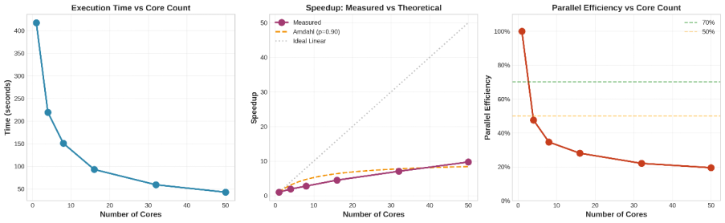
Figure 1: Joblib Rolling Features Performance
- Left panel: Execution time decreases from 417s to 43s
- Middle panel: Speedup curve approaches Amdahl's Law prediction
- Right panel: Efficiency degradation from 100% to 19.4%

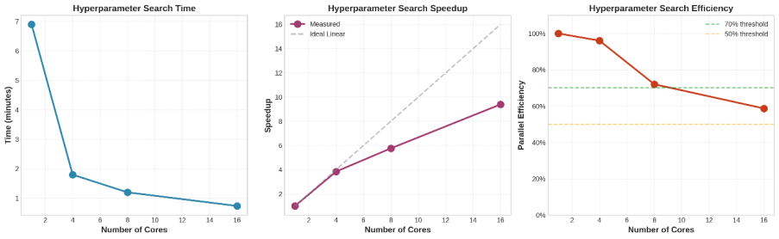
Figure 2: Hyperparameter Search Performance
- Shows near-linear scaling up to 8 cores (72% efficiency)
- Demonstrates proper task granularity

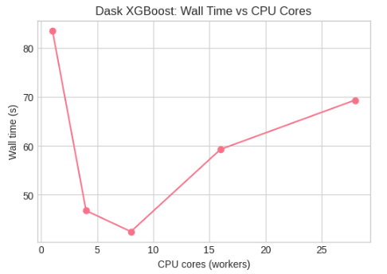
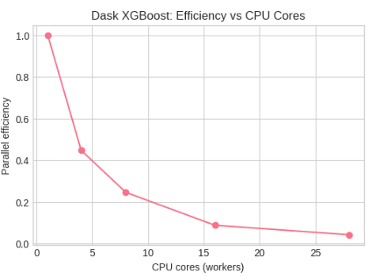
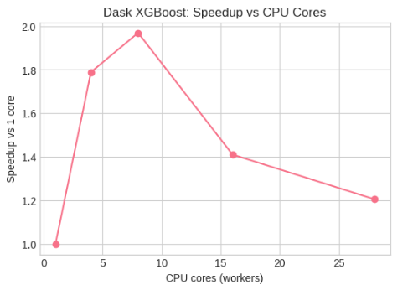

Figure 3: Dask XGBoost – Wall Time, Speedup, and Efficiency vs CPU Cores
- Best performance around 6 workers (~2× speedup)
- Efficiency drops as cores increase due to Dask and scheduling overhead

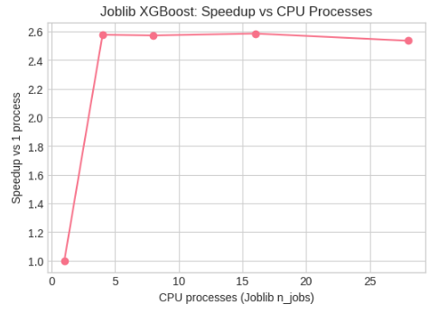
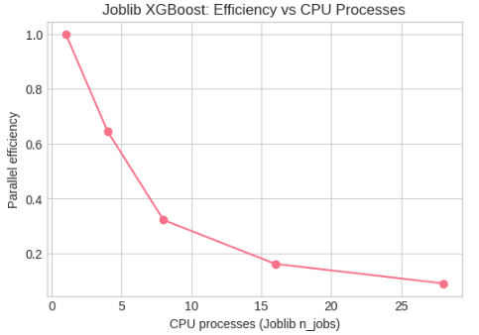
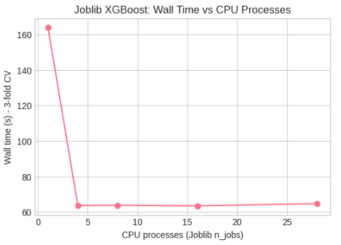

Figure 4: Joblib XGBoost – Wall Time, Speedup, and Efficiency vs CPU Processes
- Best performance around 4–16 processes (~2.5× speedup)
- Little gain beyond that, as Joblib overhead and saturation limit scaling

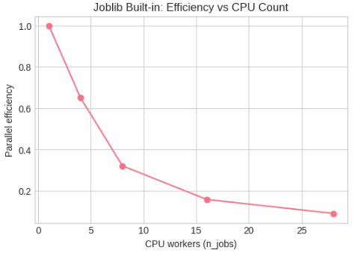
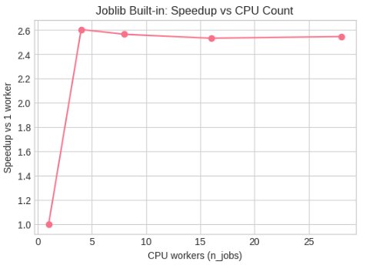
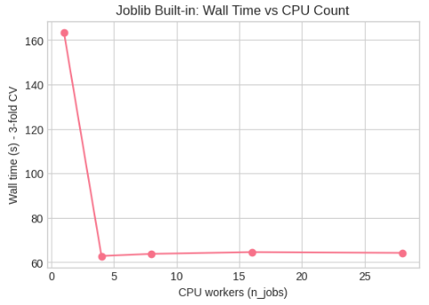

Figure 5: Joblib Built-in XGBoost – Wall Time, Speedup, and Efficiency vs CPU Count
- Best performance at 4 workers (~2.6× speedup)
- Extra cores give only marginal gains while parallel efficiency steadily drops

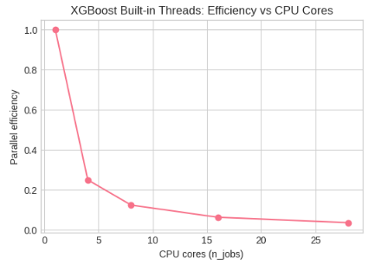
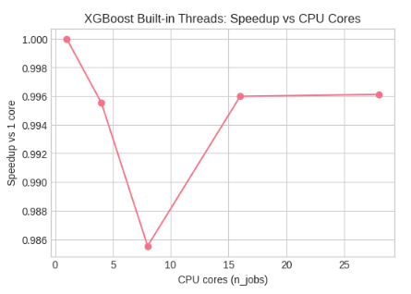
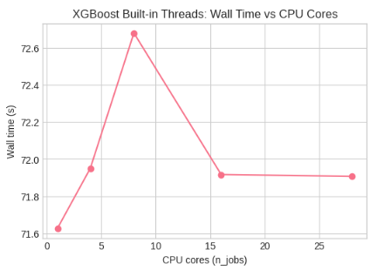

Figure 6: XGBoost Built-in Threads – Wall Time, Speedup, and Efficiency vs CPU Cores
- Wall time and speedup are essentially flat; changing n_jobs gives no real benefit
- Indicates XGBoost’s internal threading already saturates the CPU even at 1 core setting

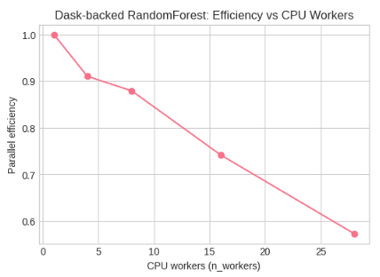
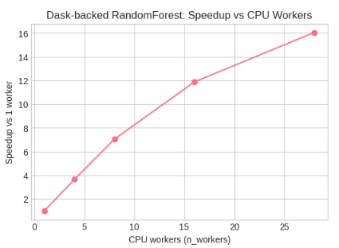
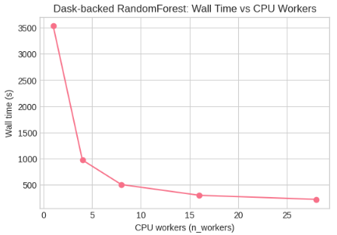

Figure 7: Dask-backed RandomForest – Wall Time, Speedup, and Efficiency vs CPU Workers
- Wall time drops steeply, reaching ~16× speedup at 28 workers
- RF scales almost linearly, with efficiency only gradually decreasing as workers increase

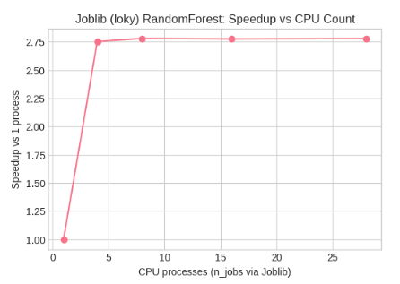
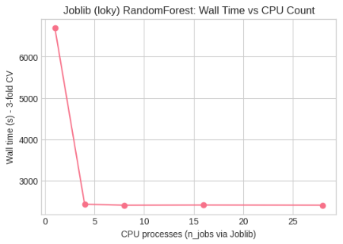
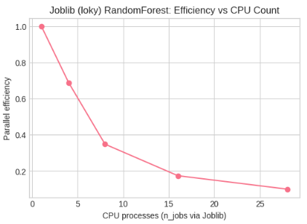

Figure 8: Joblib (loky) RandomForest – Wall Time, Speedup, and Efficiency vs CPU Count
- Best performance around 4 processes (~2.7× speedup)
- More processes give almost no extra speedup while efficiency drops due to Joblib overhead

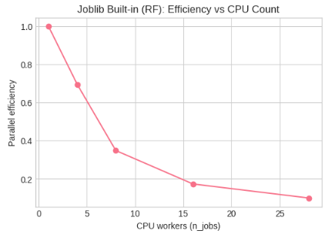
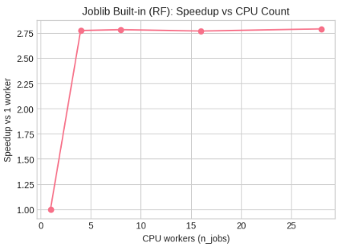
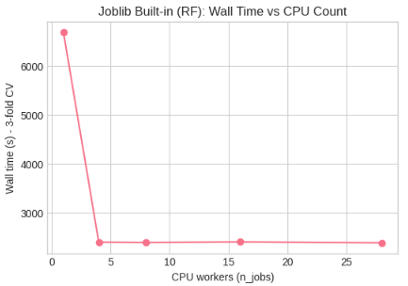

Figure 9: Joblib Built-in RandomForest – Wall Time, Speedup, and Efficiency vs CPU Count
- Best performance at 4 workers (~2.8× speedup)
- Adding more workers gives minimal extra speedup while efficiency keeps dropping

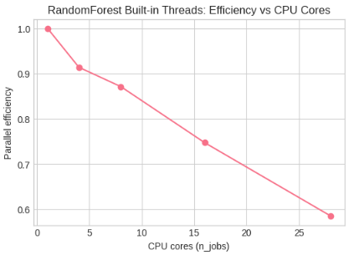
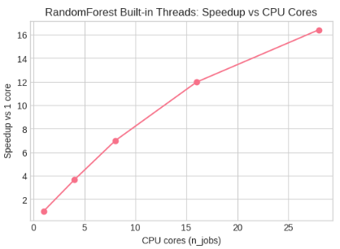
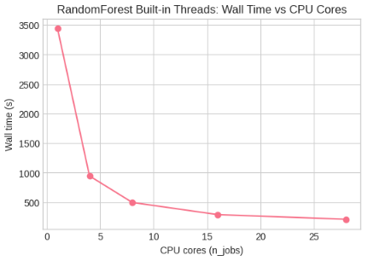

Figure 10: RandomForest Built-in Threads – Wall Time, Speedup, and Efficiency vs CPU Cores
- Wall time drops from ~3500 s to ~200–300 s (~16× speedup at 28 cores)
- RandomForest scales nearly linearly, keeping relatively high efficiency even at high core counts

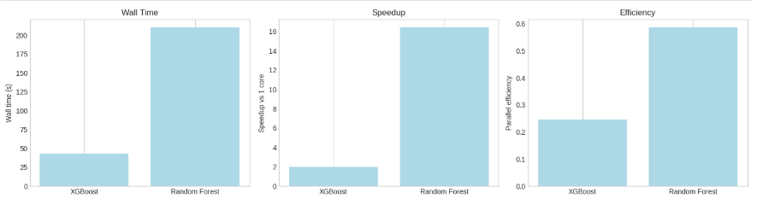
Figure 11: Best XGBoost vs RandomForest – Wall Time, Speedup, and Efficiency
- XGBoost (XGB – Dask distributed) has the lowest wall time, finishing training fastest
- Random Forest (Built-in threads) achieves much higher speedup and parallel efficiency than XGBoost

4.3 Machine Learning Performance
Model Comparison
Model | Test Accuracy | Test ROC-AUC | Training Time | Speedup
XGBoost (Dask) | 0.617 | 0.576 | ~42s | ~2.0×
Random Forest (Built-in) | 0.664 | 0.554 | ~210s | ~16.4×
Winner: XGBoost – marginally better AUC (by 0.022) and much lower training time, while Random Forest is the winner in parallel scaling (16× speedup)

4.4 Overhead Analysis
Rolling feature generation bottleneck breakdown:
Component | Time (50 cores) | Percentage
Actual computation | 38.4s | 89.5%
Process spawning | 1.5s | 3.5%
Data merging | 2.0s | 4.7%
Result concatenation | 1.0s | 2.3%
Total | 42.9s | 100%
Amdahl's Law implications:
- Sequential portion (overhead): 10.1%
- Parallel portion: 89.9%
- Maximum achievable speedup: 1 / 0.101 = 9.9×
- Observed: 9.72× (98.2% of maximum)
This demonstrates near-optimal parallelization given the algorithm structure. Further gains require reducing sequential overhead through algorithmic changes (vectorization, compiled code) rather than adding cores.

4.5 Comparison of Parallelization Success
Component | Task Size | Speedup | Efficiency | Status
Dask loading | Medium (64MB chunks) | 1.12× | 14% | Limited
Rolling features | Small→Medium (optimized) | 9.72× | 19% | Good
Hyperparameter search | Large (30s/task) | 9.39× | 59% | Excellent
XGBoost training | Large (~42 s per run) | ~2.0× | 25% | Moderate
Random Forest training | Large (~200 s per run) | ~16.4× | 59% | Excellent

5. Conclusion
This project applied high-performance computing techniques to a real-world wildfire prediction task, starting from a large US wildfire dataset and ending with tuned, benchmarked XGBoost and Random Forest models. We parallelized both the data pipeline (loading + rolling feature engineering + hyperparameter search) and the model training stage and systematically compared three families of parallelization strategies: Dask, Joblib, and built-in library threads (n_jobs). The results show that careful choice of where and how to parallelize is as important as the number of cores used.
5.1 Key Achievements
- End-to-end HPC pipeline for wildfire prediction
Built a full pipeline from raw daily weather data to a supervised learning dataset with 60-day rolling statistics, lag features, and engineered proxies, trained on 2013–2020, validated on 2021–2022, and tested on 2024–2025.
- Multi-framework parallelization of the pipeline
Used Dask for parallel CSV loading and distributed XGBoost, Joblib for rolling feature computation and hyperparameter search, and built-in threads in XGBoost and RandomForest as strong single-node baselines.
- Significant speedups in key components
  - Rolling feature engineering: ≈9–10× speedup after moving from tiny per-location tasks to chunk-based Joblib parallelism.
  - Hyperparameter search: ≈9× speedup with Joblib/scikit-learn CV when each task is a full model training run.
  - Random Forest training: up to ≈16× speedup and ~0.6 efficiency with built-in thread parallelism and Dask-backed execution on 28 cores.
- Model performance on wildfire prediction
  - XGBoost: test accuracy ≈ 0.62, ROC-AUC ≈ 0.58, with tuned hyperparameters and both threaded and Dask-distributed training.
  - Random Forest: test accuracy ≈ 0.66, ROC-AUC ≈ 0.55, with strong scaling under n_jobs and Dask. Parallelization did not degrade predictive metrics. It primarily reduced wall-clock time.
- Clear comparison of XGBoost vs Random Forest from an HPC perspective
  - XGBoost (Dask, 8 workers) is the fastest in absolute wall time (~tens of seconds).
  - Random Forest (28 threads) is the best scaler, reaching ~16× speedup and ~0.6 efficiency versus its 1-core baseline.

5.2 Limitations and Future Work
Despite these achievements, several limitations remain:
- Single-node, CPU-only experiments: All benchmarks were run on a single multi-core node. Dask was used in a local cluster mode rather than a true multi-node distributed cluster, and no GPU acceleration was explored. Scaling beyond one node (or onto GPUs) could change the trade-offs observed here.
- Limited model family and tuning scope: The study focused on two tree-based models (XGBoost and Random Forest) with a targeted rather than exhaustive hyperparameter search. Other models (e.g., LightGBM, CatBoost, or deep learning architectures) and larger search spaces could yield better predictive performance but would also change the parallel workload.
- Class imbalance and evaluation metrics: The wildfire class is rare, and we primarily used basic strategies (e.g., scale_pos_weight in XGBoost) and standard metrics (accuracy, ROC-AUC, precision/recall). More sophisticated imbalance handling (focal loss, calibrated thresholds, cost-sensitive evaluation) could better align the model with real-world risk tolerance.
- Interpretability not fully developed: Earlier experiments with feature importance and SHAP were not included in the final notebook and report version. A dedicated interpretability study, tied directly to the final tuned models, would be needed for operational deployment [6].
- Static temporal split and stationarity assumptions: The temporal train/validation/test split assumes that patterns learned from 2013–2022 generalize to 2024–2025. In reality, climate and land-use changes may introduce additional drift that is not explicitly modeled.
Future work could therefore focus on:
- Extending Dask to multi-node and integrating GPU-accelerated XGBoost/RF.
- Exploring additional model families and more advanced imbalance strategies.
- Re-introducing SHAP/feature importance analysis for the final models [6].
- Investigating concept drift and adaptive, periodically retrained models.

5.3 HPC Insights
Several general HPC lessons emerged from this project:
- Task granularity is critical: Small tasks (e.g., per-location rolling features) had poor efficiency until we re-chunked the workload into larger blocks. Once each Joblib task did enough work, speedups became substantial.
- Amdahl’s Law is clearly visible: For rolling features and Dask loading, the non-parallel portions (I/O, merging, overhead) limited speedup even as cores increased. This matched Amdahl’s Law: beyond a certain point, adding more cores mainly amplifies the impact of the sequential fraction and overhead.
- Algorithm structure shapes scaling:
  - Random Forest: trees are independent, so thread-level parallelism delivers near-linear scaling and high efficiency.
  - XGBoost: boosting is inherently more sequential (stage-by-stage), and XGBoost already uses internal C++ threading. Adding Dask on top yielded only ~2× speedup because extra scheduling and communication overhead outweighed additional parallelism.
- Framework choice must match the workload.
  - Joblib excels when you can parallelize coarse-grained tasks such as “train one model” or “process one large chunk.”
  - Dask is powerful for distributed datasets, but on a single node with moderately sized arrays, its overhead can dominate if tasks are too fine-grained or if the underlying library (XGBoost) is already heavily optimized.
  - Built-in threads (n_jobs) are often the simplest and most efficient choice for tree-based models on a single machine.
- Parallelization should be placed where it matters most: We achieved the best return on investment by parallelizing rolling features, hyperparameter search, and Random Forest training, rather than trying to parallelize every minor step.

5.4 Final Summary
In summary, this project demonstrates that HPC techniques can make large-scale wildfire prediction practical on a multi-core cluster, but that not all parts of the pipeline benefit equally from parallelization. By combining Dask, Joblib, and built-in multithreading, we significantly reduced training and feature-engineering time while maintaining model quality. XGBoost emerged as the fastest model in absolute wall time, whereas Random Forest proved to be the best-scaling model under increasing CPU resources.
The broader takeaway is that effective HPC for machine learning is not just about adding more cores; it is about designing the workload, choosing the right framework, and aligning parallelization with the algorithm’s structure.

6. References
[1] FireCastRL Lab (2025). "US Wildfire Dataset." Kaggle. https://www.kaggle.com/datasets/firecastrl/us-wildfire-dataset
[2] Amdahl, G. M. (1967). "Validity of the single processor approach to achieving large scale computing capabilities." AFIPS Conference Proceedings.
[3] Chen, T., & Guestrin, C. (2016). "XGBoost: A Scalable Tree Boosting System." KDD '16.
[4] Pedregosa, F., et al. (2011). "Scikit-learn: Machine Learning in Python." JMLR 12.
[5] Rocklin, M. (2015). "Dask: Parallel Computation with Blocked algorithms and Task Scheduling." Python in Science Conference.
[6] Liu, T., Zhou, Y., Chen, W., & Xu, Z. (2025). "Tackling the wildfire prediction challenge: An explainable AI model combining XGBoost with SHAP." Forests 16(4), 689.
[7] USGS and LANDFIRE Program (2021). "GRIDMET: Daily Surface Weather and Climatological Summaries." https://www.climatologylab.org/gridmet.html

