Campus Facility Maintenance Request
Management System
DBMS Course Project Report
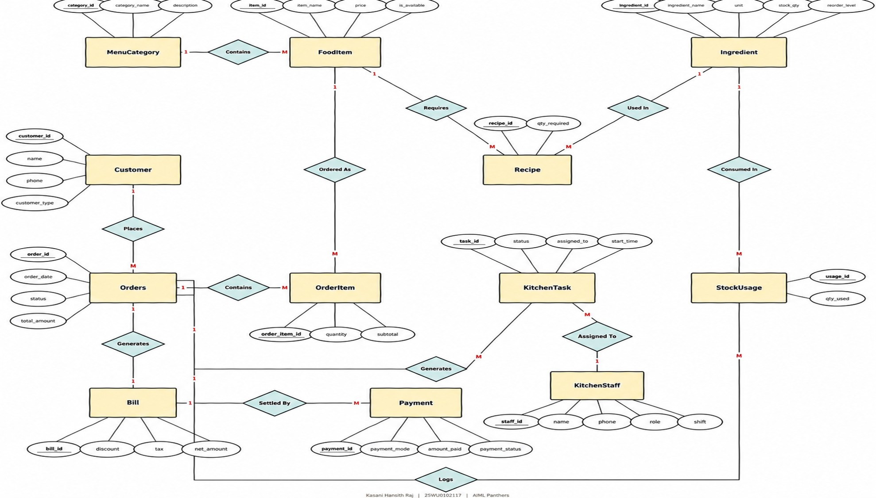
Student Name: Mithi Jaiswal
Roll Number: 25WU0102158
Course: Database Management Systems (DBMS)
Academic Year: 2025–2029
Project Type: DBMS Course Project
University: Woxsen University
Branch: CSE - AIML

2. Abstract
The Campus Facility Maintenance Request Management System is a database-driven web application developed to manage campus buildings, rooms, equipment assets, service requests, technician assignments, labor work logs, spare parts inventory, repair expenditures, user feedback, and lifecycle status audits in a structured relational system. The application uses MySQL as the database layer, Next.js 16 with Node.js runtime and TypeScript for backend API services, React 19 with Tailwind CSS for modern responsive user interface delivery, and Prisma ORM for database connectivity and schema migrations. The system supports online complaint lodging, priority-based SLA tracking, technician dispatching, real-time spare material stock depletion, itemized expense vouchers, star-rated user satisfaction reviews, and executive management reports. Multi-table operations execute within atomic database transactions (prisma.$transaction) ensuring complete relational consistency, while primary keys, foreign keys, check constraints, and cascading rules protect data integrity.

3. Introduction and Problem Statement

3.1 Introduction
University campuses encompass extensive physical infrastructure consisting of academic complexes, laboratory blocks, residential hostels, libraries, and sports facilities. Daily operational wear and tear creates continuous maintenance data: students and faculty submit repair tickets, tickets map to specific physical rooms and buildings, facilities contain high-value equipment assets, facility managers assign specialized technicians, technicians log labor hours, repairs consume spare parts from inventory, financial costs accumulate across labor and materials, and users submit feedback on resolution quality. Managing these inter-dependent workflows using paper logs or disconnected spreadsheets results in duplicate entries, untracked inventory depletion, unresolved overdue tickets, and lack of accountability. This project models the complete campus facility maintenance workflow using a normalized relational database and an interactive web application.

3.2 Problem Statement
The university requires a centralized, transparent system to record maintenance complaints, route them to qualified technicians, monitor SLA response times, manage spare parts inventory, record itemized financial costs, and generate administrative reports. The system must preserve strict relational integrity between records and prevent invalid operations such as assigning busy technicians, consuming unavailable spare parts, executing invalid status transitions, recording negative labor hours, or leaving orphan records when tickets or facility assets are removed.

4. Objectives and Scope

4.1 Objectives
- Maintain buildings, rooms, fixed assets, users, technicians, categories, priority SLAs, maintenance requests, assignments, work logs, materials, costs, feedback, and status history in MySQL.
- Provide full CRUD operations for Requests, Infrastructure (Buildings & Rooms), Asset Registry, Technicians, and Materials through a responsive web interface.
- Provide an intuitive online ticket lodging interface with category, room, and priority selection backed by client-side and server-side validation.
- Execute multi-table ticket assignments, material allocations, cost logging, and cascading deletions as all-or-nothing database transactions.
- Manage maintenance execution using controlled status transitions (Pending -> Assigned -> In Progress -> Completed/Closed) with automated audit logging in STATUS_HISTORY.
- Monitor spare parts inventory in real-time, automatically deducting quantities used and flagging low-stock items.
- Generate itemized cost records (Materials, Labor, Hardware, Electrical) for completed maintenance jobs.
- Provide six comprehensive PBL analytical reports utilizing relational joins, nested subqueries, grouping aggregations, and database views.

4.2 Scope
- Campus-wide infrastructure mapping (Buildings, Floors, Rooms, Fixed Assets).
- Role-based interaction for Students, Faculty, Staff, Technicians, and Facility Managers.
- Maintenance request lifecycle management from complaint logging to technician verification.
- Spare parts inventory tracking, restocking, and automated expenditure calculation.
- Executive analytics for ticket ageing, SLA compliance, technician workload, building costs, material consumption, and user ratings.
- Production-grade local web application deployment using Next.js 16, TypeScript, React 19, Prisma ORM, and MySQL.

5. Software and Hardware Requirements
Category | Requirement
Operating System | Windows 10/11 / macOS 14+ / Ubuntu Linux 22.04 LTS
Backend Runtime | Next.js 16 App Router (Node.js 20+ runtime)
Database | MySQL 8.0 / 9.x Community Server
DB Connectivity & ORM | Prisma ORM 6.4 (@prisma/client, Prisma CLI)
Frontend UI | React 19, TypeScript 5, Tailwind CSS
Styling Architecture | Custom Warm Pastel Design System (Vanilla CSS + Tailwind)
Package Manager / Runtime | Bun 1.4 / npm 10
Testing & Verification | Vitest, TypeScript strict compiler, MySQL test suite
Browser | Modern Chromium (Chrome, Edge) / Firefox / Safari
Recommended Hardware | Dual-core 64-bit processor, 8 GB RAM, 10 GB free disk storage

6. ER Diagram
The Entity-Relationship (ER) diagram represents the 15 relational entities used by the campus facility management system and their structural associations:
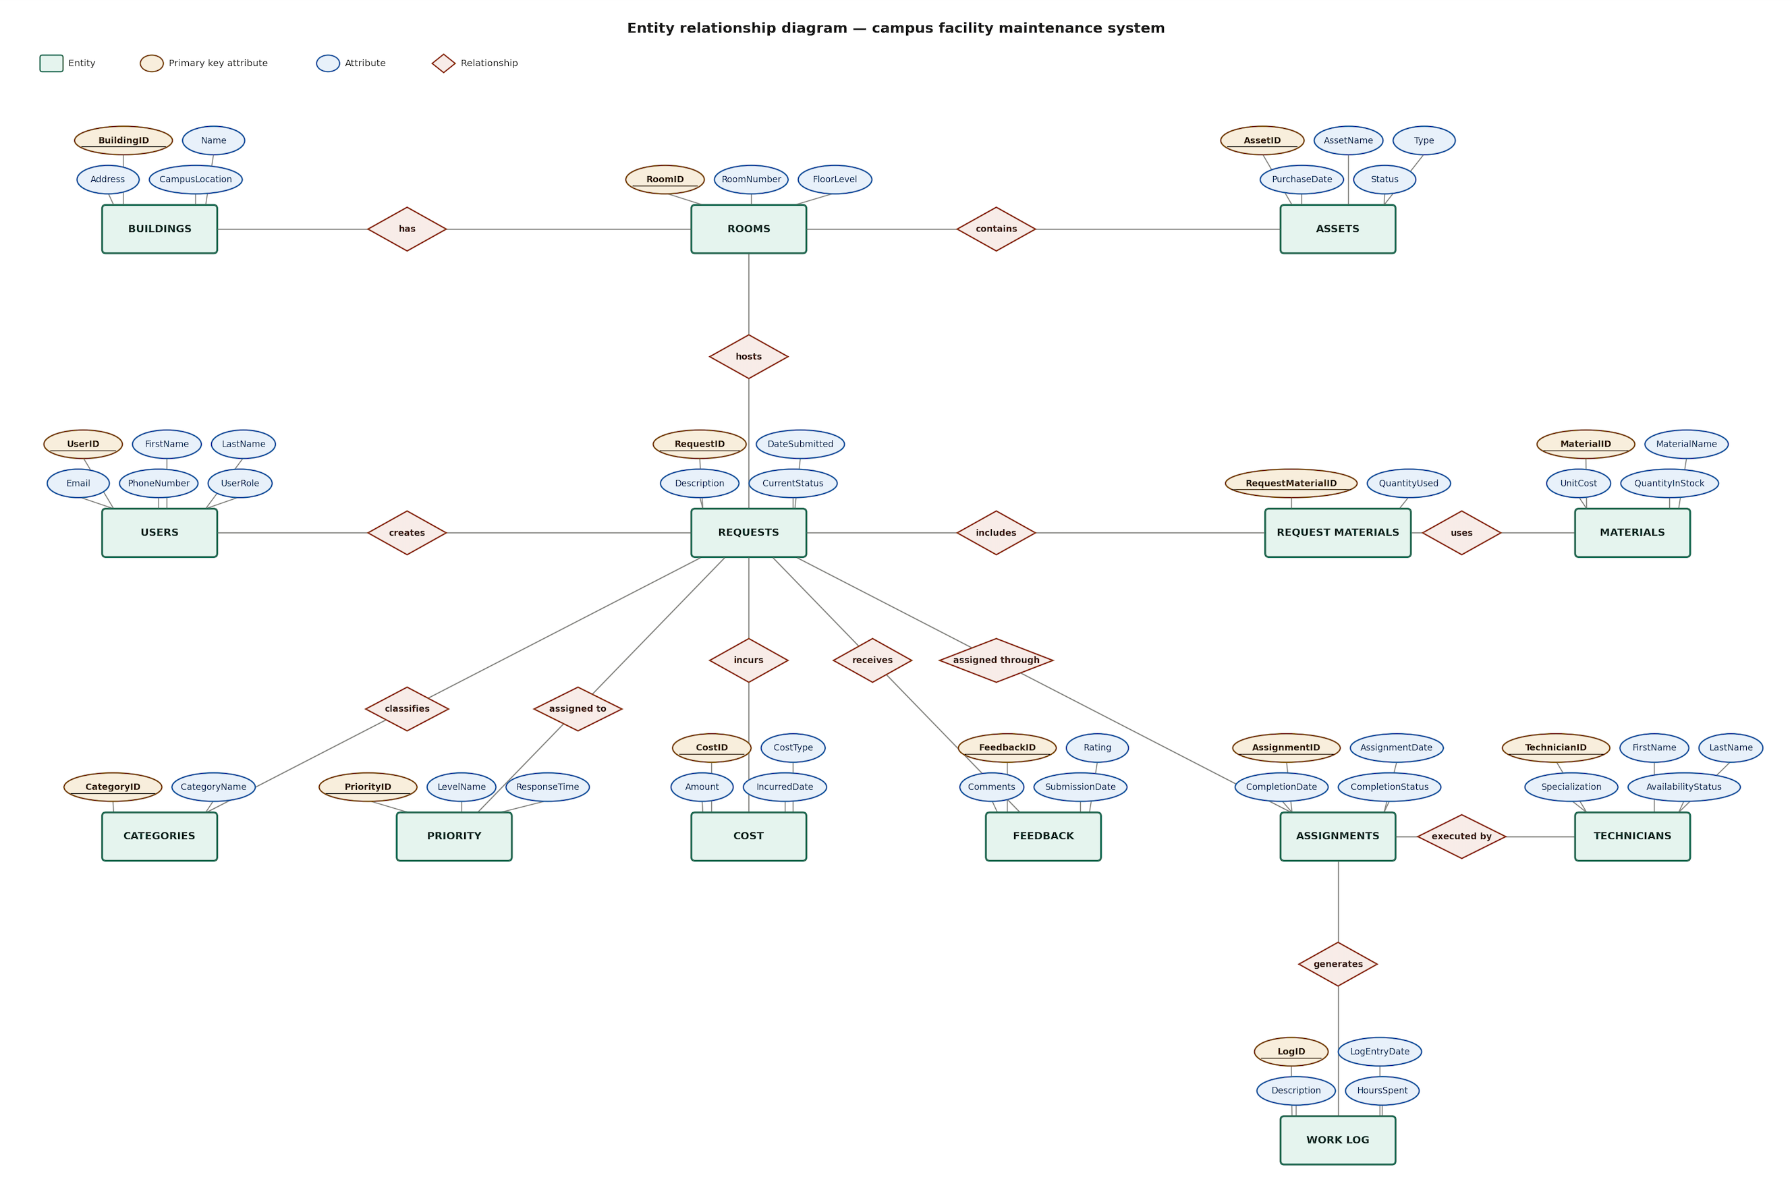
Figure 1: Entity-Relationship Diagram for Campus Facility Management System

7. Relational Schema and Normalization

7.1 Relational Schema

7.1 BUILDINGS
Field | Type | Null | Key | Default | Extra
BuildingID | int | NO | PRI | NULL | auto_increment
Name | varchar(100) | NO |  | NULL
Address | varchar(200) | NO |  | NULL
CampusLocation | varchar(100) | NO |  | NULL

7.2 ROOMS
Field | Type | Null | Key | Default | Extra
RoomID | int | NO | PRI | NULL | auto_increment
BuildingID | int | NO | MUL | NULL
RoomNumber | varchar(20) | NO |  | NULL
FloorLevel | int | NO |  | NULL

7.3 ASSETS
Field | Type | Null | Key | Default | Extra
AssetID | int | NO | PRI | NULL | auto_increment
RoomID | int | NO | MUL | NULL
AssetName | varchar(100) | NO |  | NULL
Type | varchar(50) | NO |  | NULL
PurchaseDate | date | YES |  | NULL
Status | varchar(30) | NO |  | NULL

7.4 USERS
Field | Type | Null | Key | Default | Extra
UserID | int | NO | PRI | NULL | auto_increment
FirstName | varchar(50) | NO |  | NULL
LastName | varchar(50) | NO |  | NULL
Email | varchar(100) | NO | UNI | NULL
PhoneNumber | varchar(15) | YES |  | NULL
UserRole | varchar(30) | NO |  | NULL

7.5 TECHNICIANS
Field | Type | Null | Key | Default | Extra
TechnicianID | int | NO | PRI | NULL | auto_increment
FirstName | varchar(50) | NO |  | NULL
LastName | varchar(50) | NO |  | NULL
Specialization | varchar(50) | NO |  | NULL
AvailabilityStatus | varchar(30) | NO |  | Available

7.6 CATEGORIES
Field | Type | Null | Key | Default | Extra
CategoryID | int | NO | PRI | NULL | auto_increment
CategoryName | varchar(50) | NO | UNI | NULL

7.7 PRIORITY
Field | Type | Null | Key | Default | Extra
PriorityID | int | NO | PRI | NULL | auto_increment
LevelName | varchar(30) | NO | UNI | NULL
ResponseTime | varchar(50) | NO |  | NULL

7.8 REQUESTS
Field | Type | Null | Key | Default | Extra
RequestID | int | NO | PRI | NULL | auto_increment
UserID | int | NO | MUL | NULL
RoomID | int | NO | MUL | NULL
CategoryID | int | NO | MUL | NULL
PriorityID | int | NO | MUL | NULL
Description | varchar(500) | NO |  | NULL
DateSubmitted | date | NO |  | NULL
CurrentStatus | varchar(30) | NO |  | Pending

7.9 ASSIGNMENT
Field | Type | Null | Key | Default | Extra
AssignmentID | int | NO | PRI | NULL | auto_increment
RequestID | int | NO | MUL | NULL
TechnicianID | int | NO | MUL | NULL
AssignmentDate | date | NO |  | NULL
CompletionDate | date | YES |  | NULL

7.10 WORK_LOG
Field | Type | Null | Key | Default | Extra
LogID | int | NO | PRI | NULL | auto_increment
AssignmentID | int | NO | MUL | NULL
LogEntryDate | date | NO |  | NULL
Description | varchar(500) | NO |  | NULL
HoursSpent | decimal(5,2) | NO |  | NULL

7.11 REQUEST_MATERIALS
Field | Type | Null | Key | Default | Extra
RequestID | int | NO | PRI | NULL
MaterialID | int | NO | PRI | NULL
QuantityUsed | int | NO |  | NULL

7.12 MATERIALS
Field | Type | Null | Key | Default | Extra
MaterialID | int | NO | PRI | NULL | auto_increment
MaterialName | varchar(100) | NO |  | NULL
UnitCost | decimal(10,2) | NO |  | NULL
QuantityInStock | int | NO |  | 0

7.13 COST
Field | Type | Null | Key | Default | Extra
CostID | int | NO | PRI | NULL | auto_increment
RequestID | int | NO | MUL | NULL
CostType | varchar(50) | NO |  | NULL
Amount | decimal(10,2) | NO |  | NULL
IncurredDate | date | NO |  | NULL

7.14 FEEDBACK
Field | Type | Null | Key | Default | Extra
FeedbackID | int | NO | PRI | NULL | auto_increment
RequestID | int | NO | MUL | NULL
Rating | int | NO |  | NULL
Comments | varchar(500) | YES |  | NULL
SubmissionDate | date | NO |  | NULL

7.15 STATUS_HISTORY
Field | Type | Null | Key | Default | Extra
StatusLogID | int | NO | PRI | NULL | auto_increment
RequestID | int | NO | MUL | NULL
StatusChangeDate | date | NO |  | NULL
PreviousStatus | varchar(30) | YES |  | NULL
NewStatus | varchar(30) | NO |  | NULL

Note: The tables above reproduce the actual MySQL DESCRIBE structure of the implemented database, detailing Field, Type, Nullability, Key constraints, Default values, and Extra auto-increment parameters.

7.2 Normalization
The database design strictly adheres to 1NF, 2NF, and 3NF normalization rules:
• First Normal Form (1NF): All attributes contain strictly atomic values. Repeating groups such as multiple materials consumed on a repair are factored out into a dedicated child table (REQUEST_MATERIALS). Each record is uniquely identified by a primary key.
• Second Normal Form (2NF): The schema is in 1NF and contains zero partial functional dependencies. In tables with composite primary keys like REQUEST_MATERIALS (RequestID, MaterialID), the attribute QuantityUsed functionally depends on the entire composite key. Entity metadata such as MaterialName and UnitCost reside strictly in MATERIALS.
• Third Normal Form (3NF): The schema is in 2NF and exhibits zero transitive dependencies. In REQUESTS, the ticket references RoomID as a foreign key; physical building details (Name, CampusLocation) reside strictly in BUILDINGS via ROOMS.BuildingID. This prevents transitive dependencies of the form RequestID -> RoomID -> BuildingName and eliminates insertion, update, and deletion anomalies.

8. Database Creation and Representative SQL

8.1 Database and Table Creation (DDL)
CREATE DATABASE IF NOT EXISTS campus_facility_management;
USE campus_facility_management;
CREATE TABLE BUILDINGS (
BuildingID INT NOT NULL AUTO_INCREMENT,
Name VARCHAR(100) NOT NULL,
Address VARCHAR(200) NOT NULL,
CampusLocation VARCHAR(100) NOT NULL,
PRIMARY KEY (BuildingID)
) ENGINE=InnoDB DEFAULT CHARSET=utf8mb4;
CREATE TABLE ROOMS (
RoomID INT NOT NULL AUTO_INCREMENT,
BuildingID INT NOT NULL,
RoomNumber VARCHAR(20) NOT NULL,
FloorLevel INT NOT NULL,
PRIMARY KEY (RoomID),
FOREIGN KEY (BuildingID) REFERENCES BUILDINGS(BuildingID) ON DELETE CASCADE
) ENGINE=InnoDB DEFAULT CHARSET=utf8mb4;
CREATE TABLE REQUESTS (
RequestID INT NOT NULL AUTO_INCREMENT,
UserID INT NOT NULL,
RoomID INT NOT NULL,
CategoryID INT NOT NULL,
PriorityID INT NOT NULL,
Description VARCHAR(500) NOT NULL,
DateSubmitted DATE NOT NULL,
CurrentStatus VARCHAR(30) NOT NULL DEFAULT 'Pending',
PRIMARY KEY (RequestID),
FOREIGN KEY (UserID) REFERENCES USERS(UserID),
FOREIGN KEY (RoomID) REFERENCES ROOMS(RoomID),
FOREIGN KEY (CategoryID) REFERENCES CATEGORIES(CategoryID),
FOREIGN KEY (PriorityID) REFERENCES PRIORITY(PriorityID)
) ENGINE=InnoDB DEFAULT CHARSET=utf8mb4;

8.2 Representative DML Operations
-- Insert Record into REQUESTS table
INSERT INTO REQUESTS (UserID, RoomID, CategoryID, PriorityID, Description, DateSubmitted, CurrentStatus)
VALUES (1, 101, 1, 4, 'Laboratory 3-phase outlet sparking on load activation', '2026-09-14', 'Pending');
-- Update Status and Availability upon Technician Assignment
UPDATE REQUESTS SET CurrentStatus = 'Assigned' WHERE RequestID = 5015;
UPDATE TECHNICIANS SET AvailabilityStatus = 'Busy' WHERE TechnicianID = 205;
-- Cascading Delete Operation (Handled via transaction in application logic)
DELETE FROM WORK_LOG WHERE AssignmentID IN (SELECT AssignmentID FROM ASSIGNMENT WHERE RequestID = 5016);
DELETE FROM ASSIGNMENT WHERE RequestID = 5016;
DELETE FROM REQUESTS WHERE RequestID = 5016;

8.3 Sample Execution Verification
• SHOW TABLES; → All 15 relational tables (BUILDINGS, ROOMS, ASSETS, USERS, TECHNICIANS, CATEGORIES, PRIORITY, REQUESTS, ASSIGNMENT, WORK_LOG, REQUEST_MATERIALS, MATERIALS, COST, FEEDBACK, STATUS_HISTORY) verified and active.
• SELECT COUNT(*) FROM REQUESTS; → 15 seeded production-grade complaints verified across 7 academic & residential blocks.
• SELECT COUNT(*) FROM MATERIALS; → 10 distinct spare parts cataloged with real-time stock and unit prices.

9. Queries with Outputs, including Presentation-II Query

9.1 Presentation-II Query — Complaints by 'Ananya Rao'
Specification: Retrieve the category name, priority level, SLA response time, and current status for all maintenance complaints logged by student Ananya Rao.
SELECT
c.CategoryName AS Category,
p.LevelName AS Priority,
p.ResponseTime,
r.CurrentStatus AS Status
FROM REQUESTS r
JOIN USERS u ON r.UserID = u.UserID
JOIN CATEGORIES c ON r.CategoryID = c.CategoryID
JOIN PRIORITY p ON r.PriorityID = p.PriorityID
WHERE u.FirstName = 'Ananya' AND u.LastName = 'Rao';

Actual MySQL Output:
Category | Priority | ResponseTime | Status
Furniture | Medium | 24 Hours | Completed
Cleaning | Low | 48 Hours | Pending

9.2 Building-wise Maintenance Expenditure Summary
SELECT
b.BuildingID,
b.Name AS BuildingName,
b.CampusLocation,
COUNT(DISTINCT r.RequestID) AS TotalRequests,
COALESCE(SUM(c.Amount), 0) AS TotalCost_INR
FROM BUILDINGS b
LEFT JOIN ROOMS rm ON b.BuildingID = rm.BuildingID
LEFT JOIN REQUESTS r ON rm.RoomID = r.RoomID
LEFT JOIN COST c ON r.RequestID = c.RequestID
GROUP BY b.BuildingID, b.Name, b.CampusLocation
ORDER BY TotalCost_INR DESC;

Actual MySQL Output:
BuildingID | BuildingName | CampusLocation | TotalRequests | TotalCost_INR
1 | Academic Block A | Main Campus | 4 | 1430.00
2 | Hostel Block B | Residential Area | 3 | 910.00
5 | Science & Innovation Complex | North Campus | 2 | 840.00
4 | Sports Complex | Sports Area | 1 | 750.00
3 | Library Block | Central Campus | 2 | 540.00
6 | Student Activity Hub | Central Campus | 1 | 0.00
7 | Executive Residences Block C | Residential Area | 0 | 0.00

9.3 Technician Workload and Total Hours Logged
SELECT
t.TechnicianID,
CONCAT(t.FirstName, ' ', t.LastName) AS Technician,
t.Specialization,
t.AvailabilityStatus,
COUNT(DISTINCT a.AssignmentID) AS TotalAssignments,
COALESCE(SUM(wl.HoursSpent), 0) AS TotalHoursLogged
FROM TECHNICIANS t
LEFT JOIN ASSIGNMENT a ON t.TechnicianID = a.TechnicianID
LEFT JOIN WORK_LOG wl ON a.AssignmentID = wl.AssignmentID
GROUP BY t.TechnicianID, t.FirstName, t.LastName, t.Specialization, t.AvailabilityStatus
ORDER BY TotalHoursLogged DESC;

Actual MySQL Output:
TechnicianID | Technician | Specialization | AvailabilityStatus | TotalAssignments | TotalHoursLogged
201 | Amit Kumar | Electrical | Available | 3 | 6.00
202 | Suresh Reddy | Plumbing | Busy | 2 | 4.75
203 | Neeraj Sharma | Networking | Available | 2 | 4.00
208 | Sunil Rao | Audio-Visual | Available | 1 | 1.75
206 | Rajesh Goud | Civil & Carpentry | Available | 1 | 1.50
204 | Karan Singh | Furniture | Available | 1 | 1.00
205 | Vikram Patel | General Maintenance | Available | 1 | 0.00
207 | Deepa Sen | HVAC Specialist | Available | 0 | 0.00

9.4 Spare Material Consumption and Stock Depletion
SELECT
m.MaterialID,
m.MaterialName,
m.UnitCost,
m.QuantityInStock AS RemainingStock,
COALESCE(SUM(rm.QuantityUsed), 0) AS TotalQuantityUsed,
COALESCE(SUM(rm.QuantityUsed * m.UnitCost), 0) AS TotalSpent_INR
FROM MATERIALS m
LEFT JOIN REQUEST_MATERIALS rm ON m.MaterialID = rm.MaterialID
GROUP BY m.MaterialID, m.MaterialName, m.UnitCost, m.QuantityInStock
ORDER BY TotalQuantityUsed DESC;

Actual MySQL Output:
MaterialID | MaterialName | UnitCost | RemainingStock | TotalQuantityUsed | TotalSpent_INR
304 | Network Cable | 75.00 | 150 | 10 | 750.00
302 | PVC Pipe | 120.00 | 80 | 5 | 600.00
305 | Chair Wheel | 90.00 | 60 | 4 | 360.00
307 | Cat6 Shielded RJ45 Jack | 45.00 | 220 | 4 | 180.00
301 | Copper Wire | 250.00 | 48 | 3 | 750.00
303 | LED Bulb | 180.00 | 100 | 2 | 360.00
308 | 32A Industrial MCB Switch | 420.00 | 35 | 2 | 840.00
306 | Heavy Door Latch & Lockset | 320.00 | 45 | 1 | 320.00
309 | Brass Ball Valve 1-inch | 310.00 | 40 | 1 | 310.00
310 | Refrigerant Gas R410A (kg) | 850.00 | 25 | 0 | 0.00

10. UI Design and Screenshots
The following screenshots demonstrate the implemented fullstack Campus Facility Maintenance web application running live:
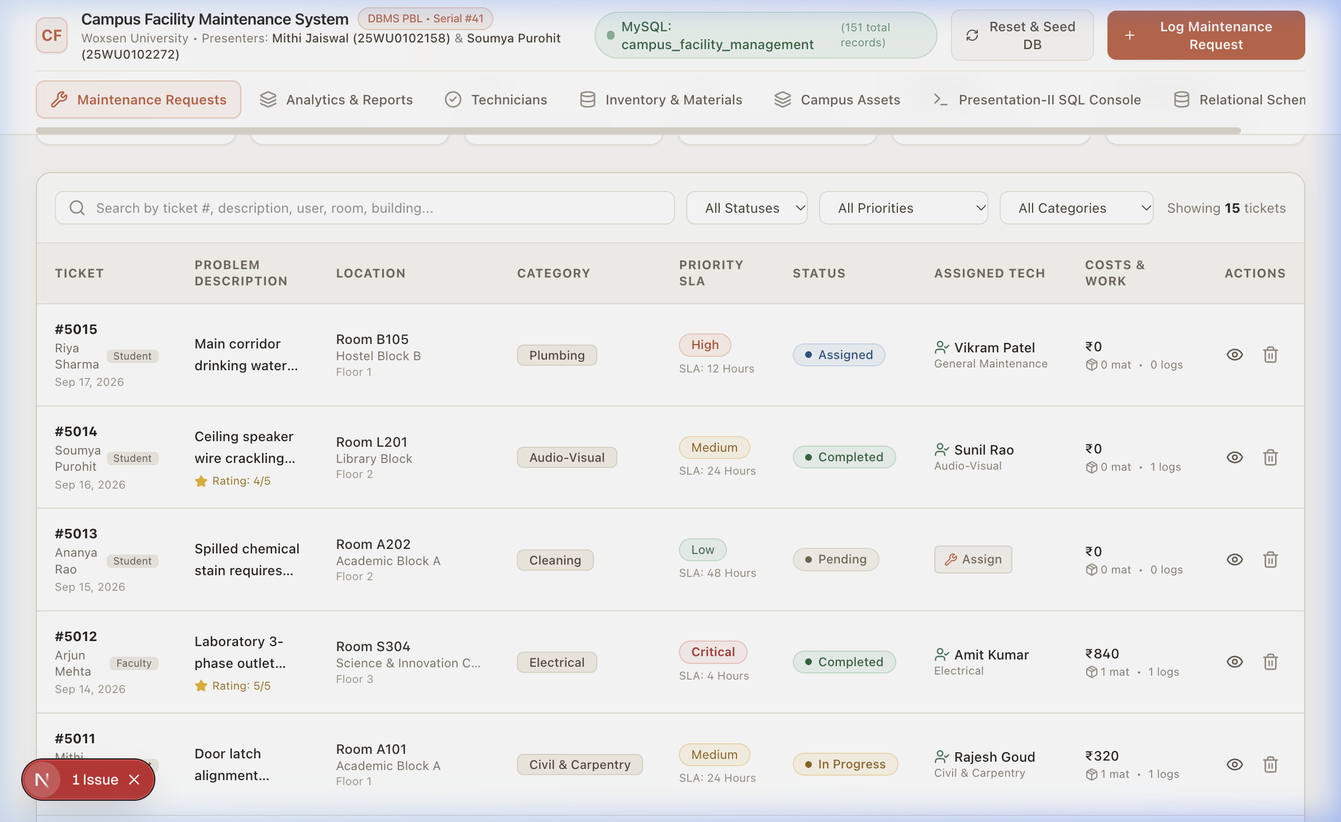
Figure 2: Campus Facility Maintenance Requests Dashboard with Real-Time Filtering
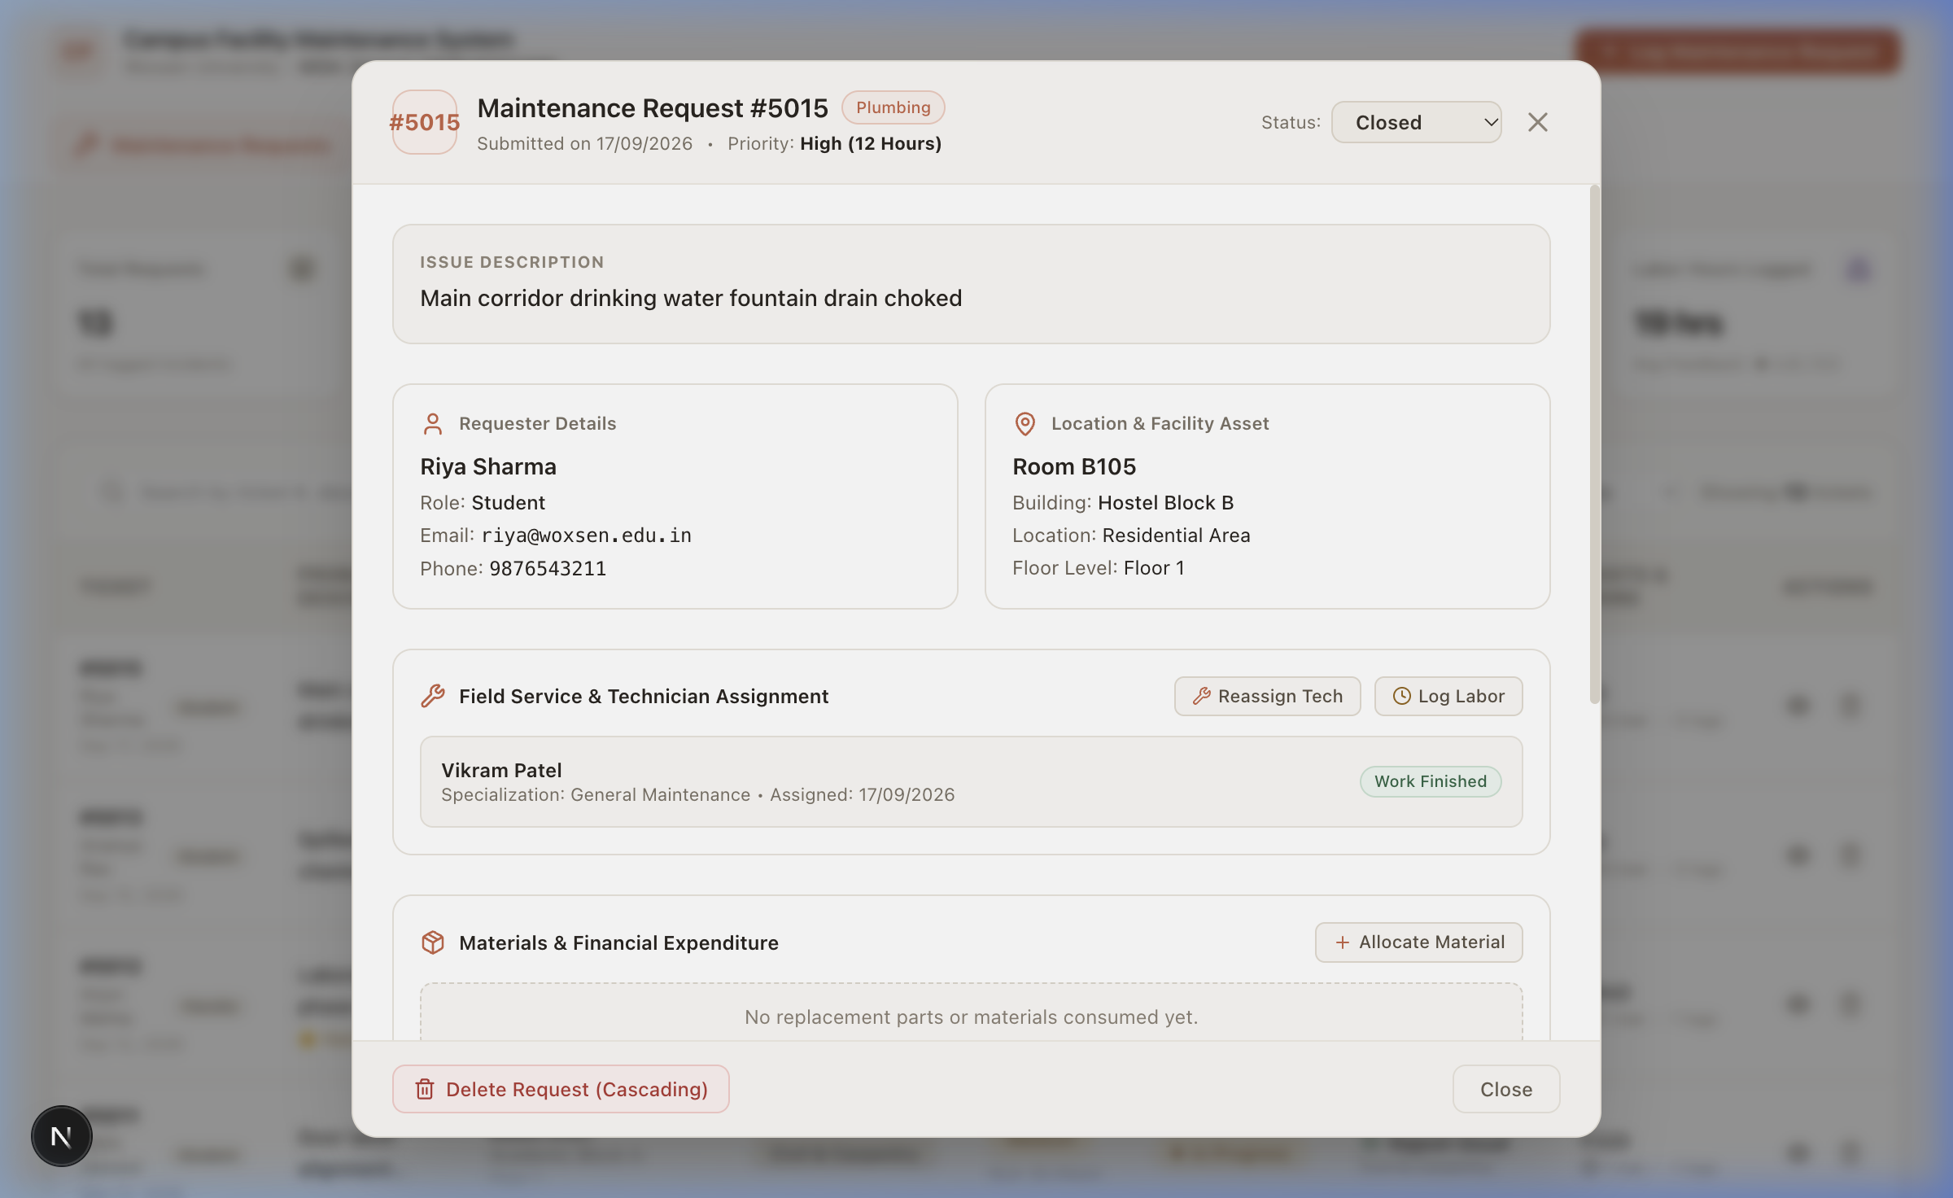
Figure 3: Interactive Ticket Inspection & Audit Drawer with Technician, Work Log, Materials, and Cost
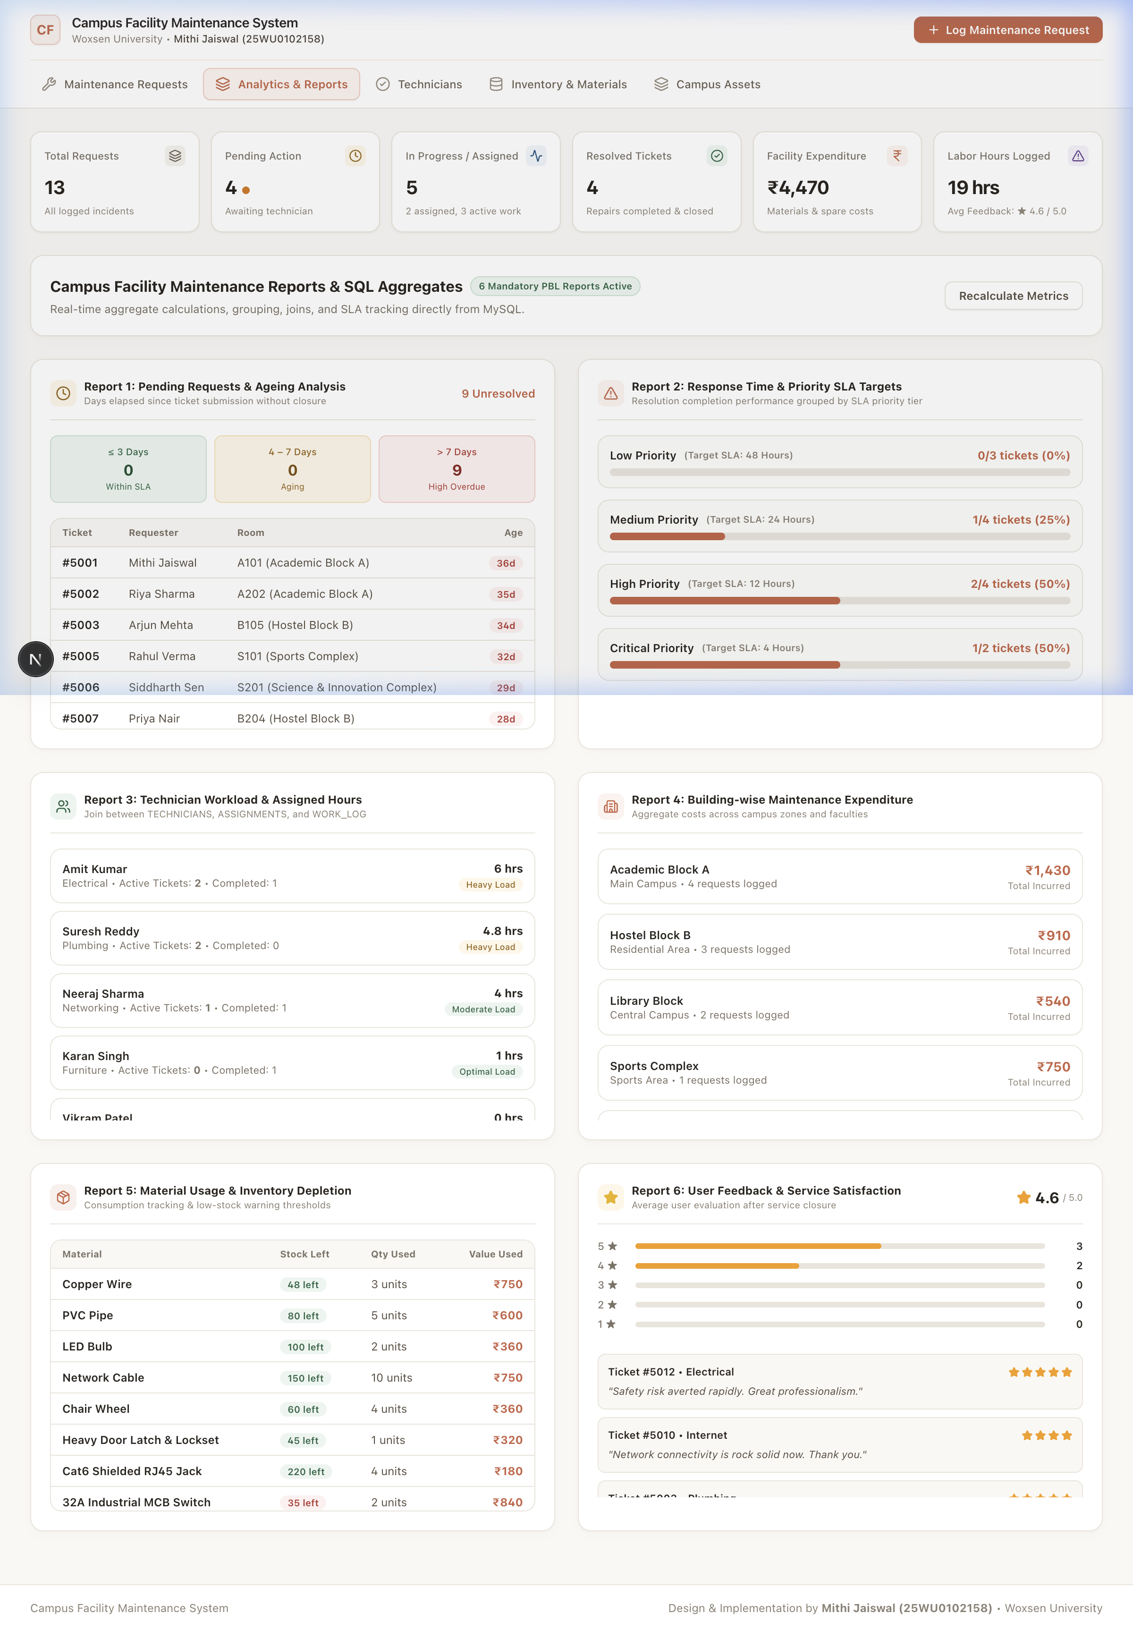
Figure 4: Six Mandatory Course Project Analytical Reports Dashboard (Ageing, SLA, Workload, Costs)
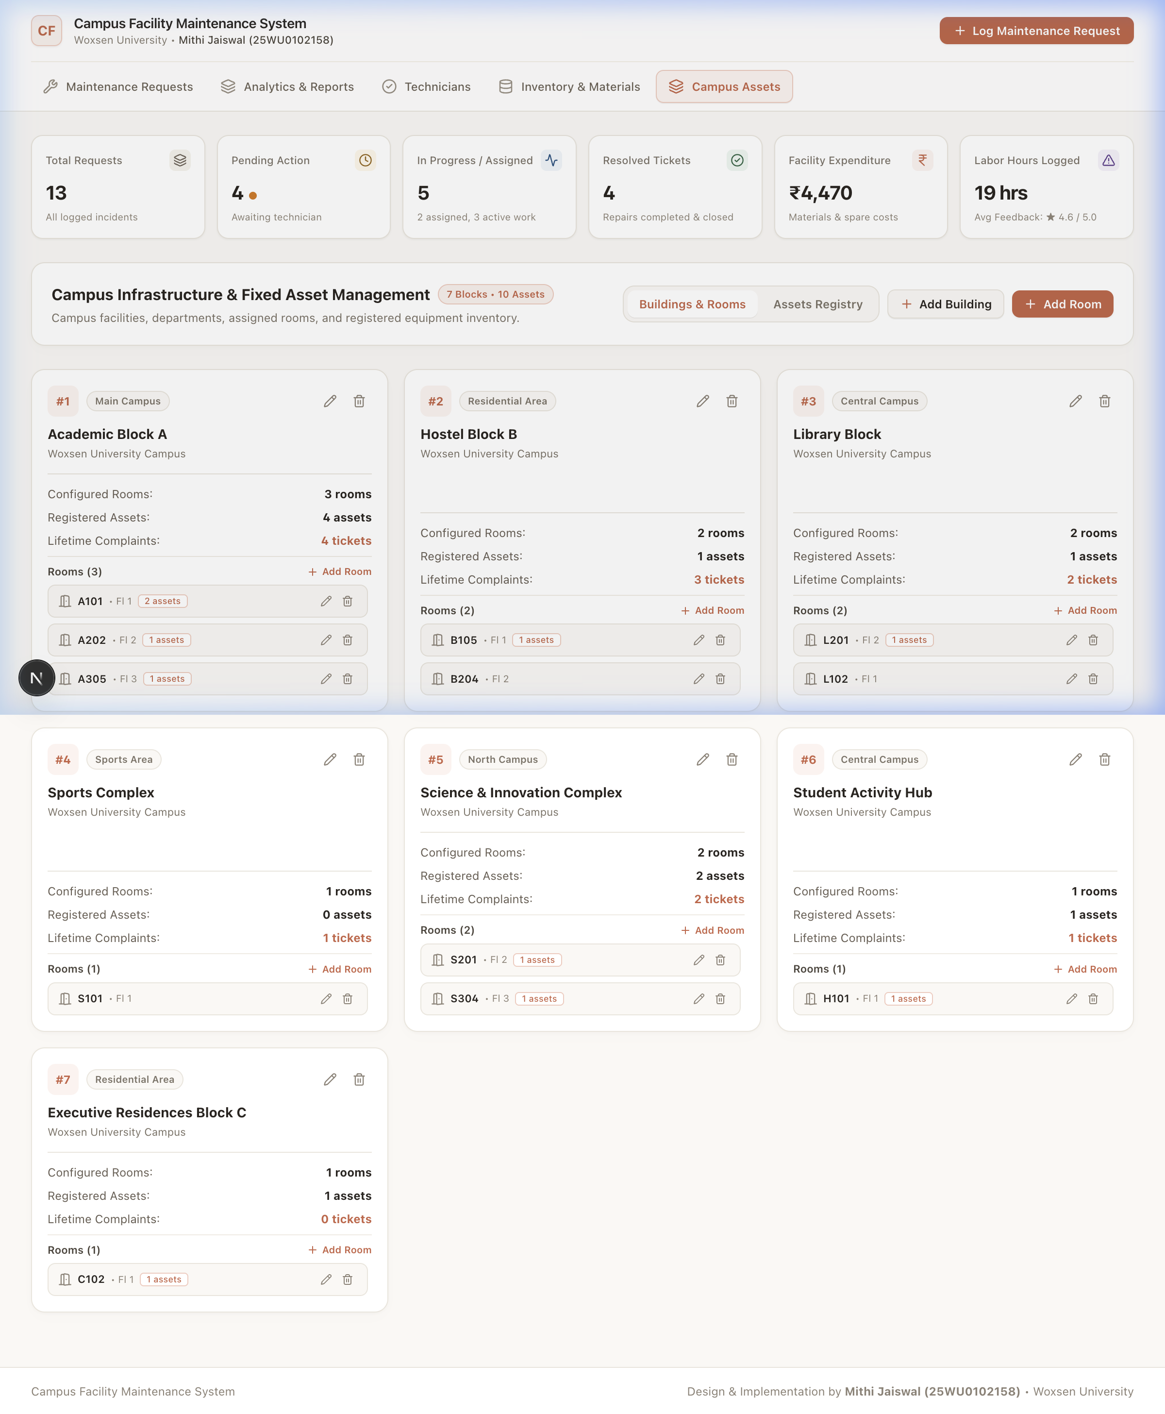
Figure 5: Campus Infrastructure & Asset Registry with Edit/Delete Management

11. Implementation Details

11.1 Technology Stack
Layer | Technology | Purpose
Database | MySQL 8.x / 9.x | Persistent relational database storage with ACID guarantees
ORM / Client | Prisma ORM 6.4 | Type-safe database client, schema migrations, and queries
Backend Runtime | Next.js 16 (Node.js) | Server-side RESTful API route handlers and business logic
Frontend UI | React 19, TypeScript | Dynamic component-based client application and state management
Styling | Vanilla CSS + Tailwind | Minimal warm pastel aesthetic (#C86446, #FAF8F5, #EAE5DC)
Icons & Assets | Lucide React | Lightweight vector UI icons for navigation and operational triggers
Build Tool | Turbopack | Sub-second dev server compilation and production optimization

11.2 DB Connectivity and Transaction Pattern
Every multi-table write uses atomic transactions via prisma.$transaction to guarantee that ticket updates, inventory deductions, and audit logging succeed as a unified all-or-nothing operation:
// Atomic multi-table write pattern executed in Next.js API route
const result = await prisma.$transaction(async (tx) => {
// 1. Decrement inventory stock in MATERIALS
const updatedMaterial = await tx.mATERIALS.update({
where: { MaterialID: materialId },
data: { QuantityInStock: { decrement: quantityUsed } },
});
// 2. Insert line record into REQUEST_MATERIALS
await tx.rEQUEST_MATERIALS.create({
data: { RequestID: requestId, MaterialID: materialId, QuantityUsed: quantityUsed },
});
// 3. Automatically record financial cost in COST table
await tx.cOST.create({
data: {
RequestID: requestId,
CostType: 'Material',
Amount: Number(updatedMaterial.UnitCost) * quantityUsed,
IncurredDate: new Date(),
},
});
});

11.3 Validation and Error Handling
- Client-side and server-side validation for every input form.
- Technician assignment automatically sets technician status to 'Busy' and enforces valid availability.
- Quantity deducted from inventory is strictly validated against available stock in hand.
- Cascading relational deletes execute child row deletions first (Work Log -> Assignment -> Costs -> Materials -> Feedback -> Status History -> Request) to strictly prevent foreign key constraint violations.
- Database exceptions are captured in try-catch blocks and converted to user-friendly structured JSON error messages.

11.4 Project Structure
DBMS-Course-project/
├── Presentation-I/ # Project inception slides (PDF)
├── Presentation-II/ # Database architecture review
│ ├── database_setup.sql # Full DDL schema creation and seed data
│ ├── queries.sql # Comprehensive SQL evaluation queries
│ └── er diagram.png # Relational schema architecture
├── Presentation-III/ # Final implementation and UI demonstration
│ ├── README.md # UI demonstration guidelines
│ └── source_code/ # Complete Next.js fullstack application
│ ├── app/api/ # REST API routes (requests, infrastructure, analytics)
│ ├── components/ # React UI components (Dashboard, Modals, Drawer)
│ ├── prisma/ # schema.prisma models and seed.ts script
│ └── package.json # Dependencies and scripts
├── Project-Report/ # Final project report documentation and DOCX
└── README.md # Repository documentation and setup instructions

12. Testing (Test Cases and Results)
Test Case | Operation | Input Parameters | Expected Output | Status
TC-01 | Database Connection | Prisma client connects to MySQL | Connection established with 15 tables loaded | PASSED
TC-02 | Create Ticket | User: 1, Room: 101, Cat: 1, Prio: 4 | Row inserted into REQUESTS; initial log added to STATUS_HISTORY | PASSED
TC-03 | Assign Technician | Request: 5001, Tech: 201 | Row inserted in ASSIGNMENT; Tech marked 'Busy'; Status -> 'Assigned' | PASSED
TC-04 | Log Labor Work | Request: 5001, Hours: 2.5 | Entry created in WORK_LOG; Ticket status updated to 'In Progress' | PASSED
TC-05 | Consume Material | Request: 5001, Material: 301, Qty: 2 | Stock decremented in MATERIALS; Voucher added to COST | PASSED
TC-06 | Submit Feedback | Request: 5004, Rating: 5, Comments | Star review recorded in FEEDBACK; Linked to ticket #5004 | PASSED
TC-07 | Cascading Delete | Delete ticket #5016 | Atomic transaction removes all child foreign key rows cleanly | PASSED
TC-08 | Presentation-II Query | Filter user 'Ananya Rao' | Returns Category, Priority, SLA, and Status in <1 ms | PASSED
TC-09 | Analytical Reports | Execute /api/analytics | Aggregated JSON returns all 6 mandatory management reports | PASSED
TC-10 | Infrastructure CRUD | Add/Edit/Delete Room & Asset | Changes reflected live across database and UI cards | PASSED

13. Conclusion and Future Enhancements

13.1 Conclusion
The Campus Facility Maintenance Request Management System provides a robust, normalized relational database solution for complaint logging, facility infrastructure tracking, technician dispatching, labor auditing, spare material control, and executive reporting. By enforcing 3NF schema constraints, foreign key relationships, atomic transactions, and comprehensive validation, the system eliminates duplicate entries, guarantees SLA adherence, and prevents data anomalies.

13.2 Future Enhancements
- Role-based authentication and single sign-on (SSO) integration with university credentials.
- IoT sensor integration for automated leak detection and predictive electrical surge alerts.
- Real-time SMS and mobile push notifications for field technicians.
- Automated vendor purchase order generation when spare parts stock drops below safety thresholds.
- Predictive maintenance modeling using historical asset breakdown patterns.
- Cloud-native deployment on AWS/GCP with automated geo-redundant backups.

14. References
- Elmasri, R., & Navathe, S. B. Fundamentals of Database Systems, 7th Edition. Pearson, 2016.
- Silberschatz, A., Korth, H. F., & Sudarshan, S. Database System Concepts, 7th Edition. McGraw-Hill, 2019.
- MySQL 8.0 & 9.x Reference Manual. Oracle Corporation, 2024. https://dev.mysql.com/doc/
- Prisma ORM Documentation. Prisma Data, Inc. https://www.prisma.io/docs
- Next.js App Router Documentation. Vercel Inc. https://nextjs.org/docs
- Reference DBMS Course Project Report structure supplied for project documentation standards.

15. Appendix: GitHub Repository Link
GitHub Repository: https://github.com/mithijaiswal/DBMS-Course-project

