Software Requirements Specification

for

MazzEvents

Version 1.0 approved

Prepared by Team IS-23

University of Colombo School of Computing

05th September 2019

Table of Contents

1. Group Members 2

2. Introduction 2

2.1 Domain description 2

2.2 Current system and it’s limitation 2

2.3 Objectives and Goals 2

2.4 Scope of the project 2

2.5 Assumptions, Constraints and limitations 2

3. Feasibility Study 3

4. Requirements 3

4.1 Stakeholders 3

4.2 Usecases and Usecase diagrams 4

4.3 Functional Requirements 5

4.4 Non-Functional Requirements 5

4.4.1 Performance Requirements 5

4.4.2 Safety Requirements 6

4.4.3 Security Requirements 6

4.4.4 Software Quality Attributes 6

4.4.5 Other requirements 6

5. Proposed System’s architecture 7

6. System’s Design 7

7. Interfaces and Interface Flow Diagram 7

7.1.1 User Interfaces 7

7.1.2 Communications Interfaces 7

8. References 7

# Group Members

|  |  |  |
| --- | --- | --- |
| **Name** | **Index Number** | **Signature** |
| 1. J.A.P.D. Kularathne | 17020425 |  |
| 1. B.M.P. Jayalath | 17020352 |  |
| 1. K.A.B.S.Kumaranayake | 17020433 |  |
| 1. W.G.N.D. Warakagoda | 17020913 |  |

# Introduction

This section introduces the requirement specification document for Mazz Events web platform. It provides the purpose and scope of the system any definition and references are listed on this section as well as an overview.

## Overall description

The overall description gives an overview of the functionality of the entire system. It will explain how the proposed system interacts with external environment and introduce the functionalities. It will also describe the type of stakeholders that uses the system and which functions are available for each other.

## Domain description

Our client is the owner of MazzEvents. MazzEvents is a professional event management company in Galle. Which specializes in planning and coordinating various events such as weddings, birthday parties, private functions and kid’s parties. Our client has a good customer base, his speed of work has been low because of the completely manual processes that he’s using. So, we develop a web based system for connecting service providers and customers to enhance the process of event planning and management.

## Objectives and Goals

This document reveals the detailed description regarding the requirements of “MAZZ Events‘’. Further the system feasibility and the architecture of the proposed system. Along with these things it contains the goals and objectives of the system. This highlights the system constraints, interfaces and interactions with other external applications along with relevant demonstrations through diagrams.

## Scope of the project

Our service Mazzevents is a web based application that aims to connect service providers that provide event related services with the customers who want to make their event a successful one. Both service providers and customers can have a chat online about their services.

The customer can select services as they prefer and get to know whether it is available on the date that the customer wants. Further they can rate the events. And also they can see upcoming events near to their location.

The service providers can add their own services and maintain their profiles. And they can handle the availability of the dates.

## Assumptions, Constraints and limitations

The assumptions are

* The user, who interacts with the system, has stable internet connection at the time he/she performing in system.
* The user has knowledge to interact with the user interfaces of the system
* Time constraints
* The automated doesn’t cover financial transactions
* Recovery of data after a system crash will be possible only if backups are taken at regular intervals

# Feasibility Study

## Six tests for feasibility

### Operational Feasibility

Operation of the proposed system depends on its various users. Admin, staff members, service providers and customers are various user types in this system. The present system has automated the manual tasks. Therefore the proposed system will increase the operational efficiency of admin and users.  With the new automated system our client can access the records which are stored efficiently and the records are more reliable Client and the staff member should have a little training to use this kind of system. Service provider and the customer who have some fluency to browse the web can easily interact with our platform. So there is no need for specific training.

If the system meets the requirements of the users, we can say that the system is operationally feasible. According to the above mentioned facts newly proposed system meets the requirements of users. Therefore, the proposed system is economically feasible.

### Cultural (Political) Feasibility

Event organizers are continually appreciating the benefits of an online event management system. Organizing an event is not an easy task, especially if the target audience is of a substantial size and if there are many teams involved during the execution phase.

We are developing an online event management system that connect customers and service providers to fulfill their wants and needs in event management field. Our client will accept the system as long as the system requirements are met, we believe that the clients will be unfamiliar yet will get adapted to using the system after experiencing how easy and time efficient the system is. Proposed system would be acceptable by other peoples because it is better than ordinary event management system. In this system we connect customers and service provider online, because of that they can save their time and cost.

### Technical Feasibility

Technical issues involved are the necessary technology existence, technical guarantees of accuracy, reliability, ease of access data security, aspects of future expansion. Technology exists to develop a system. The proposed system is capable of holding the data to be used securely. The proposed system is a web based system, so that everyone with an internet connection and any device can enroll with system. Through our web based system our client can avoid more manual hours that need to spend in record keeping and generating reports. Our application keeps the data in a centralized way which is available to all the service providers, customers, staff members and our client. This system manages historical data in database very easily. In this system service providers and customers can share their ideas by chatting. As the system is web-based the system can be expand in easily.

**What?**

As the main language, we are focusing on Java Script to develop the system. More specifically we are focusing on the react JS library to develop the interfaces of our system. As the database, we are using MongoDB. For development purposes, We are using Visual Studio Code and to collaborate with others, we are using Github. Google APIs are another technology we are planning to use.

**Why?**

The main reason following our choices is they are the best and free technologies from our point of view. MongoDB database is easy to implement and React JS is very user friendly with their component based development techniques. React bootstrap outputs are decent and it’s easy to handle.

**Is Team Capable?**

As we are second year Information System students, we all are familiar with development. In order to support that, we had a subject called Web development in first year second semester. Because of that we are familiar with html, css, boostrap so we can get a head start. All four members of the project group was a part of web development project in that semester so we had earlier experiences in developing a web based systems. ReactJs, MongoDB and some other technologies are new to us but all four members have proved that they are well adaptable to new technologies.

According to the above mentioned facts the proposed system is technically feasible.

### Scheduled Feasibility

The scope of the project can be covered within the schedule because the group consists of four members with different capabilities

### **Economic Feasibility**

Economic feasibility is used for evaluating the effectiveness of the proposed system. For any system if the expected benefits equal or exceed the expected costs that system is economically feasible. In economic feasibility, cost benefit analysis is done in which expected costs and benefits are evaluated.  Through the newly proposed system improved interaction between system users because of that they do not want to meet and discuss their needs and wants .Therefore they can save time and costs. Customers can timely access information about events and services. It decreased the redundancy or duplication of data and faster creation, access, modification and retrieval of data increase economic benefits.

#### Costs associated with developing the system

##### Personnel costs

As the four members of our group are the ones who develop the system from the system analysis to the implementation, there is no salary cost for system analysts, programmers, consultants, data entry personnel, computer operators and secretaries of the project. But still with no salary costs, all four members of the project give their time and strength for the project itself so there is a cost in personnel cost. Also from supervisor to mentor in our project, from friends to lectures they all are giving their time and support to fulfill the objectives and the goal so there is a reasonable amount of personnel costs.

##### Computer usage

There will be a computer time used for programming, testing, world processing and some other activities but there will not be any special costs for it as we all use our personal computers for the project purposes and it will be minimum when it comes to electricity and data usage cost of computers

##### Training

We use free tutorials for learning and training purposes, so there will not be any specific training costs for tutorials but there will be some time for learning the technologies but one of the primary objectives are to learn, so it is reasonable.

##### Cost of any new computer equipment and software

We use free or free and open source software for the development and there is no need of new computer equipment so there will not be a specific cost in this case.

#### Costs associated with operating a system

##### Fixed Costs

There will be a cost to host the website and for the servers so it will occur in regular intervals through the lifetime of the system

##### Variable Costs

There will be a staff to handle the system, so there salary is a cost but it will depend on how much customers we gain through the lifetime. If customer usage rises, we will need a bigger staff but in that case the revenue of the system will be also bigger.

#### Benefits

##### Tangible benefits

MazzEvents is right now a functioning company which handles this idea through a manual staff so staff can be reduced and time of the owner will be saved.

##### Intangible benefits

Revenue of the system is unfortunately depends on the usages of customers so the benefit of this is based on incomplete data. However it’s clear that it will be a success because of this idea is working on a manual way right now.

According to the above mentioned facts, benefits of the newly proposed system are exceeding the costs. Therefore, the proposed system is economically feasible.

### Legal and Ethical Feasibility

The system doesn’t include personal information on the client, only the required details. The information provided by the client will not be shared with anyone, only the client and the staff member will have access to the information through the system, clients can communicate with the service provider and the customer in a safe and professional environment.

Therefore the proposed system is legally feasible.

## Final Decision

After evaluating six criteria of feasibility study, we find the best feasible solution as this above mentioned solution from other alternative solutions. Operational and economic feasibility was the main issue we faced because of the conflict they had but after the analysis, the mentioned solution was the best feasible solution in our point of view.

# Requirements

## Stakeholders

There are four kinds of persons who can interact with this system. Users, service providers, admin, staff members.

1. Users :
   1. The event organizers will fall under this category. They can create events through this system.
2. Service provider
   1. The service providers who support the event organizers will fall under this category. They can deliver the services they provide to the users.
3. Admin
   1. Admins oversees the general status of the system. They will also handle reports and complains and they will generate statistical reports about the system.
4. Staff
   1. Staff members will handle the overall system if the is an any issue with users or service providers and the complains as well.

## Usecases and Usecase diagrams

 Customer

* Register
* Login/logout
* Change account details
* Delete account
* Book services
* Live chat
* Pay for services
* Rate service providers
* Report
* Help/support

 Admin

* Login /logout
* Edit account
* Create staff and service provider accounts
* Edit staff and service provider accounts
* Delete user , staff and service provider accounts
* Generate reports

       Service provider

* Login/logout
* Change account details
* Delete account
* Add  services
* Live chat
* Edit  services
* Report
* Help/support

Staff member

* Login /logout
* Edit account
* Delete account
* Create service provider accounts
* Edit service provider accounts
* Delete user and service provider accounts

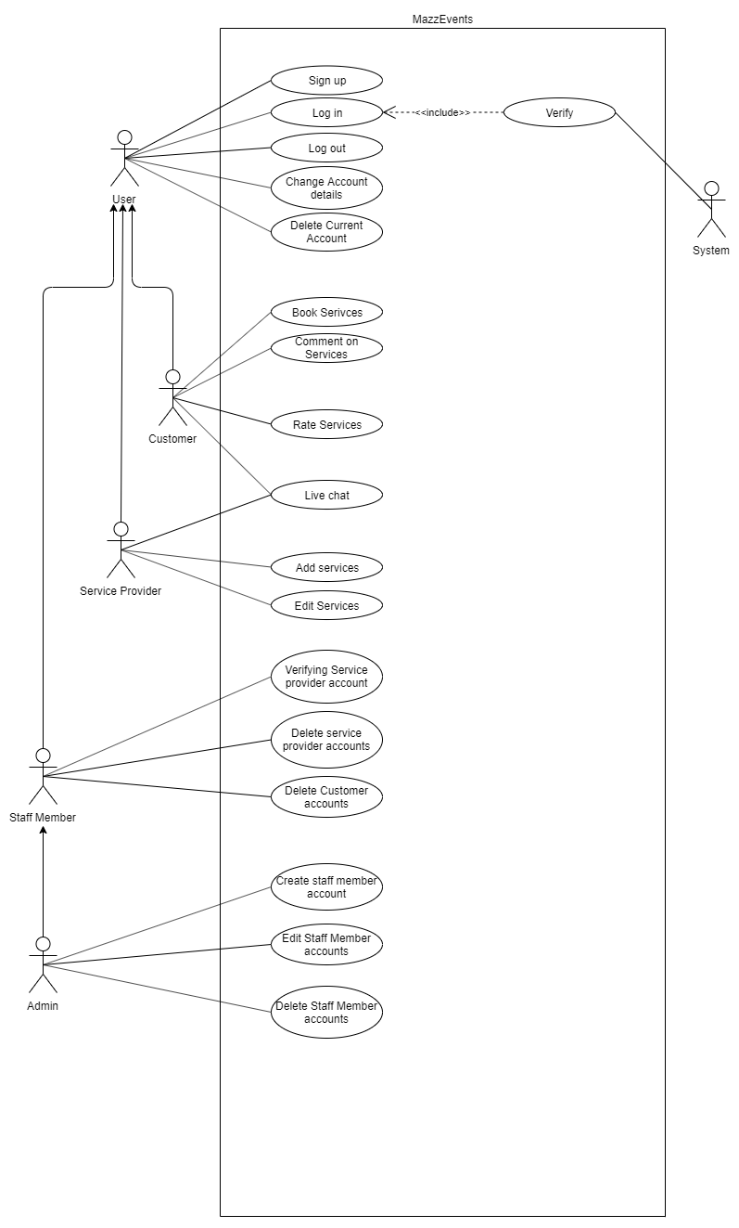

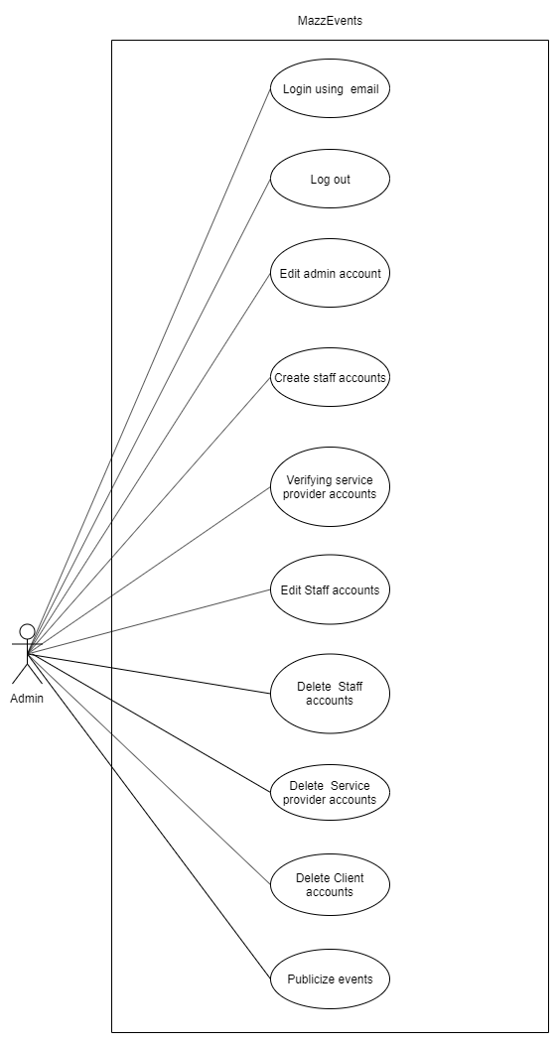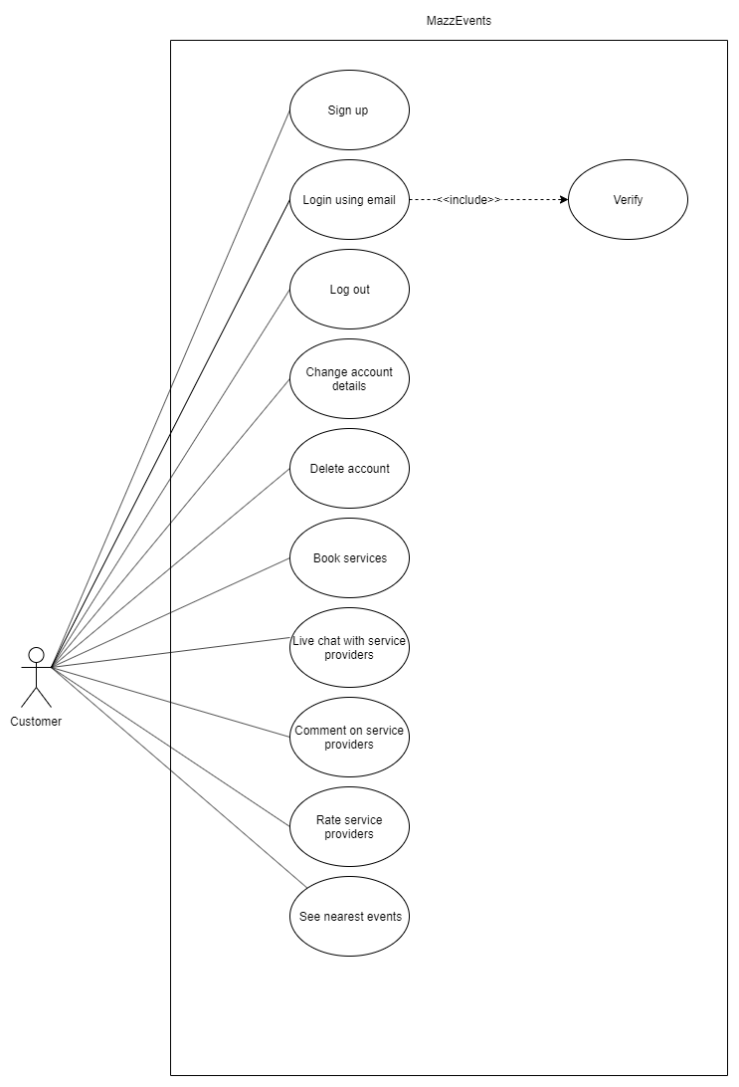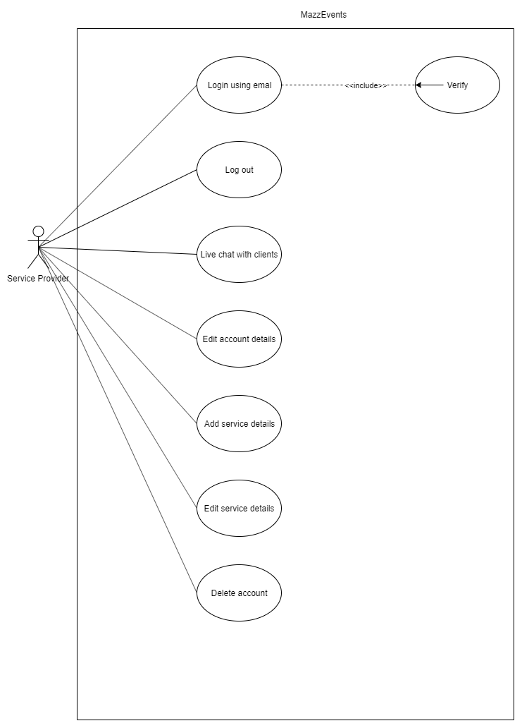

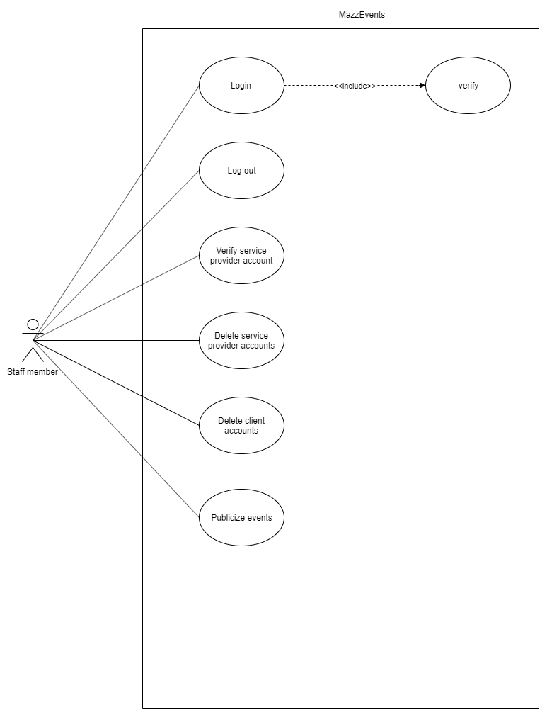

|  |  |  |
| --- | --- | --- |
| Use Case Name | Login | **Use Case Type**  System Requirement |
| Use case ID | 01 |
| Source | Web Interface |
| Primary Business Actors | Admin, customer, service provider, staff member | |
| Other Participating Actors |  | |
| Trigger | User submits the form on the web interface to login | |
| Course of Events | * User submits form with username and password * Check the username with the corresponding password in the database. * User will be logged into the system | |
| Pre-conditions | * User must not be currently logged into the system | |
| Post-conditions | * User is logged into the system under the relevant user privilege | |
| Alternative Scenarios | * If the username-password does not match, the user will receive an error message | |

|  |  |  |
| --- | --- | --- |
| Use Case Name | Logout | **Use Case Type**  System Requirements |
| Use case ID | 02 |
| Source | Web Interface |
| Primary Business Actors | Admin, customer, service provider, staff member | |
| Other Participating Actors |  | |
| Trigger | The user has to click on the logout tab of home page | |
| Course of Events | * User clicks on the logout tab in the home page * User will be logout from the system. | |
| Pre-conditions | * User must be currently logged into the system | |
| Post-conditions | * User is logged out of the system and user privileges will be taken away | |
| Alternative Scenarios | * If user declines the logout verification, logout process will be terminated and user will be stayed logged in | |

|  |  |  |
| --- | --- | --- |
| Use Case Name | Sign up | **User Case Type**  System Requirements |
| Use case ID | 03 |
| Source | Web Interface |
| Primary Business Actors | customer, service provider | |
| Other Participating Actors |  | |
| Trigger | User submits the registration form | |
| Course of Events | * User submits the registration form * All the user inputs will be validated * A new account will be created and the relevant details will be stored in the system | |
| Pre-conditions | * User must not be currently logged into the system | |
| Post-conditions | * New user account is created | |
| Alternative Scenarios | If there is an issue with the given input, an error message will be displayed | |

|  |  |  |
| --- | --- | --- |
| Use Case Name | Change Account Details | **User Case Type**  System Requirements |
| Use case ID | 04 |
| Source | Web Interface |
| Primary Business Actors | Admin, customer, service provider, staff member | |
| Other Participating Actors |  | |
| Trigger | The user has to click on the Update tab in the home page | |
| Course of Events | * User clicks on the Update tab in the home page * Then it opens the account details form * After filling out the required fields click on Update button | |
| Pre-conditions | User must be currently logged into the system | |
| Post-conditions | The user will receive update finished message | |
| Alternative Scenarios | If the user enters some details are not acceptable, error messages will be generated. | |

|  |  |  |
| --- | --- | --- |
| Use Case Name | Delete Current Account | **User Case Type**  System Requirements |
| Use case ID | 05 |
| Source | Web Interface |
| Primary Business Actors | Admin, customer, service provider, staff member | |
| Other Participating Actors |  | |
| Trigger | User delete his/her account by clicking delete tab. | |
| Course of Events | * User clicks on the Delete tab in the home page * User account will be delete from the system | |
| Pre-conditions | * User must be currently logged into the system | |
| Post-conditions | * The user will receive delete finished message. | |
| Alternative Scenarios | None | |

|  |  |  |
| --- | --- | --- |
| Use Case Name | BookServices | **User Case Type**  System Requirements |
| Use case ID | 06 |
| Source | Web Interface |
| Primary Business Actors | Customer | |
| Other Participating Actors | Service provider | |
| Trigger | Customer book services by clicking BookService tab. | |
| Course of Events | * User clicks on the BookService tab in the home page | |
| Pre-conditions | User must be currently logged into the system | |
| Post-conditions | None | |
| Alternative Scenarios | None | |

|  |  |  |
| --- | --- | --- |
| Use Case Name | Comment on Services | **User Case Type**  System Requirements |
| Use case ID | 07 |
| Source | Web Interface |
| Primary Business Actors | Customer | |
| Other Participating Actors | Service providers, admin, staff members | |
| Trigger | Customer add comments on services by clicking AddComments tab | |
| Course of Events | * User clicks AddComments tab * Then add some comments on services | |
| Pre-conditions | User must be currently logged into the system. | |
| Post-conditions | None | |
| Alternative Scenarios | None | |

|  |  |  |
| --- | --- | --- |
| Use Case Name | RateServices | **User Case Type**  System Requirements |
| Use case ID | 08 |
| Source | Web Interface |
| Primary Business Actors | Customer | |
| Other Participating Actors | Service provider | |
| Trigger | Customer add rates on services by clicking RateServices tab | |
| Course of Events | * User clicks RateServices tab * Then add rates on services | |
| Pre-conditions | User must be currently logged into the system. | |
| Post-conditions | None | |
| Alternative Scenarios | None | |

|  |  |  |
| --- | --- | --- |
| Use Case Name | LiveChat | **User Case Type**  System Requirements |
| Use case ID | 09 |
| Source | Web Interface |
| Primary Business Actors | Customer, Service provider | |
| Other Participating Actors |  | |
| Trigger | Customer and service provider can start a live chat by clicking Chat tab | |
| Course of Events | * User clicks Chat tab * Then start a chat with service provider or customer. | |
| Pre-conditions | User must be currently logged into the system. | |
| Post-conditions | None | |
| Alternative Scenarios | None | |

|  |  |  |
| --- | --- | --- |
| Use Case Name | AddServices | **User Case Type**  System Requirements |
| Use case ID | 10 |
| Source | Web Interface |
| Primary Business Actors | Service Provider | |
| Other Participating Actors |  | |
| Trigger | The service provider has to clicks on the Add Services tab in the home page. | |
| Course of Events | * Service provider clicks on the Add Services tab * Then it opens the add services form. It should be fill by service provider * After filling out the required fields click on Add Services button. | |
| Pre-conditions | * The service provider must be currently logged into the system | |
| Post-conditions | * The service provider will receive Add Services finished message | |
| Alternative Scenarios | If the user enters some details are not acceptable, error messages will be generated. | |

|  |  |  |
| --- | --- | --- |
| Use Case Name | Delete Service Provider Account | **User Case Type**  System Requirements |
| Use case ID | 14 |
| Source | Web Interface |
| Primary Business Actors | Staff member | |
| Other Participating Actors |  | |
| Trigger | The service provider has to click on the Delete tab of staff member home page. | |
| Course of Events | * Service provider clicks on the Delete tab in the home page * Service provider’s account will be delete from the system | |
| Pre-conditions | * The staff member must be currently logged into the system | |
| Post-conditions | * The staff member will receive Delete finished message | |
| Alternative Scenarios | If the user enters some details are not acceptable, error messages will be generated. | |

|  |  |  |
| --- | --- | --- |
| Use Case Name | Delete Customer Account | **User Case Type**  System Requirements |
| Use case ID | 15 |
| Source | Web Interface |
| Primary Business Actors | Staff Member, Admin | |
| Other Participating Actors |  | |
| Trigger | The staff member has to click on the Delete tab in the home page | |
| Course of Events | * Staff member or admin clicks on the Delete tab in the home page * Customer account will be delete from the system | |
| Pre-conditions | The staff member or admin must be currently logged into the system | |
| Post-conditions | The staff member or admin will receive Delete finished message | |
| Alternative Scenarios | None | |

|  |  |  |
| --- | --- | --- |
| Use Case Name | Edit Staff Member Accounts | **User Case Type**  System Requirements |
| Use case ID | 16 |
| Source | Web Interface |
| Primary Business Actors | Admin | |
| Other Participating Actors |  | |
| Trigger | The admin has to click on the Edit staff member account tab of admin home page | |
| Course of Events | * Admin clicks on the Edit tab in the home page * Then it opens staff member account form. It should be fill by admin * After filling out the required fields click on Edit button | |
| Pre-conditions | The admin must be currently logged into the system | |
| Post-conditions | The admin will receive edit finished message | |
| Alternative Scenarios | If the user enters some details are not acceptable, error messages will be generated. | |

|  |  |  |
| --- | --- | --- |
| Use Case Name | Delete Staff Member Accounts | **User Case Type**  System Requirements |
| Use case ID | 17 |
| Source | Web Interface |
| Primary Business Actors | Admin | |
| Other Participating Actors |  | |
| Trigger | The admin has to click on the Delete tab in the home page | |
| Course of Events | * Admin clicks on the Delete tab in the home page * Staff member account will be delete from the system | |
| Pre-conditions | * The admin must be currently logged into the system | |
| Post-conditions | * The admin will receive Delete finished message | |
| Alternative Scenarios | None | |

|  |  |  |
| --- | --- | --- |
| Use Case Name | Verify service provider | **User Case Type**  System Requirements |
| Use case ID | 18 |
| Source | Web Interface |
|  |  | |
|  |  | |
| Primary Business Actors | Admin, staff | |
| Other Participating Actors | Service Provider | |
| Trigger | Service provider has to sign up | |
| Course of Events | * Admin click on the verify service providers * Then it opens a list of “to be service providers” * Click an account and check the sign up details * Click the verify button | |
| Pre-conditions | The admin or staff member must be currently logged in to a system | |
| Post-conditions | Admin or staff member received a “verified successfully” message | |
| Alternative Scenarios | None | |

## Function Requirements







|  |  |  |
| --- | --- | --- |
| Use Case Name | Login | **Use Case Type**  System Requirement |
| Use case ID | 01 |
| Source | Web Interface |
| Primary Business Actors | Admin, customer, service provider, staff member | |
| Other Participating Actors |  | |
| Trigger | User submits the form on the web interface to login | |
| Course of Events | * User submits form with username and password * Check the username with the corresponding password in the database. * User will be logged into the system | |
| Pre-conditions | * User must not be currently logged into the system | |
| Post-conditions | * User is logged into the system under the relevant user privilege | |
| Alternative Scenarios | * If the username-password does not match, the user will receive an error message | |

|  |  |  |
| --- | --- | --- |
| Use Case Name | Logout | **Use Case Type**  System Requirements |
| Use case ID | 02 |
| Source | Web Interface |
| Primary Business Actors | Admin, customer, service provider, staff member | |
| Other Participating Actors |  | |
| Trigger | The user has to click on the logout tab of home page | |
| Course of Events | * User clicks on the logout tab in the home page * User will be logout from the system. | |
| Pre-conditions | * User must be currently logged into the system | |
| Post-conditions | * User is logged out of the system and user privileges will be taken away | |
| Alternative Scenarios | * If user declines the logout verification, logout process will be terminated and user will be stayed logged in | |

|  |  |  |
| --- | --- | --- |
| Use Case Name | Sign up | **User Case Type**  System Requirements |
| Use case ID | 03 |
| Source | Web Interface |
| Primary Business Actors | customer, service provider | |
| Other Participating Actors |  | |
| Trigger | User submits the registration form | |
| Course of Events | * User submits the registration form * All the user inputs will be validated * A new account will be created and the relevant details will be stored in the system | |
| Pre-conditions | * User must not be currently logged into the system | |
| Post-conditions | * New user account is created | |
| Alternative Scenarios | If there is an issue with the given input, an error message will be displayed | |

|  |  |  |
| --- | --- | --- |
| Use Case Name | Change Account Details | **User Case Type**  System Requirements |
| Use case ID | 04 |
| Source | Web Interface |
| Primary Business Actors | Admin, customer, service provider, staff member | |
| Other Participating Actors |  | |
| Trigger | The user has to click on the Update tab in the home page | |
| Course of Events | * User clicks on the Update tab in the home page * Then it opens the account details form * After filling out the required fields click on Update button | |
| Pre-conditions | User must be currently logged into the system | |
| Post-conditions | The user will receive update finished message | |
| Alternative Scenarios | If the user enters some details are not acceptable, error messages will be generated. | |

|  |  |  |
| --- | --- | --- |
| Use Case Name | Delete Current Account | **User Case Type**  System Requirements |
| Use case ID | 05 |
| Source | Web Interface |
| Primary Business Actors | Admin, customer, service provider, staff member | |
| Other Participating Actors |  | |
| Trigger | User delete his/her account by clicking delete tab. | |
| Course of Events | * User clicks on the Delete tab in the home page * User account will be delete from the system | |
| Pre-conditions | * User must be currently logged into the system | |
| Post-conditions | * The user will receive delete finished message. | |
| Alternative Scenarios | None | |

|  |  |  |
| --- | --- | --- |
| Use Case Name | BookServices | **User Case Type**  System Requirements |
| Use case ID | 06 |
| Source | Web Interface |
| Primary Business Actors | Customer | |
| Other Participating Actors | Service provider | |
| Trigger | Customer book services by clicking BookService tab. | |
| Course of Events | * User clicks on the BookService tab in the home page | |
| Pre-conditions | User must be currently logged into the system | |
| Post-conditions | None | |
| Alternative Scenarios | None | |

|  |  |  |
| --- | --- | --- |
| Use Case Name | Comment on Services | **User Case Type**  System Requirements |
| Use case ID | 07 |
| Source | Web Interface |
| Primary Business Actors | Customer | |
| Other Participating Actors | Service providers, admin, staff members | |
| Trigger | Customer add comments on services by clicking AddComments tab | |
| Course of Events | * User clicks AddComments tab * Then add some comments on services | |
| Pre-conditions | User must be currently logged into the system. | |
| Post-conditions | None | |
| Alternative Scenarios | None | |

|  |  |  |
| --- | --- | --- |
| Use Case Name | RateServices | **User Case Type**  System Requirements |
| Use case ID | 08 |
| Source | Web Interface |
| Primary Business Actors | Customer | |
| Other Participating Actors | Service provider | |
| Trigger | Customer add rates on services by clicking RateServices tab | |
| Course of Events | * User clicks RateServices tab * Then add rates on services | |
| Pre-conditions | User must be currently logged into the system. | |
| Post-conditions | None | |
| Alternative Scenarios | None | |

|  |  |  |
| --- | --- | --- |
| Use Case Name | LiveChat | **User Case Type**  System Requirements |
| Use case ID | 09 |
| Source | Web Interface |
| Primary Business Actors | Customer, Service provider | |
| Other Participating Actors |  | |
| Trigger | Customer and service provider can start a live chat by clicking Chat tab | |
| Course of Events | * User clicks Chat tab * Then start a chat with service provider or customer. | |
| Pre-conditions | User must be currently logged into the system. | |
| Post-conditions | None | |
| Alternative Scenarios | None | |

|  |  |  |
| --- | --- | --- |
| Use Case Name | AddServices | **User Case Type**  System Requirements |
| Use case ID | 10 |
| Source | Web Interface |
| Primary Business Actors | Service Provider | |
| Other Participating Actors |  | |
| Trigger | The service provider has to clicks on the Add Services tab in the home page. | |
| Course of Events | * Service provider clicks on the Add Services tab * Then it opens the add services form. It should be fill by service provider * After filling out the required fields click on Add Services button. | |
| Pre-conditions | * The service provider must be currently logged into the system | |
| Post-conditions | * The service provider will receive Add Services finished message | |
| Alternative Scenarios | If the user enters some details are not acceptable, error messages will be generated. | |

|  |  |  |
| --- | --- | --- |
| Use Case Name | Delete Service Provider Account | **User Case Type**  System Requirements |
| Use case ID | 14 |
| Source | Web Interface |
| Primary Business Actors | Staff member | |
| Other Participating Actors |  | |
| Trigger | The service provider has to click on the Delete tab of staff member home page. | |
| Course of Events | * Service provider clicks on the Delete tab in the home page * Service provider’s account will be delete from the system | |
| Pre-conditions | * The staff member must be currently logged into the system | |
| Post-conditions | * The staff member will receive Delete finished message | |
| Alternative Scenarios | If the user enters some details are not acceptable, error messages will be generated. | |

|  |  |  |
| --- | --- | --- |
| Use Case Name | Delete Customer Account | **User Case Type**  System Requirements |
| Use case ID | 15 |
| Source | Web Interface |
| Primary Business Actors | Staff Member, Admin | |
| Other Participating Actors |  | |
| Trigger | The staff member has to click on the Delete tab in the home page | |
| Course of Events | * Staff member or admin clicks on the Delete tab in the home page * Customer account will be delete from the system | |
| Pre-conditions | The staff member or admin must be currently logged into the system | |
| Post-conditions | The staff member or admin will receive Delete finished message | |
| Alternative Scenarios | None | |

|  |  |  |
| --- | --- | --- |
| Use Case Name | Edit Staff Member Accounts | **User Case Type**  System Requirements |
| Use case ID | 16 |
| Source | Web Interface |
| Primary Business Actors | Admin | |
| Other Participating Actors |  | |
| Trigger | The admin has to click on the Edit staff member account tab of admin home page | |
| Course of Events | * Admin clicks on the Edit tab in the home page * Then it opens staff member account form. It should be fill by admin * After filling out the required fields click on Edit button | |
| Pre-conditions | The admin must be currently logged into the system | |
| Post-conditions | The admin will receive edit finished message | |
| Alternative Scenarios | If the user enters some details are not acceptable, error messages will be generated. | |

|  |  |  |
| --- | --- | --- |
| Use Case Name | Delete Staff Member Accounts | **User Case Type**  System Requirements |
| Use case ID | 17 |
| Source | Web Interface |
| Primary Business Actors | Admin | |
| Other Participating Actors |  | |
| Trigger | The admin has to click on the Delete tab in the home page | |
| Course of Events | * Admin clicks on the Delete tab in the home page * Staff member account will be delete from the system | |
| Pre-conditions | * The admin must be currently logged into the system | |
| Post-conditions | * The admin will receive Delete finished message | |
| Alternative Scenarios | None | |

|  |  |  |
| --- | --- | --- |
| Use Case Name | Verify service provider | **User Case Type**  System Requirements |
| Use case ID | 18 |
| Source | Web Interface |
|  |  | |
|  |  | |
| Primary Business Actors | Admin, staff | |
| Other Participating Actors | Service Provider | |
| Trigger | Service provider has to sign up | |
| Course of Events | * Admin click on the verify service providers * Then it opens a list of “to be service providers” * Click an account and check the sign up details * Click the verify button | |
| Pre-conditions | The admin or staff member must be currently logged in to a system | |
| Post-conditions | Admin or staff member received a “verified successfully” message | |
| Alternative Scenarios | None | |

## Non-Functional Requirements

### Performance Requirements

Software output is going to be a web based solution, so we had to focus on two main things. We are going to need a powerful server to handle users because the system should be capable of handling reasonable amount of users. The second thing is we have to host our web based solution in order to release.

Client was very clear about performance requirements from users’ point of view as he requested a smooth and fast system. So in order to fulfill the performance requirements, had to focus on a latest technology to develop the system.

System should be light weight in order to perform well so we have to focus on the optimization as well.

### Safety Requirements

An agreement on the system’s condition is needed as event planning is a sensitive subject. To avoid the harm from legal and cultural impact, it is a requirement that these conditions and agreement have to be to the point just to avoid harm. As an example age restriction is one of the most important things.

### Security Requirements

Software is based on a cloud server so we should be responsible for our users’ sensitive data. Web based solution acts like a platform which brings customers and service providers together so it is a must that we keep their privacy to them as they can be used against them.

When customers buy services from service providers, events which they are planning to do can be private or public events. So as all as they don’t pay us to promote their event in our event marketing platform, we should respect their privacy as the event is a private function. It’s not up to us ‘the system and its staff’ to decide their privacy so for that we should guarantee to respect their privacy by coming terms with our service providers.

They are the main privacy requirements we should be focus on.

As security requirements, our cloud should be a well secured cloud to protect our sensitive data so we should purchase a well secured one. User passwords and the verification system should be strong and developers should focus on bringing that to the expected level as it’s the most important security requirement. Passwords must be strong and should add other methods to protect the user accounts.

### Software Quality Attributes

Software should be adaptable for various web browsers so the adaptability should be high. As a web based solution, one of the main characteristics of the system is and one of the main advantages of the system is the 24/7 availability so system should available in any minute.

The product is for our client aka the admin or staff of the system so it should be admin friendly and should be flexible and maintainable.

### Other requirements

Database requirements

Internationalization requirements

Legal requirements

Reuse objectives for the project

# Proposed System’s architecture

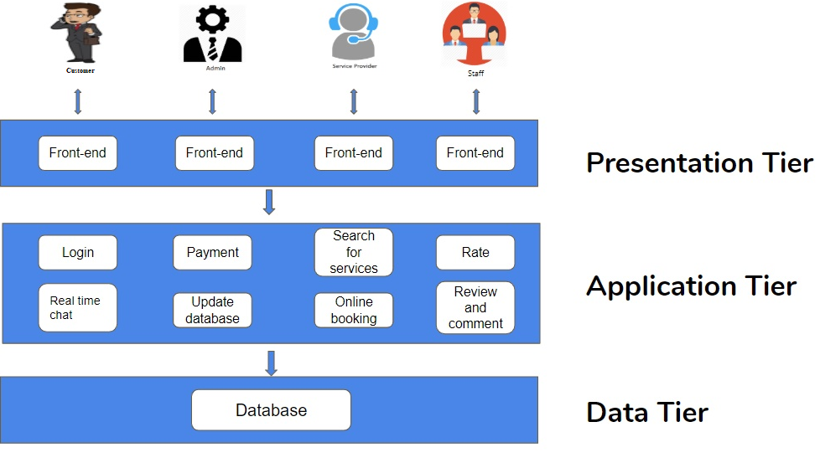

## Components and their responsibilities

**Authentication**

* Authentication component handles user authentications
* Manage Login Sessions

**Notifications**

* Notification component handles the notification through the system.

**User management**

* User management component handles the authentication, notification and other specific components.
* Customer, Staff Member, Admin and Servicer Provider is directly connecting to the User management component.

**Staff Member**

* Staff Member component controls the flow between staff member and customer.
* Staff Member component handles all the complains.
* Staff Member component verifies Service provider profiles.
* Staff Member publicizes public events.

**Admin**

* Admin component’s some objects are inherited from staff member.
* Admin component create staff member accounts as and specific task.

**Customer**

* Customer component lets to book, review, comment event related services.

**Booking**

* Booking component handles the booking of the services.
* Booking component handles the availability of the services.

**Service**

* Service component handles services related to events

**Service Provider**

* Service provider component’s object is creating events

**Live Chat**

* Customer can chat with selected service providers

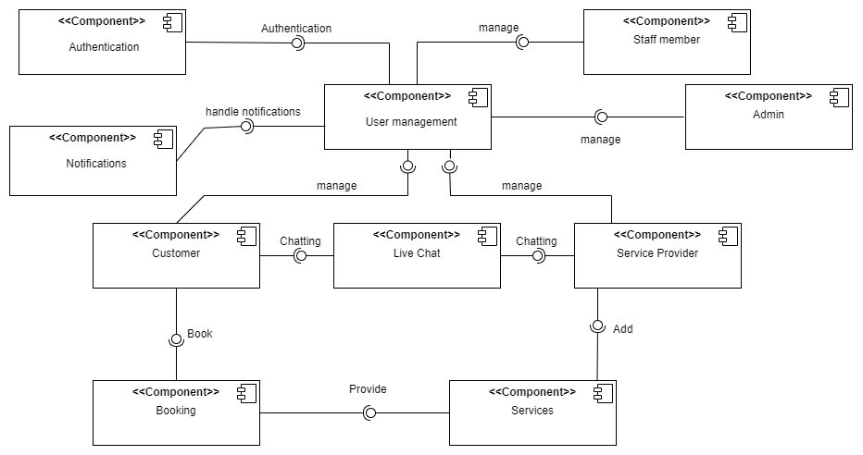

# System’s Design

## ER Diagram

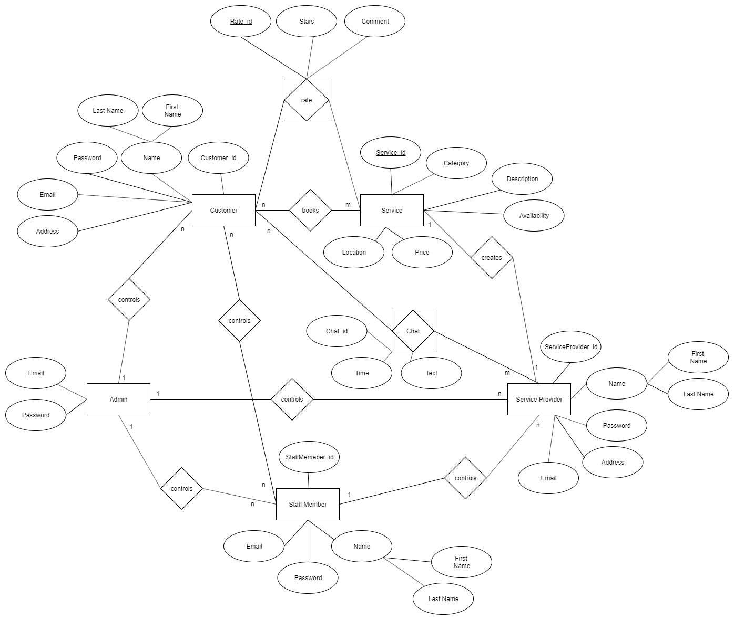

## Class Diagram

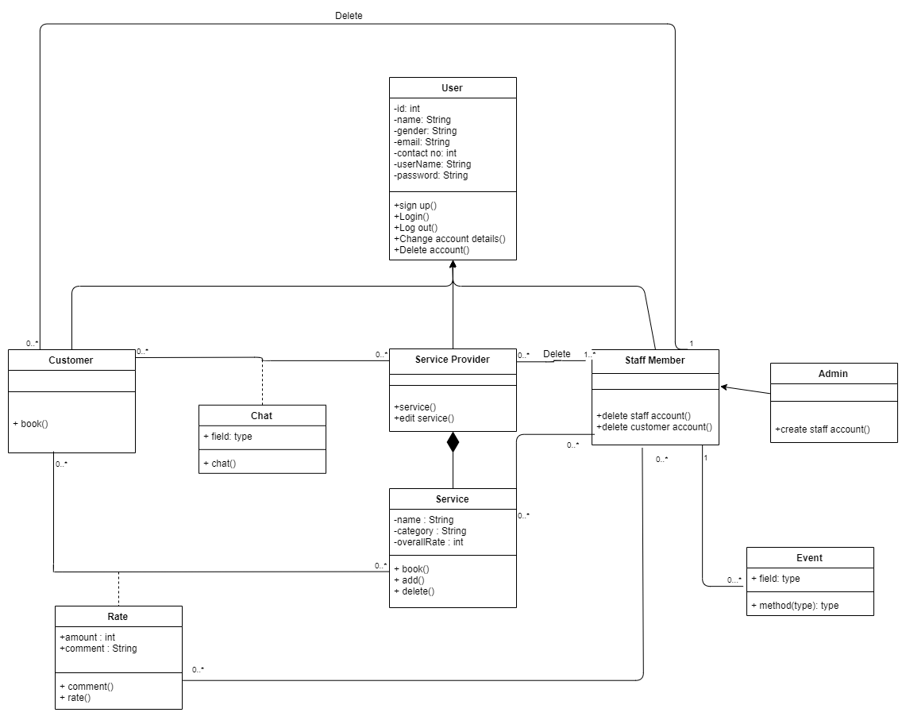

## Sequence Diagram

Customer registration

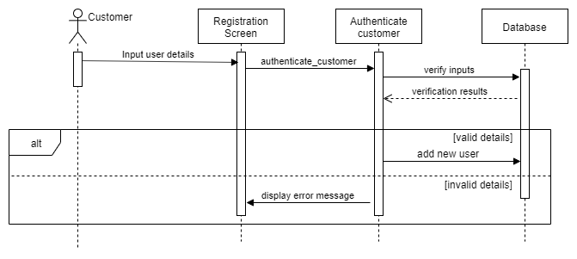

Customer login

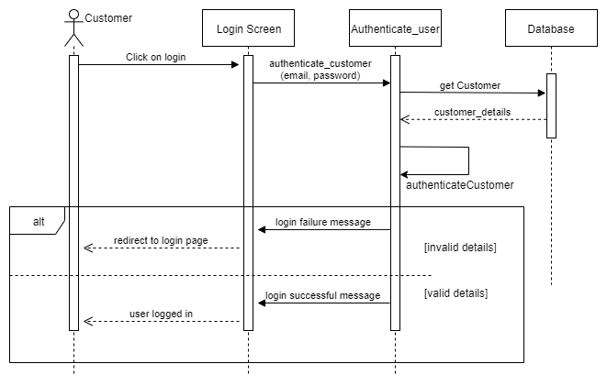

Book a service

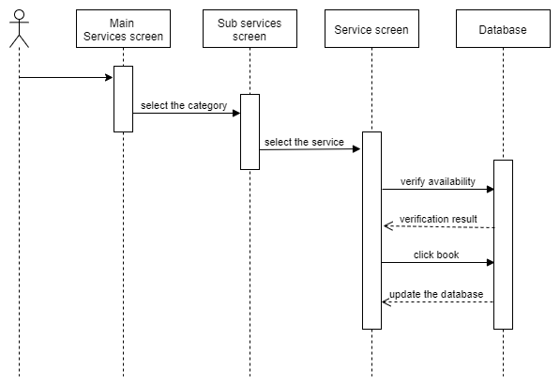

Rate the service provider

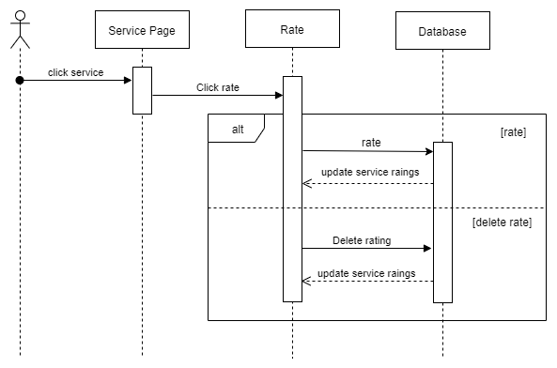

Handle services

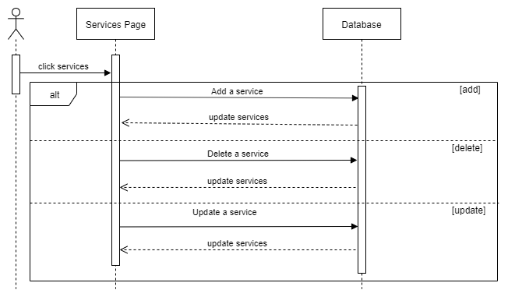

Live chat

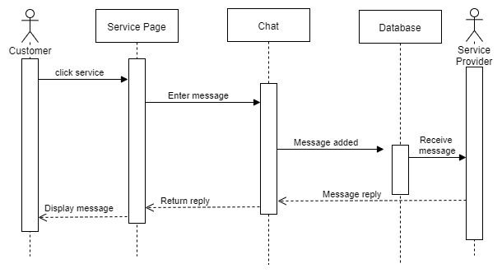

# Interfaces and Interface Flow Diagram

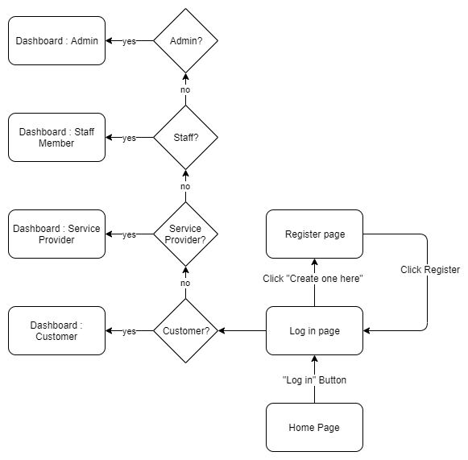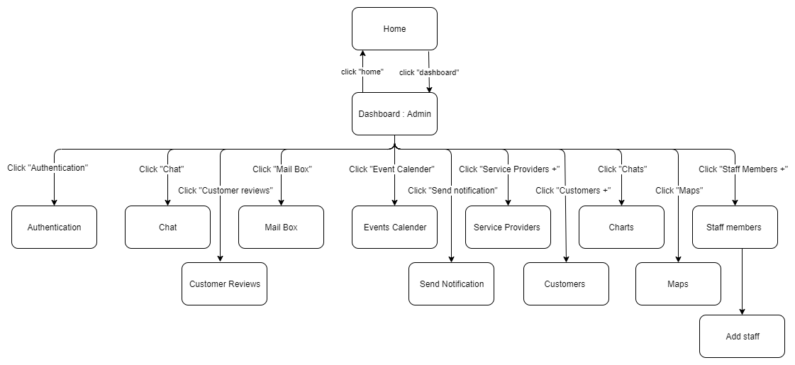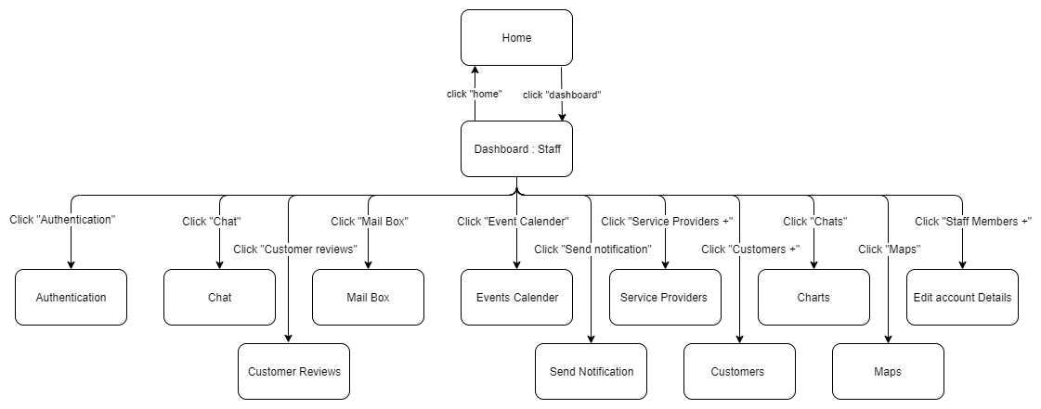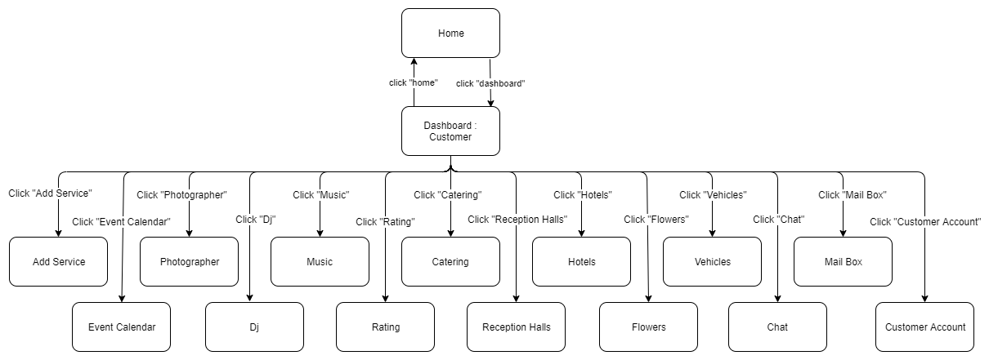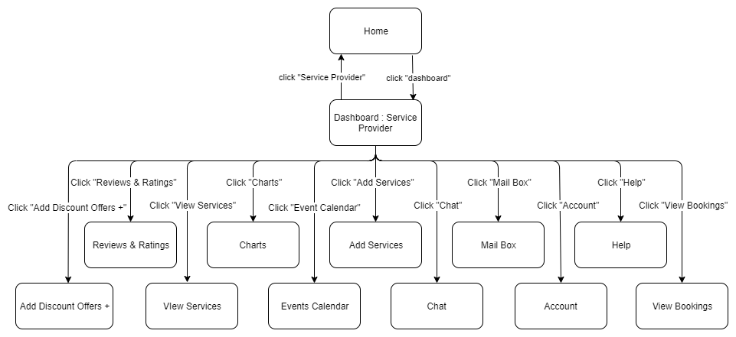

### User Interfaces

Login Page

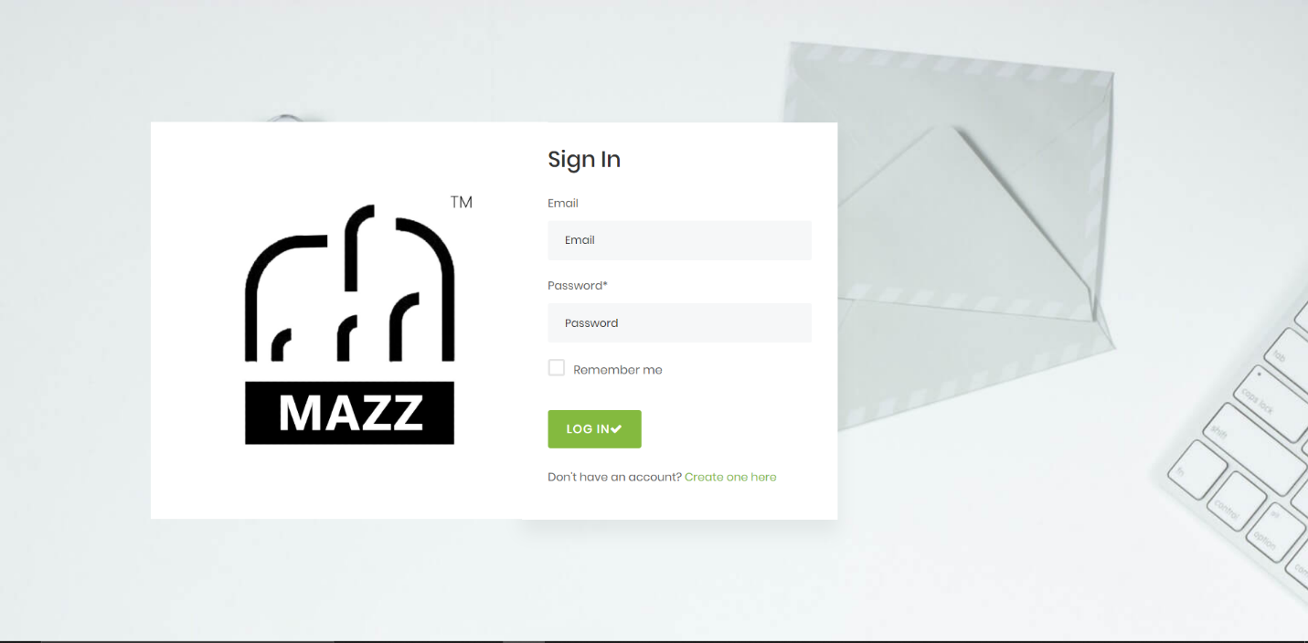

Admin Dashboard

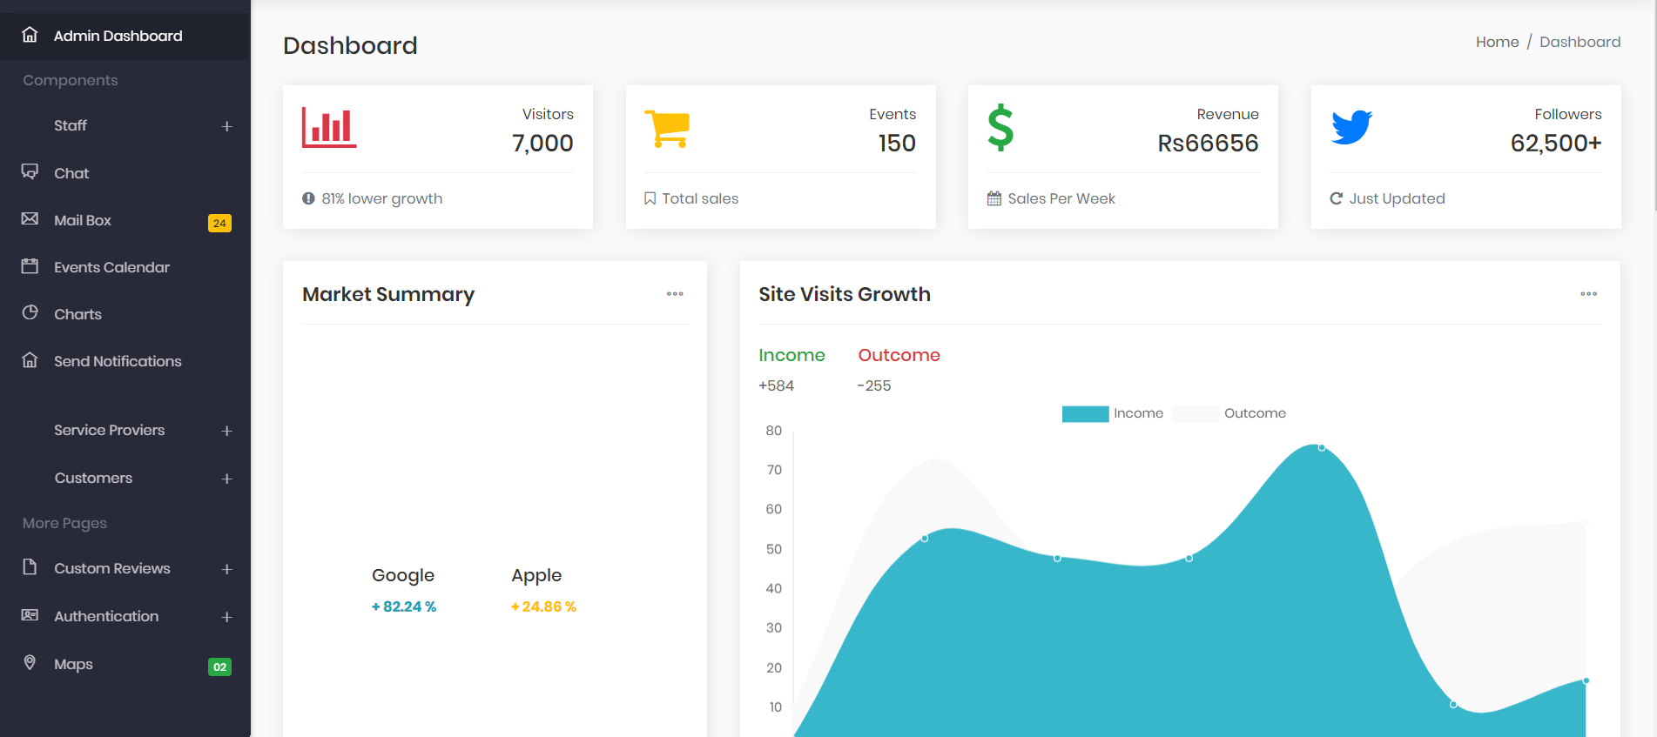

Staff Dashboard

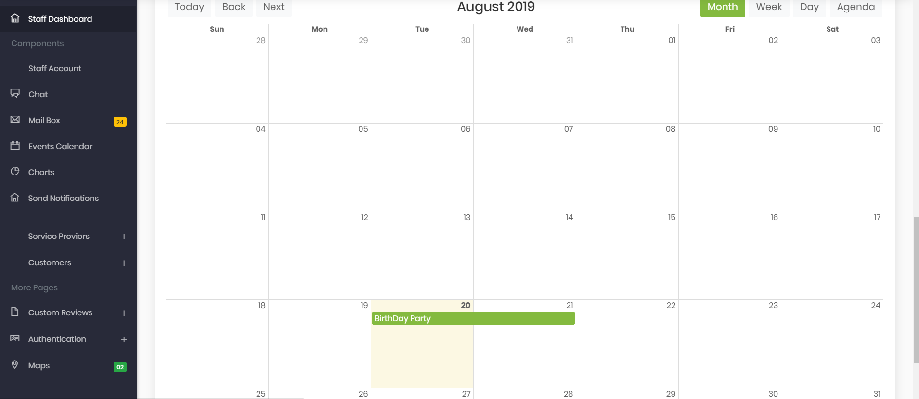

Customer Dashboard

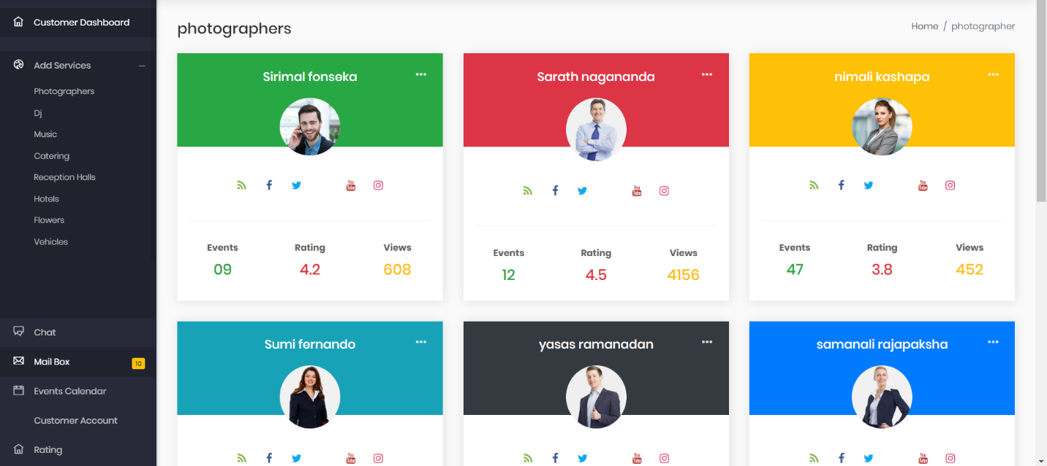

Service Provider Dashboard

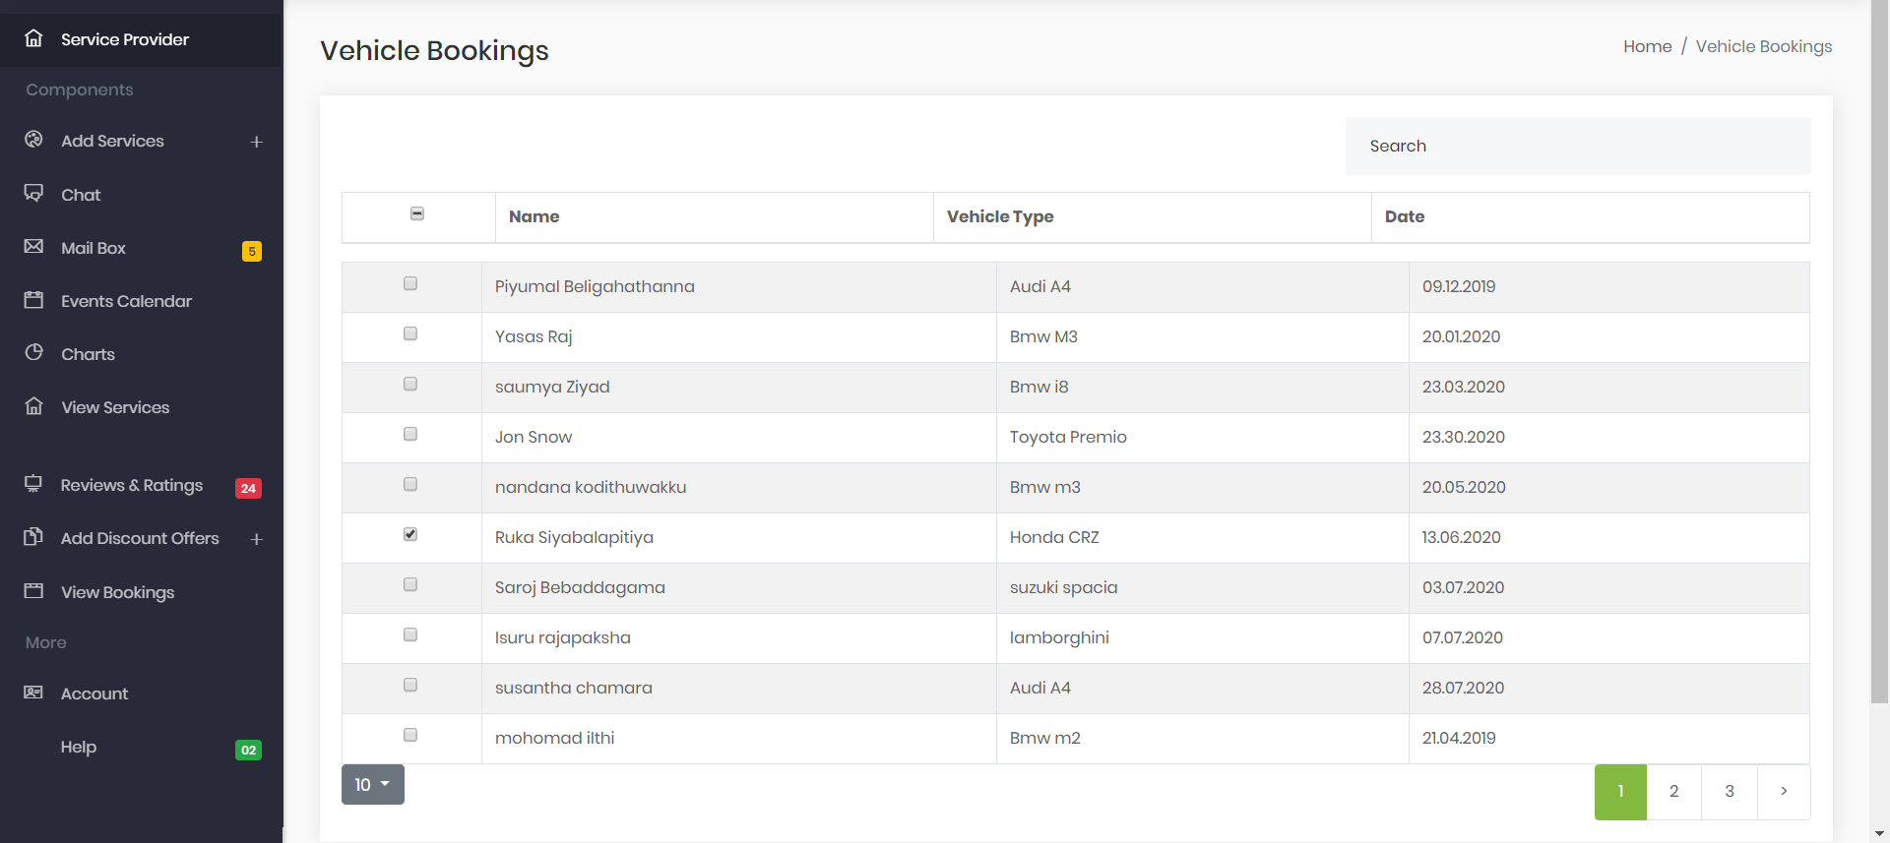

Live Chat

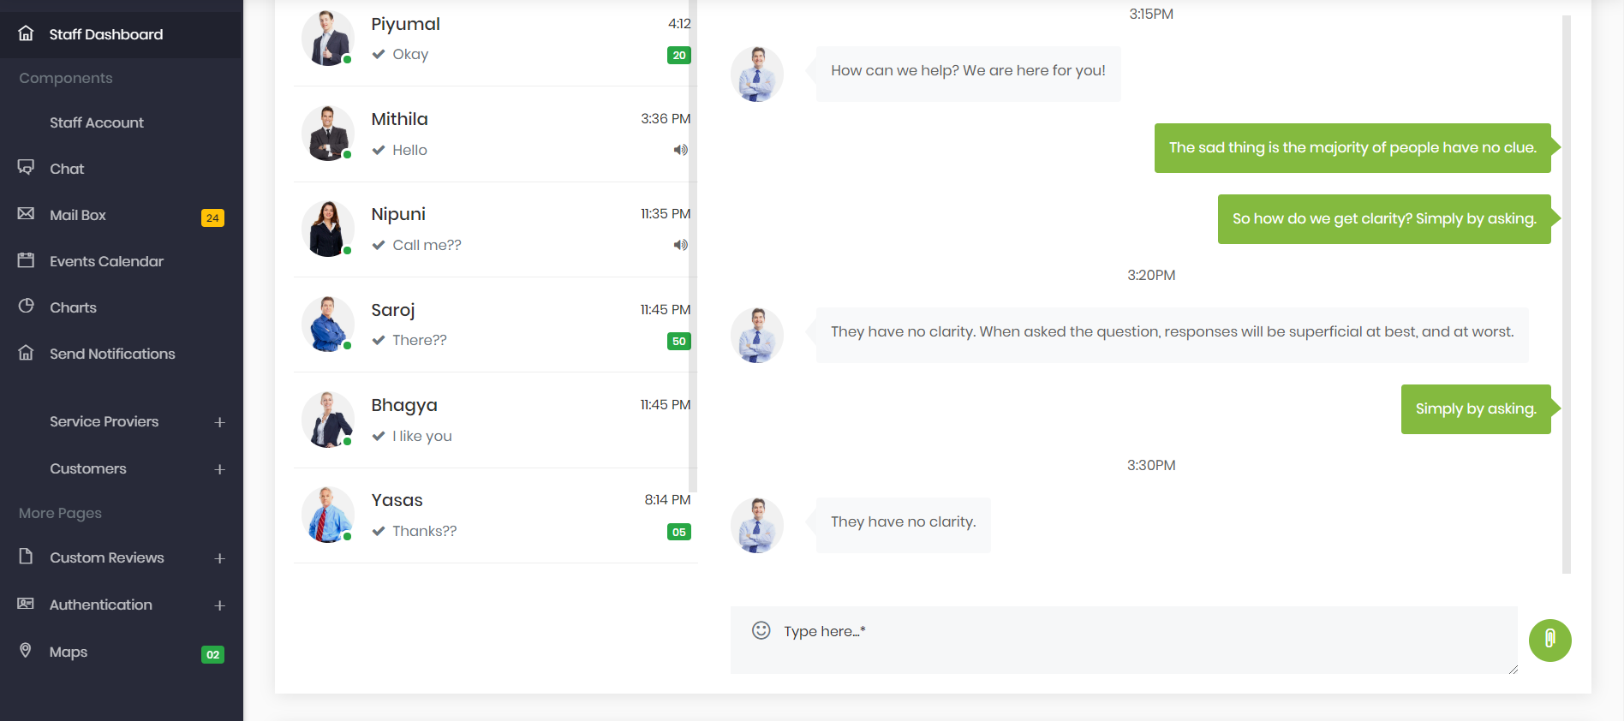

### Communications Interfaces

* All data transfer between the server and the individual computers shall use the TCP/IP networking protocol over and internet connection.
* To access the system user requires a properly configured version of a Windows /Mac/Linux/Android/IOS operating system and compatible web browser.

# References

1. 830-1984 - IEEE Guide for Software Requirements Specifications<https://ieeexplore.ieee.org/document/278253/>

2. System Analysis and Design Methods 7th edition Jeffrey L. Whitten, Lonnie D. Bentley, 2007

<https://dropbox212.wordpress.com/2014/11/03/systems-analysis-and-design-methods-7e-jeffrey-l-whitten-lonnie-d-bentley-2007/>