IN-PLANT TRAINING REPORT

NAME OF THE STUDENT: MITHIL ANIRUDDHA ZINZUWADIA
NAME OF THE INDUSTRY: RELIANCE INDUSTRIES LIMITED (DMD)
PROJECT: STUDY AND STABILIZATION OF THE DEHYDRATION COLUMN
MENTOR: PRAKASH SHAH (HOD PTA - 6)

SIGN OF THE MENTOR

INDEX

Sr. No. | TITLE | Pg. No.
1 | ACKNOWLEDGEMENT | 1
2 | RELIANCE | 2
3 | RELIANCE-DMD | 3
4 | PTA PLANT | 4
5 | PTA-6 | 8
6 | OXIDATION SECTION | 10
7 | EFFLUENT TREATMENT PLANT | 22
8 | PROJECT | 24
9 | DH COLUMN | 29
10 | STABILIZATION OF DH COLUMN | 32
11 | SAFETY ASPECTS | 35
12 | SUGGESTIONS | 35

ACKNOWLEDGEMENT

I would like to thank Mr. Prakash Shah (Mentor) for guiding me throughout my training and providing his constant support. I would also like thank Mr. Manish Bakshi (HR department) for giving me the opportunity to undergo in In-Plant training at RIL-DMD.
I appreciate the kind gesture of Mr. Suraj Iyer and Tanay Mitra for helping me get an overview of the plant.
I would also like to thank Mr. Ronak Mehta (GET) for constantly helping me understand the plant and guiding me through each and every problem I had during my training.
Lastly, I would like to thank my co-interns, who were a constant support throughout this training.

RELIANCE

Reliance Industries Limited (RIL) is an Indian conglomerate holding company headquartered in Mumbai, Maharashtra, India. Reliance owns businesses across India engaged in energy, petrochemicals, textiles, natural resources, retail and telecommunications. Reliance is the second most profitable company in India, the second-largest publicly traded company in India by market capitalization and the second largest company in India as measured by revenue after the government-controlled Indian Oil Corporation. The company is ranked 114th on the Fortune Global 500 list of the world's biggest corporations, as of 2014. RIL contributes approximately 20% of India's total exports. It is ranked 14th among the Top 250 Global Energy Companies by Platts.
The company was co-founded by Dhirubhai Ambani and his brother Champaklal Damani in 1960s as Reliance Commercial Corporation. In 1965, the partnership ended and Dhirubhai continued the polyester business of the firm. In 1966, Reliance Textiles Industries Pvt Ltd was incorporated in Maharashtra. It established a synthetic fabrics mill in the same year at Naroda in Gujarat. In 1975, the company expanded its business into textiles, with "Vimal" becoming its major brand in later years.
In 1985, the name of the company was changed from Reliance Textiles Industries Ltd. to Reliance Industries Ltd. During the years 1985 to 1992, the company expanded its installed capacity for producing polyester yarn by over 145,000 tonnes per annum.
The Hazira petrochemical plant was commissioned in 1991–92.
In 1996, it became the first private sector company in India to be rated by international credit rating agencies
The years 1998–2000 saw the construction of the integrated petrochemical complex at Jamnagar in Gujarat, the largest refinery in the world.
In 2002–03, RIL purchased a majority stake in Indian Petrochemicals Corporation Ltd. (IPCL), India's second largest petrochemicals company, from Government of India. IPCL was later merged with RIL in 2008. In the years 2005 and 2006, the company reorganized its business by demerging its investments in power generation and distribution, financial services and telecommunication services into four separate entities. In 2006, Reliance entered the organized retail market in India with the launch of its retail store format under the brand name of 'Reliance Fresh'. Major subsidiaries and associates:
- Reliance Retail
- Reliance Life Sciences
- Reliance Institute of Life Sciences (RILS)
- Reliance Logistics
- Reliance Clinical Research Services (RCRS)
- Reliance Solar
- Relicord
- Reliance Jio Infocomm Limited (RJIL)
- Reliance Industrial Infrastructure Limited (RIIL)
- LYF, a 4G-enabled VoLTE smartphone maker based in Mumbai.
Reliance Industries Limited – Dahej Manufacturing Division

Dahej Manufacturing Division (DMD), an integrated petrochemical complex located near Jageshwar Village, Bharuch District, Gujarat, 130 Kilometers southwest of Vadodara which earlier known as Indian Petrochemical Corporation Limited (IPCL) Dahej Manufacturing Division located near Bharuch, Gujarat, is spread over 1,778 acres. It comprises of an ethane / propane recovery unit, a gas cracker, a caustic chlorine plant and 4 downstream plants, which manufacture polymers and fibre intermediates.

The Dahej Manufacturing Division consists of the following existing plants & related utilities which are in operation.

- Vinyl Chloride Monomer (VCM)
- Poly Vinyl Chloride Unit (PVC)
- Chlor-Alkali Unit (CA)
- Gas Cracker Unit (GCU)
- Ethylene Oxide/ Ethylene Glycol Unit (EO/ EG)
- High Density Poly Ethylene Unit (HDPE)
- Ethylene Vinyl Acetate (EVA)
- Ethane Propane Recovery Unit (EPRU)
- Purified Terephthalic Acid Unit (PTA)
- Polyethylene Terephthalate (PET)
- Utilities including Captive Power Plant
The complex has its own facility for separating ethane/propane from rich gas containing recoverable amounts of ethane / propane purchased from GAIL. The lean gas from which the ethane / propane has been extracted is returned to GAIL. The ethane / propane mixture is then used as a feedstock for the gas cracker plant.
The complex was commissioned in two phases in order to rationalize cash flows and level of borrowings. The Caustic Chlorine, VCM and PVC pants in phase one was commissioned in 1997. After this, in phase two, HDPE plant, MEG plant, ethane / propane recovery plant and gas cracker unit were commissioned in 2000.
RIL-DMD produces main products namely Polyvinyl Chloride (PVC), High Density Poly Ethylene, (HDPE), Mono Ethylene Glycol (MEG), Caustic soda lye & Ethylene Vinyl Acetate (EVA), Polyethylene Terephthalate (PET) & Purified Terephthalic Acid (PTA) along with some valuable chemical by products like HCl, Wax, DEG, TEG, Mix Oil, RARFS etc., which are either consumed internally, exported to sister divisions or sold in the open market. Propylene produced in Gas Cracker Plant of DMD, which is a raw material for manufacture of PP Polymer, is exported to VMD where it has PP manufacturing Plant through connected piping network.

PURIFIED TEREPTHALIC ACID PLANT

- INTRODUCTION

PTA has the form of a white, crystalline powder and looks like powdered sugar. It is quite inert, which means that, for example, it is difficult to dissolve in water or other liquids. PTA is an aromatic acid, primarily applied in the production of polyester. The main raw material for PTA is Paraxylene (PX).
When Amoco Chemicals Belgium was established in 1967, the production of PTA (purified terephthalic acid) had already been planned. In 1969, the first PTA unit (PTA1) came on line and in 1991 the second one (PTA2) followed.

- RAW MATERIALS AND CHEMICALS

- Paraxylene (raw material)
- Compressed air (raw material)
- Hydrobromic acid (promoter)
- Cobalt acetate (catalyst)
- Manganese acetate (catalyst)
- CMA catalyst solution
- Acetic acid (solvent)
- Normal propyl acetate (entrainer)
- Oxalic acid (catalyst recovery reagent)
- Sodium formate
- Platinum
- Hydrogen (for purification)
- Caustic soda 5% w/w (off gas scrubbing)

- PROCESS CHEMISTRY

  - Oxidation chemistry

Terephthalic acid (TA) is produced by the liquid-phase air oxidation of paraxylene in acetic acid solvent, and is catalyzed by soluble cobalt, manganese and bromine compounds

The water produced as a by-product of the reaction will slow down or inhibit the rate of reaction if allowed to build up in the liquid phase and is therefore continually withdrawn from the reactor. The overall reaction is extremely quick and typical reactor product only contains 0.2 to 0.3% of 4-carboxybenzaldehyde (4CBA), the major impurity.

The reaction is highly exothermic, liberating close to 3,000 kcals or 12,500 kJ per kg of paraxylene consumed. The reaction proceeds via a series of steps in which each methyl group is sequentially oxidized via the aldehyde to the acid.

The slowest step in the above series of reactions is the oxidation of paratoluic acid; hence this acid is the intermediate present in the largest quantity. Since paratoluic acid is soluble in acetic acid solvent it does not appear as the major impurity in the CTA product. 4CBA, although present in smaller amounts in the reactor is much less soluble in acetic acid: It co-precipitates with terephthalic acid and hence appears as the major impurity in CTA.

The process achieves a high yield of terephthalic acid from paraxylene - typically 96-97% of stoichiometry
Apart from some unreacted paraxylene escaping in the vapour stream leaving the reactor, there are other reactions forming by-products such as benzoic and trimellitic acids and some burning to CO/CO2. Impurities in the paraxylene feed, such as ortho and metaxylenes, toluene and ethylbenzene are respectively oxidised to ortho and isophthalic acids and benzoic acid.
Although Acetic acid does not appear in the main reaction sequence, acetic acid has an important role in the oxidation process. It serves as a solvent for both paraxylene and the cobalt/manganese/bromine catalyst in the reactor feed and it forms slurry with the precipitated CTA crystals, enabling the product to be easily removed from the reaction system. Acetic acid losses are a major economic consideration in the operation of the process hence, the process conditions must be optimized to give the desired level of 4CBA in the product whilst minimizing acetic losses. The overall reaction is as follows:

3.2 Purification Chemistry
The function of the Purification Plant is to reduce the levels of intermediates and by-products. This is achieved by dissolving the CTA in water at high pressure / temperature and reacting the impurities with Hydrogen in the presence of a catalyst. This is called a Hydrogenation reaction. This reaction effectively converts the impurities into more soluble or non-coloured forms, which stay dissolved in the water phase in the subsequent crystallisation stage. Both CTA and 4CBA are very insoluble but p-TA is soluble. The p-TA and other non-coloured forms are purged from the plant in the mother liquor from the primary solid/liquid separation stage.

The main reactions that take place are: -

a) 4-CBA + Hydrogen p-TA + water (or to 4-carboxy benzyl alcohol).
Both products are soluble in water.

b) Colored impurities + Hydrogen Non - colored impurities or to soluble colored impurities.

PTA – 6 (DMD)

The PTA PLANT is designed for an annual capacity of 1,120,000 tonnes of Pure Terephthalic acid (PTA).

The PTA PLANT is designed to produce this output in an 8000 hour operating year, based on a flow sheet rate of 140 te/h of PTA, on a single stream basis. This rate is referred to as the normal capacity.

Design flexibility of the PTA PLANT is expected to allow operation in the range 70 – 110% of normal capacity.

Raw Materials required for 100 % normal capacity:
Raw Materials | Specific Consumption  (Kg/TON of PTA)
Paraxylene | 656
Acetic acid (as 100%) | 35.5
Cobalt (as metal) | 0.03
Manganese (as metal) | 0.06
HBr (as 100%) | 0.55
Entrainer (Normal Propyl Acetate) | 0.70
Catalyst Recovery Reagent (Oxalic Acid) | 0.5
Support Fuel (Methanol) | 2.62
Caustic (100%) | 4.96
Sodium Formate (as 100%) | 0.04
Hydrogen (as 100%) | 0.12
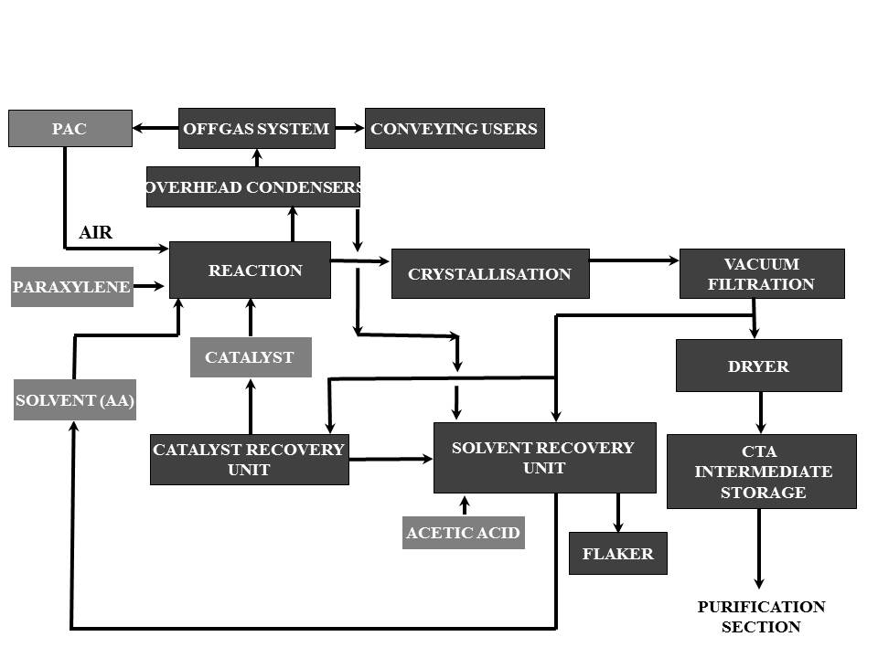
Block Flow Diagram of Oxidation Section of PTA - 6
OXIDATION SECTION

- GENERAL PROCESS:

The Oxidation Plant is designed for continuous operation and consists of six main sections: Process Air Compression and Offgas Treatment, Reaction, CTA Crystallisation, Separation & Drying, Catalyst Recovery and Solvent Recovery.

In the Process Air Compression and Offgas Treatment Section atmospheric air is compressed and fed to the reactor. Cooled offgas from the reactor is heated and passed over a catalyst before passing through an expander, being scrubbed and discharged to atmosphere.

In the Reaction Section paraxylene feedstock is mixed with acetic acid solvent and catalyst solution and reacted with air. The major proportion of the terephthalic acid produced in the exothermic reaction is precipitated in the reactor to form slurry.

In the CTA Crystallisation Section the reactor exit slurry is depressurised and cooled in a series of three crystallizing vessels. The precipitated terephthalic acid product is recovered in the Separation and Drying Section by continuous filtration incorporating a solvent wash stage. A proportion of the mother liquor generated in this stage is purged to Catalyst Recovery. Residual solvent acetic acid in the filter cake is removed in a continuous drier. The resultant product is conveyed to intermediate storage on the Purification Plant.

In the Catalyst Recovery Section, catalyst is recovered from the Oxidation Plant mother liquor purge. The composition of recovered catalyst is adjusted to produce a catalyst solution for feed to the Reaction Section.

In the Solvent Recovery Section, impure solvent recovered from the Reaction, Catalyst Recovery and CTA Recovery Sections, is processed to remove acetic acid and water from the higher boiling reaction by-products. The recovered solvent is fractionated to remove low-boiling impurities and the water of reaction, and produces purified acetic acid suitable for re-use in the Plant. The higher-boiling by-products are quench cooled in water and the resulting slurry disposed of in a Thermal Oxidizer or cooled and solidified in a Residues Flaker for subsequent processing OSBL.

- EQUIPMENT DESCRIPTION:

  - OXIDATION REACTOR:
The Oxidation Reactor is a vertical, agitated pressure vessel constructed from titanium-clad carbon steel. It has an internal diameter of 9920 mm and a tan-to-tan height of 9800 mm. The vessel has an elliptical head and base and contains four equi-spaced baffles which extend from the bottom dished end to the top tangent line. The Reactor has a design pressure of 20.9 barg and a design temperature of 281°C. All vessel internals are titanium.
Design Conditions |  | Operating Conditions |  | Dimensions
Pressure  (Barg) | Temperature  ( ºC ) | Pressure  (Barg) | Temperature  ( ºC ) | Diameter  (mm) | Height  (mm)
20.9 | 281 | 15.3 | 197 | 9920 | 9800

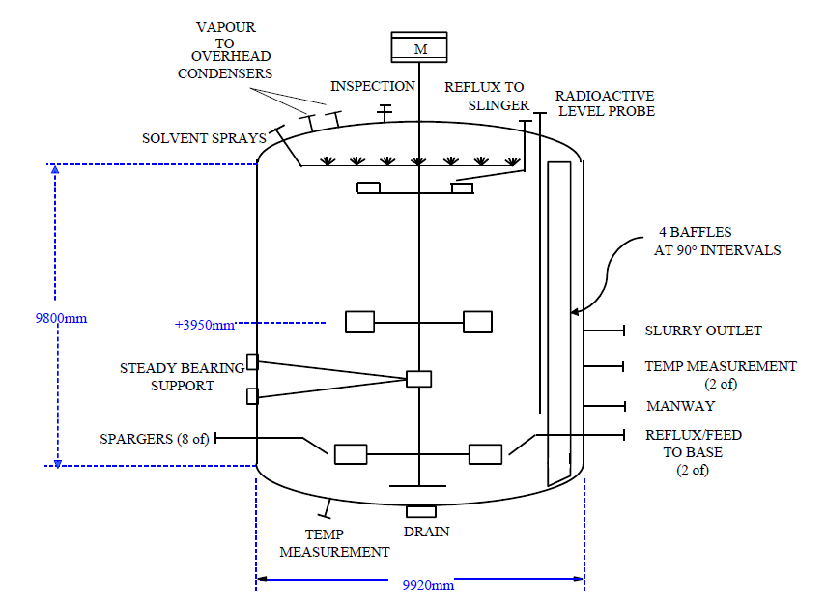

Air is supplied to the Reactor through eight sparger pipes. These are located at 45° intervals near the base of the Reactor with the internal pipe outlets at the same elevation as the centreline of the curved radial blade impeller.

During normal operation a nominal flow of HP solvent is put through these sprays to prevent build-up of solids in the spray nozzles.

A Manway is provided for vessel inspection and this is located close to the vessel bottom tan line.

Reactor Level Control:
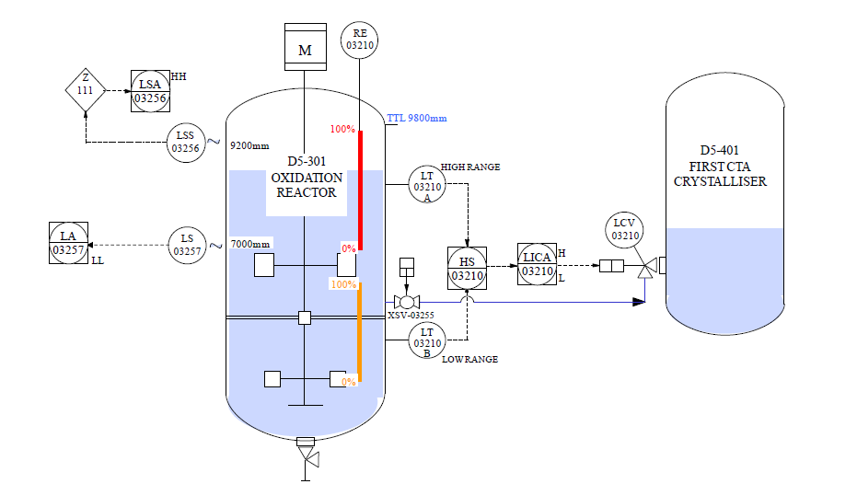
Level is measured using radioactivity. A set of radiation sources is housed in an internal dip tube, which is sealed from the process. This radiation source can be lowered and raised within the dip tube and when in the lowered position, radiation is directed through the Reactor wall to detectors. Two fixed point detectors are located approx. 9200 mm and 7000 mm respectively from the vessel bottom tan line. Two tubular detectors cover two separate ranges at the top and bottom of the vessel rather than one continuous range over the whole height.

The normal operating level for the Reactor, with aerated slurry and with the agitator running is 8000 mm above the bottom tan line. This lies within the upper range of detection. The low measurement range is only utilised during abnormal operation such as start-up, shut-down and Reactor hold, when the Reactor contents are unaerated. In these circumstances the level falls to approx. 47% of the normal height which is outside the range of the upper detector.

  - Crystallizers

The purpose of the Crystallization Stage is to reduce the pressure and temperature of the Reactor products so that the TA crystals can be separated from the Mother Liquor by the Rotary Vacuum filters. The Crystallizers also provide buffer capacity between the Reaction and Product Recovery Sections.

The Product from the Reactor is let down in pressure under level control into the First CTA Crystalliser. Acetic Acid and water are flashed off and the vapour condensed by cooling in the First CTA Crystalliser Condenser. Further cooling of the vapour takes place in the First CTA Crystalliser Vent Condenser, before being discharged into the HP Absorber.

The First CTA Crystalliser is a titanium clad carbon steel vessel fitted with bleed tubes or "Tell Tales" through the carbon shell to areas where the titanium sections are welded. If the welds fail then the bleed holes will pass liquid and warn of the leak before any serious damage to the carbon steel begins. The bleed holes must be kept clear of any vessel lagging and should be inspected daily.

The vessel is sized to provide adequate residence time for product quality control and to provide “buffer” capacity during plant upsets. Vessel diameter is designed to ensure minimal solids carryover in the vapor stream from the vessel.

The maximum design pressure and temperature of the Crystallizer are 19.7 barg and 281 ºC and it is also designed to withstand full vacuum.

The Crystalliser has diameter of 5800 mm and height of 8500 mm between upper and lower tangent lines. The vessel has an elliptical head and base and contains 4 equally spaced baffles, which extend from the bottom dished end to height 8075mm from the bottom tangent line. All vessel internals are Titanium.
The offgas from the First CTA Crystalliser is analyzed continuously for oxygen and carbon dioxide downstream of the First CTA Crystalliser Vent Condenser. Three sampling conditioning systems are provided to further cool the gas and remove any volatiles to prevent contamination and flooding in the analyzers.
For Crystallizer 1:
Design Conditions |  | Operating Conditions |  | Dimensions
Pressure  (Barg) | Temperature  ( ºC ) | Pressure  (Barg) | Temperature  ( ºC ) | Diameter  (mm) | Height  (mm)
19.7 | 281 | 13.8 | 190 | 5800 | 8500

The Second CTA Crystalliser is a titanium clad carbon steel vessel fitted with bleed tubes or through the carbon shell to areas where the titanium sections are welded. If the welds fail then the bleed holes will pass liquid and warn of the leak before any serious damage to the carbon steel begins. The bleed holes must be kept clear of any vessel lagging and should be inspected daily.
The slurry feed from the First CTA Crystalliser enters the Second CTA Crystalliser through the First CTA Crystalliser level control valve, which is pad mounted on the side of the Second Crystalliser. Slurry leaves the vessel and is fed to the Third CTA Crystalliser through a nozzle, located on the vessel side. Both the feed line and discharge line are provided with solvent flush, caustic flush and drain facilities.
For Crystallizer 2:
Design Conditions |  | Operating Conditions |  | Dimensions
Pressure  (Barg) | Temperature  ( ºC ) | Pressure  (Barg) | Temperature  ( ºC ) | Diameter  (mm) | Height  (mm)
9.9 | 225 | 4.3 | 160 | 5800 | 8800

The Third CTA Crystalliser is constructed from duplex stainless steel and is sized to provide “buffer” capacity during plant upsets. The maximum design pressure and temperature of the Crystalliser are 4.1 barg and 170 ºC. It is also designed to withstand full vacuum.
The slurry feed from the Second CTA Crystalliser enters the Third CTA Crystalliser through the Second CTA Crystalliser level control valve which is pad mounted on the side of the Third Crystalliser
For Crystallizer 3:
Design Conditions |  | Operating Conditions |  | Dimensions
Pressure  (Barg) | Temperature  ( ºC ) | Pressure  (Barg) | Temperature  ( ºC ) | Diameter  (mm) | Height  (mm)
4.1 | 170 | 0.5 | 90 | 6000 | 8500

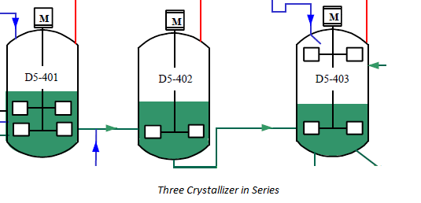
2.3 Process Air Compressor:
Air is drawn from the atmosphere through the Air Inlet Filter and Air Compressor Inlet Silencer to the suction side of each Process Air Compressor
The Process Air Compressor compresses up to ~ 490 t/h of ambient air to a pressure of up to 18.3 bara. The Compressor has five stages of compression with intercooling between the first four stages. During start up, air is discharged to atmosphere via the Blow-Off Silencer and during normal operation air is supplied to the Oxidation Reactor and First CTA Crystalliser via a common delivery line via the Air Compressor Discharge Silencer. The Oxidation Reactor can operate at pressures up to 16.25 barg. A much smaller air flow is supplied to the First CTA Crystalliser for the secondary oxidation process carried out in this vessel.
The degree of turndown of the Process Air Compressor is limited (70 - 80%) and for operation of the Oxidation Reactor at rates of 50% flowsheet or less, excess air from the delivery of the Compressor is sent to the Offgas Expander, via the air bypass route to the Catalytic Combustor, so that energy recovery can take place.
The power to drive the Compressor is provided by the Steam Turbine, which recovers energy by condensing excess plant steam and imported steam, and by the Offgas Expander which recovers energy from the Oxidation Reactor Offgas when the Reactor is on line.
The motor/generator package is used to start-up the machine and then exports excess power produced by the Steam Turbine and Offgas Expander at high plant rates.
Compressor is a five-stage multi-shaft centrifugal compressor with three intercoolers in between the stages. Intercoolers are provided for increasing the compressor Efficiency.

The normal rated flow through PAC is 379.23 m3/hr (corresponding mass flow is 490 TPH). The flow to the compressor is controlled by the Inlet Guide Vane (IGV) opening. The nominal inlet and discharge (5th stage discharge) rated Pressure are 0.99 bara and 18.3 bara. The Inlet and Outlet (5th stage) temperatures are 45 ºC (max) and 153 ºC.

The Process Air Compressor is driven by an electric motor (which can also act as a generator), Steam Turbine and an Expander. The motor will act as the Drive for the compressor at the start-up when there is no steam and Offgas generation from the process respectively. Once the plant is in operation, there is steam and Process Offgas generation to run the Turbine and Expander and hence the Compressor will then be driven by the Steam Turbine and Expander. Also, at full capacity, there is excess generation of Power and the motor will act as a generator.

Inlet Conditions |  | Discharge Conditions
Pressure  (Barg) | Temperature  ( ºC ) | Pressure  (Barg) | Temperature  ( ºC )
0.99 | 33 | 18.3 | 153

2.4 Rotary Vacuum Filter:
The CTA Rotary Vacuum Filters (ROVACs) separate the slurry fed from the Filter Feed Drum into a cake containing less than 15% w/w moisture, and Mother Liquor containing less than 1% w/w solids.

A partial vacuum is applied to the inside of a hollow rotating drum. Slurry is picked up by the drum and the Mother Liquor passes through the filtration cloth to the inside of the drum whilst the solids remain on the outer surface of the cloth forming the cake. The cake, still on the cloth, is washed with fresh solvent as the drum rotates and is then dried with gas drawn through the cake. The cake is blown off the cloth and transferred to the CTA Drier M5-423 by a series of screw conveyors. The vapour and liquid from the inside of the filter drum discharge to the CTA Mother Liquor Separator, F5-411A/B/C. The liquor passes to the Mother Liquor Drum, F5-506, and to Catalyst Recovery on level control. The vapour separates from the liquid and passes first to the CTA Vacuum Vapour Condenser E5-415A/B/C and then to the CTA Vacuum Pump G5-416A/B/C.

Three complete ROVAC systems are installed. All will normally operate together in order to improve quality and to increase operating flexibility. The systems are independent except for the CTA Vacuum Pump Knockout Drum F5-417 and the seal fluid system.

The Rotary Vacuum Filters consist of a cylindrical, perforated filtration drum covered with compartmented filter media rotating on a horizontal axis and housed in a vapour tight casing. The machine is 2205 duplex stainless steel throughout, with the discharge chute having a polished surface. The design pressure of the casing is +0.3 and FoL /-0.3 barg and the design temperature is 125°C. Drum is designed for a higher vacuum (0.1 bara) as it is connected to the vacuum creation system.

Each ROVA filter has 60% of plant name plate capacity (84 TPH of dry PTA equivalent).
Filter medium is a porous cloth made of PEEK (Poly Ether Ether Ketone) with 155 micron pore size, monofilament and twill weaved having air permeability of 260 CFM/ft2 arranged in a single layer They come in two pieces and are caulked at the two edges and center of drum surface.

Slurry is pumped from the CTA Filter Feed Drum into a trough having a pool of slurry in which the filtration drum rotates in a partially submerged state. The feed compartment is inverted pyramid shaped to eliminate the need for auxiliary mechanical agitation devices. Solids are kept in suspension continuously by the upward flow of the feed to the filter. This gentle method of agitation keeps particle degradation to a minimum. The trough is 4.8 m long and for proper functioning of the filter it is important that slurry is distributed uniformly in the slurry pool along the length of the trough with minimum turbulence on the slurry pool surface.

Five spray bars each with 26 spray nozzles (spray pattern: 90° full cone) are provided across the length of the ROVAC filter for cake washing after the first cake drying step (discussed below). The sprays are so laid out in an offset manner that the cake is washed along the entire length of the drum in the washing zone. Proper washing pattern and wash flow are very important for achieving the final quality of TA that comes out of Oxidation section of the plant.
CTA Rotary Vacuum Filter

2.5 CTA/PTA Drier:
The CTA Drier dries wet CTA cake from the Rotary Vacuum Filters reducing the solvent moisture content from 15% w/w to less than 0.1% w/w on a wet basis.

The wet cake from the Rotary Vacuum Filters is typically 70-90°C and the Drier exit CTA product is typically between 140-150 °C.

The CTA Drier is a rotary steam tube drier. It has a revolving cylindrical 2205 duplex stainless steel shell provided with four rows of 2205 duplex stainless steel steam tubes which extend along the length of the CTA Drier, designed for indirect heat-drying, using let down MP steam, normally at 8.3 barg and 177°C.

The design pressure of the shell is +0.3barg/-0.3 barg. The tubes have a design pressure of 15 barg/FV. The design temperature of the shell is 200°C and for the tubes is 230°C.

The CTA Drier has four rows of ball-in-tube knockers to reduce solid cake build-up at the inlet end. Ball knockers are “L” shaped pipes with steel balls inside. There are 4 rows of knockers with 12 knockers per row.

The temperature of the CTA powder exit the CTA Drier is important to ensure that drying is complete. The boiling point of Acetic Acid is 118 °C at atmospheric pressure and the powder must be heated above this to ensure adequate drying. Operational experience has shown that higher temperatures reduce fouling and build up on the CTA Drier tubes. The Drier should therefore be operated at a temperature of approx. 150°C.

Design Conditions |  | Operating Conditions |  | Dimensions
Pressure  (Barg) | Temperature  ( ºC ) | Pressure  (Barg) | Temperature  ( ºC ) | Diameter  (mm) | Height  (mm)
0.3 | 200 | 0.01 | 150 | 4200 | 31000

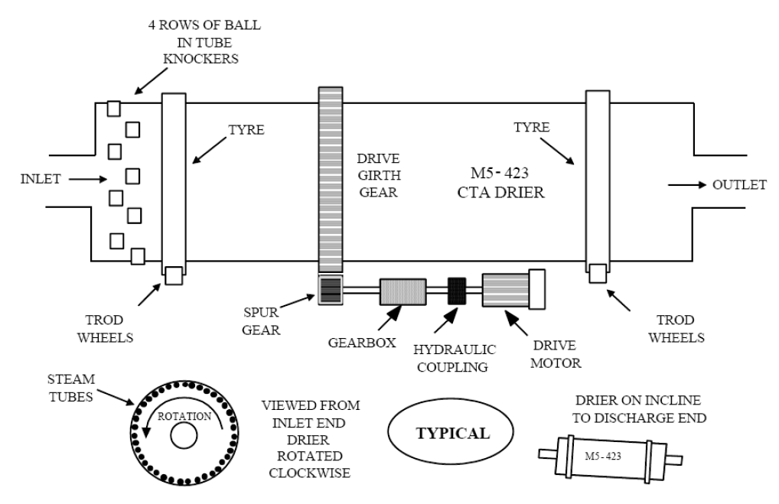
Typical CTA Drier Arrangement

2.6 Solvent Dehydration Column (DH Column):
The Solvent Dehydration Column is designed to separate water from a number of water-rich liquid and vapor streams from the Oxidation plant, and produce acetic acid containing 5.0 ±0.5% w/w water from the base for redistribution as DH Solvent in addition to water containing 0.1% w/w acetic acid from the top of the Column. The Column is an azeotropic unit using normal propyl acetate (nPA) as an entrainer to reduce the energy required for the acetic acid/water separation by breaking the acetic acid/water azeotrope at high water concentration. The heat input to the Column is provided by the DH Column Reboiler which is a thermosiphon-type unit using LP steam.
DH Column is a packed fractionating column constructed from 2205 Duplex Stainless Steel. It has an internal diameter of 6500mm (bottom) / 6900mm (top) and a tan/tan height of 38000mm. The column is separated into three sections: Zone A, Zone B and Zone C.
The top section, Zone A, is packed with one bed (Bed 1) of structured packing (Mellaplus 252Y) constructed from 316L or 2205 Duplex stainless steel.
The middle section, Zone B is packed with one bed (Bed 2) of structured packing (Mellaplus 252Y) constructed from 2205 Duplex stainless steel.
The bottom section, Zone C is packed with one bed (Bed 3) of structured packing (Mellaplus 252Y) constructed from 2205 Duplex stainless steel.
An internal baffle is provided in the column bottom sump to partition the column base. Recovered acetic acid is collected first in the reboilers liquid feed sump below bed 3, this then overflows through the baffle weir to the second larger partition for storage, make up and supply of DH Solvent.
An access panel is fitted on the partition baffle for inspection purposes and a drain hole is also provided at the baffle low point to ensure complete draining during shutdowns.

Design Pressure |  | Design Temperature |  | Dimensions
Upper Section  (Barg) | Lower Section  (Barg) | Upper Section  (ºC) | Lower Section  (ºC) | Diameter  (mm) | Height  (mm)
3.5 | 5.38 | 150 | 225 | 6500 | 38000

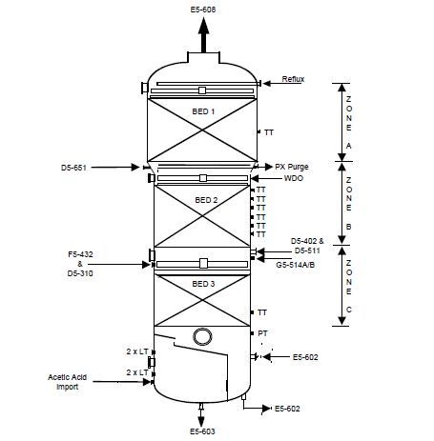
DH COLUMN

2.7 HEAT EXCHANGERS:
2.7.1 SHELL AND TUBE TYPE:
Shell and Tube Heat Exchangers are one of the most popular types of exchanger due to the flexibility the designer has to allow for a wide range of pressures and temperatures.
A shell and tube exchanger consists of a number of tubes mounted inside a cylindrical shell. Figure illustrates a typical unit that may be found in a petrochemical plant. Two fluids can exchange heat, one fluid flows over the outside of the tubes while the second fluid flows through the tubes. The fluids can be single or two phase and can flow in a parallel or a cross/counter flow arrangement.

The shell and tube exchanger consists of four major parts:
- Front Header—this is where the fluid enters the tubeside of the exchanger. It is sometimes referred to as the Stationary Header.
- Rear Header—this is where the tubeside fluid leaves the exchanger or where it is returned to the front header in exchangers with multiple tubeside passes.
- Tube bundle—this comprises of the tubes, tube sheets, baffles and tie rods etc. to hold the bundle together.
- Shell—this contains the tube bundle.
2.7.2 REBOILER
Reboilers are heat exchangers typically used to provide heat to the bottom of industrial distillation columns. They boil the liquid from the bottom of a distillation column to generate vapors which are returned to the column to drive the distillation separation. The heat supplied to the column by the reboiler at the bottom of the column is removed by the condenser at the top of the column.
Proper reboiler operation is vital to effective distillation. In a typical classical distillation column, the entire vapor driving the separation comes from the reboiler. The reboiler receives a liquid stream from the column bottom and may partially or completely vaporize that stream. Steam usually provides the heat required for the vaporization.

Kettle Reboiler
The layout of the kettle reboiler is illustrated schematically in figure below. Liquid flows from the column into a shell in which there is a horizontal tube bundle, boiling taking place from the outside this bundle. The vapor passes back to the column as shown. Kettle reboilers are widely used in the petroleum and chemical industries; their main problems are that of ensuring proper disentrainment of liquid from the outgoing vapor and the problem of the collection of scale and other solid materials in the tube bundle region over long periods of operation.
Vertical Thermosyphon Reboiler
This type is illustrated in figure below. The liquid passes from the bottom of the tower into the reboiler, with the evaporation taking place inside the tubes. The two-phase mixture is discharged back into the tower, where the liquid settles back to the liquid pool and the vapor passes up the tower as shown. The heating fluid (typically condensing steam) is on the outside of the tubes. The vertical thermosyphon reboiler is less susceptible to fouling problems and in general has higher heat transfer coefficients than does the kettle reboiler. However, additional height is required in order to mount the reboiler.
2.8 PUMPS:
2.8.1 Centrifugal Pump
A centrifugal pump is one of the simplest pieces of equipment in any process plant. Its purpose is to convert energy of a prime mover (an electric motor or turbine) first into velocity or kinetic energy and then into pressure energy of a fluid that is being pumped. The energy changes occur by virtue of two main parts of the pump, the impeller and the volute or diffuser. The impeller is the rotating part that converts driver energy into the kinetic energy. The volute or diffuser is the stationary part that converts the kinetic energy into pressure energy.

2.8.2 Reciprocating Pump

A reciprocating pump is a class of positive-displacement pumps which includes the piston pump, plunger pump and diaphragm pump. It is often used where a relatively small quantity of liquid is to be handled and where delivery pressure is quite large. In reciprocating pumps, the chamber in which the liquid is trapped, is a stationary cylinder that contains the piston or plunger.

2.9 BLOWERS:

Blowers use the kinetic energy of the impellers or the rotating blade to increase the pressure of the air/gas stream which in turn moves them against the resistance caused by ducts, dampers and other components. Centrifugal fans accelerate air radially, changing the direction (typically by 90°) of the airflow. They are sturdy, quiet, reliable, and capable of operating over a wide range of conditions.

2.10 SAFETY EQUIPMENTS:

2.10.1 Bursting Disc

Bursting Disc is a non-reclosing pressure relief device that, in most uses, protects a pressure vessel, equipment or system from over pressurization or potentially damaging vacuum conditions. A rupture disc is a type of sacrificial part because it has a one-time-use membrane that fails at a predetermined differential pressure, either positive or vacuum. The membrane is usually made out of metal, but nearly any material (or different materials in layers) can be used to suit a particular application. Rupture discs provide instant response (within milliseconds) to an increase or decrease in system pressure, but once the disc has ruptured it will not reseal.

2.10.2 Relief Valves

The pressure relief valve (PRV) is a type of valve used to control or limit the pressure in a system or vessel which can build up for a process upset, instrument or equipment failure, or fire. The pressure is relieved by allowing the pressurised fluid to flow from an auxiliary passage out of the system. The relief valve is designed or set to open at a predetermined set pressure to protect pressure vessels and other equipment from being subjected to pressures that exceed their design limits. When the set pressure is exceeded, the relief valve becomes the "path of least resistance" as the valve is forced open and a portion of the fluid is diverted through the auxiliary route. The diverted fluid (liquid, gas or liquid–gas mixture) is usually routed through a piping system known as a flare header or relief header to a central, elevated gas flare where it is usually burned and the resulting combustion gases are released to the atmosphere.

2.10.3 ROSOV

A valve designed, installed and maintained for the primary purpose of achieving rapid isolation of plant items containing hazardous substances in the event of a failure of the primary containment system.Closure of the valve can be initiated from a point remote from the valve itself. The valve should be capable of closing and maintaining tight shutoff under foreseeable conditions following such a failure (which may include fire).
Effluent Treatment Plant

The Effluent Treatment Plant has been designed to handle liquid and slurry waste streams from the PTA plant. A drainage philosophy has been developed to collect various liquid effluent streams from the site and these liquid streams are fed into the ETP at one of three entry points;
- Effluent from the Buffer Tanks, plus PET plant effluent and laboratory waste is fed into the effluent pre-treatment section,
- Raw sewage is expected to be fed to the aerobic treatment section,
- Clean water discharges (e.g. cooling tower and demin water plant blowdowns) are fed to the Treated Effluent Tank.
The ETP produces a treated liquid effluent stream, a solid effluent stream and a biogas stream. The liquid stream passes to the site liquid outfall, the solid stream is discharged for offsite disposal, and the biogas is collected and compressed for use as a fuel supplement. As an alternative, the biogas may be directed to flare stack for disposal.

The Effluent Treatment Plant is expected to comprise the following elements:

1. Effluent pre-treatment, consisting of pH control, nutrient addition and effluent temperature control.
2. Anaerobic treatment, with biogas collection and compression.
3. Aerobic treatment combined with tertiary treatment (to remove suspended solids) in a membrane bioreactor
4. Sludge dewatering and drying system.
5. Treated Effluent Tank.
6. Reverse osmosis unit.
- 7. Filtration unit for ‘clean’ process feeds to the RO unit (e.g. cooling water blowdown).
8. Pre-treatment unit for raw sewage.
9. Final Effluent Pit.

The Effluent Treatment Plant is designed to meet the following emission levels for waste water prior to discharge:

- pH 5.5 to 9
- Biological Oxygen Demand (BOD5) less than 60 mg/l
- Suspended solids less than 100 mg/l
- Mineral Oil less than 20 mg/litre
- Temperature less than 45°C
- Manganese less than 5.0 mg/l (*)
- Cobalt less than 3.0 mg/l (*)

(*) Depending on the economics of the operation, these limits may both be reduced to 2.0 mg/l.

Under certain conditions (e.g. plant overhaul) there will be little or no flow entering the Buffer Tanks. If this condition is expected to persist for a significant period of time the ETP rate will need to be reduced in order to maintain adequate operation of the anaerobic system until main flow to the Buffer Tanks can be reestablished. It is expected that the anaerobic system will be capable of turning down to 10% of normal design rate for a minimum of a fortnight and be capable of prompt resumption of higher rate operation.

PROJECT
Study and Stabilization of Dehydration Column

Distillation is the most widely used method for separating components by the Chemical Industry. The process involves successive vaporization and condensation of countercurrent flows of material in a tower containing contacting apparatus. The process relies on there being a changing composition between the liquid that is flowing down the tower and the vapour (in thermodynamic equilibrium with the liquid) that passes up the tower. Components that have a high vapour pressure/low boiling point migrate to the top of the tower and components having a low vapour pressure/high boiling point sink to the base of the tower. In the majority of cases the separation can be achieved as described above with a simple feed to the center of the tower and without having to use additional components to achieve the desired separation.

The vapour pressure of a component in a liquid mixture depends on the nature of the molecule in question, the temperature of the mixture and the composition of the mixture. For ideal mixtures, the vapour pressure is given as the vapour pressure of the pure component at the temperature multiplied by the mole fraction of the component in the liquid. However, most mixtures are not ideal and a further multiplying factor, known as the activity coefficient, is required in order to correctly model the behaviour of a component. The activity coefficient is itself a function of temperature and composition.

In some cases the combination of ideal vapour pressure, composition and activity coefficient can give rise to a situation where the composition of a vapour phase and the composition of the liquid phase in which it is in equilibrium are identical. This is termed an azeotrope and further contacting of the azeotropic vapour and liquid with each other cannot lead to further separation/concentration of the components.

Azeotropes may be high boiling or low boiling. In a high boiling azeotrope, such as occurs with water and hydrochloric acid, the azeotrope will leave from the base of a simple distillation tower and the overhead product will be either water or hydrogen chloride, depending on which component was in excess of the azeotrope in the feed. In a low boiling azeotrope, such as occurs with water and ethanol, the azeotrope will leave from the top of the tower with water or ethanol leaving from the base of the tower, once again depending which was in excess of the azeotropic composition in the feed.

Low boiling azeotropes can further be separated into homogeneous azeotropes, where the liquid is present as a single phase, and heterogeneous, where the liquid is present as two phases. Homogeneous azeotropes are difficult to break, but heterogeneous azeotropes are easy to break since the condensing azeotrope splits into two liquid phases of different composition to the azeotrope and so can be separated by simple decantation based on density difference. In order to break a homogeneous azeotrope, a further component is sometimes added in order to generate a heterogeneous azeotrope which can then be broken through decantation. The heterogeneous azeotrope produced may be either a binary azeotrope of the entrainer with one of the components of the homogeneous azeotrope, or a ternary azeotrope involving the original components of the homogeneous azeotrope plus the entrainer (the classical method of breaking the water and ethanol azeotrope using benzene or cyclohexane as the entraining agent).

The entraining agent may be introduced with the feed or may be stored in the decanter at the top of the azeotropic tower. The overheads vapour composition will be close to the azeotrope. Reflux to the tower may be either one or both liquid phases depending on the ease of the separation. It is important to control the degree of penetration of the entrainer down the tower and this is achieved through a combination of temperature and inventory control.

Acetic Acid/Water Distillation

Water and acetic acid can be separated by simple distillation. Although the components differ in boiling point by 17°C, their separation is difficult because of the non-ideal nature of the vapour-liquid equilibrium. In order to avoid a distillation requiring many theoretical stages and high energy inputs, entrainers are used to generate a low boiling, binary, heterogeneous azeotrope of the water and the entrainer. This approach requires fewer distillation stages and lower energy input. The heterogeneous azeotrope breaks on condensation into two liquid phases which can be separated by decantation.

There are a number of possible candidates for the choice of entrainer to assist in the separation of water and acetic acid. One of the constraints is to use an entrainer that is compatible with the background process. In the case of terephthalic acid production, alkyl esters of acetic acid are the most suitable choice. Normal propyl acetate, iso-butyl acetate and normal butyl acetate are all used commercially for this process.

The patented azeotropic distillation process used by Invista in recovering water from water/acetic acid mixtures uses normal propyl acetate (nPA) as the entrainer. The process operates with a single nPA-rich phase being refluxed to the dehydration tower (normally a packed unit). Use of nPA minimizes the height of the tower compared to iso-butyl acetate (iBA) or normal butyl acetate (nBA) systems for the same feed composition. The main water feed to the tower is condensate derived from the overheads from the oxidation reaction. This is typically 20 - 30% w/w water. With iBA or nBA, the aqueous phase would also have to be refluxed to obtain separation of the water from the acetic acid and to recover the entrainer. Hence the choice of nPA gives the lowest column height and lowest energy usage for these water/acetic acid feed compositions.

 | Conventional Distillation | Azeotropic Distillation
Effective Reflux Ratio | 3.8 | 1.6
Scaled Heat Load | 100% | 54%
Theoretical Stages | 52 | 24
Column Height m. (approx.) | 70 | 37
Column Diameter m.(approx.) | 7.7 increasing to 9.2 | 7.35
- WDO from HP Absorber
- Condensate from 1st crystallizer
- Vapours from 2nd crystallizer
- Vapours from Solvent Strippers
- nPA reflux
Above Streams enter DH columns at various sections of the column. Purge Stream is taken from DH to the purge column to reduce PX concentration and to break PX-nPA Azeotrope.
Fresh Acetic Acid is added from the tank farm at the bottom of the column to maintain the bottom product concentration.
Reboiler is provided near the bottom of the column which provide the heat for the distillation using a LP steam.
Bottom product concentration – Acetic acid 95% and Water 5%
Top product concentration – Water, nPA, methyl acetate and traces of acetic acid.
The overhead products from DH column are sent to DH condenser, contact and entrainer storage tank.
DH condenser condenses azeotrope of nPA and water to separate them as aqueous and organic phase in the DH decanter.
A by-pass to condenser is provided to avoid condensation of methyl acetate. If methyl acetate condenses then it gets mixed in the decanter and it is lost.
Methyl acetate vapours and condensed azeotrope are contacted at the DH column contactor so that equilibrium of various components takes places. These vapors are sent to Methyl Acetate recovery column.
Overhead stream of the recovery column contains methyl acetate as a major product.
Bottom stream of the recovery column contains waste water as a major product which is sent to various section of the plant to use and hence fresh water consumption is reduced.
Entrainer storage tank contains condensed nPA from the decanter and a stream of make up nPA from the tank farm.

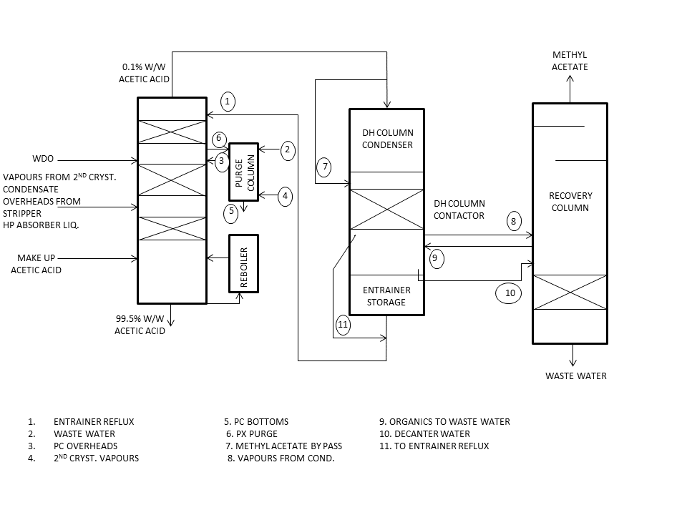
Block Flow Diagram of Solvent Dehydration Section
Solvent Dehydration Column

The Solvent Dehydration Column is designed to separate water from a number of water-rich liquid and vapour streams from the Oxidation plant, and produce acetic acid containing 5.0 ±0.5% w/w water from the base for redistribution as DH Solvent in addition to water containing 0.1% w/w acetic acid from the top of the Column. The Column is an azeotropic unit using normal propyl acetate (nPA) as an entrainer to reduce the energy required for the acetic acid/water separation by breaking the acetic acid/water azeotrope at high water concentration. The heat input to the Column is provided by the DH Column Reboiler which is a thermosiphon-type unit using LP steam. The reflux flow to the Column is provided from the Entrainer Storage Tank via the Reflux Pumps.

There are five feed streams to the DH Column in normal plant running. These are:

• Vapour from the Solvent Stripper.
• Flash vapour from the Second Crystalliser.
• "Water draw-off" from the Reactor overheads
• Condensate from the First CTA Crystalliser Vent Separator.
• Vapour from the Purge Column.

Flash vapours entering from the Solvent Stripper and Second CTA Crystalliser enter above the lower bed in order to ensure efficient methyl acetate stripping from the bottoms product. In addition, acetic acid is imported into the Oxidation plant and distributed via the base of the DH Column. Vapour from the top of the DH Column is fed to the DH Column Condenser and Decanter.

Composition Profile

Concentration vs Temperature Profile

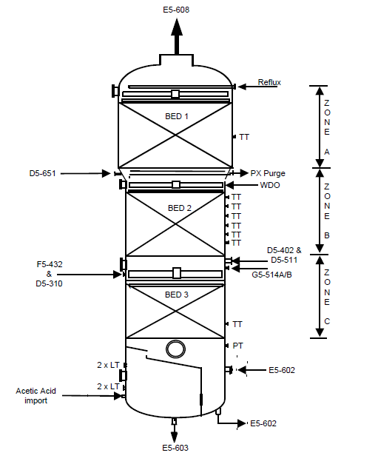
DH Column
The top section, Zone A, is packed with one bed (Bed 1) of structured packing (Mellaplus 252Y, 32 layers) constructed from 316L stainless steel.

Above this bed are the following nozzles:-
- Vapour outlet from the top
- Insert nozzle for entrainer reflux return
- Manway

The bed itself is provided with a branch for a duplex type thermowell/thermocouple.

The middle section, Zone B is packed with one bed (Bed 2) of structured packing (Mellaplus 252Y, 37 layers) constructed from 2205 Duplex stainless steel.

Above this bed are the following:-
- Insert nozzle for the Water Draw-off feed from the HP Absorber
- Paraxylene purge to Purge Column
- Purge Column overhead return
- Manway

The bed itself is provided with six equally spaced branches for duplex type thermowells/ thermocouples.

The bottom section, Zone C is packed with one bed (Bed 3) of structured packing (Mellaplus 252Y, 22 layers and Mellagrid 64Y, 2 layers) constructed from 2205 Duplex stainless steel.

Above this bed are the following:-
- Vapour from the Solvent Stripper
- Flash vapour from the Second CTA Crystalliser
- Insert for liquid from the First CTA Crystalliser Vent Separator
- Insert for acid liquor from the HP Absorber
- Atmospheric Scrubber Bottoms (NNF)
- Manway

The bed itself is provided with a branch for a duplex type thermowell/thermocouple.

Below the bed (in the sump) are the following:-
- Pressure transmitter
- Level transmitters (2 off)
- Manway
- Acetic acid make-up
- Liquid feed (on bottom cover) to the Reboiler
- Reboiler vapour return
- DH Solvent outlet (on bottom cover)

STABILIZATION OF DH COLUMN

DH column is design to provide specific top and bottom product composition. It is important for the DH column and the surrounding equipment to function properly to achieve the desired product composition. Unstable DH column leads to undesired products in the overhead and bottom stream and loss of efficiency of the process.

The Solvent Dehydration Column can become unstable due to one or more of the following problems:

- Reboiler Steam Rate: Reboiler is used to provide the necessary heat energy required to the DH column. Reboiler uses Low Pressure steam to provide this heat. Thus change in LP steam flow rate changes the column bottom profile and leads to various problems.

If the LP steam rate increases, the temperature at the bottom of the column increases and hence water concentration at the bottom of the column decreases which leads to corrosion.

If the LP steam rate decreases, the temperature at the bottom of the column decreases and hence water concentration at the bottom of the column increases which leads to high water content in the reactor which is unfavourable.

Actions that needs to be carried out:

- Check operating parameters against standard operating conditions.
- Check overall DH Column loading – possible over cooling of overheads. Adjust CW to Condenser as required.
- Check on-line analyser results against manual samples.
- Check Column base pressure is "normal" – changes in pressure alter the temperature / water concentration relationship.
- Reset column base to automatic temperature control – Ensure Column base pressure is normal.

- High Pressure: High pressure in the column will lead to increased temperature and hence the temperature profile of the column gets disturbed. Increase in temperature will lead to increased burning of acetic acid and thus decrease in process efficiency.

Actions that needs to be carried out:

- Check operating parameters against standard operating conditions.
- Is the base pressure and overheads pressure high -adjust steam flow and plant rate as required to prevent flooding, - check column differential pressure.
- Check Base level.
- Check DH Column loading e.g. high reboiler steam rates, high reflux rates.
- Check for excessive Crystalliser flash vapour rate – high crystalliser PCV output.

- High Temperature Profile: High temperature profile indicates greater accumulation of PX which leads to azeotrope formation of nPA and PX and thus full utilization of nPA is not achieved. Make up entrainer is to be added.

Actions that needs to be carried out:

- Check Column loading , eg high reboiler steam rates, high reflux rates - reduce load as required
- Check for build-up of paraxylene – consider increasing paraxlene purge rate.
- Check Crystalliser flash vapour control.

- High PX in reflux: High PX in the reflux leads to larger formation of PX-nPA azeotrope. This may occur due one of the following reasons: 1) Purge column bottom temperature too high. 2) PX feed to purge column too low.

Actions that needs to be carried out:

- Optimise bottom operating temperature setpoint for D5-651. Higher temperature gives low n-PA loss but low PX purge rate. Lower temperature gives high PX purge rate but high n-PA loss.
- Optimise water reflux flowrate. It should be approx. 1/3rd of feed flow
- Check D5-601 profile is correct

- High Methyl acetate in reflux: Methyl acetate is an important component in the reactor to carry out reaction at the desired rate. Hence it is important to separate methyl acetate in the condenser and contactor. Due to malfunctioning of the bypass of the condenser, methyl acetate may get mixed with the entrainer and finally make its way to the DH column.

To rectify such situation, increase the bypass flow of the methyl acetate through the condenser.

- High water in reflux: High water in reflux may lead to change in the temperature profile of the column due to decrease in the top temperature. High water in the reflux may be due to decanter malfunction or increases height of the decanter.

Actions that needs to be carried out:

- Check setting of height of decanter overflow weir.
- Check if knitmesh pad in central down-comeris installed or blocked.

- High propanol in reflux: Hydrolysis of nPA leads to formation of propanol and hence wastage of entrainer. High propanol in reflux may occur due to presence of acetic acid in the reflux and lack of propanol draining.

Actions that needs to be carried out:

- See high AA in waste water
- Check water in reflux – normally high water results in high propanol also. Check decanter performance.
- Increase propanol purge from Recovery Column chimney tray.
- Reduce Recovery column bottom operating temperature until COD of waste water increases to around 5000-6000ppm.

- High Acetic Acid in Waste Water: Loss of acetic acid occurs due to burning. This leads to presence of acetic acid in the overhead products of DH column in a concentration greater than 0.1 % w/w. This situation may arise due to one of the following reasons: 1) DH profile too high due to high pressure 2) Unstable DH column 3) PX reflux too high.

Actions that needs to be carried out:

- Reduce profile controller setpoint – optimize profile setting
- Eliminate possible column disturbances
- Tune profile controller

- High NPA usage: To separate water and acetic acid in the dehydration column, nPA is used as an entrainer and forms azeotrope with water and hence acetic acid is obtained as bottom product and water-nPA as overhead product. High usage of nPA may leads to high fresh make up required and hence decrease in process efficiency. High nPA usage may happen due to one of the following reasons: 1) High PX in the reflux 2) DH column profile too low and hence nPA slips in to the bottom 3) Recovery column profile too high hence nPA slips with methyl acetate to the recovery column 4) WDO % water compositon

Actions that needs to be carried out:

- Correct DH column profile controller setpoint
- Decrease Recovery Column profile controller setpoint
- Increase Purge column bottom temperature controller setpoint
- Check % water concentration in WDO is as per design – insufficient water will result in n-PA penetration further down the column

- Change WDO composition: Water Draw Off from HP absorber enters DH column between packing one and two. WDO provide majority of acetic acid and water to the column. Typical concentration of the WDO stream is 70% acetic acid and 30% water. During start up or malfunction of HP absorber, the above concentration is not maintained in the stream, which disturbs the temperature profile of the column and leads to unstability. Therefore during such situation water from waste water stream and solvent from HP solvent stream are added to WDO so as to maintain 70-30 ratio.

- Temperature of Interest and nPA front: Being an azeotropic column, the composition of the top and bottom products is maintained by controlling the composition profile in the Column. At the point where the nPA composition rises quickly (the nPA "front"), the Column temperature falls sharply (see below). The position of the sharp temperature change is therefore controlled, rather than simply monitoring the value of a single temperature point, as in conventional columns. The positioning of the nPA front is achieved by controlling the reflux rate to the column.

SAFETY ASPECTS

Flammability Hazards:

The entrainer (normal propyl acetate) and methyl acetate contained within the Solvent Dehydration area are well above their flash points (10° and -9° respectively) and some flashing will occur if liquid is released to atmosphere. To minimise the loss of containment in the event of a fire or similar, ROSOVs are installed on the lines from the base of the DH Column and DH Column Decanter. In addition, the bases of the support structures are protected by an automatic water deluge system.

The acetic acid solvent contained in the Oxidation purge and Mother Liquor treatment section of solvent recovery is well above its flash point of 40°C, meaning there is a risk of a pool fire resulting from a major spillage/leak of acetic acid. However, in practice there is no record of a major pool fire ever having occurred on this type of plant.

It is good operating practice to ensure that any loss of containment is minimised as this impacts upon both the environmental and variable cost performance of the plant. In the event of minor losses or leaks occurring then an adequate water supply should be available around the base of the structures to enable any spillages/drainings to be washed away into the drain gullies.

The solvent dehydration system is protected against over-pressure by relief valves. All relief valves that discharge toxic material are vented to the Relief Header, which discharges to the Relief Scrubber.

In addition to the relief system, the DH system has a protective inert gas system to prevent the ingress of air in the event of underpressure. This protection is not required for vessel protection as the system is designed for full vacuum, but to prevent the formation of a flammable atmosphere inside the DH system.

Fire Hazard Protection Insulation:

Solvent Recovery section that have large inventories of hot acetic acid and n-propyl acetate and have a potential to get engulfed in flame due to their proximity to grade should there be an incident of pool fire, are provided with fire resistant (FHP) insulation.

Typically FHP insulation comprises of fire resistant mineral fibre slabs for operating temperatures above 150°C and cellular glass slabs for operating temperatures of 150°C and less. The design and application of the insulation system is such that it does not dislodge by fire hose stream impingement. There is stainless steel type 304 (ASTM A240) weatherproof cladding 0.8 mm thick over the insulation.

SUGGESTIONS

- Loss of entrainer during the separation of acetic acid and water can be taken as a measure of process efficiency. Higher the loss lesser is the efficiency.

For every 140 te of PTA production 70 Kg of nPA is lost or trap.

nPA is lost or trap at one or more of the following location:

- Bottom of DH column (40 Kg)
- Purge column (2.6 Kg)
- Bottom recovery column (3.5 Kg)
- Overhead reboiler of Recovery Column(23 kg)

nPA loss in the DH bottoms can be reduced by taking greater precautions while maintaining temperature profile of the column. Also we should simulate the burning of acetic acid and saving of nPA in the column bottoms to reach an optimized temperature profile.

Similar concept can be applied to the recovery column where methyl acetate is obtained as the overhead product and waste water as the bottom product. Optimization should be done for greater condensation of nPA.

Flow rate of reflux from the reboiler should be increased so that greater nPA can be recovered and efficiency process can be increased.

- Removal of the Purge Column: The Purge Column removes entrainer from the paraxylene purge of the Solvent Dehydration Column and returns the recovered entrainer to the Solvent Dehydration Column, thereby reducing the potential losses of entrainer.

The purge from the Solvent Dehydration Column and a small flow of Oxidation waste water from Recovery Column are added to the top tray. In the process, effectively approx. 15% of paraxylene fed to Purge Column through paraxylene purge stream is purged out through Purge Column bottom stream. The paraxylene rich bottoms stream from the Purge Column gravity flows to the Mother Liquor Drum F5-506 under level control.

Boil-up in the Purge Column is provided by flash vapour from Second CTA Crystalliser, with the flow being controlled to maintain a constant temperature in the base of the Column.

The separation of paraxylene and entrainer in the presence of acetic acid requires the addition of water to break a paraxylene/entrainer azeotrope and, in order to control separation, the temperature profile of the Column must be maintained. At the point where the entrainer composition falls quickly, the Column temperature rises sharply. The position of the sharp temperature change is therefore controlled, rather than a single temperature point in standard columns, through manipulation of the waste water flow.

To remove 15% of PX from DH column, Purge column is used. This can also be achieved by taking a purge from the WDO stream entering the DH column directly to the Mother Liquor Drum. The purge stream will contain Water, Acetic acid and PX. From the Mother Liquor Drum the stream is directly sent to the oxidation reactor. By taking a purge from the WDO stream, the water – acetic acid composition in the stream may get disturbed as a result temperature profile of DH column would change. To avoid such situation water from waste water and solvent from HP solvent stream may be added so as to maintain 70-30 acetic acid to water ratio.

