Tenant ID: tenant-alpha

Client ID: transport-admin

Client Secret: transport-admin-secret-alpha-2026
Step 1 — Generate an access token
{
"tenant_id": "tenant-alpha",
"client_id": "hr-service",
"client_secret": "hr-client-secret-alpha-2026"
}

Step 2 — Inspect the roster event schema
In your second PowerShell terminal, run:
Get-ChildItem app\schemas -Recurse -Filter *.py |
Select-String -Pattern "class .*Event|employee_id|office_code|event_type|effective_at"

moveinsync_roster=# SELECT tenant_id, office_code, name, city, is_active FROM offices;
tenant_id | office_code | name | city | is_active
--------------+-------------+------------------------+-----------+-----------
tenant-alpha | BLR_01 | Bangalore Headquarters | Bangalore | t
(1 row)
{
"events": [
{
"event_id": "evt-demo-001",
"event_type": "CREATE",
"employee_id": "EMP1001",
"source_version": 1,
"source_timestamp": "2026-10-31T10:00:00Z",
"first_name": "Aarav",
"last_name": "Sharma",
"email": "aarav.sharma@example.com",
"phone": "+919876543210",
"office_code": "BLR_01",
"department": "Engineering",
"manager_id": "MGR100",
"status": "ACTIVE"
}
]
}
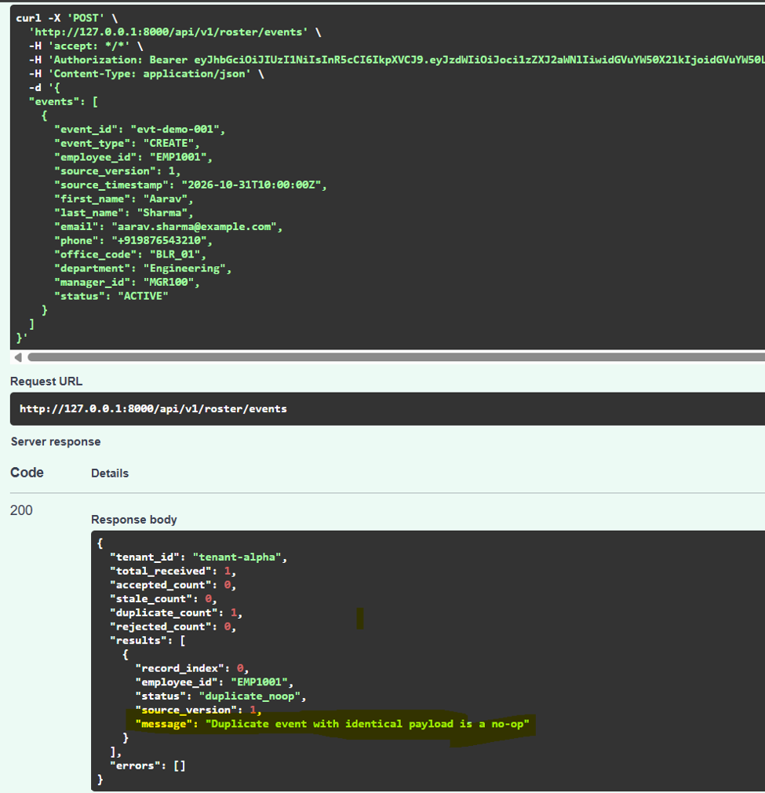
SELECT tenant_id, employee_id, first_name, last_name,
office_code, source_version, status
FROM employees
WHERE employee_id = 'EMP1001';

