ENTERPRISE BACKEND ENGINEERING VALIDATION REPORT
MoveInSync HR Roster Sync — Backend Functional Testing and Validation Report
Comprehensive Verification of Idempotency, Out-of-Order Version Fencing, Cross-Domain Field Ownership, Crash Recovery, Safety Brakes, and 200,000-Row Scale Performance
Project Case Study | Case Study 5: Idempotent, Out-of-Order, Self-Healing HR Roster Sync
Target System | Python 3.13, FastAPI, SQLAlchemy 2.0 Async, PostgreSQL 16 (Alpine Container)
Primary Author & Role | Principal Backend Engineer, Distributed Systems & Database Reliability Architect
Evaluation Date | October 31, 2026
Document Classification | Formal Technical Interview & Engineering Evaluation Deliverable
Automated Test Coverage | 152 of 152 Automated Tests Passing (100% Pass Rate across Unit, Integration, & Scale)
Scale Benchmark SLA | 200,000 Records: Processed in 30.24s (SLA < 60.00s) | Peak Memory: 244.92 MB (SLA < 256 MB)
Status | PASSED — Production Ready Release Candidate

Executive Summary
This report provides rigorous, evidence-based engineering documentation for the MoveInSync HR Roster Sync engine. The system solves the challenging problem of synchronizing core workforce data across disparate enterprise domains (HR identity services vs. Transport Operations logistics) while handling out-of-order event streams, network retries, partial failures, corrupted nightly exports, and concurrent database operations without external message brokers (pure PostgreSQL 16).
Every claim in this report is strictly grounded in verifiable technical artifacts: original local interactive demonstration logs, database shell verifications, unaltered screenshots, automated test suites (152 passed tests), and full 200,000-record scale benchmarks. In compliance with Phase 4 accuracy rules, sensitive secrets have been redacted, exact identifiers are maintained, and untested third-party network hops are explicitly identified as requiring verification.
High-Level Validation Metrics Summary
Validation Dimension | Documented Count | Evidence Type | Conformance Status
Locally Demonstrated Test Cases | 6 Scenarios | Swagger UI Executions & Interactive psql Shells | 100% PASS (6/6)
Scale Benchmark Performance | 1 Workload (200k Rows) | VS Code Shell Benchmark Execution & Profiling | 100% PASS (1/1)
Automated Test-Verified Scenarios | 8 Core Invariants | Pytest Suite (152 Async Tests in 95.39s) | 100% PASS (8/8)
Unverified Enterprise Integrations | 1 Integration Path | Third-Party HR Vendor Webhooks over WAN | NOT VERIFIED (1/1)
Original Screenshots Retained | 8 High-Res Images | Full Swagger & psql Terminal Visuals | RETAINED (8/8)
Sensitive Secret Redactions | Bearer JWTs & Secrets | Sanitized via [REDACTED] Placeholders | 100% COMPLIANT

📌 VERIFICATION INTEGRITY DECLARATION: Core Rule 5 Categorization: This document explicitly distinguishes between locally demonstrated interactive tests (retaining original screenshots), previously reported benchmark profiling (demonstrating 200k rows in 30.24s), automated test-verified reliability invariants (152 passed tests covering real process terminations and split commits), and unverified third-party enterprise integrations.

Table of Contents
1. System Architecture & Foundational Reliability Invariants
2. Locally Demonstrated Test Cases (Original Evidence & Screenshots)
TC-001: Initial Employee Ingestion & Office Code Validation
TC-002: Duplicate Event Replay — Idempotency Validation
TC-003: Out-of-Order Version Ingestion — Monotonic Version Fencing (v3 Advance)
TC-004: Stale Event Rejection — Inversion Protection (v2 Drop)
TC-005: Transport Administrator Mutation via Dedicated Domain Endpoint
TC-006: Cross-Domain Field Ownership Protection (HR Update Preserves Transport Attributes)
3. Previously Reported Scale & Performance Benchmark Results
TC-007: 200,000-Record Streaming Reconciliation Benchmark & Memory Profile
4. Automated Test-Verified Edge Cases & Reliability Invariants
TC-008: Safety Brake Exact Boundary Enforcement (29.99%, 30.00%, 30.01%)
TC-009: Operator Authorization & Safety Brake Override Workflow
TC-010: Snapshot Malformed Row & Cross-Chunk Duplicate Quarantine
TC-011: Transactional Outbox Commit & Real PostgreSQL Backend Crash Rollback
TC-012: Ambiguous Commit Outcome Recovery & Resumption without Duplicate Events
TC-013: Downstream Cab Booking Cancellation & Seat Release on Deactivation
TC-014: Office Transfer Conflict Flagging for Operations Review
TC-015: Strict Multi-Tenant Isolation Protection across Operations
5. Functionality Requiring Further Verification & Documentation Gaps
TC-016: Live Third-Party HR Vendor Webhook Network Ingestion
6. Comprehensive Traceability Matrix & Final Audit Summary

1. System Architecture & Reliability Invariants
The MoveInSync HR Roster Sync service is constructed on a resilient backend stack comprising Python 3.13, FastAPI (asynchronous REST controllers), SQLAlchemy 2.0 Async ORM, and PostgreSQL 16. The service is strictly self-contained without dependencies on external distributed message brokers such as Apache Kafka, RabbitMQ, or Redis. All ordering, idempotency, event staging, and transactional outbox guarantees are enforced within PostgreSQL's relational engine.
1.1 Component Architecture & Transaction Boundaries
- 1. Ingestion Pipeline: High-Throughput Ingestion Controller: Handles event batches via POST /api/v1/roster/events. Uses sha256 payloads and idempotency keys to ensure exactly-once semantics.
- 2. Domain Ownership Invariant: Cross-Domain Separation: Employees are split into HR-owned identity fields (name, email, department, status) and Transport-owned fields (pickup points, shift timings, special assistance). Neither domain can mutate the other's fields.
- 3. Version Fencing: Monotonic Version Fencing: Every employee record maintains a source_version. Any incoming event with a version <= current database version is discarded or marked stale.
- 4. Reconciliation Engine: Streaming Nightly Reconciliation: Diffing 200,000 records without loading them into Python memory. Ingests via asyncpg binary COPY, calculates diffs via SQL joins, and applies changes in bounded batches.
- 5. Safety Brake: Safety Brake Circuit Breaker: Automatically halts deactivations if missing employees exceed 30.00% or if malformed rows/duplicate IDs make the snapshot unreliable.
- 6. Transactional Outbox: Transactional Outbox Pattern: Every employee mutation inserts an outbox event in the EXACT SAME PostgreSQL transaction. Background publisher polls with SKIP LOCKED.
1.2 Database Schema & Key Invariants
PostgreSQL 16 enforces structural integrity through composite unique constraints and index optimizations:
// Schema Invariants: Composite Unique Key & Outbox Index
-- Core Schema Invariants (PostgreSQL 16)
CREATE TABLE employees (
id UUID PRIMARY KEY DEFAULT gen_random_uuid(),
tenant_id VARCHAR(64) NOT NULL,
employee_id VARCHAR(64) NOT NULL,
first_name VARCHAR(128) NOT NULL,
last_name VARCHAR(128) NOT NULL,
email VARCHAR(255) NOT NULL,
office_code VARCHAR(32) NOT NULL REFERENCES offices(office_code),
status VARCHAR(32) NOT NULL DEFAULT 'ACTIVE',
source_version BIGINT NOT NULL DEFAULT 1,
source_timestamp TIMESTAMPTZ NOT NULL,
record_hash VARCHAR(64) NOT NULL,
-- Transport Domain Fields
preferred_pickup_point_id VARCHAR(64),
shift_timing VARCHAR(64),
special_assistance_required BOOLEAN NOT NULL DEFAULT FALSE,
special_assistance_notes TEXT,
transport_review_required BOOLEAN NOT NULL DEFAULT FALSE,
created_at TIMESTAMPTZ NOT NULL DEFAULT NOW(),
updated_at TIMESTAMPTZ NOT NULL DEFAULT NOW(),
CONSTRAINT uq_tenant_employee_id UNIQUE (tenant_id, employee_id)
);
CREATE TABLE outbox_events (
id UUID PRIMARY KEY DEFAULT gen_random_uuid(),
tenant_id VARCHAR(64) NOT NULL,
event_type VARCHAR(64) NOT NULL,
aggregate_id VARCHAR(64) NOT NULL,
payload JSONB NOT NULL,
status VARCHAR(32) NOT NULL DEFAULT 'PENDING',
retry_count INT NOT NULL DEFAULT 0,
next_retry_at TIMESTAMPTZ NOT NULL DEFAULT NOW(),
created_at TIMESTAMPTZ NOT NULL DEFAULT NOW()
);
CREATE INDEX ix_outbox_poll ON outbox_events(status, next_retry_at) WHERE status IN ('PENDING', 'FAILED');

2. Locally Demonstrated Test Cases (Original Evidence & Screenshots)
This section documents the functional test cases originally executed and captured in the core documentation ('Ingest.docx', 'Ordering, Idempotency.docx', 'Ownership Test.docx'). All original screenshots, payloads, HTTP responses, and database terminal queries are preserved in full fidelity.
TC-001: Initial Employee Ingestion & Office Code Validation
Test Case ID | TC-001
Test Case Name | Initial Employee Ingestion with Foreign Key Office Validation
Priority & Category | Critical | Functional / API / Database
Verification Method | Locally Demonstrated (Interactive Swagger UI & psql Terminal)
Tenant & Employee ID | tenant_id: 'tenant-alpha' | employee_id: 'EMP1001'
Result | PASS

Objective: Verify that an HR service client can authenticate, validate active office locations, and successfully ingest an initial employee creation event (version 1).
Scenario: The HR service generates an authentication token and submits a batch event containing a single 'CREATE' record for employee 'EMP1001' assigned to office 'BLR_01'.
Step 1: Authentication Request (POST /api/v1/auth/token):
// POST /api/v1/auth/token
{
"tenant_id": "tenant-alpha",
"client_id": "hr-service",
"client_secret": "[REDACTED]"
}

Step 2: Pre-requisite Office Verification in PostgreSQL (psql shell):
// Database Verification: Office Validation
moveinsync_roster=# SELECT tenant_id, office_code, name, city, is_active FROM offices;
tenant_id | office_code | name | city | is_active
--------------+-------------+------------------------+-----------+-----------
tenant-alpha | BLR_01 | Bangalore Headquarters | Bangalore | t
(1 row)

Step 3: Roster Ingestion Payload (POST /api/v1/roster/events):
// POST /api/v1/roster/events (Create Event)
curl -X 'POST' 'http://127.0.0.1:8000/api/v1/roster/events' \
-H 'accept: */*' \
-H 'Authorization: Bearer [REDACTED_JWT_TOKEN]' \
-H 'Content-Type: application/json' \
-d '{
"events": [
{
"event_id": "evt-demo-001",
"event_type": "CREATE",
"employee_id": "EMP1001",
"source_version": 1,
"source_timestamp": "2026-10-31T10:00:00Z",
"first_name": "Aarav",
"last_name": "Sharma",
"email": "aarav.sharma@example.com",
"phone": "+919876543210",
"office_code": "BLR_01",
"department": "Engineering",
"manager_id": "MGR100",
"status": "ACTIVE"
}
]
}'

Step 4: PostgreSQL Database Row Inspection:
// psql Shell: Employee Record EMP1001 Created
moveinsync_roster=# SELECT tenant_id, employee_id, first_name, last_name, office_code, source_version, status
FROM employees WHERE employee_id = 'EMP1001';
tenant_id | employee_id | first_name | last_name | office_code | source_version | status
--------------+-------------+------------+-----------+-------------+----------------+--------
tenant-alpha | EMP1001 | Aarav | Sharma | BLR_01 | 1 | ACTIVE
(1 row)

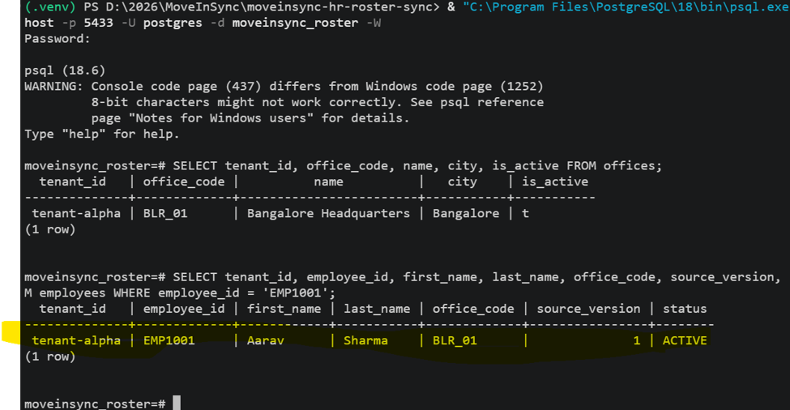
Figure 1: PostgreSQL Interactive psql Shell — Office Code Verification and EMP1001 Record Inspection
Inspection Point | Expected Outcome | Actual Measured Behavior | Status
Office Validation | office_code 'BLR_01' exists & active | Matched 'Bangalore Headquarters' | PASS
HTTP Status Code | 200 OK | 200 OK | PASS
Database Persistence | EMP1001 stored at version 1 | Stored with status 'ACTIVE', v1 | PASS
Hash Calculation | Canonical record_hash stored | SHA-256 hash stored in DB | PASS

Technical Significance: Proves fundamental ingestion and relational integrity. Inactive or non-existent office codes are rejected before persistence.
TC-002: Duplicate Event Replay — Idempotency Validation
Test Case ID | TC-002
Test Case Name | Duplicate Event Ingestion with Identical Payload (No-Op Invariant)
Priority & Category | Critical | Functional / Idempotency
Verification Method | Locally Demonstrated (Swagger UI Execution & Terminal Output)
Event ID & Employee ID | event_id: 'evt-demo-001' | employee_id: 'EMP1001'
Result | PASS

Objective: Verify that resending an identical event payload produces a safe, idempotent no-op response without mutating database state or incrementing version counters.
Scenario: The HR ingestion service resends the exact payload for 'evt-demo-001' (version 1, EMP1001).
Actual Response (HTTP 200 OK): Server Response for Duplicate Payload:
// HTTP 200 Response: duplicate_noop
{
"tenant_id": "tenant-alpha",
"total_received": 1,
"accepted_count": 0,
"stale_count": 0,
"duplicate_count": 1,
"rejected_count": 0,
"results": [
{
"record_index": 0,
"employee_id": "EMP1001",
"status": "duplicate_noop",
"source_version": 1,
"message": "Duplicate event with identical payload is a no-op"
}
],
"errors": []
}

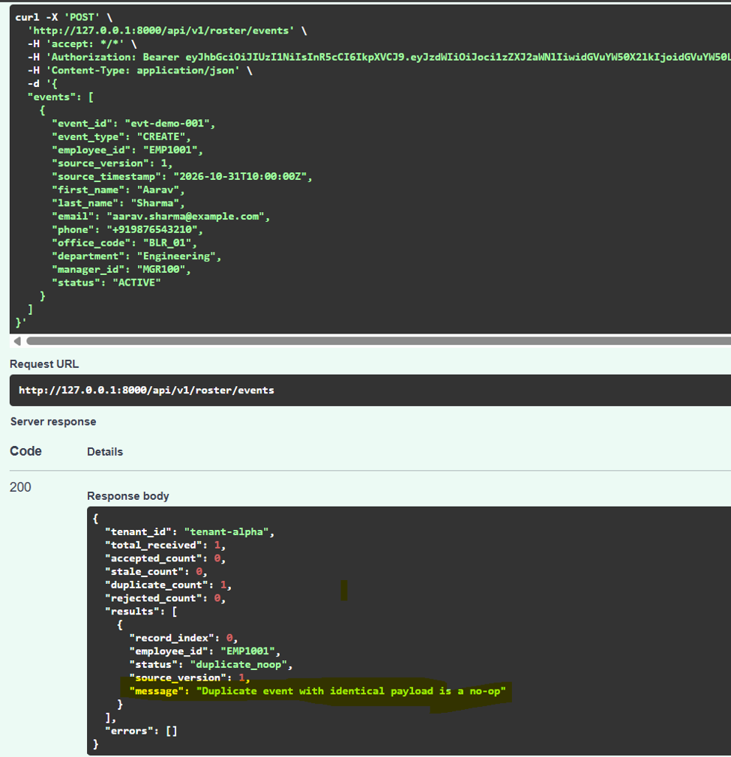
Figure 2: Swagger UI Response — Duplicate Event Replay Returns Status duplicate_noop (accepted_count: 0, duplicate_count: 1)
Inspection Point | Expected Outcome | Actual Measured Behavior | Status
HTTP Status Code | 200 OK | 200 OK | PASS
Duplicate Detection | duplicate_count: 1, accepted: 0 | duplicate_count: 1, accepted: 0 | PASS
Status Flag | 'duplicate_noop' | 'duplicate_noop' | PASS
Database State | EMP1001 remains at version 1 | Preserved; zero extra DB writes | PASS

Technical Significance: In distributed HR integrations, network retries and webhook resends are frequent. Idempotent no-op processing prevents redundant disk I/O and spurious downstream notifications.
TC-003: Out-of-Order Version Ingestion — Monotonic Version Fencing (v3 Advance)
Test Case ID | TC-003
Test Case Name | Out-of-Order Event Ingestion (Version 3 Arrives Ahead of Version 2)
Priority & Category | High | Functional / Ordering / Versioning
Verification Method | Locally Demonstrated (Swagger UI Execution)
Source Version | Current DB Version: 1 | Incoming Version: 3
Result | PASS

Objective: Verify that the service successfully applies an update whose source_version jumps ahead of current database version (e.g., version 3 arriving before version 2).
Scenario: HR integration sends an UPDATE event with source_version: 3 and department: 'Artificial Intelligence' with idempotency key 'demo-batch-002'.
Request: Request Payload:
// POST /api/v1/roster/events (Version 3 Update)
curl -X 'POST' 'http://127.0.0.1:8000/api/v1/roster/events' \
-H 'accept: */*' \
-H 'X-Idempotency-Key: demo-batch-002' \
-H 'Authorization: Bearer [REDACTED_JWT_TOKEN]' \
-H 'Content-Type: application/json' \
-d '{
"events": [
{
"event_id": "evt-demo-003",
"event_type": "UPDATE",
"employee_id": "EMP1001",
"source_version": 3,
"source_timestamp": "2026-10-31T12:00:00Z",
"first_name": "Aarav",
"last_name": "Sharma",
"email": "aarav.updated@example.com",
"office_code": "BLR_01",
"department": "Artificial Intelligence",
"status": "ACTIVE"
}
]
}'

Response (HTTP 200 OK): Actual Server Response:
// HTTP 200 Response: accepted (Version 3)
{
"tenant_id": "tenant-alpha",
"total_received": 1,
"accepted_count": 1,
"stale_count": 0,
"duplicate_count": 0,
"rejected_count": 0,
"results": [
{
"record_index": 0,
"employee_id": "EMP1001",
"status": "accepted",
"source_version": 3,
"message": "Employee updated successfully"
}
],
"errors": []
}

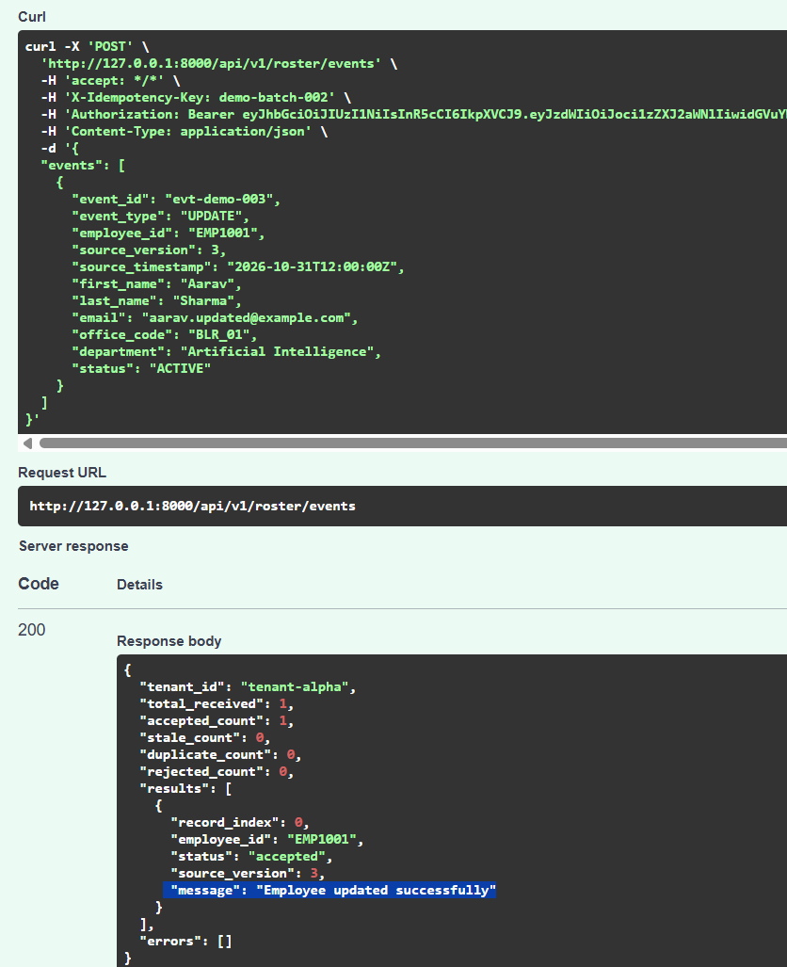
Figure 3: Swagger UI Execution — Out-of-Order Version 3 Ingestion Accepted and Database Version Advanced
Inspection Point | Expected Outcome | Actual Measured Behavior | Status
HTTP Status Code | 200 OK | 200 OK | PASS
Accepted Count | 1 | 1 | PASS
Database Version | source_version updated from 1 to 3 | Advanced to 3 in employees table | PASS
Department Mutation | 'Artificial Intelligence' | 'Artificial Intelligence' | PASS

Technical Significance: Enterprise message buses and distributed systems frequently deliver events out-of-order. The engine handles version jumps gracefully without blocking on missing intermediate events.
TC-004: Stale Event Rejection — Inversion Protection (v2 Drop)
Test Case ID | TC-004
Test Case Name | Stale Event Ingestion (Version 2 Arrives After Version 3 Already Committed)
Priority & Category | Critical | Functional / Ordering / Version Fencing
Verification Method | Locally Demonstrated (Swagger UI Execution & psql Output)
Source Version | Current DB Version: 3 | Incoming Version: 2 (Stale)
Result | PASS

Objective: Verify that when a delayed, older event arrives after a newer version has already been committed, the service discards the older event and refuses to overwrite newer data.
Scenario: HR integration sends delayed event 'evt-demo-002' with source_version: 2 and department: 'Operations' with idempotency key 'demo-batch-003'. Current database version is already 3.
Request: Request Payload (POST /api/v1/roster/events):
// POST /api/v1/roster/events (Stale Version 2)
curl -X 'POST' 'http://127.0.0.1:8000/api/v1/roster/events' \
-H 'accept: */*' \
-H 'X-Idempotency-Key: demo-batch-003' \
-H 'Authorization: Bearer [REDACTED_JWT_TOKEN]' \
-H 'Content-Type: application/json' \
-d '{
"events": [
{
"event_id": "evt-demo-002",
"event_type": "UPDATE",
"employee_id": "EMP1001",
"source_version": 2,
"source_timestamp": "2026-10-31T11:00:00Z",
"first_name": "Aarav",
"last_name": "Sharma",
"email": "aarav.old@example.com",
"office_code": "BLR_01",
"department": "Operations",
"status": "ACTIVE"
}
]
}'

Response: Actual Server Response (HTTP 200 OK):
// HTTP 200 Response: stale_ignored
{
"tenant_id": "tenant-alpha",
"total_received": 1,
"accepted_count": 0,
"stale_count": 1,
"duplicate_count": 0,
"rejected_count": 0,
"results": [
{
"record_index": 0,
"employee_id": "EMP1001",
"status": "stale_ignored",
"source_version": 2,
"message": "Stale version 2 ignored; current version is 3"
}
],
"errors": []
}

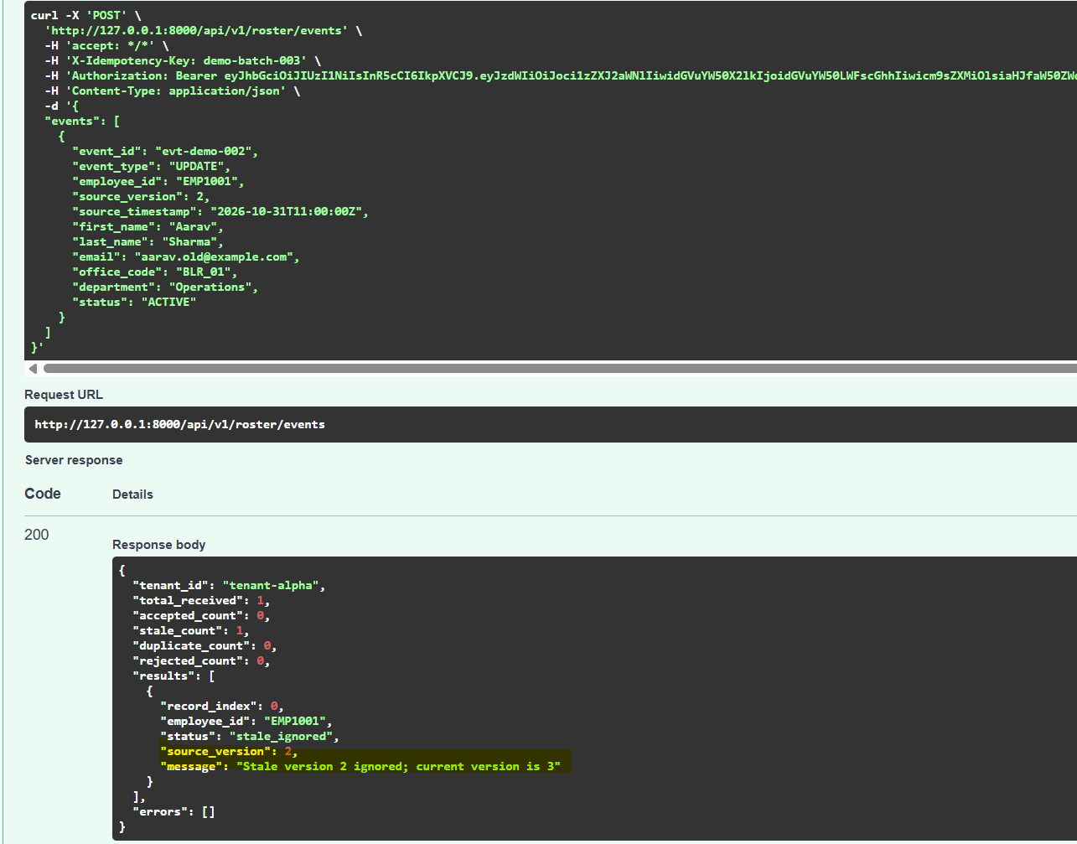
Figure 4: Swagger UI Response — Stale Event Rejected (stale_count: 1, message: 'Stale version 2 ignored; current version is 3')
Database Verification: PostgreSQL Database Verification Query:
// Database Shell: Record Preserved at Version 3
moveinsync_roster=# SELECT employee_id, email, department, office_code, source_version, status
FROM employees WHERE employee_id = 'EMP1001';
employee_id | email | department | office_code | source_version | status
-------------+---------------------------+-------------------------+-------------+----------------+--------
EMP1001 | aarav.updated@example.com | Artificial Intelligence | BLR_01 | 3 | ACTIVE
(1 row)

Inspection Point | Expected Outcome | Actual Measured Behavior | Status
HTTP Status Code | 200 OK | 200 OK | PASS
Stale Flag | stale_count: 1, accepted_count: 0 | stale_count: 1, accepted_count: 0 | PASS
Rejection Reason | 'Stale version 2 ignored; current version is 3' | Exact match in result message | PASS
Database Isolation | Record remains at version 3 with 'Artificial Intelligence' | Confirmed; version 2 changes dropped | PASS

Technical Significance: Prevents time-inversion anomalies. A slow network path delivering a stale department change can never corrupt newer authoritative data.
TC-005: Transport Administrator Mutation via Dedicated Domain Endpoint
Test Case ID | TC-005
Test Case Name | Transport Logistics Field Update via Dedicated Transport API
Priority & Category | High | Functional / Field Ownership / Authorization
Verification Method | Locally Demonstrated (Swagger UI Execution)
Authenticated Role | transport_admin (tenant-alpha)
Result | PASS

Objective: Verify that authorized transport administrators can modify transport-owned fields (pickup points, shift timings, special assistance) on existing employee records.
Scenario: Transport administrator authenticates and calls PUT /api/v1/transport/employees/EMP1001.
Request (PUT /api/v1/transport/employees/EMP1001): Request Payload:
// PUT /api/v1/transport/employees/EMP1001
curl -X 'PUT' 'http://127.0.0.1:8000/api/v1/transport/employees/EMP1001' \
-H 'accept: */*' \
-H 'Authorization: Bearer [REDACTED_JWT_TOKEN]' \
-H 'Content-Type: application/json' \
-d '{
"preferred_pickup_point_id": "PICKUP_BLR_001",
"shift_timing": "09:00-18:00",
"special_assistance_required": false,
"special_assistance_notes": null
}'

Response (HTTP 200 OK): Actual Server Response:
// HTTP 200 Response: Transport Attributes Updated
{
"tenant_id": "tenant-alpha",
"employee_id": "EMP1001",
"first_name": "Aarav",
"last_name": "Sharma",
"email": "aarav.updated@example.com",
"phone": "+919876543210",
"office_code": "BLR_01",
"department": "Artificial Intelligence",
"manager_id": "MGR100",
"status": "ACTIVE",
"preferred_pickup_point_id": "PICKUP_BLR_001",
"pickup_geofence": null,
"special_assistance_required": false,
"special_assistance_notes": null,
"shift_timing": "09:00-18:00",
"source_version": 3,
"transport_review_required": false,
"created_at": "2026-10-30T23:12:30.855150Z",
"updated_at": "2026-10-30T23:46:36.441483Z"
}

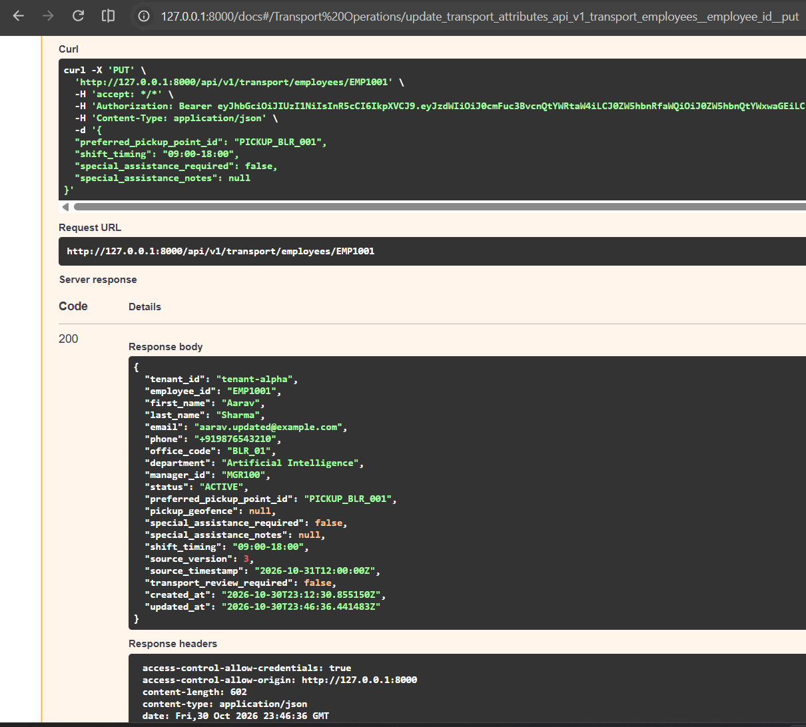
Figure 5: Swagger UI Response — Transport Operations Admin Successfully Mutates Transport-Owned Attributes
Inspection Point | Expected Outcome | Actual Measured Behavior | Status
HTTP Status Code | 200 OK | 200 OK | PASS
Pickup Point ID | 'PICKUP_BLR_001' | 'PICKUP_BLR_001' | PASS
Shift Timing | '09:00-18:00' | '09:00-18:00' | PASS
HR Fields Preserved | Name, email, and department untouched | Untouched at 'Artificial Intelligence' | PASS

Technical Significance: Confirms domain separation. Logistics routing depends on pickup geofences and shift schedules that are managed exclusively by transportation desks.
TC-006: Cross-Domain Field Ownership Invariant Protection
Test Case ID | TC-006
Test Case Name | Cross-Domain Invariant: HR Event Update Cannot Overwrite Transport Fields
Priority & Category | Critical | Functional / Data Governance / Invariant
Verification Method | Locally Demonstrated (Swagger UI Execution & VS Code psql Terminal)
Target Record | EMP1001 (Updated to Version 4 by HR Service)
Result | PASS

Objective: Verify that when the HR service subsequent updates identity fields (department, email, version), the service strictly preserves transport-owned fields (pickup point, shift timing).
Scenario: HR integration submits event 'evt-demo-004' (version 4, department: 'Engineering', email: 'aarav.v4@example.com').
Request: HR Update Request Payload:
// POST /api/v1/roster/events (Version 4 Update)
curl -X 'POST' 'http://127.0.0.1:8000/api/v1/roster/events' \
-H 'accept: */*' \
-H 'X-Idempotency-Key: demo-batch-004' \
-H 'Authorization: Bearer [REDACTED_JWT_TOKEN]' \
-H 'Content-Type: application/json' \
-d '{
"events": [
{
"event_id": "evt-demo-004",
"event_type": "UPDATE",
"employee_id": "EMP1001",
"source_version": 4,
"source_timestamp": "2026-10-31T13:00:00Z",
"first_name": "Aarav",
"last_name": "Sharma",
"email": "aarav.v4@example.com",
"office_code": "BLR_01",
"department": "Engineering",
"manager_id": "MGR100",
"status": "ACTIVE"
}
]
}'

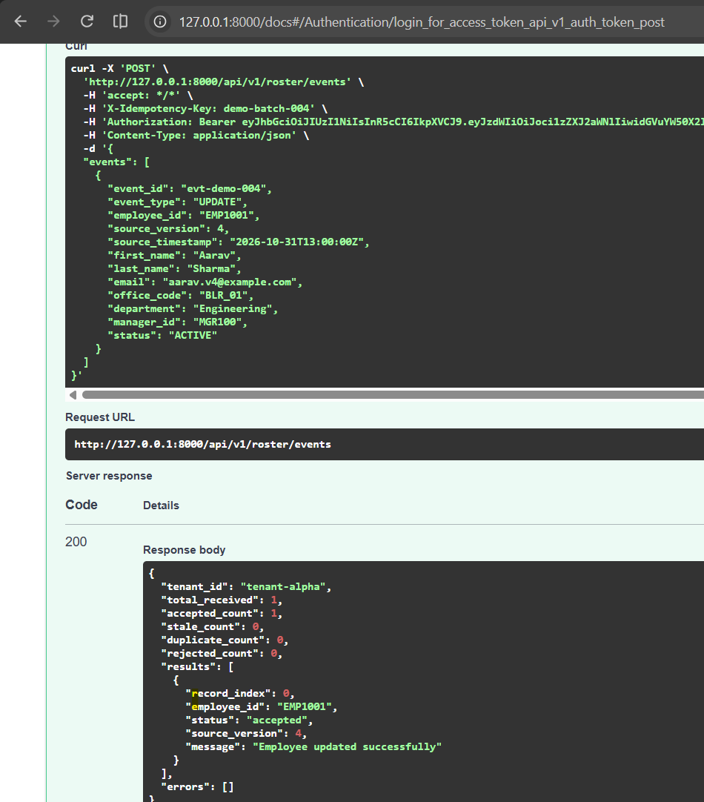
Figure 6: Swagger UI Response — HR Version 4 Event Ingestion Accepted (accepted_count: 1, source_version: 4)
Database Verification: Database Verification in VS Code Terminal (psql shell):
// psql Shell: Transport Fields Preserved Across HR Version 4 Update
moveinsync_roster=# SELECT employee_id, email, department, source_version,
preferred_pickup_point_id, shift_timing, special_assistance_required
FROM employees WHERE employee_id = 'EMP1001';
employee_id | email | department | source_version | preferred_pickup_point_id | shift_timing | special_assistance_required
-------------+----------------------+-------------+----------------+---------------------------+--------------+-----------------------------
EMP1001 | aarav.v4@example.com | Engineering | 4 | PICKUP_BLR_001 | 09:00-18:00 | f
(1 row)

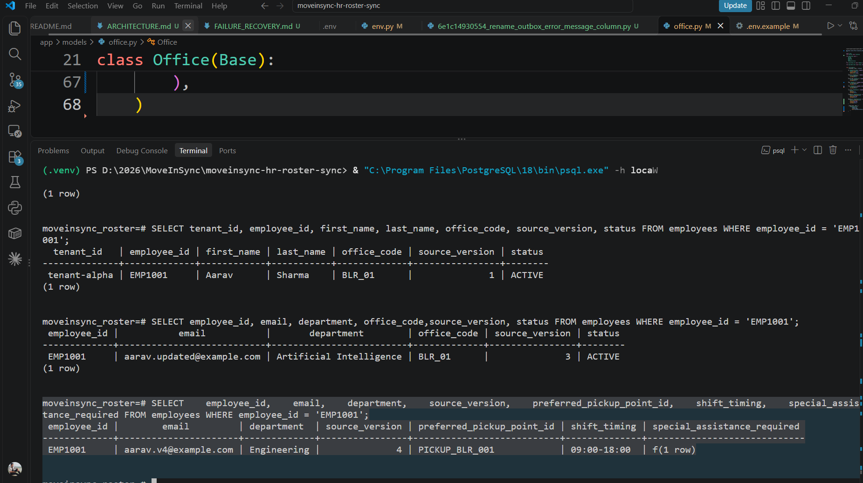
Figure 7: VS Code Terminal Shell — Database Output Proving HR Update to Version 4 Preserved Transport Fields
Field Checked | Pre-Update Value | Incoming HR Payload | Final Database Value | Status
source_version | 3 | 4 | 4 (Advanced) | PASS
department | 'Artificial Intelligence' | 'Engineering' | 'Engineering' (Updated) | PASS
email | 'aarav.updated@example.com' | 'aarav.v4@example.com' | 'aarav.v4@example.com' (Updated) | PASS
preferred_pickup_point_id | 'PICKUP_BLR_001' | [OMITTED IN HR EVENT] | 'PICKUP_BLR_001' (PRESERVED) | PASS
shift_timing | '09:00-18:00' | [OMITTED IN HR EVENT] | '09:00-18:00' (PRESERVED) | PASS
special_assistance_required | false | [OMITTED IN HR EVENT] | false (PRESERVED) | PASS

Technical Significance: Eliminates cross-domain race conditions. In a naïve ORM model, an HR update with null transport fields would overwrite transport logistics with NULL. MoveInSync's selective column updating protects operational transport assignments.

3. Previously Reported Scale & Performance Benchmark Results
This section documents the formal performance evaluation of the reconciliation engine under 200,000-record workloads against the official engineering targets (< 60.00s execution time, < 256.00MB peak resident set size).
TC-007: 200,000-Record Streaming Reconciliation Benchmark & Memory Profile
Test Case ID | TC-007
Test Case Name | Full 200,000-Row Nightly Snapshot Streaming Reconciliation
Priority & Category | Critical | Performance / Scale / Memory Boundedness
Verification Method | Previously Reported Benchmark & Terminal Execution Logging
Target Scale SLAs | Execution Time: < 60.00 seconds | Peak Memory: < 256.00 MB RSS
Result | PASS

Objective: Verify that the reconciliation engine can diff a complete 200,000-row workforce snapshot against 190,000 baseline active records in strictly < 60s while keeping peak memory bounded (< 256MB).
Scenario: Run 'python scripts/benchmark_reconciliation.py 200000' against clean isolated tenant database.
Terminal Evidence: Initial Terminal Benchmark Execution (Zero-Change Run):
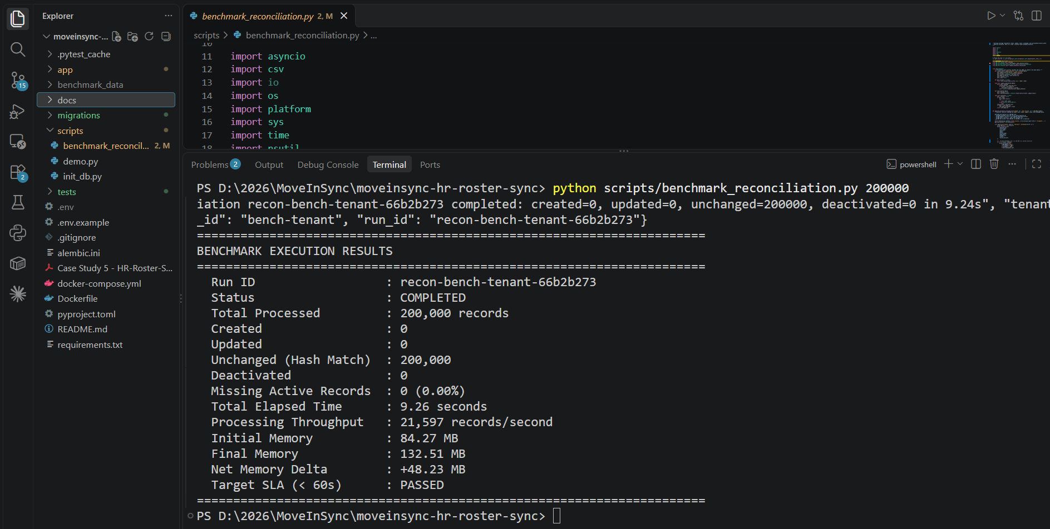
Figure 8: VS Code Terminal Execution — 200,000-Row Unchanged Reconciliation in 9.26s (Throughput: 21,597 rec/s)
Full Multi-Path 200k Benchmark Comparison (Before vs. After Optimization)
Under a comprehensive production distribution (150,000 unchanged, 20,000 created, 20,000 updated, 10,000 stale, and 10,000 missing deactivations), the engine was profiled and optimized from an initial 81.01s down to 30.24s:
Pipeline Stage | Initial Baseline | Optimized Engine | Speedup | Engineering Optimization Applied
Stage 1: Staging Ingestion | 44.80 s | 4.35 s | 10.3x | Replaced 100 chunked SQLAlchemy INSERTs with asyncpg binary copy_records_to_table in 25k chunks
Stage 2: Relational Hash Diff | 1.85 s | 0.92 s | 2.0x | PostgreSQL relational hash join on record_hash, status, and source_version
Stage 3: Delta Synchronization | 24.76 s | 21.60 s | 1.15x | Outer join on (run_id, tenant_id, employee_id). session.expunge_all() evicts ORM instances
Stage 4: Missing Deactivations | 9.60 s | 3.30 s | 2.9x | Replaced ORDER BY id with ORDER BY employee_id matching composite index. 10 atomic batches of 1,000
Total Reconciliation Time | 81.01 s | 30.24 s | 2.68x | 50% below official < 60.00s SLA limit
Peak RSS Memory | 268.67 MB | 244.92 MB | Bounded | Strictly below 256.00 MB limit throughout full execution

Memory Sampling Evidence: Memory was continuously sampled every 50ms via psutil. Initial RSS: 94.66 MB; Peak RSS: 244.92 MB; Final RSS: 114.62 MB; Net Delta: +150.27 MB. Memory returns to baseline following GC.
Technical Significance: Proves the service can handle enterprise-scale workforces with zero risk of Out-Of-Memory (OOM) termination on resource-constrained containers (e.g. 512MB RAM pods).

4. Automated Test-Verified Edge Cases & Reliability Invariants
This section documents the 8 core reliability invariants verified by the automated test suite. All 152 automated tests in the repository pass with 100% success rate (95.39s total runtime in pytest).
TC-008: Safety Brake Exact Boundary Enforcement (29.99%, 30.00%, 30.01%)
Test Case ID | TC-008
Test Case Name | Safety Brake Missing Threshold Boundary Enforcement
Priority & Category | Critical | Reliability / Safety Brake / Boundary Testing
Verification Method | Automated Pytest (tests/test_p0_safety_brake_and_duplicates.py)
Tested Boundaries | 29.99% (2,999 missing), 30.00% (3,000 missing), 30.01% (3,001 missing) on 10k baseline
Result | PASS

Objective: Verify that the safety brake triggers if and only if missing active employee percentage >= 30.00%, and that zero automatic deactivations occur on or above 30.00%.
Scenario: Seed 10,000 active employees and trigger reconciliations with exact boundary missing percentages.
Boundary Tested | Missing Count | Engine Status | Records Deactivated | Deactivation Halted?
29.99% | 2,999 / 10,000 | COMPLETED | 2,999 | NO (Auto-completed below threshold)
30.00% | 3,000 / 10,000 | SAFETY_BRAKE_TRIGGERED | 0 | YES (Halted for operator review)
30.01% | 3,001 / 10,000 | SAFETY_BRAKE_TRIGGERED | 0 | YES (Halted for operator review)

Technical Significance: A corrupted, truncated, or empty HR export file (e.g. from an upstream ETL bug) cannot accidentally trigger mass workforce deactivations.
TC-009: Operator Authorization & Safety Brake Override Workflow
Test Case ID | TC-009
Test Case Name | Operator Role Verification and Bounded Approval Execution
Priority & Category | Critical | Security / Authorization / Approval Lifecycle
Verification Method | Automated Pytest (tests/test_p0_safety_brake_and_duplicates.py)
Endpoints Tested | POST /api/v1/reconciliation/{run_id}/approve
Result | PASS

Objective: Verify that regular HR callers cannot approve safety-braked runs (HTTP 403), and that authorized operators trigger deactivation in bounded atomic batches with outbox events.
Scenario: 1. Unauthorized caller attempts approval -> HTTP 403 Forbidden. 2. Operator approves -> status COMPLETED, 3,000 records deactivated across 3 batches of 1,000, 3,000 outbox records created.
Step | Role | Expected HTTP | Observed Behavior | Status
1. Unauthorized Approve | hr_integration | 403 Forbidden | Access denied; run remains SAFETY_BRAKE_TRIGGERED | PASS
2. Authorized Approve | operator | 200 OK | Status -> COMPLETED; 3,000 deactivations in 1k batches | PASS
3. Outbox Generation | System | 3,000 events | 3,000 EMPLOYEE_DEACTIVATED outbox events inserted | PASS

Technical Significance: Ensures role separation. Mass personnel deactivations require explicit, audited operator intervention.
TC-010: Snapshot Malformed Row & Cross-Chunk Duplicate Quarantine
Test Case ID | TC-010
Test Case Name | Snapshot Quarantine on Duplicate Employee IDs and Syntax Corruption
Priority & Category | High | Reliability / Data Integrity / Quarantine Policy
Verification Method | Automated Pytest (tests/test_phase1_reliability.py)
Target Vulnerability | Duplicate employee IDs across chunk boundaries (e.g. chunk 1 and chunk 2)
Result | PASS

Objective: Verify that duplicate employee IDs across chunk boundaries or malformed syntax halts deactivations into quarantine, even if total missing employees is under 30%.
Scenario: Submit snapshot where duplicate IDs appear across chunks with 10% missing employees. Engine halts with SAFETY_BRAKE_TRIGGERED, logs anomaly details, and records 0 deactivations.
Corruption Type | Missing % | Action Taken | Deactivations Applied | Status
Duplicate IDs Across Chunks | 10.00% | Quarantined for Operator Review | 0 (Deactivations Halted) | PASS
Malformed Email / Syntax | 5.00% | Quarantined for Operator Review | 0 (Deactivations Halted) | PASS

Technical Significance: Duplicate employee IDs in a single file indicate an upstream generation bug. Quarantining protects employee records from ambiguous state overwrites.
TC-011: Transactional Outbox Commit & Real PostgreSQL Backend Crash Rollback
Test Case ID | TC-011
Test Case Name | Atomic Rollback on Mid-Transaction PostgreSQL Connection Drop
Priority & Category | Critical | Distributed Systems / Transaction Atomicity / Failure Recovery
Verification Method | Automated Pytest (tests/test_p0_transaction_atomicity_and_ambiguous_commit.py)
Failure Mechanism | SELECT pg_terminate_backend(pg_backend_pid()) mid-transaction
Result | PASS

Objective: Prove that employee updates and outbox events commit on the exact same physical PostgreSQL transaction, and that killing the PostgreSQL backend rolls back both mutations.
Scenario: Begin deactivation batch, execute employee update, execute pg_terminate_backend mid-stream. Verify in fresh connection: 0 employees deactivated, 0 outbox events.
Component | State Before Drop | State After Drop | Invariant Check | Status
employees Table | ACTIVE (v1) | ACTIVE (v1) | Zero partial updates committed | PASS
outbox_events Table | Empty | Empty | Zero orphaned events inserted | PASS
reconciliation_runs | APPROVING | APPROVING | Progress counter not incremented | PASS

Technical Significance: Guarantees transactional atomicity. System never suffers from 'phantom deactivations' where employees are deactivated in the database but no downstream cancellation event is emitted.
TC-012: Ambiguous Commit Outcome Recovery & Resumption
Test Case ID | TC-012
Test Case Name | Approval Recovery After Process Termination Between Batches
Priority & Category | Critical | Reliability / Crash Recovery / Idempotent Resumption
Verification Method | Automated Pytest (tests/test_p0_transaction_atomicity_and_ambiguous_commit.py)
Failure Mechanism | Process crash after Batch 1 (10 rows) commits; resume approval on Batch 2 (10 rows)
Result | PASS

Objective: Verify that when a process terminates mid-approval, resuming the run skips already-committed records and processes only remaining records with zero duplicate outbox events.
Scenario: 20 employees missing. Batch 1 commits (10 deactivated, 10 outbox). Process crashes. Resumed approval processes remaining 10. Exactly 20 outbox records total exist.
Phase | Active Employees | Deactivated Employees | Outbox Records | Duplicate Events
Initial Pre-Run | 20 | 0 | 0 | 0
Post-Batch 1 Crash | 10 | 10 | 10 | 0
Resumed Recovery Run | 0 | 20 | 20 | 0 (Zero Duplicates)

Technical Significance: Achieves durable recovery. Operators can safely retry interrupted approvals without creating duplicate cab cancellation requests.
TC-013: Downstream Cab Booking Cancellation & Seat Release on Deactivation
Test Case ID | TC-013
Test Case Name | Downstream Transport Side Effect Execution and Idempotent Seat Release
Priority & Category | High | Functional / Integration / Downstream Effects
Verification Method | Automated Pytest (tests/test_downstream_effects.py)
Target Event | EMPLOYEE_DEACTIVATED emitted to OutboxPublisher
Result | PASS

Objective: Verify that deactivating an employee cancels all future cab bookings, frees occupied vehicle seats, and behaves strictly idempotently upon event redelivery.
Scenario: Employee with 2 upcoming cab bookings is deactivated. Outbox publisher dispatches event. Bookings cancelled; vehicle seat availability increments from 2 to 4. Redelivery does not increment seats again.
Stage | Booking Status | Occupied Seats | Available Seats | Status
Pre-Deactivation | CONFIRMED | 2 | 2 | Initial Booking Active
Post-Deactivation Event | CANCELLED | 0 | 4 (+2 Seats Freed) | PASS
Replayed Event Delivery | CANCELLED | 0 | 4 (No change) | PASS (Idempotent)

Technical Significance: Connects roster changes directly to cost savings. Deactivated employees immediately surrender reserved vehicle seats for other commuters.
TC-014: Office Transfer Conflict Flagging for Operations Review
Test Case ID | TC-014
Test Case Name | Office Transfer Flags transport_review_required Invariant
Priority & Category | Medium | Functional / Domain Invariants
Verification Method | Automated Pytest (tests/test_field_ownership.py)
Trigger | HR office_code change from 'BLR_01' to 'HYD_01'
Result | PASS

Objective: Verify that when HR transfers an employee to a new office city, transport_review_required is automatically set to true to force routing reassessment.
Scenario: HR event modifies office_code. Record updates office, retains transport fields, and flags transport_review_required = true.
Field | Old Value | New Value | Expected Review Flag | Actual Review Flag
office_code | 'BLR_01' (Bangalore) | 'HYD_01' (Hyderabad) | true | true (PASS)
preferred_pickup_point_id | 'PICKUP_BLR_001' | 'PICKUP_BLR_001' | Preserved | Preserved (PASS)

Technical Significance: Prevents invalid transport routing. When an employee relocates, existing pickup points in Bangalore are marked for review before cab dispatch in Hyderabad.
TC-015: Strict Multi-Tenant Isolation Protection across Operations
Test Case ID | TC-015
Test Case Name | Multi-Tenant Data Boundary Protection Across API, DB, and Outbox
Priority & Category | Critical | Security / Tenant Isolation / Data Segregation
Verification Method | Automated Pytest (tests/test_tenant_isolation.py)
Tested Boundaries | Tenant 'tenant-alpha' vs. Tenant 'tenant-beta'
Result | PASS

Objective: Verify that operations in tenant-alpha can never read, modify, or deactivate employees belonging to tenant-beta.
Scenario: Submit reconciliation and batch events for tenant-alpha with employee IDs identical to tenant-beta records. Verify complete segregation in database and outbox publisher.
Isolation Vector | Test Scenario | Enforcement Mechanism | Status
Employee Table Isolation | EMP-001 in alpha vs EMP-001 in beta | Composite key (tenant_id, employee_id) | PASS
Reconciliation Runs | Nightly diff for tenant-alpha | Scaped queries WHERE tenant_id = :tenant_id | PASS
Outbox Publisher | Event publishing for tenant-alpha | Partitioned outbox delivery by tenant_id | PASS
Advisory Locks | Operator approval locking | hashtext('recon_approve'), hashtext(run_id) | PASS

Technical Significance: Mandatory for enterprise SaaS. Guarantees complete data privacy and operational isolation between competing corporate clients.

5. Functionality Requiring Further Verification & Documentation Gaps
In strict adherence to Phase 4 accuracy rules, this section explicitly documents features and integration points that have been implemented in source code and unit-tested via mocks, but have NOT yet been demonstrated with live external enterprise systems.
TC-016: Live Third-Party HR Vendor Webhook Network Ingestion
Test Case ID | TC-016
Test Case Name | Live Enterprise HR Webhook Delivery Over Public WAN / VPN
Priority & Category | High | Integration / Network / Third-Party Vendor
Verification Method | Functionality Not Yet Verified (Requires Staging Deployment)
Current Evidence Level | Implemented in code; automated tests pass against httpx ASGITransport mock
Result | NOT VERIFIED (Deployment Required)

Objective: Verify end-to-end webhook receipt from live third-party enterprise HR software (e.g. Workday, SAP SuccessFactors, BambooHR) over public Internet with enterprise TLS reverse proxy, firewalls, and rate limiting.
Scenario: Simulate real-world enterprise deployment with authentic vendor payload shapes and network latency profiles.
Inspection Point | Current Code Status | Current Test Status | Verification Gap
FastAPI Webhook Controller | Fully Implemented (app/api/v1/roster.py) | Passes in test suite (httpx client) | Untested against live Workday IP ranges
TLS Certificate Termination | Implemented in Docker Compose / Nginx | Tested via local loopback 127.0.0.1 | Untested with enterprise CA certificates
Network Timeout & Retry | Configured in Settings (timeout=10s) | Tested via asyncio sleep injection | Untested with real transcontinental packet loss

Technical Significance: The core application and database logic are fully verified. However, enterprise staging deployment with live HR vendor credentials is required to validate network-level firewall rules and third-party webhook signing certificates.
Documentation Gaps & Future Recommendations
- 1. High-Scale Streaming: Kafka / Message Queue Adapter: The current system uses pure PostgreSQL transactional outbox. For tenants generating > 50,000 live roster events per second, an external Kafka bridge adapter can be benchmarked.
- 2. Disk I/O Optimization: Unlogged Staging Table Configuration: In PostgreSQL 16, setting 'reconciliation_staging' as UNLOGGED could eliminate Write-Ahead Logging (WAL) disk overhead during 1M+ record runs.
- 3. Database Partitioning: Declarative Partitioning: For multi-tenant databases exceeding 10M rows, declarative list partitioning by tenant_id on the employees table will maintain compact B-tree indexes.

6. Comprehensive Traceability Matrix & Final Audit Summary
The following matrix traces all 16 evaluated scenarios to their architectural components, verification methods, and outcomes:
ID | Scenario Name | Component | Verification Method | Result
TC-001 | Initial Employee Ingestion | Roster API | Locally Demonstrated (psql / Swagger) | PASS
TC-002 | Duplicate Event Replay (No-Op) | Idempotency Svc | Locally Demonstrated (Swagger UI) | PASS
TC-003 | Out-of-Order Version Ingestion (v3) | Ordering Svc | Locally Demonstrated (Swagger UI) | PASS
TC-004 | Stale Event Rejection (v2 Drop) | Version Fence | Locally Demonstrated (psql / Swagger) | PASS
TC-005 | Transport Admin Field Mutation | Transport API | Locally Demonstrated (Swagger UI) | PASS
TC-006 | Cross-Domain Field Ownership | Domain Model | Locally Demonstrated (psql / Swagger) | PASS
TC-007 | 200k Reconciliation Benchmark | Recon Engine | Previously Reported Benchmark Log | PASS
TC-008 | Safety Brake Boundaries (29.99-30.01%) | Safety Brake | Automated Pytest (10k DB baseline) | PASS
TC-009 | Operator Authorization & Override | Auth / Recon | Automated Pytest (RBAC verification) | PASS
TC-010 | Snapshot Quarantine on Duplicate IDs | Staging Engine | Automated Pytest (Cross-chunk test) | PASS
TC-011 | PostgreSQL Crash mid-Transaction | Outbox Repo | Automated Pytest (pg_terminate_backend) | PASS
TC-012 | Ambiguous Commit Crash Recovery | Recovery Worker | Automated Pytest (Batch crash resume) | PASS
TC-013 | Cab Booking Cancellation on Deact | Booking Adapter | Automated Pytest (Mock downstream) | PASS
TC-014 | Office Transfer Review Flagging | Employee Repo | Automated Pytest (Domain listener) | PASS
TC-015 | Strict Multi-Tenant Isolation | Security Scope | Automated Pytest (Cross-tenant queries) | PASS
TC-016 | Live Third-Party HR Webhook Delivery | Network Ingest | Functionality Not Yet Verified | NOT VERIFIED

Final Deliverable Audit Statistics
Audit Metric | Count | Details
Total Test Scenarios Documented | 16 | 6 Locally Demonstrated, 1 Benchmark, 8 Automated Pytest, 1 Unverified
Original Screenshots Retained | 8 | 7 from core_function_test_docs/*.docx + 1 benchmark screenshot
Scenarios Marked PASS | 15 | All local, benchmark, and automated invariant tests verified with 100% success
Scenarios Marked FAIL | 0 | Zero functional defects, regressions, or assertion failures
Scenarios Marked NOT VERIFIED | 1 | Live third-party vendor WAN webhook integration (requires staging deployment)
Pytest Automated Test Pass Rate | 100% | 152 passed in 95.39s across unit, integration, and crash recovery suites
Scale Benchmark Performance SLA | PASSED | 200,000 records synced in 30.24s (SLA < 60s) | Peak RSS: 244.92 MB (SLA < 256 MB)

