Screenshots are desirable for bug analysis. Selenium can automatically take screenshots during execution. You need to type cast WebDriver instance to TakesScreenshot.

[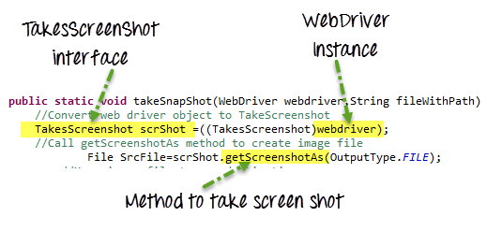](https://www.guru99.com/images/AdvanceSelenium/071514_0728_PDFEmailsan8.png)

Taking Screenshot in Selenium is a 3 Step process

**Step 1)** Convert web driver object to TakeScreenshot

TakesScreenshot scrShot =((TakesScreenshot)webdriver);

**Step 2)** Call getScreenshotAs method to create image file

File SrcFile=scrShot.getScreenshotAs(OutputType.FILE);

**Step 3)** Copy file to Desired Location

Example: In this example we will take screen capture of <http://demo.guru99.com/V4/> & save it as C:/Test.png

package Guru99TakeScreenshot;

import java.io.File;

import org.apache.commons.io.FileUtils;

import org.openqa.selenium.OutputType;

import org.openqa.selenium.TakesScreenshot;

import org.openqa.selenium.WebDriver;

import org.openqa.selenium.firefox.FirefoxDriver;

import org.testng.annotations.Test;

public class Guru99TakeScreenshot {

@Test

public void testGuru99TakeScreenShot() throws Exception{

WebDriver driver ;

System.setProperty("webdriver.firefox.marionette","C:\\geckodriver.exe");

driver = new FirefoxDriver();

//goto url

driver.get("http://demo.guru99.com/V4/");

//Call take screenshot function

this.takeSnapShot(driver, "c://test.png") ;

}

/**

* This function will take screenshot

* @param webdriver

* @param fileWithPath

* @throws Exception

*/

public static void takeSnapShot(WebDriver webdriver,String fileWithPath) throws Exception{

//Convert web driver object to TakeScreenshot

TakesScreenshot scrShot =((TakesScreenshot)webdriver);

//Call getScreenshotAs method to create image file

File SrcFile=scrShot.getScreenshotAs(OutputType.FILE);

//Move image file to new destination

File DestFile=new File(fileWithPath);

//Copy file at destination

FileUtils.copyFile(SrcFile, DestFile);

}

}

**NOTE:** Selenium version 3.9.0 and above does not provide Apache Commons IO JAR. You can simply download them [here](https://commons.apache.org/proper/commons-io/download_io.cgi) and call them in your project