**What is Cross Browser Testing?**

**Cross Browser Testing** is a type of functional test to check that your web application works as expected in different browsers.

[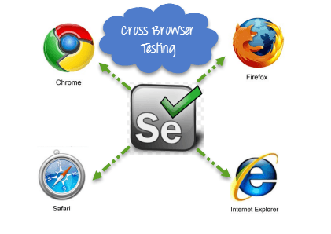](https://www.guru99.com/images/AdvanceSelenium/071514_0700_CrossBrowse1.png)

**Why do we need Cross Browser Testing?**

Web-based applications are totally different from Windows applications. A web application can be opened in any browser by the end user. For example, some people prefer to open [**http://twitter.com**](http://twitter.com) in **Firefox browser,** while other's can be using **Chrome browser** or **IE**.

In the diagram below you can observe that in **IE**, the login box of Twitter is not showing curve at all corners, but we are able to see it in Chrome browser.

[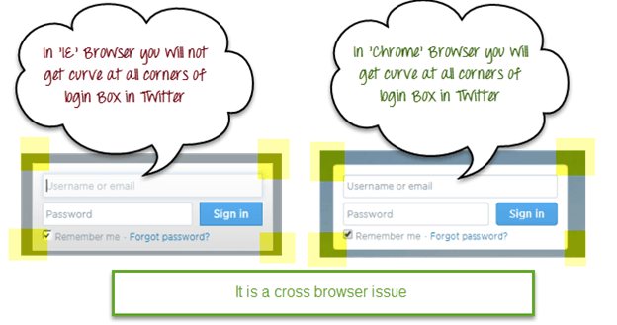](https://www.guru99.com/images/AdvanceSelenium/071514_0700_CrossBrowse2.png)

So we need to ensure that the web application will work as expected in all popular browsers so that more people can access it and use it.

This motive can be fulfilled with Cross Browser [Testing](https://www.guru99.com/software-testing.html) of the product.

**Reason Cross Browser Issues**

1. Font size mismatch in different browsers.
2. JavaScript implementation can be different.
3. CSS,HTML validation difference can be there.
4. Some browser still not supporting HTML5.
5. Page alignment and div size.
6. Image orientation.
7. Browser incompatibility with OS. Etc.

**How to perform Cross Browser Testing**

If we are using Selenium WebDriver, we can automate test cases using Internet Explorer, FireFox, Chrome, Safari browsers.

To execute test cases with different browsers in the same machine at the same time we can integrate [Testng](https://www.guru99.com/all-about-testng-and-selenium.html) framework with Selenium WebDriver.

Your testing.xml will look like that,

[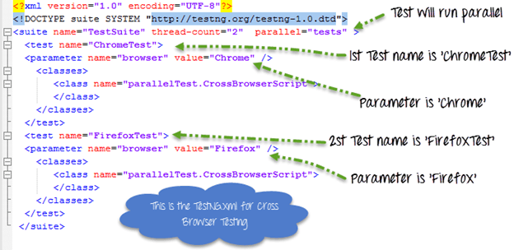](https://www.guru99.com/images/AdvanceSelenium/071514_0700_CrossBrowse3.png)

This testing.xml will map with the [Test Case](https://www.guru99.com/test-case.html) which will look like that

[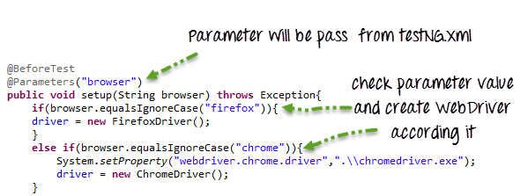](https://www.guru99.com/images/AdvanceSelenium/071514_0700_CrossBrowse4.png)

Here because the testing.xml has two Test tags ('ChromeTest','FirefoxTest'),this test case will execute two times for 2 different browsers.

First Test 'ChromeTest' will pass the value of parameter 'browser' as 'chrome' so ChromeDriver will be executed. This test case will run on Chrome browser.

Second Test 'FirefoxTest' will pass the value of parameter 'browser' as 'Firefox' so FirefoxDriver will be executed. This test case will run on FireFox browser.

Complete Code:

**Guru99CrossBrowserScript.java**

package parallelTest;

import java.util.concurrent.TimeUnit;

import org.openqa.selenium.By;

import org.openqa.selenium.WebDriver;

import org.openqa.selenium.WebElement;

import org.openqa.selenium.chrome.ChromeDriver;

import org.openqa.selenium.edge.EdgeDriver;

import org.openqa.selenium.firefox.FirefoxDriver;

import org.testng.annotations.BeforeTest;

import org.testng.annotations.Parameters;

import org.testng.annotations.Test;

public class CrossBrowserScript {

WebDriver driver;

/**

* This function will execute before each Test tag in testng.xml

* @param browser

* @throws Exception

*/

@BeforeTest

@Parameters("browser")

public void setup(String browser) throws Exception{

//Check if parameter passed from TestNG is 'firefox'

if(browser.equalsIgnoreCase("firefox")){

//create firefox instance

System.setProperty("webdriver.firefox.marionette", ".\\geckodriver.exe");

driver = new FirefoxDriver();

}

//Check if parameter passed as 'chrome'

else if(browser.equalsIgnoreCase("chrome")){

//set path to chromedriver.exe

System.setProperty("webdriver.chrome.driver",".\\chromedriver.exe");

//create chrome instance

driver = new ChromeDriver();

}

//Check if parameter passed as 'Edge'

else if(browser.equalsIgnoreCase("Edge")){

//set path to Edge.exe

System.setProperty("webdriver.edge.driver",".\\MicrosoftWebDriver.exe");

//create Edge instance

driver = new EdgeDriver();

}

else{

//If no browser passed throw exception

throw new Exception("Browser is not correct");

}

driver.manage().timeouts().implicitlyWait(10, TimeUnit.SECONDS);

}

@Test

public void testParameterWithXML() throws InterruptedException{

driver.get("http://demo.guru99.com/V4/");

//Find user name

WebElement userName = driver.findElement(By.name("uid"));

//Fill user name

userName.sendKeys("guru99");

//Find password

WebElement password = driver.findElement(By.name("password"));

//Fill password

password.sendKeys("guru99");

}

}

**testing.xml**

<?xml version="1.0" encoding="UTF-8"?>

<!DOCTYPE suite SYSTEM "http://testng.org/testng-1.0.dtd">

<suite name="TestSuite" thread-count="2" parallel="tests" >

<test name="ChromeTest">

<parameter name="browser" value="Chrome" />

<classes>

<class name="parallelTest.CrossBrowserScript">

</class>

</classes>

</test>

<test name="FirefoxTest">

<parameter name="browser" value="Firefox" />

<classes>

<class name="parallelTest.CrossBrowserScript">

</class>

</classes>

</test>

<test name="EdgeTest">

<parameter name="browser" value="Edge" />

<classes>

<class name="parallelTest.CrossBrowserScript">

</class>

</classes>

</test>

</suite>

**NOTE:** To run the test, Right click on the **testing.xml,** Select Run As, and Click TestNG

[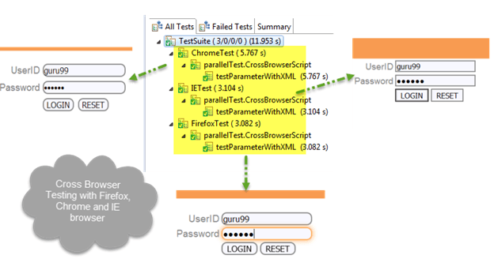](https://www.guru99.com/images/AdvanceSelenium/071514_0700_CrossBrowse5.png)

Summary

1. Cross browser Testing is a technique to test web application with different web browsers.
2. Selenium can support different type of browsers for automation.
3. Selenium can be integrated with TestNG to perform Multi Browser Testing.
4. From parameters in testing.xml we can pass browser name, and in a test case, we can create WebDriver reference accordingly.

**Note:** The given program was built & tested on selenium 3.0.1, Chrome 56.0.2924.87 , Firefox 47.0.2 & Microsoft Edge 14.14393. If the programs give an error, please update the driver