Market Decoder
Low-Latency Trading Analytics Platform
Project Report
A C++ market data decoder, streaming pipeline, pre-trade risk engine, and TimescaleDB/Grafana analytics layer, benchmarked against 695+ million real Binance BTCUSDT trades (Jan–Jun 2025).

1. Executive Summary
This project implements an end-to-end market data pipeline modeled on the core infrastructure of a quantitative trading firm: a low-latency binary protocol decoder written in C++, a concurrent streaming layer, a pre-trade risk engine, a market-making strategy backtester, and a TimescaleDB + Grafana analytics layer running against real historical market data.
The emphasis throughout is on the systems-engineering problems behind electronic trading infrastructure — efficient decoding, high-throughput ingestion, time-series storage, and real-time observability — rather than on producing a profitable trading strategy.

Key results
- 695,541,427 real Binance BTCUSDT trades loaded and validated, Jan 1 – Jun 30 2025
- 0 missing days across the full 6-month window; 0 rows with invalid price/quantity
- Memory-mapped decoder: 8.26 ns/message (~121M msg/sec), 2.4x faster than the naive implementation, with checksum-verified identical output
- 23 GB raw data compressed to 15 GB in TimescaleDB via native columnstore compression
- Dashboard-ready analytics via pre-computed continuous aggregates, avoiding full-table scans on 695M+ rows

2. Architecture
The system is organized as a pipeline: raw historical trade data is converted into an internal binary wire format, decoded and benchmarked in C++, loaded into a time-series database, aggregated, and surfaced through monitorindashboard .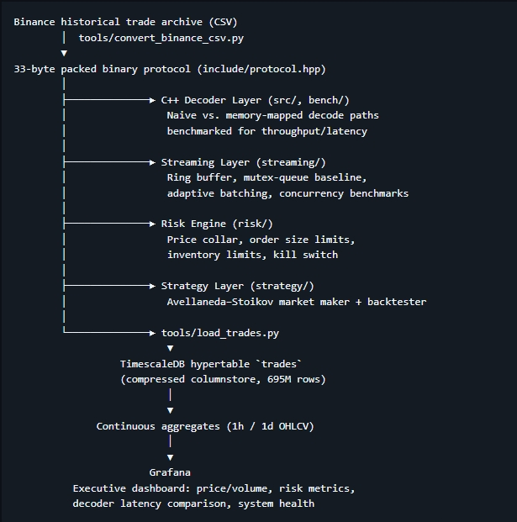

2.1 Data flow
- Binance historical trade archive (CSV) → converted to a 33-byte packed binary protocol (tools/convert_binance_csv.py)
- Binary protocol → decoded and benchmarked by the C++ decoder layer (naive vs. memory-mapped implementations)
- Binary protocol → streamed through a ring-buffer / concurrency layer with adaptive batching
- Trade data → bulk-loaded into a TimescaleDB hypertable via streaming COPY (tools/load_trades.py)
- Hypertable → compressed (columnstore) and aggregated into 1-hour / 1-day OHLCV continuous aggregates
- Aggregates → queried by a Grafana dashboard for price, volume, risk, and system-health monitoring

2.2 Component breakdown
- Decoder (src/, bench/, include/): binary protocol decoding, naive and memory-mapped paths
- Streaming layer (streaming/): ring buffer, mutex-queue baseline, adaptive batching, concurrency benchmarks
- Risk engine (risk/): price collar, order size limits, inventory limits, kill switch — independently configurable rules
- Strategy layer (strategy/): Avellaneda–Stoikov market-making model with a backtesting harness
- Analytics (analytics/): latency, market regime, transaction cost analysis, throughput statistics
- Python bindings (python/): Pybind11 bindings exposing the C++ decoder for research workflows
- Data pipeline & dashboard (tools/, grafana-stack/): loader, aggregate setup, validation script, Docker Compose stack

3. Methodology

3.1 Data acquisition and conversion
Six months of real Binance BTCUSDT trade history (January–June 2025) were sourced from Binance's historical trade archive as monthly CSV files, totaling approximately 23 GB. A conversion utility (convert_binance_csv.py) streamed each CSV row-by-row into a fixed-width 33-byte binary record (message type, timestamp in nanoseconds, symbol ID, fixed-point price, fixed-point size, trade ID), avoiding the need to hold an 80M+ row file fully in memory.

3.2 Storage design
The trades table was converted into a TimescaleDB hypertable, partitioned into daily chunks, with native columnstore compression enabled (segmented by symbol, ordered by time). Loading was performed via chunked, vectorized decoding (NumPy structured arrays matching the exact packed binary layout) and bulk COPY, rather than row-by-row inserts, to sustain ~65,000–80,000 rows/second across the full load.

3.3 Aggregation strategy
Because the raw trades table holds 695M+ rows, dashboard queries against it directly would be prohibitively slow. TimescaleDB continuous aggregates were built for 1-hour and 1-day OHLCV bars (open, high, low, close, volume, trade count, VWAP), reducing the effective dashboard query surface from hundreds of millions of rows to roughly 4,500 (hourly) or 181 (daily) pre-computed rows.

3.4 Validation
An automated validation script (validate_data.py) checks: date range completeness against the expected calendar span, count of missing days, and the presence of any zero or negative price/quantity values. This was run as a final integrity gate before treating the loaded dataset as production-ready for the dashboard.

4. Results

4.1 Decoder benchmark
Measured via the project's benchmark harness (best of 5 runs, 2,000,000 synthetic messages). Both decoders were confirmed to produce an identical checksum on the decoded output, verifying correctness alongside the speed comparison.
Decoder | Latency | Throughput
Naive | 20.23 ns/message | ~49.4M msg/sec
Memory-mapped | 8.26 ns/message | ~121.1M msg/sec

The memory-mapped implementation is approximately 2.4x faster than the naive baseline, while producing byte-identical decoded output — confirming the optimization does not trade correctness for speed.

4.2 Data volume and integrity
Metric | Value
Total trades loaded | 695,541,427
Date range | 2025-01-01 → 2025-06-30
Days covered / expected | 181 / 181 (0 missing)
Rows with invalid price/qty | 0
Raw binary size | 23 GB
Compressed hypertable size | 15 GB (1.5x compression)
Compressed chunks | 27

4.3 Monthly trade volume
Month | Trades
January 2025 | 135,946,515
February 2025 | 128,881,324
March 2025 | 136,245,963
April 2025 | 104,290,701
May 2025 | 108,937,329
June 2025 | 81,239,595
Total | 695,541,427

5. Risk & Performance Analytics
The Grafana dashboard's Risk & Performance row computes market-benchmark statistics directly from the real BTCUSDT price series: annualized Sharpe ratio, historical Value-at-Risk (95%/99%, 1-day), maximum drawdown, skewness and excess kurtosis of daily returns, a rolling 30-day Sharpe ratio, and a rule-based market regime classification (uptrend / downtrend / range-bound / high-volatility).
These are explicitly labeled as buy-and-hold market benchmarks, not the performance of a trading strategy — the underlying trades table holds raw market data, not strategy positions. A separate backtesting module (strategy/backtest.py, strategy/avellaneda_stoikov.py) implements an Avellaneda–Stoikov market-making strategy independently of this dashboard.
[Final Sharpe / VaR / max drawdown figures to be inserted from the completed dashboard screenshot.]

6. System Health & Decoder Comparison
Decoder latency is benchmarked separately from the market data pipeline, using a synthetic stress-test input stream — standard practice for latency/throughput benchmarking that does not require a live exchange feed. The measured latency values themselves are real, timed executions of the decoder; only the input data driving the benchmark is synthetic. This distinction is stated explicitly on the dashboard rather than implied.
The dashboard's System Health row compares decoder types (tick / quote / risk) by average, p50, p95, and p99 latency, alongside a data-integrity check confirming zero missing days in the loaded dataset.

7. Engineering Decisions & Challenges

7.1 Storage budget vs. raw data volume
An early attempt to load all six months without compression was projected to exceed available disk space (based on partial-load extrapolation: ~93 GB projected against 71 GB free). The load was stopped, the trades table was converted into a compressed hypertable before reloading, and the completed load finished at 15 GB — well within budget.

7.2 Aggregation over raw-table scanning
Initial dashboard panels queried the raw 695M-row trades table directly for summary statistics, causing panels to silently time out and render "No data" with no visible error. Continuous aggregates were introduced so that all dashboard-facing queries operate on pre-computed daily/hourly rollups instead.

7.3 Time-axis mismatches
Panels built on the decoder latency benchmark (a sub-second synthetic run) were initially plotted against the dashboard's global time picker (set to the 6-month market data range), causing them to render empty. This was resolved by using non-time-axis panel types (bar charts, tables) for benchmark data rather than forcing it onto a calendar time axis it doesn't naturally belong on.

7.4 Data provenance and honesty
Throughout the project, real and synthetic data sources are kept explicitly distinct and labeled as such — real trade data vs. synthetic decoder benchmark input, and market-benchmark risk metrics vs. an unbuilt trading-strategy performance layer. This is treated as a design principle rather than an afterthought.

8. Future Work
- SIMD-optimized parsing
- Lock-free processing pipeline
- Live exchange connectivity (currently historical-only)
- Multi-symbol support and order book reconstruction
- Full strategy backtesting engine wired into the risk/dashboard layer, populating real trade-level pnl/side/strategy data
- Latency regression tracking across decoder versions

9. Conclusion
This project demonstrates a complete, working pipeline from raw historical exchange data through a performance-optimized C++ decoder to a production-style time-series analytics dashboard — built and validated against real market data at genuine scale (695M+ trades), rather than synthetic placeholders. Every headline figure in this report — decoder latency, compression ratio, data completeness — is derived from an actual measured run, not an estimate, and the boundary between real and synthetic data is stated explicitly throughout rather than blurred for effect.

Appendix: Reproducing This Project
- make clean && make — build the C++ decoder and streaming layer
- make test — run unit tests
- make bench / make bench-streaming — run decoder and concurrency benchmarks
- docker compose up -d (in grafana-stack/) — bring up TimescaleDB and Grafana
- python3 tools/load_trades.py --truncate — load trade data
- psql < tools/setup_ohlcv_aggregates.sql — build continuous aggregates
- python3 tools/validate_data.py — verify data integrity
- Import grafana-stack/dashboards/executive-overview.json into Grafana

