**Data Visualisation Assignment 2**

**Customer analysis using tableau**

**Sheet1**

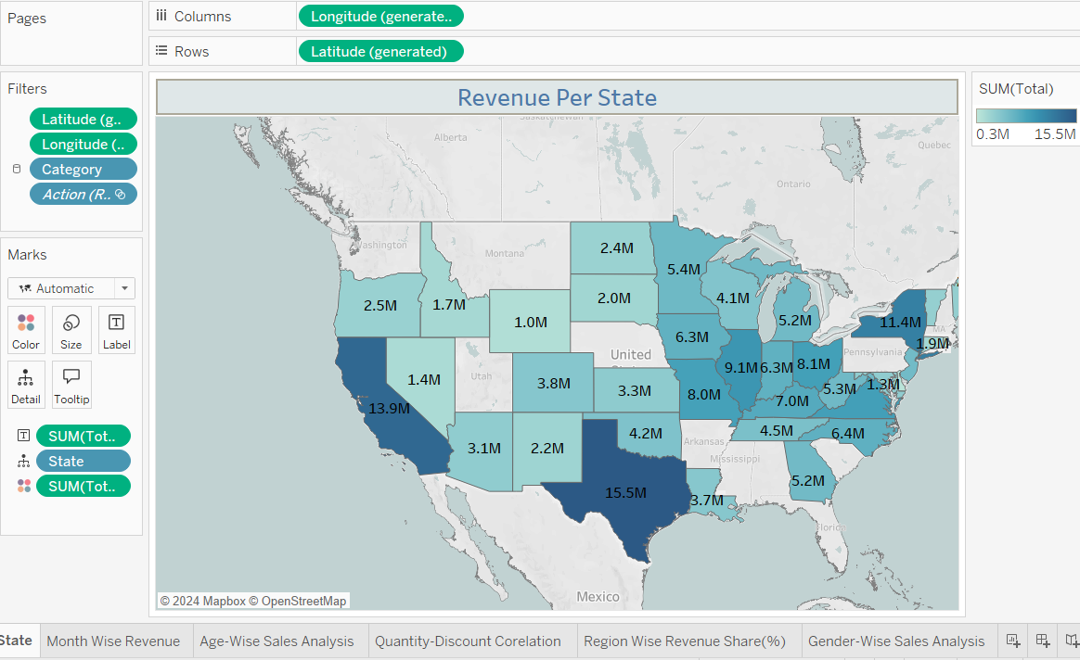

**Sheet 2**

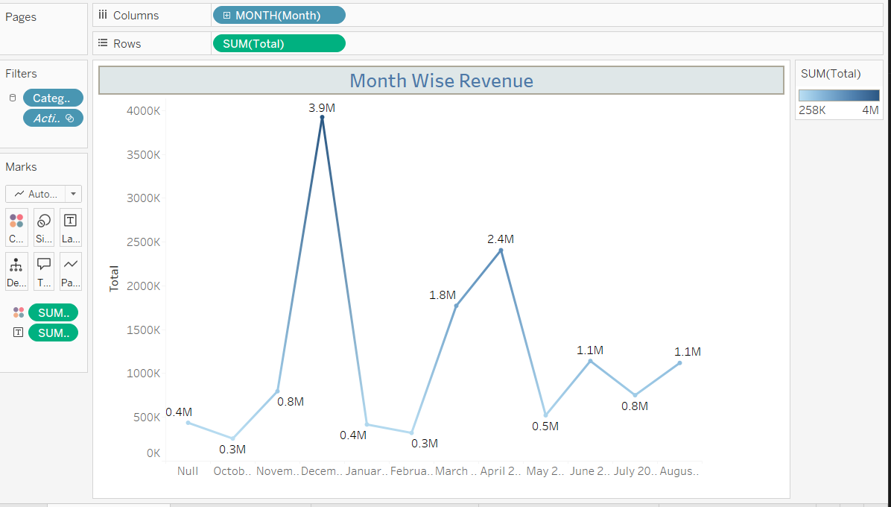

**Sheet 3**

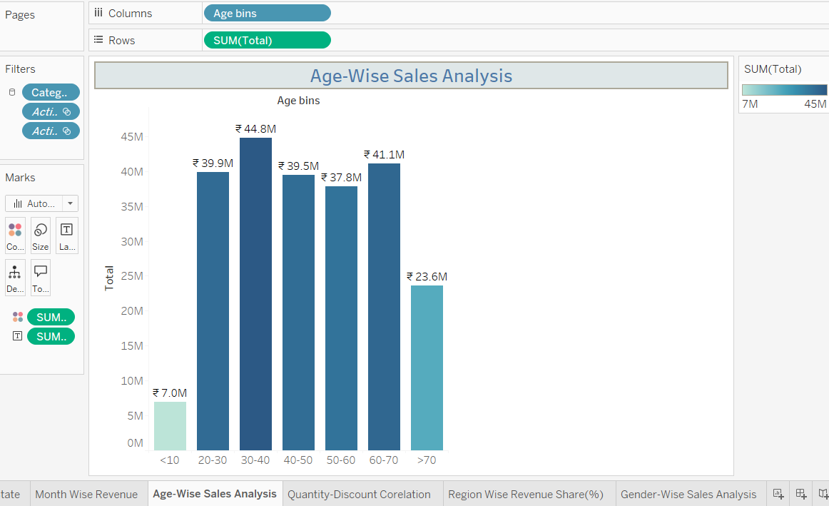

**Sheet4**

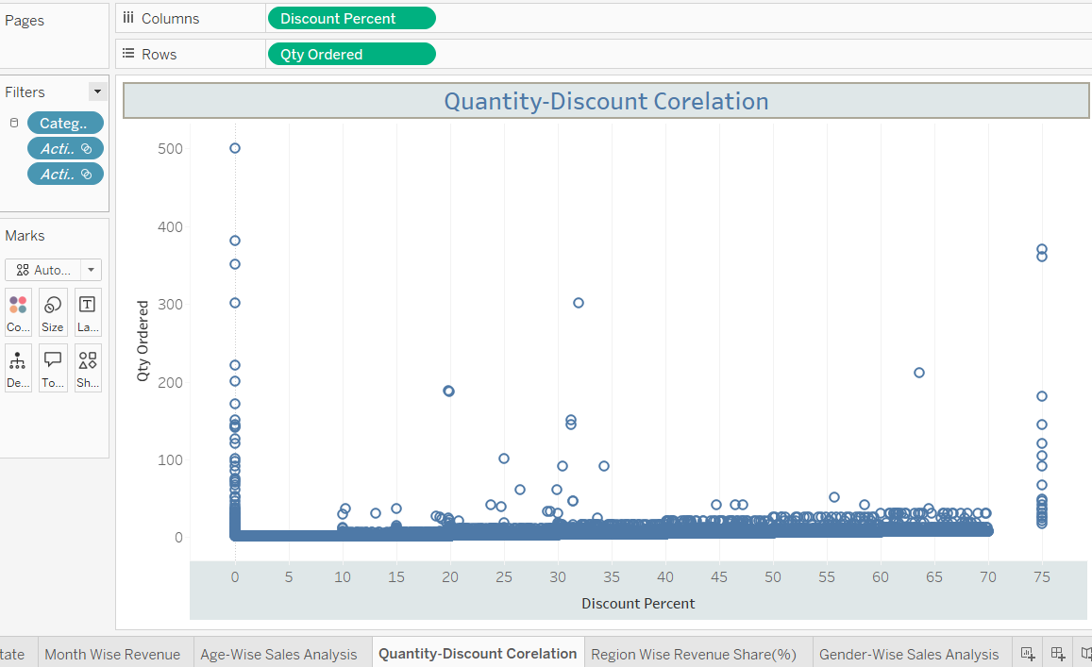

**Sheet 5**

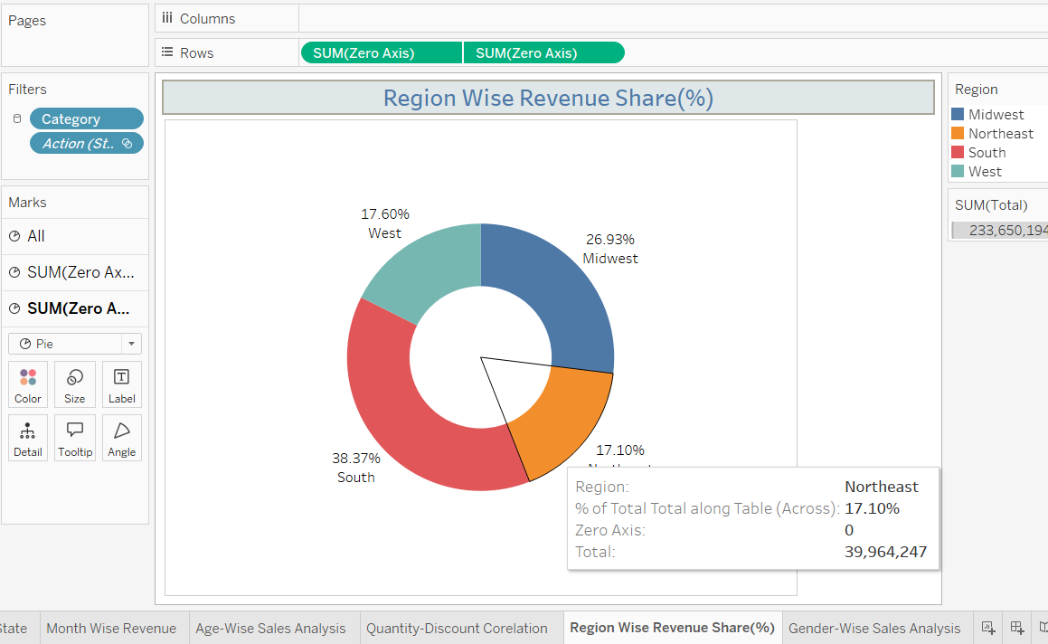

**Sheet 6**

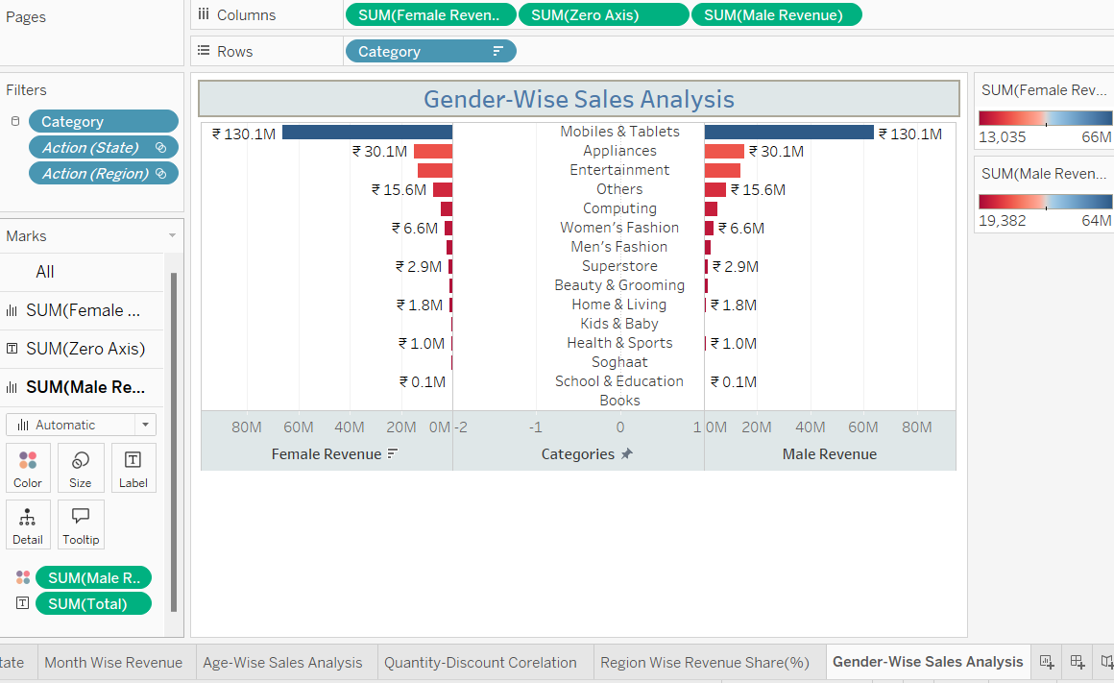

**KPI**

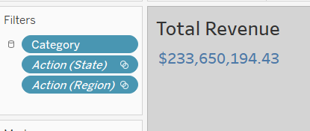

**Final Dashboard**

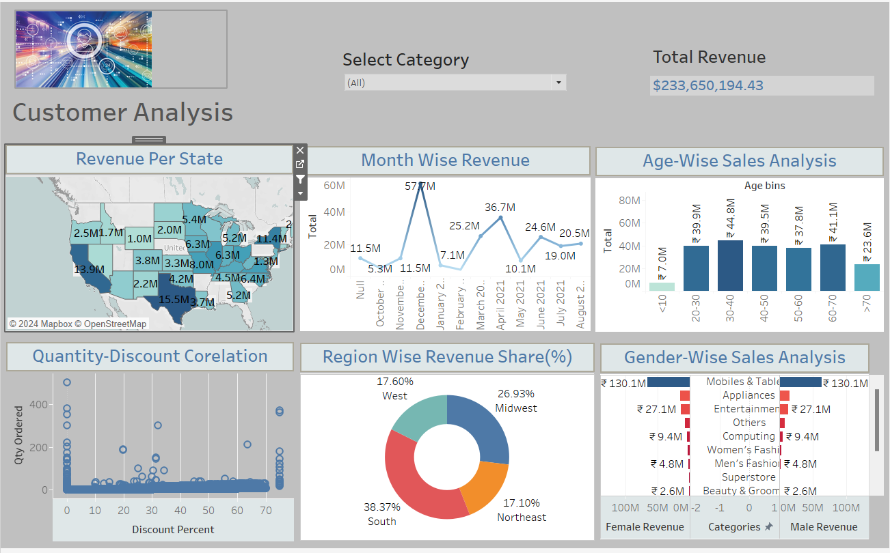

**Data Visualization changes as per your selection for eg. Look at below SS . Here I have click on a single state so it shows me only that state data in all visualization.**

**In upwards there is a catergory selection option where we can select any category we want and it shows me that vaisualization in other plots.**

