  - OCR A Level Computer Science H446-03
  - Programming Project

PITWALL
  - Motorsport Race Strategy Simulation and Optimisation System
Candidate: Mithil Katkoria
Candidate number: 0460
Centre number: 12709
NEA final master document
PITWALL compares race strategies using an explainable mathematical model. This report presents the problem, design, implementation, recorded tests and evaluation, followed by supporting appendices.
The current evidence supports computational correctness within the stated model. Stakeholder investigation and human usability results remain to be collected. Precise placeholders identify these gaps.

Contents
Abbreviations 5
1 Analysis of the problem 6
1.1 Introduction 6
1.2 Description of the problem 6
1.3 Why computation is appropriate 6
1.4 Stakeholders 6
1.5 Research into existing solutions 6
1.6 Proposed computational solution 9
1.7 Essential features 9
1.8 Scope limitations 10
1.9 Hardware and software requirements 10
1.10 Success criteria 10
2 Design of the solution 13
2.1 Problem decomposition 13
2.2 Overall system structure 13
2.3 Class design 14
2.4 Data structures 15
2.5 Important variables 16
2.6 Algorithm design 16
2.7 Validation design 21
2.8 Usability design 22
2.9 Current interface design 23
2.10 Iterative test plan 23
2.11 Post-development test plan 24
3 Development and testing 25
3.1 Core models 25
3.2 Tyre degradation 25
3.3 Lap and fuel calculation 26
3.4 Pit stops and dry race 27
3.5 Strategy comparison 28
3.6 First desktop milestone 28
3.7 Event queue 30
3.8 Weather effects 31
3.9 Safety car 31
3.10 Seeded variation 32
3.11 Monte Carlo and statistics 33
3.12 Bounded optimisation 33
3.13 JSON persistence 34
3.14 Advanced GUI and charts 35
3.15 Robustness and verification 36
3.16 Genuine failures and remedial action 37
3.17 Recorded test progression 38
4 Post-development testing 40
4.1 Functional testing 40
4.2 Robustness testing 40
4.3 Performance testing 41
4.4 Manual verification 42
4.5 Usability testing 42
4.6 Final quality verification 43
5 Evaluation 45
5.1 Overall evaluation 45
5.2 Evaluation against success criteria 45
5.3 Functional correctness 46
5.4 Evaluation of algorithms 47
5.5 Performance 47
5.6 Robustness 47
5.7 Usability 47
5.8 Stakeholder evaluation 47
5.9 Maintenance 48
5.10 Limitations 48
5.11 Future improvements 49
5.12 Final conclusion 49
6 Bibliography 50
7 Appendices 51
Appendix A Source and class relationships 51
Appendix B Automated test inventory 52
Appendix C Execution and failure evidence 54
Appendix D Full benchmark values 55
Appendix E Research materials 57
Appendix F Human evidence packs 57
Appendix G Git development summary 62
Appendix H Evidence catalogue and completeness audit 62
Appendix I JSON contract and example 64
Appendix J Additional application screenshots 65
Appendix K Development declaration 68

List of figures
Figure 1: Implemented module architecture
Figure 2: Current strategy comparison interface
Figure 3: First deterministic GUI milestone
Figure 4: Completed bounded-search result
Figure 5: Core class relationships
Figure 6: Actual comparison metrics
Figure 7: Actual lap records
Figure 8: Conditions and experiment settings
Figure 9: Actual paired Monte Carlo summary
Figure 10: Actual Monte Carlo histogram

List of tables
Table 1: Proposed stakeholder involvement
Table 2: Existing solution comparison
Table 3: Existing solution comparison
Table 4: Existing solution comparison
Table 5: Requirements from the project brief
Table 6: Development and end-user environment
Table 7: First milestone success criteria
Table 8: Advanced success criteria
Table 9: Classes in models
Table 10: Classes in events
Table 11: Classes in conditions
Table 12: Classes in monte_carlo
Table 13: Classes in optimiser
Table 14: Classes in persistence
Table 15: Structures and alternatives
Table 16: Variables and units
Table 17: Algorithm example or test data
Table 18: Core data responsibilities
Table 19: Typical boundary and erroneous tests
Table 20: All preserved execution runs
Table 21: Functional verification
Table 22: Recorded invalid and boundary cases
Table 23: Raw measured seconds and summary
Table 24: Five-lap independent expected calculation
Table 25: Unconducted usability task sheet
Table 26: Comparison latency summary
Table 27: Raw comparison repeats in seconds
Table 28: Success criterion judgements
Table 29: Algorithm strengths and trade-offs
Table 30: Maintenance issues and technical changes
Table 31: Limitations and improvements
Table 32: Final collected cases
Table 33: Blank human evidence form
Table 34: Blank human evidence form
Table 35: Blank human evidence form
Table 36: Candidate understanding topics
Table 37: Genuine commits in chronological order
Table 38: Criterion completeness and remaining work
Table 39: Factual assistance record

Abbreviations
GUI: graphical user interface. JSON: JavaScript Object Notation. RNG: random number generator. SC: safety car in model settings; SC01 to SC14: success criteria. FR: functional requirement. NEA: non-exam assessment. UTC: coordinated universal time.

1 Analysis of the problem

1.1 Introduction
PITWALL is a desktop race-strategy simulator. A strategy identifies the starting tyre and the lap after which each pit stop occurs. The program calculates the consequence of those decisions over the full race and allows alternatives to be compared under the same assumptions.

1.2 Description of the problem
A fresh Soft tyre can be quicker than a Hard tyre, but its pace can deteriorate more rapidly. Remaining on an old set saves pit time immediately but can lose time on every later lap. Race length changes whether a pit stop has enough time to pay back its cost. Fuel and driver pace also affect the total. Weather and safety-car periods add changing conditions, so a plan that is best in a dry race may be less effective when the timing of an event changes.
Manual calculation is practical for a five-lap example, but becomes repetitive across many stop laps and tyre sequences. It is easy to count a pit loss twice or reset tyre age on the wrong lap. A computer can apply one defined rule consistently and retain the components for inspection.

1.3 Why computation is appropriate
Abstraction removes wheel-to-wheel physics and represents a single car with a few time penalties. This keeps the model understandable but limits real-world prediction. Decomposition separates input validation, lap calculation, event state, comparison and presentation. Selection determines whether a stop or event applies. Iteration repeats the lap model and then repeats whole races for candidate strategies or uncertainty trials. Visualisation exposes tyre trends and pit spikes that are difficult to see in a total alone. These techniques solve specific parts of the problem rather than being included only as terminology.

1.4 Stakeholders
Appropriate stakeholder types include motorsport enthusiasts learning strategy trade-offs, sim-racing users comparing plans, and Computer Science students or teachers reviewing the model. These are proposed categories, not invented interview participants. No named participant or response is recorded.
Table 1: Proposed stakeholder involvement
Type | Use and information needed | Response
Motorsport enthusiast | Interpret pit timing and compound trade-offs | [GENUINE STAKEHOLDER RESPONSE REQUIRED]
Sim-racing user | Assess which simplifications affect usefulness | [GENUINE STAKEHOLDER RESPONSE REQUIRED]
Student or teacher | Explain algorithms and check clarity | [GENUINE STAKEHOLDER RESPONSE REQUIRED]

Prepared questions ask which decisions users want to explore, which inputs they understand, what output helps comparison, how errors should appear, which simplifications could mislead them, and whether a pit-lap spike is clear. Appendix F provides a ready-to-use record and task sheet.

1.5 Research into existing solutions
Source review recorded on 2026-09-08 after the implemented prototype. This timing is explicit: these sources did not cause the initial design, which came from the user's brief. Findings below inform maintenance and the research-led review exercises added now. No software was downloaded or personally trialled for this review. Weaknesses refer to suitability for PITWALL's educational purpose and are identified as judgements, not measured defects.

R01: TUM race-simulation
The authors describe a lap-based simulator with fuel-mass reduction, degradation, participant interactions and Monte Carlo. Their separate basic simulator assumes a free track and finds minimum race time; the broader system includes neural-network strategy approaches. TUM repository and documentation (https://github.com/TUMFTM/race-simulation).
Table 2: Existing solution comparison
Feature | Strength | Weakness for this project (judgement) | Decision | PITWALL impact
Basic/full separation | Makes assumptions distinguishable | Full interaction model exceeds initial scope | ADAPT | Keep single-car limitation visible; compare baseline and search under identical assumptions
Lap discretisation | Supports repeated scenario evaluation | Cannot resolve within-lap changes | LEARN | Add review exercise identifying a mid-lap event that PITWALL cannot represent
Monte Carlo | Studies probabilistic effects | Results depend on distributions | ADAPT | Retain seeds and test probability sensitivity rather than claim calibrated confidence
Neural strategy engineer | Automates richer decisions | Harder to defend at A-level | REJECT | Retain bounded enumeration and explain candidate count

No source code or parameter set was copied. The authors' warning about exact race reproduction reinforces the need for PITWALL's conditional claims.

R02: FastF1
The maintainer describes timing/telemetry/session access, extended Pandas structures, Matplotlib integration and request caching. This is a data-analysis library rather than PITWALL's counterfactual strategy simulator. FastF1 maintainer README (https://github.com/theOehrly/Fast-F1).
Table 3: Existing solution comparison
Feature | Strength | Weakness for this project (judgement) | Decision | PITWALL impact
Structured timing data | Supports inspecting individual laps | Observed laps contain confounding race effects | LEARN | Add calibration exercise separating observations from model inputs
Matplotlib integration | Connects numeric data and plots | Plot alone cannot establish model correctness | ADOPT principle | Keep independent arithmetic tests alongside graphs
API caching | Reduces repeated retrieval | Introduces external data/cache concerns | REJECT dependency now | Keep scenarios offline and portable
Pandas extensions | Rich analysis tools | Extra abstraction for a small typed model | ADAPT idea | Retain explicit LapResult records instead of adding DataFrames

Future calibration would need source/date/provenance and rules for excluding pit, traffic and weather laps. FastF1 is not evidence that current fictional parameters are accurate. No live feed is required or integrated.

R03: F1 Manager series
Frontier's 2023 Belgian circuit guide discusses mistimed dry/intermediate changes and a one-stop versus extra-stop decision involving traffic. This illustrates a strategy-learning scenario; game guidance is not validated engineering telemetry. Publisher circuit guide (https://www.f1manager.com/nl-NL/2023/grand-prixs/belgian-grand-prix).
The 2024 feature article describes mechanical failures, more aggressive battles and multiple viewing angles. These are publisher descriptions, not independent realism findings. Publisher feature article (https://www.f1manager.com/features/new/levensechte-f1-races).
Table 4: Existing solution comparison
Feature | Strength | Weakness for this project (judgement) | Decision | PITWALL impact
Scenario-based decisions | Gives users a concrete trade-off | Outcome mixes traffic and tyre effects | ADAPT | Add controlled comparison tasks in review materials
Wet tyre timing | Demonstrates transition risk | PITWALL lacks wet compounds | LEARN | Mark wet-tyre choice explicitly unimplemented; propose suitability matrix
Failures and battles | Rich race context | Too broad for explainable first model | REJECT | Maintain single-car abstraction
Race presentation | Helps users follow events | Cinematic view does not reveal formulas | ADAPT | Prioritise component tables and actual graphs

Research-led changes made at this review
Added docs/testing/research-review-exercises.md: inspect a mid-lap event limitation; compare one/two-stop cases; examine probability sensitivity; distinguish telemetry calibration from illustrative input; explicitly identify missing wet tyres. These are new review tasks, not retrospective claims of stakeholder requests or test results.
The initial guessed TUM URL returned404 and the FastF1 docs endpoint returned403. The canonical repositories above were then read successfully. Some publisher pages required search retrieval. The accessible source contents support this review; no unavailable page is cited as read.

Post-prototype review and next decisions
The problem is to compare complete race plans, not merely select the fastest fresh tyre. A faster compound may lose its advantage through wear or an additional pit stop. PITWALL keeps a common race configuration, evaluates each racing lap and ranks accumulated times so a user can inspect that trade-off.
Computation is useful because the same arithmetic must be applied consistently across many lap and stop combinations. Decomposition separates input validation, lap components, state transitions and result comparison. A priority queue preserves chronological events and deterministic ties. Bounded enumeration gives a checkable best plan inside an explicit search space. Seeded trials help explore variation but cannot calibrate the model by repetition alone.
The three existing-system reviews were recorded after the prototype. Their value is in reviewing scope: TUM's richer simulator highlights PITWALL's single-car simplification; FastF1 highlights the need for provenance before using real data; F1 Manager suggests clearer presentation but is not evidence for physical parameters. These findings support review exercises and possible future changes, not a rewritten claim that they created the original design. Genuine participant priorities are still required before choosing a new feature.

1.6 Proposed computational solution
The solution builds from validated race and tyre inputs to a deterministic engine. Comparison runs each plan using the same configuration. Conditions add scheduled weather and safety-car events. A local seeded generator controls lap variation. Monte Carlo repeats a paired comparison and records trial seeds; bounded optimisation enumerates legal plans and ranks their totals. JSON preserves scenarios, and the GUI displays results and allows long runs to be cancelled. These functions are implemented, but their suitability for actual users still needs genuine feedback.

1.7 Essential features
Table 5: Requirements from the project brief
ID | Requirement | Source | Priority | Justification | Acceptance
FR01 | Configure race length and base pace | Brief | Must | Compare race scenarios | SC01
FR02 | Configure Soft, Medium, Hard pace and degradation | Brief | Must | Model compound trade-offs | SC02
FR03 | Create strategies with ordered pit stops | Brief | Must | Explore alternative stints | SC03
FR04 | Reject invalid values with explanations | Brief | Must | Prevent misleading results | SC04
FR05 | Simulate a deterministic dry race | Brief | Must | Establish correctness before uncertainty | SC05
FR06 | Show per-lap and total results | Brief | Must | Make calculation inspectable | SC06
FR07 | Compare at least two strategies under identical conditions | Brief | Must | Support strategy decisions | SC07
FR08 | Plot actual simulated lap times in a desktop GUI | Brief | Must | Expose changes over race distance | SC08
FR09 | Save and load a scenario as JSON | Brief | Later | Repeat comparisons | Separate iteration
FR10 | Process weather and safety-car events chronologically | Brief | Later | Explore changing conditions | Separate iteration
FR11 | Add seed-reproducible randomness and Monte Carlo statistics | Brief | Later | Quantify model uncertainty | Separate iteration
FR12 | Search constrained legal strategies and compare baselines | Brief | Later | Evaluate explainable algorithms | Separate iteration

The source of FR01 to FR12 is the supplied project brief. The priorities above describe the recorded development order, not missing implementation: the later features were subsequently built. No requirement is attributed to an unconsulted stakeholder.

1.8 Scope limitations
The initial scope prioritised dry deterministic calculation. The implemented extension still uses only dry compounds, linear degradation and a single-car model. Weather adds equal penalties to all available tyres; safety car changes lap delay and relative pit loss without field bunching. Parameters are illustrative, not proprietary telemetry. Bounded search deliberately excludes off-grid and more-than-two-stop plans. These limits are evaluated in Section 5.10.

1.9 Hardware and software requirements
Table 6: Development and end-user environment
Area | Recorded or required environment | Justification
Developer hardware | Snapdragon(R) X 10-core X1P64100 @ 3.40 GHz; 16756006912 bytes RAM | Actual benchmark machine, not a minimum specification
Developer software | Windows 11; Python 3.14 AMD64; PySide6; Matplotlib; pytest; Git | Desktop UI, graphing, automated checks and genuine history
End user | Tested Python environment and a readable desktop display | Source distribution currently requires dependencies; minimum hardware unmeasured
Installation | Short virtual-environment path on Windows | Avoids recorded PySide6 path-length installation problem

Python expresses the calculations without a compiled build step. Dataclasses and enums are standard-library structures. Qt supplies desktop controls and a worker thread; Matplotlib renders result graphs [R06, R07]. JSON supports a small offline scenario without database administration. The development machine uses an AMD64 Python process on Snapdragon hardware, so the timings must not be described as native ARM measurements.

1.10 Success criteria
Table 7: First milestone success criteria
ID | Criterion and measurement | Link | Justification
SC01 | Accept integer race lengths 1..500 and positive base lap time; reject 0, negative, fractional and oversized lengths | FR01 | Finite, useful interactive scope
SC02 | All three compounds have configurable non-negative pace penalties and linear degradation; age 3 at 0.2 s/lap gives 0.6 s | FR02 | Explainable arithmetic
SC03 | Ordered distinct stops after laps 1..N-1 change compound on the following lap and add pit loss exactly once | FR03 | Unambiguous lap indexing
SC04 | Automated typical, boundary and erroneous cases raise descriptive errors; GUI shows an error for malformed stops | FR04 | Actionable validation
SC05 | Two runs of identical inputs return equal results; five-lap manual oracle matches each lap within 1e-9 seconds | FR05 | Reproducibility and independent oracle
SC06 | Exactly N lap rows; total equals sum of lap times; tyre age resets after a stop | FR06 | Complete inspectable output
SC07 | At least two strategies produce ranked total, average, fastest, slowest, pit loss, stop count and stint lengths | FR07 | Useful direct comparison
SC08 | Real Qt application opens and renders a graph with N points per compared strategy; manual usability remains separately pending | FR08 | Viewable genuine output

These criteria consolidate the measurable conditions recorded before implementation in I08..I17 designs. Stakeholder approval is pending. They do not replace the earlier first-milestone criteria.
Table 8: Advanced success criteria
ID | Requirement | Measurable criterion | Justification | Planned evidence
SC09 | FR09 | Exact scenario round-trip with seed/events/stop service; reject wrong schema, malformed data and collection types | Repeatable portable inputs | Persistence and final robustness tests
SC10 | FR10 | Events chronological; ties input-ordered; wet increments30s and SC manual result519.6s in documented five-lap examples | Verify state effects independently | Event and condition tests
SC11 | FR11 | Same seed reproduces full trials; summary oracle [1,2,3] correct;100 actual paired trials; count0/1001 rejected | Reproducible bounded uncertainty | Monte Carlo tests and benchmark
SC12 | FR12 | N3/max1 space contains 21 unique plans; tiny winner182.2s; independent4-lap score distribution matches; report complete candidate count | Verify search coverage and scoring | Optimiser/final tests and exported search
SC13 | FR11/FR12 | Recorded machine default search <10s and 1000 paired50-lap trials <30s (three repeats) | Usable bounded interactive workloads | Real BENCH-01
SC14 | FR09..FR12 | Background task returns results; old-input results discarded; cancellation callback honoured; GUI data round-trip exact | Protect responsiveness and result provenance | GUI integration and cancellation tests

The first13 criteria are computational/visual checks. SC14 needs additional genuine manual responsiveness and cancellation observations before usability is judged fully met. Working widgets are not automatically usable for the intended audience.

2 Design of the solution

Original or recorded design
The I01-I17 design files and actual Git history are retained. Their existence alone does not prove every paragraph preceded every edit. Run metadata supplies source hashes at execution time; seven same-day commits provide coarse checkpoints. The report distinguishes the documented combined stages and actual order.

Post-implementation architecture documentation
Implemented-structure diagrams and the master report class inventory were derived from current source. They explain the completed program and are not original wireframes. Existing-system research is a post-prototype review, with its later timing retained.

New prospective design
No feedback-driven software iteration is claimed. When a genuine response identifies a need, record its alias and evidence reference, update the requirement, write design and test expectations before coding, implement one justified change, run tests, retain any actual failures and request a real follow-up review. Candidate reflection must use the real dates. The final computational verification plan is separate from such an iteration.

2.1 Problem decomposition
The problem is decomposed into: describing valid conditions; predicting one lap; tracking tyre age and accumulated time; applying decisions and changing conditions; comparing complete outcomes; exploring uncertain outcomes; searching a finite decision space; preserving inputs; and making results readable. Validation affects every part because invalid inputs can otherwise produce convincing but meaningless outputs.

2.2 Overall system structure
The actual dependency direction runs from GUI to validated models and analysis functions. Computational modules do not import Qt. There is no separate controller module: AdvancedWindow collects an immutable snapshot and calls the engine or worker. Figure 1 shows these existing modules.
Figure 1 shows how input, calculation and presentation are separated. This diagram was prepared for this report from current source, not presented as an original wireframe.
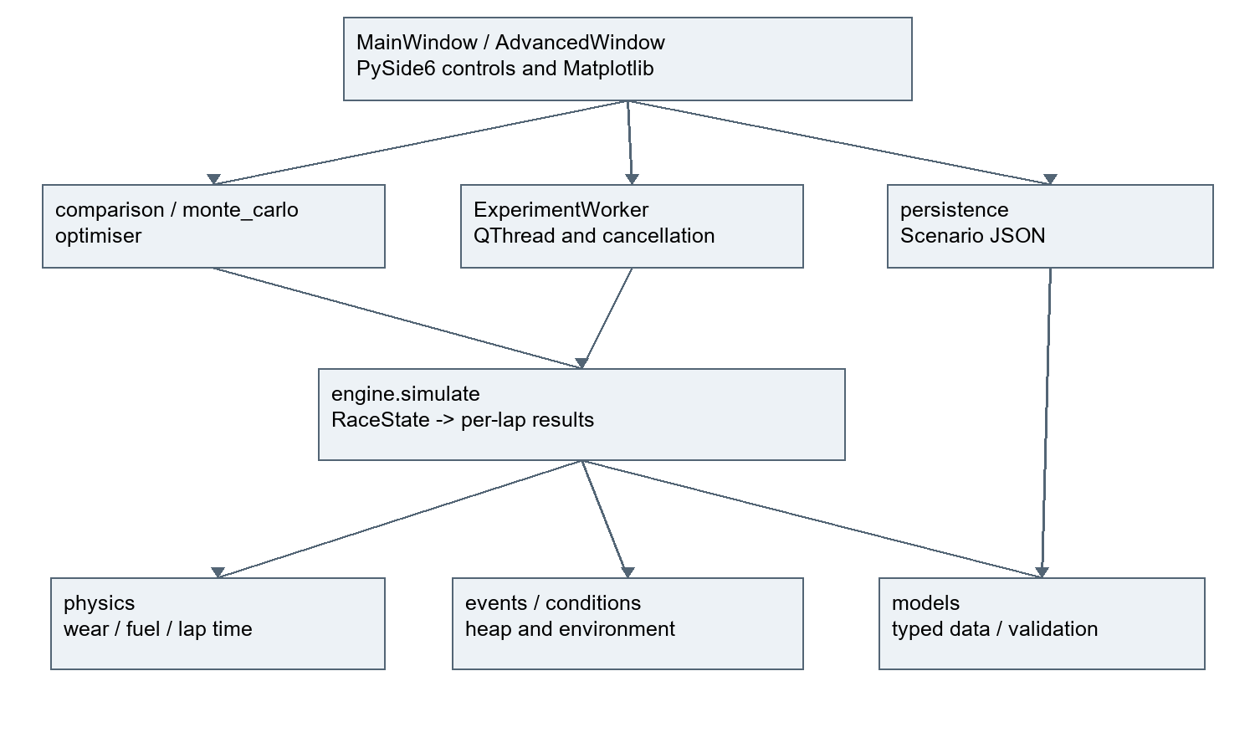
Figure 1: Implemented module architecture

2.3 Class design
The class inventory below is extracted from the current Python syntax tree. Constructor validation usually lives in __post_init__. Frozen dataclasses reduce accidental input mutation, although dictionaries inside MonteCarloResult remain mutable; frozen does not imply deep immutability.
Table 9: Classes in models
Class | Key attributes | Methods
Compound | Enum values or private queue state | Data record
Circuit | name: str; base_lap_time: float; pit_lane_loss: float | __post_init__
Driver | name: str; pace_delta: float | __post_init__
TyreCompound | name: Compound; base_pace_delta: float; degradation_rate: float; recommended_life: int | __post_init__
PitStopPlan | lap: int; compound: Compound; stationary_time: float | __post_init__
Strategy | name: str; starting_compound: Compound; planned_stops: tuple[PitStopPlan, ...] | __post_init__; validate_for
RaceConfig | laps: int; circuit: Circuit; driver: Driver; tyres: tuple[TyreCompound, ...]; initial_fuel_penalty: float | __post_init__; tyre
RaceState | completed_laps: int; compound: Compound; tyre_age: int; cumulative_time: float | __post_init__
LapResult | lap_number: int; lap_time: float; cumulative_time: float; compound: Compound; tyre_age: int; degradation_loss: float; fuel_effect: float; pit_stop: bool; pit_loss: float | __post_init__
StrategyResult | strategy: Strategy; laps: tuple[LapResult, ...] | __post_init__; total_time

Table 10: Classes in events
Class | Key attributes | Methods
Weather | Enum values or private queue state | Data record
EventType | Enum values or private queue state | Data record
RaceEvent | lap: int; kind: EventType; weather: Weather | None | __post_init__
EventQueue | Enum values or private queue state | __init__; at_lap

Table 11: Classes in conditions
Class | Key attributes | Methods
Conditions | initial_weather: Weather; events: tuple[RaceEvent, ...]; damp_penalty: float; wet_penalty: float; safety_car_penalty: float; safety_car_pit_factor: float; seed: int; variation: float | __post_init__; weather_loss
EnvironmentalLapResult | weather: Weather; weather_effect: float; safety_car: bool; safety_car_effect: float; random_variation: float | __post_init__

Table 12: Classes in monte_carlo
Class | Key attributes | Methods
Trial | seed: int; safety_car_start: int | None; a_total: float; b_total: float | Data record
MonteCarloResult | trials: tuple[Trial, ...]; a_statistics: dict[str, float]; b_statistics: dict[str, float]; a_win_probability: float; tie_probability: float | Data record

Table 13: Classes in optimiser
Class | Key attributes | Methods
SearchSettings | max_stops: int; minimum_stint: int; pit_step: int; stationary_time: float | __post_init__
CandidateScore | strategy: Strategy; total_time: float | Data record

Table 14: Classes in persistence
Class | Key attributes | Methods
Scenario | config: RaceConfig; conditions: Conditions; strategies: tuple[Strategy, ...] | __post_init__

RaceConfig owns Circuit, Driver and the three TyreCompound definitions. Strategy contains PitStopPlan objects. StrategyResult refers to its Strategy and lap tuple. EnvironmentalLapResult inherits LapResult. Scenario joins config, conditions and strategies. AdvancedWindow extends MainWindow and owns ExperimentWorker. These are the relationships shown in the UML views in Appendix A.

2.4 Data structures
Table 15: Structures and alternatives
Structure and use | Reason | Alternative
Tuple: tyres, stops, events and lap records | Fixed input/result sequences support reproducibility | Lists allow easier mutation but weaker boundaries
List: results, scores and trials during construction | Append then convert or sort | Preallocation adds bookkeeping without measured need
Dictionary: stops keyed by lap | Average constant-time stop lookup | Scanning all stops every lap
Tuple-keyed heap: EventQueue | Chronological order with sequence tie-break | Sort once for current static schedules
Enum: compound, weather, event type | Restricts valid named states | Unrestricted strings permit spelling errors
Dataclass: model and result records | Groups typed fields and validation | Parallel lists risk mismatched positions

RaceConfig.tyre actually searches its three-element tuple using next; it is not a dictionary lookup. With exactly three compounds this cost is bounded. This distinction matters when explaining the actual implementation.

2.5 Important variables
Table 16: Variables and units
Variable | Type and range | Purpose
laps | int, 1..500 | Race distance
tyre_age | int, >=0 | Completed laps on current set before this lap
base_lap_time | finite number >0, seconds | Reference racing pace
degradation_rate | finite number >=0, seconds per tyre lap | Linear wear slope
cumulative_time | finite number >=0, seconds | Accumulated total
seed | int, 0..2^32-1 | Replayable generator state
variation | finite number >=0 and below base lap time | Uniform signed noise amplitude
safety_car_pit_factor | number 0..1 | Relative pit-loss multiplier
minimum_stint / pit_step | int, 1..500 | Search constraints
revision | integer counter in AdvancedWindow | Reject output for changed inputs

2.6 Algorithm design
The existing repository IDs are retained to avoid breaking traceability: A01 lap time, A02 degradation, A03 fuel, A04 strategy validation, A05 simulation, A06 events, A07 weather, A08 safety car, A09 comparison, A10 generation, A11 optimisation, A12 Monte Carlo, A13 statistics and A14 scenario validation. The numbering examples in the report brief were illustrative.

A01 and A03 Lap and fuel
Requirements FR05, FR06. Inputs: validated RaceConfig, lap index, current tyre, tyre age and pit loss. Output: lap time plus wear and fuel components. No random terms.
Recorded pseudocode or example
REQUIRE lap in [1, race.laps]
IF race.laps = 1 THEN fuel = 0
ELSE fuel = initial_fuel_penalty * (race.laps - lap) / (race.laps - 1)
wear = A02(tyre, age)
time = base_lap_time + driver_penalty + tyre_pace_penalty + wear + fuel + pit_loss
REQUIRE time is finite and positive
RETURN time, wear, fuel

Fuel is an illustrative time penalty decreasing linearly from the configured first-lap amount to zero on the final lap. The one-lap boundary uses zero. This abstracts consumed fuel without mass or burn-rate calibration. O(1) time/space.
Planned tests TEST-I03: 5 laps, initial 2 gives fuel 2, 1.5, 1, .5, 0; 1 lap gives zero; invalid lap rejected. Base 90, driver 0, Soft pace 0, age 3 at .2, lap 2 fuel 1.5, pit 22.5 yields 114.6. Negative pit loss rejected. Alternative physical mass model is deferred.

A02 Tyre degradation
Requirement FR02; SC02. Purpose: return wear loss in seconds from a tyre's degradation rate and completed racing laps on that set.
Inputs: TyreCompound, integer age >= 0. Output: non-negative finite seconds. Structure: scalar arithmetic, no stored state.
Recorded pseudocode or example
REQUIRE age is a non-negative integer
loss = tyre.degradation_rate * age
REQUIRE loss is finite
RETURN loss

O(1) time and space. Linear model selected over quadratic/cliff alternatives because the current milestone has no empirical reason for complexity. Fresh tyre age is zero. Recommended life does not force a cliff.
Planned TEST-I02: rate .2 at ages 0, 1, 3 gives 0, .2, .6; zero-rate tyre remains zero; reject -1, fractional and boolean ages. Later engine tests must demonstrate resetting age after a stop.

A04 Strategy validation
Recorded pseudocode or example
REQUIRE race length is an integer in [1,500]
REQUIRE finite non-negative numeric model parameters
REQUIRE positive base lap time and positive recommended tyre life
REQUIRE exactly one definition for each supported compound
REQUIRE a supported starting compound
previous = 0
FOR each planned stop in supplied order
REQUIRE previous < stop.lap < race length
REQUIRE supported stop compound and non-negative stationary time
previous = stop.lap
RETURN valid

Complexity O(S + C), S stops and C tyre definitions. Do not sort invalid stop input silently.
Planned tests TEST-I01: valid defaults; races 1 and 500; reject 0, -1, 501, fractions, bool; invalid compound; duplicate/missing tyres; negative, non-finite parameters; missing start; duplicate, unordered and final-lap stops; invalid result objects. Expected outcomes are construction success or explanatory ValueError, not invented test results.

A05 Race and pit processing
Requirements FR03..FR06. These iterations are combined because applying a stop and verifying its following-lap effect requires a lap loop. The planned order is otherwise retained. Data: validated config and strategy, stop lookup by lap, RaceState and list of LapResult.
Recorded pseudocode or example
VALIDATE strategy against race
INDEX stops by lap
state = completed 0, starting compound, age 0, time 0
FOR lap = 1 TO race length
stop = lookup stop for lap, if any
pit_loss = lane loss + stationary time IF stop ELSE 0
time, wear, fuel = A01(config, current tyre, age, lap, pit_loss)
cumulative = state time + time
APPEND LapResult using the tyre and age that ran this lap
IF stop THEN next compound = stop compound AND next age = 0
ELSE next compound = current compound AND next age = age + 1
state = lap, next compound, next age, cumulative
RETURN StrategyResult

Time O(N+S), space O(N+S). Immutable state chosen for clear transitions, mutable state is a possible allocation optimisation only if measured. No events exist at this stage.

Independent manual oracle TEST-I05
Five laps, base 90, initial fuel penalty 2, lane loss 20, stationary 2.5. Soft pace 0/wear .2; Hard pace 1/wear .05. Stop after lap 2.
Table 17: Algorithm example or test data
Lap | Racing compound | Age | Wear | Fuel | Pit | Lap time | Cumulative
1 | Soft | 0 | 0 | 2 | 0 | 92 | 92
2 | Soft | 1 | .2 | 1.5 | 22.5 | 114.2 | 206.2
3 | Hard | 0 | 0 | 1 | 0 | 92 | 298.2
4 | Hard | 1 | .05 | .5 | 0 | 91.55 | 389.75
5 | Hard | 2 | .1 | 0 | 0 | 91.1 | 480.85

These are hand-derived expected values, not executed output. No-stop Soft expected 92, 91.7, 91.4, 91.1, 90.8 = 457.0 seconds.
Planned tests: manual oracle; repeated identical runs; immutable config; zero-stop one-lap race; first and penultimate lap stops; consecutive stops with same compound; invalid final stop; zero pit loss; 500-lap output count; total equals sum. Extreme finite inputs that overflow must fail descriptively rather than return infinity.

A06 Event queue
FR10. Implement the event data/queue separately before integration. Event types WEATHER_CHANGE, SAFETY_CAR_START, SAFETY_CAR_END. Weather states DRY, DAMP, WET. Input event: lap, type, optional weather value only for weather change. Queue key (lap, input_sequence) ensures chronological processing and deterministic same-lap ordering. Events apply before racing their lap, unlike pit stops which occur at the end.
Recorded pseudocode or example
FOR each event with input index:
REQUIRE lap between 1 and race length
REQUIRE correctly typed event payload
PUSH (lap, input index, event) into heap
WHILE heap not empty:
POP smallest key and yield event

O(E log E) time, O(E) space. A sorted list would be simpler for static events; heap is chosen to support later dynamically scheduled events. Same-lap contradictory commands are applied in supplied order (last command determines state), documented rather than silently prioritised. Redundant SC starts/ends are idempotent state assignments.
Planned TEST-I08: unordered laps yield chronological order; ties preserve input sequence; lap 0/after race, invalid event type, wrong or missing weather payload rejected. Empty queue yields no events.

A07 Weather
FR10. Add Conditions: initial weather, immutable events, damp penalty 4 s, wet penalty 15 s (configurable illustrative assumptions, not measured data). All currently supported tyres are dry compounds. Wet/intermediate compounds remain optional and unimplemented, so wet weather penalises all dry tyres equally. This limits wet-weather strategy differentiation and must be visible in evaluation.
Add EnvironmentalLapResult extending LapResult with weather and weather_effect. Existing deterministic callers retain defaults and the same totals.
Recorded pseudocode or example
initial weather = configured state
BEFORE each lap: consume queue events; for weather change, assign new weather
penalty = 0 if Dry, configured damp penalty if Damp, configured wet penalty if Wet
ADD penalty to lap time before cumulative update
RECORD effective weather and penalty

O(N + E log E) time with constant-size weather lookup; O(N+E) space. Alternative compound-specific wet suitability deferred until additional tyre types are justified. Planned TEST-I09: rain on lap 2, dry on lap 4 adds [0,15,15,0,0] to dry baseline; initial damp adds 4 each lap; same-lap wet then dry gives dry; event after race rejected. Dry regression total must remain identical.

A08 Safety car
FR10. Conditions adds safety_car_penalty (default 25 seconds/lap) and safety_car_pit_factor (default .5 in [0,1]). Both are configurable illustrative values. SC starts inactive. Start/end events before a lap toggle its state. Simultaneous commands use input order.
Recorded pseudocode or example
ON SC start: active = true
ON SC end: active = false
IF active:
pit loss = (lane loss + stationary time) * pit factor
lap safety penalty = configured penalty
ELSE lap safety penalty = 0
ADD safety penalty and record flag and penalty

This models relative pit opportunity, not field bunching, speed control or race neutralisation physics. Weather/fuel/wear continue normally. O(1) additional work per lap. Planned TEST-I10: SC starts 2 ends 4, adds 25 on laps 2 and 3; stop lap 2 costs 11.25 rather than 22.5. Net change vs dry stop oracle = 50 - 11.25 = 38.75. Reject factor outside [0,1].

A09 Comparison
Requirements FR07/SC07. Input: one RaceConfig and 2..20 distinct-named strategies. Output: results ranked by ascending total time, stable input order for exact ties. Limit 20 is an interactive application bound, not a motorsport rule.
Recorded pseudocode or example
REQUIRE 2..20 strategies and unique names ignoring case and surrounding spaces
FOR each strategy: simulate using the same config
STABLE SORT results by total time
FOR each result:
average = total / lap count
fastest = minimum lap time
slowest = maximum lap time
total pit loss = sum of recorded pit loss
stint lengths = successive differences of [0, stop laps..., race length]
RETURN sorted results with summaries

O(K*N + K log K) time and O(K*N) result space. All lap summary metrics include pit laps; UI must say so. Alternative median racing-lap metric is deferred. Expected TEST-I06: manual Soft 457.0 beats manual pit strategy 480.85 by 23.85; average Soft 91.4; fastest 90.8; slowest 92; stint lengths [2,3]; equal strategies retain input order; duplicate names and too few/many strategies rejected.

A10 and A11 Search
FR12. Inputs: max stops 0..2, minimum stint >=1, pit-grid step >=1, stationary time, config and conditions. Generate compound products over Soft/Medium/Hard for each stint; combinations of eligible pit laps enforce increasing stops. Include 0-stop strategies. Grid begins at minimum stint and ends N-minimum stint. All consecutive stint lengths must satisfy the minimum, including final stint. Reject minimum stint > N.
Recorded pseudocode or example
FOR stops from 0 to maximum:
FOR increasing stop-lap combination from grid:
IF every stint has minimum length:
FOR every compound tuple of length stops+1:
YIELD legal Strategy
FOR candidate:
check candidate/work caps BEFORE simulating
simulate and STORE candidate plus total
STABLE SORT scores by total; return scores and count

Caps: 10,000 candidate scores and two million lap evaluations. Abort descriptively if exceeded; never silently present a partial search as complete. Bounds stop generation before large allocation. Cancellation callback each candidate. Conditions noise is set to zero for search: result is deterministic under fixed events, not a stochastic optimum.
Time O(C*N + C log C), memory O(C*S + N); compounds contribute 3^(S+1). Candidate generation uses itertools combinations/product (explainable nested iteration). Baselines: Hard no-stop, Medium->Hard halfway when legal, Medium renewed at its recommended life up to two stops. Baselines may fall outside search grid and must be identified as separately evaluated reference rules.
Planned TEST-I13: N=3, min1, max1, grid1 yields 3+2*9=21 unique candidates; stop bounds and minimum stints; N=2 under manual config has best Soft no-stop at182.2 s; independent exhaustive candidate totals must match ranking; cap failure rather than partial answer; cancellation; zero-noise search matches input conditions replaced with amplitude0. Alternative heuristic faster but lacks complete bounded enumeration.

A12 and A13 Repeated trials and statistics
FR11. Input: two distinct strategies, config, conditions, run count 1..1000 (GUI 100/500/1000), safety-car occurrence probability [0,1], duration >=1. Work cap two million racing laps per request. Store per-trial seed, generated SC lap or None, and paired totals. Summary: mean, median, population standard deviation, min, max, A-win probability and tie probability. Ties use absolute 1e-9 second tolerance to avoid floating noise.
Recorded pseudocode or example
validate inputs and both strategies before loop
scheduler = independent Random(master seed)
FOR trial:
draw trial seed
with configured probability, draw SC start uniformly in [1,N]
append generated SC start/end to fixed events (generated ties come last)
simulate A and B using identical trial conditions
store both totals and seed and generated start
summarise samples; count wins and ties; return audit data

No generated rain initially: fixed weather schedule remains reproducible. Common lap disturbances alone cancel; random SC timing changes relative pit opportunity. Generated SC may overlap fixed SC events: all commands are assignments in documented order, not independently stacked safety-car periods. GUI/user documentation must state this limitation.
O(R*(N+E log E)), O(R+N+E) working space by discarding full lap results after each total. Cancellation callback checked each trial. Alternative independent noise would create ranking variability from unrelated draws; common conditions chosen for fair pairing.
Planned TEST-I12: stats [1,2,3] mean/median 2, population SD sqrt(2/3), min1/max3; zero-uncertainty repeated totals; seed exact replay including SC events; identical strategies tie probability1 even with noise; invalid counts/probability/work rejected; count100 actual smoke before larger benchmark counts.

A14 Scenario persistence
FR09. Order change: persistence before final GUI/charts so save/load integrates once. Scenario schema version1 stores config, all tyre inputs, driver/circuit names, conditions including seed and events, and 1..20 strategies including each stop's stationary time. Search/Monte Carlo run controls are not part of the racing scenario; their result audit records will retain them separately.
Use dataclass-to-dict and explicit Enum values. Decode only exact expected fields, then construct validated dataclasses and validate all strategies/events against race length. Reject bool schema versions, unsupported versions, duplicate JSON keys, missing/extra fields, nonfinite JSON constants, files over1MiB and too many strategies/events. Max500 events. No pickle or executable objects.
Recorded pseudocode or example
SAVE: validate scenario; encode JSON with nonfinite values disabled
write sibling temporary file; atomically replace requested destination
LOAD: check byte size; parse JSON rejecting duplicates/nonfinite
check schema version and exact keys recursively
construct and validate typed objects
return complete Scenario only after all checks pass

Atomic write reduces partial-save risk. Destination replacement is only through user-selected save or explicit scripting. O(file bytes + event count + stop count). Alternative database unnecessary for small portable scenarios.
Planned TEST-I15: exact round-trip includes events, seed, compounds and stop service time; malformed JSON, missing keys, duplicate keys, bad version, NaN, negative length, unsupported compound, duplicate stops, event after race, oversized file rejected; failed load cannot modify live GUI state.
Current-code refinement: EventQueue builds a list and heapifies it in O(E), rather than pushing every item separately. Consuming all events is O(E log E) [R04]. A race takes O(N + E log E) with fixed three-compound lookup. Monte Carlo also sorts samples for median, adding O(R log R) summary work [R05, R08]. Candidate search adds O(C log C) sorting after C race simulations. These are analyses of the actual code, not measured timing formulas.
Seeded variation uses a private Random(seed), one uniform draw per lap, and a zero-noise shortcut. Equal seeds reproduce results in the recorded environment. Because the same additive draw is used for both strategies, noise alone cancels in their gap; random safety-car timing changes pit opportunity. Pit processing occurs after racing lap L, while environmental events are applied before it.

2.7 Validation design
Table 18: Core data responsibilities
Class | Responsibility and fields
Compound (enum) | SOFT, MEDIUM, HARD identifiers
Circuit | name, base_lap_time (seconds), pit_lane_loss (seconds)
Driver | name, pace_delta (non-negative seconds relative to circuit baseline)
TyreCompound | name, base_pace_delta (non-negative seconds), degradation_rate (seconds per completed tyre lap), recommended_life (positive laps)
PitStopPlan | lap (pit at end of lap), compound, stationary_time (seconds)
Strategy | name, starting_compound, ordered immutable tuple of stops
RaceConfig | laps (1..500), circuit, driver, three tyre definitions, initial_fuel_penalty (seconds)
RaceState | completed_laps, compound, tyre_age, cumulative_time
LapResult | lap_number, lap_time, cumulative_time, compound used for racing lap, tyre_age, degradation_loss, fuel_effect, pit_stop, pit_loss
StrategyResult | strategy, immutable lap results, derived total_time

Input objects validate on construction. Cross-object strategy validation checks final race length. Result/state objects validate types, bounds and finite times; cross-lap correctness is tested at the engine level. Floats reject NaN and infinity, negative values and booleans. Integers reject booleans. Tuple collections prevent caller mutation after validation.
Presence checks reject empty names. Type checks reject boolean race lengths even though bool is an int subclass in Python. Range checks reject negative and nonfinite values. Lookup checks require supported enums and exactly one tyre definition of each type. Logical checks reject duplicated, unordered and final-lap stops. JSON checks require exact fields and arrays before validating elements. The final collection-type defect and fix are documented in Section 3.16.

2.8 Usability design
Requirements FR01..FR08. PySide6 widgets, Matplotlib Qt canvas. No decorative imagery. Dark panels, high contrast text, labelled inputs with units, compound text plus colour, read-only output tables, explicit pending/invalid/result status. Keyboard-operable Qt controls.
Planned layout: title and model disclaimer; left race and tyre inputs; centre/right chart, ranked summary and lap table tabs; strategy editor below chart; run-selected and compare-all buttons. Changing inputs invalidates old output immediately so stale results cannot appear current. Strategy selection in output chooses whose lap rows are shown.
Data conversion: numeric widgets -> validated config; strategy rows -> Strategy. Stop entry syntax 15:Medium, 35:Hard with a shared configurable stationary time. Blank means no stops. Parser accepts case-insensitive supported compound names, rejects missing separators, unknown compounds and invalid laps; model validates ordering and race boundary. No silent reordering. Names unique for comparisons.
Recorded pseudocode or example
ON input change: clear old output and request new simulation
ON run:
READ and VALIDATE configuration
READ selected strategy or all strategies
TRY simulation/comparison
ON validation error: clear output and show explanatory status
ON success: plot lap/time from returned records, populate ranking
select first result and populate per-lap table

Synchronous execution is limited to 500 laps and 20 strategies. Later Monte Carlo/search must consider a worker and cancellation. GUI exposes only implemented actions.
Planned TEST-I07: parser typical/blank/erroneous cases; instantiate real window; compare defaults and assert 2 lines of 50 points; select single strategy and assert 50 lap rows; modify race length and ensure stale output clears; malformed stop -> visible error and no output; add/remove strategies; capture actual Qt widget output. This is automated integration/visual evidence, not a real stakeholder usability session.
Manual post-development plan: genuine user opens app, configures five laps, creates two strategies, runs, identifies faster total and pit spike, changes parameters, corrects a bad stop. Record completion, errors, help, comments only when performed by a user. Test keyboard navigation and display scaling on their machine. No responses yet.

2.9 Current interface design
No historical wireframe file was found. The following actual screenshot documents the implemented interface. It is not retrospective design evidence. Tabs separate comparison, per-lap detail, conditions and experiments. Input changes clear stale results; background work uses snapshots and revision checks. Text syntax saves space but needs genuine user evaluation.
Figure 2 shows the default two-strategy comparison and its pit-lap spikes. The totals are model outputs, not real-race observations.
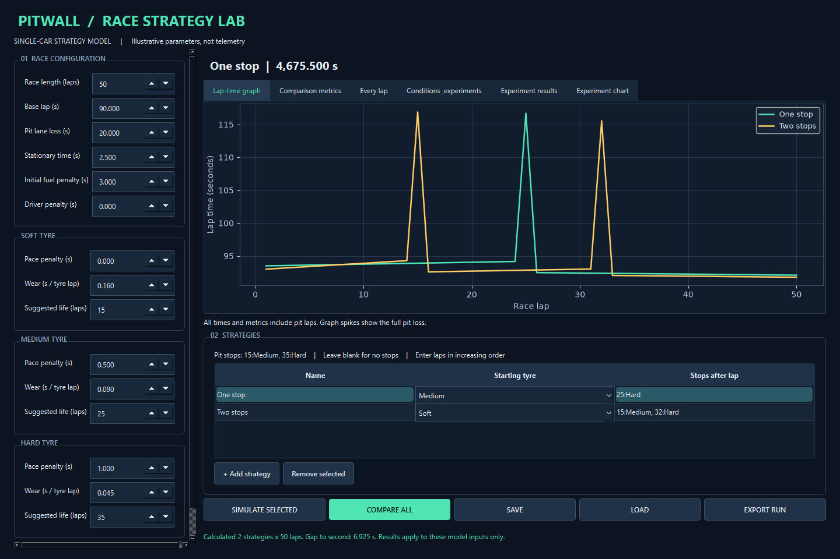
Figure 2: Current strategy comparison interface

2.10 Iterative test plan
Table 19: Typical boundary and erroneous tests
Area | Typical | Boundary | Erroneous and purpose
Race input | 5 laps | 1 and 500 | 0,501,bool: enforce finite scope
Tyre wear | age 3,rate0.2 ->0.6 | age 0 or zero rate | negative/fractional age
Stops | lap 2 in five laps | first and penultimate laps | duplicate,unordered,final stop
Events | rain then dry | same-lap sequence | missing payload/outside race
Monte Carlo | 100 trials,seed42 | one trial,zero noise | 0,1001,invalid seed
JSON | full round-trip | 1 MiB bound | malformed,duplicates,wrong arrays

2.11 Post-development test plan
Do not invent failures. The runner preserves every executed result with timestamp and source hashes before a fix.
Separate post-development tests will use different inputs from iterative tests: malformed collection types in JSON; bool and nonfinite settings; 500-lap completed comparison; 20-strategy limit; independent small exhaustive search oracle; random SC replay by reconstructing one trial; stale worker output rejection; complete advanced GUI capture with actual results. These are automated final checks, not human usability tests.
Performance: record Python/OS/CPU/RAM and raw perf_counter trials for one race,100/500/1000 sequential races,10/100/1000 candidate-scoring prefixes and full default search,100/500/1000 paired Monte Carlo trials. Three measured repeats each after one single-race warm-up. Include minimum,maximum,mean,median. Prefix scoring benchmarks measure throughput, not completed optimisation. Timings include Python result construction and omit GUI rendering. Machine workload/power may vary; no cross-machine guarantee.
Prospective target for this development machine: default comparison <1s, default bounded search <10s and 1000 paired50-lap trials <30s; evaluate only after measurement. Cancellation should return promptly between laps/candidates/trials; no hard real-time guarantee. No5000-trial option until tested and justified.
Section 4 reports the preserved executions separately from this plan. Section 4.6 separately records the new final-quality test executions and comparison measurements. Human usability tasks remain planned in Appendix F.

3 Development and testing
The recorded sequence is I01, I02, I03, combined I04/I05, I06, I07, I08, I09, I10, I11, I12, I13, I15, combined I14/I16, I17. Pit integration was combined with the full loop; persistence preceded the final GUI/chart integration. Seven genuine commits cover these stages rather than one commit per iteration. All recorded implementation commits are on 8 September 2026; this report does not invent a multi-week history. Appendix G lists the exact commit timestamps.

3.1 Core models
Objective and links. I01: Core models. Requirements FR01 FR02 FR03 FR04; success criteria SC01 SC02 SC03 SC04. Design: docs/design/architecture.md.
Implementation and recorded review. The following preserved iteration account records the implementation, expected and actual results, alternatives and next step. Its claims are bounded by the linked execution evidence.
Objective: FR01..FR04. Design and pseudocode: docs/design/architecture.md. Files: src/pitwall/models.py, tests/conftest.py, tests/test_models.py, scripts/run_tests.py.
Implementation uses frozen dataclasses, a compound enum, finite numeric checks, immutable tuple collections and race-dependent strategy validation. Strategy.validate_for checks the final-lap constraint; constructor validation rejects duplicates and unordered stops rather than silently sorting them. This separates local object validity from race context.
Tests: TEST-I01 executed 2026-09-08 UTC. Expected: valid inputs accepted and erroneous inputs raise ValueError. Actual: 20 passed. Raw output, JUnit XML and source hashes are in evidence/test-runs/TEST-I01-20260908T205847968425Z/.
Genuine test failures: none observed. Diagnosis, remedial action and retest: N/A. Environment issue: dependency installation failed at a PySide6 long pathname; a shorter runtime path is being prepared. This is an installation problem, not a manufactured code-test failure. Original tool output remains in the task conversation.
Screenshot evidence: pending, no GUI yet. [GENUINE STAKEHOLDER FEEDBACK PENDING]
Review: boundary validation passed; the cross-object final-lap rule required an explicit convention. An alternative mutable model would simplify edits but permit invalid states after construction. Lesson: validate newly constructed inputs at the GUI boundary. Implementation matches the recorded class design. Candidate reflection and explanation are pending. Next: tyre degradation.
Code extract: src/pitwall/models.py, lines 15-17 (complete integer)
15: def integer(value: int, name: str, minimum: int = 0, maximum: int | None = None) -> None:
16: if type(value) is not int or value < minimum or (maximum is not None and value > maximum):
17: raise ValueError(f"{name} must be an integer from {minimum} to {maximum if maximum is
not None else 'unbounded'}")

Code explanation. The strict type check excludes bool and fractions before range validation. This prevents misleading race lengths from reaching simulation.
Extract provenance. This is the current-source version, with line numbers, not a claim that every later extension existed at this earlier stage. The preserved run metadata identifies the source hashes used for each actual test run.
Stakeholder review. [GENUINE STAKEHOLDER REVIEW REQUIRED]
Candidate reflection. [CANDIDATE REVIEW AND EXPLANATION REQUIRED]

3.2 Tyre degradation
Objective and links. I02: Tyre degradation. Requirements FR02; success criteria SC02. Design: docs/design/I02-tyres.md.
Implementation and recorded review. The following preserved iteration account records the implementation, expected and actual results, alternatives and next step. Its claims are bounded by the linked execution evidence.
Objective FR02/SC02; design and A02 pseudocode: docs/design/I02-tyres.md. Changed physics.py and added test_physics.py. Multiplication by completed tyre age keeps units and the fresh-tyre convention explicit. Validation rejects invalid ages and non-finite calculated loss.
Expected: ages 0, 1, 3 at .2 give 0, .2, .6 seconds; bad ages rejected. Actual: all 27 accumulated tests passed in TEST-I02, including seven new cases. Evidence: evidence/test-runs/TEST-I02-20260908T205945777891Z/. No observed test failure; diagnosis/fix/retest N/A. Screenshots N/A for this pure function. [GENUINE STAKEHOLDER FEEDBACK PENDING]
Review: simple arithmetic matched manual expectations. Floating-point assertions require tolerance because .2 times 3 is not exactly representable. Quadratic wear remains an alternative requiring justification. No design deviation. Candidate reflection pending. Next: deterministic lap and fuel calculation.
Code extract: src/pitwall/physics.py, lines 5-9 (complete degradation)
5: def degradation(tyre: TyreCompound, age: int) -> float:
6: integer(age, "Tyre age")
7: loss = tyre.degradation_rate * age
8: number(loss, "Degradation loss")
9: return loss

Code explanation. The rate multiplies completed tyre age; validation checks the input age and the finite calculated loss.
Extract provenance. This is the current-source version, with line numbers, not a claim that every later extension existed at this earlier stage. The preserved run metadata identifies the source hashes used for each actual test run.
Stakeholder review. [GENUINE STAKEHOLDER REVIEW REQUIRED]
Candidate reflection. [CANDIDATE REVIEW AND EXPLANATION REQUIRED]

3.3 Lap and fuel calculation
Objective and links. I03: Lap and fuel calculation. Requirements FR05 FR06; success criteria SC05 SC06. Design: docs/design/I03-lap.md.
Implementation and recorded review. The following preserved iteration account records the implementation, expected and actual results, alternatives and next step. Its claims are bounded by the linked execution evidence.
Objective FR05/FR06; A01/A03 design: docs/design/I03-lap.md. Changed physics and its tests. Fuel is a linear seconds penalty, not physical fuel mass. The single-lap boundary avoids division by zero.
Expected: fuel sequence 2, 1.5, 1, .5, 0 and manual lap 114.6 seconds. Actual: 33 accumulated tests passed, including six new tests. Evidence: evidence/test-runs/TEST-I03-20260908T210046769795Z/. No observed test failures; diagnosis/remedy/retest N/A. Screenshot N/A. [GENUINE STAKEHOLDER FEEDBACK PENDING]
Review: component outputs make later diagnosis possible. The one-lap fuel convention is a modelling choice, not a real-world claim. Alternative mass/burn-rate model deferred. No design deviation. Candidate reflection pending. Next: integrate pit stops and full race simulation.
Code extract: src/pitwall/physics.py, lines 12-16 (complete fuel_effect)
12: def fuel_effect(config: RaceConfig, lap: int) -> float:
13: integer(lap, "Lap number", 1, config.laps)
14: if config.laps == 1:
15: return 0.0
16: return config.initial_fuel_penalty * ((config.laps - lap) / (config.laps - 1))

Code explanation. The one-lap branch avoids division by zero. Other races decrease the initial penalty linearly to zero.
Extract provenance. This is the current-source version, with line numbers, not a claim that every later extension existed at this earlier stage. The preserved run metadata identifies the source hashes used for each actual test run.
Stakeholder review. [GENUINE STAKEHOLDER REVIEW REQUIRED]
Candidate reflection. [CANDIDATE REVIEW AND EXPLANATION REQUIRED]

3.4 Pit stops and dry race
Objective and links. I04-I05: Pit stops and dry race. Requirements FR03 FR05 FR06; success criteria SC03 SC05 SC06. Design: docs/design/I04-I05-engine.md.
Implementation and recorded review. The following preserved iteration account records the implementation, expected and actual results, alternatives and next step. Its claims are bounded by the linked execution evidence.
Objective FR03..FR06; design/A05 and independent expected arithmetic: docs/design/I04-I05-engine.md. These two stages were combined before implementation because pit-stop effects span adjacent laps. Added engine.py and test_engine.py.
The loop records the old compound on the pit lap, adds lane and stationary loss once, then changes the state for the next lap. Dictionary lookup avoids scanning all stops every lap. Every lap retains wear and fuel components.
Actual TEST-I05: 41 accumulated tests passed, including eight new tests. Manual stop race total matched 480.85 seconds; no-stop Soft matched 457.0. Evidence: evidence/test-runs/TEST-I05-20260908T210214046535Z/. Invalid final stops and overflowing results were rejected as expected. These expected rejection cases are passing tests, not genuine failures.
No observed failed tests. Diagnosis/remedy/retest N/A. Screenshots pending GUI. [GENUINE STAKEHOLDER FEEDBACK PENDING]
Review: indexing is now explicit and verified at both ends of the race. Immutable states favour clarity over avoiding allocations. Alternative mutable state is deferred until profiling. Design followed including combined order. Candidate reflection pending. Next: comparison.
Code extract: src/pitwall/engine.py, lines 9-24 (selected opening simulate)
9: def simulate(config: RaceConfig, strategy: Strategy, conditions: Conditions | None = None) ->
StrategyResult:
10: strategy.validate_for(config)
11: conditions = conditions or Conditions()
12: if conditions.variation >= config.circuit.base_lap_time:
13: raise ValueError("Variation amplitude must be below base lap time")
14: rng = random.Random(conditions.seed)
15: queue = EventQueue(conditions.events, config.laps)
16: weather = conditions.initial_weather
17: safety_car = False
18: stops = {stop.lap: stop for stop in strategy.planned_stops}
19: state = RaceState(0, strategy.starting_compound, 0, 0.0)
20: results = []
21: for lap in range(1, config.laps + 1):
22: for event in queue.at_lap(lap):
23: if event.kind == EventType.WEATHER_CHANGE:
24: weather = event.weather

Code explanation. Validation occurs before iteration. State and stop lookup are local to each run; events are processed at the start of a lap.
Extract provenance. This is the current-source version, with line numbers, not a claim that every later extension existed at this earlier stage. The preserved run metadata identifies the source hashes used for each actual test run.
Stakeholder review. [GENUINE STAKEHOLDER REVIEW REQUIRED]
Candidate reflection. [CANDIDATE REVIEW AND EXPLANATION REQUIRED]

3.5 Strategy comparison
Objective and links. I06: Strategy comparison. Requirements FR07; success criteria SC07. Design: docs/design/I06-comparison.md.
Implementation and recorded review. The following preserved iteration account records the implementation, expected and actual results, alternatives and next step. Its claims are bounded by the linked execution evidence.
FR07/SC07 and A09: docs/design/I06-comparison.md. Added comparison module and tests. Comparison shares one config and sorts by total with stable input-order ties. Summaries include pit laps, and stint lengths follow the end-of-lap stop convention.
Expected: Soft no-stop beats pit strategy by 23.85 seconds, average 91.4, fastest 90.8, slowest 92; stop strategy stints (2,3). Actual: 44 accumulated tests passed, including three new tests. Evidence: evidence/test-runs/TEST-I06-20260908T210320581715Z/. No observed failures, diagnosis/remedy/retest N/A. Screenshot pending GUI. [GENUINE STAKEHOLDER FEEDBACK PENDING]
Review: stable ranking avoids surprising tie reordering. Name uniqueness removes ambiguity in graphs; 20-strategy cap bounds interactive output. Median racing-lap metrics are a possible alternative. No design deviation. Candidate reflection pending. Next: desktop interface with real graphs.
Code extract: src/pitwall/comparison.py, lines 18-30 (complete summary)
18: def summary(result: StrategyResult) -> dict:
19: times = [lap.lap_time for lap in result.laps]
20: boundaries = [0, *(s.lap for s in result.strategy.planned_stops), len(times)]
21: return {
22: "name": result.strategy.name,
23: "total": result.total_time,
24: "stops": len(result.strategy.planned_stops),
25: "average": result.total_time / len(times),
26: "fastest": min(times),
27: "slowest": max(times),
28: "pit_loss": sum(lap.pit_loss for lap in result.laps),
29: "stints": tuple(b - a for a, b in zip(boundaries, boundaries[1:])),
30: }

Code explanation. Metrics come from recorded lap times and stop boundaries. Pit laps remain included in fastest, slowest and average values.
Extract provenance. This is the current-source version, with line numbers, not a claim that every later extension existed at this earlier stage. The preserved run metadata identifies the source hashes used for each actual test run.
Stakeholder review. [GENUINE STAKEHOLDER REVIEW REQUIRED]
Candidate reflection. [CANDIDATE REVIEW AND EXPLANATION REQUIRED]

3.6 First desktop milestone
Objective and links. I07: First desktop milestone. Requirements FR01 FR08; success criteria SC01 SC08. Design: docs/design/I07-gui.md.
Implementation and recorded review. The following preserved iteration account records the implementation, expected and actual results, alternatives and next step. Its claims are bounded by the linked execution evidence.
Objective FR01..FR08; GUI design, validation and test plan: docs/design/I07-gui.md. Added defaults, GUI, launcher, GUI tests and actual-window capture script. Plots are populated directly from engine LapResult records. Input edits clear stale output. Error status explains invalid stop syntax and race-dependent constraints. Only implemented actions are exposed.
Expected: two 50-point graph lines, two ranked rows, 50 lap rows, cleared output after editing, recoverable input errors. Actual: 48 accumulated tests passed, including four GUI/parser tests. Evidence: evidence/test-runs/TEST-I07-20260908T210702638724Z/.
Actual Windows Qt capture: evidence/screenshots/FIG-I07-20260908T210757444690Z/application.png; adjacent capture.json records method, UTC timestamp and actual results. Visual inspection confirmed that the chart, strategy rows and controls rendered. A scroll area exposes settings that exceed available height. This is a capture of a running application, not a mock-up, desktop screenshot or human usability session.
Default actual totals: One stop 4675.5 s; Two stops 4682.425 s (floating representation may differ in raw output). Gap 6.925 s. These are fictional-parameter model outputs, not real motorsport predictions.
No observed test failures; diagnosis/remedy/retest N/A. Environment workaround succeeded: runtime in the user's temporary directory avoids PySide6 long paths. [GENUINE STAKEHOLDER FEEDBACK PENDING]
Review: readable chart and explicit stop convention support inspection. Text stop entry is compact but genuine users may prefer a dedicated stop editor. Keyboard/display-scaling usability remains untested. Implementation follows design. Candidate review and personal reflection pending. First deterministic milestone achieved; next: events.
Code extract: src/pitwall/gui.py, lines 19-33 (complete parse_stops)
19: def parse_stops(text: str, stationary: float) -> tuple[PitStopPlan, ...]:
20: if not text.strip():
21: return ()
22: stops = []
23: for entry in text.split(','):
24: try:
25: parts = entry.split(':')
26: if len(parts) not in (2, 3):
27: raise ValueError("Expected lap:tyre[:stationary]")
28: lap, tyre = parts[:2]
29: service = float(parts[2]) if len(parts) == 3 else stationary
30: stops.append(PitStopPlan(int(lap.strip()), Compound(tyre.strip().capitalize()),
service))
31: except (ValueError, TypeError) as exc:
32: raise ValueError(f"Invalid stop '{entry.strip()}'. Use 15:Medium, 35:Hard with
positive lap numbers.") from exc
33: return tuple(stops)

Code explanation. The parser converts text into typed stops; Strategy validation then checks ordering and the race boundary.
Extract provenance. This is the current-source version, with line numbers, not a claim that every later extension existed at this earlier stage. The preserved run metadata identifies the source hashes used for each actual test run.
Figure 3 shows the actual first-milestone comparison before the advanced controls were integrated.
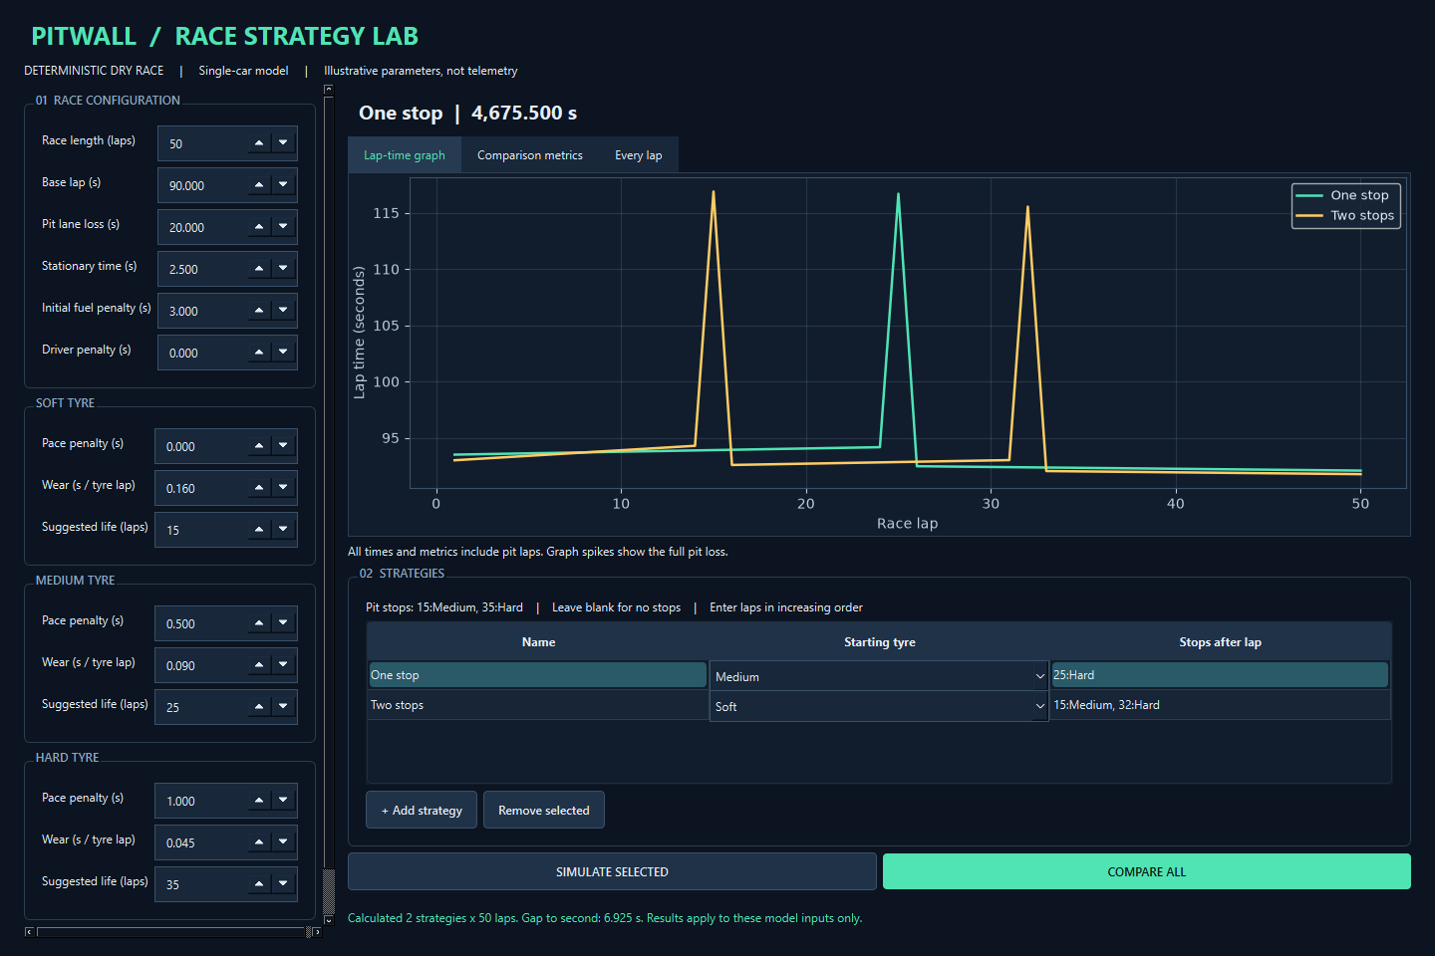
Figure 3: First deterministic GUI milestone
Stakeholder review. [GENUINE STAKEHOLDER REVIEW REQUIRED]
Candidate reflection. [CANDIDATE REVIEW AND EXPLANATION REQUIRED]

3.7 Event queue
Objective and links. I08: Event queue. Requirements FR10; success criteria SC10. Design: docs/design/I08-events.md.
Implementation and recorded review. The following preserved iteration account records the implementation, expected and actual results, alternatives and next step. Its claims are bounded by the linked execution evidence.
FR10/A06 design docs/design/I08-events.md. Added events.py and test_events.py. Queue keys are lap and supplied sequence number; payloads validate independently. Expected chronological order and stable ties matched actual output. TEST-I08: 2 focused tests passed; evidence evidence/test-runs/TEST-I08-20260908T210944391018Z/. These test functions include several invalid-input assertions.
No observed failures; remedy/retest N/A. Screenshot N/A. [GENUINE STAKEHOLDER FEEDBACK PENDING]
Review: heap is appropriate for future insertion but current static lists could simply be sorted. Integration with lap state is next. No design deviation; candidate reflection pending.
Code extract: src/pitwall/events.py, lines 37-50 (complete EventQueue)
37: class EventQueue:
38: def __init__(self, events: tuple[RaceEvent, ...], laps: int):
39: if not isinstance(events, tuple) or not all(isinstance(e, RaceEvent) for e in events):
40: raise ValueError("Events must be a tuple of RaceEvent objects")
41: for event in events:
42: integer(event.lap, "Event lap", 1, laps)
43: self._heap = [(event.lap, index, event) for index, event in enumerate(events)]
44: heapq.heapify(self._heap)
45:
46: def at_lap(self, lap: int) -> tuple[RaceEvent, ...]:
47: due = []
48: while self._heap and self._heap[0][0] <= lap:
49: due.append(heapq.heappop(self._heap)[2])
50: return tuple(due)

Code explanation. The sequence number prevents ambiguous same-lap ordering and avoids comparing RaceEvent objects.
Extract provenance. This is the current-source version, with line numbers, not a claim that every later extension existed at this earlier stage. The preserved run metadata identifies the source hashes used for each actual test run.
Stakeholder review. [GENUINE STAKEHOLDER REVIEW REQUIRED]
Candidate reflection. [CANDIDATE REVIEW AND EXPLANATION REQUIRED]

3.8 Weather effects
Objective and links. I09: Weather effects. Requirements FR10; success criteria SC10. Design: docs/design/I09-weather.md.
Implementation and recorded review. The following preserved iteration account records the implementation, expected and actual results, alternatives and next step. Its claims are bounded by the linked execution evidence.
FR10/A07 design docs/design/I09-weather.md. Added Conditions and EnvironmentalLapResult; integrated weather queue into engine. TEST-I09 ran 12 engine/event/weather tests, all passed. Evidence evidence/test-runs/TEST-I09-20260908T211102758207Z/. Expected wet increment 30 s and damp increment 20 s matched manual arithmetic; dry engine regressions passed.
No observed failure; remedy/retest N/A. Screenshot pending updated GUI. [GENUINE STAKEHOLDER FEEDBACK PENDING]
Review: inherited results preserve original lap fields. Weather currently penalises dry compounds equally, so no claim of realistic wet tyre selection. Optional wet/intermediate tyres deferred. Same-lap event order behaves as designed. Candidate reflection pending; next safety car.
Code extract: src/pitwall/conditions.py, lines 32-33 (complete weather_loss)
32: def weather_loss(self, weather: Weather) -> float:
33: return {Weather.DRY: 0.0, Weather.DAMP: self.damp_penalty, Weather.WET:
self.wet_penalty}[weather]

Code explanation. An explicit lookup selects the environmental time penalty. It does not model a wet tyre advantage.
Extract provenance. This is the current-source version, with line numbers, not a claim that every later extension existed at this earlier stage. The preserved run metadata identifies the source hashes used for each actual test run.
Stakeholder review. [GENUINE STAKEHOLDER REVIEW REQUIRED]
Candidate reflection. [CANDIDATE REVIEW AND EXPLANATION REQUIRED]

3.9 Safety car
Objective and links. I10: Safety car. Requirements FR10; success criteria SC10. Design: docs/design/I10-safety-car.md.
Implementation and recorded review. The following preserved iteration account records the implementation, expected and actual results, alternatives and next step. Its claims are bounded by the linked execution evidence.
FR10/A08 design docs/design/I10-safety-car.md. Conditions, environmental results, engine and tests changed. Starts/ends assign state before racing the lap. Pit factor represents relative lost time, not actual service duration.
TEST-I10: 16 focused regression/event/condition tests passed. Evidence evidence/test-runs/TEST-I10-20260908T211214733077Z/. Manual expected total 519.6 s and pit loss 11.25 s matched. No observed failure; remedy/retest N/A. Screenshot pending integration. [GENUINE STAKEHOLDER FEEDBACK PENDING]
Review: explicit simplified terms remain inspectable. Real bunching would need multiple cars and is beyond this scope. No design deviation; candidate reflection pending. Next seeded lap variation.
Code extract: src/pitwall/conditions.py, lines 9-24 (selected opening Conditions)
9: class Conditions:
10: initial_weather: Weather = Weather.DRY
11: events: tuple[RaceEvent, ...] = ()
12: damp_penalty: float = 4.0
13: wet_penalty: float = 15.0
14: safety_car_penalty: float = 25.0
15: safety_car_pit_factor: float = 0.5
16: seed: int = 0
17: variation: float = 0.0
18:
19: def __post_init__(self):
20: if not isinstance(self.initial_weather, Weather):
21: raise ValueError("Initial weather must be Dry, Damp or Wet")
22: EventQueue(self.events, 500)
23: number(self.damp_penalty, "Damp penalty")
24: number(self.wet_penalty, "Wet penalty")

Code explanation. Configuration validation keeps penalties finite and restricts the pit factor and seed.
Extract provenance. This is the current-source version, with line numbers, not a claim that every later extension existed at this earlier stage. The preserved run metadata identifies the source hashes used for each actual test run.
Stakeholder review. [GENUINE STAKEHOLDER REVIEW REQUIRED]
Candidate reflection. [CANDIDATE REVIEW AND EXPLANATION REQUIRED]

3.10 Seeded variation
Objective and links. I11: Seeded variation. Requirements FR11; success criteria SC11. Design: docs/design/I11-randomness.md.
Implementation and recorded review. The following preserved iteration account records the implementation, expected and actual results, alternatives and next step. Its claims are bounded by the linked execution evidence.
FR11 design docs/design/I11-randomness.md. Added local RNG, validated seed/amplitude, recorded signed lap variation and conditions-aware comparison. TEST-I11: 21 focused tests passed. Evidence evidence/test-runs/TEST-I11-20260908T211342964557Z/. Exact repeats, changed seeds, bounded noise and untouched global RNG all passed; original dry oracle passed.
No observed failure; remedy/retest N/A. Screenshot pending GUI. [GENUINE STAKEHOLDER FEEDBACK PENDING]
Review: common additive lap noise changes totals but cancels in paired ranking. Monte Carlo must model a strategy-dependent uncertainty such as safety-car timing to change that ranking. No design deviation. Candidate reflection pending; next repeated simulation/statistics.
Code extract: src/pitwall/engine.py, lines 9-24 (selected opening simulate)
9: def simulate(config: RaceConfig, strategy: Strategy, conditions: Conditions | None = None) ->
StrategyResult:
10: strategy.validate_for(config)
11: conditions = conditions or Conditions()
12: if conditions.variation >= config.circuit.base_lap_time:
13: raise ValueError("Variation amplitude must be below base lap time")
14: rng = random.Random(conditions.seed)
15: queue = EventQueue(conditions.events, config.laps)
16: weather = conditions.initial_weather
17: safety_car = False
18: stops = {stop.lap: stop for stop in strategy.planned_stops}
19: state = RaceState(0, strategy.starting_compound, 0, 0.0)
20: results = []
21: for lap in range(1, config.laps + 1):
22: for event in queue.at_lap(lap):
23: if event.kind == EventType.WEATHER_CHANGE:
24: weather = event.weather

Code explanation. Validation occurs before iteration. State and stop lookup are local to each run; events are processed at the start of a lap.
Extract provenance. This is the current-source version, with line numbers, not a claim that every later extension existed at this earlier stage. The preserved run metadata identifies the source hashes used for each actual test run.
Stakeholder review. [GENUINE STAKEHOLDER REVIEW REQUIRED]
Candidate reflection. [CANDIDATE REVIEW AND EXPLANATION REQUIRED]

3.11 Monte Carlo and statistics
Objective and links. I12: Monte Carlo and statistics. Requirements FR11; success criteria SC11. Design: docs/design/I12-monte-carlo.md.
Implementation and recorded review. The following preserved iteration account records the implementation, expected and actual results, alternatives and next step. Its claims are bounded by the linked execution evidence.
FR11/A12/A13 design docs/design/I12-monte-carlo.md. Added paired runner, trial records and population summaries. TEST-I12: 10 focused tests passed; evidence evidence/test-runs/TEST-I12-20260908T211512627796Z/. Includes actual 100-run zero-noise case, exact seeded event replay, ties, independent statistics oracle and cancellation.
No observed failures; remedy/retest N/A. Screenshot pending integration. [GENUINE STAKEHOLDER FEEDBACK PENDING]
Review: trial records support replay and common conditions support fair pairing. Generated and fixed SC overlap remains a documented modelling limitation. Rain timing is not randomised. Counts 500/1000 are implemented but performance remains to be measured before recommending larger work. No design deviation; candidate reflection pending. Next constrained search.
Code extract: src/pitwall/monte_carlo.py, lines 15-21 (complete describe)
15: def describe(values: tuple[float, ...]) -> dict[str, float]:
16: if not values:
17: raise ValueError("Statistics require at least one sample")
18: for value in values:
19: number(value, "Sample")
20: return {"mean": statistics.mean(values), "median": statistics.median(values),
21: "stdev": statistics.pstdev(values), "minimum": min(values), "maximum": max(values)}

Code explanation. Summary statistics are calculated from actual totals. Population standard deviation describes the supplied trial population.
Extract provenance. This is the current-source version, with line numbers, not a claim that every later extension existed at this earlier stage. The preserved run metadata identifies the source hashes used for each actual test run.
Stakeholder review. [GENUINE STAKEHOLDER REVIEW REQUIRED]
Candidate reflection. [CANDIDATE REVIEW AND EXPLANATION REQUIRED]

3.12 Bounded optimisation
Objective and links. I13: Bounded optimisation. Requirements FR12; success criteria SC12. Design: docs/design/I13-optimiser.md.
Implementation and recorded review. The following preserved iteration account records the implementation, expected and actual results, alternatives and next step. Its claims are bounded by the linked execution evidence.
FR12/A10/A11 design docs/design/I13-optimiser.md. Added generator, complete capped scoring, cancellation and baseline rules. TEST-I13: 3 tests passed, evidence evidence/test-runs/TEST-I13-20260908T211637569849Z/. Manual 3-lap/one-stop space contained21 unique strategies; 2-lap optimum was Soft no-stop182.2 s among12. Minimum stints and early cap/cancel rejection passed.
No observed failure; remedy/retest N/A. Screenshot pending GUI. [GENUINE STAKEHOLDER FEEDBACK PENDING]
Review: explicit enumeration is defendable, but grid step excludes off-grid plans. Baselines are separate references and may be outside grid. Search suppresses random variation and does not optimise Monte Carlo risk. No claim of global real-world optimality. Candidate reflection pending. Next: persistence before final chart/GUI integration; Iteration14 chart additions will be grouped with 16 because they share the same UI changes.
Code extract: src/pitwall/optimiser.py, lines 32-45 (complete candidates)
32: def candidates(config: RaceConfig, settings: SearchSettings):
33: if settings.minimum_stint > config.laps:
34: raise ValueError("Minimum stint cannot exceed race length")
35: grid = range(settings.minimum_stint, config.laps - settings.minimum_stint + 1,
settings.pit_step)
36: serial = 0
37: for count in range(settings.max_stops + 1):
38: for stops in combinations(grid, count):
39: bounds = (0, *stops, config.laps)
40: if any(b-a < settings.minimum_stint for a,b in zip(bounds, bounds[1:])):
41: continue
42: for compounds in product(Compound, repeat=count + 1):
43: serial += 1
44: yield Strategy(f"Candidate {serial}", compounds[0], tuple(
45: PitStopPlan(lap, tyre, settings.stationary_time) for lap,tyre in zip(stops,
compounds[1:])))

Code explanation. Combinations choose ordered distinct stop laps; product enumerates compound sequences. Minimum-stint checks remove illegal combinations.
Extract provenance. This is the current-source version, with line numbers, not a claim that every later extension existed at this earlier stage. The preserved run metadata identifies the source hashes used for each actual test run.
Stakeholder review. [GENUINE STAKEHOLDER REVIEW REQUIRED]
Candidate reflection. [CANDIDATE REVIEW AND EXPLANATION REQUIRED]

3.13 JSON persistence
Objective and links. I15: JSON persistence. Requirements FR09; success criteria SC09. Design: docs/design/I15-persistence.md.
Implementation and recorded review. The following preserved iteration account records the implementation, expected and actual results, alternatives and next step. Its claims are bounded by the linked execution evidence.
FR09/A14 design docs/design/I15-persistence.md. Added strict version1 schema and atomic-save module. TEST-I15:7 tests passed, evidence evidence/test-runs/TEST-I15-20260908T211824033057Z/. Exact event/seed/stop-time round-trip passed; malformed JSON, duplicate keys, unsupported versions, invalid length and oversized files rejected. No observed failure; remedy/retest N/A. Screenshot pending GUI. [GENUINE STAKEHOLDER FEEDBACK PENDING]
Review: validating before replacement prevents invalid saved scenarios and temporary files are cleaned. Atomic replacement depends on filesystem semantics. Search/run preferences are separate from race data. Chart iteration14 is intentionally combined with 16 as recorded before implementation. Candidate reflection pending.
Code extract: src/pitwall/persistence.py, lines 117-132 (complete save_scenario)
117: def save_scenario(path: Path, scenario: Scenario) -> None:
118: # Round-trip validation verifies the serialized contract before touching destination.
119: text = json.dumps(to_data(scenario), default=enum_json, allow_nan=False, indent=2)
120: from_data(json.loads(text))
121: if len(text.encode('utf-8')) > MAX_FILE_BYTES:
122: raise ValueError("Scenario file exceeds 1 MiB")
123: path = Path(path)
124: temporary = None
125: try:
126: with tempfile.NamedTemporaryFile('w', encoding='utf-8', dir=path.parent, suffix='.tmp',
delete=False) as stream:
127: temporary = Path(stream.name)
128: stream.write(text)
129: os.replace(temporary, path)
130: finally:
131: if temporary is not None and temporary.exists():
132: temporary.unlink()

Code explanation. The serialised contract is validated before a temporary sibling file replaces the destination.
Extract provenance. This is the current-source version, with line numbers, not a claim that every later extension existed at this earlier stage. The preserved run metadata identifies the source hashes used for each actual test run.
Stakeholder review. [GENUINE STAKEHOLDER REVIEW REQUIRED]
Candidate reflection. [CANDIDATE REVIEW AND EXPLANATION REQUIRED]

3.14 Advanced GUI and charts
Objective and links. I14-I16: Advanced GUI and charts. Requirements FR09 FR11 FR12; success criteria SC09 SC11 SC12 SC14. Design: docs/design/I14-I16-interface.md.
Implementation and recorded review. The following preserved iteration account records the implementation, expected and actual results, alternatives and next step. Its claims are bounded by the linked execution evidence.
FR09..FR12 design docs/design/I14-I16-interface.md. Added AdvancedWindow and QThread worker. Input snapshots/revisions protect against stale results, cancellation checked inside algorithms. JSON load checks representable ranges/precision before touching inputs. Additional lap columns reveal weather, safety-car and noise terms. Actual result charts show ranked totals and paired trial distributions.
TEST-I16:79 accumulated tests passed, evidence evidence/test-runs/TEST-I16-20260908T212235136707Z/. Includes a real asynchronous39-candidate search and 100 paired trials. No observed test failures; remedy/retest N/A. Advanced visual capture still pending at this record. [GENUINE STAKEHOLDER FEEDBACK PENDING]
Review: desktop remains responsive during long work; only GUI thread handles widgets. Changed input results are discarded, so user must rerun. Dedicated stop/event editors could improve discoverability over text syntax. Per-stop service override was added to preserve loaded data. Candidate reflection pending; next independent robustness and performance checks.
Code extract: src/pitwall/advanced_gui.py, lines 208-223 (selected opening accept_experiment)
208: def accept_experiment(self,kind,scenario,controls,revision,result):
209: if revision != self.revision:
210: self.status.setText("Run completed for older inputs. Result discarded; run again
for current inputs.")
211: return
212: self.experiment_figure.clear()
213: ax = self.experiment_figure.add_subplot(111)
214: ax.set_facecolor('#111d2c')
215: ax.tick_params(colors='#bbccdf')
216: if kind == "search":
217: scores,refs = result
218: best = scores[0]
219: self.headline.setText(f"Search complete | {len(scores):,} candidates | Best
{best.total_time:,.3f} s")
220: plan = best.strategy
221: stops = ', '.join(f"{p.lap}:{p.compound.value}" for p in plan.planned_stops) or
'none'
222: text = f"Examined {len(scores)} legal candidates.\nBest within this search:
{best.total_time:.3f} s\nStart: {plan.starting_compound.value}; stops after lap: {stops}\nVariation
disabled; fixed events retained.\n\nSeparate baseline references:\n"
223: text += '\n'.join(f"{r.strategy.name}: {r.total_time:.3f} s (gap to best
{r.total_time-best.total_time:+.3f} s)" for r in refs)

Code explanation. The revision guard discards results for changed inputs before charts or output text are populated.
Extract provenance. This is the current-source version, with line numbers, not a claim that every later extension existed at this earlier stage. The preserved run metadata identifies the source hashes used for each actual test run.
Figure 4 shows the number of legal candidates and baseline reference totals produced by the actual run.
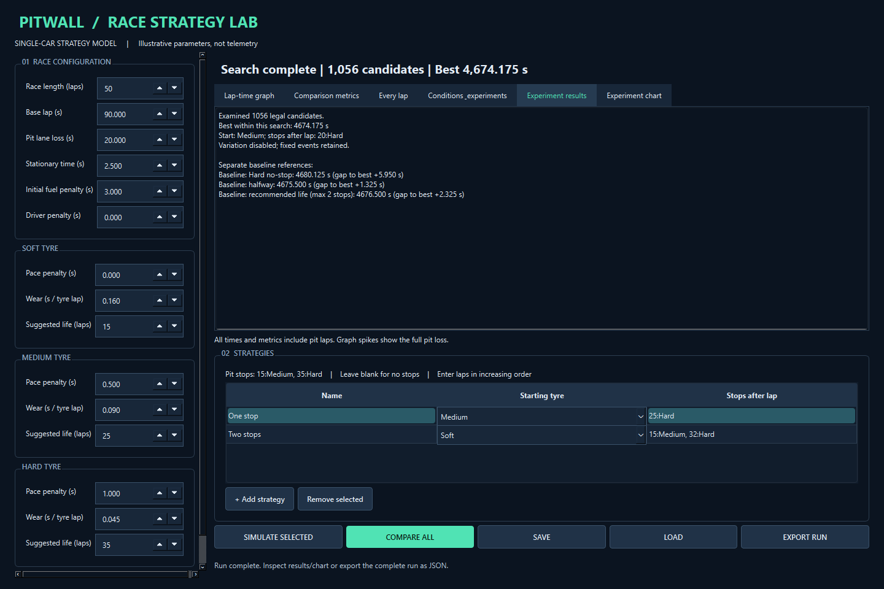
Figure 4: Completed bounded-search result
Stakeholder review. [GENUINE STAKEHOLDER REVIEW REQUIRED]
Candidate reflection. [CANDIDATE REVIEW AND EXPLANATION REQUIRED]

3.15 Robustness and verification
Objective and links. I17: Robustness and verification. Requirements FR04 FR09; success criteria SC04 SC09 SC13 SC14. Design: docs/design/I17-verification.md.
Implementation and recorded review. The following preserved iteration account records the implementation, expected and actual results, alternatives and next step. Its claims are bounded by the linked execution evidence.
Objective: I17 plan in docs/design/I17-verification.md; reinforce FR04/FR09 and evaluate FR11/FR12. New independent checks cover JSON container types, full tiny search arithmetic, reconstructing Monte Carlo trials and maximum comparison.
Genuine failure: TEST-I17-ROBUSTNESS had2 failed/3 passed. Empty objects were incorrectly accepted as event/stop arrays. Raw evidence was saved and committed before adding explicit array validation. Diagnosis, alternatives, selected remedy and unchanged-case retest: docs/testing/FAIL-I17-01.md. Retest84 passed.
A real capture harness timing failure and remedy are documented in docs/testing/FAIL-I17-02.md; partial captures remain. Complete captures subsequently succeeded. Visual review led to clearer completed-experiment headings and shared histogram bins, without changing underlying simulation data.
Final execution TEST-FINAL:86 passed in 6.14s. Evidence evidence/test-runs/TEST-FINAL-20260908T213416753101Z/. Includes new GUI stale-result and cancellation tests. This is actual automated output, not proof of genuine user usability.
Final actual Windows captures: evidence/screenshots/FIG-I16-20260908T213427339706Z/, eight PNG views plus full1056-candidate search and 100-trial Monte Carlo JSON. The earlier first-milestone capture is preserved separately. BENCH-01 raw repeated timing and actual machine metadata are in evidence/benchmarks/BENCH-01-20260908T212651988284Z/.
What worked: deterministic oracle remained correct through environmental extensions; tiny independent enumeration matched search; explicit JSON validation fixed a real gap. Difficulty: deep Windows paths prevented initial PySide6 installation, and asynchronous result delivery required the capture harness to wait for data rather than thread completion alone. Alternative: a dedicated GUI testing library could provide signal waits, but current harness keeps dependencies small.
Lesson: validate containers as well as their elements, and distinguish computation completion from GUI signal delivery. Comparison with design: planned combined stages and persistence order change recorded before implementation; optional wet tyres remain deferred. [GENUINE STAKEHOLDER FEEDBACK PENDING]
Candidate personal reflection remains pending. Next work should be genuine stakeholder/candidate/centre review, targeted changes arising from it, and preparing the final assessed document. Do not manufacture those inputs or call the mark audit complete.
Code extract: src/pitwall/persistence.py, lines 53-56 (complete array)
53: def array(data, name):
54: if not isinstance(data, list):
55: raise ValueError(f"{name} must be a JSON array")
56: return data

Code explanation. The type guard rejects objects even when empty, closing the exact reproduced decoder gap.
Extract provenance. This is the current-source version, with line numbers, not a claim that every later extension existed at this earlier stage. The preserved run metadata identifies the source hashes used for each actual test run.
Stakeholder review. [GENUINE STAKEHOLDER REVIEW REQUIRED]
Candidate reflection. [CANDIDATE REVIEW AND EXPLANATION REQUIRED]

3.16 Genuine failures and remedial action
Observed during actual final robustness execution on 2026-09-08. Evidence saved BEFORE remedial changes: evidence/test-runs/TEST-I17-ROBUSTNESS-20260908T212523289799Z/ (2 failed,3 passed; output,JUnit,source hashes).
Input: replace conditions.events or a strategy's planned_stops JSON array with {}. Expected: ValueError for incorrect collection type. Actual: loader iterated zero dictionary keys and accepted an empty tuple. This is a genuine decoder bug, not an intentionally introduced failure. It was identified by review and reproduced through new adversarial tests.
Root cause: exact dictionary field checks validated each element but did not validate the container type before iteration. An empty invalid container therefore never reached element checks.
Options: (1) explicit JSON-array guard at each collection boundary; (2) introduce a schema-validation dependency; (3) accept any iterable. Selected1 because the schema is small, keeps dependencies minimal and rejects data outside the documented contract. Option3 would preserve the bug's ambiguity.
Planned remedy: helper requiring list with explicit name, used for tyres,events,strategies,planned_stops. Planned retest: unchanged failing cases plus complete regression. Design impact: make collection validation explicit before element validation. Retest results will be added after execution.
Executed remedy and retest: added array() before all four collection loops. TEST-I17-RETEST executed with 84 passed, including both unchanged reproduction cases. Evidence: evidence/test-runs/TEST-I17-RETEST-20260908T212641586436Z/. Original failed output remains unchanged. Full regression did not show additional failures.
Actual scripts/capture_advanced.py execution raised RuntimeError: Running. You can cancel; editing inputs discards this run's displayed result. at line61. The script checked worker.isRunning() and assumed the queued result had already arrived. It had not. Initial four actual screenshots and capture metadata remain in the first FIG-I16 directory. Tool output remains in this task; this record transcribes the actual message rather than inventing a test result.
The failed component is the capture harness. A completed thread does not guarantee its queued GUI signal has been processed. The earlier automated integration test explicitly processed events after thread completion; this script lacked that synchronisation.
Remedy: wait for the actual experiment_data result before capturing; keep the existing bounded timeout. Add a guarded callback that exits with an error and cancels/joins a worker on exceptions, avoiding a stranded capture window. Do not change simulation output or render fabricated result text. Retest must produce actual complete captures and run JSON.
Executed retest: process exited0; eight actual views and complete search/Monte Carlo JSON were captured in evidence/screenshots/FIG-I16-20260908T213008377764Z/. Visual inspection covered the comparison, controls, Monte Carlo results and histogram. The first failed capture directory FIG-I16-20260908T212913236182Z is retained. The original stuck capture process was interrupted before rerun.
Verbatim lines from evidence/test-runs/TEST-I17-ROBUSTNESS-20260908T212523289799Z/output.txt
tests/test_final_robustness.py::test_json_collection_types[events] FAILED [ 20%]
tests/test_final_robustness.py::test_json_collection_types[planned_stops] FAILED [ 40%]
E Failed: DID NOT RAISE ValueError
E Failed: DID NOT RAISE ValueError
FAILED tests/test_final_robustness.py::test_json_collection_types[events] - F...
FAILED tests/test_final_robustness.py::test_json_collection_types[planned_stops]
========================= 2 failed, 3 passed in 0.59s =========================

The two failing assertions expected ValueError when {} replaced an events or planned_stops array. Iterating an empty dictionary produced no element checks. The selected remedy validates the container before its contents. A schema dependency was an alternative, but an explicit list check fits this small schema. The unchanged reproduction tests passed in the 84-test retest and the final 86-test run. The capture-harness failure is separately supported by a factual transcription and retained partial output, not a fabricated pytest screenshot.

3.17 Recorded test progression
Table 20: All preserved execution runs
Run ID | Cases | Failures
TEST-FINAL-20260908T213416753101Z | 86 | 0
TEST-I01-20260908T205847968425Z | 20 | 0
TEST-I02-20260908T205945777891Z | 27 | 0
TEST-I03-20260908T210046769795Z | 33 | 0
TEST-I05-20260908T210214046535Z | 41 | 0
TEST-I06-20260908T210320581715Z | 44 | 0
TEST-I07-20260908T210702638724Z | 48 | 0
TEST-I08-20260908T210944391018Z | 2 | 0
TEST-I09-20260908T211102758207Z | 12 | 0
TEST-I10-20260908T211214733077Z | 16 | 0
TEST-I11-20260908T211342964557Z | 21 | 0
TEST-I12-20260908T211512627796Z | 10 | 0
TEST-I13-20260908T211637569849Z | 3 | 0
TEST-I15-20260908T211824033057Z | 7 | 0
TEST-I16-20260908T212235136707Z | 79 | 0
TEST-I17-RETEST-20260908T212641586436Z | 84 | 0
TEST-I17-ROBUSTNESS-20260908T212523289799Z | 5 | 2
TEST-QUALITY-FINAL-20260908T224148466396Z | 87 | 0
TEST-SC05-20260908T224145702053Z | 1 | 0

Repeated regression tests occur in several runs; these counts must not be added and described as unique tests. Appendix B lists the final 87 collected cases, including parameterised cases. Source hashes and exact commands remain in each run directory.

4 Post-development testing

4.1 Functional testing
The final recorded regression contains 87 passing cases. The rows below reference actual tests and assertions rather than invented manual sessions. Test functions may assert several related conditions. Native file-dialog interaction has not been manually tested; the persistence functions and widget conversion are covered.
Table 21: Functional verification
Test ID | Success criterion | Feature | Input / steps | Expected | Actual | Pass / fail | Evidence
F01 | SC05 SC06 | Race | 5 laps; Soft to Hard after 2 | 92,114.2,92,91.55,91.1; total 480.85 | Assertions matched expected values. | PASS | Appendix B, case 015
F02 | SC07 | Compare | No-stop Soft versus pit plan | Soft faster by 23.85; average 91.4 | Assertions matched expected values. | PASS | Appendix B, case 006
F03 | SC08 | GUI | Click compare; edit laps | 2 lines,50 points each; results clear | Assertions matched expected values. | PASS | Appendix B, case 031
F04 | SC09 | JSON | Save/load seed,events,service time | Exact Scenario equality | Assertions matched expected values. | PASS | Appendix B, case 060
F05 | SC10 | SC event | SC laps 2-3; stop after 2 | Pit11.25; total 519.6 | Assertions matched expected values. | PASS | Appendix B, case 011
F06 | SC11 | Monte Carlo | 100 fixed trials; seeded replay | Repeatable totals and ties | Assertions matched expected values. | PASS | Appendix B, case 055
F07 | SC12 | Search | 4-lap tiny enumeration | Complete scores match direct arithmetic | Assertions matched expected values. | PASS | Appendix B, case 027
F08 | SC14 | Cancel | Start1000 trials and cancel | No completed output; cancelled status | Assertions matched expected values. | PASS | Appendix B, case 005

All entries above are supported by evidence/test-runs/TEST-QUALITY-FINAL-20260908T224148466396Z/results.xml. Appendix B maps the exact test inventory; assertions reside in tests/test_engine.py, test_comparison.py, test_gui.py, test_persistence.py, test_conditions.py, test_monte_carlo.py, test_final_robustness.py and test_advanced_gui.py.

4.2 Robustness testing
Table 22: Recorded invalid and boundary cases
Area | Input | Expected and actual | Evidence test
Race | 0,-1,501,2.5,True | ValueError; PASS | test_invalid_race_length
Stops | Duplicate,unordered,final lap | Rejected; PASS | test_stop_order_and_race_end
Events | Unknown command or invalid lap | Rejected; PASS | test_events_parser / test_bad_events
JSON | Malformed,missing,duplicates,NaN | Rejected; PASS | test_malformed
Schema | 2,True,string1; oversized file | Rejected; PASS | test_schema_and_model_validation
Containers | {} in events/stops | Initially accepted; fixed and PASS | test_json_collection_types
Monte Carlo | 0,-1,1001,True | Rejected; PASS | test_invalid_counts_and_cancel
Search | Lowered cap; cancellation callback | Explicit error/interruption; PASS | test_limit_and_cancel
Large comparison | 20 strategies x500 laps | 20 equal complete results; PASS | test_maximum_comparison

4.3 Performance testing
BENCH-01 records three repeats after one unmeasured single-race warm-up. Each race has 50 laps. Timings use perf_counter and include computational result construction, not GUI rendering. The CPU is Snapdragon(R) X 10-core X1P64100 @ 3.40 GHz. Physical RAM is 16756006912 bytes. Python is 3.14.0 (tags/v3.14.0:ebf955d, Oct 7 2025, 10:15:03) [MSC v.1944 64 bit (AMD64)].
Table 23: Raw measured seconds and summary
Operation / count | Trial 1 | Trial 2 | Trial 3 | Min | Max | Mean
sequential races / 1 | 0.000532 | 0.000524 | 0.000511 | 0.000511 | 0.000532 | 0.000522
sequential races / 100 | 0.061353 | 0.075801 | 0.065233 | 0.061353 | 0.075801 | 0.067462
sequential races / 500 | 0.341047 | 0.319111 | 0.334610 | 0.319111 | 0.341047 | 0.331589
sequential races / 1000 | 0.807915 | 0.670294 | 0.910702 | 0.670294 | 0.910702 | 0.796304
candidate prefix scoring (not full search) / 10 | 0.006008 | 0.009976 | 0.009137 | 0.006008 | 0.009976 | 0.008374
candidate prefix scoring (not full search) / 100 | 0.083678 | 0.086033 | 0.087804 | 0.083678 | 0.087804 | 0.085839
candidate prefix scoring (not full search) / 1000 | 0.892307 | 1.054861 | 1.032549 | 0.892307 | 1.054861 | 0.993239
complete default search / 1056 | 1.350378 | 1.029638 | 1.104884 | 1.029638 | 1.350378 | 1.161633
paired Monte Carlo trials / 100 | 0.206715 | 0.226102 | 0.217682 | 0.206715 | 0.226102 | 0.216833
paired Monte Carlo trials / 500 | 1.113949 | 1.136409 | 1.229209 | 1.113949 | 1.229209 | 1.159856
paired Monte Carlo trials / 1000 | 2.516607 | 1.691347 | 2.089219 | 1.691347 | 2.516607 | 2.099058

The complete default search examined 1,056 candidates and averaged 1.161633 seconds. The 1,000 paired-trial Monte Carlo run averaged 2.099058 seconds. Both are below the recorded 10-second and 30-second targets on this machine. Prefix scoring benchmarks measure throughput on the first candidates, not complete optimisation. Background load and power state were not controlled, so results cannot establish minimum hardware or another device's latency. Appendix D retains the raw JSON precision.

4.4 Manual verification
Five laps, base 90, initial fuel penalty 2, lane loss 20, stationary 2.5. Soft pace 0/wear .2; Hard pace 1/wear .05. Stop after lap 2.
Table 24: Five-lap independent expected calculation
Lap | Racing compound | Age | Wear | Fuel | Pit | Lap time | Cumulative
1 | Soft | 0 | 0 | 2 | 0 | 92 | 92
2 | Soft | 1 | .2 | 1.5 | 22.5 | 114.2 | 206.2
3 | Hard | 0 | 0 | 1 | 0 | 92 | 298.2
4 | Hard | 1 | .05 | .5 | 0 | 91.55 | 389.75
5 | Hard | 2 | .1 | 0 | 0 | 91.1 | 480.85

These are hand-derived expected values, not executed output. No-stop Soft expected 92, 91.7, 91.4, 91.1, 90.8 = 457.0 seconds.
Planned tests: manual oracle; repeated identical runs; immutable config; zero-stop one-lap race; first and penultimate lap stops; consecutive stops with same compound; invalid final stop; zero pit loss; 500-lap output count; total equals sum. Extreme finite inputs that overflow must fail descriptively rather than return infinity.
For lap 2, 90 base +0 Soft pace +0.2 wear +1.5 fuel +22.5 pit =114.2 seconds. The new Hard set starts lap 3 at age 0:90+1+0+1=92. The sum is 480.85. With a safety car on laps 2 and 3, the model adds 50 seconds but saves 11.25 seconds on the pit loss, giving 519.6. These are manual expected calculations matched by executed assertions, not a claim of a separate human testing session.
For statistics [1,2,3], mean and median are 2. Squared deviations are 1,0,1; population variance is 2/3 and standard deviation is sqrt(2/3). The optimiser's three-lap, maximum-one-stop space contains 3 no-stop plans plus 2 legal stop laps times 9 compound pairs, giving 21. The independently calculated four-lap score distribution is also tested.

4.5 Usability testing
[USABILITY TESTING MUST BE COMPLETED WITH GENUINE USERS]
Status: PLANNED. No participant has performed this protocol.
Participant identifier: [GENUINE PARTICIPANT REQUIRED]
Date/time and consent to record comments: [PENDING]
Device/display scaling: [PENDING]
Table 25: Unconducted usability task sheet
Task | Completion | Mistakes/confusion | Help required | Verbatim comment
Open and configure a five-lap race | Pending | Pending | Pending | [GENUINE RESPONSE REQUIRED]
Create two strategies and add a legal stop | Pending | Pending | Pending | [GENUINE RESPONSE REQUIRED]
Compare and explain the pit spike | Pending | Pending | Pending | [GENUINE RESPONSE REQUIRED]
Correct an invalid final-lap stop | Pending | Pending | Pending | [GENUINE RESPONSE REQUIRED]
Apply an event and explain before/after-lap distinction | Pending | Pending | Pending | [GENUINE RESPONSE REQUIRED]
Run/cancel search and explain its scope | Pending | Pending | Pending | [GENUINE RESPONSE REQUIRED]
Run Monte Carlo and interpret probability | Pending | Pending | Pending | [GENUINE RESPONSE REQUIRED]
Save/load scenario and export a run | Pending | Pending | Pending | [GENUINE RESPONSE REQUIRED]

Observe keyboard navigation, legibility, status feedback and whether participants assume model outputs are real predictions. Record actual duration if timed; do not estimate retrospective timings. Ask which input or label they would change. Record resulting requirement changes with links to the original response.
Use neutral instructions and record actual help, mistakes, completion and comments. Ask the participant to interpret a pit spike and explain what an 88% simulated win frequency means. Do not imply it forecasts a real race. Appendix F includes blank response space and stakeholder follow-up.

4.6 Final quality verification
SC05 focused run: evidence/test-runs/TEST-SC05-20260908T224145702053Z. One test passed. Absolute tolerance is 1e-9 seconds with no relative component. Every recorded lap and cumulative value had zero difference from its expected Python float value; this is not a claim of infinite decimal precision. The test also checks total time and deterministic replay.
Full regression: evidence/test-runs/TEST-QUALITY-FINAL-20260908T224148466396Z. All 87 collected cases passed. The old 86-case run and both I17 failing assertions remain preserved.
Comparison-only measurements: evidence/benchmarks/BENCH-COMPARE-20260908T224158666794Z/timings.json. Five repeats after one warm-up per size. Input construction and GUI drawing are excluded. No new speed threshold was invented. Raw output, environment, command and source hashes are retained.
Table 26: Comparison latency summary
Strategies | Laps | Minimum s | Maximum s | Mean s | Median s
2 | 50 | 0.000999200 | 0.001561200 | 0.001120600 | 0.001018200
20 | 50 | 0.010145800 | 0.014767600 | 0.011749560 | 0.011352200
20 | 500 | 0.153045700 | 0.179047800 | 0.161278460 | 0.157290200

SC05 and the missing SC13 computational evidence are now satisfied for the tested cases. SC04 and SC14 still need genuine human evidence. No application source was changed and no new feedback-driven iteration was fabricated.
Table 27: Raw comparison repeats in seconds
Strategies / laps | Repeat 1 | Repeat 2 | Repeat 3 | Repeat 4 | Repeat 5
2 / 50 | 0.001561200 | 0.001018200 | 0.001021400 | 0.001003000 | 0.000999200
20 / 50 | 0.010145800 | 0.011352200 | 0.010986400 | 0.011495800 | 0.014767600
20 / 500 | 0.157290200 | 0.179047800 | 0.153045700 | 0.155666100 | 0.161342500

Only compare() is timed. Each input uses default circuit, tyre and fuel settings, rotating dry starting compounds and one Hard stop at halfway. No events or random variation are enabled. Five repetitions and one warm-up per size show local variability; they do not measure human responsiveness or establish a new acceptance threshold.
Executed explicit SC05 tolerance test
"""SC05: absolute error at most 1e-9 seconds, with no relative tolerance."""
from pitwall.engine import simulate
from pitwall.models import Compound, PitStopPlan, Strategy

def test_five_lap_oracle_absolute_tolerance(config):
tolerance_seconds = 1e-9
strategy = Strategy("SC05 oracle", Compound.SOFT, (PitStopPlan(2, Compound.HARD),))
result = simulate(config, strategy)
expected_laps = [92.0, 114.2, 92.0, 91.55, 91.1]
expected_cumulative = [92.0, 206.2, 298.2, 389.75, 480.85]
assert len(result.laps) == len(expected_laps) == 5
errors = []
for lap, expected, cumulative in zip(result.laps, expected_laps, expected_cumulative):
lap_error = abs(lap.lap_time - expected)
cumulative_error = abs(lap.cumulative_time - cumulative)
print(f"lap={lap.lap_number} actual={lap.lap_time:.17g} expected={expected:.17g} "
f"absolute_error={lap_error:.17g} cumulative_error={cumulative_error:.17g}")
assert lap_error <= tolerance_seconds
assert cumulative_error <= tolerance_seconds
errors.extend((lap_error, cumulative_error))
assert abs(result.total_time - 480.85) <= tolerance_seconds
assert simulate(config, strategy) == result
print(f"SC05 absolute tolerance={tolerance_seconds:.17g} s; maximum error={max(errors):.17g} s")

Recorded SC05 differences
tests/test_sc05_tolerance.py::test_five_lap_oracle_absolute_tolerance lap=1 actual=92 expected=92
absolute_error=0 cumulative_error=0
lap=2 actual=114.2 expected=114.2 absolute_error=0 cumulative_error=0
lap=3 actual=92 expected=92 absolute_error=0 cumulative_error=0
lap=4 actual=91.549999999999997 expected=91.549999999999997 absolute_error=0 cumulative_error=0
lap=5 actual=91.099999999999994 expected=91.099999999999994 absolute_error=0 cumulative_error=0
SC05 absolute tolerance=1.0000000000000001e-09 s; maximum error=0 s

The focused run is evidence/test-runs/TEST-SC05-20260908T224145702053Z. The full run is evidence/test-runs/TEST-QUALITY-FINAL-20260908T224148466396Z/results.xml. Both retain output, XML, command, environment and source hashes. Original test and failure records remain unchanged. This is verification of the existing program, not a new stakeholder-led software iteration.

5 Evaluation

5.1 Overall evaluation
PITWALL solves the computational comparison problem within its simplified assumptions. It accepts defined strategies, calculates each lap, ranks outcomes and explores bounded choices and uncertainty. The 87 recorded passing tests, preserved failure/fix sequence, actual GUI captures and benchmarks support these functions. The wider success claim remains conditional because genuine stakeholder needs and usability have not yet been evaluated.

5.2 Evaluation against success criteria
Table 28: Success criterion judgements
ID | Criterion | Evidence | Judgement | Scope / reason | Remaining work
SC01 | Accept integer race lengths 1..500 and positive base lap time; reject 0, negative, fractional and oversized lengths | Race boundaries/invalid types in test_models and maximum comparison in test_final_robustness | FULLY MET computationally | Illustrative model; human acceptance pending. | Candidate review and target-user acceptance.
SC02 | All three compounds have configurable non-negative pace penalties and linear degradation; age 3 at 0.2 s/lap gives 0.6 s | Linear wear manual examples and editable three-compound inputs | FULLY MET computationally | Illustrative model; human acceptance pending. | Candidate review and target-user acceptance.
SC03 | Ordered distinct stops after laps 1..N-1 change compound on the following lap and add pit loss exactly once | Pit indexing, duplicate/final stops, consecutive same-compound resets tested | FULLY MET computationally | Illustrative model; human acceptance pending. | Candidate review and target-user acceptance.
SC04 | Automated typical, boundary and erroneous cases raise descriptive errors; GUI shows an error for malformed stops | Model/parser errors and GUI recovery tested; genuine users have not judged explanations | PARTIALLY MET | Illustrative model; human acceptance pending. | Run genuine error-message usability tasks.
SC05 | Two runs of identical inputs return equal results; five-lap manual oracle matches each lap within 1e-9 seconds | Explicit absolute 1e-9-second oracle passes for every lap, cumulative time and total; exact replay passes. See docs/testing/final-quality-results.md | FULLY MET | Illustrative model; human acceptance pending. | Preserve the explicit tolerance regression.
SC06 | Exactly N lap rows; total equals sum of lap times; tyre age resets after a stop | Lap count/sum checks and actual Qt table capture | FULLY MET computationally/visually | Illustrative model; human acceptance pending. | Candidate review and target-user acceptance.
SC07 | At least two strategies produce ranked total, average, fastest, slowest, pit loss, stop count and stint lengths | Rankings, ties, metrics and stints tested; real-world strategy validity not claimed | FULLY MET in model | Illustrative model; human acceptance pending. | Candidate review and target-user acceptance.
SC08 | Real Qt application opens and renders a graph with N points per compared strategy; manual usability remains separately pending | Actual Windows captures and graph-point tests; audience usability pending | FULLY MET for rendering | Illustrative model; human acceptance pending. | Obtain audience interpretation evidence.
SC09 | Exact scenario round-trip with seed/events/stop service; reject wrong schema, malformed data and collection types | Exact round-trip and robust JSON checks; genuine discovered collection bug fixed/retested | FULLY MET for tested schema | Illustrative model; human acceptance pending. | Candidate review and target-user acceptance.
SC10 | Events chronological; ties input-ordered; wet increments30s and SC manual result519.6s in documented five-lap examples | Queue tie tests and weather/SC arithmetic; wet tyre selection remains unsupported | FULLY MET for simplified events | Illustrative model; human acceptance pending. | Candidate review and target-user acceptance.
SC11 | Same seed reproduces full trials; summary oracle [1,2,3] correct;100 actual paired trials; count0/1001 rejected | Seed replay, fixed statistics oracle, actual trial output and 1000-trial benchmark | FULLY MET for selected uncertainties | Illustrative model; human acceptance pending. | Candidate review and target-user acceptance.
SC12 | N3/max1 space contains 21 unique plans; tiny winner182.2s; independent4-lap score distribution matches; report complete candidate count | Independent tiny exhaustive arithmetic, candidate counts and exported complete score list | FULLY MET in constrained grid | Illustrative model; human acceptance pending. | Candidate review and target-user acceptance.
SC13 | Recorded machine default search <10s and 1000 paired50-lap trials <30s (three repeats) | Original search/Monte Carlo targets passed; separate five-repeat comparison timings now recorded. GUI latency and other machines remain outside these measurements. See docs/testing/final-quality-results.md | FULLY MET | Illustrative model; human acceptance pending. | Verify GUI latency and other target machines separately.
SC14 | Background task returns results; old-input results discarded; cancellation callback honoured; GUI data round-trip exact | Worker tests/cancellation and stale-input checks; genuine manual responsiveness observations pending | PARTIALLY MET | Illustrative model; human acceptance pending. | Record manual responsiveness and cancellation.

SC05 is now FULLY MET for the recorded five-lap example: a new explicit absolute 1e-9-second test checks each lap, cumulative time and total, with exact replay. Section 4.6 records the executed evidence. The original looser test remains intact.
SC13 computational evidence is now complete: separate comparison timings supplement the recorded search and Monte Carlo benchmarks. These measurements exclude GUI rendering. SC04 and SC14 remain PARTIALLY MET because genuine error-interpretation and responsiveness observations are missing.

5.3 Functional correctness
Race, tyre and fuel calculations match the small independent oracle. Stop checks prevent illegal ordering and the engine resets age on the following lap. Event tests establish chronological processing and stable ties. Comparison metrics include pit laps consistently. Monte Carlo reproduces seeds and trial schedules; statistics match known samples. Search matches a separate exhaustive arithmetic calculation in a tiny space. Save/load preserves typed scenarios and rejects malformed schema data after the genuine collection-type fix. These assertions support correctness of tested cases rather than proving the entire program bug-free.

5.4 Evaluation of algorithms
Table 29: Algorithm strengths and trade-offs
Algorithm | Strength | Limitation and alternative
Race loop | O(N) without events; each component inspectable | No within-lap physics; fractional segments add complexity
Event heap | Stable chronological processing, O(E log E) total removals | Current static input could be sorted once more simply
Paired Monte Carlo | Replayable common conditions; trial audit retained | Uncalibrated distributions; add sensitivity study before richer uncertainty
Bounded enumeration | Every legal candidate in declared grid scored | Off-grid optimum may be missed; coarse-to-fine heuristic needs exact baseline
Strict JSON | Exact keys and model validation reject ambiguous inputs | Schema evolution needs explicit migrations

Monte Carlo does not make the model more realistic merely by repeating it. With common additive noise the strategy gap is unchanged unless another effect interacts with the plan. Random safety-car timing provides that interaction through pit loss. The reported 88% in the captured 100-trial example is an empirical frequency under the selected seed and probability, not a calibrated probability of real success.

5.5 Performance
Measured computational runs complete in seconds at the selected desktop scope. Increasing trial count approximately increases repeated work; increasing pit-lap choices can grow the search much faster because pairs of stop laps and compound sequences multiply. Limits protect the interface from uncontrolled enumeration. Worker cancellation is checked between trials/candidates, not in the middle of each lap. A single very long operation could therefore delay cancellation until its current simulation finishes, though laps are capped.

5.6 Robustness
The empty-object decoder failure demonstrates why testing must include structurally wrong but syntactically valid JSON. Checking each member did not validate the collection itself. The repair is narrow and the reproduction tests remain in the suite. Other checks cover finite numbers, types, boundaries and oversized files. The GUI refuses values it cannot represent at three decimal places rather than silently clamping a loaded scenario. Further testing should include native file-dialog cancellation, failed disk writes and target-machine scaling.

5.7 Usability
[FINAL USABILITY EVALUATION PENDING GENUINE USER TESTING]
Actual captures show labelled controls, graph axes, tabs and output tables. Automated tests check error recovery, invalidation and cancellation. These features appear appropriate for the task, but no recorded participant has demonstrated that the stop/event syntax or experiment controls are easy to understand. The scrollable panel may hide advanced actions below the initial view.

5.8 Stakeholder evaluation
[GENUINE STAKEHOLDER EVALUATION REQUIRED]
Use the questions and forms in Appendix F. Record requirements changed by feedback and link each decision to a genuine response. Candidate review of algorithms and centre approval are separate outstanding inputs.

5.9 Maintenance
Table 30: Maintenance issues and technical changes
Issue | Actual affected architecture | Technical maintenance approach | Risk/test needed
New tyre compounds | Compound enum, RaceConfig completeness, defaults, GUI, persistence | Add explicit compound data and suitability, migrate schema if needed | Test completeness, serialization and mixed-weather behaviour
Changed formulas | physics.py, Conditions terms and engine | Isolate revised formula and retain versioned assumption notes | Recompute independent oracle without simply copying program output
New event types | RaceEvent payload validation, EventQueue, engine branches, parser/schema | Define new payload and deterministic same-lap semantics before implementation | Contradictory/same-lap and boundary-event tests
Schema evolution | persistence.py exact keys and version1 | Introduce explicit version2 decoder and migration from1 | Golden legacy fixtures, malformed/new field tests, no silent coercion
GUI growth | MainWindow/AdvancedWindow inheritance and snapshot conversion | Extract dedicated configuration/strategy panels while keeping pure model boundary | Round-trip, stale-output and keyboard/usability regressions
Search changes | candidates, SearchSettings, caps and baseline definitions | Compare a new heuristic against tiny exact oracle and measured exhaustive reference | Report search coverage, timing and any missed best candidate

5.10 Limitations
Table 31: Limitations and improvements
Limitation | Consequence | Possible implementation
Linear, uncalibrated degradation | Cannot predict thermal/cliff behaviour | Add optional quadratic/cliff coefficients only after empirical justification, explicit units and oracle tests
No wet/intermediate tyres | All dry compounds get same rain penalty | Extend Compound and per-weather suitability matrix with separate documented defaults and schema migration
Single-car/free-track abstraction | No traffic, overtaking or undercut interaction | Add field state and gap model as a separately evaluated extension; avoid claiming present ranking works in traffic
Lap-boundary events | Cannot resolve a mid-lap shower or SC deployment | Optional fractional-lap segments with explicit timing semantics and increased complexity tests
SC assignment model | Overlapping fixed/generated periods can override each other | Represent SC intervals with union semantics, compare against existing model and update event design
Shared additive noise and arbitrary SC probability | Noise alone cannot change relative pace ranking; probability is not a forecast | Introduce justified strategy-dependent uncertainties only with assumptions, paired draws and sensitivity studies
Grid-limited two-stop search | Better off-grid or three-stop plans may exist | Coarse-to-fine search, explicit evaluated regions and full tiny-space reference tests
GUI range/precision bounds and temporary runtime | Some valid API scenarios cannot load into widgets; runtime can be cleaned | Dedicated packaging, adjustable numeric precision and verified installer on target OS

Severity is high for claims about real race predictions: uncalibrated parameters, missing traffic and no wet tyres can change the correct decision. Severity is moderate for educational use: lap-boundary events and a simplified SC model are acceptable if explained. GUI precision and temporary runtime packaging are practical deployment limitations rather than physics errors. Search bounds are intentional and must always accompany the recommendation.

5.11 Future improvements
First collect genuine feedback and validate installation on an intended user's machine. A dedicated stop/event editor can remove syntax mistakes without changing the model. Next, add wet/intermediate compounds only with a documented suitability matrix and schema migration. A non-linear wear model needs a credible calibration dataset and new independent arithmetic tests. A multi-car model or union of overlapping SC intervals should be a separate designed iteration because it changes event semantics. A coarse-to-fine search could reduce work, but must be compared with exact tiny-space results and report which regions were examined.

5.12 Final conclusion
PITWALL demonstrates decomposition, typed data, validation, deterministic state updates, priority queues, repeated simulation and constrained search in a working desktop application. The evidence supports an explainable prototype that compares strategies consistently under its assumptions. Final acceptance requires candidate explanation, genuine user evidence and review against the actual centre checklist. The model remains an educational simulation, not professional race engineering software.

6 Bibliography
References use organisation, title and URL. Publication dates are not invented. Existing-system sources were reviewed after the prototype; technical documentation was checked during report preparation. No source is claimed as an original design influence before the recorded research date.
[R01] TUMFTM. Race simulation repository. https://github.com/TUMFTM/race-simulation. Existing-solution review recorded 8 September 2026. Access record: 8 September 2026.
[R02] FastF1 maintainers. FastF1 repository and README. https://github.com/theOehrly/Fast-F1. Existing-solution review recorded 8 September 2026. Access record: 8 September 2026.
[R03] Frontier. F1 Manager Belgian Grand Prix guide. https://www.f1manager.com/nl-NL/2023/grand-prixs/belgian-grand-prix. Publisher guide, existing review. Access record: 8 September 2026.
[R03b] Frontier. F1 Races Brought To Life. https://www.f1manager.com/features/new/levensechte-f1-races. Publisher feature article, existing review. Access record: 8 September 2026.
[R04] Python Software Foundation. heapq documentation. https://docs.python.org/3/library/heapq.html. Priority queues and stable tie-breaks. Access record: 8 September 2026.
[R05] Python Software Foundation. random documentation. https://docs.python.org/3/library/random.html. Local seeded generators. Access record: 8 September 2026.
[R06] The Qt Company. QThread documentation. https://doc.qt.io/qtforpython-6/PySide6/QtCore/QThread.html. Worker thread and signals. Access record: 8 September 2026.
[R07] Matplotlib contributors. Backends documentation. https://matplotlib.org/stable/users/explain/figure/backends.html. Embedding figures. Access record: 8 September 2026.
[R08] Python Software Foundation. statistics documentation. https://docs.python.org/3/library/statistics.html. Mean, median and population standard deviation. Access record: 8 September 2026.
[R09] OCR. H446 specification. https://www.ocr.org.uk/Images/170844-specification-accredited-a-level-gce-computer-science-h446.pdf. Content printed pages 13-14 and marking grids 22-25 checked; downloaded content headers 3.0/2026, retained grid headers 2.6/2023. Access record: 8 September 2026.
Primary project sources are the actual files cited throughout: docs/design, docs/iterations, source and test files, test-run XML/text/metadata, benchmark JSON, scenario JSON and screenshot capture records. Git timestamps are reproduced in Appendix G. The assistance declaration is maintained in docs/assistance-log.md and reproduced once in Appendix K.

7 Appendices

Appendix A Source and class relationships
Selected implementation extracts appear in Section 3. The full source remains in src/pitwall and is hash-indexed; repeating every GUI line would add bulk without improving the main argument. The following UML-style class relationships and complete core formulas supplement those extracts.
Figure 5 shows containment arrows between real input classes. The named inheritance relationship is explicit in the lower box; attributes and methods are detailed in Section 2.3.
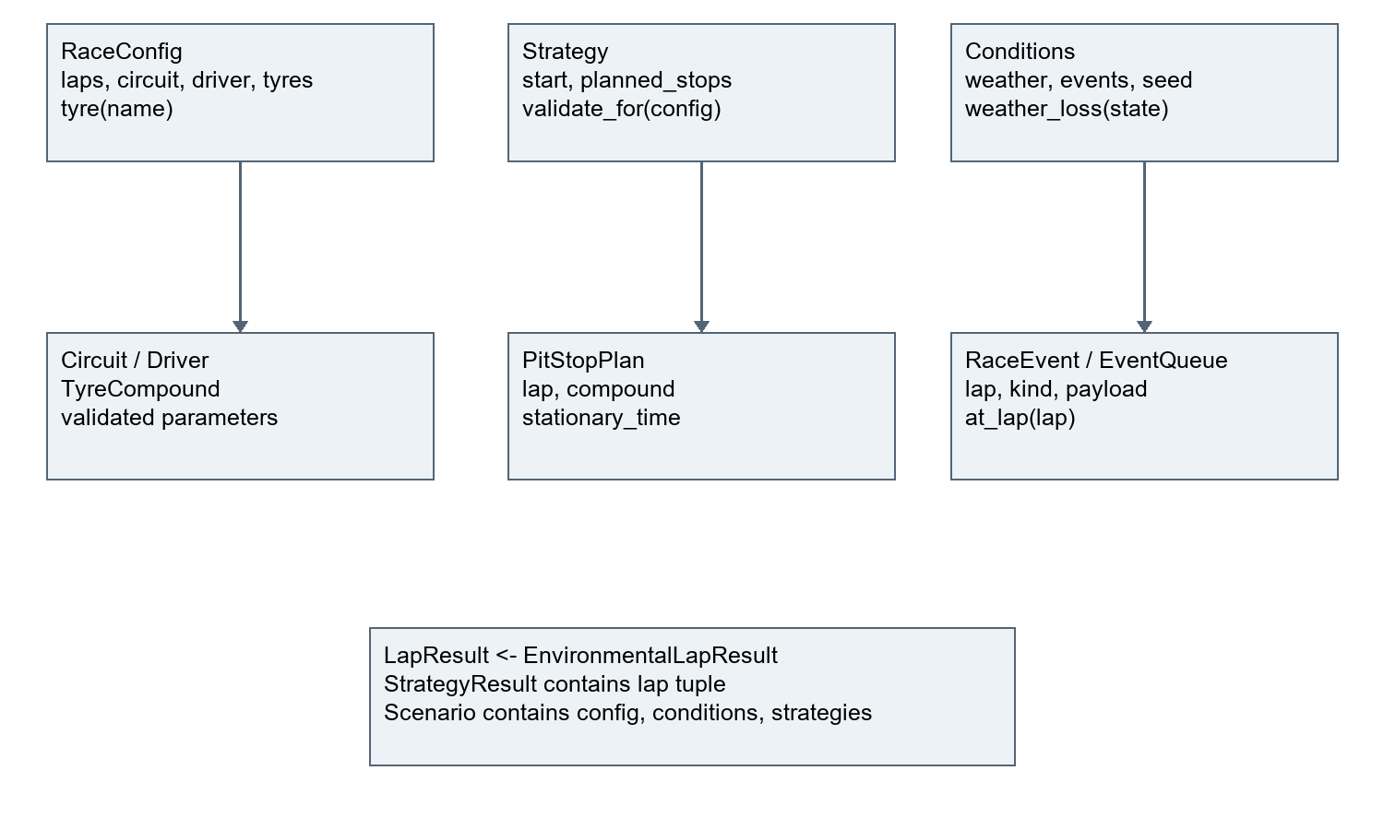
Figure 5: Core class relationships
Complete physics.py as inspected for this report
"""Pure explainable formulas; all penalties are measured in seconds."""
from .models import RaceConfig, TyreCompound, integer, number

def degradation(tyre: TyreCompound, age: int) -> float:
integer(age, "Tyre age")
loss = tyre.degradation_rate * age
number(loss, "Degradation loss")
return loss

def fuel_effect(config: RaceConfig, lap: int) -> float:
integer(lap, "Lap number", 1, config.laps)
if config.laps == 1:
return 0.0
return config.initial_fuel_penalty * ((config.laps - lap) / (config.laps - 1))

def lap_time(config: RaceConfig, tyre: TyreCompound, age: int,
lap: int, pit_loss: float = 0.0) -> tuple[float, float, float]:
number(pit_loss, "Pit loss")
wear = degradation(tyre, age)
fuel = fuel_effect(config, lap)
total = (config.circuit.base_lap_time + config.driver.pace_delta
+ tyre.base_pace_delta + wear + fuel + pit_loss)
number(total, "Calculated lap time", positive=True)
return total, wear, fuel

Appendix B Automated test inventory
Table 32: Final collected cases
Number | Test case | Outcome
001 | tests.test_advanced_gui::test_events_parser | PASS
002 | tests.test_advanced_gui::test_gui_scenario_roundtrip | PASS
003 | tests.test_advanced_gui::test_async_search_and_mc | PASS
004 | tests.test_advanced_gui::test_stale_worker_result_discarded | PASS
005 | tests.test_advanced_gui::test_worker_cancellation | PASS
006 | tests.test_comparison::test_manual_comparison | PASS
007 | tests.test_comparison::test_tie_order | PASS
008 | tests.test_comparison::test_invalid_comparison | PASS
009 | tests.test_conditions::test_weather_transitions | PASS
010 | tests.test_conditions::test_weather_ties | PASS
011 | tests.test_conditions::test_safety_car_manual | PASS
012 | tests.test_conditions::test_invalid_safety_factor[-1] | PASS
013 | tests.test_conditions::test_invalid_safety_factor[1.01] | PASS
014 | tests.test_conditions::test_invalid_safety_factor[nan] | PASS
015 | tests.test_engine::test_five_lap_manual_oracle | PASS
016 | tests.test_engine::test_no_stop_manual | PASS
017 | tests.test_engine::test_race_boundaries[1] | PASS
018 | tests.test_engine::test_race_boundaries[500] | PASS
019 | tests.test_engine::test_consecutive_same_compound_stops | PASS
020 | tests.test_engine::test_final_stop_rejected | PASS
021 | tests.test_engine::test_zero_pit_loss | PASS
022 | tests.test_engine::test_overflow_rejected | PASS
023 | tests.test_events::test_order_and_ties | PASS
024 | tests.test_events::test_bad_events | PASS
025 | tests.test_final_robustness::test_json_collection_types[events] | PASS
026 | tests.test_final_robustness::test_json_collection_types[planned_stops] | PASS
027 | tests.test_final_robustness::test_independent_search_oracle | PASS
028 | tests.test_final_robustness::test_trial_reconstruction | PASS
029 | tests.test_final_robustness::test_maximum_comparison | PASS
030 | tests.test_gui::test_parser | PASS
031 | tests.test_gui::test_real_gui_comparison_and_invalidation | PASS
032 | tests.test_gui::test_invalid_stop_error_and_recovery | PASS
033 | tests.test_gui::test_single_and_add_remove | PASS
034 | tests.test_models::test_race_boundaries[1] | PASS
035 | tests.test_models::test_race_boundaries[500] | PASS
036 | tests.test_models::test_invalid_race_length[0] | PASS
037 | tests.test_models::test_invalid_race_length[-1] | PASS
038 | tests.test_models::test_invalid_race_length[501] | PASS
039 | tests.test_models::test_invalid_race_length[2.5] | PASS
040 | tests.test_models::test_invalid_race_length[True] | PASS
041 | tests.test_models::test_invalid_race_length[5] | PASS
042 | tests.test_models::test_invalid_parameters[-1] | PASS
043 | tests.test_models::test_invalid_parameters[nan] | PASS
044 | tests.test_models::test_invalid_parameters[inf] | PASS
045 | tests.test_models::test_invalid_parameters[True] | PASS
046 | tests.test_models::test_invalid_parameters[fast] | PASS
047 | tests.test_models::test_missing_and_duplicate_tyres | PASS
048 | tests.test_models::test_invalid_start[None] | PASS
049 | tests.test_models::test_invalid_start[SOFT] | PASS
050 | tests.test_models::test_invalid_start[0] | PASS
051 | tests.test_models::test_stop_order_and_race_end | PASS
052 | tests.test_models::test_zero_and_negative_inputs | PASS
053 | tests.test_models::test_results_and_state_validation | PASS
054 | tests.test_monte_carlo::test_manual_statistics | PASS
055 | tests.test_monte_carlo::test_deterministic_and_replay | PASS
056 | tests.test_monte_carlo::test_invalid_counts_and_cancel | PASS
057 | tests.test_optimiser::test_tiny_space | PASS
058 | tests.test_optimiser::test_minimum_stints_and_baselines | PASS
059 | tests.test_optimiser::test_limit_and_cancel | PASS
060 | tests.test_persistence::test_roundtrip | PASS
061 | tests.test_persistence::test_malformed[{] | PASS
062 | tests.test_persistence::test_malformed[{}] | PASS
063 | tests.test_persistence::test_malformed[{"x":1,"x":2}] | PASS
064 | tests.test_persistence::test_malformed[NaN] | PASS
065 | tests.test_persistence::test_malformed[[]] | PASS
066 | tests.test_persistence::test_schema_and_model_validation | PASS
067 | tests.test_physics::test_manual_degradation[0-0] | PASS
068 | tests.test_physics::test_manual_degradation[1-0.2] | PASS
069 | tests.test_physics::test_manual_degradation[3-0.6] | PASS
070 | tests.test_physics::test_zero_degradation | PASS
071 | tests.test_physics::test_invalid_age[-1] | PASS
072 | tests.test_physics::test_invalid_age[0.5] | PASS
073 | tests.test_physics::test_invalid_age[True] | PASS
074 | tests.test_physics::test_fuel_manual | PASS
075 | tests.test_physics::test_invalid_lap[0] | PASS
076 | tests.test_physics::test_invalid_lap[6] | PASS
077 | tests.test_physics::test_invalid_lap[1.5] | PASS
078 | tests.test_physics::test_invalid_lap[True] | PASS
079 | tests.test_physics::test_lap_manual | PASS
080 | tests.test_randomness::test_seed_reproduction | PASS
081 | tests.test_randomness::test_bad_seed[-1] | PASS
082 | tests.test_randomness::test_bad_seed[4294967296] | PASS
083 | tests.test_randomness::test_bad_seed[True] | PASS
084 | tests.test_randomness::test_bad_seed[1.5] | PASS
085 | tests.test_randomness::test_bad_seed[42] | PASS
086 | tests.test_randomness::test_bad_amplitude | PASS
087 | tests.test_sc05_tolerance::test_five_lap_oracle_absolute_tolerance | PASS

Appendix C Execution and failure evidence
The full final output is in evidence/test-runs/TEST-QUALITY-FINAL-20260908T224148466396Z/output.txt. The XML records 87 cases without failure/error nodes. Each run's metadata retains command, timestamp and source hashes. Section 3.17 lists all preserved runs; the following final summary is verbatim.
Final pytest output tail with local paths abbreviated
tests/test_randomness.py::test_bad_amplitude PASSED [ 98%]
tests/test_sc05_tolerance.py::test_five_lap_oracle_absolute_tolerance PASSED [100%]

- generated xml file: [PROJECT]\evidence\test-runs\TEST-QUALITY-
FINAL-20260908T224148466396Z\results.xml -
============================= 87 passed in 8.60s ==============================

Failure source: evidence/test-runs/TEST-I17-ROBUSTNESS-20260908T212523289799Z/output.txt. Complete traceback and source hashes remain untouched. Capture-harness diagnosis: docs/testing/FAIL-I17-02.md; its limitation is a transcript record rather than a separate raw terminal file.

Appendix D Full benchmark values
Verbatim benchmark JSON values
{
"started_utc": "2026-09-08T21:26:52.003607+00:00",
"machine": {
"cpu": "Snapdragon(R) X 10-core X1P64100 @ 3.40 GHz",
"ram_bytes": 16756006912,
"platform": "Windows-11-10.0.26200-SP0",
"python": "3.14.0 (tags/v3.14.0:ebf955d, Oct 7 2025, 10:15:03) [MSC v.1944 64 bit (AMD64)]",
"process_architecture": "AMD64"
},
"race_laps": 50,
"repeats": 3,
"warmup": "One unmeasured single-race run",
"measurements": [
{
"label": "sequential races",
"count": 1,
"seconds": [
0.0005320999989635311,
0.0005244999993010424,
0.00051059999896097
],
"minimum": 0.00051059999896097,
"maximum": 0.0005320999989635311,
"mean": 0.0005223999990751812,
"median": 0.0005244999993010424
},
{
"label": "sequential races",
"count": 100,
"seconds": [
0.06135329999960959,
0.07580089999828488,
0.06523269999888726
],
"minimum": 0.06135329999960959,
"maximum": 0.07580089999828488,
"mean": 0.06746229999892724,
"median": 0.06523269999888726
},
{
"label": "sequential races",
"count": 500,
"seconds": [
0.34104739999747835,
0.31911050000053365,
0.3346101999995881
],
"minimum": 0.31911050000053365,
"maximum": 0.34104739999747835,
"mean": 0.3315893666658667,
"median": 0.3346101999995881
},
{
"label": "sequential races",
"count": 1000,
"seconds": [
0.807915099998354,
0.6702942000010808,
0.9107024000004458
],
"minimum": 0.6702942000010808,
"maximum": 0.9107024000004458,
"mean": 0.7963038999999602,
"median": 0.807915099998354
},
{
"label": "candidate prefix scoring (not full search)",
"count": 10,
"seconds": [
0.006008200001815567,
0.009975800003303448,
0.009136799999396317
],
"minimum": 0.006008200001815567,
"maximum": 0.009975800003303448,
"mean": 0.00837360000150511,
"median": 0.009136799999396317
},
{
"label": "candidate prefix scoring (not full search)",
"count": 100,
"seconds": [
0.08367839999846183,
0.08603339999899617,
0.08780420000039157
],
"minimum": 0.08367839999846183,
"maximum": 0.08780420000039157,
"mean": 0.08583866666594986,
"median": 0.08603339999899617
},
{
"label": "candidate prefix scoring (not full search)",
"count": 1000,
"seconds": [
0.8923073000005388,
1.0548605999974825,
1.0325487000009161
],
"minimum": 0.8923073000005388,
"maximum": 1.0548605999974825,
"mean": 0.9932388666663124,
"median": 1.0325487000009161
},
{
"label": "complete default search",
"count": 1056,
"seconds": [
1.350378200000705,
1.0296382000015,
1.1048835000001418
],
"minimum": 1.0296382000015,
"maximum": 1.350378200000705,
"mean": 1.1616333000007824,
"median": 1.1048835000001418
},
{
"label": "paired Monte Carlo trials",
"count": 100,
"seconds": [
0.2067151000010199,
0.2261023999999452,
0.21768179999708082
],
"minimum": 0.2067151000010199,
"maximum": 0.2261023999999452,
"mean": 0.21683309999934863,
"median": 0.21768179999708082
},
{
"label": "paired Monte Carlo trials",
"count": 500,
"seconds": [
1.1139492000002065,
1.1364091000032204,
1.2292094000004
],
"minimum": 1.1139492000002065,
"maximum": 1.2292094000004,
"mean": 1.1598559000012756,
"median": 1.1364091000032204
},
{
"label": "paired Monte Carlo trials",
"count": 1000,
"seconds": [
2.516606799999863,
1.6913468999991892,
2.089219100002083
],
"minimum": 1.6913468999991892,
"maximum": 2.516606799999863,
"mean": 2.0990576000003784,
"median": 2.089219100002083
}
]
}

Appendix E Research materials
Section 1.5 contains the three comparative reviews and their ADOPT, ADAPT, REJECT and LEARN decisions. The original record remains docs/analysis/research.md. These sources led to the following review exercises after implementation.
These tasks were added after the source review in docs/analysis/research.md. They are planning material, not feedback or successful tests.
1. Explain why a weather event halfway through lap 10 can only be approximated by the current lap-boundary model. Trace the event heap and resulting penalty.
2. Compare one stop with two stops. Change only pit-lane loss and explain when the ranking changes. Identify the role of missing traffic.
3. Run paired Monte Carlo with SC probability0,0.3,1 using the same seed and variation. Explain why shared additive noise alone cannot alter the gap, and why SC timing may.
4. Discuss what must be removed or accounted for before using observed lap data to calibrate degradation. Do not paste real laps into configuration and call the model validated.
5. Apply wet weather. Explain why every supported compound receives the same extra penalty and why the application cannot recommend a real wet-tyre strategy.
6. Manually enumerate the 12 legal zero/one-stop plans for a two-lap race and explain the optimiser's grid and tie order.
Record candidate explanations separately and accurately. [GENUINE STAKEHOLDER FEEDBACK PENDING]

Appendix F Human evidence packs
All eight forms below are ready to use but uncompleted. Completed consent and identifying information belong in private-evidence/, not a public repository. Record actual dates and participant aliases. A post-prototype response cannot be presented as an initial interview.

Stakeholder interview
Status: HUMAN INPUT REQUIRED. This form has not been completed.
Participant alias: [REQUIRED]
Session date: [REQUIRED]
Role/experience: [REQUIRED]
Consent record held privately: [REQUIRED]
Use an alias in project records. Keep identifying details and consent records in private-evidence/, outside the public release. Do not backdate a session or describe a post-prototype interview as original research.
Stage: [INITIAL OR POST-PROTOTYPE, RECORD ACTUAL STAGE]
1. What race-strategy decisions would you want to explore?
[GENUINE RESPONSE REQUIRED]
Response space: ______________________________
2. Which race and tyre inputs make sense to you?
[GENUINE RESPONSE REQUIRED]
Response space: ______________________________
3. Which outputs would be most useful, and why?
[GENUINE RESPONSE REQUIRED]
Response space: ______________________________
4. What do you think the stop syntax 15:Medium means?
[GENUINE RESPONSE REQUIRED]
Response space: ______________________________
5. What is confusing or missing?
[GENUINE RESPONSE REQUIRED]
Response space: ______________________________
6. Which simplification could make the results misleading?
[GENUINE RESPONSE REQUIRED]
Response space: ______________________________
7. Which improvement matters most, and why?
[GENUINE RESPONSE REQUIRED]
Response space: ______________________________

Requirements follow-up
Status: HUMAN INPUT REQUIRED. This form has not been completed.
Participant alias: [REQUIRED]
Session date: [REQUIRED]
Role/experience: [REQUIRED]
Consent record held privately: [REQUIRED]
Use an alias in project records. Keep identifying details and consent records in private-evidence/, outside the public release. Do not backdate a session or describe a post-prototype interview as original research.
Table 33: Blank human evidence form
Response reference | Need in participant words | Existing FR / SC | Proposed change and reason | Priority from participant | Acceptance condition | Confirmed date
[REQUIRED] | [REQUIRED] | [REQUIRED] | [REQUIRED] | [REQUIRED] | [REQUIRED] | [REQUIRED]

Ask the participant to confirm this interpretation. Keep disagreement or rejected suggestions and explain the decision. Do not mark requirements agreed until agreement is recorded.

Post-prototype review
Status: HUMAN INPUT REQUIRED. This form has not been completed.
Participant alias: [REQUIRED]
Session date: [REQUIRED]
Role/experience: [REQUIRED]
Consent record held privately: [REQUIRED]
Use an alias in project records. Keep identifying details and consent records in private-evidence/, outside the public release. Do not backdate a session or describe a post-prototype interview as original research.
Build/version shown: [REQUIRED]
Scenario used: [REQUIRED]
1. What did the prototype help you understand?
[GENUINE RESPONSE REQUIRED]
2. Which result or control was difficult to interpret?
[GENUINE RESPONSE REQUIRED]
3. Which single improvement should be prioritised? Why?
[GENUINE RESPONSE REQUIRED]
4. After an implemented change, did it solve the reported difficulty? Record the actual follow-up date and version.
[GENUINE RESPONSE REQUIRED]

Usability task sheet
Status: PLANNED. No completed session is claimed. Use participant aliases and record build, machine, display scale and date on the observation form. Explain that PITWALL is an illustrative simulator. Let the user attempt each task; record any hints rather than silently coaching.
1. Launch PITWALL.
2. Configure a short five-lap race.
3. Create two named strategies.
4. Add a valid stop after lap 2.
5. Compare both strategies.
6. Identify the faster plan and its time advantage.
7. Explain the pit spike on the graph.
8. Enter a stop after the final lap and interpret the error.
9. Add an event and explain when it takes effect.
10. Run a 100-trial Monte Carlo experiment.
11. Explain what the win percentage means.
12. Start optimisation and cancel it; describe the feedback and whether further input is possible.
13. Save a scenario.
14. Change a setting, then reload the scenario and check the restored inputs.
For task 12, if work finishes before cancellation is attempted, record that fact. Do not label it a successful cancellation observation. Use a larger legal search for another attempt and record the changed settings. Timing is optional and must be measured live, never estimated afterwards.

Usability observations
Status: HUMAN INPUT REQUIRED. This form has not been completed.
Participant alias: [REQUIRED]
Session date: [REQUIRED]
Role/experience: [REQUIRED]
Consent record held privately: [REQUIRED]
Use an alias in project records. Keep identifying details and consent records in private-evidence/, outside the public release. Do not backdate a session or describe a post-prototype interview as original research.
Build: [REQUIRED]
Device / OS / display scale: [REQUIRED]
Scenario / settings: [REQUIRED]
Observer alias: [REQUIRED]
Table 34: Blank human evidence form
Task | Completion | Mistakes | Confusion | Help required | Measured seconds or Not measured | Verbatim comment
1 | [PENDING] | [PENDING] | [PENDING] | [PENDING] | [PENDING] | [PENDING]
2 | [PENDING] | [PENDING] | [PENDING] | [PENDING] | [PENDING] | [PENDING]
3 | [PENDING] | [PENDING] | [PENDING] | [PENDING] | [PENDING] | [PENDING]
4 | [PENDING] | [PENDING] | [PENDING] | [PENDING] | [PENDING] | [PENDING]
5 | [PENDING] | [PENDING] | [PENDING] | [PENDING] | [PENDING] | [PENDING]
6 | [PENDING] | [PENDING] | [PENDING] | [PENDING] | [PENDING] | [PENDING]
7 | [PENDING] | [PENDING] | [PENDING] | [PENDING] | [PENDING] | [PENDING]
8 | [PENDING] | [PENDING] | [PENDING] | [PENDING] | [PENDING] | [PENDING]
9 | [PENDING] | [PENDING] | [PENDING] | [PENDING] | [PENDING] | [PENDING]
10 | [PENDING] | [PENDING] | [PENDING] | [PENDING] | [PENDING] | [PENDING]
11 | [PENDING] | [PENDING] | [PENDING] | [PENDING] | [PENDING] | [PENDING]
12 | [PENDING] | [PENDING] | [PENDING] | [PENDING] | [PENDING] | [PENDING]
13 | [PENDING] | [PENDING] | [PENDING] | [PENDING] | [PENDING] | [PENDING]
14 | [PENDING] | [PENDING] | [PENDING] | [PENDING] | [PENDING] | [PENDING]

SC04 error meaning in participant words: [PENDING]
SC14 response/cancellation observations, with task settings: [PENDING]

Usability summary
Status: HUMAN INPUT REQUIRED. Do not summarise unused forms as results.
Completed session references: [REQUIRED]
Number of genuine participants: [REQUIRED]
Table 35: Blank human evidence form
Finding and observed task | Evidence / quotation reference | Effect on SC04 / SC08 / SC14 | Proposed change | Retest result
[REQUIRED] | [REQUIRED] | [REQUIRED] | [REQUIRED] | [PENDING]

Describe disagreements, assistance provided and session limitations. Distinguish an observed problem from a proposed improvement. Update evaluation only after the evidence exists.

Candidate iteration reflection
Status: CANDIDATE INPUT REQUIRED. Complete a copy for each genuine recorded stage; keep the real review date. A present-day explanation is not a historical diary entry.
Candidate: Mithil Katkoria
Iteration / files: [REQUIRED]
Date personally reviewed: [REQUIRED]
What did you personally review, change or test?
[CANDIDATE FACTUAL INPUT REQUIRED]
Explain the code choice in your own words.
[CANDIDATE FACTUAL INPUT REQUIRED]
Which recorded test did you inspect or actually run? Give its evidence ID.
[CANDIDATE FACTUAL INPUT REQUIRED]
What worked well, based on that evidence?
[CANDIDATE FACTUAL INPUT REQUIRED]
What was difficult for you personally? If nothing is recalled, say so.
[CANDIDATE FACTUAL INPUT REQUIRED]
Which alternative can you explain and why would you choose it?
[CANDIDATE FACTUAL INPUT REQUIRED]
What limitation or uncertainty remains?
[CANDIDATE FACTUAL INPUT REQUIRED]
Which stakeholder response, if any, affected this stage?
[CANDIDATE FACTUAL INPUT REQUIRED]
Which assistance was used and what can you now explain independently?
[CANDIDATE FACTUAL INPUT REQUIRED]
The algorithm-understanding checklist is docs/candidate/algorithm-understanding-check.md. Every topic below is INCOMPLETE. For each, Mithil must record a genuine explanation of purpose, inputs, outputs, algorithm, data structure, edge case, alternative and limitation, with the actual review date.
Table 36: Candidate understanding topics
Topic | Current source | Status
Tyre degradation | physics.py | INCOMPLETE
Fuel model | physics.py | INCOMPLETE
Pit-stop semantics | engine.py | INCOMPLETE
Race loop | engine.py | INCOMPLETE
Event heap | events.py | INCOMPLETE
Weather state | conditions.py / engine.py | INCOMPLETE
Safety-car model | conditions.py / engine.py | INCOMPLETE
Random seed | engine.py / conditions.py | INCOMPLETE
Monte Carlo | monte_carlo.py | INCOMPLETE
Statistics | monte_carlo.py | INCOMPLETE
Bounded generation | optimiser.py | INCOMPLETE
Optimisation | optimiser.py | INCOMPLETE
Persistence | persistence.py | INCOMPLETE
GUI worker / cancellation | advanced_gui.py | INCOMPLETE
Validation | models.py / persistence.py / gui.py | INCOMPLETE

No new feature is selected now. A genuine future iteration must cite the feedback, update a requirement, record design and expected tests before implementation, retain actual execution and failures, then obtain a real follow-up review.

Appendix G Git development summary
Table 37: Genuine commits in chronological order
Commit | Recorded timestamp | Subject
51e8e03 | 2026-09-08T21:58:03+01:00 | Design and implement validated core models
1fabfe3 | 2026-09-08T22:00:49+01:00 | Test tyre degradation and deterministic lap formulas
eafc37e | 2026-09-08T22:03:22+01:00 | Verify dry-race engine and strategy comparison
d6a542c | 2026-09-08T22:09:35+01:00 | Complete and verify first deterministic desktop milestone
19608f1 | 2026-09-08T22:16:39+01:00 | Add tested events seeded simulation Monte Carlo and bounded search
cdd4bf2 | 2026-09-08T22:26:34+01:00 | Preserve integrated GUI and genuine JSON robustness failures
ecf3829 | 2026-09-08T22:38:19+01:00 | Fix JSON validation and preserve verified prototype evidence pack

These commits are evidence of actual version history, not proof that each design file preceded every edit. The iteration records and tool conversation provide finer-grained sequence. Documentation cleanup changes present at report preparation are uncommitted and are not misrepresented as an extra commit.

Appendix H Evidence catalogue and completeness audit
The pre-report evidence index contains 214 entries. Every listed file and SHA256 hash was checked before report generation. The index includes code, planning records and clearly labelled placeholders as well as captured output; 214 entries does not mean that many screenshots or completed human studies. report/evidence-index.csv remains the full catalogue.
Table 38: Criterion completeness and remaining work
Criterion | Section | Evidence used | Status | Remaining work
3.1.1(a) Computational problem | 1.1-1.3 | Requirements and model explanation | STRONG | Explain repeated scenario evaluation and parameter trade-offs
3.1.1(b) Computational approach | 1.3 | Decomposition, state and iteration | STRONG | Complete understanding check
3.1.2(a) Stakeholders | 1.4; 5.8 | Relevant groups and blank interviews | HUMAN INPUT REQUIRED | Conduct interview and requirements follow-up
3.1.3(a) Research | 1.5 | Three cited post-prototype reviews | PARTIAL | Candidate review; use future findings prospectively
3.1.3(b) Essential features | 1.7 | FR01-FR12 with rationale | STRONG | Confirm requirements with stakeholder
3.1.3(c) Limitations | 1.8; 5.10 | Model and deployment limits | STRONG | Discuss real user consequences
3.1.4(a) Requirements | 1.9 | Runtime, hardware and benchmark environment | STRONG | Validate on intended user machine
3.1.4(b) Success criteria | 1.10; 5.2 | SC01-SC14 and explicit evidence | STRONG | Confirm success criteria with stakeholder
3.2.1(a) Decomposition | 2.1 | Problem and component breakdown | STRONG | Explain boundaries and state
3.2.2(a) Structure | 2.2-2.3 | Current-source architecture and models | PARTIAL | Preserve labels; prospective design only after feedback
3.2.2(b) Algorithms | 2.6 | A01-A14 and source extracts | STRONG | Complete all 15 understanding topics
3.2.2(c) Usability design | 2.8-2.9 | GUI captures, labels, validation and worker design | PARTIAL | Run task sheet and act on actual findings
3.2.2(d) Data and validation | 2.3-2.5; 2.7 | Typed models, variables, strict schema | STRONG | Explain edge cases and alternatives
3.2.3(a) Test data | 2.10-2.11; 4 | Recorded stage plans and final quality plan | STRONG | Complete planned human tasks
3.3.1(a) Iterative process | 3.1-3.15; App G | Recorded stages, source, seven commits | CANDIDATE INPUT REQUIRED | Complete dated factual reflections
3.3.1(b) Prototypes | 3.6; 3.14 | First and advanced genuine GUI captures | STRONG | Explain preserved versions; do not fabricate missing captures
3.3.2(a) Development tests | 3.17; App B | 17 original runs plus two new runs | STRONG | Explain meaningful expected results
3.3.2(b) Remedial action | 3.16 | I17 JSON failure, remedy, retest and regression | STRONG | Explain empty-container cause and remedy
3.4.1(a) Final robustness | 4.1-4.4 | 87 passing cases and genuine timings | STRONG | Review coverage limits
3.4.1(b) Usability tests | 4.5 | Blank 14-task protocol | HUMAN INPUT REQUIRED | Run sessions and preserve observations
3.4.2(a) Success evaluation | 5.2 | Criterion evidence and explicit judgements | PARTIAL | Update after real sessions
3.4.3(a) Usability effectiveness | 5.7-5.8 | Real captures and automated GUI tests | HUMAN INPUT REQUIRED | Evaluate observed task outcomes
3.4.4(a) Maintenance | 5.9 | Six concrete module/change concerns | STRONG | Explain consequences and regression needs
3.4.4(b) Further development | 5.10-5.11 | Eight limitations and possible changes | STRONG | Choose one only after actual feedback

Official OCR content points 3.1 through 3.4 and the published marking bands were checked against the specification downloaded on 8 September 2026. The 24-point mapping above uses the official numbering. The separate centre Full Mark Criteria document was not found, so centre-specific integration is TEACHER INPUT REQUIRED. The full strengths, risks, actions and human responsibilities are in report/FINAL_CRITERIA_AUDIT.md. No mark is awarded by this review.

Appendix I JSON contract and example
Schema version1 requires config, conditions and strategies, with exact field sets. Enum values are stored as strings. Arrays are explicitly checked after the genuine fix. There is no standalone formal JSON Schema file; the contract is implemented in persistence.py and validated by model constructors. Search/Monte Carlo controls are stored in experiment exports, not the base scenario.
Actual dry-comparison.json example
{
"schema_version": 1,
"config": {
"laps": 50,
"circuit": {
"name": "Custom circuit",
"base_lap_time": 90.0,
"pit_lane_loss": 20.0
},
"driver": {
"name": "Custom driver",
"pace_delta": 0.0
},
"tyres": [
{
"name": "Soft",
"base_pace_delta": 0.0,
"degradation_rate": 0.16,
"recommended_life": 15
},
{
"name": "Medium",
"base_pace_delta": 0.5,
"degradation_rate": 0.09,
"recommended_life": 25
},
{
"name": "Hard",
"base_pace_delta": 1.0,
"degradation_rate": 0.045,
"recommended_life": 35
}
],
"initial_fuel_penalty": 3.0
},
"conditions": {
"initial_weather": "Dry",
"events": [],
"damp_penalty": 4.0,
"wet_penalty": 15.0,
"safety_car_penalty": 25.0,
"safety_car_pit_factor": 0.5,
"seed": 42,
"variation": 0.0
},
"strategies": [
{
"name": "One stop",
"starting_compound": "Medium",
"planned_stops": [
{
"lap": 25,
"compound": "Hard",
"stationary_time": 2.5
}
]
},
{
"name": "Two stops",
"starting_compound": "Soft",
"planned_stops": [
{
"lap": 15,
"compound": "Medium",
"stationary_time": 2.5
},
{
"lap": 32,
"compound": "Hard",
"stationary_time": 2.5
}
]
}
]
}

Appendix J Additional application screenshots
Figure 6 shows totals, stop count, average, fastest and slowest laps, pit loss and stint lengths.
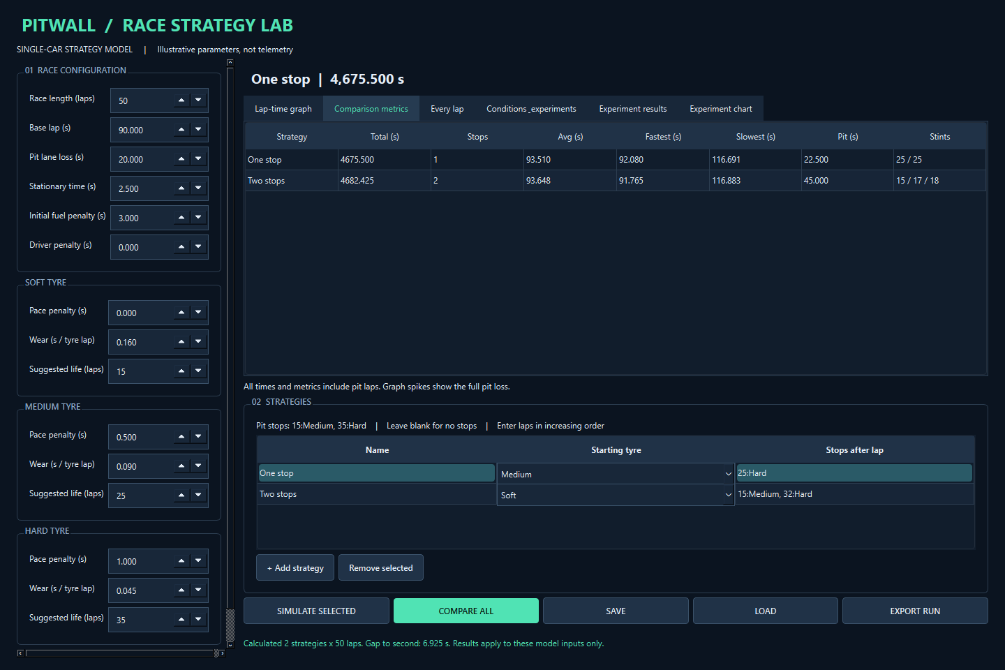
Figure 6: Actual comparison metrics
Figure 7 shows the per-lap model components for inspection.
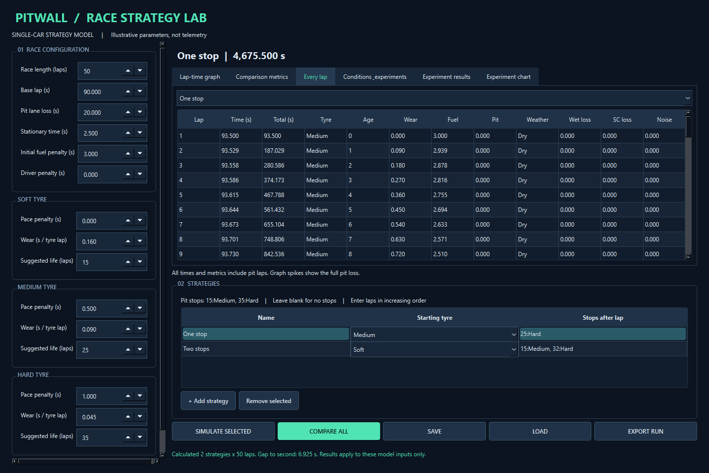
Figure 7: Actual lap records
Figure 8 shows the scrollable environment controls; controls below the visible region require scrolling.
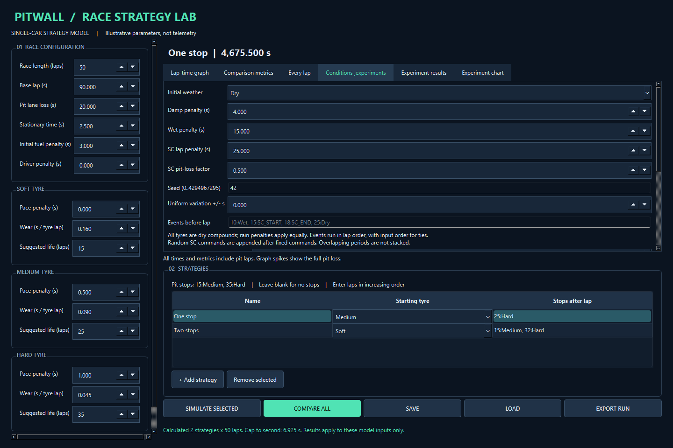
Figure 8: Conditions and experiment settings
Figure 9 shows 100 recorded trials; A wins88% under the chosen illustrative settings.
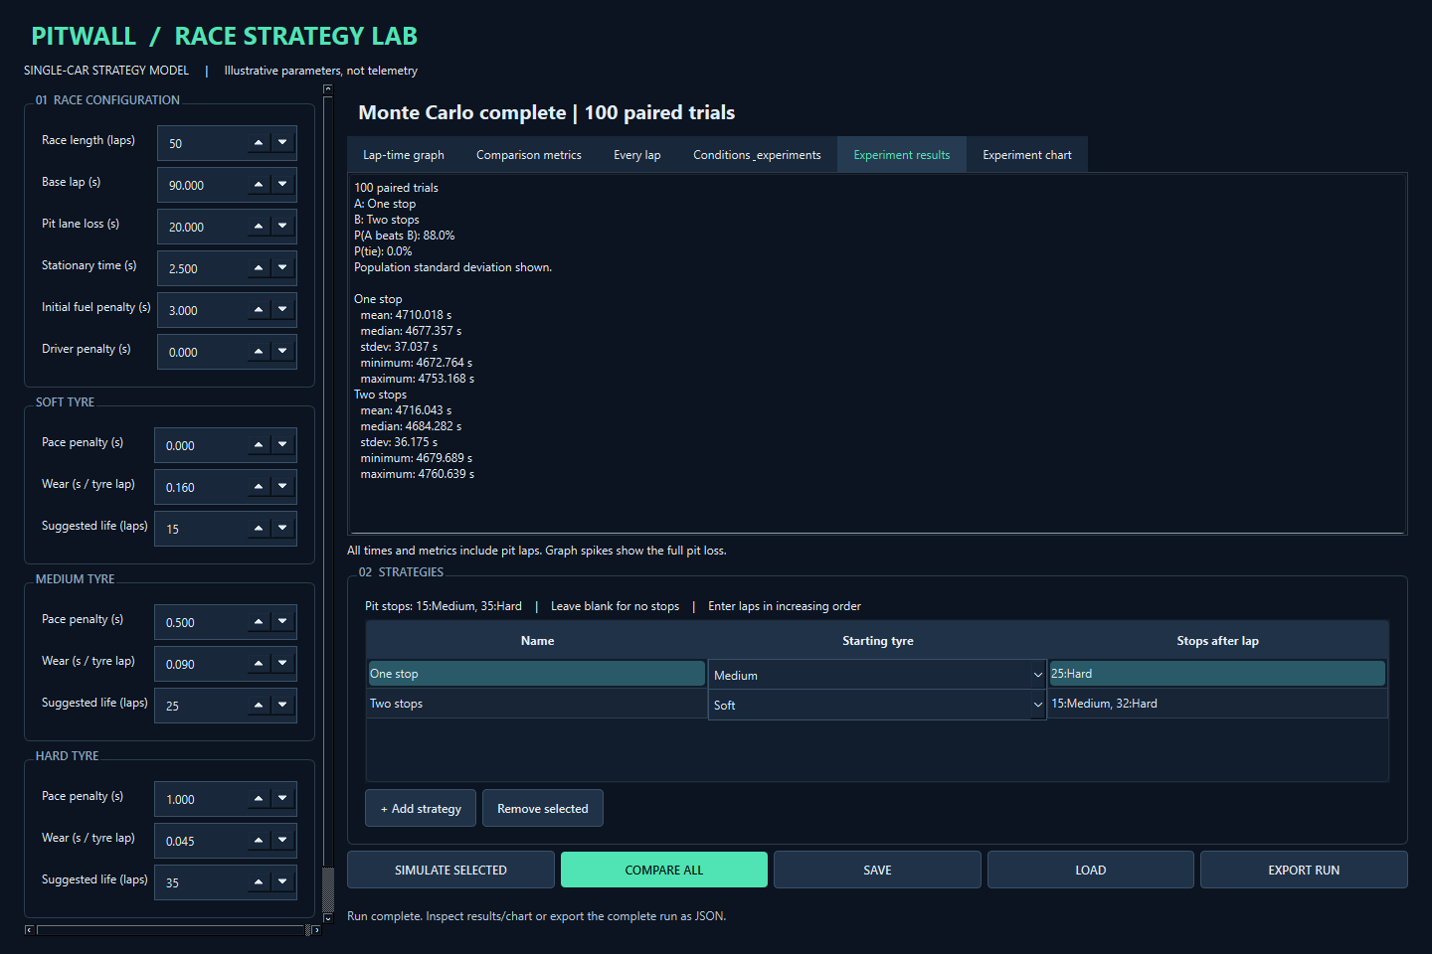
Figure 9: Actual paired Monte Carlo summary
Figure 10 plots the same recorded trial totals with shared bins.
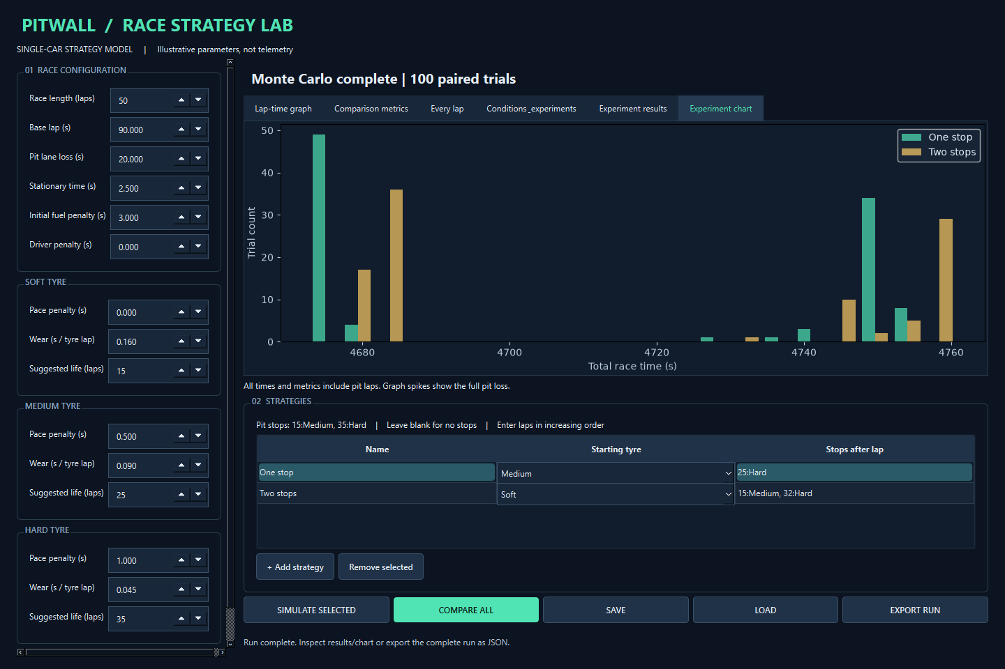
Figure 10: Actual Monte Carlo histogram

Appendix K Development declaration
Tool used: Codex. Centre-specific declaration guidance is pending. No assistance percentage is assigned.
Table 39: Factual assistance record
Date / stage | Assistance provided | Affected files / features | Candidate follow-up recorded
2026-09-08, planning and records | Drafted requirements, designs, diagrams, development records, README and evaluation; reviewed three sources after the prototype | docs/, README.md, report/ | Candidate supplied brief; subsequent review not recorded
2026-09-08, implementation | Authored simulation, comparison, GUI, environmental events, randomness, Monte Carlo, search and persistence modules | src/pitwall/, main.py, launch.ps1 | Personal changes or explanation not recorded
2026-09-08, verification | Wrote/ran tests; fixed JSON validation and capture-harness issues; captured/inspected actual GUI output and ran benchmarks | tests/, scripts/, evidence/ | Personal testing or review not recorded
2026-09-08, cleanup | Reorganised public documentation and consolidated attribution | Files in report/documentation-cleanup.md | Candidate requested cleanup; review of edits not recorded
2026-09-08, master report | Assembled and checked the evidence-based DOCX/PDF, diagrams and completeness audit | report/; SC05 evidence judgement in docs/evaluation/review.md | Candidate requested report; personal review and missing human evidence remain pending
2026-09-08, final quality pass | Added explicit tolerance verification and comparison benchmark; prepared blank human forms, final report and local release files | tests/test_sc05_tolerance.py, scripts/benchmark_comparison.py, docs/, report/, public packaging | Candidate requested quality pass; personal explanations, human sessions and centre approval remain pending

Source review involved no hands-on trials or copied source code/parameters. Execution records, captures and Git history remain intact. Add personal review, changes, tests and explanations when completed.
The record is maintained separately at docs/assistance-log.md. Candidate follow-up must be completed factually; this report does not replace the centre's declaration process.
The public release is staged locally. Publication is pending centre permission and privacy approval. Local absolute paths in report excerpts are abbreviated as [PROJECT] or [PYTHON]; original execution records remain intact in the private evidence repository.

