**Angular**

Angular is a framework for building client applications in HTML and TypeScript

**Component**

A component controls a part of the web application screen. It consists of JavaScript (or precisely TypeScript) code, HTML code and CSS

import { Component } from "@angular/core";

@Component({

selector: "app-root",

templateUrl: "./app.component.html",

styleUrls: ["./app.component.css"]

})

export class AppComponent {

title = "Angular";

}

**CLI command**

ng g component MyComponent / ng g c MyComponent

**Data Binding**

data binding provide the communication between a component class and the template that its associated with

* interpolation Binding
* Property Binding

set the html element attribute value to the value of a template expression

* Event Binding

Event Binding allows our component to listen to events triggered by user actions in the view

* Two-Way Binding

The square brackets indicate Property Binding and the parenthesis indicate Event Binding to send a notification of the user entered data back to the property

**Decorators**

***Decorators*** are functions that modify JavaScript classes. Decorators are used for attaching metadata to classes, it knows the configuration of those classes and how they should work.

In TypeScript, decorators are implemented using functions. Actually it's a function that returns a function. The outside function is called as decorator factory and the inside one is called as the decorator. The decorator factory takes some configuration values and returns a decorator.

Angular uses quite a lot of decorators. There are decorators for classes, properties, methods and even parameters. Some of the important decorators are:

* NgModule
* Component
* Input
* Output

The *Component* decorator is used to decorate a class as an angular component and adds additional metadata information like the template, selector name, styles etc. to it.

The *Component* decorator does the following things.

* Creates an instance of a function called *DecoratorFactory* (derived from *Directive*).
* Fills that instance with the passed arguments (selector, template etc).
* Defines a static property in the component type with name "__annotations__" and assign the instance to it.

To verify this, please run the below statement.

|  |  |
| --- | --- |
| 1 | console.log(GreetingComponent['__annotations__']); |

*Listing 5. Displaying GreetingComponent's Annotations*

You'll see the below output.

[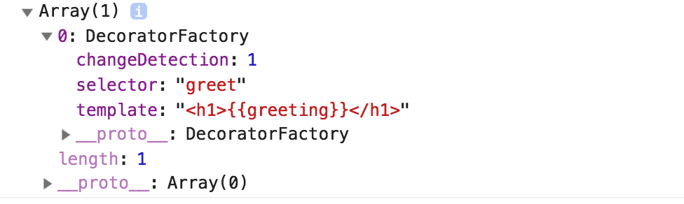](http://prideparrot.com/demos/hollywood/index.html)

*GreetingComponent's annotations*

**Directives**

Provide new behavior or modify existing behavior of HTML elements

There are three kinds of directives in Angular:

1. Components—directives with a template.
2. Structural directives—change the DOM layout by adding and removing DOM elements.
3. Attribute directives—change the appearance or behavior of an element, component, or another directive.

Structural directives alter layout by adding, removing, and replacing elements in DOM.

Let us briefly understand the two majorly used built-in structural directives:

<li *ngFor="let movie of movies"></li>

<movie-detail *ngIf="selectedMovie"></movie-detail>

Attribute directive alter the appearance or behavior of an existing elemen

<input [(ngModel)]="movie.name">

ngSwitch , ngStyle and ngClass

**Component Vs Directive**

**A @Component requires a view whereas a @Directive does not.**

Directives

Directives add behaviour to an existing DOM element or an existing component instance. One example use case for a directive would be to log a click on an element.

import {Directive} from '@angular/core';

@Directive({

selector: "[logOnClick]",

hostListeners: {

'click': 'onClick()',

},

})

class LogOnClick {

constructor() {}

onClick() { console.log('Element clicked!'); }

}

Which would be used like so:

<button logOnClick>I log when clicked!</button>

Components

A component, rather than adding/modifying behaviour, actually creates its own view (hierarchy of DOM elements) with attached behaviour. An example use case for this might be a contact card component:

import {Component, View} from '@angular/core';

@Component({

selector: 'contact-card',

template: `

<div>

<h1>{{name}}</h1>

<p>{{city}}</p>

</div>

`

})

class ContactCard {

@Input() name: string

@Input() city: string

constructor() {}

}

Which would be used like so:

<contact-card [name]="'foo'" [city]="'bar'"></contact-card>

**What is a typescript?**

Typescripts is superset of javascripts its mean whatever we do in javascript it can be possible in typescript. In the end typescript code will be compiled in javascripts code (tsc)

Browser understand javascript not typescript

In Interface or class to make property as optional use ? after property name

interface Employee{

Name:string

Age?:number

}

AngularJS is MVC arch but angular 2+ follow component and Module archi

**Angular code flow**

Then entry point to every Angular application is the main.ts file which contains this last line:

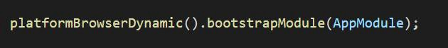

In our AppModule, we then need to specify the component that will serve as the entry point component for our application. This happens in our app.module.ts file where we import the entry component (conventionally AppComponent) and supply it as the only item in our bootstrap array inside the NgModule configuration object.

https://cdn-images-1.medium.com/max/800/1*KL1JJ4iAP_it0VJyHjNH0A.jpeg

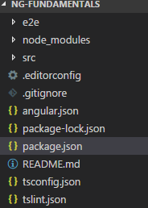

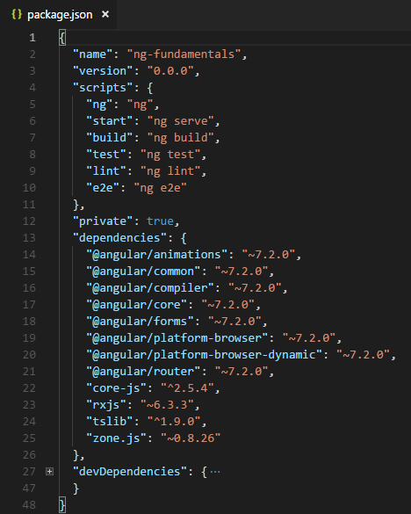

 This file holds various metadata relevant to the project. This file is used to give information to npm that allows it to identify the project as well as handle the project's dependencies

The package.json is organized into two groups of packages:

* [Dependencies](https://angular.io/guide/npm-packages#dependencies) are essential to *running* applications.
* [DevDependencies](https://angular.io/guide/npm-packages#dev-dependencies) are only necessary to *develop* applications.

**For angular.json see below link**

<https://angular.io/guide/workspace-config>

**NgModules**

An NgModule is a class marked by the @[NgModule](https://angular.io/api/core/NgModule) decorator. @[NgModule](https://angular.io/api/core/NgModule) takes a metadata object that describes how to compile a component's template and how to create an injector at runtime. It identifies the module's own components, directives, and pipes, making some of them public, through the [exports](https://angular.io/api/core/NgModule#exports) property, so that external components can use them. @[NgModule](https://angular.io/api/core/NgModule) can also add service providers to the application dependency injectors.

NgModule metadata does the following:

* Declares which components, directives, and pipes belong to the module.
* Makes some of those components, directives, and pipes public so that other module's component templates can use them.
* Imports other modules with the components, directives, and pipes that components in the current module need.
* Provides services that the other application components can use.

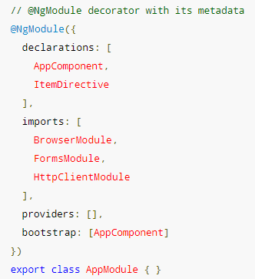

@Input

@Input decorator binds a property within one component (child component) to receive a value from another component (parent component). This is one way communication from parent to child

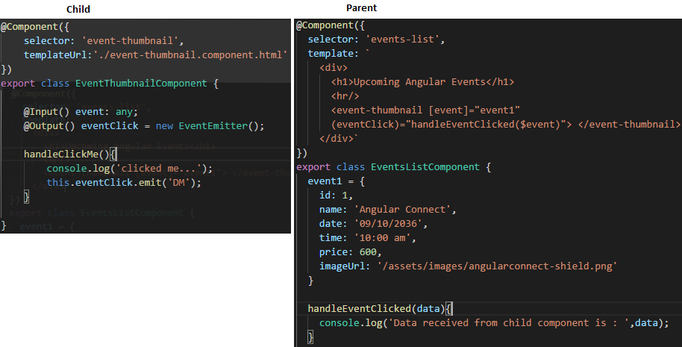

@Output decorator binds a property of a component to send data from one component (child component) to calling component (parent component).

## Template reference variables ( #var )

Use the hash symbol (#) to declare a reference variable. The #phone declares a phone variable on an <input>

<input #phone placeholder="phone number">

You can refer to a template reference variable anywhere in the template. The phone variable declared on this <input> is consumed in a <button> on the other side of the template

<!-- phone refers to the input element; pass its `value` to an event handler --> <button (click)="callPhone(phone.value)">Call</button>

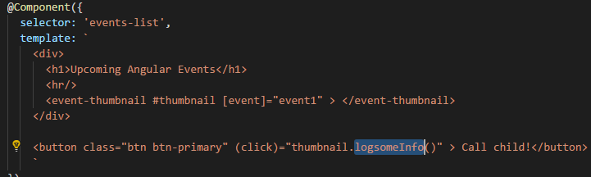

You can use the ref- prefix alternative to #. This example declares the fax variable as ref-fax instead of #fax.

<input ref-fax >

<button (click)="callFax(fax.value)">Fax</button>

Three ways we can interact with parent and child components

1. @input
2. @output
3. Template ref variable #

Safe Navigation Operator (?.)

Safe navigation operator avoids exception for null and undefined values in property paths. While accessing properties from object it may throw exception if object is null or undefined. For safer side we can use safe navigation operator to access property from object and hence it will not throw exception for the scenario that object is null or undefined. If we have an object person with the properties name then using safe navigation operator we will access object property as follows.

{{personone?.name}}

{{companythree?.owner?.name}}

**Class Binding & NgClass**

If you want to bind single class to element then use below pattern

<div [class.active]="isActive">

...

</div>

If you want to bind one or more than one class then use ngClass binding

We can use ngClass with many ways

[ngClass]="text-success"

[ngClass]="getCurrentClass()"

getCurrentClass(){

return {text-success:true} **or**

return ‘text-success’ **or**

return [‘text-success’]

}

[ngClass]="{'text-success':true}"

[ngClass]="{'text-success':checkMyFunction()}"

[ngClass]="{'text-success':person.country === 'UK'}"

<li [ngClass]="{

'text-success':person.country === 'UK',

'text-primary':person.country === 'USA',

'text-danger':person.country === 'HK'

}">

**NgStyle**

<div [ngStyle]="{'background-color':'green'}"></<div>

<div [ngStyle]="{'background-color':person.country === 'UK' ? 'green' : 'red' }"></<div>

[ngStyle]="{'color':getColor(person.country)}"

[style.font-size.**px**]="24"

<div [style.color]="getColor(person.country)"> </<div>

**Dependency Injection**

* DI is a coding pattern in which a class asks for dependencies from external sources rather than creating them itself
* A component can get services from its own injector, from the injectors of its component ancestors, from the injector of its parent NgModule, or from the root injector.
* The @Injectable() decorator has the providedIn metadata option, where you can specify the provider of the decorated service class with the root injector, or with the injector for a specific NgModule
* The @NgModule() and @Component() decorators have the providers metadata option, where you can configure providers for NgModule-level or component-level injectors.
* Services are singletons within the scope of an injector. That is, there is at most one instance of a service in a given injector.
* Whenever Angular creates a new instance of a component that has providers specified in @Component(), it also creates a new child injector for that instance
* Child modules and component injectors are independent of each other, and create their own separate instances of the provided services
* When Angular destroys an NgModule or component instance, it also destroys that injector and that injector's service instances.

**Optional dependencies**

HeroService requires a logger, but what if it could get by without one?

When a component or service declares a dependency, the class constructor takes that dependency as a parameter. You can tell Angular that the dependency is optional by annotating the constructor parameter with @Optional().

When using @[Optional](https://angular.io/api/core/Optional)(), your code must be prepared for a null value. If you don't register a logger provider anywhere, the injector sets the value of logger to null.

constructor(@Optional() private logger: Logger) {

if (this.logger) {

this.logger.log(some_message);

}

}

@[Inject](https://angular.io/api/core/Inject)() and @[Optional](https://angular.io/api/core/Optional)() are parameter decorators.

Angular 6 brought us new better providedIn syntax for registration of services into Angular dependency injection mechanism

component providers are made available to the component and all its view AND content child components

View providers are only made available for the component and its view child components. They are declared by the viewProviders option in the component decorator

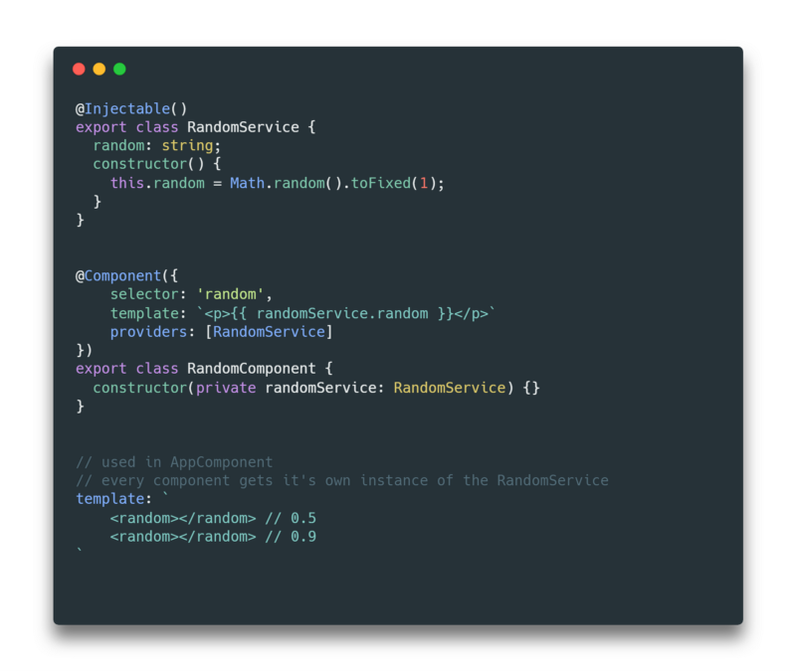

The RandomService is registered in the providers: [] of the RandomComponent so we will get different random number every time we use <random></random> component in our template.

Before  providedIn, libraries had to provide all heir publicly available services in the providers: []field of the main module

In providedIn metadata we can not use component name like below

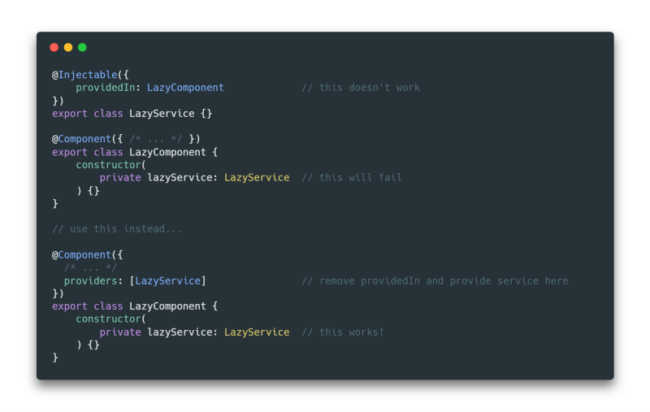

**Lifecycle Hooks**

You don't have to add the lifecycle hook interfaces to directives and components to benefit from the hooks themselve

Angular instead inspects directive and component classes and calls the hook methods if they are defined. Angular finds and calls methods like ngOnInit(), with or without the interfaces.

it's good practice to add interfaces to TypeScript directive classes in order to benefit from strong typing and editor tooling.

1. **ngOnChanges()**

* Used in pretty much any component that has an input.
* Called whenever an input value changes
* Is called the first time before ngOnInit

1. **ngOnInit()**

* Used to initialize data in a component.
* Called after input values are set when a component is initialized.
* Added to every component by default by the Angular CLI.
* Called only once

1. **ngDoCheck()**

* Called during all change detection runs
* A run through the view by Angular to update/detect changes

1. **ngAfterContentInit()**

* Called only once after first ngDoCheck()
* Called after the first run through of initializing content

1. **ngAfterContentChecked()**

* Called after every ngDoCheck()
* Waits till after ngAfterContentInit() on first run through

1. **ngAfterViewInit()**

* Called after Angular initializes component and child component content.
* Called only once after view is initialized

1. **ngAfterViewChecked()**

* Called after all the content is initialized and checked. (Component and child components).
* First call is after ngAfterViewInit()
* Called after every ngAfterContentChecked() call is completed

1. **ngOnDestroy()**

* Used to clean up any necessary code when a component is removed from the DOM.
* Fairly often used to unsubscribe from things like services.
* Called only once just before component is removed from the DOM.

In my experience as an Angular developer, I primarily use only four of these hooks. Mostly because I don’t want to do something to a component after the content has already been checked.

ngOnChanges()

ngOnInit()

ngAfterViewInit()

ngOnDestory()

The first two I use fairly frequently. They are very useful when dealing with input values or setting your component state based on outside data. The other two are very use case specific. If for some reason you need to do something after your component content has been set, use ngAfterViewInit. As I stated above, clean up your component with ngOnDestory().