ReactJS-HOL

**1.**

import logo from './logo.svg';

import './App.css';

function App() {

return (

<h1>Welcome the first session of React</h1>

);

}

export default App;

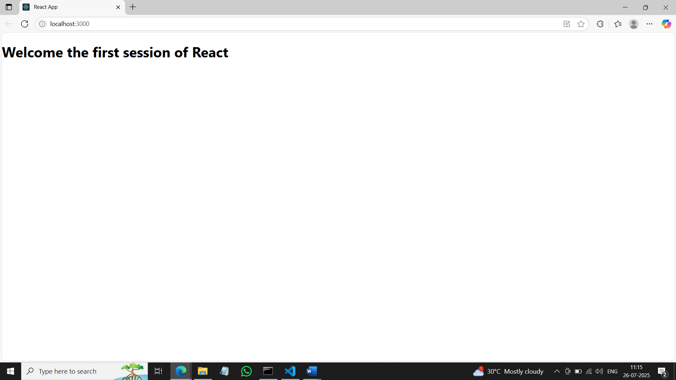

**2.**

**Home.js**

import React, { Component } from 'react';

class Home extends Component {

  render() {

    return (

      <div>

        <h3>Welcome to the Home Page of Student Management Portal</h3>

      </div>

    );

  }

}

export default Home;

**About.js**

import React, { Component } from 'react';

class About extends Component {

  render() {

    return (

      <div>

        <h3>Welcome to the About Page of Student Management Portal</h3>

      </div>

    );

  }

}

export default About;

**Contact.js**

import React, { Component } from 'react';

class Contact extends Component {

  render() {

    return (

      <div>

        <h3>Welcome to the Contact Page of Student Management Portal</h3>

      </div>

    );

  }

}

export default Contact;

**App.js**

import React from 'react';

import logo from './logo.svg';

import './App.css';

import Home from './Components/Home';

import About from './Components/About';

import Contact from './Components/Contact';

function App() {

  return (

    <div className="container">

      <Home />

      <About />

      <Contact />

    </div>

  );

}

export default App;

**3. CalculateScore.js**

import '../Stylesheets/mystyle.css';

const percentToDecimal = (decimal) => {

  return (decimal.toFixed(2) + '%');

};

const calcScore = (total, goal) => {

  return percentToDecimal(total / goal);

};

export const CalculateScore = ({ Name, School, total, goal }) => (

  <div className="formatstyle">

    <h1><font color="Brown">Student Details:</font></h1>

    <div className="Name">

      <b><span> Name: </span></b>

      <span>{Name}</span>

    </div>

    <div className="School">

      <b><span> School: </span></b>

      <span>{School}</span>

    </div>

    <div className="Total">

      <b><span>Total: </span></b>

      <span>{total}</span>

      <span> Marks</span>

    </div>

    <div className="Score">

      <b>Score:</b>

      <span>{calcScore(total, goal)}</span>

    </div>

  </div>

);

**mystyle.css**

.Name {

    font-weight: 300;

    color: blue;

  }

  .School {

    color: crimson;

  }

  .Total {

    color: darkmagenta;

  }

  .formatstyle {

    text-align: center;

    font-size: large;

  }

  .Score {

    color: forestgreen;

  }

**App.js**

import logo from './logo.svg';

import './App.css';

import { CalculateScore } from './Components/CalculateScore';

function App() {

  return (

    <div>

      <CalculateScore Name={"Steeve"}

      School={"DNV Public School"}

      total={284}

      goal={3}

      />

    </div>

  );

}

export default App;

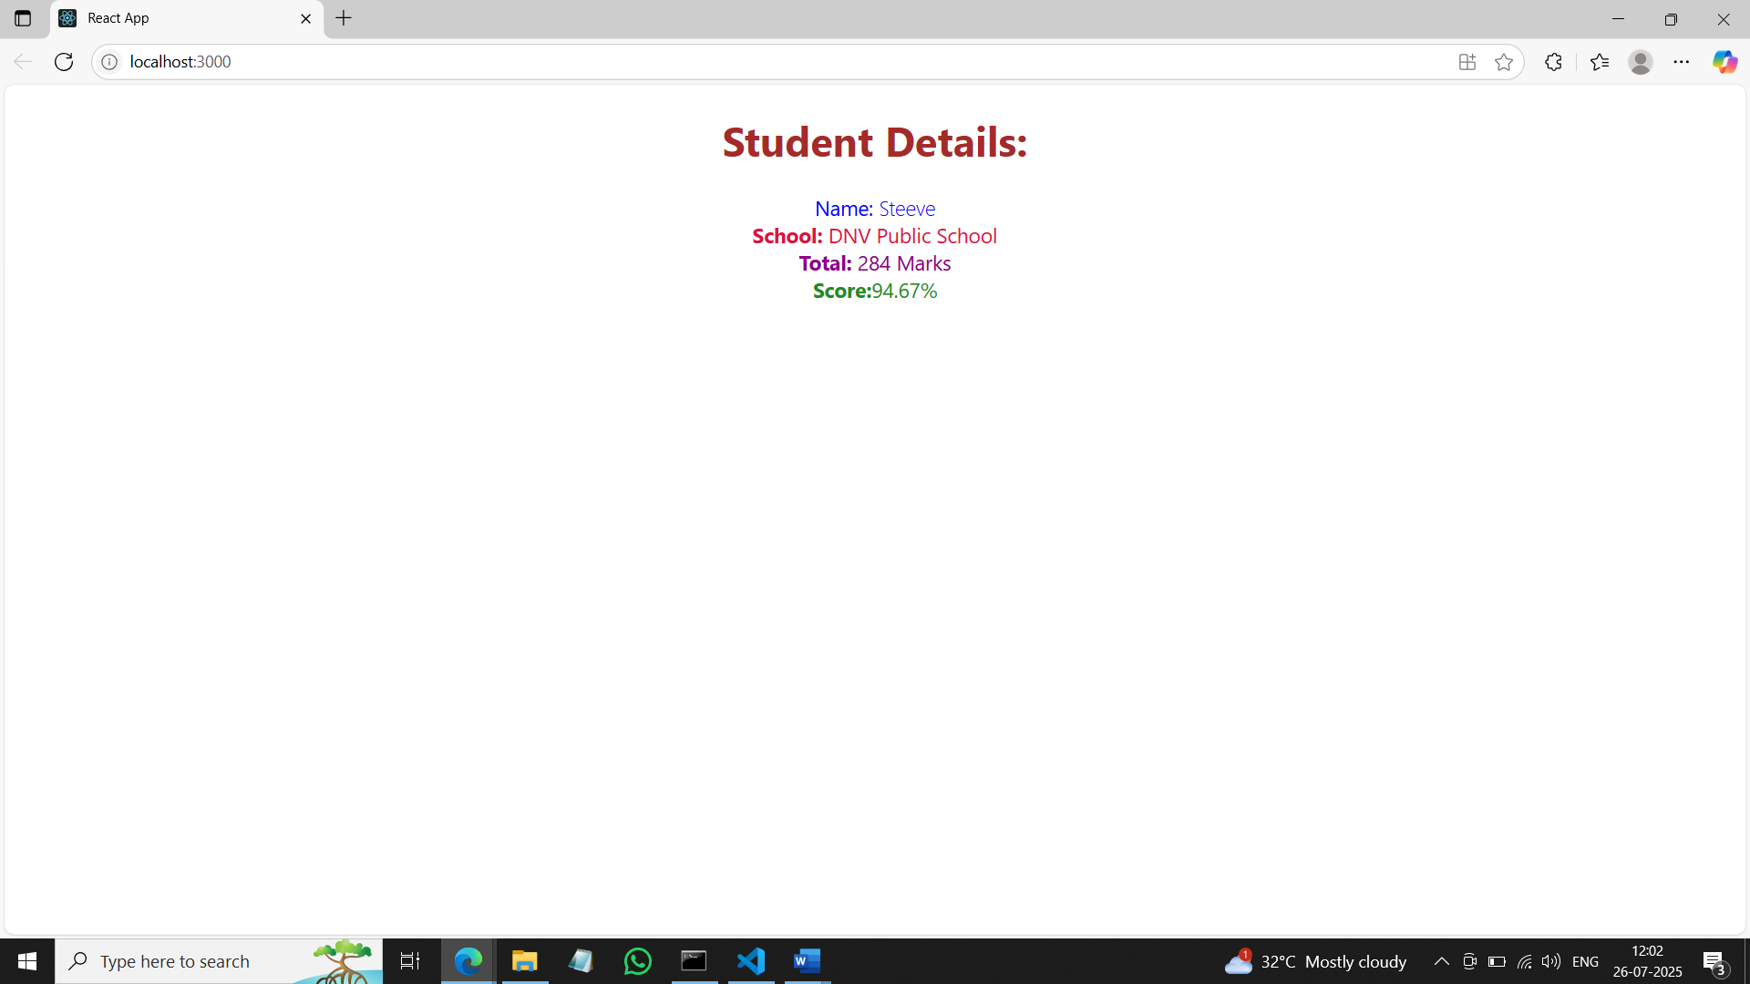

**4. Post.js**

class Post {

    constructor(id, title, body){

        this.id=id;

        this.title=title;

        this.body=body;

    }

}

export default Post;

**Posts.js**

import React from 'react';

class Posts extends React.Component {

  constructor(props) {

    super(props);

    this.state = {

      posts: []

    };

  }

  loadPosts = () => {

    fetch('https://jsonplaceholder.typicode.com/posts')

      .then(response => response.json())

      .then(data => {

        this.setState({ posts: data });

      })

      .catch(error => {

        console.error('Error fetching posts:', error);

      });

  };

  componentDidMount() {

    this.loadPosts();

  }

  componentDidCatch(error, info) {

    alert("An error occurred: " + error.toString());

  }

  render() {

    return (

      <div>

        <h2>Posts</h2>

        {this.state.posts.map(post => (

          <div key={post.id}>

            <h3>{post.title}</h3>

            <p>{post.body}</p>

          </div>

        ))}

      </div>

    );

  }

}

export default Posts;

**App.js**

import React from 'react';

import Posts from './Posts';

function App() {

  return (

    <div className="App">

      <Posts />

    </div>

  );

}

export default App;

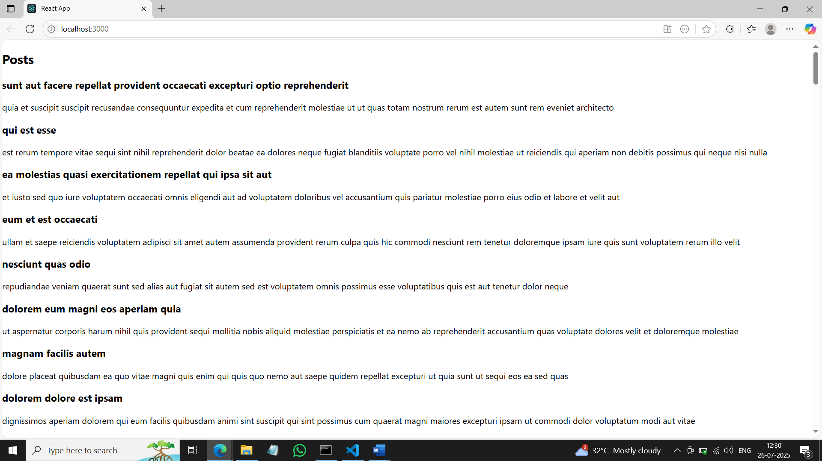

**5. CohortDetails.js**

import React from 'react';

import styles from './CohortDetails.module.css';

function CohortDetails({ name, start, status, coach, trainer }) {

  const headingStyle = {

    color: status.toLowerCase() === 'ongoing' ? 'green' : 'blue'

  };

  return (

    <div className={styles.box}>

      <h3 style={headingStyle}>{name}</h3>

      <dl>

        <dt>Started On</dt>

        <dd>{start}</dd>

        <dt>Current Status</dt>

        <dd>{status}</dd>

        <dt>Coach</dt>

        <dd>{coach}</dd>

        <dt>Trainer</dt>

        <dd>{trainer}</dd>

      </dl>

    </div>

  );

}

export default CohortDetails;

**CohortDetails.module.css**

.box {

  width: 300px;

  display: inline-block;

  margin: 10px;

  padding: 10px 20px;

  border: 1px solid black;

  border-radius: 10px;

}

dt {

  font-weight:bold;

}

**App.js**

import React from 'react';

import CohortDetails from './CohortDetails';

function App() {

  return (

    <div>

      <h1>Cohort Details</h1>

      <CohortDetails name="INTADMDF10 -.NET FSD" start="22-Feb-2022" status="Scheduled" coach="Aathma" trainer="Jojo Jose"/>

      <CohortDetails name="ADM21JF014 -JAVA FSD" start="10-Sep-2021" status="Ongoing" coach="Apoorv" trainer="Elisa Smith"/>

      <CohortDetails name="CDBJF21025 -JAVA FSD" start="24-Dec-2021" status="Ongoing" coach="Aathma" trainer="John Doe"/>

    </div>

  );

}

export default App;

