**1.**

91824@LAPTOP-PC27GJF4 MINGW64 ~

$ git config --global core.editor "\"C:/Program Files/Notepad++/notepad++.exe\" -multiInst -nosession"

91824@LAPTOP-PC27GJF4 MINGW64 ~

$ git config --global core.editor

"C:/Program Files/Notepad++/notepad++.exe" -multiInst -nosession

91824@LAPTOP-PC27GJF4 MINGW64 ~

$ git --version

git version 2.48.1.windows.1

91824@LAPTOP-PC27GJF4 MINGW64 ~

$ git config --global user.name "mithra31"

91824@LAPTOP-PC27GJF4 MINGW64 ~

$ git config --global user.email "ilavarasanemithra@gmail.com"

91824@LAPTOP-PC27GJF4 MINGW64 ~

$ git config --global core.editor "\"C:/Program Files/Notepad++/notepad++.exe\" -multiInst -nosession"

91824@LAPTOP-PC27GJF4 MINGW64 ~

$ git config --global --list

http.postbuffer=524288000

user.name=mithra31

user.email=ilavarasanemithra@gmail.com

core.editor="C:/Program Files/Notepad++/notepad++.exe" -multiInst -nosession

91824@LAPTOP-PC27GJF4 MINGW64 ~

$ mkdir ~/GitDemo

91824@LAPTOP-PC27GJF4 MINGW64 ~

$ cd ~/GitDemo

91824@LAPTOP-PC27GJF4 MINGW64 ~/GitDemo

$ git init

Initialized empty Git repository in C:/Users/91824/GitDemo/.git/

91824@LAPTOP-PC27GJF4 MINGW64 ~/GitDemo (master)

$ echo "Welcome to the GitDemo project" > welcome.txt

91824@LAPTOP-PC27GJF4 MINGW64 ~/GitDemo (master)

$ cat welcome.txt

Welcome to the GitDemo project

91824@LAPTOP-PC27GJF4 MINGW64 ~/GitDemo (master)

$ git add welcome.txt

warning: in the working copy of 'welcome.txt', LF will be replaced by CRLF the n

ext time Git touches it

91824@LAPTOP-PC27GJF4 MINGW64 ~/GitDemo (master)

$ git commit

[master (root-commit) 43baee2] Initial commit: add welcome.txt

1 file changed, 1 insertion(+)

create mode 100644 welcome.txt

91824@LAPTOP-PC27GJF4 MINGW64 ~/GitDemo (master)

$ git remote add origin https://gitlab.com/ilavarasanemithra-group/gitdemo.git

91824@LAPTOP-PC27GJF4 MINGW64 ~/GitDemo (master)

$ git remote -v

origin https://gitlab.com/ilavarasanemithra-group/gitdemo.git (fetch)

origin https://gitlab.com/ilavarasanemithra-group/gitdemo.git (push)

91824@LAPTOP-PC27GJF4 MINGW64 ~/GitDemo (master)

$ git push -u origin main || git push -u origin master

error: src refspec main does not match any

error: failed to push some refs to 'https://gitlab.com/ilavarasanemithra-group/g

itdemo.git'

Enumerating objects: 3, done.

Counting objects: 100% (3/3), done.

Writing objects: 100% (3/3), 261 bytes | 261.00 KiB/s, done.

Total 3 (delta 0), reused 0 (delta 0), pack-reused 0 (from 0)

remote:

remote: To create a merge request for master, visit:

remote: https://gitlab.com/ilavarasanemithra-group/gitdemo/-/merge_requests/ne

w?merge_request%5Bsource_branch%5D=master

remote:

To https://gitlab.com/ilavarasanemithra-group/gitdemo.git

* [new branch] master -> master

branch 'master' set up to track 'origin/master'.

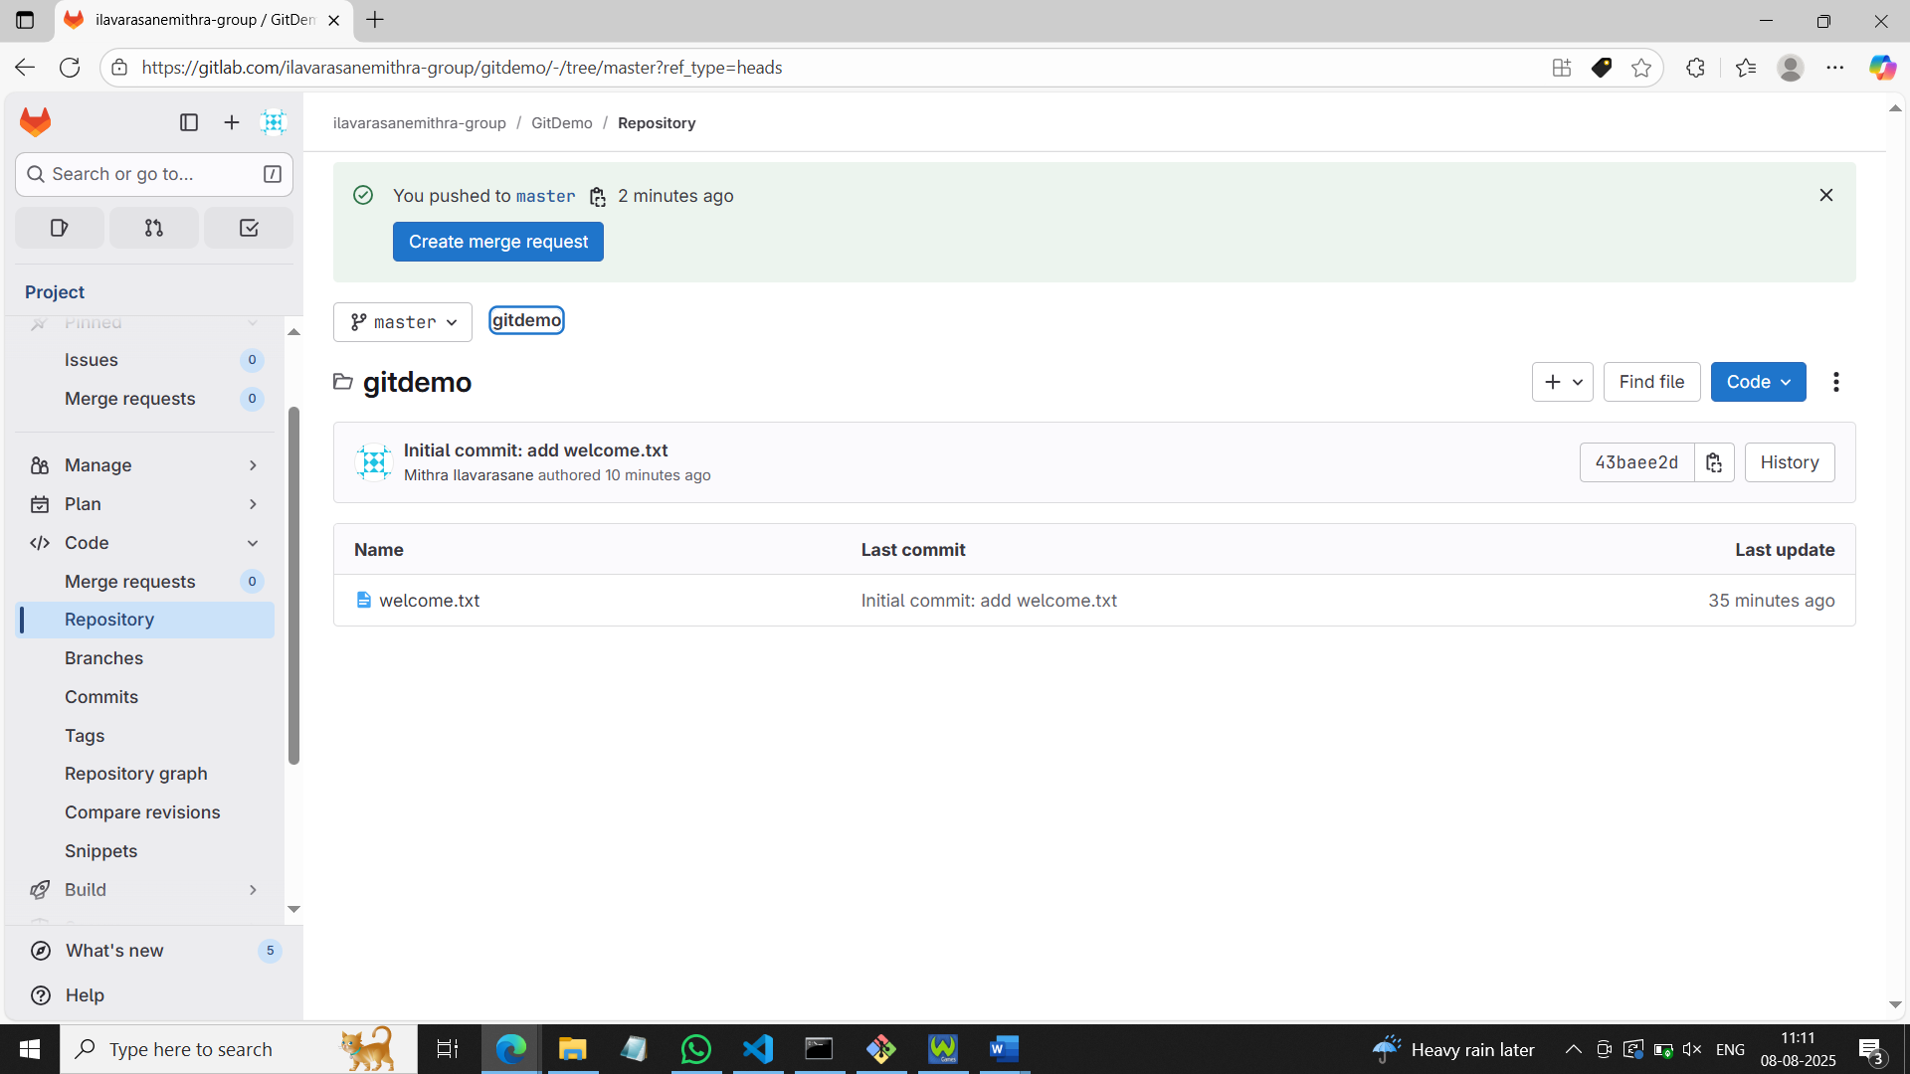

**2.**

91824@LAPTOP-PC27GJF4 MINGW64 ~/GitDemo (master)

$ echo "this is a test log" > app.log

91824@LAPTOP-PC27GJF4 MINGW64 ~/GitDemo (master)

$ mkdir -p log

91824@LAPTOP-PC27GJF4 MINGW64 ~/GitDemo (master)

$ echo "error: something" > log/error.log

91824@LAPTOP-PC27GJF4 MINGW64 ~/GitDemo (master)

$ ls -la

total 46

drwxr-xr-x 1 91824 197609 0 Aug 8 11:19 **.**/

drwxr-xr-x 1 91824 197609 0 Aug 8 10:34 **..**/

drwxr-xr-x 1 91824 197609 0 Aug 8 10:43 **.git**/

-rw-r--r-- 1 91824 197609 19 Aug 8 11:19 app.log

drwxr-xr-x 1 91824 197609 0 Aug 8 11:20 **log**/

-rw-r--r-- 1 91824 197609 31 Aug 8 10:35 welcome.txt

91824@LAPTOP-PC27GJF4 MINGW64 ~/GitDemo (master)

$ tree -a . | sed -n '1,50p'

bash: tree: command not found

91824@LAPTOP-PC27GJF4 MINGW64 ~/GitDemo (master)

$ notepad++.exe .gitignore

91824@LAPTOP-PC27GJF4 MINGW64 ~/GitDemo (master)

$ git status

On branch master

Your branch is up to date with 'origin/master'.

Untracked files:

(use "git add <file>..." to include in what will be committed)

.gitignore

nothing added to commit but untracked files present (use "git add" to track)

91824@LAPTOP-PC27GJF4 MINGW64 ~/GitDemo (master)

$ git add .gitignore

91824@LAPTOP-PC27GJF4 MINGW64 ~/GitDemo (master)

$ git commit -m "Add .gitignore to ignore *.log files and log folder"

[master e7af923] Add .gitignore to ignore *.log files and log folder

1 file changed, 5 insertions(+)

create mode 100644 .gitignore

91824@LAPTOP-PC27GJF4 MINGW64 ~/GitDemo (master)

$ git push

Enumerating objects: 4, done.

Counting objects: 100% (4/4), done.

Delta compression using up to 4 threads

Compressing objects: 100% (3/3), done.

Writing objects: 100% (3/3), 367 bytes | 367.00 KiB/s, done.

Total 3 (delta 0), reused 0 (delta 0), pack-reused 0 (from 0)

remote:

remote: To create a merge request for master, visit:

remote: https://gitlab.com/ilavarasanemithra-group/gitdemo/-/merge_requests/new?merge_request%5Bsource_branch%5D=master

remote:

To https://gitlab.com/ilavarasanemithra-group/gitdemo.git

43baee2..e7af923 master -> master

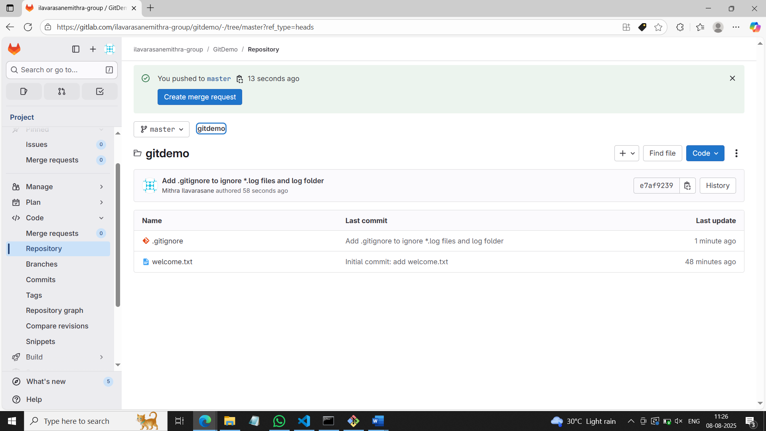

**3.**

91824@LAPTOP-PC27GJF4 MINGW64 ~/GitDemo (master)

$ git branch GitNewBranch

91824@LAPTOP-PC27GJF4 MINGW64 ~/GitDemo (master)

$ git checkout GitNewBranch

Switched to branch 'GitNewBranch'

91824@LAPTOP-PC27GJF4 MINGW64 ~/GitDemo (GitNewBranch)

$ echo "This is content in the new branch" > branchfile.txt

91824@LAPTOP-PC27GJF4 MINGW64 ~/GitDemo (GitNewBranch)

$ git add branchfile.txt

warning: in the working copy of 'branchfile.txt', LF will be replaced by CRLF th

e next time Git touches it

91824@LAPTOP-PC27GJF4 MINGW64 ~/GitDemo (GitNewBranch)

$ git commit -m "Add branchfile.txt in GitNewBranch"

[GitNewBranch 8a70bc4] Add branchfile.txt in GitNewBranch

1 file changed, 1 insertion(+)

create mode 100644 branchfile.txt

91824@LAPTOP-PC27GJF4 MINGW64 ~/GitDemo (GitNewBranch)

$ git checkout master

Switched to branch 'master'

Your branch is up to date with 'origin/master'.

91824@LAPTOP-PC27GJF4 MINGW64 ~/GitDemo (master)

$ git diff master GitNewBranch

**diff --git a/branchfile.txt b/branchfile.txt**

**new file mode 100644**

**index 0000000..a46c707**

**--- /dev/null**

**+++ b/branchfile.txt**

@@ -0,0 +1 @@

+This is content in the new branch

91824@LAPTOP-PC27GJF4 MINGW64 ~

$ git config --global diff.tool p4merge

91824@LAPTOP-PC27GJF4 MINGW64 ~

$ git config --global difftool.p4merge.path "C:/Program Files/Perforce/p4merge.exe"

91824@LAPTOP-PC27GJF4 MINGW64 ~

$ git config --global merge.tool p4merge

91824@LAPTOP-PC27GJF4 MINGW64 ~

$ git config --global mergetool.p4merge.path "C:/Program Files/Perforce/p4merge.exe"

91824@LAPTOP-PC27GJF4 MINGW64 ~/GitDemo (master)

$ git difftool master GitNewBranch

Viewing (1/1): 'branchfile.txt'

Launch 'p4merge' [Y/n]? y

91824@LAPTOP-PC27GJF4 MINGW64 ~/GitDemo (master)

$ git merge GitNewBranch

Updating e7af923..8a70bc4

Fast-forward

branchfile.txt | 1 +

1 file changed, 1 insertion(+)

create mode 100644 branchfile.txt

91824@LAPTOP-PC27GJF4 MINGW64 ~/GitDemo (master)

$ git log --oneline --graph --decorate

* b60b634 (**HEAD** -> **master**) Merge branch 'GitNewBranch' into master

|\

| * aac2cfa (**GitNewBranch**) Add branchfile.txt in GitNewBranch

|/

* e7af923 (**origin/master**) Add .gitignore to ignore *.log files and log folder

* 43baee2 Initial commit: add welcome.txt

91824@LAPTOP-PC27GJF4 MINGW64 ~/GitDemo (master)

$ git branch -d GitNewBranch

Deleted branch GitNewBranch (was aac2cfa).

**4.**

91824@LAPTOP-PC27GJF4 MINGW64 ~/GitDemo (master)

$ cd ~/GitDemo

91824@LAPTOP-PC27GJF4 MINGW64 ~/GitDemo (master)

$ git checkout master

Already on 'master'

Your branch is ahead of 'origin/master' by 2 commits.

(use "git push" to publish your local commits)

91824@LAPTOP-PC27GJF4 MINGW64 ~/GitDemo (master)

$ git status

On branch master

Your branch is ahead of 'origin/master' by 2 commits.

(use "git push" to publish your local commits)

nothing to commit, working tree clean

91824@LAPTOP-PC27GJF4 MINGW64 ~/GitDemo (master)

$ git checkout -b GitWork

Switched to a new branch 'GitWork'

91824@LAPTOP-PC27GJF4 MINGW64 ~/GitDemo (GitWork)

$ echo "<greeting>Hello from GitWork</greeting>" > hello.xml

91824@LAPTOP-PC27GJF4 MINGW64 ~/GitDemo (GitWork)

$ git add hello.xml

warning: in the working copy of 'hello.xml', LF will be replaced by CRLF the nex

t time Git touches it

91824@LAPTOP-PC27GJF4 MINGW64 ~/GitDemo (GitWork)

$ git commit -m "Add hello.xml in GitWork"

[GitWork 6030f32] Add hello.xml in GitWork

1 file changed, 1 insertion(+)

create mode 100644 hello.xml

91824@LAPTOP-PC27GJF4 MINGW64 ~/GitDemo (GitWork)

$ echo "<greeting>Hello from GitWork - updated</greeting>" > hello.xml

91824@LAPTOP-PC27GJF4 MINGW64 ~/GitDemo (GitWork)

$ git status

On branch GitWork

Changes not staged for commit:

(use "git add <file>..." to update what will be committed)

(use "git restore <file>..." to discard changes in working directory)

modified: hello.xml

no changes added to commit (use "git add" and/or "git commit -a")

91824@LAPTOP-PC27GJF4 MINGW64 ~/GitDemo (GitWork)

$ git add hello.xml

warning: in the working copy of 'hello.xml', LF will be replaced by CRLF the nex

t time Git touches it

91824@LAPTOP-PC27GJF4 MINGW64 ~/GitDemo (GitWork)

$ git commit -m "Update hello.xml in GitWork"

[GitWork 676957e] Update hello.xml in GitWork

1 file changed, 1 insertion(+), 1 deletion(-)

91824@LAPTOP-PC27GJF4 MINGW64 ~/GitDemo (GitWork)

$ git checkout master

Switched to branch 'master'

Your branch is ahead of 'origin/master' by 2 commits.

(use "git push" to publish your local commits)

91824@LAPTOP-PC27GJF4 MINGW64 ~/GitDemo (master)

$ echo "<greeting>Hello from master</greeting>" > hello.xml

91824@LAPTOP-PC27GJF4 MINGW64 ~/GitDemo (master)

$ git add hello.xml

warning: in the working copy of 'hello.xml', LF will be replaced by CRLF the nex

t time Git touches it

91824@LAPTOP-PC27GJF4 MINGW64 ~/GitDemo (master)

$ git commit -m "Add hello.xml in master (conflicting)"

[master 4ac4f9f] Add hello.xml in master (conflicting)

1 file changed, 1 insertion(+)

create mode 100644 hello.xml

91824@LAPTOP-PC27GJF4 MINGW64 ~/GitDemo (master)

$ git log --oneline --graph --decorate --all

* 4ac4f9f (**HEAD** -> **master**) Add hello.xml in master (conflicting)

| * 676957e (**GitWork**) Update hello.xml in GitWork

| * 6030f32 Add hello.xml in GitWork

|/

* b60b634 Merge branch 'GitNewBranch' into master

|\

| * aac2cfa Add branchfile.txt in GitNewBranch

|/

* e7af923 (**origin/master**) Add .gitignore to ignore *.log files and log folder

* 43baee2 Initial commit: add welcome.txt

91824@LAPTOP-PC27GJF4 MINGW64 ~/GitDemo (master)

$ git diff master GitWork

**diff --git a/hello.xml b/hello.xml**

**index 9d60142..c236a33 100644**

**--- a/hello.xml**

**+++ b/hello.xml**

@@ -1 +1 @@

-<greeting>Hello from master</greeting>

+<greeting>Hello from GitWork - updated</greeting>

91824@LAPTOP-PC27GJF4 MINGW64 ~/GitDemo (master)

$ git difftool master GitWork

Viewing (1/1): 'hello.xml'

Launch 'p4merge' [Y/n]? y

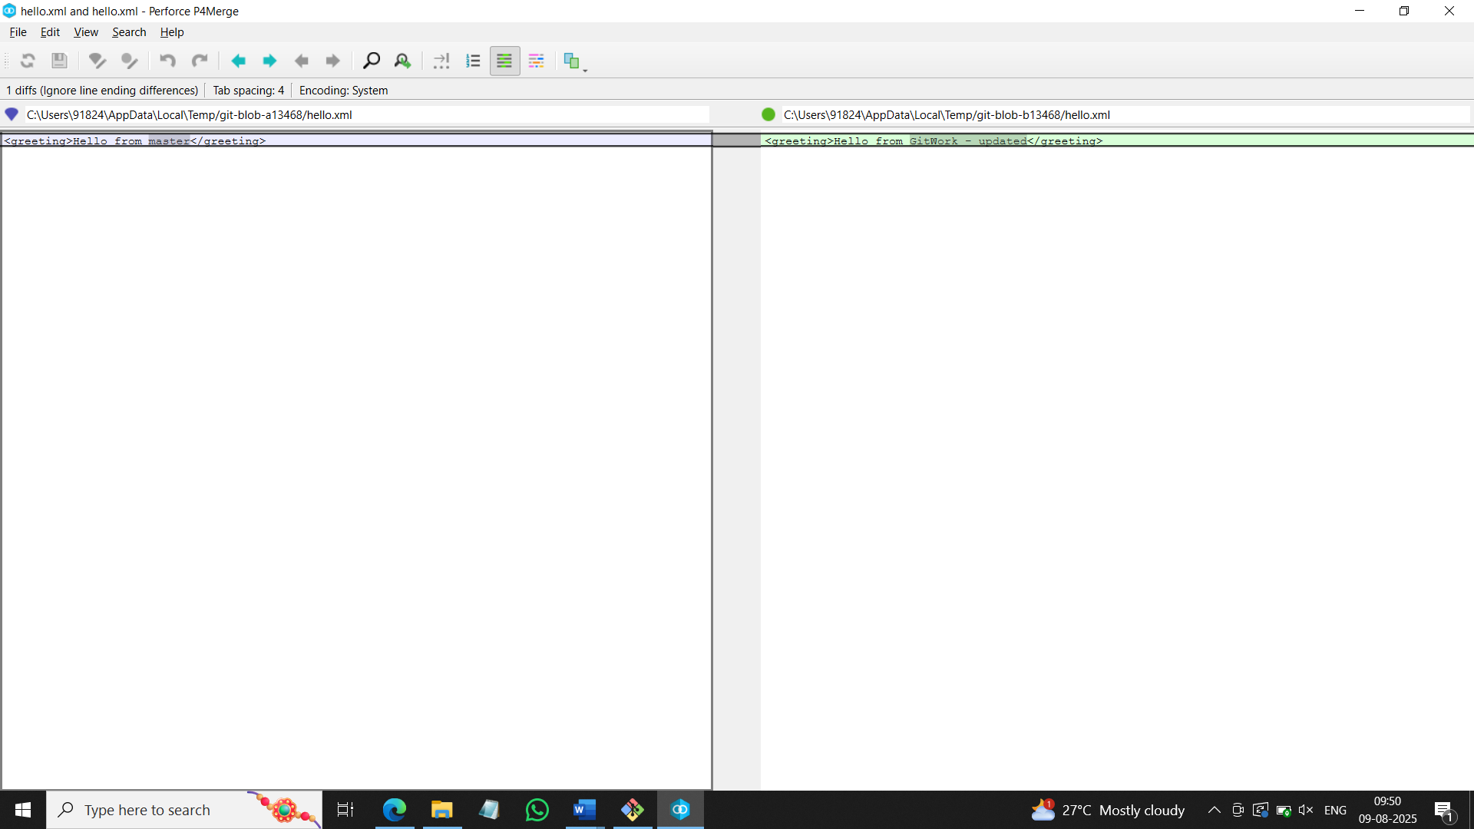

91824@LAPTOP-PC27GJF4 MINGW64 ~/GitDemo (master)

$ git merge GitWork

Auto-merging hello.xml

CONFLICT (add/add): Merge conflict in hello.xml

Automatic merge failed; fix conflicts and then commit the result.

91824@LAPTOP-PC27GJF4 MINGW64 ~/GitDemo (master|MERGING)

$ git mergetool

Merging:

hello.xml

Normal merge conflict for 'hello.xml':

{local}: created file

{remote}: created file

error: invalid path './hello_BASE_1142.xml'

91824@LAPTOP-PC27GJF4 MINGW64 ~/GitDemo (master|MERGING)

$ git add hello.xml

91824@LAPTOP-PC27GJF4 MINGW64 ~/GitDemo (master|MERGING)

$ git commit -m "Resolve merge conflict for hello.xml (merge GitWork into master)"

[master c6c0ca3] Resolve merge conflict for hello.xml (merge GitWork into master

)

91824@LAPTOP-PC27GJF4 MINGW64 ~/GitDemo (master)

$ git status

On branch master

Your branch is ahead of 'origin/master' by 6 commits.

(use "git push" to publish your local commits)

Untracked files:

(use "git add <file>..." to include in what will be committed)

hello.xml.orig

nothing added to commit but untracked files present (use "git add" to track)

91824@LAPTOP-PC27GJF4 MINGW64 ~/GitDemo (master)

$ ls -la

total 54

drwxr-xr-x 1 91824 197609 0 Aug 9 09:55 **.**/

drwxr-xr-x 1 91824 197609 0 Aug 9 09:49 **..**/

drwxr-xr-x 1 91824 197609 0 Aug 9 09:57 **.git**/

-rw-r--r-- 1 91824 197609 82 Aug 8 11:22 .gitignore

-rw-r--r-- 1 91824 197609 19 Aug 8 11:19 app.log

-rw-r--r-- 1 91824 197609 35 Aug 9 09:35 branchfile.txt

-rw-r--r-- 1 91824 197609 131 Aug 9 09:51 hello.xml

-rw-r--r-- 1 91824 197609 131 Aug 9 09:51 hello.xml.orig

drwxr-xr-x 1 91824 197609 0 Aug 8 11:20 **log**/

-rw-r--r-- 1 91824 197609 31 Aug 8 10:35 welcome.txt

91824@LAPTOP-PC27GJF4 MINGW64 ~/GitDemo (master)

$ echo "*.orig" >> .gitignore

91824@LAPTOP-PC27GJF4 MINGW64 ~/GitDemo (master)

$ git add .gitignore

warning: in the working copy of '.gitignore', LF will be replaced by CRLF the ne

xt time Git touches it

91824@LAPTOP-PC27GJF4 MINGW64 ~/GitDemo (master)

$ git commit -m "Ignore merge backup files (*.orig)"

[master 2b372a4] Ignore merge backup files (*.orig)

1 file changed, 1 insertion(+)

91824@LAPTOP-PC27GJF4 MINGW64 ~/GitDemo (master)

$ git branch -a

GitWork

* master

remotes/origin/master

91824@LAPTOP-PC27GJF4 MINGW64 ~/GitDemo (master)

$ git branch -d GitWork

Deleted branch GitWork (was 676957e).

91824@LAPTOP-PC27GJF4 MINGW64 ~/GitDemo (master)

$ git log --oneline --graph --decorate

* 2b372a4 (**HEAD** -> **master**) Ignore merge backup files (*.orig)

* c6c0ca3 Resolve merge conflict for hello.xml (merge GitWork into master)

|\

| * 676957e Update hello.xml in GitWork

| * 6030f32 Add hello.xml in GitWork

* | 4ac4f9f Add hello.xml in master (conflicting)

|/

* b60b634 Merge branch 'GitNewBranch' into master

|\

| * aac2cfa Add branchfile.txt in GitNewBranch

|/

* e7af923 (**origin/master**) Add .gitignore to ignore *.log files and log folder

* 43baee2 Initial commit: add welcome.txt

**5.**

91824@LAPTOP-PC27GJF4 MINGW64 ~/GitDemo (master)

$ cd ~/GitDemo

91824@LAPTOP-PC27GJF4 MINGW64 ~/GitDemo (master)

$ git checkout master

Already on 'master'

Your branch is ahead of 'origin/master' by 7 commits.

(use "git push" to publish your local commits)

91824@LAPTOP-PC27GJF4 MINGW64 ~/GitDemo (master)

$ git status

On branch master

Your branch is ahead of 'origin/master' by 7 commits.

(use "git push" to publish your local commits)

nothing to commit, working tree clean

91824@LAPTOP-PC27GJF4 MINGW64 ~/GitDemo (master)

$ git branch -a

* master

remotes/origin/master

91824@LAPTOP-PC27GJF4 MINGW64 ~/GitDemo (master)

$ git pull origin master

From https://gitlab.com/ilavarasanemithra-group/gitdemo

* branch master -> FETCH_HEAD

Already up to date.

91824@LAPTOP-PC27GJF4 MINGW64 ~/GitDemo (master)

$ git push origin master

Enumerating objects: 21, done.

Counting objects: 100% (21/21), done.

Delta compression using up to 4 threads

Compressing objects: 100% (16/16), done.

Writing objects: 100% (19/19), 1.87 KiB | 239.00 KiB/s, done.

Total 19 (delta 7), reused 0 (delta 0), pack-reused 0 (from 0)

remote:

remote: To create a merge request for master, visit:

remote: https://gitlab.com/ilavarasanemithra-group/gitdemo/-/merge_requests/ne

w?merge_request%5Bsource_branch%5D=master

remote:

To https://gitlab.com/ilavarasanemithra-group/gitdemo.git

e7af923..2b372a4 master -> master

